A PROJECT REPORT ON

FOODGUARD AI
A Dual-Pipeline Food Safety Detection System Using Deep Learning, OCR and FSSAI Compliance Rules

Submitted in partial fulfilment of the requirements for the award of the degree of
BACHELOR OF TECHNOLOGY
in
COMPUTER SCIENCE AND ENGINEERING

Submitted by
[Student Name] ([University Roll No.])

Under the guidance of
[Guide Name]
[Designation], Department of Computer Science and Engineering

[College logo]

DEPARTMENT OF COMPUTER SCIENCE AND ENGINEERING
[COLLEGE NAME]
(Affiliated to [University Name])
2026

CERTIFICATE
This is to certify that the project report entitled "FoodGuard AI: A Dual-Pipeline Food Safety Detection System Using Deep Learning, OCR and FSSAI Compliance Rules" submitted by [Student Name] ([University Roll No.]) in partial fulfilment of the requirements for the award of the degree of Bachelor of Technology in Computer Science and Engineering of [University Name] is a record of bonafide work carried out under my supervision and guidance during the academic year 2025–2026.
The results embodied in this report have not been submitted to any other university or institute for the award of any degree or diploma.
[Guide Name] [Head of Department]
Project Guide Head of the Department
External Examiner Date: ____________

DECLARATION
I hereby declare that the project report entitled "FoodGuard AI: A Dual-Pipeline Food Safety Detection System Using Deep Learning, OCR and FSSAI Compliance Rules" submitted to Department of Computer Science and Engineering, [College Name], is a record of original work done by me under the guidance of [Guide Name]. The information and data given in the report are authentic to the best of my knowledge.
This report has not been submitted to any other university or institution for the award of any degree, diploma or fellowship.
Place: ____________ [Student Name]
Date: ____________ [University Roll No.]

ACKNOWLEDGEMENT
I express my sincere gratitude to my project guide, [Guide Name], [Designation], Department of Computer Science and Engineering, for the guidance, encouragement and constructive feedback given throughout this project.
I thank [Head of Department], Head of the Department, and the Principal of [College Name] for providing the facilities required to carry out this work.
I am grateful to the faculty and staff of the department for their support, and to my family and friends for their constant encouragement.
I also acknowledge the open-source communities behind PyTorch, EasyOCR, OpenAI CLIP, OpenCV and Flask, the contributors of the Open Food Facts database, and the author of the Kaggle produce dataset used in this work.
[Student Name]

ABSTRACT
Consumers in India make many daily food decisions with little support: whether a tomato is still fresh, or whether a packet of chips is high in salt, sugar or saturated fat. The Food Safety and Standards Authority of India (FSSAI) defines limits for foods high in fat, sugar and salt (HFSS), but reading a small, glossy nutrition table and comparing it with those limits is tedious and error-prone.
This project presents FoodGuard AI, a web application that gives one clear verdict (SAFE, CAUTION or UNSAFE) for a photograph of food. It has two pipelines. For raw fruit and vegetables, a MobileNetV2 convolutional neural network fine-tuned on 12 fresh and stale classes estimates spoilage, and a Grad-CAM heat map shows which regions drove the decision. For packaged food, EasyOCR reads the back-of-pack nutrition table after OpenCV pre-processing; a rule-based parser normalises the values to per 100 g or per 100 ml and checks them against category-specific FSSAI limits, showing red hexagon warnings when a limit is exceeded. An expiry date can optionally be entered by the user and is checked when given.
Because a classifier will always produce some answer, three guardrails run before analysis: a CLIP zero-shot filter rejects photos that are not food, a category check catches a juice submitted as solid food or a label submitted as produce, and an identity check uses barcodes, the Open Food Facts database and brand families to detect a photo of a different product than the one named. Every analysed item also receives a 0–100 health score with a rating and information about the food.
On a leakage-safe test split of 2,208 images grouped by source photo, the spoilage model reached 97.2 % 12-class accuracy and 97.1 % fresh-versus-stale accuracy, with zero stale items marked SAFE. The out-of-food filter rejected 23 of 24 non-food photos at the first stage while falsely rejecting only 0.4 % of valid images. The OCR pipeline read 100 % of fields on a distorted synthetic bench and 76 % of values on real Indian label photos. A 49-test unit suite covers the parser, the FSSAI rules, identity logic and the review module.
Keywords: food safety, spoilage detection, MobileNetV2, transfer learning, OCR, EasyOCR, CLIP, out-of-distribution detection, FSSAI, HFSS, Grad-CAM, Flask.

TABLE OF CONTENTS

If the page numbers above are missing, right-click the table in Word and choose Update Field.

LIST OF FIGURES
Figure 4.1 System architecture of FoodGuard AI
Figure 6.1 Confusion matrix of the spoilage model on the test split
Figure 6.2 Home page in the light theme
Figure 6.3 Processing animation: a scanning beam over the user's photo with step-by-step progress
Figure 6.4 Result for a fresh tomato: inspection seal with health score, food information, score breakdown, checks and Grad-CAM
Figure 6.5 Result for a high-fat, high-salt snack: red hexagon warnings, nutrient bars against FSSAI limits and share of daily maximum
Figure 6.6 The same result in the dark theme
Figure 6.7 Category mismatch with a one-click suggestion to check again as a drink
Figure 6.8 Responsive layout at phone width

LIST OF TABLES
Table 3.1 Hardware used for development and recommended minimum
Table 3.2 Software stack
Table 4.1 Food categories
Table 4.2 Verdicts returned by the system
Table 4.3 Software modules
Table 5.1 Dataset split by source photo
Table 5.2 Training configuration
Table 5.3 HFSS limits used by the engine (values from the project brief)
Table 5.4 Health score rules
Table 6.1 Spoilage model results on the test split
Table 6.2 Per-class precision, recall and F1-score
Table 6.3 Guardrail results
Table 6.4 End-to-end test scenarios

LIST OF ABBREVIATIONS
AMP Automatic Mixed Precision
API Application Programming Interface
CLAHE Contrast Limited Adaptive Histogram Equalisation
CLIP Contrastive Language–Image Pre-training
CNN Convolutional Neural Network
CRAFT Character Region Awareness for Text detection
CRNN Convolutional Recurrent Neural Network
CUDA Compute Unified Device Architecture
FSSAI Food Safety and Standards Authority of India
Grad-CAM Gradient-weighted Class Activation Mapping
HFSS High in Fat, Sugar and Salt
HSV Hue, Saturation, Value colour space
OCR Optical Character Recognition
OOD Out-of-Distribution
USDA United States Department of Agriculture
WHO World Health Organization

CHAPTER 1
INTRODUCTION

1.1 Background
Food safety concerns in everyday life fall into two broad groups. The first is spoilage of fresh produce: fruit and vegetables bruise, rot and grow mould, and the visual signs are easy to miss when buying in bulk or storing at home. The second is the nutritional quality of packaged food. India has seen rapid growth in the consumption of packaged snacks, biscuits, instant noodles and sweetened beverages, many of which are high in fat, sugar or salt (HFSS). Excess intake of these nutrients is linked to obesity, hypertension and diabetes.
FSSAI regulates labelling through the Food Safety and Standards (Labelling and Display) Regulations, 2020, and has proposed front-of-pack nutrition labelling to warn consumers about HFSS foods. However, a consumer standing in a shop still has to find the nutrition table, read small print, convert per-serve values to per 100 g, convert salt to sodium, and remember the limits for each category. This project automates that process with computer vision and a transparent rule engine.

1.2 Problem Statement
Design and implement a system that, from one or more smartphone photographs, (a) detects spoilage in common raw produce, (b) reads the nutrition table of packaged food and checks it against FSSAI HFSS limits for the correct food category, (c) refuses to give a verdict on photos that are not food, are of the wrong category, or show a different product than the one named, and (d) explains every decision in plain language.

1.3 Objectives
- Fine-tune a lightweight CNN (MobileNetV2) to classify six produce types as fresh or stale, evaluated on a test split that is free of near-duplicate leakage.
- Build an OCR pipeline that reads Indian nutrition labels robustly under glare, blur and perspective distortion, and parses the values into a per-100 g or per-100 ml basis.
- Implement a configurable FSSAI compliance engine with separate limits for solid foods and beverages, and an exempt category for single-ingredient foods such as oil, ghee and honey.
- Add guardrails for out-of-distribution input: non-food photos, category mismatches, unsupported produce and wrong-product photos.
- Give every result a health score, a rating and useful information about the food, with an optional user-entered expiry check.
- Deliver the system as a responsive web application with light and dark themes, and measure its accuracy with reproducible scripts.

1.4 Scope of the Project
The system covers six produce types (apple, banana, bitter gourd, capsicum, orange and tomato) and four food categories: raw produce, packaged solid food, packaged liquid beverage, and exempt single-ingredient packaged food. Cooked or prepared dishes are out of scope and are rejected with an explanation. The application runs locally on a computer with an optional NVIDIA GPU; only product look-ups contact the public Open Food Facts service. FoodGuard AI is a decision-support and study tool and does not replace laboratory testing or regulatory certification.

1.5 Organisation of the Report
Chapter 2 surveys related work. Chapter 3 lists the hardware and software requirements. Chapter 4 describes the system architecture and design. Chapter 5 explains the methodology and implementation of each module. Chapter 6 presents testing and results. Chapter 7 concludes the report and discusses limitations and future work. Appendices give installation steps and the configuration format.

CHAPTER 2
LITERATURE SURVEY

2.1 Spoilage Detection with Convolutional Neural Networks
Visual inspection of fruit and vegetables has moved from hand-crafted colour and texture features to convolutional neural networks (CNNs) trained end to end. Transfer learning, in which a network pre-trained on ImageNet [18] is fine-tuned on a small domain dataset, is the standard approach when labelled data is limited. MobileNetV2 [1] uses inverted residual blocks with linear bottlenecks and depthwise separable convolutions, giving accuracy close to much larger networks at a fraction of the computation, which makes it suitable for deployment on ordinary computers and phones.
A recurring problem in published produce datasets is that they contain many augmented copies of the same original photograph. When such a dataset is split at random, near-identical images appear in both the training and test sets and reported accuracy is inflated. This is a form of data leakage [19]; this project addresses it by grouping images by source photo before splitting.

2.2 Explainability with Grad-CAM
Gradient-weighted Class Activation Mapping (Grad-CAM) [3] produces a coarse heat map of the image regions that most influenced a CNN's prediction by weighting the final convolutional feature maps with the gradients of the class score. It needs no change to the network and is widely used to check that a model attends to the object rather than the background. FoodGuard AI shows a Grad-CAM map with every produce verdict.

2.3 Optical Character Recognition for Labels
Modern scene-text OCR uses two stages: a text detector and a sequence recogniser. EasyOCR [6] combines the CRAFT character-region detector [4] with a CRNN recogniser [5] that pairs convolutional features with a recurrent network trained with CTC loss. Pre-processing strongly affects accuracy on photographs: contrast-limited adaptive histogram equalisation (CLAHE) [7] improves contrast in unevenly lit regions, while thresholding and up-scaling help with small print. Nutrition tables add a structural challenge, since values must be associated with the correct row and column (per 100 g versus per serve).

2.4 Zero-Shot Classification and Out-of-Distribution Detection
A classifier trained on a closed set of classes assigns one of those classes to any input, including inputs far from the training distribution. Hendrycks and Gimpel [20] showed that softmax confidence alone is a weak signal for detecting such inputs. CLIP [2] learns a joint embedding of images and text from 400 million image–caption pairs and can classify an image against arbitrary text prompts without task-specific training. This makes it a practical out-of-distribution filter: a photo can be scored against prompts describing food and non-food scenes before it ever reaches the specialised model.

2.5 Food Labelling Regulation in India
The Food Safety and Standards (Labelling and Display) Regulations, 2020 [8] make nutrition information mandatory on most pre-packaged foods, declared per 100 g or 100 ml. FSSAI has also published draft amendments on front-of-pack nutrition labelling [9] to flag HFSS foods. International guidance from the World Health Organization recommends limiting free sugars to under 10 % of energy [10], sodium to under 2 g per day [11] and saturated fat to under 10 % of energy. FoodGuard AI keeps all thresholds in a configuration file so that they can be updated to the final notified values without code changes.

2.6 Open Food Databases
Open Food Facts [13] is a crowd-sourced, openly licensed database of packaged products with barcodes, brands, ingredients and nutrition values. It has good coverage of Indian brands and provides a public API, which this project uses as a reference to verify that a label photo belongs to the named product.

2.7 Research Gap
Existing consumer apps either scan barcodes and rely entirely on a database, or classify produce freshness without any guard against invalid input. Few systems combine produce spoilage detection and label reading in one tool, apply the correct category-specific Indian limits, and explicitly refuse to answer when the photo is not suitable. FoodGuard AI addresses this gap with a guarded dual pipeline and plain-language explanations.

CHAPTER 3
SYSTEM REQUIREMENTS

3.1 Hardware Requirements
Table 3.1: Hardware used for development and recommended minimum
Component | Used in this project | Minimum
Processor | x86-64 desktop processor | Any 64-bit quad-core CPU
GPU | NVIDIA GeForce RTX 5060 Ti, 16 GB | Optional (CPU inference works, slower)
Memory | System RAM sufficient for PyTorch and CLIP | 8 GB RAM (16 GB recommended)
Storage | SSD | 5 GB free (models, datasets, libraries)
Camera | Smartphone camera for test photos | Any camera of 8 MP or more

3.2 Software Requirements
Table 3.2: Software stack
Software | Version | Purpose
Windows 11 Pro | 10.0.26200 | Operating system
Python | 3.12.10 | Programming language
PyTorch / torchvision | 2.11.0 / 0.26.0 (CUDA 12.8) | Deep learning, MobileNetV2
Hugging Face Transformers | 5.17.0 | CLIP ViT-B/32 model
EasyOCR | 1.7.2 | Text detection and recognition
OpenCV | 5.0.0 | Image pre-processing, barcode decoding
RapidFuzz | 3.14.6 | Fuzzy matching of nutrient names and products
Flask | 3.1.3 | Web server and REST API
scikit-learn, Matplotlib | latest | Metrics and confusion matrix
pytest | 8.x | Unit testing
Web browser | Any modern browser | User interface (HTML, CSS, JavaScript)

3.3 Functional Requirements
- The user can choose a category (fruit or vegetable, packaged food, packaged drink, or oil / ghee / honey) and upload one to three photos.
- The user can optionally enter a product name, a barcode and an expiry date.
- The system rejects non-food and cooked-food photos, detects category mismatches and wrong products, and suggests the correct category where possible.
- For produce, the system reports freshness, a grade, a Grad-CAM heat map and the share of discoloured surface.
- For packaged food, the system reads and displays the nutrients, compares them with FSSAI limits, and shows red hexagon warnings for exceeded limits.
- Every analysed item receives a health score (0–100), a rating, and information about the food.
- The system exposes a JSON API (POST /api/analyze, GET /api/health) for integration and testing.

3.4 Non-Functional Requirements
- Safety first: a stale item must not be marked SAFE; when the system is unsure it answers CAUTION or asks for a better photo.
- Explainability: every verdict includes a plain-language reason, the result of each check, and evidence images.
- Configurability: all thresholds and limits live in JSON files, with no magic numbers in code.
- Performance: a produce check completes in about a second on a GPU; a label check in a few seconds.
- Privacy: images are processed locally and are not stored.
- Usability and accessibility: responsive layout down to phone width, light and dark themes, keyboard focus styles, and reduced-motion support.

CHAPTER 4
SYSTEM DESIGN

4.1 System Architecture
FoodGuard AI follows a guarded pipeline architecture (Figure 4.1). Every request passes through three guardrail stages before reaching one of two analysis pipelines. Each stage can stop the request with a REJECTED or MISMATCH verdict and an explanation, so the specialised models only ever see input they were designed for. The review module then adds a health score and food information, and the orchestrator returns one verdict.
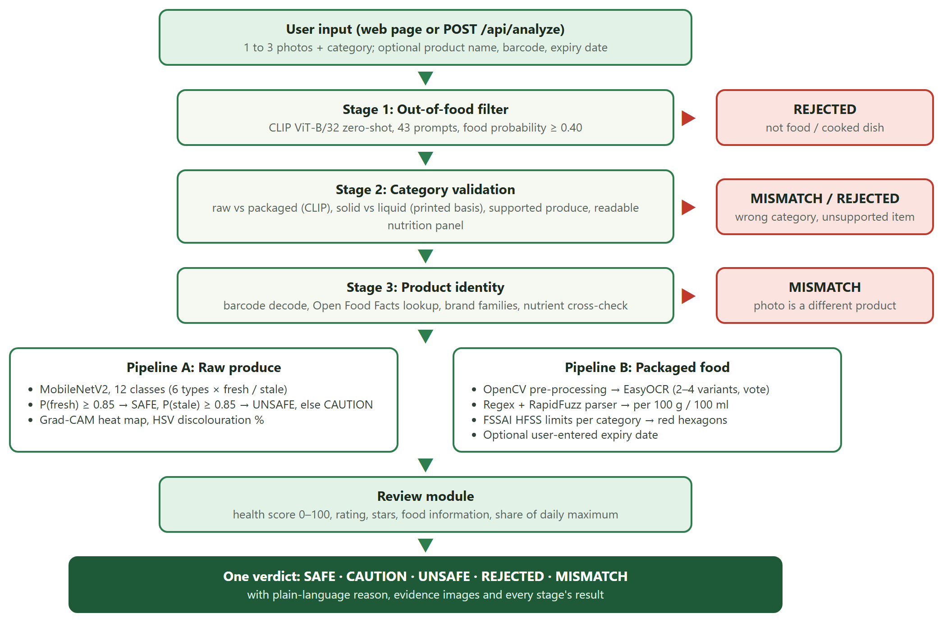
Figure 4.1: System architecture of FoodGuard AI

4.2 Food Category Taxonomy
A single set of limits cannot be applied to all foods: a juice is measured per 100 ml and has stricter limits than a biscuit, while pure ghee is entirely fat but is a single-ingredient food outside HFSS front-of-pack rules. The system therefore uses four categories (Table 4.1).
Table 4.1: Food categories
Category | Examples | Analysis
Raw produce | Apple, banana, bitter gourd, capsicum, orange, tomato | Pipeline A: spoilage CNN
Packaged – solid | Chips, biscuits, chocolate, noodles | Pipeline B, limits per 100 g
Packaged – liquid | Juice, soft drinks, flavoured milk | Pipeline B, limits per 100 ml
Packaged – exempt | Oil, ghee, honey, dried fruit | Pipeline B, nutrients shown, HFSS limits not applied

4.3 Verdict Definitions
Table 4.2: Verdicts returned by the system
Verdict | Meaning | Typical cause
SAFE | Good to eat | Fresh produce; pack within all limits (and in date, if a date was entered)
CAUTION | Eat with care | Borderline produce; a nutrient could not be read
UNSAFE | Better not eat | Spoiled produce; any HFSS limit exceeded; entered expiry date has passed
REJECTED | Cannot check this photo | Not food; cooked dish; unsupported produce; no readable label
MISMATCH | Photo does not match | Wrong category selected; photo of a different product than named

4.4 Module Design
Table 4.3: Software modules
Module | Responsibility
app.py | Flask server, request validation, model warm-up, JSON API
foodguard/config.py | Paths, categories, supported produce, threshold loading
foodguard/models.py | Lazy, thread-safe loading of CLIP, EasyOCR and MobileNetV2
foodguard/guardrails.py | Stages 1 and 2: CLIP zero-shot scene and produce identification
foodguard/vision.py | Pipeline A: spoilage prediction, Grad-CAM, HSV discolouration
foodguard/ocr_engine.py | Pipeline B: OpenCV pre-processing, EasyOCR, line grouping, annotation
foodguard/label_parser.py | Nutrient matching, units, per-100 normalisation, ingredient list
foodguard/fssai_engine.py | FSSAI limits per category, red hexagons, exempt detection, optional expiry
foodguard/identity.py | Stage 3: barcode decoding, Open Food Facts, brand families, cross-check
foodguard/review.py | Health score, rating and food information
foodguard/pipeline.py | Orchestrator that runs the stages and builds one verdict
templates/, static/ | Web interface: HTML template, CSS themes, JavaScript client

4.5 Data Flow and API Design
The browser sends a multipart POST request to /api/analyze with the images, the category and the optional fields. The server returns a JSON report containing the verdict (status, headline, reason, details), the result of each stage, warnings, red hexagons, the produce or packaged result, the identity check, the review, and evidence images encoded in base64. GET /api/health reports the device and which models are loaded; the web page uses it to show a status indicator.
POST /api/analyze (multipart/form-data)
images 1-3 image files (jpg, png, webp, bmp)
category raw_produce | packaged_solid | packaged_liquid | packaged_exempt
product_name optional, e.g. "Amul Butter" or "tamatar"
barcode optional, EAN / UPC digits
expiry_date optional, YYYY-MM-DD

200 OK { verdict: {status, headline, reason, details}, stages: [...], warnings: [...],
hexagons: [...], produce | packaged: {...}, identity: {...},
review: {score, rating, stars, breakdown, info}, evidence: [{title, png}] }

4.6 User Interface Design
The interface was designed to feel calm and human rather than technical. The light theme uses white, off-white (#F6F8F2) and leaf green; the dark theme uses deep forest tones. Headings use the Young Serif typeface and body text uses Figtree, both bundled with the application. The verdict is presented as an inspection stamp: a circular seal showing the health score, coloured by the verdict, which animates in like a rubber stamp. While a check runs, a green scanning beam sweeps over the user's own photo and the steps of the pipeline tick off one by one. The layout is a two-column workspace on desktop and a single column on phones.

CHAPTER 5
METHODOLOGY AND IMPLEMENTATION

5.1 Dataset and Leakage-Safe Split
The produce model is trained on the Kaggle dataset Fresh and Stale Images of Fruits and Vegetables [14], which contains 12 classes: fresh and stale versions of apple, banana, bitter gourd, capsicum, orange and tomato. Inspection showed that the dataset is heavily augmented: a single original photo appears up to 164 times as rotated, flipped or noisy copies. A random split would place copies of the same photo in both training and test sets.
The download script therefore recovers the source photo of each file from its name and splits by source photo (seed 42), so that no test image has a sibling in the training set. Table 5.1 summarises the result.
Table 5.1: Dataset split by source photo
Split | Images | Notes
Training | 10,329 | Used to fit the model
Validation | 2,145 | Model selection (best macro-F1)
Test | 2,208 | Held out; reported results
Distinct source photos | 1,621 | Vegetable classes have only 8–32 each

5.2 Spoilage Model (Pipeline A)

5.2.1 Network and training
MobileNetV2 with ImageNet weights is used as the backbone, with a new 12-way classification head. Training runs in two phases: first only the head is trained with the backbone frozen, then the whole network is fine-tuned at a lower learning rate. Class-weighted cross-entropy with light label smoothing compensates for class imbalance. Mixed-precision (AMP) training on the GPU completes in about three minutes.
Table 5.2: Training configuration
Setting | Value
Input size | 224 × 224, ImageNet normalisation
Phase 1 (head only) | 3 epochs, learning rate 1e-3
Phase 2 (full fine-tune) | 12 epochs, learning rate 3e-4
Optimiser | AdamW, weight decay 1e-4 [16]
Schedule | One-cycle learning rate [17], 15 % warm-up
Loss | Class-weighted cross-entropy, label smoothing 0.05
Batch size | 64
Augmentation | Random resized crop (0.6–1.0), horizontal and vertical flips, rotation ±20°, colour jitter with small hue change (±0.02)
Model selection | Best validation macro-F1 (0.9726, phase 2 epoch 3)

Hue jitter is deliberately small because colour change is the main visual signal of spoilage; strong hue augmentation would teach the model to ignore it.

5.2.2 Decision rule
The 12 class probabilities are summed into P(fresh) and P(stale). If P(fresh) ≥ 0.85 the verdict is SAFE (grade A); if P(stale) ≥ 0.85 it is UNSAFE (grade D); otherwise CAUTION (grade B). The threshold was chosen on the validation data so that no stale item is ever marked SAFE while keeping the CAUTION share small.

5.2.3 Explanation
Grad-CAM is computed on the last convolutional block and overlaid on the photo. In addition, the foreground is segmented and the share of dark or brown surface pixels in HSV colour space is reported as a simple, interpretable discolouration measure.

5.3 Guardrails

5.3.1 Stage 1: out-of-food filter
CLIP ViT-B/32 scores the photo against 43 text prompts grouped into raw produce, packaged solid, packaged liquid, exempt products, prepared food and non-food scenes. If the summed probability of the food groups is below 0.40, the photo is rejected. A photo whose best match is prepared food is rejected with a separate message, since cooked dishes are out of scope.

5.3.2 Stage 2: category validation
- Raw versus packaged: if CLIP's group probabilities differ from the selected category by more than 0.30, the verdict is MISMATCH with a suggested category and a one-click re-run.
- Unsupported produce: the CNN only knows six types and would confidently grade a mango as an apple. If CLIP puts less than 0.10 total probability on the six supported types, the photo is rejected as unsupported.
- Readable label: packaged photos need at least 6 OCR text regions and at least 2 recognised nutrition rows.
- Solid versus liquid: the printed basis decides; "per 100 ml" means a beverage and "per 100 g" a solid food.

5.3.3 Stage 3: product identity
When the user names a product or a barcode is visible, the system checks that the photo really shows that product:
- Barcode: decoded from the photo with OpenCV's barcode detector or typed by the user; two different codes give MISMATCH.
- Reference record: fetched from Open Food Facts by barcode or by name search, preferring a close name match that has nutrition data.
- Brand families: brands printed on the pack are matched against the named product using a registry of parent companies; a brand from a different company gives MISMATCH.
- Nutrient cross-check: label values are compared with the reference; if three or more nutrients disagree (and at least 60 % of those compared), the verdict is MISMATCH; two disagreements give a warning.
- Raw produce: the typed name, in English or Hindi (for example tamatar or kela), must match what CLIP and the CNN see.

5.4 Label Reading (Pipeline B)

5.4.1 Pre-processing and OCR
Phone photos of labels suffer from glare, blur, curvature and uneven lighting. The OCR engine prepares several variants of each image: the original colour image, a CLAHE-enhanced greyscale image with glare regions inpainted, an up-scaled greyscale image, and an adaptively thresholded binary image. The colour and enhanced variants always run; the slower ones run only if fewer than five nutrient rows were found. Early experiments showed that CLAHE alone sometimes erased decimal points, so the colour image is read first.
Text boxes are grouped into lines by vertical overlap. For each nutrient, the variants vote: a value that two variants agree on wins. If one variant reads 33 and another 3.3, the smaller reading is preferred because OCR drops decimal points far more often than it invents them.

5.4.2 Parsing and normalisation
The parser matches nutrient names with regular expressions and RapidFuzz fuzzy matching, allowing for common OCR confusions (for example "Sodiurn" for "Sodium" and "(g)" read as "(9)"). It detects the table layout (per 100 g, per 100 ml, per serve, or both columns), converts mg to g and salt to sodium (sodium = salt ÷ 2.5), and restores lost decimals using the ratio between the per-100 and per-serve columns. A physical plausibility check (for example, no food has more than 900 kcal or 100 g of a nutrient per 100 g) prevents a per-serve table from being scaled into impossible values.

5.5 FSSAI Compliance Engine
The compliance engine compares the parsed values with the limits for the selected category, all stored in fssaiconfig/safetythresholds.json (Table 5.3). Any exceeded limit produces a red hexagon warning (for example HIGH SAT FAT or HIGH SALT) and an UNSAFE verdict. If added sugar is not declared, total sugars are used instead, which is conservative. A value printed as "< 5 g" against a 4.2 g limit cannot be decided and is reported as uncertain.
Table 5.3: HFSS limits used by the engine (values from the project brief)
Category | Basis | Added sugar | Saturated fat | Sodium
Packaged – solid | per 100 g | > 3.0 g | > 4.2 g | > 0.625 g
Packaged – liquid | per 100 ml | > 1.5 g | > 2.1 g | > 0.300 g
Packaged – exempt | – | exempt | exempt | exempt

Note: these limits were taken from the project brief. FSSAI's front-of-pack labelling rules have been published as drafts, so the values must be checked against the current FSSAI notification before final submission, and the exact clause cited. Because the limits live in the JSON file, updating them needs no code change.
If the product title or a one- or two-item ingredient list matches keywords such as ghee, honey, mustard oil or almonds, the system suggests re-running the check in the exempt category, while snack words such as "cookies" block the suggestion.

5.5.1 Optional expiry date
Dates printed by inkjet or dot-matrix are unreliable for OCR, so the system does not read them from the photo. Instead, the user may type an expiry or best-before date. A date that has passed makes the verdict UNSAFE and the health score 0; a valid date is mentioned in the result; and leaving it empty never lowers the verdict.

5.6 Review Module and Health Score
Each analysed item receives a score from 0 to 100, a rating and information about the food (Table 5.4).
Table 5.4: Health score rules
Food | Score
Raw produce | Freshness confidence of the spoilage model: P(fresh) × 100
Packaged | Starts at 100. For each HFSS nutrient with ratio r = value ÷ limit, the penalty is 0 for r ≤ 0.5, rises linearly to 12 at r = 1, and then to a maximum of 35 at r = 3. Any exceeded limit caps the score at 45, so the score always agrees with an UNSAFE verdict. An expired pack scores 0.
Exempt | Not scored
Ratings | 85+ Excellent, 70+ Good, 50+ Fair, 30+ Poor, below 30 Avoid; stars = score ÷ 20 in half steps

For produce, the food information includes nutrition per 100 g (energy, carbohydrate, fibre, natural sugars, vitamin C, potassium) from USDA FoodData Central [12], what the item is known for, how to store it, how long it keeps and the signs that it has gone off. For packaged food, it lists the nutrients read from the label, the ingredients, and each nutrient's share of the WHO adult daily maximum (2,000 kcal, 50 g free sugar, 22 g saturated fat, 2 g sodium).

5.7 Web Application
The Flask server loads all models in a background thread at start-up so that the first request is fast, and a lock serialises GPU access. The client is plain HTML, CSS and JavaScript with no framework. It remembers the chosen theme in the browser, limits uploads to one photo for produce and three for packs, hides the barcode and expiry fields for produce, and renders the JSON report into the verdict seal, red hexagons, information sections, nutrient bars against the limits, the score breakdown, the list of checks, and the evidence images.

CHAPTER 6
TESTING AND RESULTS

6.1 Spoilage Model
Table 6.1 reports results on the held-out test split of 2,208 images. All figures are reproducible with scripts/evaluate_vision.py.
Table 6.1: Spoilage model results on the test split
Metric | Value
12-class accuracy | 97.2 % (macro F1 0.967)
Fresh-versus-stale accuracy | 97.1 %
Verdicts: SAFE / CAUTION / UNSAFE | 929 / 222 / 1,057
Accuracy on decided cases (SAFE or UNSAFE) | 99.3 %
Stale produce marked SAFE | 0
Fresh produce marked UNSAFE | 13

Table 6.2: Per-class precision, recall and F1-score
Class | Precision | Recall | F1 | Images
fresh apple | 0.984 | 1.000 | 0.992 | 254
fresh banana | 1.000 | 0.991 | 0.996 | 234
fresh bitter gourd | 1.000 | 1.000 | 1.000 | 40
fresh capsicum | 0.874 | 1.000 | 0.933 | 153
fresh orange | 0.995 | 0.973 | 0.984 | 223
fresh tomato | 1.000 | 0.780 | 0.877 | 123
stale apple | 1.000 | 0.989 | 0.994 | 352
stale banana | 0.991 | 1.000 | 0.995 | 220
stale bitter gourd | 1.000 | 1.000 | 1.000 | 42
stale capsicum | 1.000 | 0.866 | 0.928 | 164
stale orange | 0.976 | 0.996 | 0.986 | 240
stale tomato | 0.858 | 1.000 | 0.924 | 163

The weakest class is fresh tomato (recall 0.78), mostly confused with stale tomato, followed by capsicum. These vegetable classes come from only 8–32 distinct source photos each, so their results are less certain than those of the fruit classes. Importantly, the errors are on the safe side: fresh items are sometimes sent to CAUTION or UNSAFE, but no stale item is marked SAFE.
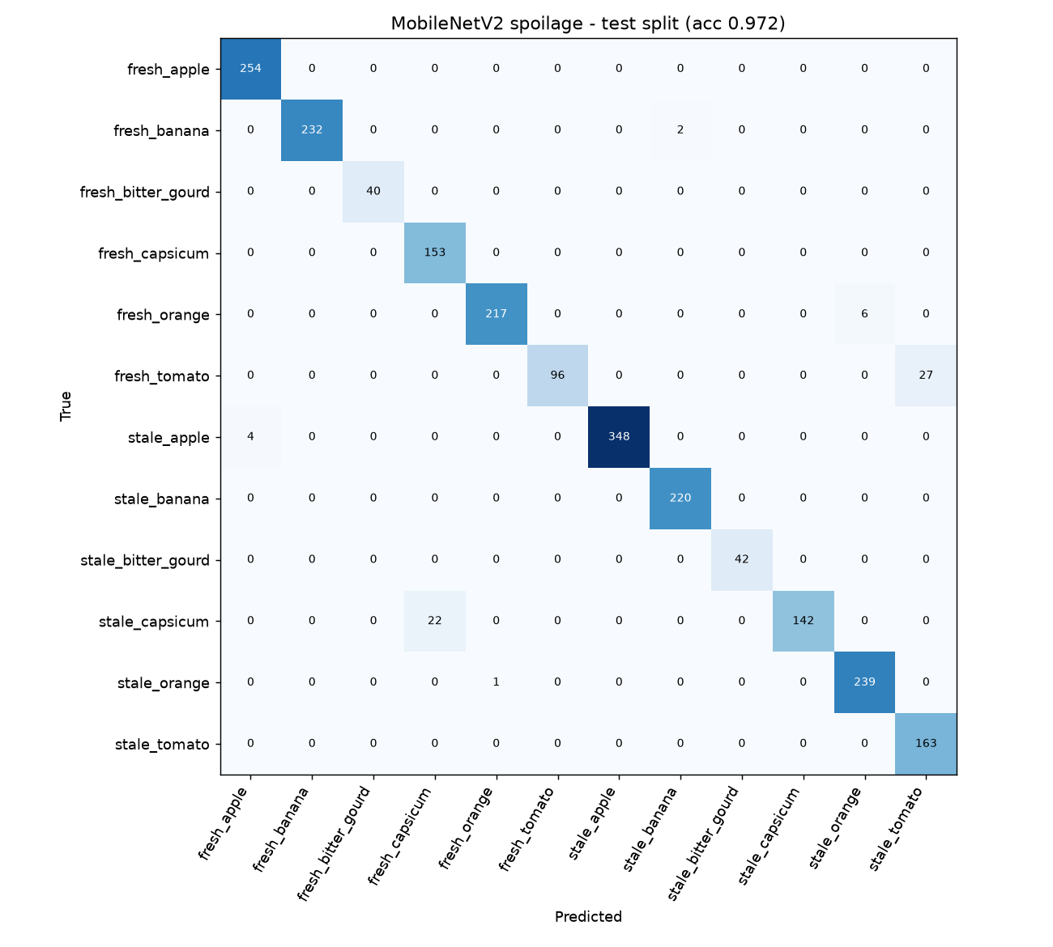
Figure 6.1: Confusion matrix of the spoilage model on the test split

6.2 Guardrails
The CLIP thresholds were calibrated on 740 in-distribution test images and 54 out-of-distribution photos from Wikimedia Commons (cats, shoes, phones, cars, people, shampoo, and unsupported produce such as mango, onion, carrot and pomegranate).
Table 6.3: Guardrail results
Check | Valid images wrongly rejected | Invalid images caught
Non-food filter (Stage 1) | 0.4 % | 23 of 24 at Stage 1; the 24th (a shampoo bottle) rejected at Stage 2 for having no nutrition panel
Raw versus packaged mismatch | 0.9 % | –
Unsupported produce | 1.2 % | 17 of 22 (77 %)

6.3 OCR and FSSAI Parser
- Synthetic bench: six labels rendered with known values and distorted like phone photos (perspective, rotation, blur, noise, uneven light and glare). Per-field accuracy and verdict agreement were both 100 %. This shows the logic is correct on clean print, not real-world accuracy.
- Real Indian labels: 20 photos from Open Food Facts (Parle-G, Lays, Maggi, Kellogg's, Good Day, Snickers and others). Six were correctly rejected as unreadable (low resolution or no table). Of the values the system did read, 76 % matched the reference within 15 %; the crowd-sourced reference itself is sometimes wrong or from a different pack version.
- Repairs that made a measurable difference: reading the colour image first, voting across image variants, restoring decimals from the per-serve column, treating "(g)" misread as "9" as a unit, and the plausibility check before scaling per-serve tables.

6.4 Unit Testing
The pytest suite contains 49 tests, all passing. They cover nutrient name matching with OCR errors, unit and salt conversion, decimal restoration, table layout detection, FSSAI limit checks per category, exempt suggestions, identity verification logic (barcode conflicts, brand families, nutrient divergence), the optional expiry check, and the health score (a healthy pack scores 100, an exceeded limit caps the score at 45, an expired pack scores 0, exempt items are not scored).

6.5 End-to-End Scenarios
Table 6.4 lists scenarios run through the HTTP API of the running application.
Table 6.4: End-to-end test scenarios
Input | Category given | Result
Fresh tomato photo | Fruit or vegetable | SAFE, score 94 (Excellent), Grad-CAM shown
Stale banana photo | Fruit or vegetable | UNSAFE, score 6 (Avoid)
Masala chips label (sat. fat 15.2 g, sodium 740 mg) | Packaged food | UNSAFE, red hexagons HIGH SAT FAT and HIGH SALT, score 45 (Poor)
Digestive biscuits label, expiry 2027-03-01 | Packaged food | SAFE, "It is in date", score 87 (Excellent)
Same label, expiry 2026-01-01 | Packaged food | UNSAFE, expired, score 0
Mango drink label (per 100 ml) | Packaged food | MISMATCH, suggests Packaged drink
Photo of a cat | Fruit or vegetable | REJECTED, not food
Mango | Fruit or vegetable | REJECTED, unsupported produce
Shampoo bottle | Packaged food | REJECTED, no nutrition table
Parle-G label named "Amul Butter" | Packaged food | MISMATCH, wrong product
Nutrition label | Fruit or vegetable | MISMATCH, looks packaged
Text file instead of image / invalid date | any | HTTP 400 with a clear error message

6.6 User Interface
Figures 6.2 to 6.8 show the web application in use. Screenshots were taken from the running application in a desktop browser at 1400 px width and at a phone width of 390 px.
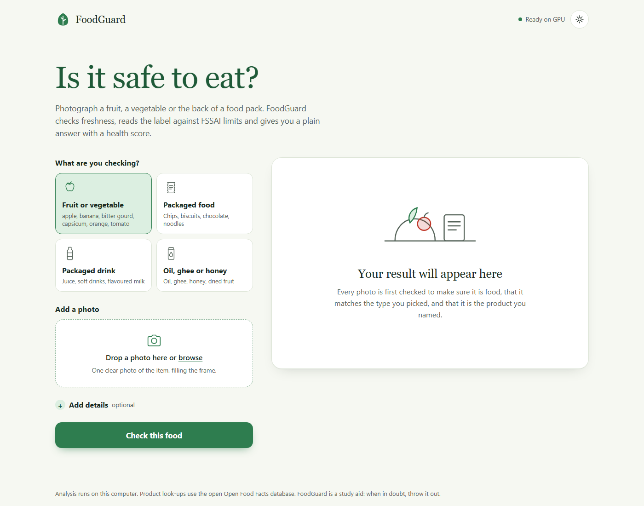
Figure 6.2: Home page in the light theme
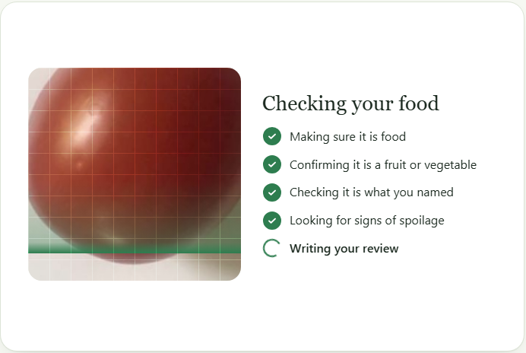
Figure 6.3: Processing animation: a scanning beam over the user's photo with step-by-step progress
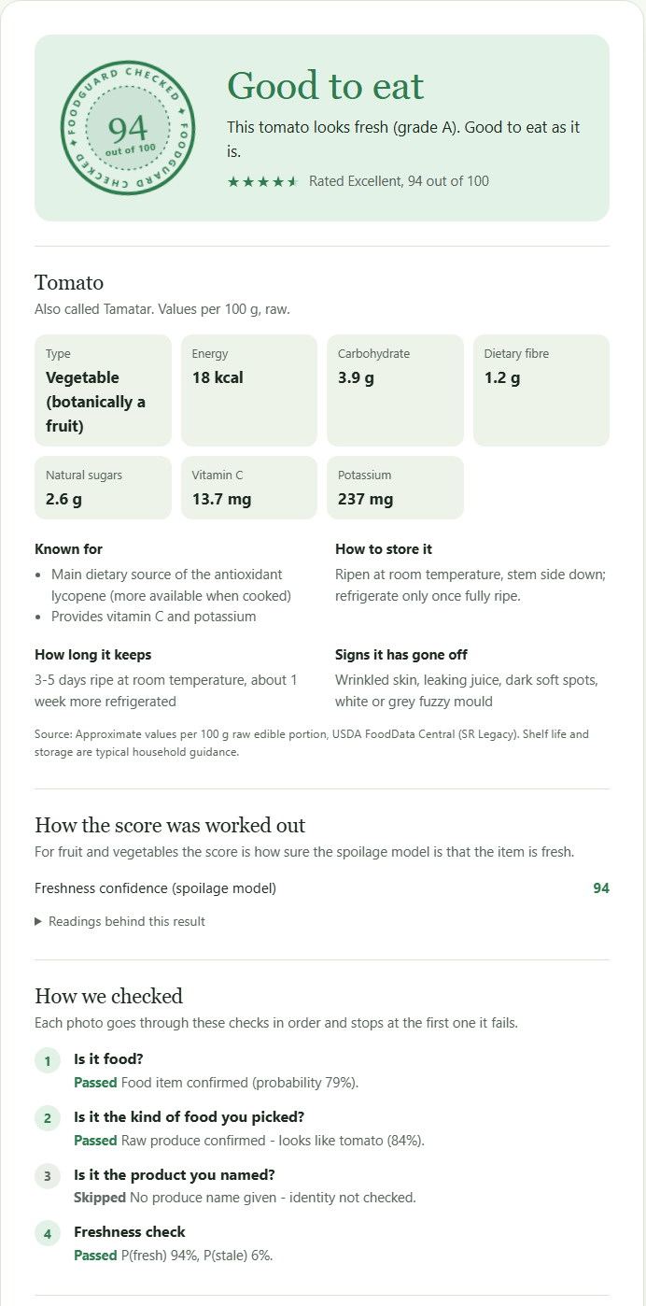
Figure 6.4: Result for a fresh tomato: inspection seal with health score, food information, score breakdown, checks and Grad-CAM
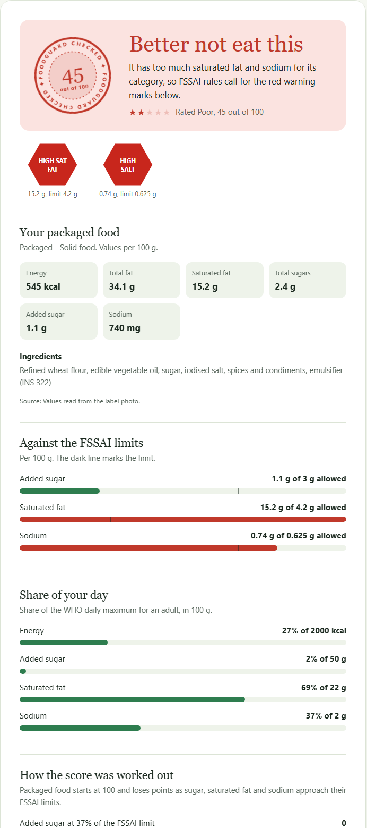
Figure 6.5: Result for a high-fat, high-salt snack: red hexagon warnings, nutrient bars against FSSAI limits and share of daily maximum
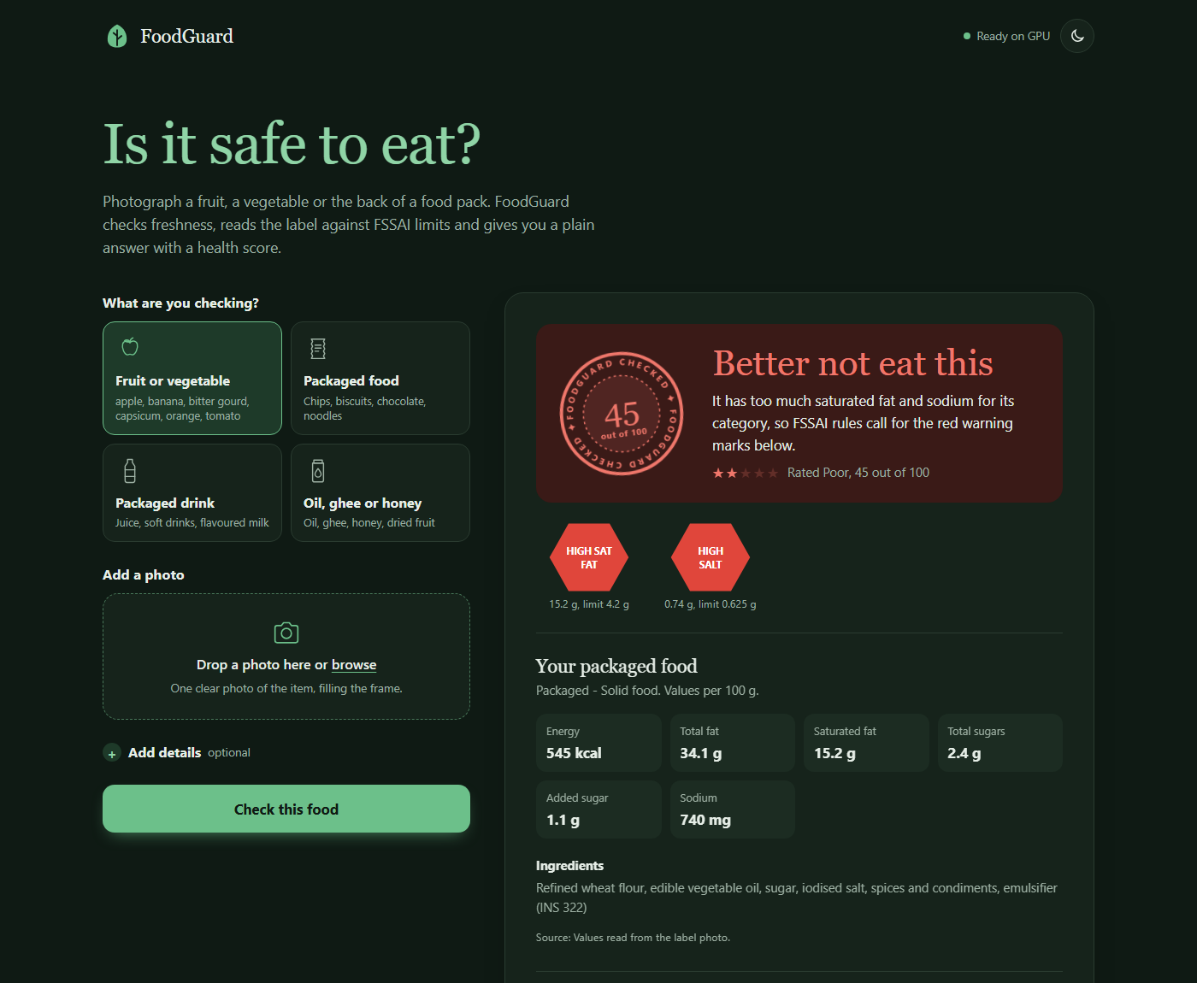
Figure 6.6: The same result in the dark theme
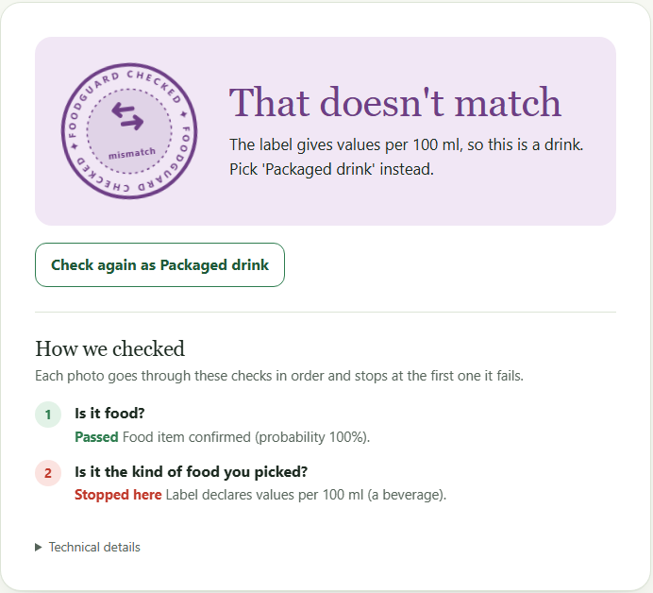
Figure 6.7: Category mismatch with a one-click suggestion to check again as a drink
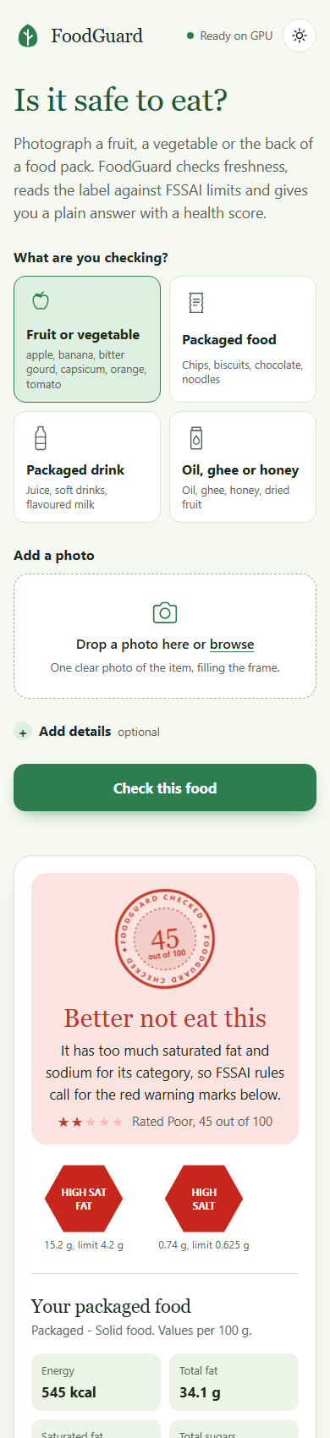
Figure 6.8: Responsive layout at phone width

CHAPTER 7
CONCLUSION AND FUTURE SCOPE

7.1 Conclusion
FoodGuard AI shows that a guarded, dual-pipeline design can turn a single photo into a clear, explained food safety verdict. The spoilage model achieves 97 % accuracy on a test set that was carefully separated from the training data, and its decision rule never marked a stale item as safe. The label pipeline reads Indian nutrition tables under realistic distortions and applies the correct category-specific FSSAI limits. Most importantly for a real product, the system knows when not to answer: it rejects non-food photos, catches category and product mismatches, and asks for a better photo instead of guessing. The review module and the redesigned interface present the result the way a person would: a plain sentence, a score, and useful information about the food.

7.2 Limitations
- OCR on small, curved, glossy or low-resolution print is the main source of error; the system answers CAUTION or asks for a retake in these cases.
- The spoilage model covers six produce types, and the vegetable classes come from few source photos; other produce is rejected, not graded.
- The FSSAI limits come from the project brief and must be verified against the current notification.
- Name-based identity depends on crowd-sourced Open Food Facts data; barcode-based identity is much more reliable.
- Expiry dates are not read from the photo; the user must type them.
- The health score is a simple, explainable heuristic built on FSSAI limits and WHO guidance, not a clinical or regulatory score.

7.3 Future Scope
- Collect a larger, more diverse produce dataset photographed in Indian markets and homes, and add more produce types.
- Train a dedicated detector for nutrition tables and a recogniser fine-tuned on Indian label fonts, and read printed dates with a specialised model.
- Package the system as an Android application with on-device inference using a quantised model.
- Support Hindi and regional-language labels, and voice output for accessibility.
- Track a household's purchases over time and give personalised dietary guidance.

REFERENCES
[1] M. Sandler, A. Howard, M. Zhu, A. Zhmoginov and L.-C. Chen, "MobileNetV2: Inverted Residuals and Linear Bottlenecks," in Proc. IEEE/CVF Conf. Computer Vision and Pattern Recognition (CVPR), 2018, pp. 4510–4520.
[2] A. Radford et al., "Learning Transferable Visual Models From Natural Language Supervision," in Proc. Int. Conf. Machine Learning (ICML), 2021.
[3] R. R. Selvaraju, M. Cogswell, A. Das, R. Vedantam, D. Parikh and D. Batra, "Grad-CAM: Visual Explanations from Deep Networks via Gradient-Based Localization," in Proc. IEEE Int. Conf. Computer Vision (ICCV), 2017, pp. 618–626.
[4] Y. Baek, B. Lee, D. Han, S. Yun and H. Lee, "Character Region Awareness for Text Detection," in Proc. IEEE/CVF Conf. Computer Vision and Pattern Recognition (CVPR), 2019.
[5] B. Shi, X. Bai and C. Yao, "An End-to-End Trainable Neural Network for Image-Based Sequence Recognition and Its Application to Scene Text Recognition," IEEE Trans. Pattern Analysis and Machine Intelligence, vol. 39, no. 11, pp. 2298–2304, 2017.
[6] JaidedAI, "EasyOCR: Ready-to-use OCR with 80+ supported languages," GitHub repository. [Online]. Available: https://github.com/JaidedAI/EasyOCR
[7] K. Zuiderveld, "Contrast Limited Adaptive Histogram Equalization," in Graphics Gems IV, Academic Press, 1994, pp. 474–485.
[8] Food Safety and Standards Authority of India, "Food Safety and Standards (Labelling and Display) Regulations, 2020." [Online]. Available: https://www.fssai.gov.in
[9] Food Safety and Standards Authority of India, "Draft Food Safety and Standards (Labelling and Display) Amendment Regulations on front-of-pack nutrition labelling," 2022. [Online]. Available: https://www.fssai.gov.in
[10] World Health Organization, "Guideline: Sugars Intake for Adults and Children," Geneva, 2015.
[11] World Health Organization, "Guideline: Sodium Intake for Adults and Children," Geneva, 2012.
[12] U.S. Department of Agriculture, Agricultural Research Service, "FoodData Central." [Online]. Available: https://fdc.nal.usda.gov
[13] Open Food Facts, "Open Food Facts: the free food products database." [Online]. Available: https://world.openfoodfacts.org
[14] R. Potdar, "Fresh and Stale Images of Fruits and Vegetables," Kaggle dataset. [Online]. Available: https://www.kaggle.com/datasets/raghavrpotdar/fresh-and-stale-images-of-fruits-and-vegetables
[15] A. Paszke et al., "PyTorch: An Imperative Style, High-Performance Deep Learning Library," in Advances in Neural Information Processing Systems (NeurIPS), 2019.
[16] I. Loshchilov and F. Hutter, "Decoupled Weight Decay Regularization," in Proc. Int. Conf. Learning Representations (ICLR), 2019.
[17] L. N. Smith and N. Topin, "Super-Convergence: Very Fast Training of Neural Networks Using Large Learning Rates," in Proc. SPIE Artificial Intelligence and Machine Learning for Multi-Domain Operations Applications, 2019.
[18] J. Deng, W. Dong, R. Socher, L.-J. Li, K. Li and L. Fei-Fei, "ImageNet: A Large-Scale Hierarchical Image Database," in Proc. IEEE Conf. Computer Vision and Pattern Recognition (CVPR), 2009.
[19] S. Kaufman, S. Rosset, C. Perlich and O. Stitelman, "Leakage in Data Mining: Formulation, Detection, and Avoidance," ACM Trans. Knowledge Discovery from Data, vol. 6, no. 4, 2012.
[20] D. Hendrycks and K. Gimpel, "A Baseline for Detecting Misclassified and Out-of-Distribution Examples in Neural Networks," in Proc. Int. Conf. Learning Representations (ICLR), 2017.

APPENDIX A: INSTALLATION AND USAGE
1. Install the dependencies (Windows, NVIDIA GPU; on a CPU-only machine install the CPU build of PyTorch instead):
cd FoodGuard_AI
pip install torch torchvision --index-url https://download.pytorch.org/whl/cu128
pip install -r requirements.txt
2. Prepare data and train (already done in the delivered folder):
python scripts/download_datasets.py # Kaggle download + split by source photo
python scripts/train_vision.py # about 3 minutes on an RTX 5060 Ti
python scripts/evaluate_vision.py # test-split metrics and confusion matrix
python scripts/make_synthetic_labels.py # synthetic labels for the OCR bench
python scripts/evaluate_ocr.py # OCR bench
python -m pytest # 49 unit tests
3. Run the application:
python app.py # then open http://127.0.0.1:5000
4. Use the web page: choose what you are checking, add a photo (one for produce; up to three for packs, with the nutrition table first), optionally open "Add details" to give the product name, barcode or expiry date, and press "Check this food". The sun and moon button switches between light and dark themes.

APPENDIX B: CONFIGURATION FILE
All limits and thresholds are stored in fssaiconfig/safetythresholds.json. An excerpt:
{
"packaged_categories": {
"packaged_solid": { "basis": "100g",
"limits": { "added_sugar_g": 3.0, "saturated_fat_g": 4.2, "sodium_g": 0.625 } },
"packaged_liquid": { "basis": "100ml",
"limits": { "added_sugar_g": 1.5, "saturated_fat_g": 2.1, "sodium_g": 0.300 } },
"packaged_exempt": { "limits": {} }
},
"nutrient_rules": { "salt_to_sodium_factor": 2.5, "use_total_sugar_if_added_missing": true },
"guardrails": {
"food_probability_min": 0.40, "category_margin": 0.30, "liquid_margin": 0.20,
"min_text_boxes_packaged": 6, "min_nutrition_keywords": 2,
"produce_supported_min_prob": 0.10, "identity_fuzzy_min_score": 70
},
"exempt_keywords": ["ghee", "honey", "mustard oil", "almonds", "jaggery", ...]
}

