### Change Logs: Insurance API specs

| Version | FIS13_2.0.0_070524 |
| --- | --- |
| Updates in BRD | 6th May 2024 |
| Updates in PRD/Change log | 7th May 2024 |
| Updates in API Specs on dev doc | 7th May 2024 |

##### Motor Insurance:

1. Added manual review flag as part of on_search. This is added to allow the buyer app to improve the buyer journey by filtering policies where manual review is not required.

**Example Snippet:**

| "tags": [  {  "descriptor": {  "name": "General Information",  "code": "GENERAL_INFO"  },  "list": [  {  "descriptor": {  "code": "MANUAL_REVIEW",  "name": "Manual Review",  "short_desc": "Describes manual review value”  },  "value": "true"  }  ] } ] |
| --- |

1. Added following optional fields as part ofrenewal form. This is added to allow the seller app and buyer app to share previous policy details when the seller is unable to fetch data from the Vahan portal.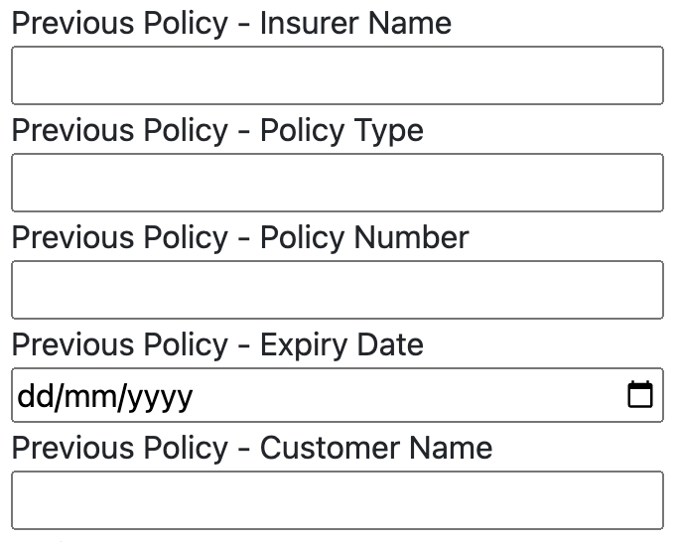
   * Case 1: The buyer app choose to send optional details upfront to the seller app
     + Here the seller app has previous policy details therefore even if the vahan portal is not returning the data seller app can use the data shared by the buyer app to generate offers.
   * Case 2: The buyer app chose not to send optional details upfront to the seller app
     + Sub case 1 : Previous Policy details were not received from Vahan portal
       - The seller app will NACK the submission of the form with the error code “81208”, Event: “Previous Policy Details Required”. In this scenario the buyer app will collect the optional fields and submit the entire form again.
     + Sub case 2: Previous Policy details were received from Vahan portal
       - The seller app shares the submission ID for the form submission with the buyer app.
2. Added IDV_VALUE, IDV_MIN_VALUE, and IDV_MAX_VALUE to the on_search feature. This is added to allow the seller to share the IDV range supported and for the buyer to share the IDV desired by the buyer which shall be within the range shared by the seller.
   * Based on IDV_MIN_VALUE & IDV_MAX_VALUE the buyer app will allow users to set custom IDV value.

**Example Snippet:**

| "tags": [  {  "descriptor": {  "name": "General Information",  "code": "GENERAL_INFO"  },  "list": [  {  "descriptor": {  "code": "IDV_VALUE",  "name": "IDV Value",  "short_desc": "Describes the IDV value"  },  "value": "350000"  },  {  "descriptor": {  "code": "IDV_MIN_VALUE",  "name": "IDV Min Value",  "short_desc": "Describes the IDV's min value"  },  "value": "150000"  },  {  "descriptor": {  "code": "IDV_MAX_VALUE",  "name": "IDV Max Value",  "short_desc": "Describes the IDV' max value"  },  "value": "500000"  }  ] |
| --- |

* + IDV_SELECTED as part of the selectcall will be shared. The buyer app will send the selected IDV value as part of tags & in on_select the seller app will send the value as part of IDV_VALUE.

**Example snippet:**

| "tags": [  {  "descriptor": {  "name": "General Information",  "code": "GENERAL_INFO"  },  "list": [  {  "descriptor": {  "code": "IDV_SELECTED",  "name": "IDV Selected"  },  "value": "350000"  }  ]  } ] |
| --- |

1. Some of the information was changed from optional to mandatory and vice versa. Below are the snippets of changes.
   * Please note that information could be either in tags or attributes or as part of the form as per the use case.







 

 