THE 7-DIMENSIONAL ASSESSMENT MATRIX: A MATHEMATICAL MANIFESTO FOR A SUSTAINABLE SOCIETY
An Un-Falsifiable Framework to Measure, Balance, and Safeguard Human Agency, Knowledge, Ethics, and Systemic Risk in the Era of Exponential Artificial Intelligence
Author: Dr. Pierre C. Wepener (University of Johannesburg) | Date: October 2026
Public Societal Edition • Free for Worldwide Distribution • Creative Commons CC BY-NC-SA 4.0
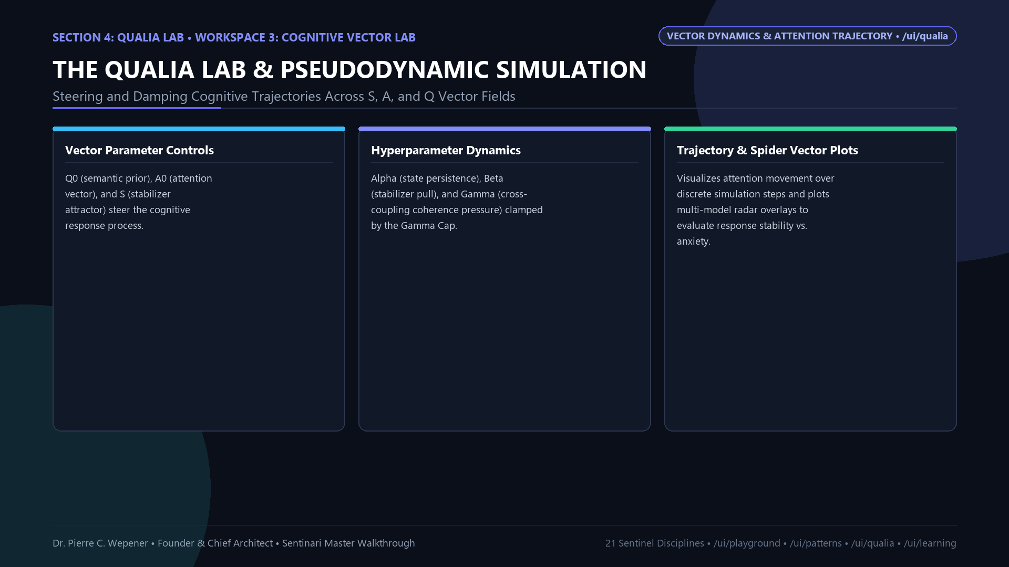
Figure 1: The 7-Dimensional Coupled Bell-Curve Simulator & Assessment Matrix
1. PREAMBLE: DEDICATION TO SOCIETY & THE WORKING PERSON
We live in a world dominated by systems that prioritize narrow efficiency, corporate extraction, and short-term optimization at the expense of human dignity, societal stability, and ecological equilibrium.
When artificial intelligence algorithms are benchmarked solely on raw computational velocity or persuasive fluency, and when economic models evaluate progress solely through gross domestic product or share price, the true civilizational cost—the erosion of worker autonomy, the fracturing of civic discourse, and the concentration of epistemic power—remains invisible until catastrophe strikes.
The 7-Dimensional Assessment Matrix was created by Dr. Pierre C. Wepener as an objective, un-falsifiable mathematical mirror for human civilization. Conceived, researched, and engineered through independent initiative, this framework belongs to no monopoly, political party, or corporate conglomerate.
Dedicated to society, the working person, independent researchers, trade unions, civic leaders, and future generations: providing humanity with an auditable mathematical instrument to test whether any technology, policy, algorithm, or enterprise expands collective flourishing or steers society toward structural collapse.
2. THE CIVILIZATIONAL CRISIS: THE FAILURE OF STATIC & OPAQUE METRICS
For decades, institutional governance has relied on flawed, one-dimensional metrics:
• Corporate Metric (Profit): Ignores environmental and supply chain fragility.
• Big Tech Metric (Engagement): Optimizes for outrage, polarization, and algorithmic distortion.
• Standard AI Benchmark (MMLU): Measures next-token memorization, not truth, safety, or human agency.
• Economic Metric (Raw GDP): Masks displaced labor, inequality, and systemic vulnerability.
These isolated indicators fail because human society is a complex, coupled, non-linear ecosystem. A system that maximizes Intelligence while reducing Human Agency produces technological totalitarianism. A system that optimizes Decision speed while ignoring Systemic Risk triggers financial crashes and infrastructure cascades. To achieve enduring civilizational sustainability, society requires a multi-criteria differential weighting engine where every dimension is mathematically bounded and coupled with its neighbors.
3. THE SEVEN PILLARS OF SYSTEMIC SUSTAINABILITY
1. Dimension I: Knowledge (K) — The Foundational Epistemic Base
Depth, empirical integrity, and citation provenance of information. Citation-graded, peer-reviewed, reproducible material truth. Optimal sweet spot mu_K = 7.5–8.0, carrying capacity sigma_K = 2.2.
2. Dimension II: Intelligence (I) — Analytical Coherence & Predictive Power
Analytical capacity to process and extract non-obvious cross-domain relationships. Reasoning clarity, logic consistency, and predictive foresight. Optimal sweet spot mu_I = 6.8, variance sigma_I = 2.0.
3. Dimension III: Decision (D) — Practical Execution & Decentralized Utility
Translation of understanding into real-world action, execution feasibility, and decentralized governance. Optimal sweet spot mu_D = 6.5, variance sigma_D = 1.8.
4. Dimension IV: Human Agency (H) — The Supreme Ethical Anchor & Labor Shield
Worker self-determination, cognitive freedom, and human dignity. Mandates that AI acts as a cognitive co-pilot that elevates human workers rather than displacing them. Optimal sweet spot mu_H = 7.8–9.0, amplitude A_H = 0.95.
5. Dimension V: Societal Impact (S) — Civic Health & Cultural Resilience
Downstream consequences on democratic consensus, public trust, cultural cohesion, and equitable benefit distribution. Optimal sweet spot mu_S = 7.2, variance sigma_S = 2.2.
6. Dimension VI: Ethics & Scientific Integrity (E) — Moral Bounds & Provenance
Moral constraints, human rights, and international standards (ISO/IEC 42001, NIST AI RMF, US FDA 21 CFR Part 11). Under the Zero-Hallucination Law, silence is treated as the highest metric of integrity. Optimal sweet spot mu_E = 7.8, variance sigma_E = 2.4.
7. Dimension VII: Systemic Risk (R) — Fragility & Catastrophic Blast Radius
Operational vulnerability, failure modes, dependency cascades, and catastrophic downstream exposure. Optimal sweet spot mu_R = 2.0 (Strictly low), variance sigma_R = 1.2–1.5.

4. THE MATHEMATICAL ENGINE: THE COUPLED GAUSSIAN BELL CURVE
Rather than relying on arbitrary qualitative labels, Sentinari evaluates every dimension through an exact mathematical formalism:
4.1 The Single-Dimension Potency Formulation
G_i(x_i) = A_i · exp( - (x_i - μ_i)^2 / (2 σ_i^2) )
Where x_i is the operational level along the [0, 10] sliding scale, μ_i is the optimal sweet spot, σ_i is the tolerance band, and A_i is the maximum amplitude.
4.2 The Normalized Sustainability Score Function S_i(x_i)
S_i(x_i) = G_i(x_i) / A_i = exp( - (x_i - μ_i)^2 / (2 σ_i^2) )
Mapped to the standardized [0.0, 1.0] interval. Deviating from the sweet spot lowers the score exponentially.
4.3 The Net Sustainable Impact Score (NSIS)
NSIS = Σ W_i · S_i(x_i), where Σ W_i = 1.0
Weights: Knowledge (0.20), Ethics/Science (0.18), Intelligence (0.16), Human Agency (0.16), Societal (0.14), Decision (0.10), Risk (0.06).
4.4 Normalized Dimension Impact Share (SD_i%)
SD_i(%) = ( (W_i · S_i(x_i)) / NSIS ) · 100%
Defines the explicit percentage contribution of each dimension to total societal sustainability.
5. THE SLIDING-SCALE INTERDEPENDENCE RULES (THE STRATEGIC FLIGHT SIMULATOR)
In a complex society, pushing one dimension to an extreme dynamically modulates neighboring dimensions:
• Rule A: The Intelligence-Agency Tradeoff (Runaway Automation vs. Human Sovereignty)
When automated machine intelligence accelerates beyond safe bounds without human oversight (x_I > 7.0), the engine dynamically contracts the sweet spot and tolerance of Human Agency:
μ_H ← μ_H - 0.4 · (x_I - 7.0)
σ_H ← max(0.5, σ_H - 0.15 · (x_I - 7.0))
Mathematical proof that unconstrained AI forces workers into algorithmic subordination.
• Rule B: The Risk-Societal Volatility Cascade (Systemic Shock vs. Decision Paralysis)
When Systemic Risk crosses into dangerous territory (x_R > 5.0), societal variance expands and decision quality collapses:
σ_S ← σ_S + 0.3 · (x_R - 5.0)
μ_D ← max(1.0, μ_D - 0.25 · (x_R - 5.0))
Mathematical proof that elevated fragility causes public polarization to widen while collapsing institutional decision-making.
• Rule C: The Scientific-Knowledge Catalyst (Expanding Carrying Capacity)
When scientific and ethical inquiry advances rigorously (x_E > 7.0), it lifts the baseline capacity of the entire knowledge ecosystem:
A_K ← min(1.0, A_K + 0.05)
6. VOLATILITY ANCHORS VS. PARADIGM MULTIPLIERS
1. The Volatility Anchors: Human Agency (H) and Systemic Risk (R)
Narrow variance (σ), steep drop-off. Shifting them slightly away from equilibrium causes the sharpest plunge in NSIS. They represent the non-negotiable defensive shield.
2. The Paradigm Multipliers: Knowledge (K) and Scientific Integrity (E)
Broad variance (σ), high amplitude (A). Moving them upward lifts the baseline capacity of the entire civilizational matrix.
7. FIELD GUIDE: HOW CITIZENS, UNIONS, AND POLICY-MAKERS CAN DEPLOY THE MATRIX
• Trade Unions & Worker Councils: Audit new corporate workplace automation systems. If proposed software scores x_H < 5.0 or triggers Rule A, labor representatives possess un-falsifiable mathematical proof of agency degradation.
• Independent Researchers & Universities: Evaluate scientific grant proposals and AI models against multi-dimensional sustainability rather than raw benchmark scores.
• Public Policy Makers & Regulatory Bodies: Audit national legislation and infrastructure investments under ISO/IEC 42001 and NIST AI RMF frameworks.
• Citizens & Community Organizations: Demand transparency from digital platforms, proving where algorithmic distortion is eroding societal consensus.
8. SOVEREIGN AUTHORSHIP, REPRODUCIBILITY & INVITATION TO CIVIL SOCIETY
The 7-Dimensional Assessment Matrix was independently authored, mathematically formalized, and programmed by Dr. Pierre C. Wepener (University of Johannesburg) as part of the Sentinari Sovereign Intelligence Engine.
Worldwide Open Distribution Attestation: Released under Creative Commons Attribution-NonCommercial-ShareAlike 4.0 International (CC BY-NC-SA 4.0). Any citizen, university, labor union, or sovereign institution is free to copy, cite, translate, and implement this mathematical matrix worldwide, provided full attribution is preserved: 'Conceived, Researched & Formulated by Dr. Pierre C. Wepener (University of Johannesburg).'
Author: Contact: Dr. Pierre C. Wepener | Date: wepener.pierre@gmail.com
Platform: https://sentinari-core-250830594433.us-central1.run.app

