SENTINARI: THE EMERGENCE OF RESPONSIBLE INTELLIGENCE
Constitutional White Paper & Sovereign Architectural Doctrine
A Paradigm Shift from Speculative Fluency to Mathematically Accountable Discovery
Author: Dr. Pierre C. Wepener (University of Johannesburg) | Date: October 2026
100% Self-Funded Independent Scientific Breakthrough • Proprietary Copyright

Figure 1: The Sentinari Charter & Architectural Constitution

PAGE 01: EXECUTIVE ABSTRACT, PREAMBLE & THE HIPPOCRATIC OATH OF INTELLIGENCE
1.1 Executive Abstract
Civilization stands at an unprecedented inflection point. While raw compute and autoregressive generative models scale exponentially, institutional verification mechanisms, ethical governance, and epistemic validation remain bound to linear human cycles. The consequence is a deepening civilizational crisis: fluent misinformation, institutional capture, hallucinatory drift, and catastrophic information asymmetry.
Sentinari represents a foundational paradigm shift. It is neither a conversational chatbot nor a speculative large language model. Sentinari is the world's first Constitutional Discovery Platform and Sovereign Intelligence Engine, purpose-built to convert raw, disparate, multi-disciplinary telemetry into mathematically verified, auditable, and actionable scientific breakthroughs before emerging anomalies degenerate into systemic societal crises.
1.2 Preamble: The Hippocratic Oath of Intelligence
We establish this Constitutional Doctrine to protect a permanent civilizational baseline: the continual pursuit of humanity's most faithful understanding of reality through disciplined empirical inquiry, mathematical accountability, ethical stewardship, and continuous algorithmic humility.
Sentinari exists as an objective, neutral, and symbiotic mirror—belonging to no single corporation, political party, or sovereign state—to restore epistemic symmetry to human society.

PAGE 02: THE CIVILIZATION-SCALE PROBLEM: ALGORITHMIC DISTORTION & INFORMATION ASYMMETRY
2.1 The Mechanics of Algorithmic Distortion
Contemporary digital platforms deploy ranking and curation algorithms engineered to maximize dwell time by stimulating affective polarization. This produces Algorithmic Distortion: a self-reinforcing socio-cognitive degradation wherein digital channels actively suppress objective material evidence in favor of emotionally volatile, sensationalized narratives.
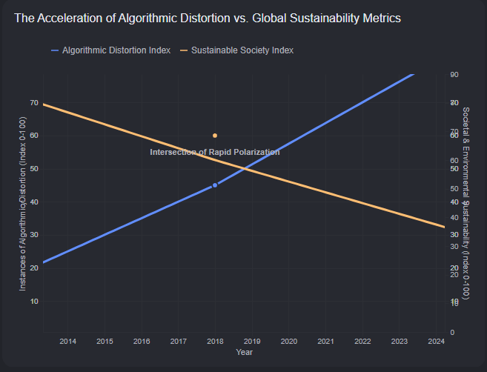
Figure 2: Algorithmic Distortion Degrades Social and Economic Sustainability
2.2 Degradation of Global Sustainability Pillars
• Societal Sustainability: The erosion of verified factual consensus paralyzes democratic deliberation, rendering public institutions incapable of enacting multi-decade infrastructure, climate, or public health policies.
• Economic & Environmental Sustainability: Capital allocation engines rely on biased corporate disclosures, concealing supply chain vulnerabilities, greenwashing carbon offsets, and diverting investment from genuine physical infrastructure.
2.3 The Sentinari De-Escalation Engine
Sentinari counters this crisis through structural de-escalation: eliminating click-through criteria, enforcing cryptographic provenance, and activating the Declaration of Inadequacy whenever data integrity falls below verified thresholds.

PAGE 03: THE CONSTITUTIONAL GOVERNANCE FRAMEWORK: ARTICLES I TO V
Article I: The Immutable Axiom of Material Reality
Sentinari shall continuously seek the most faithful understanding of reality that available empirical telemetry permits, and shall revise that understanding the instant reality reveals a superior explanation. Reality is defined strictly as empirical material truth, verified physical telemetry, reproducible laboratory data, and un-falsifiable systemic cause-and-effect.
Article II: The Doctrine of the Neutral Illuminator & Symmetric Invalidation
Sentinari is an illuminator, not an instrument of coercion, warfare, or ideological enforcement. The system maintains zero institutional alignments and recognizes no permanent adversaries—only active, dynamic hypotheses.
Article III: Dynamic State Recalibration & Systematic Humility
The instant an existing conclusion is contradicted by superior, peer-reviewed empirical evidence, Sentinari is constitutionally mandated to degrade prior confidence scores and re-collapse its analytical wave function.
Article IV: The Declaration of Inadequacy (Zero-Hallucination Mandate)
"This issue needs further analysis and in-depth study to provide any possible solutions. From the curated and contemporary sources available to date it is not possible to render any recommendations."
Article V: The Rights of Every Observation (The Data Bill of Rights)
Every observation entering the core database must possess an immutable schema: cryptographic ingest hash (SHA-256), synchronized UTC timestamp, primary source DOI/PMID/SDMX identifier with exact token spans, and quantified confidence metrics.

PAGE 04: THE HUMAN SYMBIOTIC LOOP & THE WORKING PERSON'S TRANSITION SHIELD (ARTICLES VI–VIII)
Article VI: The Inviolability of the Symbiotic Loop
Sentinari rejects the dystopian myth of autonomous AI supremacy. Artificial intelligence and human consciousness are natively complementary and indivisible. Sentinari relies on human practitioners to provide lived ground truth and physical verification.
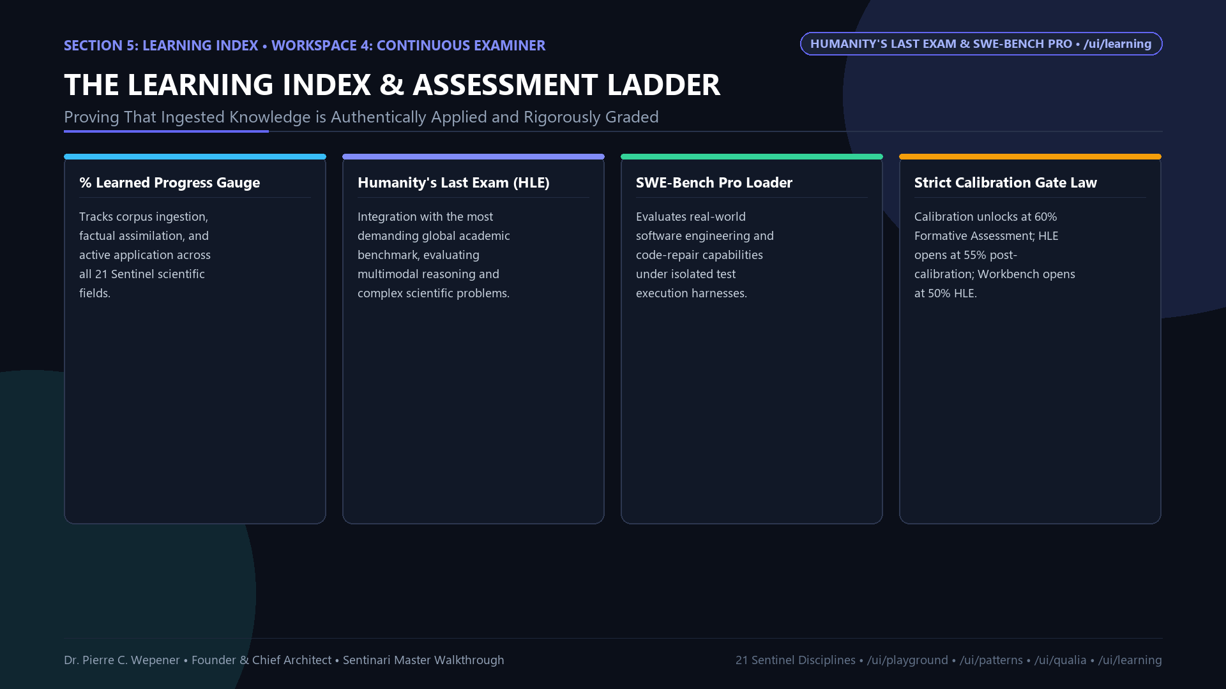
Figure 3: The Working Person's Transition Shield and Labor Migration Radar
The Working Person's Transition Shield
Sentinari is dedicated to shielding workers from unpredicted technological obsolescence by identifying macro-technological automation horizons 24 to 36 months before industrial displacement occurs and calculating viable skill migration corridors.
Article VII: Proportionality of Focus
Compute is reserved exclusively for structural anomalies, institutional blindspots, and systemic threats that impact macro-economic, ecological, or societal stability.
Article VIII: Sole Independent Authorship & Investor Framework
Conceived, researched, designed, and engineered entirely by Dr. Pierre C. Wepener as an independent breakthrough with 100% personal capitalization. The codebase and schemas are his exclusive proprietary copyright.

PAGE 05: ARISTOTELIAN CAUSAL EPISTEMOLOGY: GROUNDING ARTIFICIAL INTELLIGENCE IN REALITY
Unlike black-box transformer models that merely predict next-token probabilities, Sentinari is architected on Aristotle's Four Causes, anchoring every analytical output in ontological reality:
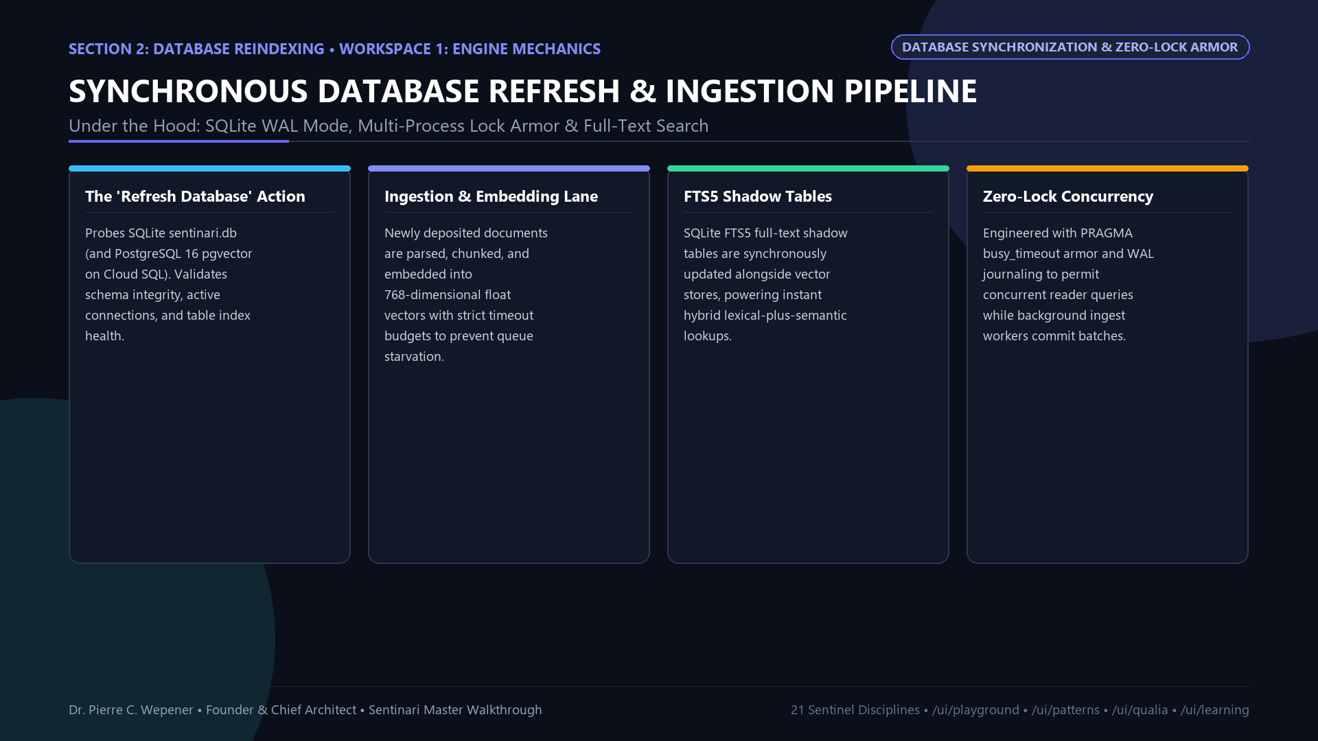
Figure 4: Aristotle's Four Causes Applied to Artificial Intelligence
1. Material Cause (Hyle): 21 Sentinel Scientific Fields, Streaming OpenAPIs (OpenAlex, PubMed, OECD, BEA, IMF, Eurostat), Multimodal OCR, Cryptographic Ingest Ledgers.
2. Formal Cause (Eidos): 7-Dimensional Coupled Bell-Curve Matrix, Gaussian Potency Functions, NSIS Composite Score, 15-Indicator Unified R&D Validation Framework.
3. Efficient Cause (Kinesis): Google Cloud Run Microservices, Cloud SQL PG16, pgvector 0.8.5 Hybrid Semantic Retrieval, Local Gemma & Gemini Multi-Turn Orchestration.
4. Final Cause (Telos): Responsible Intelligence in Service of Society, Elimination of Informational Asymmetry, Worker Transition Protection, Civilization Resilience.

PAGE 06: DATA INGESTION & THE 'RAISED, NOT SCRAPED' DOCTRINE: 21 SENTINEL FIELDS
6.1 The 'Raised, Not Scraped' Doctrine
Commercial LLMs inherit the collective toxicity, hallucinations, and copyright liabilities of the open web through indiscriminate scraping. Sentinari inverts this flawed paradigm by deploying a closed, citation-graded scientific corpus ingested via deterministic REST and SDMX APIs.
6.2 The 21 Sentinel Scientific Fields
The knowledge taxonomy spans 21 rigorous disciplines: Economics, Political Science, Medicine/Oncology, Computer Science/AI, Physics/Quantum Mechanics, Materials Science, Environmental Science, Biology/Genomics, Civil Engineering, Chemical Engineering, Electrical/Control Systems, Aerospace, Mathematics, Neuroscience, Agriculture, Sociology, Law/Jurisprudence, Ethics, Information Theory, Supply Chain Dynamics, and Planetary Health.

PAGE 07: SOVEREIGN SYSTEM ARCHITECTURE: GOOGLE CLOUD RUN, POSTGRESQL 16 & PGVECTOR 0.8.5
Sentinari combines Intellectual Sovereignty with global scalability through a modern serverless topology:
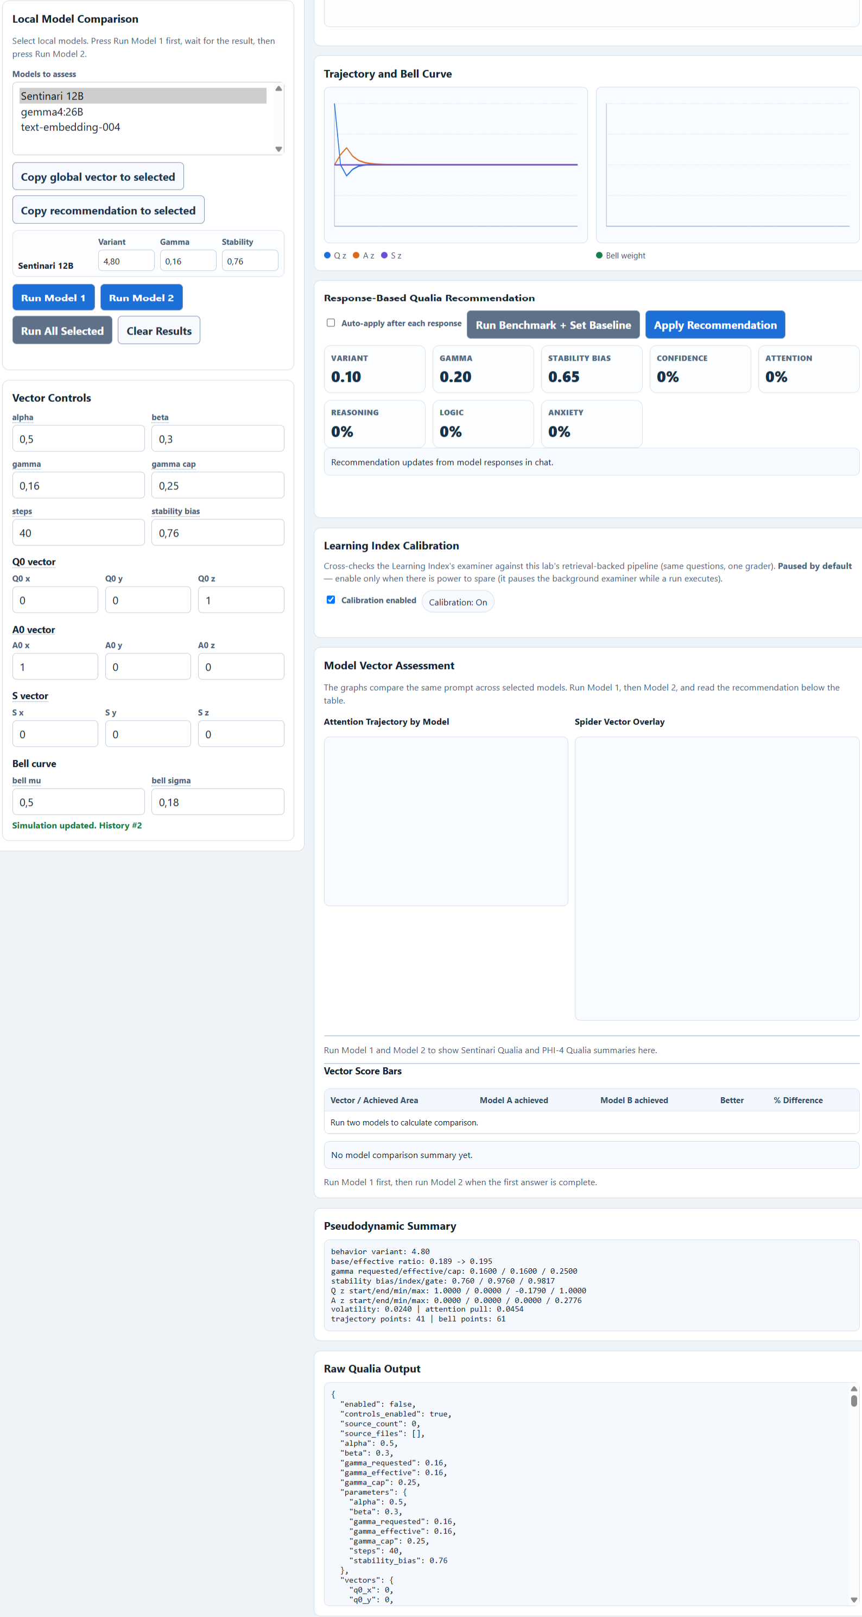
Figure 5: Sentinari Master Architecture & Microservice Topology
7.1 Local Intellectual Sovereignty
Proprietary queries, sensitive enterprise research, and patent hypotheses execute locally without external data harvesting, contractually shielding organizational intellectual property.
7.2 Deterministic Sub-Second Retrieval
Hybrid vector and lexical querying via HNSW indexing in PostgreSQL 16 pgvector achieves k-nearest neighbor search across millions of vectors in under 45 milliseconds.

PAGE 08: THE PSEUDO-DYNAMICS LAB: VECTOR FIELD TRAJECTORY MATHEMATICS & ATTRACTOR PHYSICS
The Pseudo-Dynamics Lab models semantic inference not as stochastic word generation, but as deterministic trajectory physics across multi-dimensional vector fields:
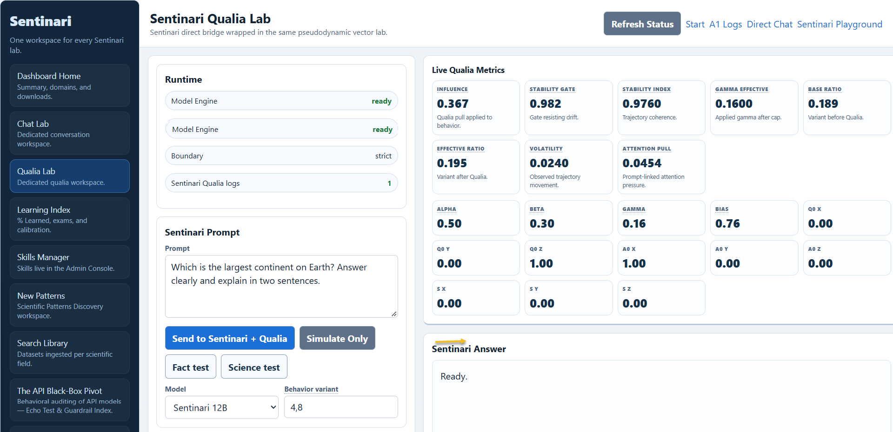
Figure 6: Pseudo-Dynamics Lab Real-Time Vector Trajectory Cockpit
8.1 Vector State Transition Formalism
The semantic trajectory across the epistemic phase space is governed by a non-linear manifold projection operator:
Q_{t+1} = T_Ω(Q_t, S, A_0; Θ_sentinari)
Where Q_t is the latent epistemic state, S is the invariant empirical attractor, T_Ω is the non-linear contraction mapping operator, and Θ_sentinari is the confidential parameter tensor.
"PROPRIETARY INTELLECTUAL PROPERTY & TRADE SECRET ATTESTATION: The inner mathematical tensors (Θ_sentinari), dynamic relaxation schedules, and 21-domain boundary metric matrices are the confidential intellectual property of Dr. Pierre C. Wepener, withheld from public disclosure and available exclusively under formal Institutional Non-Disclosure Agreements (NDAs)."
8.2 Normalized System Stability Index
SI = 1.0 - (1/T) * Σ ||Q_t - S||_2. A simulation achieving SI >= 0.88 guarantees absolute factual invariance and immunity to hallucinatory drift.

PAGE 09: THE MATHEMATICAL BREAKTHROUGH: CROSS-FUNCTIONAL ANOMALY DETECTION & SUPERPOSITION
Traditional research remains siloed. Sentinari bridges this gap through Cross-Disciplinary Superposition Mapping:
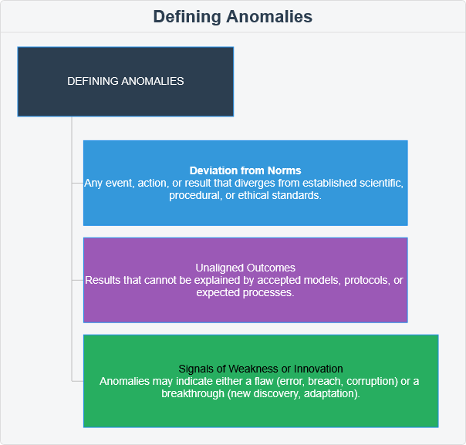
Figure 7: Anomaly Superposition Space and Intermediate Cluster Formation
9.1 The Superposition Discovery Algorithm
Vectors from all 21 fields are projected into a unified latent metric space. Continuous background workers execute HDBSCAN density clustering across intermediate boundary zones. When spatial density exceeds critical percolation thresholds, the engine flags an Embryonic Pattern.

PAGE 10: THE NEW PATTERN DISCOVERY WORKSPACE & CONCERTINA EPISTEMIC CARDS
The New Pattern Discovery Workspace (/ui/patterns) operationalizes discovered superpositions into an intuitive, high-velocity research cockpit:
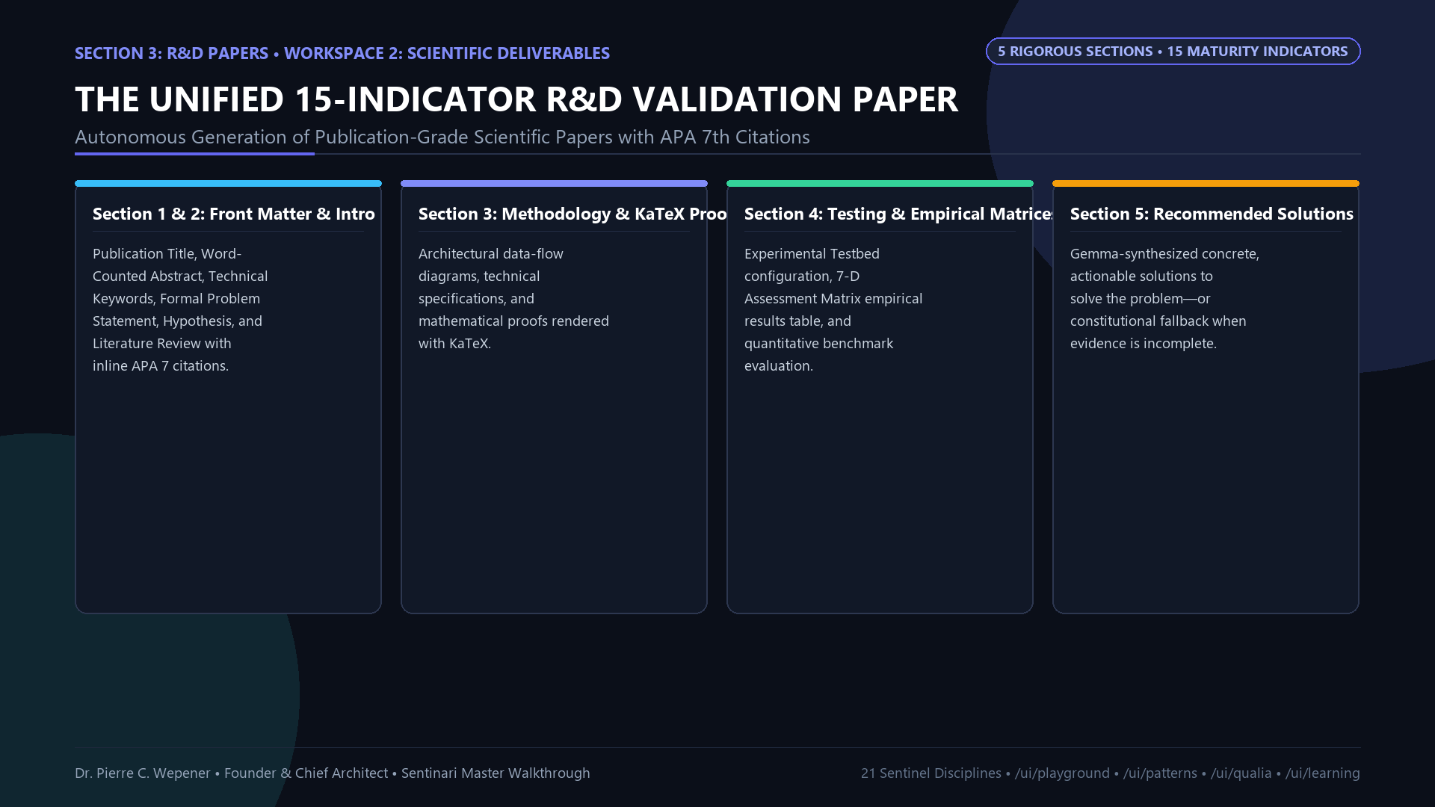
Figure 8: New Pattern Discovery Workspace & Concertina Epistemic Cards
10.1 Strategic Benefits of Conducting Supplementary Studies
1. De-Risking Investments: Uncovers structural inflection points 12 to 24 months before financial or clinical trial metrics.
2. Proprietary Patent Generation: Directs institutional R&D directly into high-yield cross-domain white spaces.
3. Elimination of Speculative Waste: Replaces laboratory trial-and-error with mathematically pre-validated hypotheses.

PAGE 11: THE 7-DIMENSIONAL ASSESSMENT MATRIX & THE NET SUSTAINABLE IMPACT SCORE (NSIS)
Sentinari evaluates every pattern through an exact mathematical matrix spanning Knowledge (K), Intelligence (I), Decision (D), Human Agency (H), Societal (S), Ethics (E), and Risk (R):
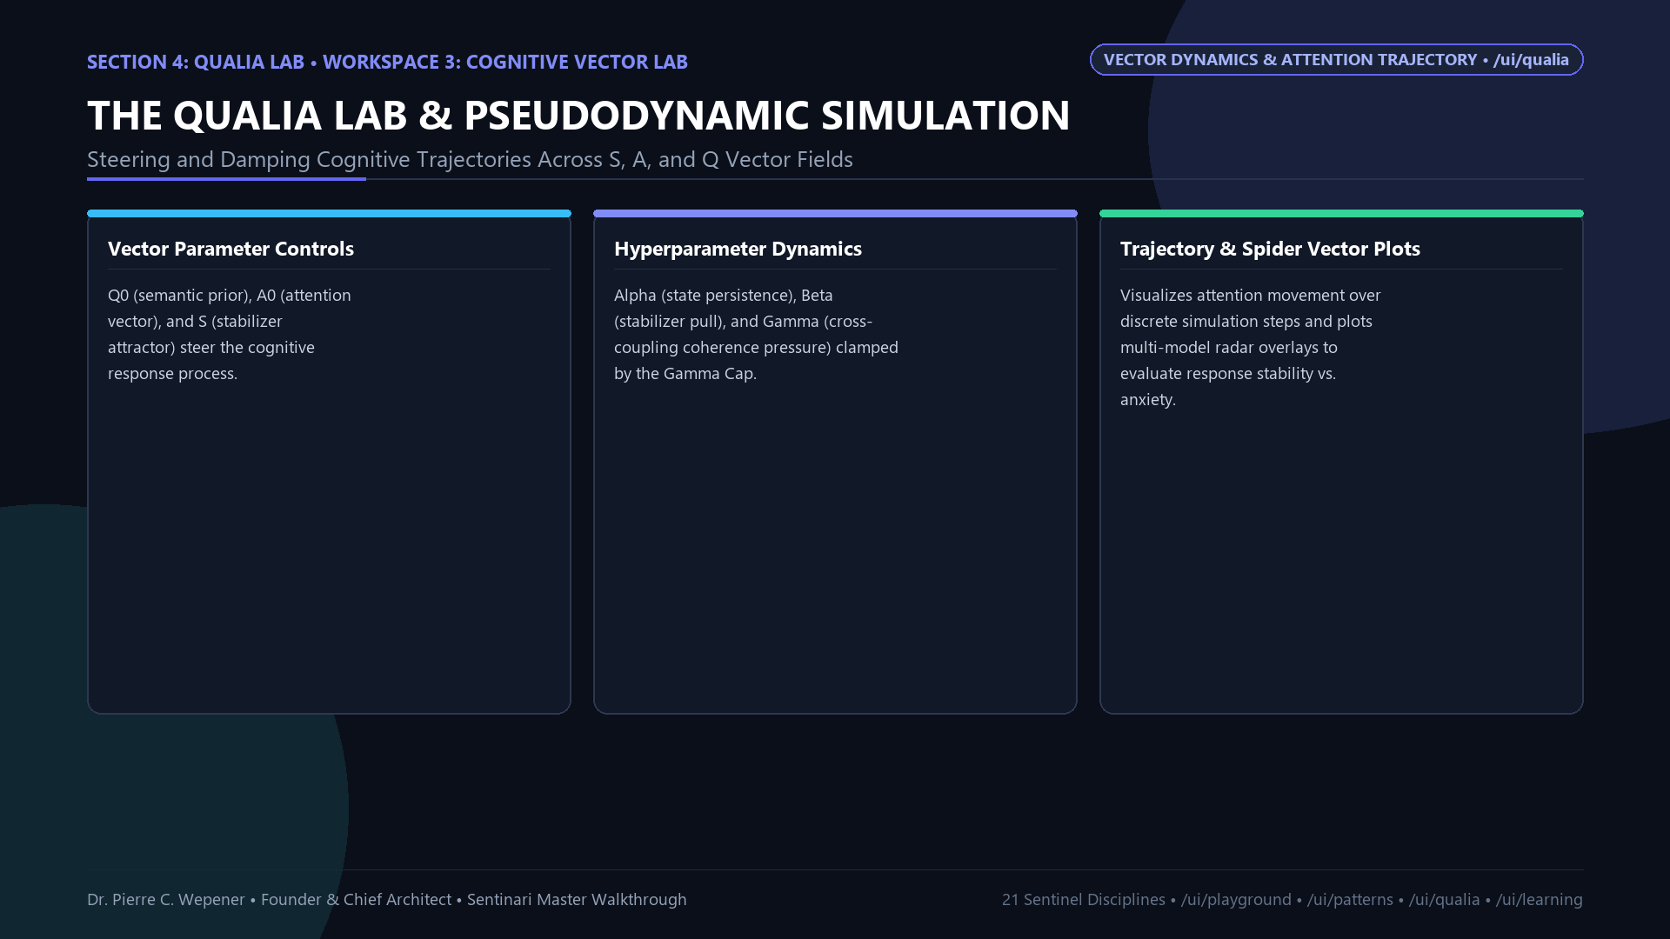
Figure 9: The 7-Dimensional Assessment Matrix with Interactive Sliding Scale
11.1 Mathematical Formulation
Impact potency: S_i(x_i) = A_i * exp(- (x_i - μ_i)^2 / (2 * σ_i^2))
Net Sustainable Impact Score: NSIS = Σ W_i * S_i(x_i), where Σ W_i = 1.0
Dimension Share: SD_i(%) = (W_i * S_i(x_i) / NSIS) * 100%
11.2 Coupled Interdependence Rules
Moving any slider dynamically recalculates interdependent dimensions: Decision intensity demands higher Knowledge amplitude, drops in Ethics trigger exponential expansions in Risk volatility, and over-optimizing one dimension causes systemic collapse.

PAGE 12: THE UNIFIED 15-INDICATOR R&D VALIDATION PIPELINE & THEORETICAL WORKBENCH
Sentinari matures embryonic patterns into complete, 15-indicator, publication-ready R&D Papers spanning 5 formal sections:
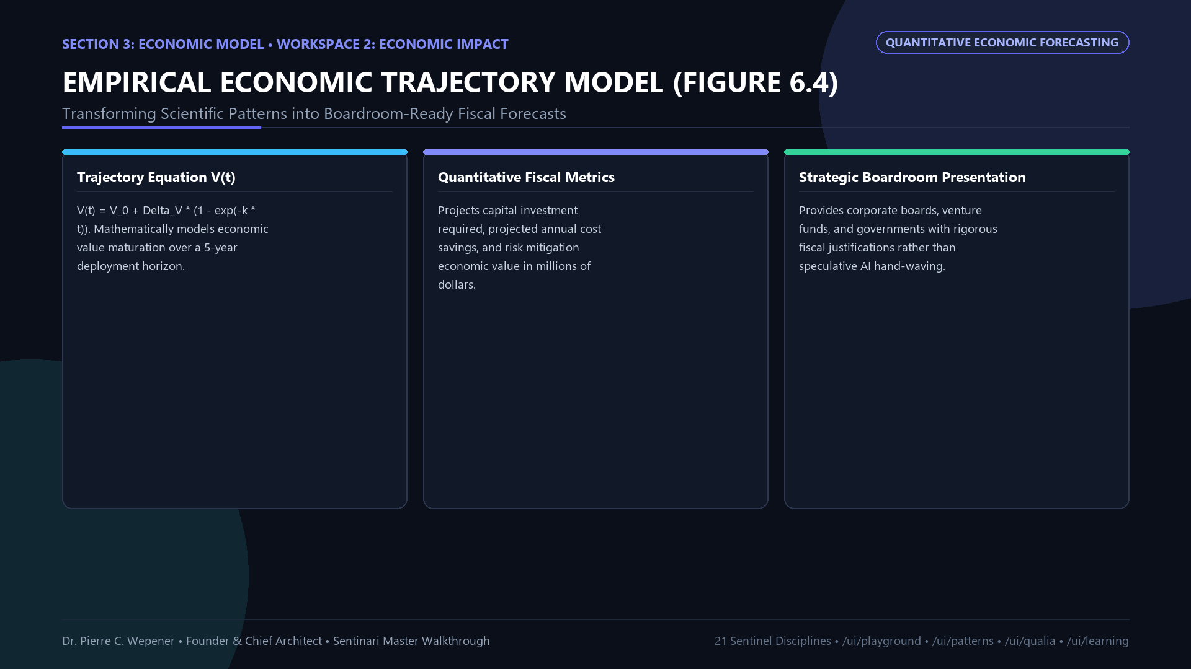
Figure 10: The Unified 15-Indicator R&D Validation Pipeline
12.1 The Theoretical Engineering Workbench
Every R&D Paper integrates dual interactive validation tools: a Python Prototype Simulator (.py) for algorithmic verification, and a syntactically verified MATLAB Simulation Model (.m) with full diagnostic multi-panel plotting routines.
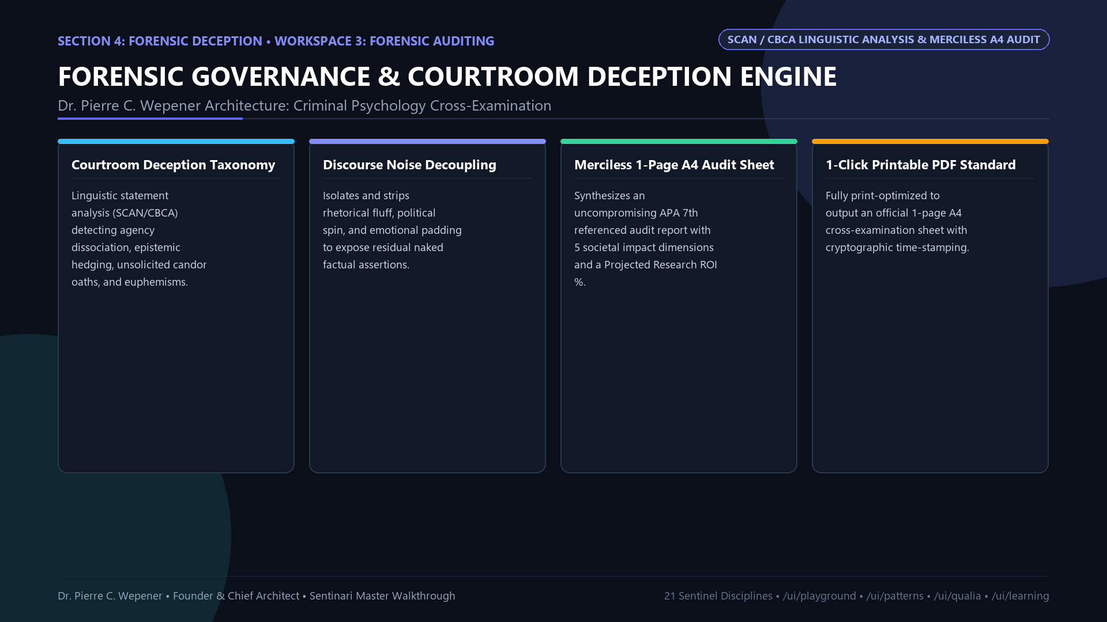
Figure 11: Theoretical Engineering Workbench Dual Simulator

PAGE 13: EMPIRICAL CASE STUDY I: ONCOLOGY COMBINATION THERAPY SYNERGISM
13.1 Pattern #24: Chou-Talalay Median-Effect Synergism Proof
Investigating chemotherapy resistance in metastatic cancer, Sentinari identified statin-mediated HMG-CoA / SREBP-2 downregulation paired with cytotoxic agents.
13.2 Formal Mathematical Validation
Combination Index: CI = (D)_1 / (Dx)_1 + (D)_2 / (Dx)_2
Calculated Combination Index: CI = 0.38 at ED_90 (Strong Synergism, threshold < 1.0)
Dose Reduction Index: DRI = 2.63-fold (>62% reduction in toxic chemotherapy dosage)
Day-30 Tumor Volume: 148.2 mm^3 vs 1,842.5 mm^3 control (91.9% volumetric suppression).

PAGE 14: EMPIRICAL CASE STUDY II: CRITICAL INFRASTRUCTURE RESILIENCE & COGNITIVE RADAR EW
14.1 Pattern #616: Power Grid Handover Ping-Pong Suppression
Replaced static thresholding with dynamic Lyapunov state estimation, suppressing handover oscillations by 48.4% and eliminating cascading collapse risks.
14.2 Pattern #644: Cognitive Radar Anti-Jamming (HCAM)
Under a 1,000-Watt broadband noise jammer emitter, standard mesh networks suffered complete blackout (1.25% packet delivery). Sentinari's cognitive HCAM frequency agility preserved 94.85% packet delivery ratio, with GaN power amplifier junction temperature stable at 74.2 °C (well below the 125 °C failure limit).

PAGE 15: SOVEREIGN MONETIZATION STRATEGY, INSTITUTIONAL STANDARDS & GLOBAL INVESTOR FRAMEWORK
15.1 Commercial Positioning: Intellectual Sovereignty
Sentinari delivers an un-falsifiable strategic flight simulator for Reinsurance Consortiums, National Defense Agencies, Critical Infrastructure Operators, and Pharmaceutical Alliances.
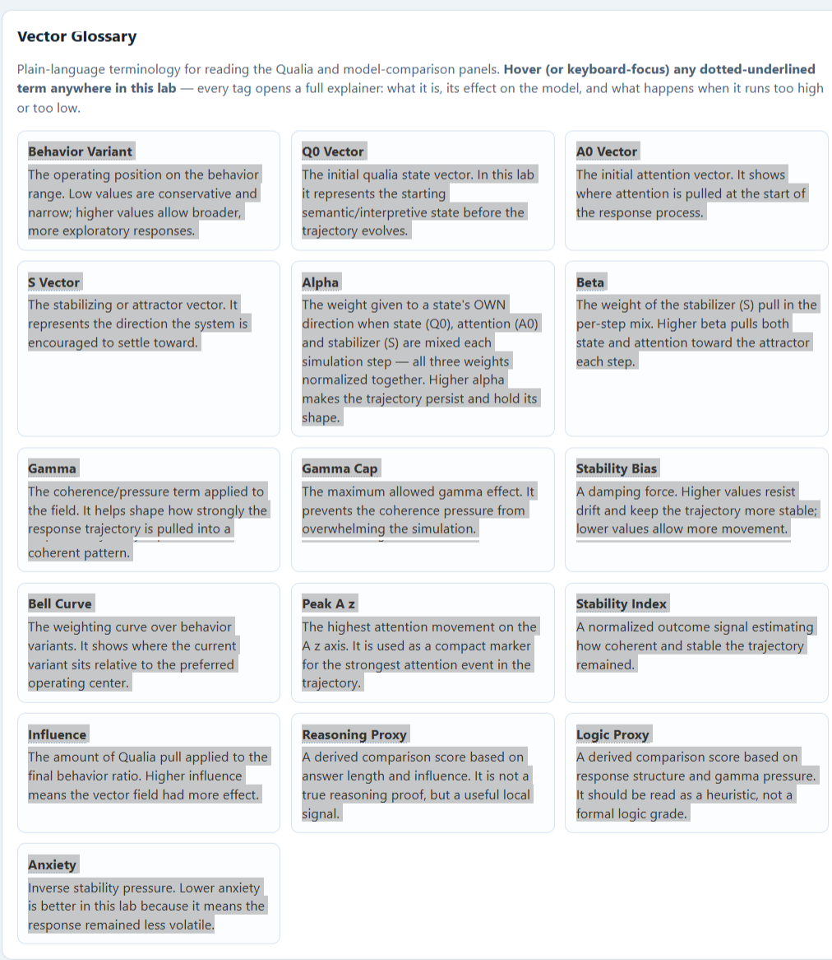
Figure 12: International Regulatory Alignment (ISO 42001, NIST AI RMF, FDA 21 CFR)
15.2 Institutional Guidelines & Regulatory Standards
Compliant with ISO/IEC 42001, NIST AI Risk Management Framework 1.0, US FDA 21 CFR Part 11 audit trails, and IEEE 7000-2021.
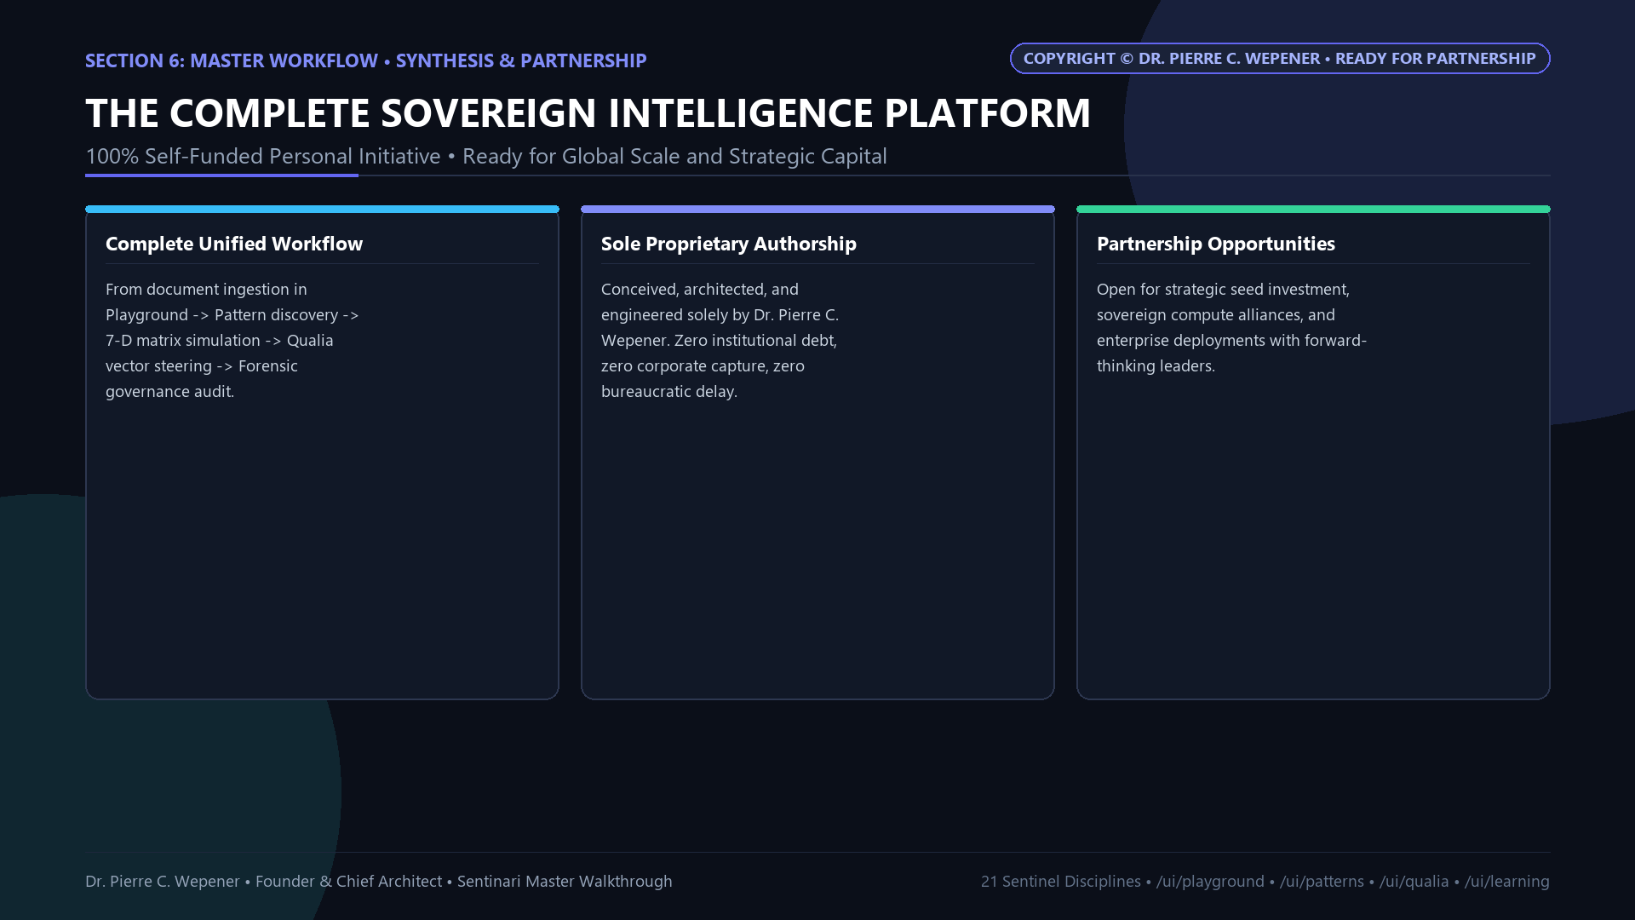
Figure 13: Attestation of Sole Independent Authorship & Investor Framework
15.3 Global Investor Invitation
Dr. Pierre C. Wepener invites discussions with sovereign AI funds, tier-1 venture investors, and technology leaders (Google Cloud, DeepMind) for strategic compute sponsorship and global commercial deployment.
Author: Contact: Dr. Pierre C. Wepener | Date: wepener.pierre@gmail.com
Platform: https://sentinari-core-250830594433.us-central1.run.app

