Download GUDID Schema
GUDID ReleasesGUDID DownloadsGUDID SchemaGUDID Releases RSSSupplemental DownloadsDelimited .TXT FilesLarge Data Sets
Additional Help
- Download Help
- Delimited Files Help
Coming Soon: GMDN Enhancements
NLM will update AccessGUDID to include more Global Medical Device Nomenclature (GMDN) information - Term Codes, Code Status (Active or Obsolete), and a GMDN Implantable flag (True or False). Device records containing a GMDN Preferred Term (gmdnPTName) will include the equivalent GMDN Term Code on AccessGUDID.The following are the new GMDN fields:
- GMDN Term Code
- GMDN Implantable
- GMDN Code Status
The Schema files are updated with the new GMDN terms. Please take a moment to review the information and ensure your system is able to download and process the updated files.
New Data Elements
New on April 2, 2018: updates to AccessGUDID data! The following new data elements are now available on AccessGUDID, in the download files, and in the APIs. More easily track GUDID device record updates, manage changes, and link to other data sets.
- Public Version Number
- Public Version Date
- Public Version Status (new/update/delete)
- Public Device Record Key
- Labeler D-U-N-S® Number
- FDA Premarket Submission Number*
- FDA Premarket Supplement Number*
The updated schema file, sample download records and read-me-first files are included in the zip file below. Please take a moment to review the information and ensure your system is able to download and process the updated files.
* As of July 9, 2018, values for FDA Premarket Submission Number and FDA Premarket Supplement Number are included in the device record when available and publicly releasable.
Device record versioning is new
Starting April 2, 2018, you can track changes to device records using the new data elements Public Version Number, Public Version Date, Public Version Status, and Public Device Record Key.
Public Device Record Key is the primary key for device records on AccessGUDID: it can be used to uniquely identify a device record and maintain its history. Public Device Record Key will never change for an individual device record even if the device record’s Primary Device Identifier (DI) Number changes.
The table below shows the information you can expect to see in the new data elements Public Version Number, Public Version Date, and Public Version Status.
Action | Public Version Number | Public Version Date | Public Version Status | Device Record Status | Additional Information
Record released to AccessGUDID for the first time | 1 | Date the record is initially released to AccessGUDID | New | Published
Record update released to AccessGUDID | Add 1 to previous Public Version Number | Date the updated record is released to AccessGUDID | Update | Published
Record is removed from AccessGUDID | Add 1 to previous Public Version Number | Date the record removal notification is sent to AccessGUDID | Delete | Unpublished/Deactivated | Record will no longer be searchable via AccessGUDID Search interface or APIs
New data elements added to existing records on AccessGUDID on April 2, 2018 | 2 | April 2, 2018 | Update | Published | Public Version Number 1 of the existing records is implied prior to April 2, 2018

Current Schema File
The GUDID schema file is a ZIP file containing XSD files. The XSD files explain the format for GUDID release XML files. The GUDID schema ZIP file also contains an Excel file with version history for the XSD files.
- GUDID_Download_Schema_20230616.zip
  - Date Created: Aug 14, 2023
  - Number of Files: 4
  - File Size: 22.1 KB
  - MD5 Checksum: b1a0d5276deadba2fa2a4025d8b5c43e
Previous GUDID Schema File
- GUDID_Download_Schema_NEW.zip
  - Date Created: Feb 15, 2018
  - Number of Files: 6
  - File Size: 25.9 KB
  - MD5 Checksum: a7669e76c116b8aa010e72b24d4d2f53
- GUDID-Download-Schema.zip
  - Date Created: Mar 30, 2017
  - Number of Files: 4
  - File Size: 19.3 KB
  - MD5 Checksum: 3645b3e8ad64a07aa7e3368d05d57b8f

RSS Feeds
Title | Copy URLs to RSS Reader
Schema Releases | https://accessgudid.nlm.nih.gov/download.rss?files=schema

For more information on AccessGUDID RSS Feeds, visit https://accessgudid.nlm.nih.gov/resources/feeds/rss.
Resources HomeNoticeGenerating UMLS TicketsFeedsRSSAPIs
- V3 APIs
- V2 APIs
- V1 APIs
Download FilesImplantable List Download
- Importing Delimited Device Files
  - Microsoft Excel
  - Microsoft Access
  - Oracle Database (Manual)
  - Oracle Database (SQL Loader)
  - MySQL Database (Load Data Script)
Importing Delimited Device Files into a MySQL Database using a MySQL Load Data Script
The Pipe-Delimited | device files provide a relational view of the device record data. These files can be imported into a database for easier reading and interaction.
Notice
Be aware of the file size and row limitations of the software you are attempting to import the files into. For information on limitations, look at the software's official documentation
Directions
The following directions are for the MySQL CMD Line tool, but similar actions can be taken in other SQL tools and database types.
- Extract the Import Scripts to your workarea.
- Place your Delimited Device Files into the data directory.
- Update and uncomment the runner script with the appropriate parameters for your environment.
  - If you are using a Linux computer to run these scripts, update the mysql/mysql_populate_ag_tables.sh file.
  - If you are using a Windows computer to run these scripts, update the mysql/mysql_populate_ag_tables.bat file.
The variables that need to be updated are as follows:
Parameter | Description
MYSQL_EXECUTABLE | The location of the mysql cmd line executable (ex: ~/MySQL/bin/mysql)
user | The user name to use to connect to your database schema
password | The password to use to connect to your database schema
dbserver | The IP or url of the server
db_name | The name of your database schema
- Execute the runner script
  - If you are using a Linux computer, run the mysql/mysql_populate_ag_tables.sh file.
  - If you are using a Windows computer, run the mysql/mysql_populate_ag_tables.bat file.
- Check the mysql_ag.log file generated in the mysql directory for a generated report.
Download Import Scripts
You can download the Import Scripts here. The following files can be found in the download:
Directory/File Name | Description
oracle/populate_ag_tables.sh | Shell Script runner for all ctl and sql files in a Linux Environment.  Note: You must update the parameters ORACLE_HOME, user, password, and tns_name to connect to your database and use your SQL Loader and SQL Plus applications
oracle/populate_ag_tables.bat | Batch runner for all ctl and sql files in a Windows Environment.  Note: You must update the parameters ORACLE_HOME, user, password, and tns_name to connect to your database and use your SQL Loader and SQL Plus applications
oracle/ag_build_tables.sql | Drops and Creates new tables that the ctl scripts will populate
oracle/ag_device_sizes.ctl | Control File for the Delimited Device File data/deviceSizes.txt  Populates the AG_DEVICE_SIZES table
oracle/ag_contacts.ctl | Control File for the Delimited Device File data/contacts.txt  Populates the AG_CONTACTS table
oracle/ag_sterilization_methods.ctl | Control File for the Delimited Device File data/sterilizationMethodTypes.txt  Populates the AG_STERILIZATION_METHODS table
oracle/ag_identifiers.ctl | Control File for the Delimited Device File data/identifiers.txt  Populates the AG_IDENTIFIERS table
oracle/ag_product_codes.ctl | Control File for the Delimited Device File data/productCodes.txt  Populates the AG_PRODUCT_CODES table
oracle/ag_gmdn_terms.ctl | Control File for the Delimited Device File data/gmdnTerms.txt  Populates the AG_GMDN_TERMS table
oracle/ag_environmental_conditions.ctl | Control File for the Delimited Device File data/environmentalConditions.txt  Populates the AG_ENVIRONMENTAL_CONDITIONS table
oracle/ag_device.ctl | Control File for the Delimited Device File data/device.txt  Populates the AG_DEVICE table
data/* | This directory will contain the Delimited Device Files you will process.
bad/* | This directory will contain the .bad files that get generated any time a bad record is read during processing
discard/* | This directory will contain the .dsc files that get generated any time record is discarded during processing
External Tools and References
Technology | Notes | Link(s)
Oracle SQL Client Tools | Oracle SQL Client Tools | Oracle SQL Client
Oracle Database | Oracle Database official size limitations | Oracle Physical Database Limits

v1 APIs
Resources HomeNoticeGenerating UMLS TicketsFeedsRSSAPIs
- V3 APIs
  - Implantable List
  - Device Lookup
  - Device History API
  - Device SNOMED
  - Parse UDI
- V2 APIs
- V1 APIs
Download FilesImplantable List Download
- Importing Delimited Device Files
Notice
** Update July 2021 **
AccessGUDID V1 APIs are currently deprecated (no longer supported for bug fixes and enhancements) and will be removed after December 31, 2022.
December 28, 2018
AccessGUDID is deprecating its V1 APIs and will no longer be available for use after December 31, 2019.
The new base URL for the web service is: https://accessgudid.nlm.nih.gov/api/v2/
The V2 APIs are in production as of January 1, 2019.
If you are using our V1 web services, please update your code to use V2 by January 1, 2019. After that date, V1 APIs will no longer be supported in terms of bug fixes and enhancements. If you have questions about the switch to V2, please ask us via the NLM Support Center.
Developers v1 API
REST APIs
• Implantable List
• Device Lookup
• Device SNOMED
• Parse UDI
Download Files
• Implantable List
Resources
• Generating UMLS Tickets

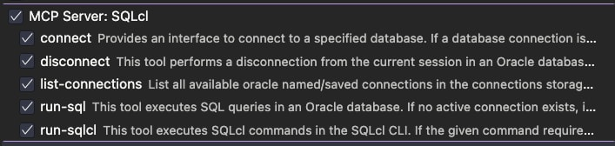
Product updates are delivered quarterly, adding capabilities from SQL Developer Classic along with new features that take advantage of the VS Code platform.
Getting Started
Install SQL Developer for VS Code by clicking the Install button above.
Complete Feature List
- Oracle SQLcl MCP Server Integration
- 🔥 APEXLang IDE Support
- JSON Duality Views Support
- Diagramming
- 🔥 Connectivity
- 🔥 DBA Panel
- 🔥 Performance
- 🔥 Security
- Schema Navigation
- SQL Worksheet
- Data Grids
- SQL Notebooks
- PL/SQL Code Editor
- PL/SQL Debugger
- Post-Execution Debugging of MLE JavaScript Modules
- Code Snippets
- Integrated Command Line Interface via Oracle SQLcl
- Useful Commands
- Quick Start Examples
  - Start working
  - Worksheet
  - Auto-complete
  - SQL Snippets
  - SQL History
  - Working with database objects
  - JSON data and JSON duality views
- Supported Locales
- Bookmarks
- Support
- Data and Telemetry
- License
Oracle SQLcl MCP Server Integration
When installed, the extension registers the Oracle SQLcl MCP Server for GitHub Copilot, making your SQL Developer database connections available for agentic chat requests, including running SQL and PL/SQL against your database.
Optionally, you can invoke the Configure Cline SQLcl MCP command palette operation to get a JSON snippet that registers SQLcl's MCP Server for any local AI agent. Cline is provided only as an example. Neither Cline nor Copilot is required.
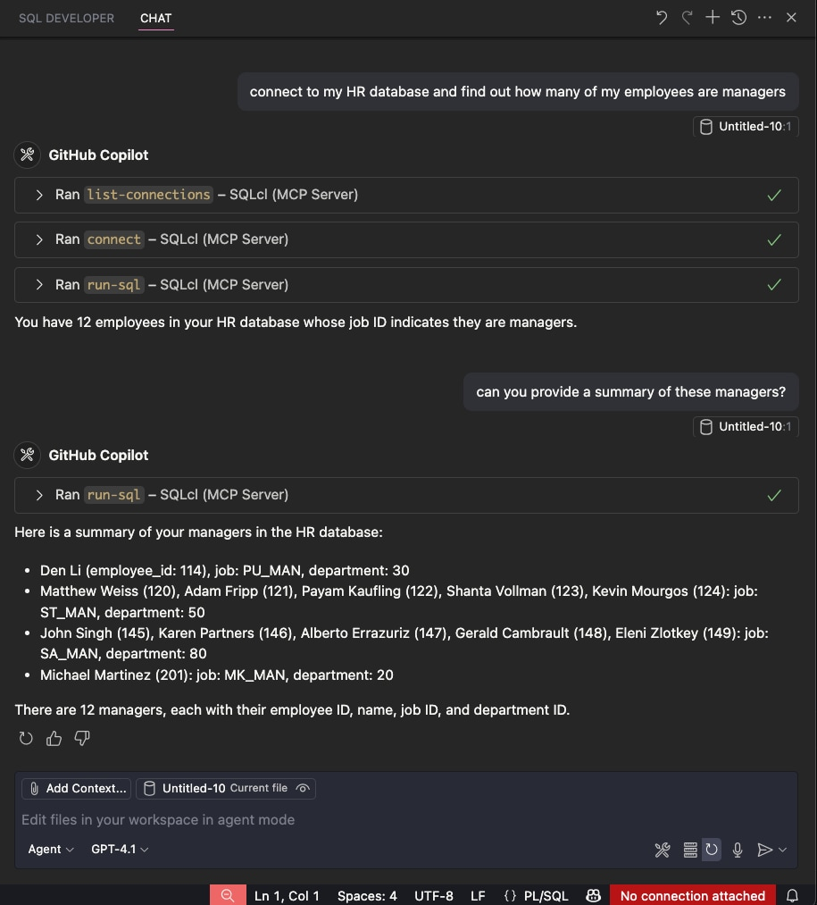
In this Copilot session, a request for a list of managers from the HR database can use a database connection named HR, inspect the schema, identify the EMPLOYEES table, query the requested information, and return a summary report.
Note regarding Oracle Database access via MCP and AI chat assistants
- Apply least privilege: Use dedicated database users with minimal permissions for AI assistants and MCP integrations.
- Segregate environments: Connect to sanitized development and test databases; restrict and monitor access to production systems.
- Never auto-approve actions: Always review and approve actions requested by AI or Copilot integrations.
Oracle APEXLang IDE Support
APEXLang is a complete application specification language for Oracle APEX, with a documented grammar and compiler. APEXLang files are plain-text, human-readable, source-control friendly, and designed for diffing, merging, reviewing, and automation.
SQL Developer for VS Code includes native APEXLang support, providing a rich editing experience powered by the Language Server Protocol (LSP). Features include syntax highlighting, code completion, validation, diagnostics, formatting, and intelligent editing assistance. Export APEX applications from the database, manage them as source code, and import them back to create or update applications.
The extension simplifies AI-assisted development through its built-in SQLcl MCP Server. This enables AI agents to generate and work with APEXLang while securely connecting to your Oracle AI Database. Rather than producing arbitrary code, AI assistants generate structured application specifications that are validated and compiled through the same APEX compiler, governance, and security model used by developers.
By leveraging the integrated SQLcl MCP Server, AI-driven workflows operate with the same database identity, security policies, and audit controls as traditional development workflows, enabling secure and governed application development with Oracle APEX.
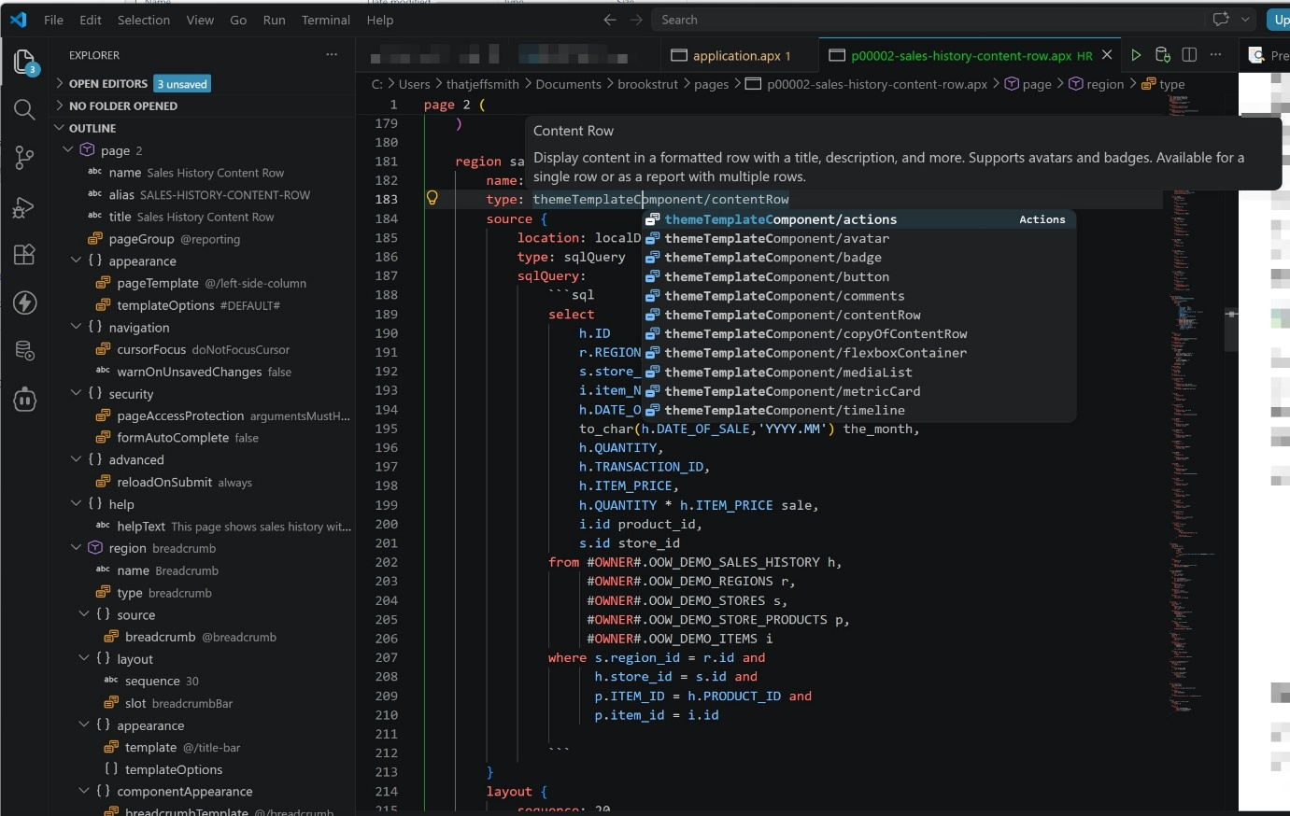
JSON Duality Views Support
With the JSON duality view builder, you can create, edit, and test JSON duality views. Duality views are treated as database objects and are available as a separate node in the Connections panel.
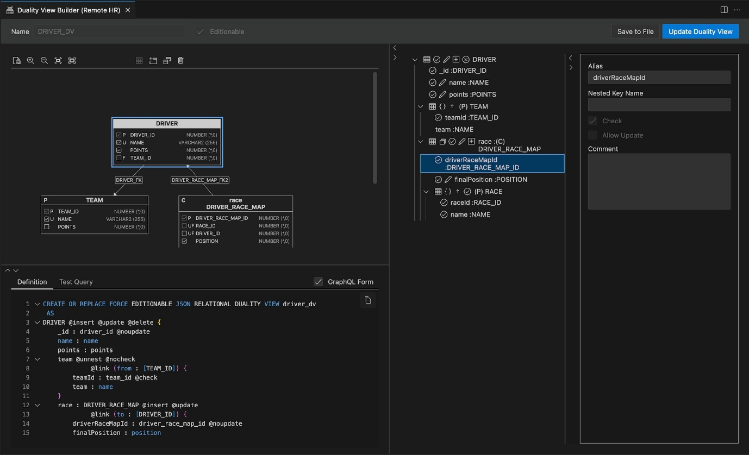
Diagramming
Right-click a connection and select Open Diagram to create an empty diagram. Select tables and views, then drag and drop them onto the diagram.
NOTE: Hold Shift while the cursor is over the diagram. Hold Alt/Option while releasing the mouse button to add objects with dependencies defined by foreign key constraints.
Drag a connection folder to a diagram to add all tables, views, and duality views from the connection schema.
To add all tables and views to a diagram, select the table or view folders from the connected schema, or from schemas under the Other Users node.
Arrange objects on the diagram using Auto Layout, then fine-tune the layout manually. Save diagrams to the file system and reopen them later with the same connection, or with another connection that has access to the same objects.
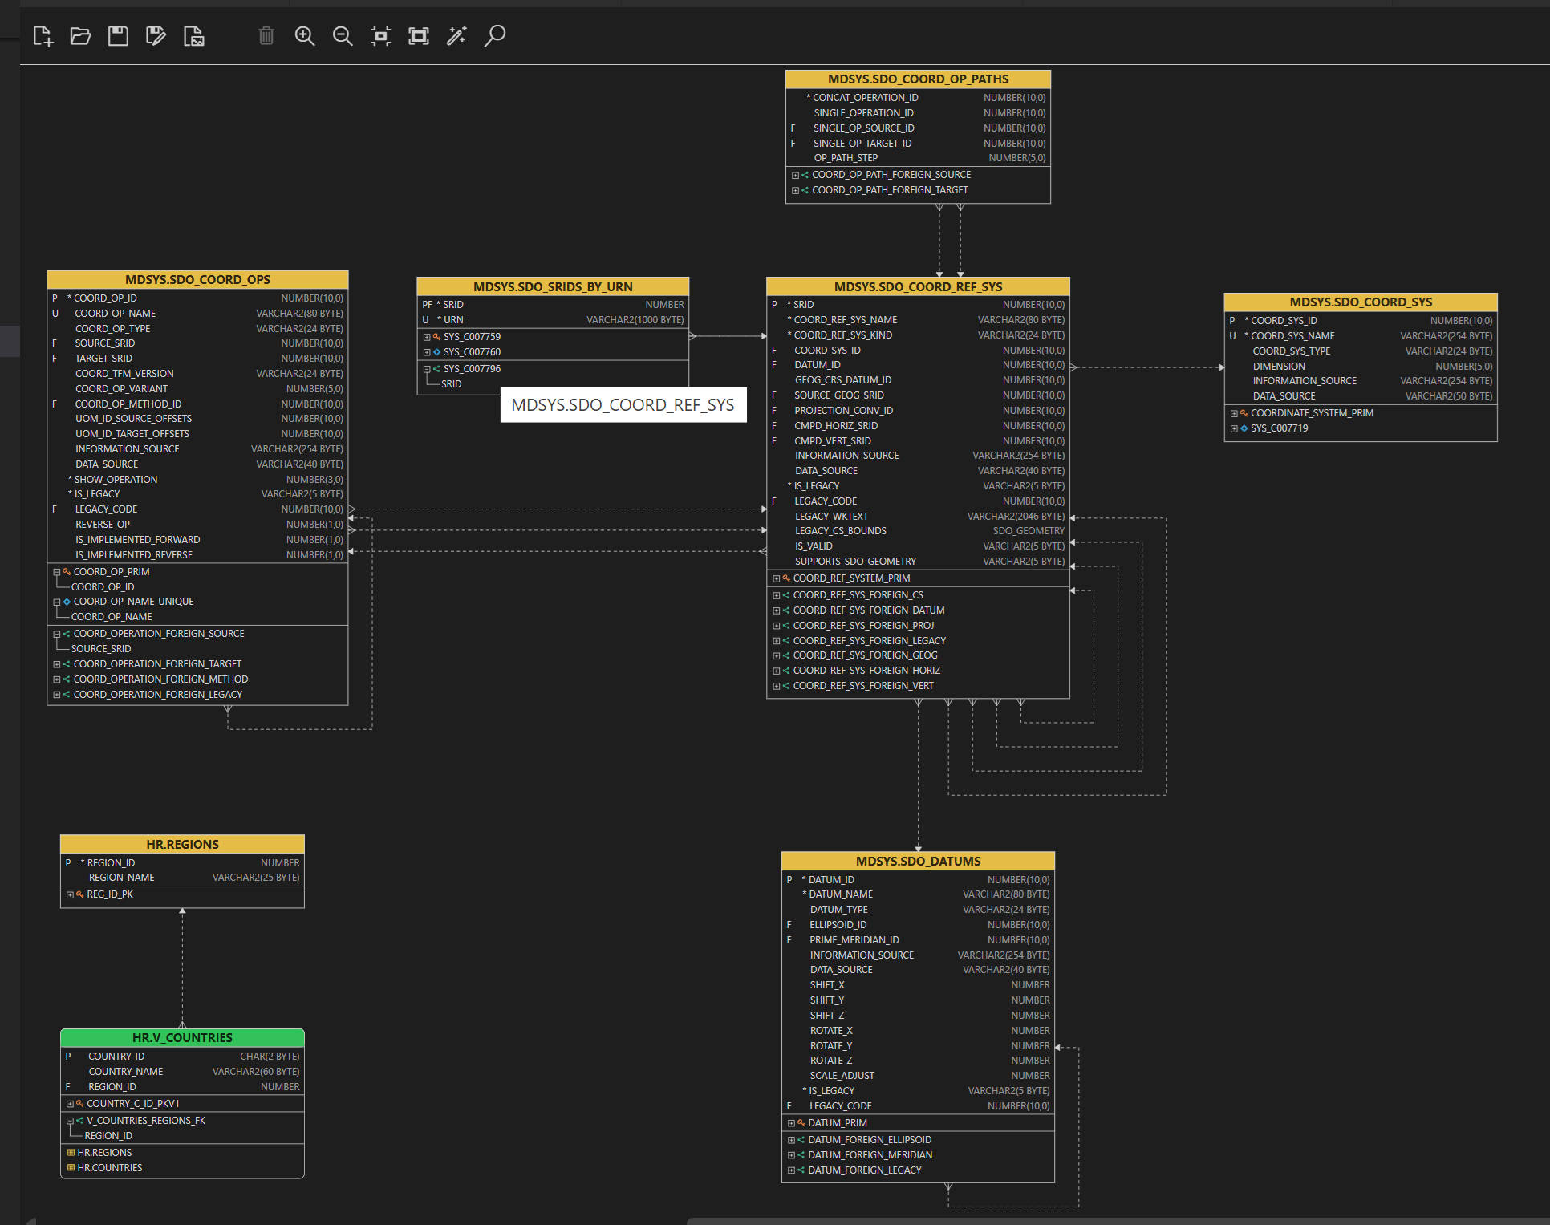
Connectivity
Everything required to connect to your database is included in the extension. If you have a tnsnames.ora file, you can use it to define your database connections.
Create connections by entering EZConnect or Basic connection properties, referencing a TNS entry, using an Oracle Cloud Autonomous Database wallet ZIP file, or importing existing connections from the Oracle Cloud Infrastructure (OCI) Database Tools service.
You can also import existing connections you have previously defined in your Oracle Cloud Infrastructure (OCI) tenancy via the Database Tools service.
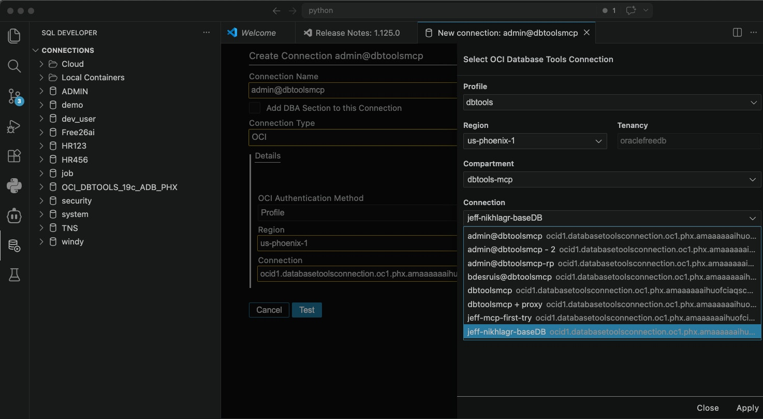Set your profile, region, and compartment, then search for your connection.
Features include:
- Named connections
- Connection folders and subfolders for organizing connections
- Create, save, test, clone, and import connections
- Preferences for the location of tnsnames.ora and auto-execute startup SQL scripts
- 🔥Import and use existing connections defined in OCI Database Tools
- 🔥Connection colors that decorate the Connections tree and open editor tabs, making it easier to identify editors and files by database connection
- 🔥DBA connection mode, which adds DBA-focused tree nodes and administration workflows
- 🔥Connection-level licensing opt-ins for features that require the Oracle Diagnostics Pack and Oracle Tuning Pack
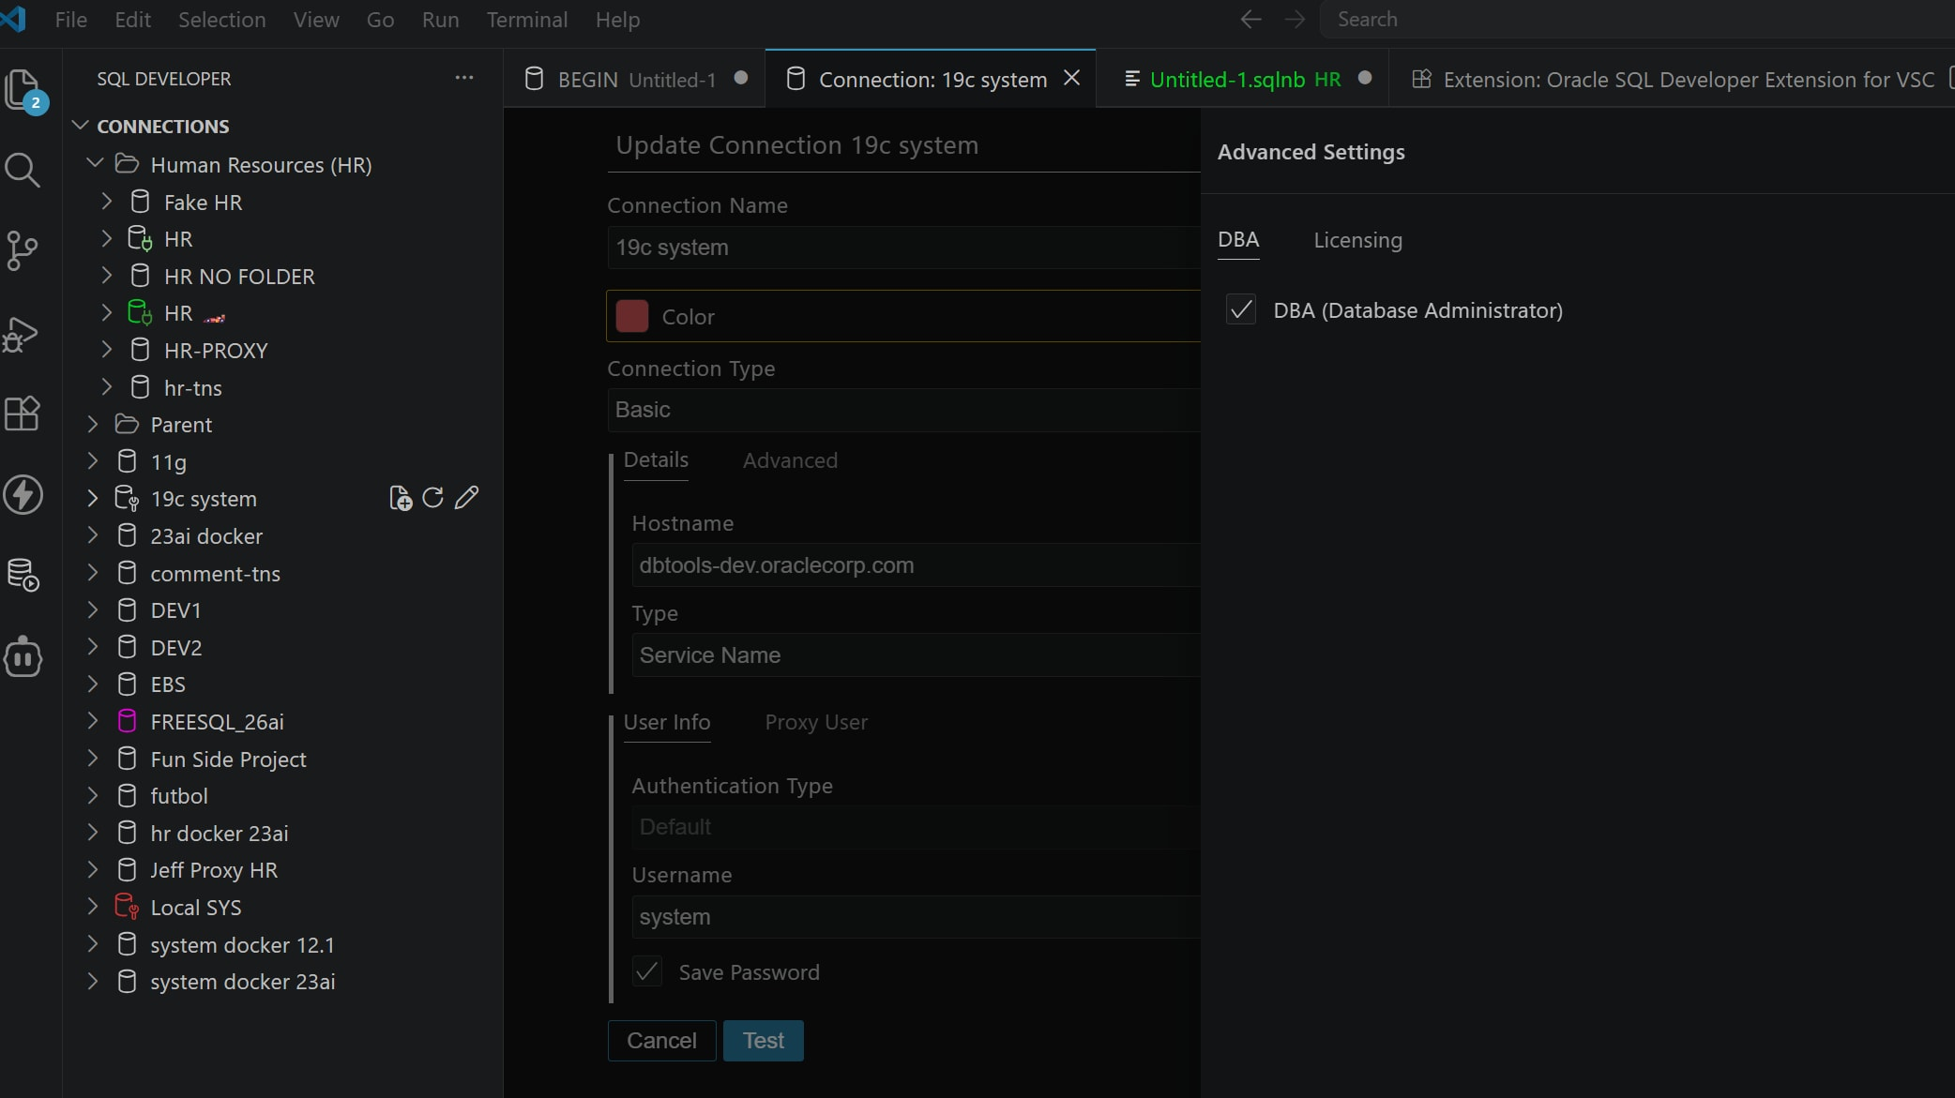Add a connection color and/or toggle on the DBA features.
Once connected, right-click to open a Worksheet. For any code editor, use the connection selector in the bottom-right corner to switch to a different database.
If a connection is interrupted, you will be prompted to reconnect automatically.
We take security seriously. Saved connection passwords are stored securely in private Java wallets.
Connections defined in SQL Developer for VS Code are also available to independent installs of Oracle SQLcl on your machine.
DBA Panel
Mark a connection as DBA to enable DBA-focused nodes and workflows in the Connections tree.
The DBA Panel now includes DBMS_SCHEDULER support, so you can review existing scheduler jobs and create new jobs from VS Code.
- View and manage DBA tree nodes from marked DBA connections
- Browse existing DBMS_SCHEDULER jobs
- Create new scheduler jobs
- Keep administrative workflows close to the SQL and PL/SQL code you are already working on
Performance
Create database performance reports directly from SQL Developer for VS Code, including Active Session History (ASH) and Automatic Workload Repository (AWR) reports.
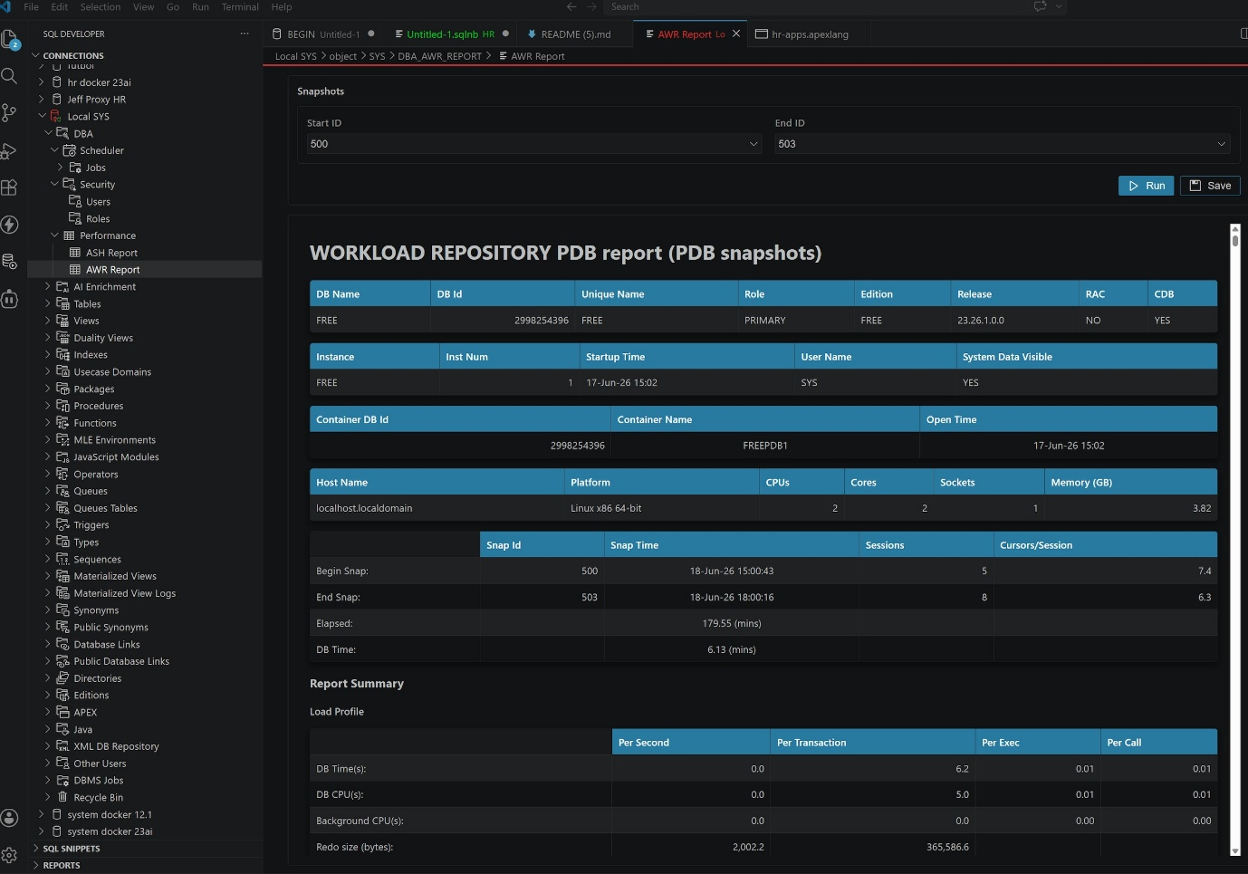Add a connection color and/or toggle on the DBA features.
- Create ASH reports
- Create AWR reports
- Use connection-level licensing opt-ins for features that require the Oracle Diagnostics Pack or Oracle Tuning Pack
- Keep performance investigation in the same workspace as your database code
Security
Manage users and roles from SQL Developer for VS Code, with workflows designed for experienced Oracle Database administrators and developers who need to understand exactly what will change.
- Create new users
- Clone existing users
- Lock and unlock accounts
- Manage role privileges, including removing privileges from a role
- Generate DDL for user and role changes so you can review, save, or run it according to your change-management process
Schema Navigation
Your connection can be expanded to display a tree representation of your schema and the other schemas in your database.
To open an object, click it. You can also drag and drop items into a code editor to generate SQL or DML code.
An alternative navigation aid is available through VS Code breadcrumbs. SQL Developer presents the contents of your database as a virtual file system. Use the drop-down controls to change the schema, object type, or object you want to browse.
ET /devices/snomed
Returns a single device's associated SNOMED information in XML or JSON. A device identifier and a UMLS single-use ticket are required to receive a response.
Resource Information
format | URL
JSON | https://accessgudid.nlm.nih.gov/api/v2/devices/snomed.json
XML | https://accessgudid.nlm.nih.gov/api/v2/devices/snomed.xml
Parameters
Either a di, udi, or a record_key must be provided.
parameter | type | description
ticket | String | The single-use ticket used to access UMLS. A valid ticket is required.  Example Value: ST-210847-HwTfbMTY100CWNe2owFF-cas  For information on how to generate a single-use ticket, please see the page on Generating UMLS Tickets.
di | String | The Device Identifier string unique to a specific device
udi | String | The full Unique Device Identifier string for a device  This calls and uses the Parse UDI API and returns the parsed UDI information.  The UDI parameter should be percent-encoded.
record_key | String | The unique Public Device Record Key string for a device
Examples
JSON: GET with DIhttps://accessgudid.nlm.nih.gov/api/v2/devices/snomed?ticket=ST-163397-AmYzAyfCfhWjqbod4nHc-cas&di=08717648200274
{
concepts: [
{
snomedCTName: "Drug-eluting coronary artery stent, non-bioabsorbable-polymer-coated (physical object)",
snomedIdentifier: 700516001
}
]
}
XML: GET with UDIhttps://accessgudid.nlm.nih.gov/api/v2/devices/snomed.xml?ticket=ST-163439-GTEVSfgIPLe1dBkrM51X-cas&udi=%3D%2F08717648200274%3D%2C000025%3DA99971312345600%3D>014032%3D%7D013032%26%2C1000000000000XYZ123
<result>
<concepts type="array">
<concept>
<snomedCTName>
Drug-eluting coronary artery stent, non-bioabsorbable-polymer-coated (physical object)
</snomedCTName>
<snomedIdentifier type="integer">700516001</snomedIdentifier>
</concept>
</concepts>
<udi>
<udi>
=/08717648200274=,000025=A99971312345600=>014032=}013032&,1000000000000XYZ123
</udi>
<issuingAgency>ICCBBA</issuingAgency>
<di>08717648200274</di>
<serialNumber>000025</serialNumber>
<donationId>A99971312345600</donationId>
<expirationDateOriginalFormat>YYYJJJ</expirationDateOriginalFormat>
<expirationDateOriginal>014032</expirationDateOriginal>
<expirationDate type="date">2014-02-01</expirationDate>
<manufacturingDateOriginalFormat>YYYJJJ</manufacturingDateOriginalFormat>
<manufacturingDateOriginal>013032</manufacturingDateOriginal>
<manufacturingDate type="date">2013-02-01</manufacturingDate>
<lotNumber>000000000000XYZ123</lotNumber>
</udi>
</result>

- cs
- Drugs & Supplements
- Genetics
- Medical Tests
- Medical Encyclopedia
NIH Websites Are Changing
- Get the Latest Updates and FAQs on the transition
- Per Executive Order 14434, federal agencies are now using 'Super Intelligence' (SI) in place of 'Artificial Intelligence' (AI). You may see both terms across NIH content during this transition.
x
You Are Here:
Home →
MedlinePlus Connect
MedlinePlus Connect

MedlinePlus Connect is a free service of the National Library of Medicine (NLM), National Institutes of Health (NIH), and the Department of Health and Human Services (HHS). This service allows health organizations and health IT providers to link patient portals and electronic health record (EHR) systems to MedlinePlus, an authoritative up-to-date health information resource for patients, families, and health care providers.
How It Works
MedlinePlus Connect accepts and responds to requests for information based on diagnosis (problem) codes, medication codes, laboratory test codes, and medical procedure codes. When an EHR, patient portal or other system submits a code-based request, MedlinePlus Connect returns a response that includes links to patient education information relevant to the code. MedlinePlus Connect is available as a Web application or a Web service. It is available in English and Spanish.
Upon receiving a problem code request, MedlinePlus Connect returns relevant MedlinePlus health topics, genetic condition information, or information from other NIH Institutes and Centers.
For problem code requests, MedlinePlus Connect supports:
- ICD-9-CM (International Classification of Diseases, 9th edition, Clinical Modification)
- ICD-10-CM (International Classification of Diseases, 10th edition, Clinical Modification)
- SNOMED CT® (Systematized Nomenclature of Medicine, Clinical Terms). Note: MedlinePlus Connect coverage of SNOMED CT focuses on CORE Problem List Subset codes (Clinical Observations Recording and Encoding) and their descendants.

MedlinePlus Connect News



For some problem code requests in English, M+ Connect also returns information pages about genetic conditions. MedlinePlus has more than 1,300 summaries that educate patients about the features, genetic causes, and inheritance of genetic conditions. (Prior to 2020 this content was labelled “Genetics Home Reference”; the content is now a part of MedlinePlus.)
MedlinePlus Connect can also link your EHR system to drug information written especially for patients. When an EHR system sends MedlinePlus Connect a request that includes a medication code, the service will return link(s) to the most appropriate drug information. MedlinePlus drug information is the AHFS Consumer Medication Information and is licensed for use on MedlinePlus from the American Society of Health-System Pharmacists, ASHP, Inc.
For medication requests, MedlinePlus Connect supports:
- RXCUI (RxNorm Concept Unique Identifier)
- NDC (National Drug Code)
MedlinePlus Connect also returns information in response to laboratory test codes. This information is from the MedlinePlus medical tests collection.
For lab test requests, MedlinePlus Connect supports:
- LOINC® (Logical Observation Identifiers Names and Codes)
For medical procedure codes, MedlinePlus Connect supports:
- CPT® (Current Procedural Terminology)
- SNOMED CT® (Systematized Nomenclature of Medicine, Clinical Terms). Note: MedlinePlus Connect coverage of SNOMED CT focuses on CORE Problem List Subset codes (Clinical Observations Recording and Encoding) and their descendants.
MedlinePlus Connect supports requests for information in English or Spanish. MedlinePlus Connect is intended for use within the United States health care system and cannot support coding systems not used in the United States.
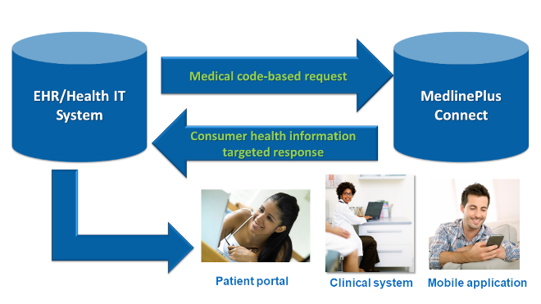
Implementing MedlinePlus Connect
To use MedlinePlus Connect, work with a technical representative or staff member to set up the MedlinePlus Connect Web application or Web service as described in the technical documentation. They will use the coding information already in your system (e.g., ICD-9-CM, NDC, etc.) to automatically send requests to MedlinePlus Connect in a standard format and use the reply to provide relevant patient education from MedlinePlus.
- MedlinePlus Connect supports the HL7 Context-Aware Knowledge Retrieval (Infobutton) standard.
- The level of effort for implementation varies depending on the flexibility and customizability of your system.
- Implementing MedlinePlus Connect is a one-time effort. Once you make this change in your system, MedlinePlus Connect will update and maintain the links between the codes and the consumer health information.
- See examples of health care organizations, electronic health records systems, and other systems using MedlinePlus Connect.
Quick Facts
- MedlinePlus Connect is free and does not require registration.
- MedlinePlus Connect may help you achieve one of the criteria for Meaningful Use of Health Information Technology.
- Implementing MedlinePlus Connect will make a global change; you don't need to create individual links.
- You don't have to use MedlinePlus Connect exclusively to link to patient education information. Many EHR systems can be configured to link to more than one source of consumer health information.
- MedlinePlus Connect isn't a replacement for MedlinePlus. It is a value-added service to bring MedlinePlus content to electronic health record systems.
- MedlinePlus Connect provides links to copyrighted drug information from American Society of Health-System Pharmacists, ASHP, Inc. Users of MedlinePlus Connect are prohibited from ingesting and/or branding this copyrighted content in their EHR or other health IT system. If you want to incorporate this content into your EHR or brand it, you must license the content directly from the information vendor. See our page on linking to MedlinePlus for more details.
More Information
- How MedlinePlus Connect Works
- MedlinePlus Connect News
- Demonstrations — Web application, Web service, and Post requests
- Technical information for developers
- MedlinePlus Connect Users and Partners
- MedlinePlus Connect handout - PDF
- Frequently Asked Questions (FAQs)
- MedlinePlus Connect email list
- Contact MedlinePlus Connect

NIH Websites Are Changing
- Get the Latest Updates and FAQs on the transition
- Per Executive Order 14434, federal agencies are now using 'Super Intelligence' (SI) in place of 'Artificial Intelligence' (AI). You may see both terms across NIH content during this transition.
x
You Are Here:
Home →
MedlinePlus Connect →
MedlinePlus Connect: Technical Information
MedlinePlus Connect: Technical Information
MedlinePlus Connect is available as a Web application or a Web service.
Sign up for the MedlinePlus Connect email list to keep up with developments and exchange ideas with your colleagues. It's the best way for us to keep you informed of updates and enhancements. Please tell us if you implement MedlinePlus Connect by contacting us.
Technical Quick Facts:
- MedlinePlus Connect is an API provided by the National Library of Medicine. It is available as a Web application or a Web service.
- MedlinePlus Connect will update and maintain the responses to code requests. The possible types of queries and reponses are described on the How it Works page.
  - Queries are URL-based. MedlinePlus Connect supports both GET and POST methods.
  - POST requests must use standard form data (URL-encoded name-value pairs). JSON and XML request payloads are not supported.
  - Only one code can be submitted per request.
- Supports the HL7 Context-Aware Knowledge Retrieval (Infobutton) standard.
- Connects using HTTPS connections.
- A personal health record (PHR) or electronic health record (EHR) vendor may activate MedlinePlus Connect at an enterprise level so it is available to all users.
- Health IT managers, such as at hospital systems or health care providers, may implement MedlinePlus Connect in their system if they have the administrative rights to make these adjustments.
For detailed implementation instructions, request parameters, demonstrations, and examples, go to the
- Web Application Technical Information Page
- Web Service Technical Information Page
MedlinePlus Connect Implementation Options
Web Application
How does it work?
- Responds to requests with an on-demand, formatted MedlinePlus Connect Web page
- The page is responsively-designed, has a toggle button for Spanish/English (when appropriate).
- Web Application demonstration
Technical Details and Demonstrations
- Web Application Technical Information page — Includes implementation instructions and information.
- Web Application demonstration page — Includes examples of MedlinePlus Connect Web Application response pages.
Web Service
How does it work?
- Responds to requests with XML, JSON, or JSONP, which implementers can use to incorporate MedlinePlus information and links into any health IT interface
- It is a REST-based Web Service
- The implementer may select which MedlinePlus links and information to provide from within the system instead of automatically providing a link to the standard MedlinePlus Connect response page
- Web Service demonstration
Technical Details and Demonstrations
- Web Service Technical Information page — Includes implementation instructions and information.
- Web Service demonstration page — Includes examples of responses generated by the Web service.
Acceptable Use Policy
In order to avoid overloading the MedlinePlus servers, NLM requires that users of MedlinePlus Connect send no more than 100 requests per minute per IP address. Requests that exceed this limit will not be serviced, and service will not be restored for 300 seconds or until the request rate falls beneath the limit, whichever comes later. To limit the number of requests that you send to Connect, NLM recommends caching results for a 12-24 hour period.
This policy is in place to ensure that the service remains available and accessible to all users. If you have a specific use case that requires you to send a large number of requests to MedlinePlus Connect, and thus exceed the request rate limit outlined in this policy, please contact us. NLM staff will evaluate your request and determine if an exception may be granted. Please also review the MedlinePlus XML files documentation. These XML files contain complete health topic records and can serve as an alternate method of accessing MedlinePlus data.
More Information
- How MedlinePlus Connect Works
- MedlinePlus Connect News
- Demonstrations — Web application, Web service, and Post requests
- Technical information for developers
- MedlinePlus Connect Users and Partners
- MedlinePlus Connect handout - PDF
- Frequently Asked Questions (FAQs)
- MedlinePlus Connect email list
- Contact MedlinePlus Connect

cbcdb993ed1ba542ccb66878440cf7783008

https://ncbi.github.io/cxx-toolkit/pages/ch_getcode_svn#ch_getcode_svn.windows_scripts
https://www.cgtrader.com/3d-models/human-anatomy

https://www.turbosquid.com/3d-models/complete-human-anatomymale-3d-model-1930116

https://free3d.com/3d-models/anatomy
https://www.printables.com/tag/anatomical
https://sketchfab.com/tilt/collections/anatomy-models-141d7538cdea49f394b9bddf458a72f9

