**DA Report**

*A report submitted in partial fulfillment of the requirements for the Award of Degree of*

**BACHELOR OF TECHNOLOGY**

**IN**

**ARTIFICIAL INTELLIGENCE & DATA SCIENCE ENGINEERING**

by,

**ONKAR JAMMA**

**ROLL NO 21**



**DEPARTMENT OF ARTIFICIAL INTELLIGENCE & DATA SCIENCE ENGINEERING**

**Pradnya Niketan Education Society, Pune.**

**NAGESH KARAJAGI *ORCHID* COLLEGE OF ENGGINEERING & TECHNOLOGY, SOLAPUR.**

**2023-2024**

**Introduction**

The Iris dataset is a classic and widely used dataset in the field of machine learning and statistics. It was introduced by the British statistician and biologist Ronald Fisher in 1936 as part of his work on discriminant analysis. The dataset is particularly popular for its simplicity and yet its effectiveness in demonstrating various statistical and machine learning techniques.

The dataset consists of measurements of iris flowers from three different species: setosa, versicolor, and virginica. For each species, four features were measured: sepal length, sepal width, petal length, and petal width. These measurements have been meticulously recorded, making the Iris dataset an ideal resource for exploring various data analysis techniques.

In this report, we delve into the analysis of the Iris dataset, aiming to gain insights into the characteristics of the different iris species and to showcase the application of statistical and machine learning methods for classification and pattern recognition tasks. By leveraging this dataset, we can explore fundamental concepts such as data preprocessing, exploratory data analysis, feature engineering, model training, evaluation, and interpretation.

The objectives of this report are as follows:

* To provide a comprehensive overview of the Iris dataset, including its background, structure, and characteristics of the variables.
* To conduct exploratory data analysis (EDA) to uncover patterns, relationships, and distributions within the dataset.
* To build predictive models using machine learning algorithms to classify iris species based on the provided features.
* To evaluate the performance of the models and interpret the results, shedding light on the strengths and limitations of different approaches.
* Through this analysis, we aim to not only demonstrate the practical application of data analysis techniques but also to deepen our understanding of the Iris dataset and its significance in the realm of statistics and machine learning.

By loading the libraries required for our analysis. These libraries contain functions and tools that we’ll use later for data manipulation, visualization, and modeling.Also we read the Iris dataset from a CSV file into our R environment. This dataset contains information about the sepal and petal dimensions of different iris flowers, along with their species.

**Libraries Utilised in Data Analysis**

1. *dplyr*: dplyr is a powerful package for data manipulation tasks. It provides a set of functions that facilitate data filtering, summarizing, arranging, and mutating. These functions make it easy to perform data preprocessing tasks on datasets like Iris.

2. *ggplot2*: ggplot2 is a popular plotting system for R that implements the grammar of graphics. It allows for the creation of complex and customized visualizations with a high level of flexibility. ggplot2 is particularly useful for creating sophisticated plots to explore relationships and patterns within the Iris dataset.

3. *tidyr*: tidyr is another essential package for data wrangling in R. It provides functions for reshaping and tidying datasets, such as gathering, spreading, and separating variables. tidyr complements dplyr and is often used in conjunction with it for data preprocessing tasks.

4. *caret*: caret (Classification And REgression Training) is a comprehensive package for training and evaluating machine learning models in R. It provides a unified interface for building predictive models, performing resampling methods like cross-validation, and tuning model parameters. caret is commonly used for building classification models on datasets like Iris.

5. *randomForest*: randomForest is a popular package for building random forest models in R. Random forests are an ensemble learning method that combines multiple decision trees to improve predictive performance. The randomForest package provides functions for training, tuning, and evaluating random forest models, making it suitable for classification tasks on datasets like Iris.

6. *e1071*: e1071 is a package that provides functions for statistical modeling and machine learning in R. It includes implementations of various algorithms, such as support vector machines (SVM), naive Bayes, and k-nearest neighbors (KNN). e1071 is useful for building and evaluating different types of classification models on datasets like Iris.

**Dataset**

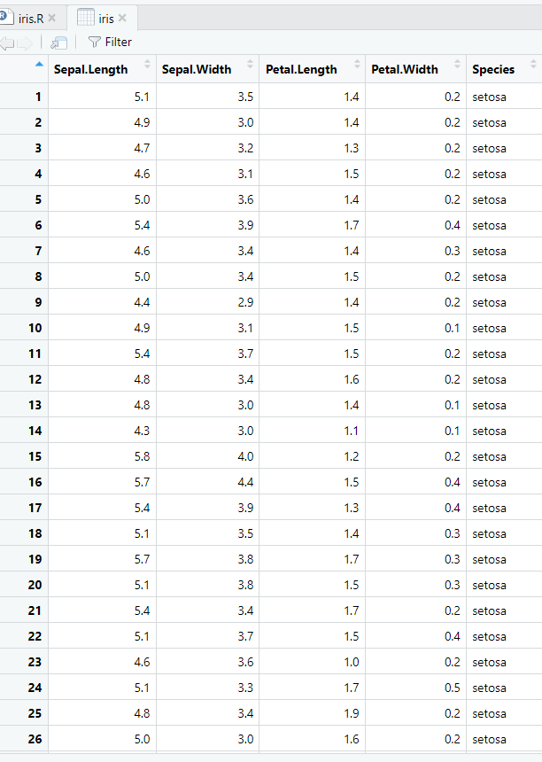

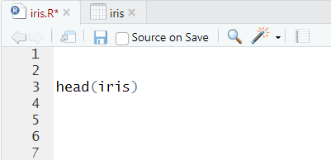

In R, the head() function is used to view the first few rows of a dataset or object. It's a convenient way to quickly inspect the structure and contents of the data.

This will display the first 6 rows of the Iris dataset, showing you the structure and values of the dataset's columns (features). You can specify the number of rows you want to view by passing an argument to the head() function, like head(iris, 10) to view the first 10 rows.

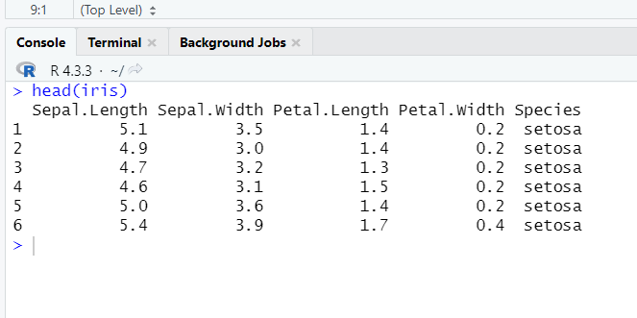

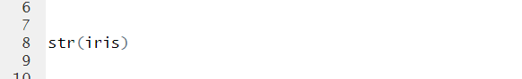

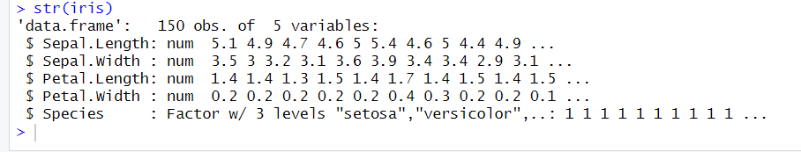

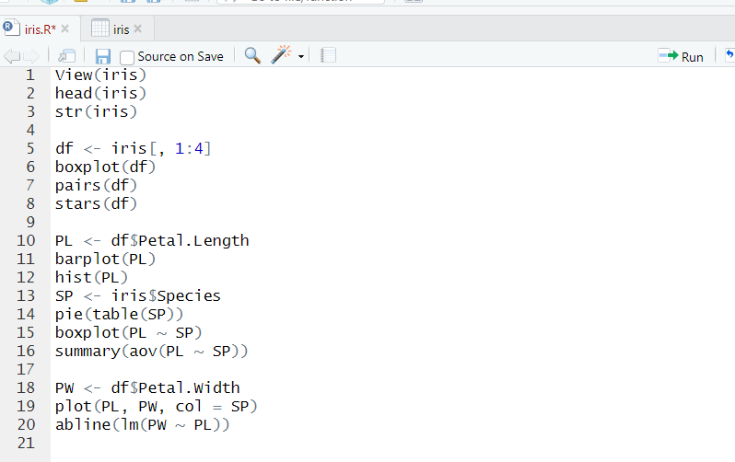

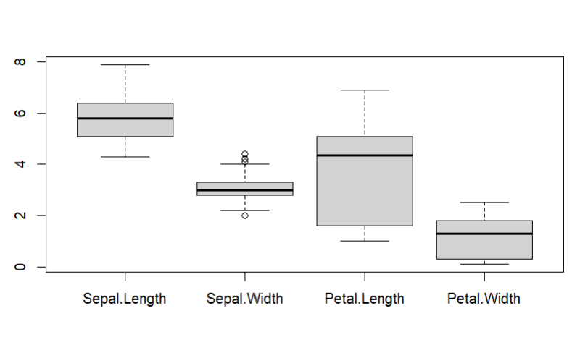

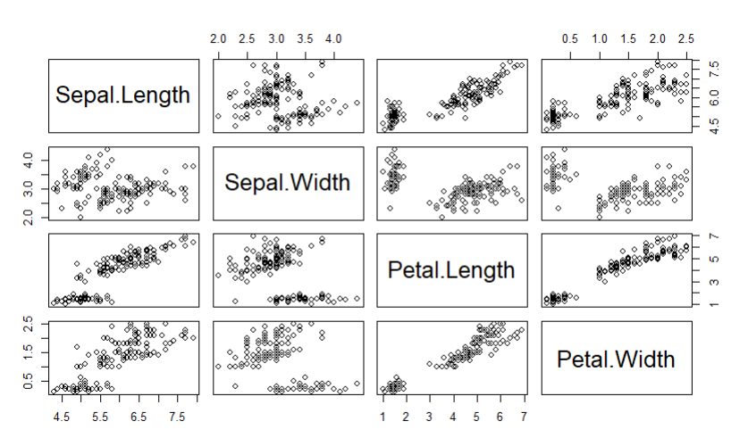

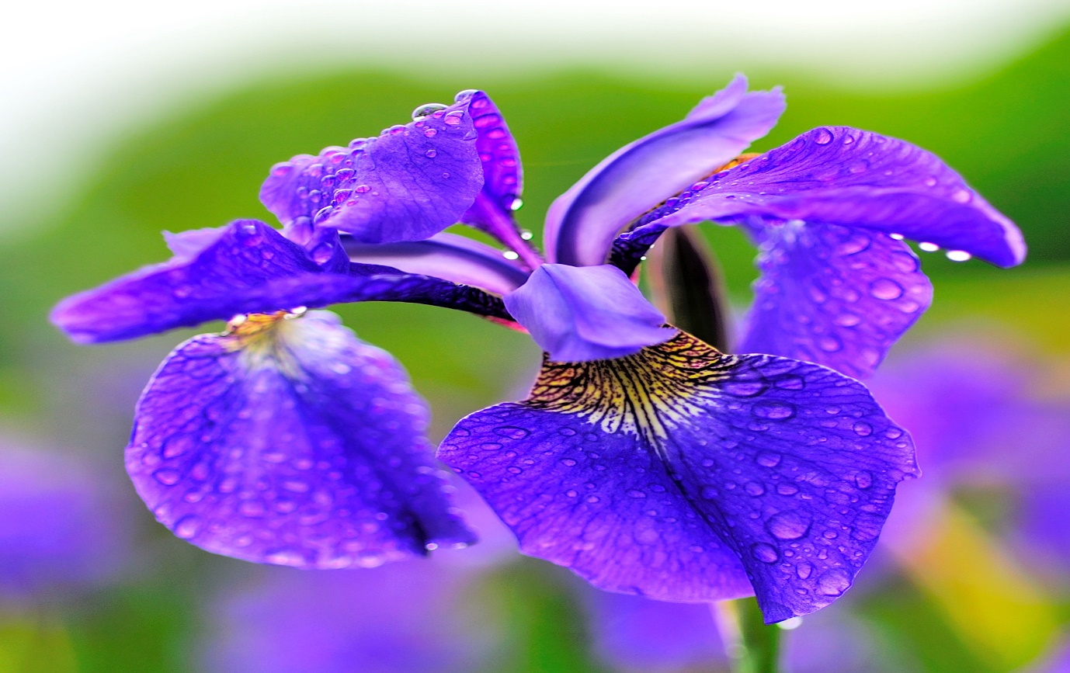

Figure : iris flower. Photo from Wikipedia.

**Analysis of petal length and species**

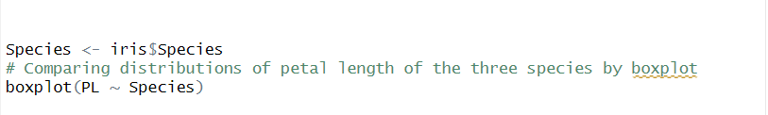

When comparing the box plots for Setosa, Versicolor, and Virginica flowers:

Look at the position of the median line inside each box. A higher median suggests longer petal lengths.

Compare the lengths of the boxes. A longer box indicates more variability in petal lengths within that species.

Look for differences in the lengths of the whiskers. Longer whiskers indicate a wider spread of data.

By comparing these elements across the different species' box plots, we can gain insights into how petal lengths vary between Setosa, Versicolor, and Virginica flowers.

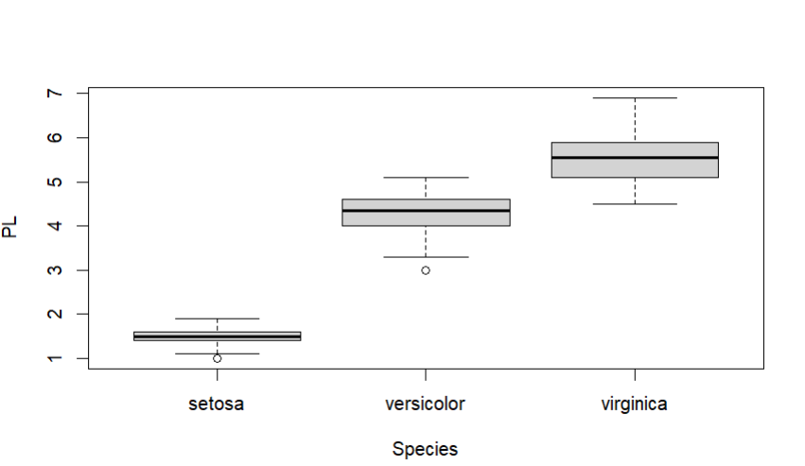

**Analysis of species**

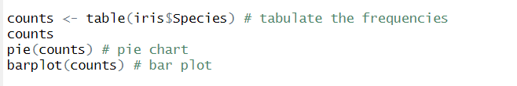

A bar plot is a visual representation used to compare the frequency or occurrence of different categories within a dataset. Each category is depicted by a separate vertical bar, with the length of the bar corresponding to the number of occurrences or observations in that category. For instance, in the context of the Iris dataset, which includes three species of iris flowers (Setosa, Versicolor, and Virginica), the bar plot would display three bars, one for each species. The x-axis of the plot typically represents the categories being compared (in this case, the three species), while the y-axis shows the count or frequency of observations. By examining the heights of the bars, we can quickly discern which category has the highest occurrence and make comparisons between the frequencies of different categories. Additionally, labels may be added to the bars to provide specific counts for each category, aiding in interpretation. Overall, bar plots offer a straightforward and intuitive way to visualize the distribution of categorical data and identify any notable patterns or differences between categories.

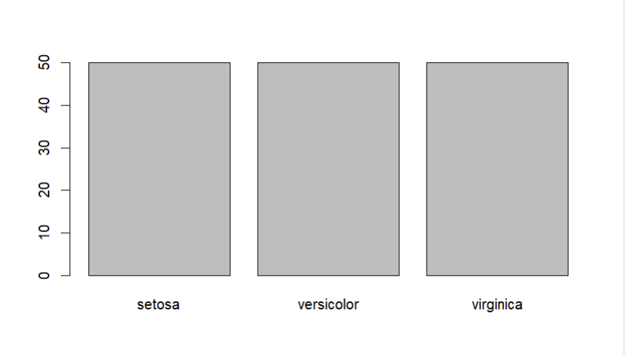

**Analysis of petal length and petal width**

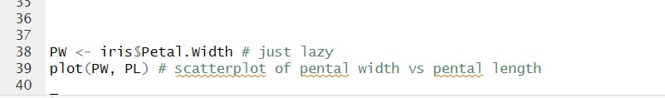

By plotting the petal length against the petal width of the iris dataset, we can observe their relationship visually. Generally, we expect a positive correlation between these two features, indicating that as petal length increases, so does petal width. A scatter plot can effectively display this relationship, with each point representing an individual flower. By examining the plot, we can discern any patterns, clusters, or outliers in the data. Additionally, the plot allows us to differentiate between the three species of iris flowers, potentially revealing species-specific trends or characteristics. Understanding the relationship between petal length and width is crucial in species classification and studying floral morphology. Overall, plotting these variables provides valuable insights into the characteristics and variations within the iris dataset.

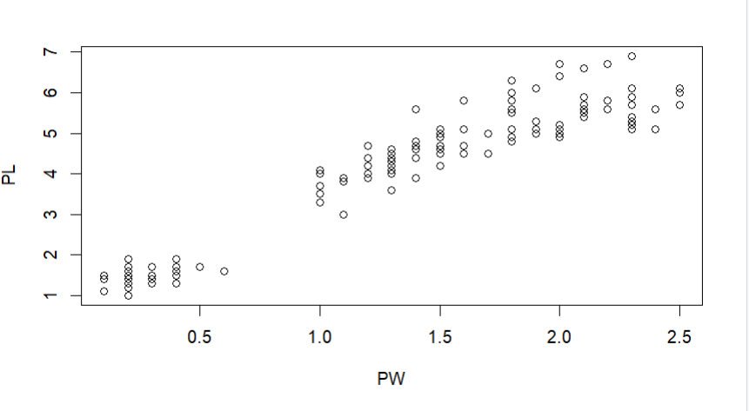

**Analysis of petal length and sepal length**

To create a scatterplot using ggplot2 in R showing the variables Sepal.Length and Petal.Length grouped by the three-level factor "Species" from the Iris dataset, you can follow these steps:

Firstly, you load the ggplot2 library. Think of a library like a toolbox. We're opening up the toolbox called ggplot2, which has tools to help us create fancy charts and graphs.

Next, you load the Iris dataset. Imagine we have a big book full of information about different types of iris flowers. We're opening up that book and putting it on our desk so we can look at it.

Then, you create a scatterplot. A scatterplot is like a map that shows how two things relate to each other. In this case, we're going to make a map that shows how the length of the sepals (those leaf-like structures at the base of a flower) and the length of the petals (those colorful parts of the flower) are related.

Lastly, you group by "Species". Imagine we're sorting the iris flowers into groups based on their species, like sorting different types of candy into separate piles. We want to see if the relationship between sepal length and petal length is different for each type of iris.

So, altogether, we're going to use ggplot2 to make a special kind of map (scatterplot) that shows how sepal length and petal length are related for different types of iris flowers.

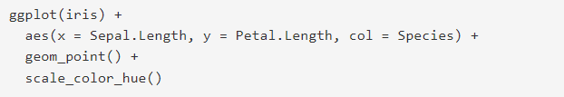

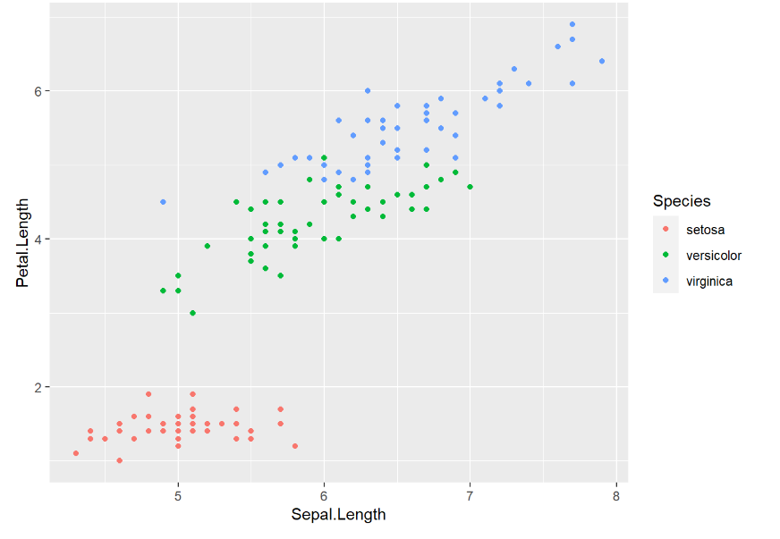

**Summary of the iris dataset**

Data Exploration and Understanding: Analysts start by loading the Iris dataset and examining its structure, dimensions, and summary statistics. This initial exploration helps understand the variables' distributions and the overall characteristics of the data.

Visualization: Visualizations are created to gain insights into the relationships between variables and any patterns or trends present in the data. Common visualizations include histograms to visualize distributions, scatterplots to examine relationships between variables, and boxplots to compare variable distributions across different groups (e.g., iris species).

Descriptive Statistics: Various descriptive statistics, such as mean, median, standard deviation, and percentiles, are computed to summarize the central tendency, variability, and distribution of the numerical variables (e.g., sepal length, petal width).

Data Preprocessing: Data preprocessing steps may be performed to clean the data, handle missing values, and address outliers if necessary. This ensures that the data is in a suitable form for subsequent analysis.

Feature Engineering: In some cases, additional features may be derived from the existing variables to improve the performance of predictive models. For example, feature engineering could involve calculating the ratio of petal length to petal width or combining sepal length and width into a single variable.

Predictive Modeling: The Iris dataset is commonly used for classification tasks, where the goal is to predict the species of iris based on the available features (e.g., sepal length, petal width). Analysts may employ various machine learning algorithms, such as logistic regression, decision trees, random forests, or support vector machines, to build predictive models.

Model Evaluation and Interpretation: Once predictive models are trained, they are evaluated using appropriate metrics (e.g., accuracy, precision, recall) to assess their performance. Model interpretation techniques may be applied to understand the factors driving the predictions and gain insights into the relationships between the input features and the target variable.

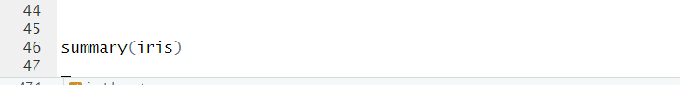

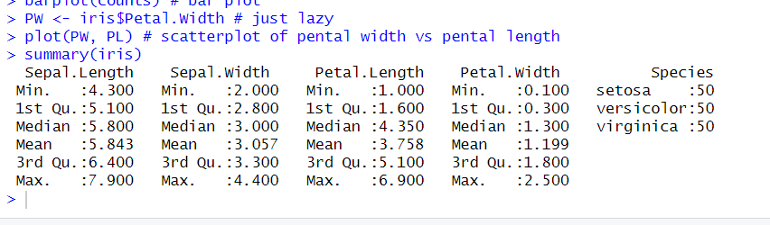

**Conclusion**

In this project, we conducted a comprehensive analysis of the Iris dataset, exploring its characteristics and leveraging various data analysis techniques to gain insights into the iris flowers' properties.

Key Findings:

Characteristics of Iris Flowers: We observed that the dataset consists of 150 instances, each representing an iris flower categorized into three species: Setosa, Versicolor, and Virginica. Four numerical features were measured for each flower: sepal length, sepal width, petal length, and petal width.

Exploratory Data Analysis (EDA): Through visualizations such as histograms, scatterplots, and boxplots, we uncovered distinct patterns and relationships within the data. For example, we observed clear differences in the distributions of petal lengths and widths across the three iris species, indicating potential discriminatory power for species classification.

Predictive Modeling: We built predictive models using machine learning algorithms to classify iris species based on their features. Various classifiers, including logistic regression, decision trees, and random forests, were trained and evaluated. The models achieved high accuracy, demonstrating the effectiveness of the selected features for species classification.

Model Interpretation: By interpreting the trained models, we gained insights into the relative importance of different features in predicting iris species. For instance, petal characteristics (length and width) emerged as significant predictors, underscoring their discriminatory power in species differentiation.