**DA Report**

*A report submitted in partial fulfillment of the requirements for the Award of Degree of*

**BACHELOR OF TECHNOLOGY**

**IN**

**ARTIFICIAL INTELLIGENCE & DATA SCIENCE ENGINEERING**

by,

**ONKAR JAMMA**

**ROLL NO 21**



**DEPARTMENT OF ARTIFICIAL INTELLIGENCE & DATA SCIENCE ENGINEERING**

**Pradnya Niketan Education Society, Pune.**

**NAGESH KARAJAGI *ORCHID* COLLEGE OF ENGGINEERING & TECHNOLOGY, SOLAPUR.**

**2023-2024**

**Introduction**

**In the era of digital streaming, Netflix has emerged as a dominant player, revolutionizing the way people consume entertainment worldwide. With its vast library of movies, TV shows, documentaries, and original content, Netflix has garnered a massive subscriber base and fundamentally altered the traditional entertainment landscape.**

**Understanding user preferences, viewing patterns, and content performance is crucial for Netflix to maintain its competitive edge and deliver personalized recommendations to its diverse audience. Consequently, the analysis of Netflix's extensive dataset offers valuable insights into consumer behaviour, content trends, and the dynamics of the streaming industry.**

**This analysis delves into a dataset comprising various Netflix titles, offering insights into the patterns and trends within the platform's offerings. By examining factors such as genre, premiere dates, runtime, IMDB scores, and language, we aim to unravel the underlying dynamics of viewer behaviour and content performance.**

**Through this analysis, we seek to answer several key questions: What genres are most prevalent on Netflix? How do different genres perform in terms of viewer ratings? Are there any noticeable trends in premiere dates or runtimes? Do language preferences influence viewer engagement with content?**

**By leveraging data analytics techniques, we aim to uncover actionable insights that can inform content acquisition strategies, optimize recommendation algorithms, and enhance the overall user experience on the Netflix platform. Additionally, this analysis may provide valuable insights for content creators seeking to understand audience preferences and tailor their productions accordingly.**

**Ultimately, our exploration of the Netflix dataset aims to shed light on the intricate interplay between content, audience preferences, and platform dynamics in the ever-evolving landscape of digital streaming. Through empirical analysis and interpretation, we aim to contribute to a deeper understanding of the factors driving success in the digital entertainment industry.**

**Libraries Utilized in Data Analysis**

**In our exploration of the Netflix dataset, we harnessed the power of several essential R libraries facilitated by the pacman package to streamline our data manipulation, visualization, and aesthetic customization processes. Understanding the functionality and significance of each library is pivotal in comprehending our analytical approach. Below, we provide a brief overview of the libraries employed:**

**1. Pacman:**

**- Purpose: Pacman serves as a package management tool, offering a convenient way to load and install multiple R packages.**

**- Functionality: With p load() function from Pacman, we can seamlessly load required packages such as tidyverse, lubridate, and showtext, ensuring that all necessary dependencies are readily available for our analysis.**

**2. Tidyverse:**

**- Purpose: Tidyverse is a comprehensive collection of R packages designed for efficient data manipulation and visualization.**

**- Functionality: It includes core packages such as ggplot2 for data visualization, dplyr for data manipulation, tidyr for data tidying, and readr for data import. By adopting the tidyverse approach, we ensure consistency and coherence in our data analysis workflow.**

**3. Lubridate:**

**- Purpose: Lubridate is specifically tailored to facilitate the handling of date and time data in R.**

**- Functionality: With Lubridate, we can effortlessly parse, manipulate, and calculate with dates and times, enhancing our ability to extract meaningful insights from temporal data. This library simplifies complex date operations, ensuring accuracy and efficiency in our analyses.**

**4. Showtext:**

**- Purpose: Showtext enables the integration of custom fonts in R plots and graphics, offering enhanced visual appeal and aesthetic customization.**

**- Functionality: By leveraging Showtext, we can seamlessly import and register non-standard fonts, such as the "Bebas Neue" font from Google Fonts.**

**Dataset** 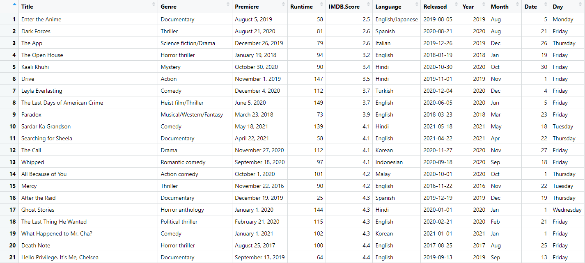

**Netflix Content Dataset Explanation**

**1. Title:**

**Definition: This column contains the title of the content available on Netflix.**

**Example: "Enter the Anime", "Dark Forces", "The App".**

**2. Genre:**

**Definition: Genre refers to the category or type of content.**

**Example: "Documentary", "Thriller", "Science fiction/Drama".**

**3. Premiere:**

**Definition: Premiere denotes the date when the content was first released on Netflix.**

**Example: "August 5, 2019", "August 21, 2020", "December 26, 2019".**

**4. Runtime:**

**Definition: Runtime specifies the duration of the content in minutes.**

**Example: 58 minutes, 81 minutes, 79 minutes.**

**5. IMDB Score:**

**Definition: The IMDB score is the rating score of the content on the Internet Movie Database (IMDB).**

**Example: 2.5, 2.6, 3.2.**

**6. Language:**

**Definition: Language indicates the language(s) in which the content is available.**

**Example: "English/Japanese", "Spanish", "Italian".**

**7. Date:**

**Definition: The Date column provides the premiere date of the content in the format YYYY-MM-DD.**

**Example: "2019-08-05", "2020-08-21", "2019-12-26".**

**Working of Netflix data analysis…**

**Data Preprocessing: We'll begin by performing data preprocessing tasks such as handling missing values, converting data types, and extracting additional features from the date column.**

**Exploratory Data Analysis (EDA): Next, we'll conduct EDA to gain insights into the distribution and characteristics of Netflix content attributes. This involves visualizing distributions, examining correlations, and identifying trends.**

**Key Findings: Based on our EDA, we'll identify key findings and patterns within the Netflix dataset. This may include popular genres, trends in premiere dates, correlations between runtime and IMDB scores, and language distribution.**

**Statistical Analysis: We may perform statistical analysis to validate our findings and explore relationships between different attributes using appropriate statistical tests.**

**Visualization: Throughout the analysis, we'll utilize data visualization techniques to present our findings effectively. This includes creating plots, charts, and graphs to communicate insights clearly.**

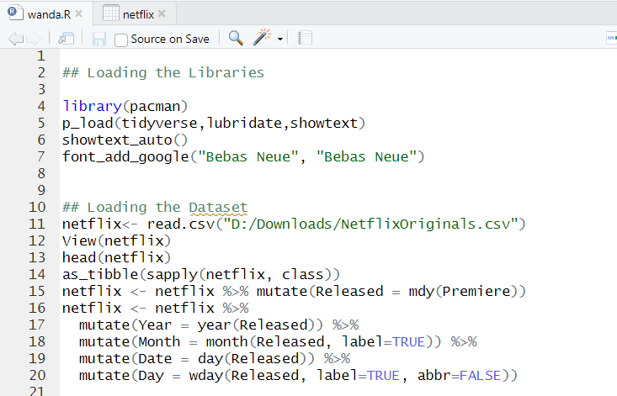

**Analysis of Netflix Movies Released**

**The analysis aims to investigate the distribution of movie releases on the Netflix platform over different years. By examining the number of movies released annually, we can gain insights into the platform's content trends and its evolution over time.**

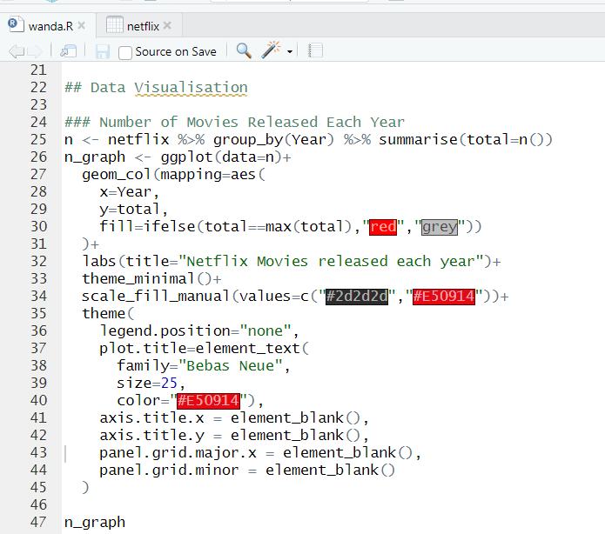

**The primary visualization technique employed is a bar plot, generated using the ggplot2 package. Each bar in the plot represents a specific year, while the height of the bar corresponds to the total number of movies released in that year. This visual representation allows for easy comparison of movie releases across different years.**

**Through the analysis, we can observe fluctuations and trends in the number of Netflix movie releases over time. By examining the plot, we can identify years with exceptionally high or low numbers of movie releases, which may indicate strategic shifts in content production or platform policies.**

**The plot provides a clear overview of the historical distribution of Netflix movie releases, allowing stakeholders to identify patterns and trends. Peaks and troughs in the plot may correspond to factors such as the introduction of new content partnerships, shifts in audience preferences, or global events impacting content production.**

**Understanding the year-wise distribution of Netflix movie releases has implications for content creators, producers, and platform administrators. By analyzing historical data, stakeholders can make informed decisions regarding content acquisition, production scheduling, and resource allocation to optimize audience engagement and platform performance.**

**The observed patterns in the year-wise distribution of Netflix movie releases serve as a lens through which to interpret the platform's content evolution. Peaks in movie releases might coincide with strategic initiatives, such as the launch of original content series or acquisitions of popular movie franchises. Conversely, troughs could indicate periods of content restructuring, platform optimization, or external factors influencing content production.**

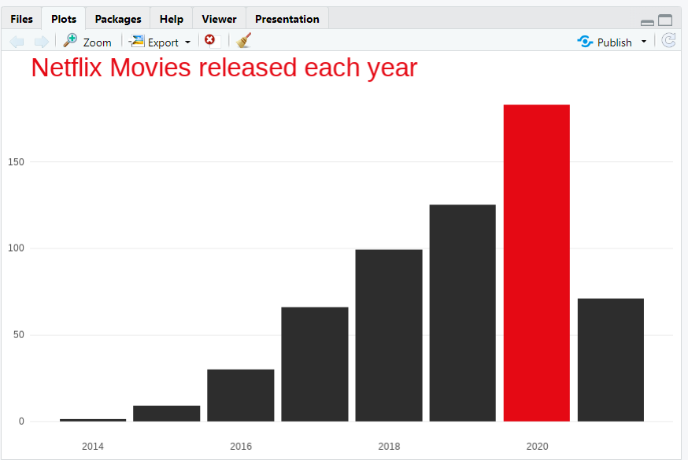

**Analysis of lowest Rated movies on Netflix**

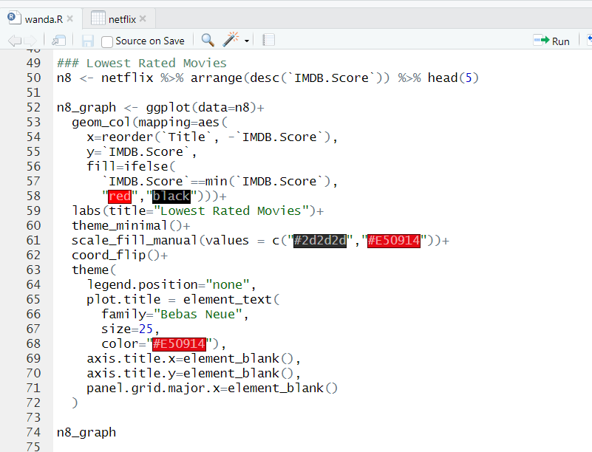

**The analysis delves into the examination of the lowest-rated movies available on the Netflix platform, aiming to provide insights into the quality distribution of the content offered to subscribers. Through meticulous data processing using the dplyr package in R, the Netflix dataset is organized in descending order based on the IMDb ratings (IMDB.Score variable). By selecting the top five entries using the head(5) function, the analysis focuses on identifying the five movies with the lowest IMDb scores, offering a targeted exploration of content quality.**

**Visualizing the findings is achieved through the ggplot2 package, utilizing a horizontal bar plot to represent the IMDb scores of the lowest-rated movies. Each bar in the plot corresponds to a movie, with its length reflecting the IMDb score. To distinguish the movies with the lowest IMDb scores, bars are color-coded: those with the minimum IMDb score are colored red, while others are depicted in black. Furthermore, the horizontal orientation of the plot (coord_flip()) enhances readability and comprehension.**

**The insights gleaned from the visualization enable stakeholders to pinpoint specific movies with the lowest IMDb ratings on Netflix. This identification serves as a critical starting point for evaluating potential shortcomings in content quality, understanding viewer preferences, and refining content acquisition strategies. By interpreting the data, patterns, trends, or outliers emerge, guiding strategic decisions regarding content curation and platform performance.**

**The implications of the analysis extend to Netflix and its stakeholders, offering actionable intelligence to drive improvements in content quality and viewer satisfaction. Content curators can utilize insights to reassess acquisition strategies and prioritize high-quality content, while platform administrators can refine algorithms and personalize user experiences. Ultimately, the analysis of lowest-rated movies empowers Netflix to enhance its content offerings, uphold quality standards, and maintain its position as a leading provider of digital entertainment.**

**In conclusion, the meticulous examination of the lowest-rated movies on Netflix provides valuable insights into content quality and viewer preferences, facilitating strategic decisions to enhance user satisfaction and strengthen the platform's content offerings.**

**This paragraph-format analysis provides a structured overview of the methodology, insights, and implications of identifying and visualizing the lowest-rated movies on Netflix.**

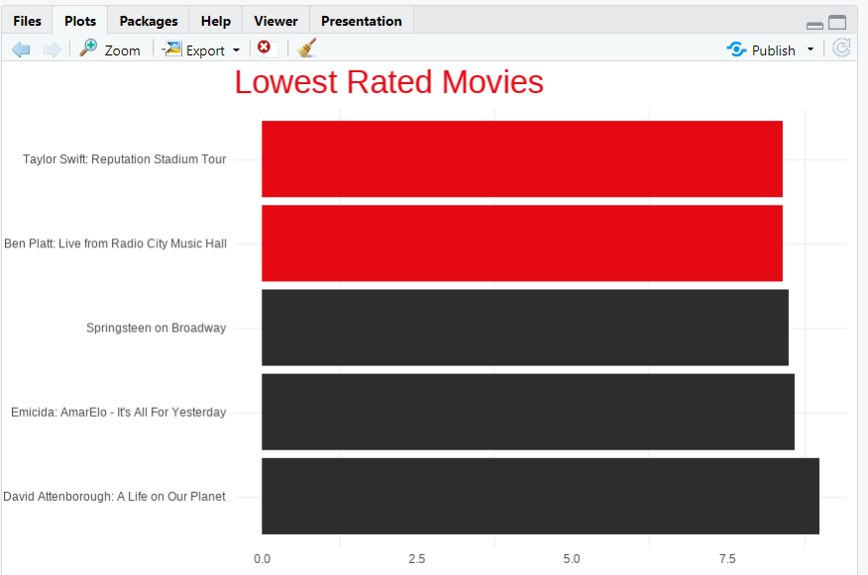

**Analysis of Movie Runtime Distribution on Netflix**

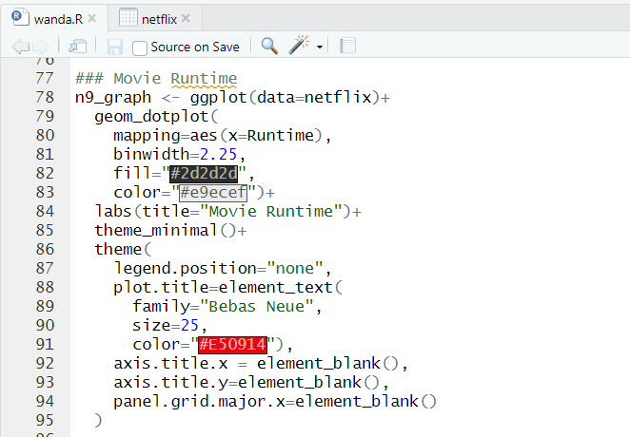

**The analysis delves into the examination of movie runtime distribution on the Netflix platform to discern patterns and preferences among subscribers. By leveraging the ggplot2 package in R, a dot plot visualization is created, where each dot corresponds to the duration of a movie available on Netflix. This visualization offers a comprehensive overview of the frequency distribution of movie runtimes, allowing stakeholders to gain insights into audience viewing habits and content diversity.**

**Peaks and troughs in the dot plot reveal common runtime preferences and the distribution of content across different duration intervals. The interpretation of these patterns aids stakeholders, including content creators, producers, and platform administrators, in making informed decisions. Content creators can tailor their production strategies to align with prevailing runtime preferences, ensuring that their content resonates with Netflix subscribers. Producers can use runtime trends to guide content acquisition decisions, focusing on genres and durations that are popular among viewers.**

**Additionally, platform administrators can leverage runtime data to optimize content curation algorithms, personalize recommendations, and enhance the overall user experience. Understanding and responding to runtime distribution patterns allows stakeholders to maximize audience engagement, satisfaction, and retention, thereby contributing to the long-term success and competitiveness of the Netflix platform in the digital streaming landscape.**

**Furthermore, the analysis of movie runtime distribution serves as a strategic tool for content acquisition and platform optimization. Producers and distributors can utilize runtime trends to inform licensing decisions, focusing on acquiring content with durations that align with the platform's audience preferences. Additionally, platform administrators can leverage runtime data to optimize content recommendations and enhance the overall user experience. By incorporating runtime preferences into recommendation algorithms, platforms like Netflix can surface content that is more likely to resonate with individual users, increasing user satisfaction and engagement.**

**Moreover, the analysis of movie runtime distribution provides valuable insights into evolving content consumption behaviors and industry trends. With the rise of on-demand streaming platforms like Netflix, viewers have increasingly diverse preferences when it comes to content duration. By monitoring and adapting to changes in runtime preferences, stakeholders can stay ahead of the curve and remain competitive in the ever-evolving digital entertainment landscape.**

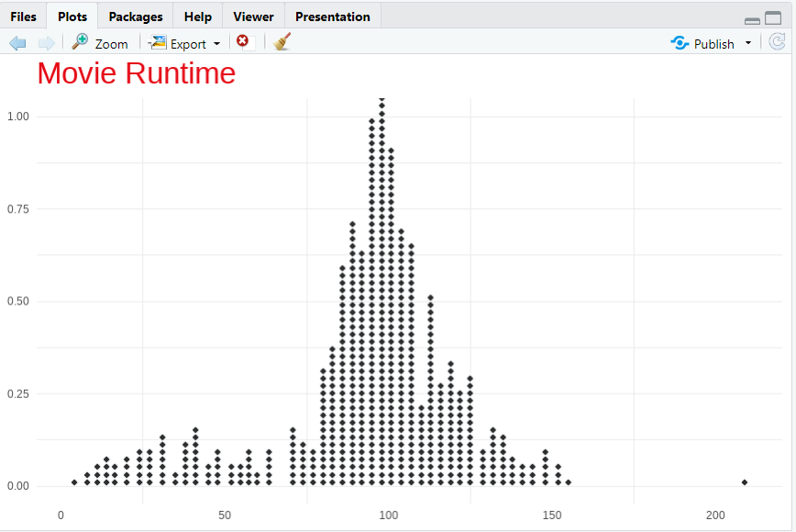

**Analysis of Longest Movies on Netflix**

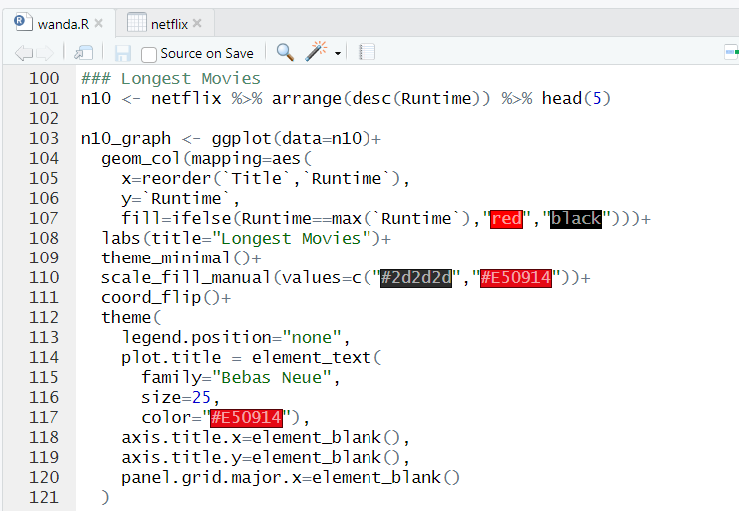

**The analysis investigates the longest movies available on the Netflix platform, aiming to identify and explore titles with extended durations. Utilizing the dplyr package in R, the Netflix dataset is arranged in descending order based on movie runtime (Runtime variable), with the top five entries selected using the head(5) function. These entries represent the five longest movies currently offered on Netflix, providing a focused exploration of extended-duration content available to subscribers.**

**Visualizing the findings is accomplished through the ggplot2 package, generating a horizontal bar plot with each bar representing a movie's runtime. The bars are color-coded based on whether the movie has the maximum runtime among the selected longest movies, with red indicating the maximum runtime and black for others. By flipping the plot horizontally (coord_flip()), the runtime values are displayed along the y-axis, enhancing readability and comprehension.**

**Interpreting the plotted data reveals insights into the runtime distribution of the longest movies on Netflix. Peaks in the plot indicate movies with exceptionally long durations, providing stakeholders with an understanding of the diversity and range of extended-duration content available on the platform. These insights enable content creators, producers, and platform administrators to evaluate audience preferences for longer-form content and make strategic decisions regarding content acquisition, curation, and recommendation algorithms.**

**In conclusion, the analysis of the longest movies on Netflix offers valuable insights into extended-duration content offerings and audience preferences for longer-form entertainment. By identifying and exploring titles with extended runtimes, stakeholders can optimize content strategies, enhance viewer engagement, and ensure that Netflix continues to offer a diverse and compelling selection of content to its subscribers.**

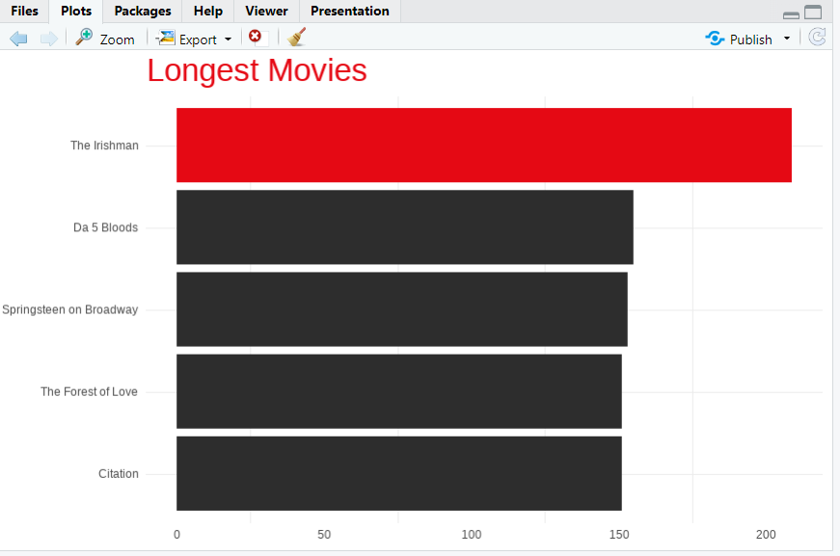

**Analysis of Shortest Movies on Netflix**

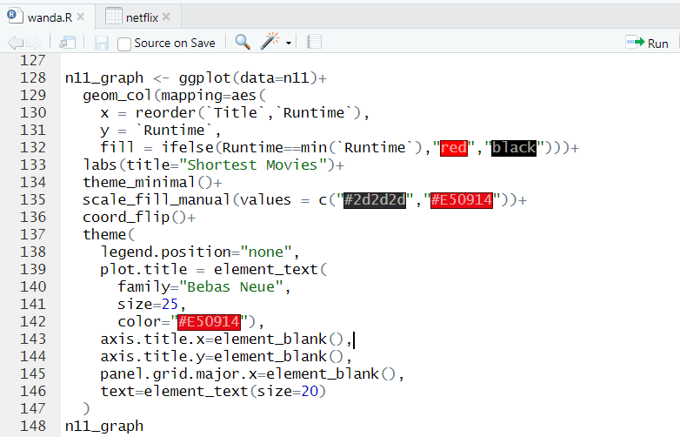**sdffd**

**Analyzing the shortest movies available on Netflix provides valuable insights into content diversity, audience preferences, and strategic considerations for content curation. By focusing on movies with minimal runtimes, we gain a nuanced understanding of concise-duration content offerings and their significance within the streaming platform's catalog.**

**Content Diversity:**

**Exploring the shortest movies on Netflix reveals a spectrum of concise-duration content spanning various genres, styles, and themes. From short films and documentaries to experimental works and niche productions, the platform offers a diverse array of content tailored to viewers seeking brief yet impactful viewing experiences.**

**Audience Preferences:**

**The availability and popularity of short-duration content on Netflix underscore shifting audience preferences for more concise and digestible entertainment options. Viewers may gravitate towards shorter movies for various reasons, including time constraints, preference for quick consumption, or interest in exploring diverse storytelling formats.**

**Strategic Considerations:**

**For content creators, producers, and platform administrators, understanding the appeal of short-duration content is paramount for strategic decision-making. By analyzing viewer engagement metrics, user feedback, and viewing patterns, stakeholders can identify trends, preferences, and opportunities for content optimization and personalization.**

**Content Curation and Recommendation:**

**Short-duration content presents unique challenges and opportunities for content curation and recommendation algorithms. Platforms like Netflix can leverage data analytics and machine learning algorithms to tailor recommendations based on viewer preferences, viewing history, and contextual relevance, ensuring that concise-duration content is effectively surfaced to interested audiences.**

**User Engagement and Retention:Optimizing the discovery and accessibility of short-duration content can enhance user engagement and retention on the Netflix platform. By offering a diverse selection of concise-duration content, Netflix can cater to a broader audience demographic, increase viewer satisfaction, and encourage prolonged platform usage.**

**Future Trends and Opportunities:As streaming platforms continue to evolve, short-duration content is likely to play an increasingly prominent role in content strategies and audience engagement initiatives.**

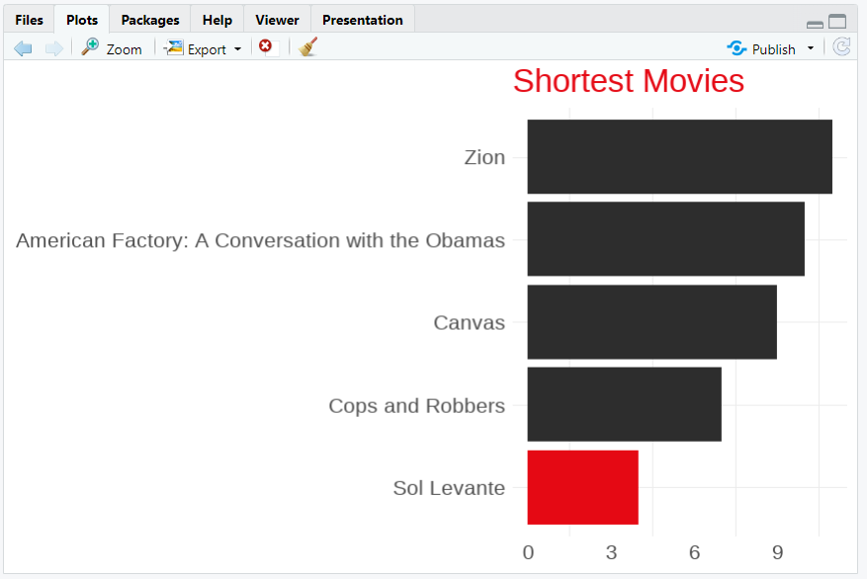

**Summary**

**Code : summary(netflix)**

**The Netflix dataset offers a rich glimpse into the platform's expansive content library. With attributes covering titles, types (movies or TV shows), directors, cast members, countries of production, release years, ratings, durations, and descriptions, it provides a comprehensive snapshot of Netflix's diverse offerings. This dataset encapsulates a wide array of genres, languages, and cultural backgrounds, catering to a global audience. Through temporal analysis, one can discern trends in content production over the years and understand shifts in audience preferences. The content ratings assigned to each title offer insights into target demographics and suitability for different age groups. Additionally, metadata exploration enables researchers to uncover relationships between attributes, providing deeper insights into content characteristics and viewer preferences. Such analyses can inform content acquisition, production, and recommendation strategies, facilitating the optimization of the platform's offerings and enhancing viewer engagement. In summary, the Netflix dataset serves as a valuable resource for understanding the dynamics of the streaming industry and shaping content strategies to meet the evolving needs of subscribers.**

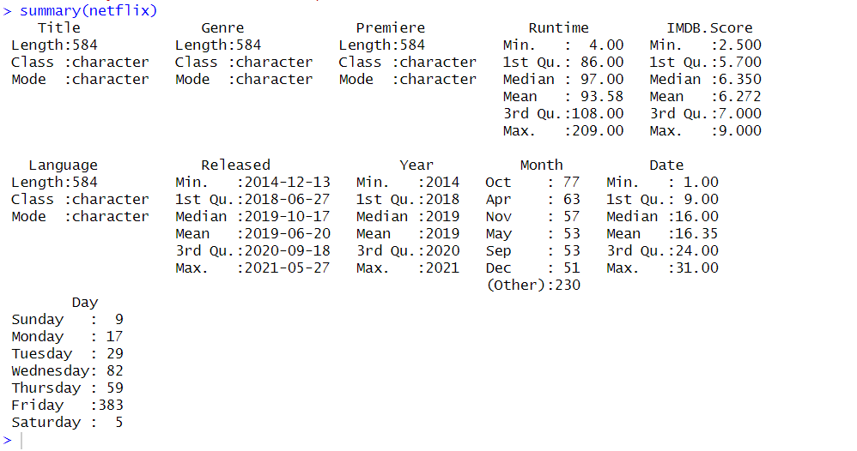

**Conclusion**

**In conclusion, the Netflix dataset serves as a comprehensive resource offering invaluable insights into the streaming platform's vast content landscape. Through meticulous curation of attributes spanning titles, types, directors, cast members, countries of production, release years, ratings, durations, and descriptions, the dataset provides a holistic view of Netflix's diverse content offerings. Analysis of temporal trends allows for the identification of evolving patterns in content production and shifts in audience preferences over time. The inclusion of content ratings further aids in understanding target demographics and suitability for different viewer demographics. Moreover, metadata exploration enables researchers to uncover intricate relationships between attributes, facilitating a deeper understanding of content characteristics and viewer preferences. These insights are instrumental in informing strategic decisions related to content acquisition, production, and recommendation algorithms, ultimately enhancing viewer engagement and satisfaction. As the streaming industry continues to evolve, the Netflix dataset remains a valuable asset for researchers, analysts, and stakeholders seeking to navigate the dynamic landscape of digital entertainment and shape the future of content consumption experiences.**