|  |
| --- |
| Healthcare Institutions Save Time and Reduce Development Costs by up to  90 Percent with Cloud-Based Portal  Real Impact for  BETTER HEALTH |

|  |  |
| --- | --- |
| A global leader in aging and brain health, Baycrest wanted to more easily share resources with other healthcare organizations in Canada and around the world. Working with Microsoft Partner Network member Orangutech, Baycrest developed eHealth2Share, a cloud-based portal based on Microsoft Office 365 that allows hospital workers to share information and expertise. By reusing software applications and electronic forms that were developed by other organizations, eHealth2Share will help healthcare institutions save weeks of employee labor time and reduce development costs by as much as 90 percent.  Real Impact Summary  [Baycrest](http://www.baycrest.org/) offers a comprehensive system of care for aging patients and one of the world's top research institutes in cognitive neuroscience. The organization wanted to improve efficiency by sharing information and expertise with other hospitals in Canada and around the world. Healthcare officials realized that cloud technologies could help Baycrest develop a centralized information hub without investing a lot of time or money.  Working together with award-winning [Microsoft Partner Network](https://partner.microsoft.com/global/partner?countrycode=worldwide) member [Orangutech](http://www.orangutech.com/), Baycrest built [eHealth2Share](http://www.ehealth2share.com/), a centralized information portal that allows healthcare providers to share a range of information, including electronic forms, policies, software applications, training programs, and best practices. Baycrest developed the portal by using [Microsoft Office 365](http://www.office365.com/), which provided an affordable way for organizations to access and share documents using the Microsoft Office applications that most employees are already familiar with.  With eHealth2Share, healthcare organizations can save time and lower development costs by as much as 90 percent by downloading software applications and electronic forms that other institutions have already produced. They can also improve care by more easily sharing knowledge and expertise with colleagues at other institutions. In addition, employees can save time by sharing electronic forms, policies, best practices, and employee training programs.  “It can cost [US]$10,000 to $40,000 every time a healthcare institution needs to develop an electronic form,” says Terrie Tucker, Director of eHealth at Baycrest. “By sharing standardized forms on eHealth2Share, hospitals can download forms that already exist, make the minor edits needed, and have a customized form and associated workflow ready to go, with substantially less investment in staff time and effort.”  “By openly sharing best-in-class electronic forms and e-learning modules, healthcare institutions can save weeks—and even months—of time… It’s all about sharing resources and saving public taxpayer dollars.”  Terrie Tucker, Director of eHealth, Baycrest | **Company:** Baycrest  **Website:** [www.baycrest.org](http://www.baycrest.org)  **Country:** Canada  **Industry:** Healthcare  **Employees:** 2,000  **Partner:** Orangutech  **Website:** [www.orangutech.com](http://www.orangutech.com)  **Company Profile:** Baycrest is a global leader in developing and providing innovations in aging and brain health. It provides care to more than 2,500 frail and active seniors every day in outpatient and inpatient programs and residential settings.  **Partner Profile:** Orangutech is an information technology and system integrator company focused on the Microsoft Office SharePoint Server platform.  **Solution:** Partnering with Orangutech, Baycrest created a cloud-based portal to share electronic documents and other resources.  **Software & Services:**   * Microsoft Office 365 * Microsoft SharePoint Online     Take this story with you!    Get the free mobile app at http://gettag.mobi |

The Full Impact Story

Connecting People and Information

Headquartered in Ontario, Canada, and affiliated with the University of Toronto, Baycrest combines a comprehensive system of care for aging patients, one of the world’s top research institutes in cognitive neuroscience, dedicated centers focused on mitigating the impact of age-related illness and impairment, and unmatched global knowledge exchange and commercialization capacity.

Baycrest wanted to share information more effectively. Healthcare providers wasted a lot of time sending draft policies, presentations, and other documents back and forth to their coworkers, and then searching for these documents later when they needed them. “I didn’t think I needed a policy anymore and would hit the delete key, but then three months later, I’d realize that I did need it,” says Tucker. “So then I’d send an email message to everyone trying to track it down, which wasn’t very efficient.”

Baycrest employees decided they could save time by putting these documents on a centralized healthcare portal that anyone could access. “We wanted to connect people and information,” Tucker says. “And we realized we could do that more efficiently through a central website rather than by sending hundreds of documents all over the place.”

Access to Information Whenever It’s Needed

Baycrest worked with Microsoft Partner Network member Orangutech, an information technology company and system integrator based in Ottawa, Canada, to create a web-based healthcare portal called eHealth2Share. Baycrest had recently adopted Microsoft Office 365, which delivers familiar Microsoft Office [collaboration and productivity tools through the cloud](http://www.microsoft.com/health/en-us/initiatives/Pages/cloud-services-for-health.aspx). Baycrest and Orangutech decided to build the portal using the document sharing service Microsoft SharePoint Online, a component of Office 365, and host it within Microsoft data centers as a cloud service.

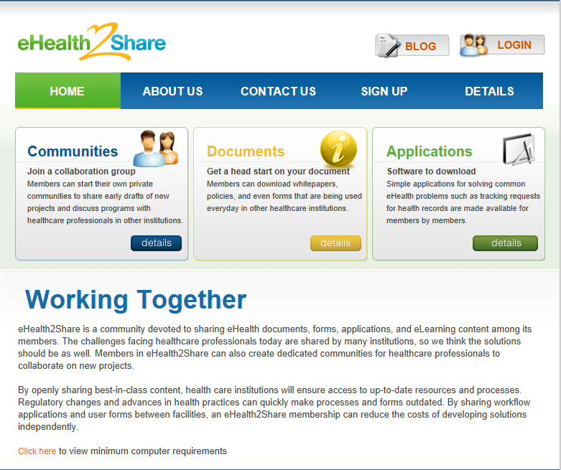

Figure 1: The eHealth2Share portal page.

Developing the portal as a cloud service using Microsoft software made it possible for Baycrest to create eHealth2Share quickly and at low cost. “We wouldn’t have done this if we had to maintain it internally and had to worry about security, access, and all those types of things,” Tucker says. “The fact that it’s in the cloud and someone else is managing the servers is what made it all possible.”

Building a cloud-based portal also provided an affordable way for Baycrest to share resources with other healthcare institutions. “The reason we built this by using Office 365 is that not all hospitals have Office applications,” says Mike Maadarani, President and CEO of Orangutech. “Office 365 was the perfect fit because it provided [an inexpensive way for organizations to access and share documents](http://www.microsoft.com/health/ww/solutions/Pages/communication-collaboration.aspx) using the Office tools most employees are already familiar with.”

By subscribing to the portal for $500 per year, healthcare providers can share a broad range of information both within the organization and with colleagues at other healthcare institutions. To access eHealth2Share, healthcare workers simply pay an affordable annual subscription fee. They can then access documents such as policies, procedures, presentations, templates, and best practices, whenever they need them. They can also download software applications, electronic forms, and employee training modules already produced by other healthcare organizations. Additionally, they can request participation in private discussion forums in which members share information on specific healthcare subjects. Baycrest started working on eHealth2Share in early 2011. The portal took less than two months to develop and went live in June 2011.

Real Impact for Today’s Healthcare Organizations

Already, Baycrest is seeing the benefits of eHealth2Share. Employees are saving time and labor by downloading documents developed by other institutions and then customizing these documents to meet their specific needs. Baycrest has posted several software applications to eHealth2Share for other institutions to download free of charge, [potentially saving them thousands of dollars in development costs](http://blogs.technet.com/b/microsoft_on_the_issues/archive/2010/11/11/the-economic-impact-of-the-cloud.aspx).

For example, Baycrest posted an application that Orangutech created to more easily comply with new regulations governing Freedom of Information and Protection of Privacy Act (FIPPA)—saving other organizations much of the work required to get ready for the new legislation, which took effect on January 1, 2012. “It cost us $10,000 to develop an application that makes it easier for Baycrest to comply with new freedom of information regulations,” says Maadarani. “Reusing that application and customizing it to meet their specific needs will save other healthcare institutions 90 percent of these development costs. That’s a significant savings.”

Baycrest also posted an electronic human resource “employee change of status” form that it developed using Microsoft InfoPath and posted with Microsoft SharePoint Online to automatically track the approval process as it’s circulated from department to department. Using this form, other healthcare institutions can also save the three weeks of labor it took Baycrest to create it. “Organizations can spend a lot of time and resources developing their individual forms, even though our processes are pretty much the same,” Tucker says. “Now it’s just posted up there for any subscriber to download and use.”

eHealth2Share has also made it possible for healthcare organizations to standardize their employee training programs, saving months of work usually required to create and update new curricula. Using the same e-learning modules also has another benefit: physicians and other employees who work at more than one institution no longer need to complete similar lessons multiple times. “Now all practitioners are getting the same training, and they’re getting that training once,” Tucker says. “That’s a huge benefit, especially for physicians whose time is very valuable.”

“By openly sharing best-in-class electronic forms and e-learning modules, healthcare institutions can save weeks—and even months—of time that it takes to create them,” says Tucker. “It’s all about sharing resources and saving public taxpayer dollars.”

To date, about 40 healthcare providers at 40 institutions have subscribed to eHealth2Share, including all the major teaching hospitals in the Toronto area. Baycrest eventually hopes to extend the portal to healthcare institutions around the world. Tucker believes the portal will be especially useful for smaller healthcare organizations and those in remote areas that don’t have the same resources as larger, urban-based institutions. “This is truly an innovative use of cloud services in the healthcare sector,” she says. “It presents a huge opportunity for knowledge exchange and relationship building. Ultimately, this has the potential to save healthcare institutions a lot of time and money.”

|  |
| --- |
| Health Tech Today Segment on Baycrest :  [www.microsoft.com/industry/healthcare/healthtechtoday/default.aspx#5-2](http://www.microsoft.com/industry/healthcare/healthtechtoday/default.aspx#5-2)  Microsoft Health  For more information about Microsoft Health, please go to:  [www.microsoft.com/industry/healthcare](http://www.microsoft.com/industry/healthcare)  Customer Success Stories  For more information about other Microsoft customer successes, please visit:  [www.microsoft.com/casestudies](http://www.microsoft.com/casestudies) |