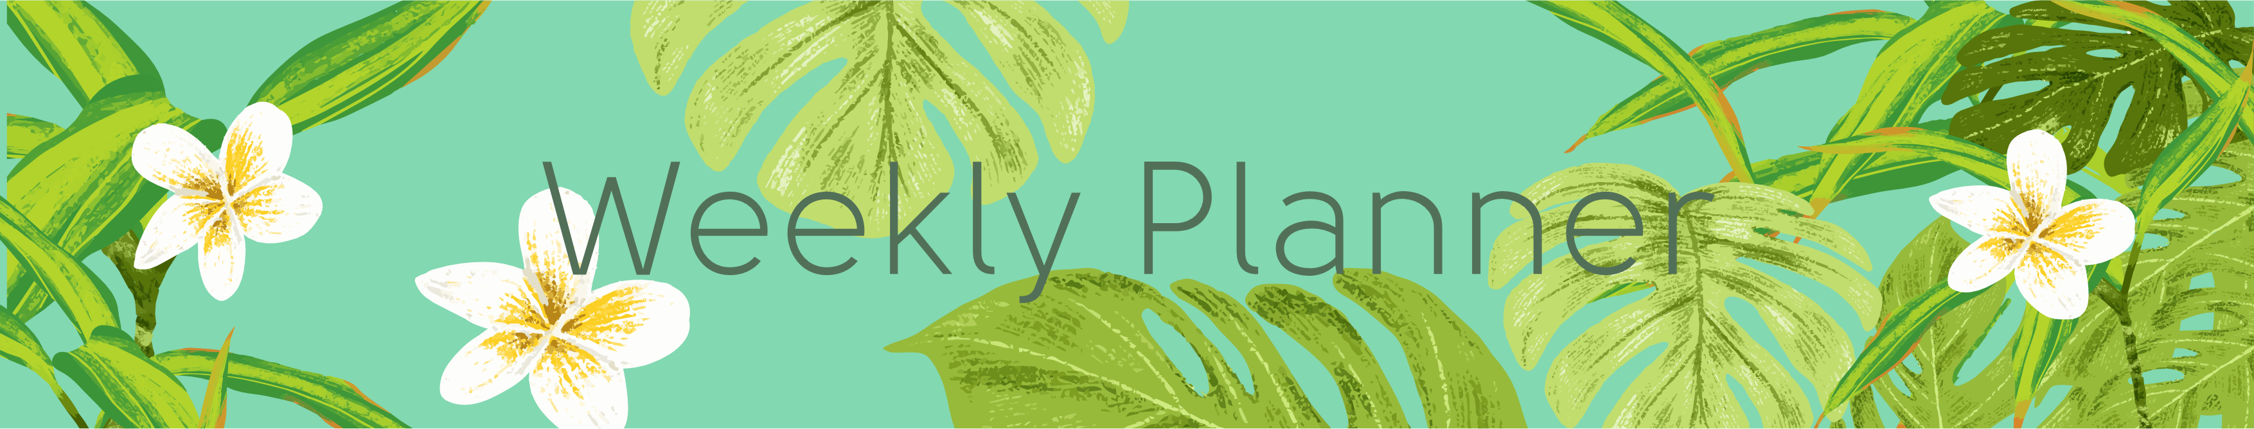

|  |  |  |  |  |  |  |
| --- | --- | --- | --- | --- | --- | --- |
| Monday | Tuesday | Wednesday | Thursday | Friday | Saturday | Sunday |
|  |  |  |  |  |  |  |
|  |  |  |  |  |  |  |
|  |  |  |  |  |  |  |
|  |  |  |  |  |  |  |
|  |  |  |  |  |  |  |
|  |  |  |  |  |  |  |
|  |  |  |  |  |  |  |
|  |  |  |  |  |  |  |
|  |  |  |  |  |  |  |
|  |  |  |  |  |  |  |
|  |  |  |  |  |  |  |