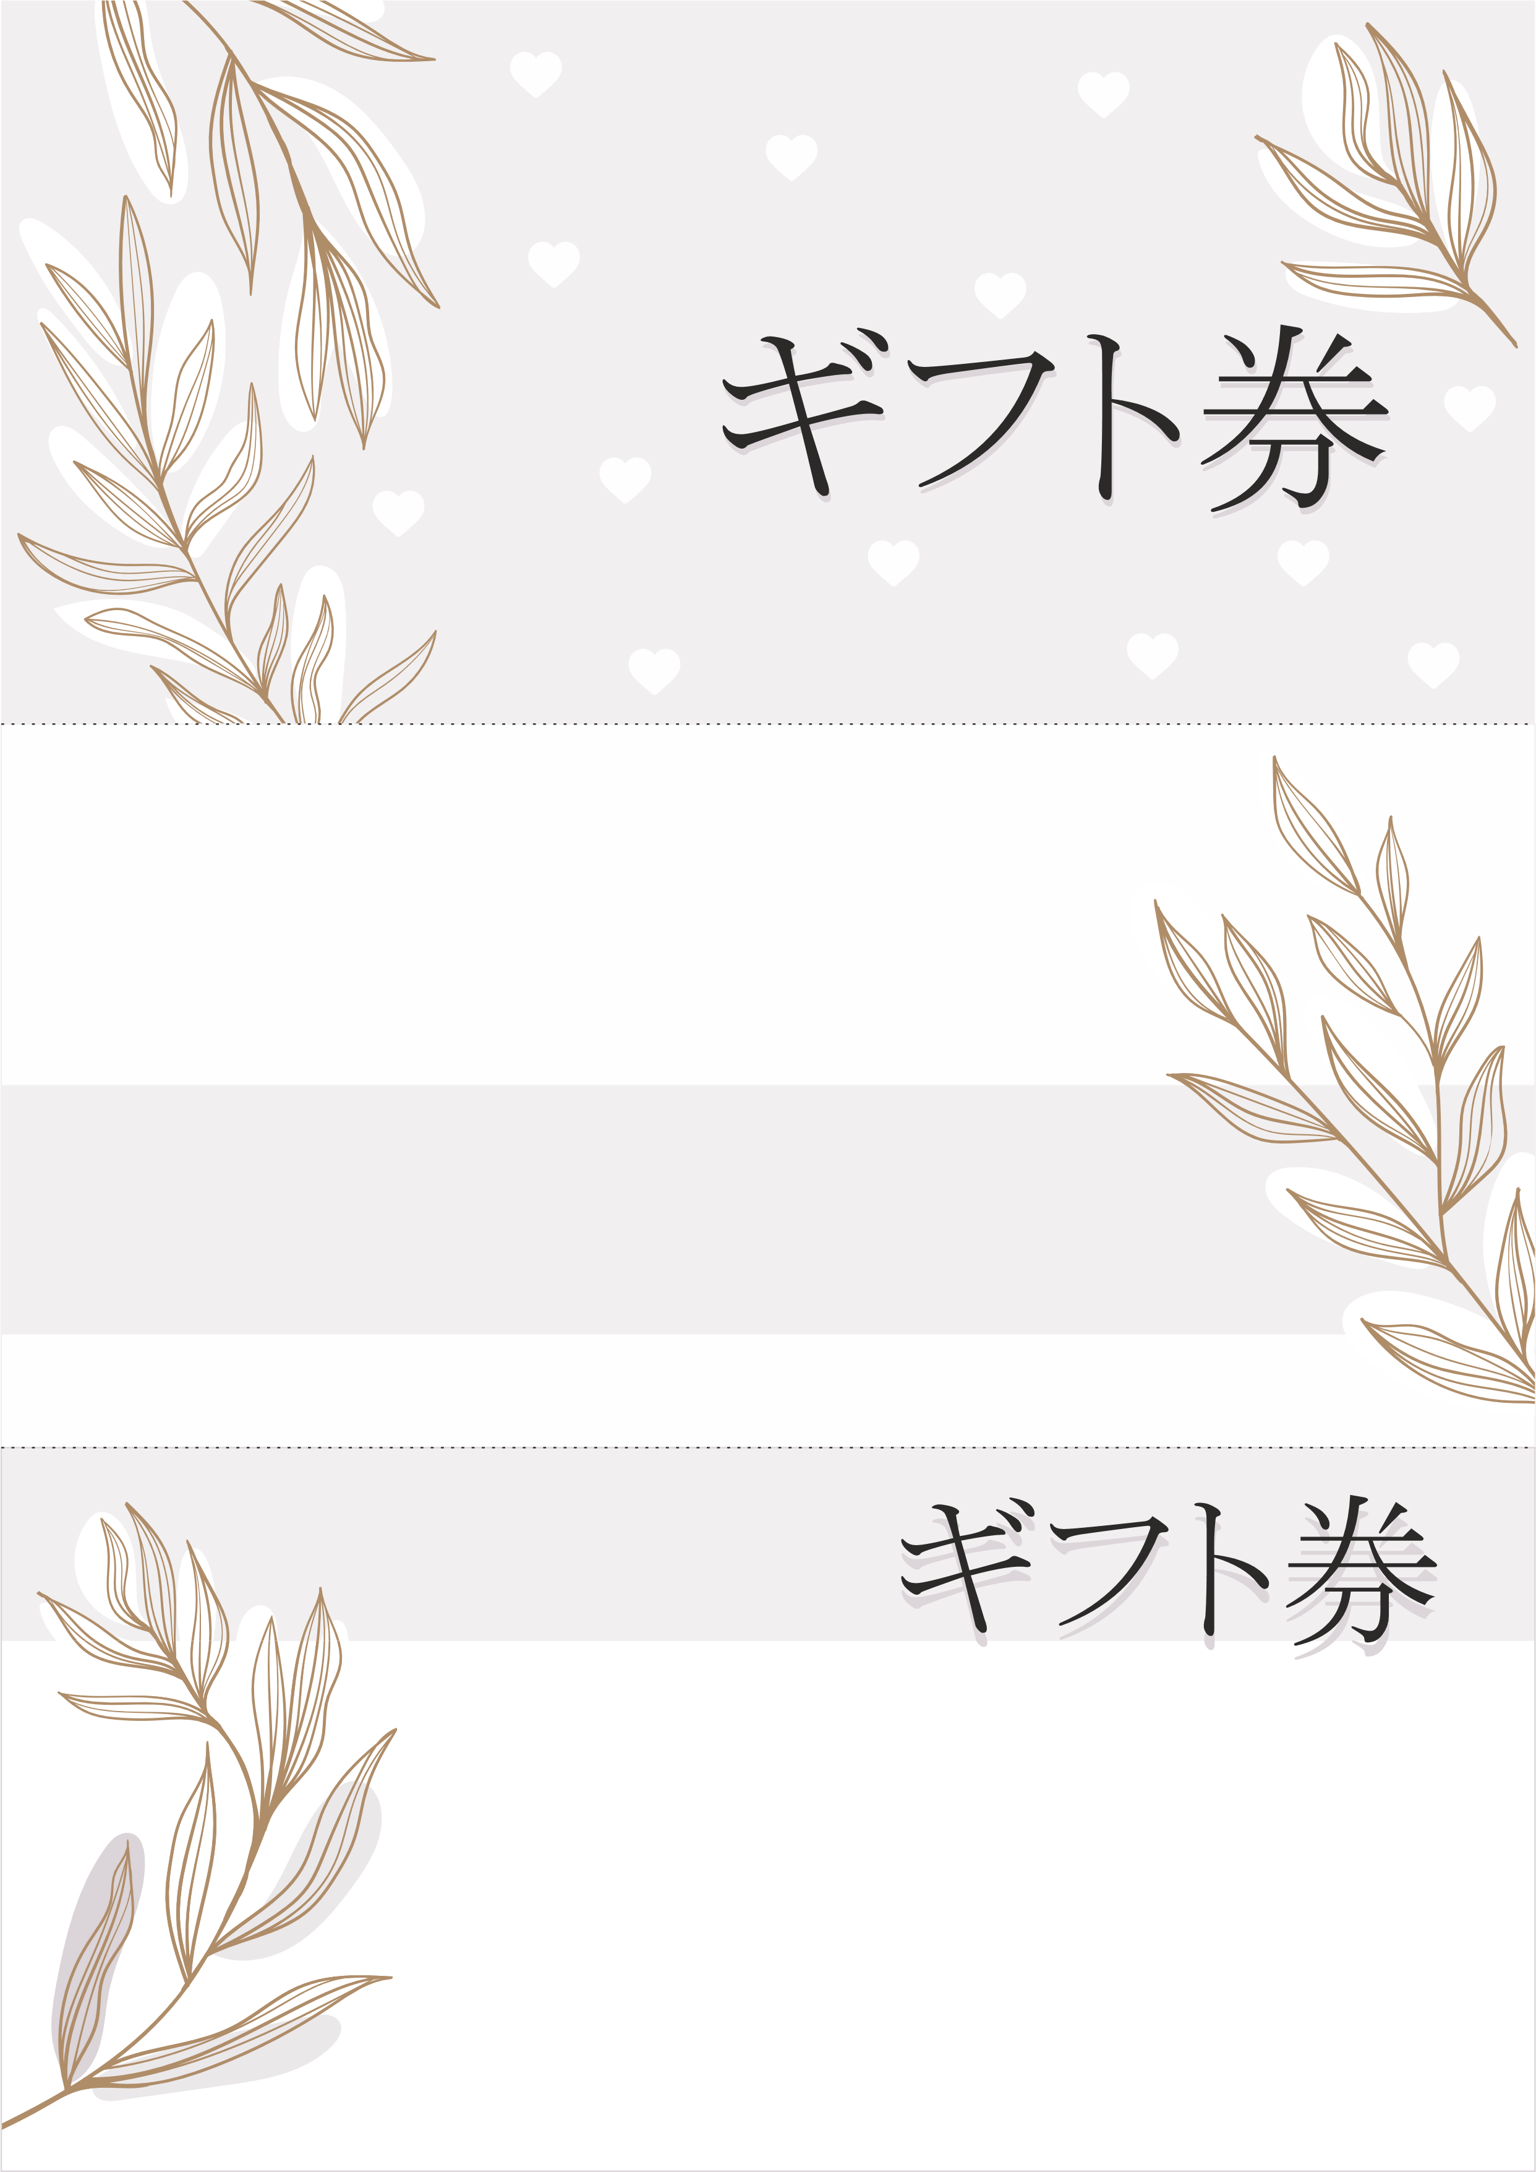

|  |  |  |  |
| --- | --- | --- | --- |
| ブランド名 | | 番号 | № 00 0000 |
| 有効期限 | 日付を入力してください |
|  | | | |
| 金額 | | | |
| **00円** | | | |

|  |
| --- |
| To: |
|  |
|  |
| From: |
|  |
|  |

|  |  |  |
| --- | --- | --- |
| 住所 | (999) 999 9999 | www.website.com |

|  |  |  |
| --- | --- | --- |
| ブランフォ名 | 番号 | № 00 0000 |
| 有効期限 | 日付を入力 |
|  | | |
| 金額 | | |
| **00円** | | |

|  |
| --- |
| To: |
|  |
| From: |
|  |

|  |  |  |
| --- | --- | --- |
| 住所 | (999) 999 9999 | www.website.com |