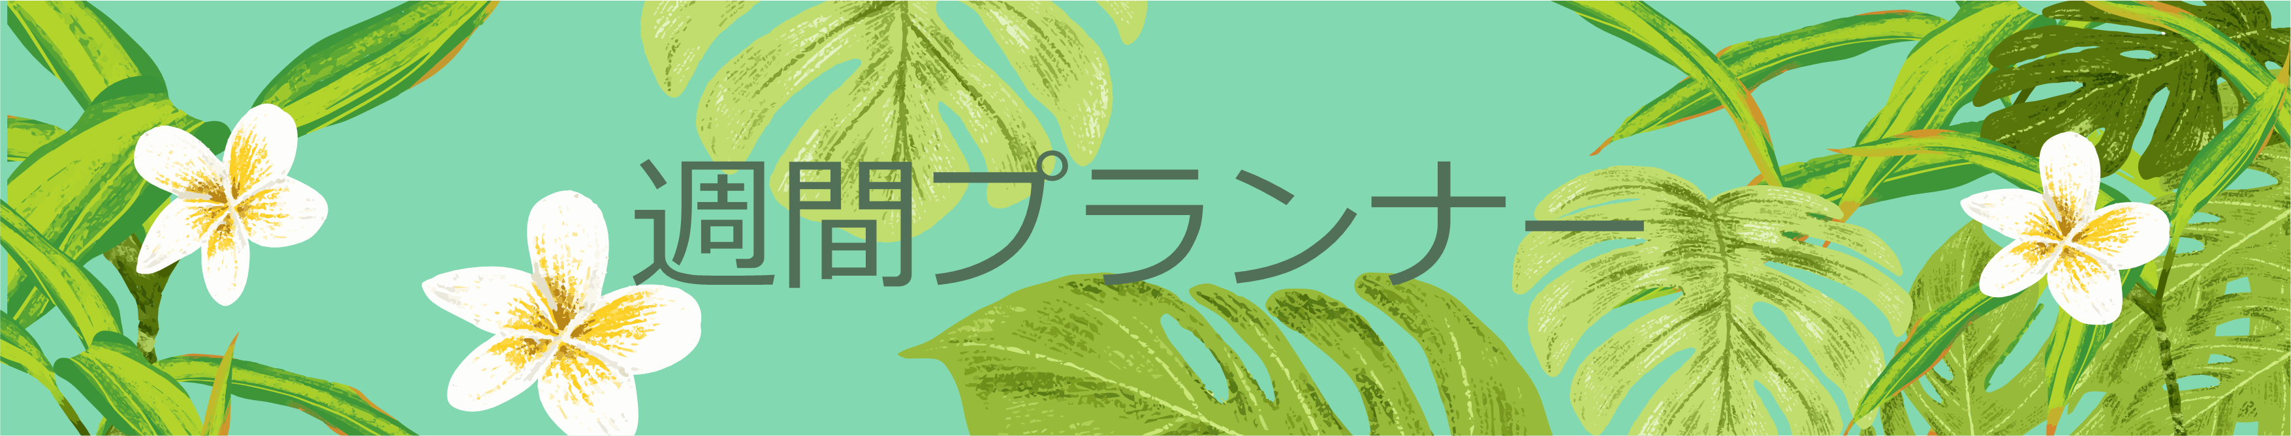

|  |  |  |  |  |  |  |
| --- | --- | --- | --- | --- | --- | --- |
| **月** | **火** | **水** | **木** | **金** | **土** | **日** |
|  |  |  |  |  |  |  |
|  |  |  |  |  |  |  |
|  |  |  |  |  |  |  |
|  |  |  |  |  |  |  |
|  |  |  |  |  |  |  |
|  |  |  |  |  |  |  |
|  |  |  |  |  |  |  |
|  |  |  |  |  |  |  |
|  |  |  |  |  |  |  |
|  |  |  |  |  |  |  |
|  |  |  |  |  |  |  |