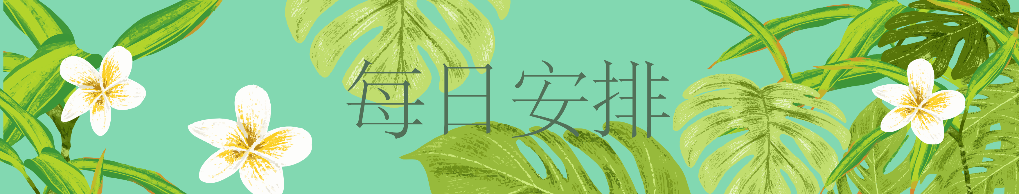

|  |  |  |  |  |  |  |
| --- | --- | --- | --- | --- | --- | --- |
| 周一 | 周二 | 周三 | 周四 | 周五 | 周六 | 周日 |
|  |  |  |  |  |  |  |
|  |  |  |  |  |  |  |
|  |  |  |  |  |  |  |
|  |  |  |  |  |  |  |
|  |  |  |  |  |  |  |
|  |  |  |  |  |  |  |
|  |  |  |  |  |  |  |
|  |  |  |  |  |  |  |
|  |  |  |  |  |  |  |
|  |  |  |  |  |  |  |
|  |  |  |  |  |  |  |