Original locations

Rendered as hexes

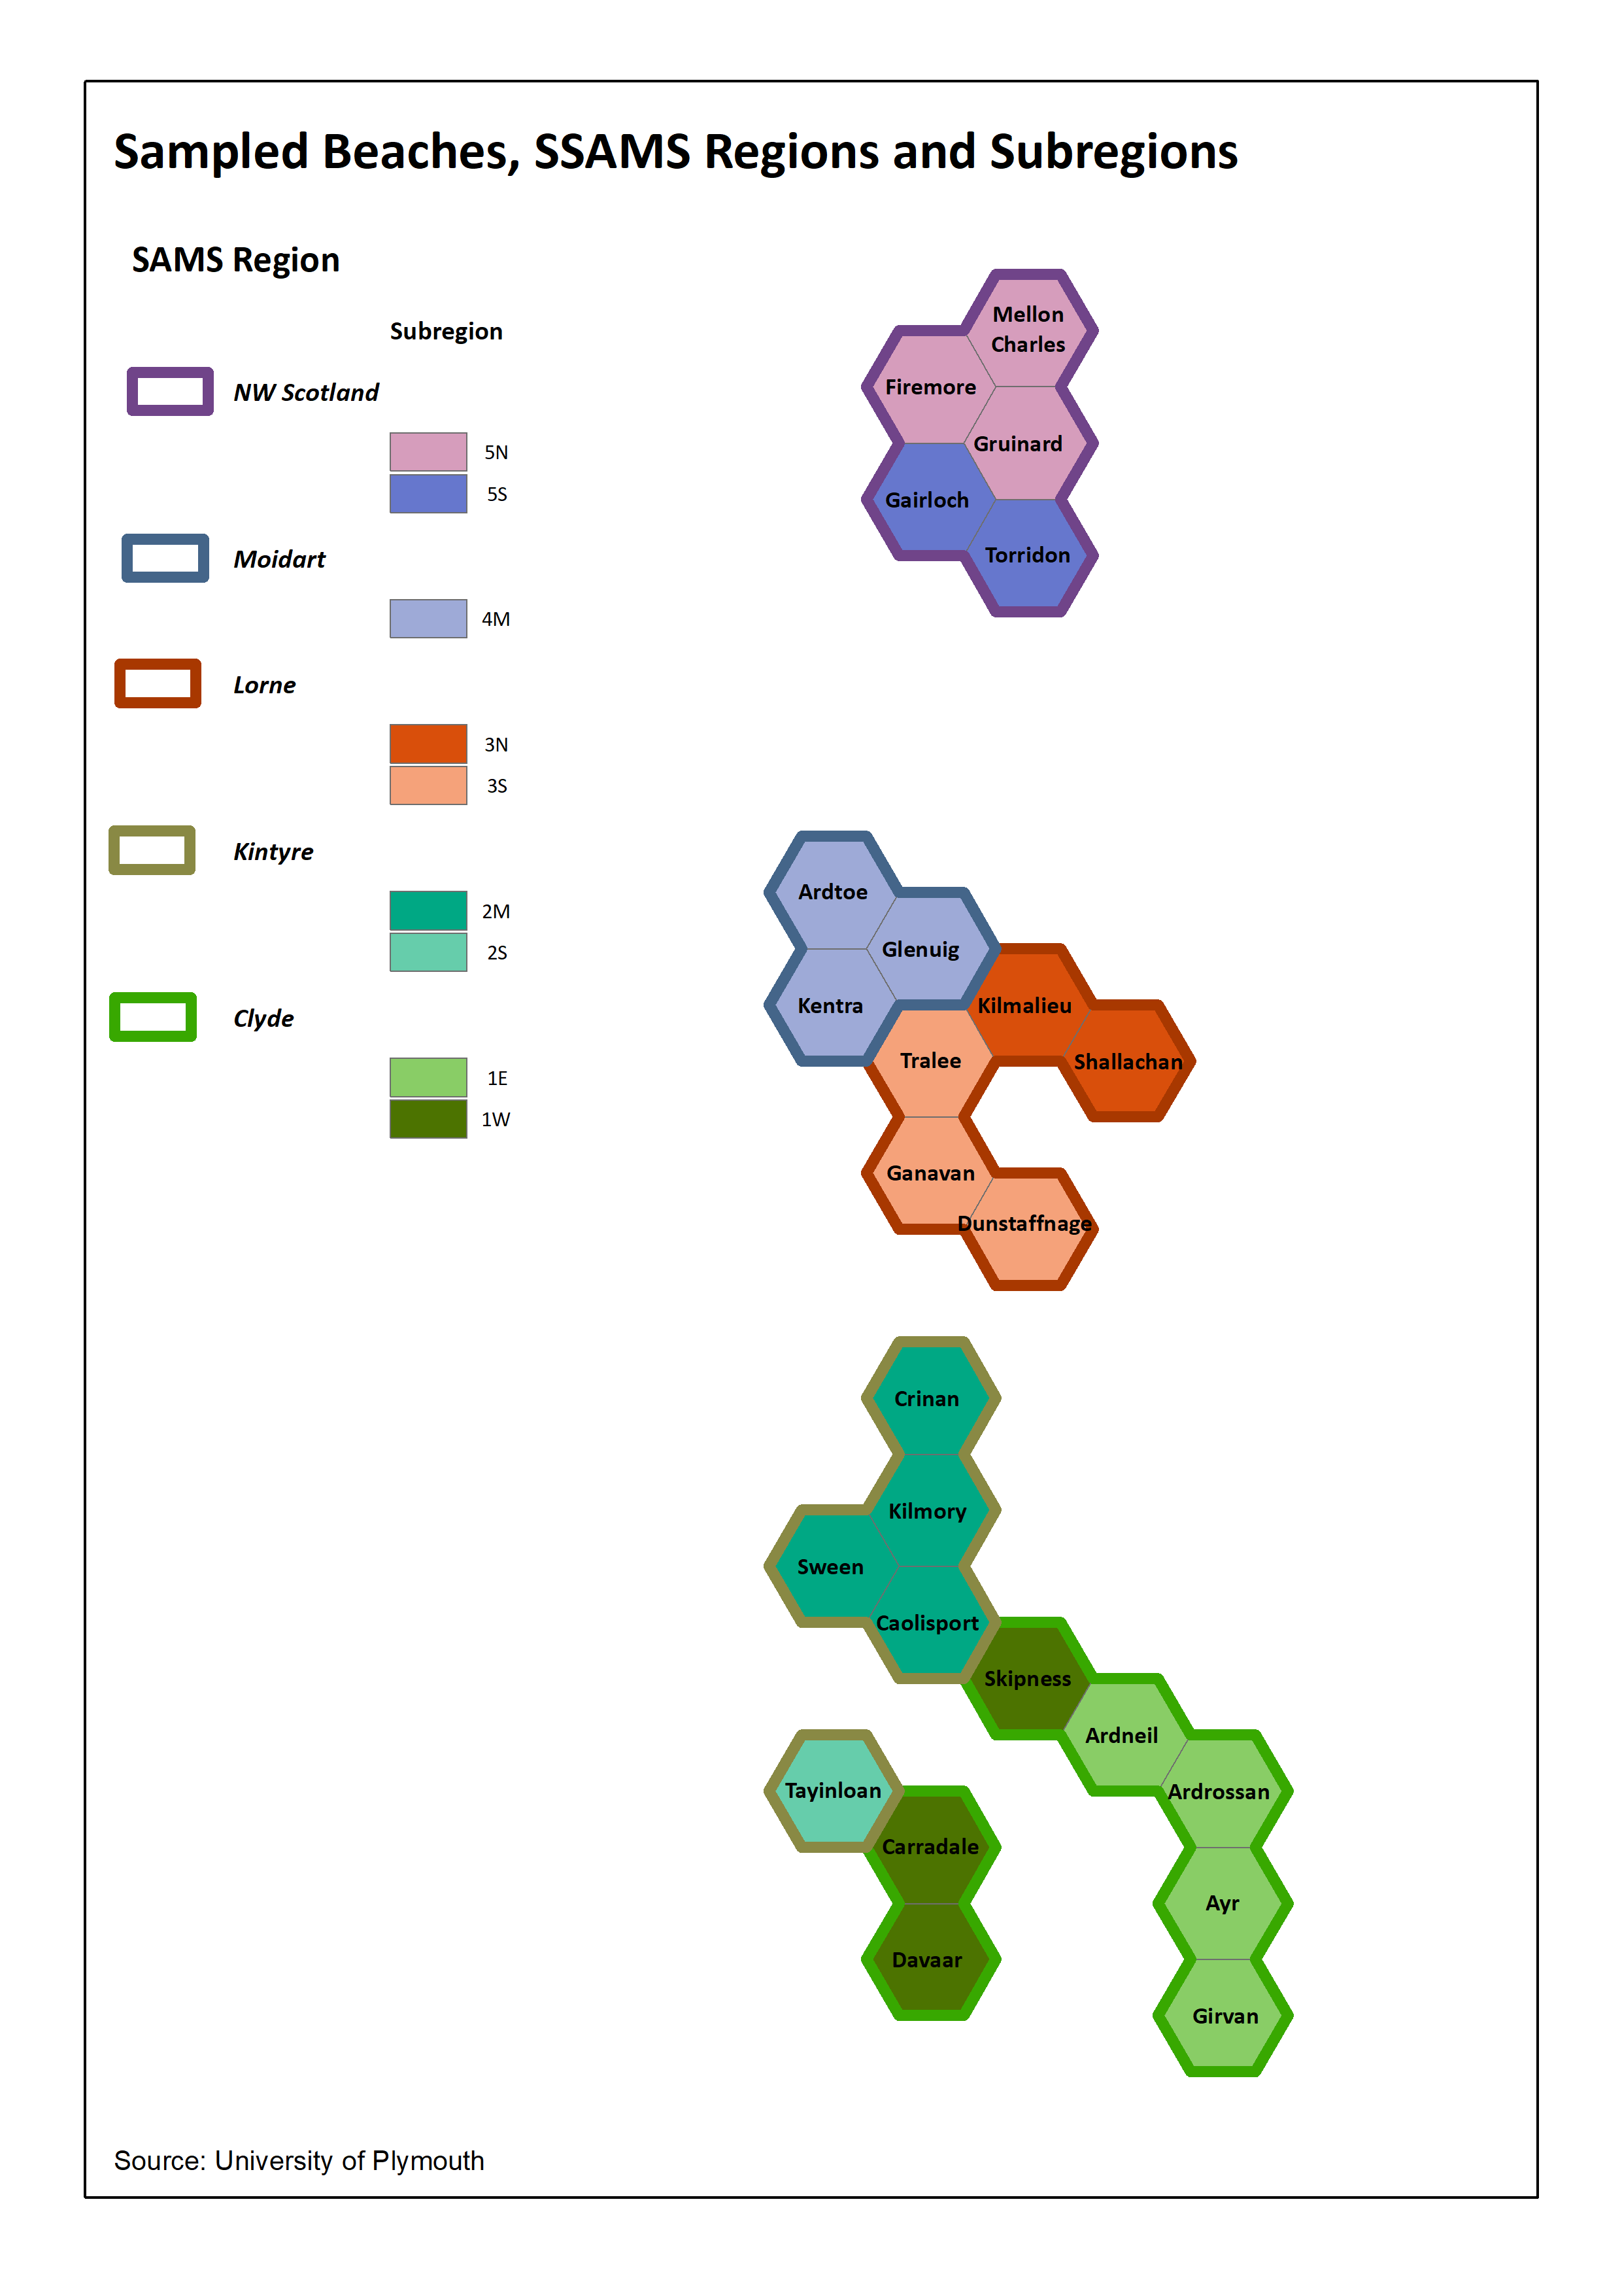Only those with data – Regions and Subregions

