Data quality report

Introduction
This report summarises the data quality of financial variables extracted from pdf returns sourced from Companies House.
We limit this to data quality for two reasons: Firstly, the system exists to provide a proof-of-concept therefore, we intend to show whether or not it is possible to extract the required data from these pdfs. Secondly, it is generally easier to develop a system to produce the required data quality, then optimise or improve the usability of the system whilst retaining data quality that the other way around. Hence the focus on data quality.

The System
The system can be split up into several distinct steps below. This details how the system works and will be used to break down the performance of the system to show where improvements can be made and what they might be. The description below assumes collecting pdfs from Companies House has been completed and the source of pdfs is readily available for processing.

Converting pdf to image
This is carried out by [tool] – a command line tool available for linux[and windows?] operating systems. This has not been formally checked as other stages have, though from observing outputs this process appears to accurately reproduce the pdf pages as images so no further checking took place.

Optical character recognition
This is carried out by Tesseract 4.0 [check]. Tesseract is an open source optical character recognition tool that is the industry standard [ref?]. The latest release uses a Long Short-Term Memory deep learning neural network to recognise and extract text data from images. This stage has not been checked independently, but by checking the final data output, we can see how well this step is working for this use case.

Balance sheet detection
The next step is to locate the balance sheet with the financial information required. This is currently carried out with a series of regex rules to detect specific phrases in each page that indicates if the current page might contain the balance sheet.

Financial variable extraction
Once balance sheets have been found, each row or rows of text that match a regex rule is taken as a financial variable. These are collated into a csv file detailing the company’s finical assets.

Test data sample
A random [check] sample of 756 pdfs were processed. Of these 506 (67%) returned data, meaning that at least one variable was extracted, where 250 (33%) did not.

Data Quality

Balance sheet detection
Of the 250 pdfs that did not return data 124 pdfs returned a balance page, but no data. 126 did not return a balance page(s), this gives an overall balance page detection rate of 83%. Some spot checks were carried out on a random sample of 25 of these to check the actual balance page was amongst those pages identified. All correctly included the balance page(s).

Improvements
Changeing the regex conditions to searching for the presence or absence of a text string appears to improve this process. Of the 126 pdfs that did not return a balance page, all but three did after this change in the approach, providing a balance page detection rate of 99.6%. Again a random sample of 25 showed that the balance page was correctly identified as one of the possible balance pages.
Of the 123 pdfs that returned a balance page after this improvement, 83 returned at least one identified variable when processed through the rest of the pipeline. This increased the returned data rate by 11%, from 67% to 78%.

Caveats
For the 83 more pdfs returning data, no checks have been carried out, so no accuracy figures are avialble In addition the changes to the balance page detection function in the code mean that more pages are return as balance pages, meaning we have increased the number of false positivies (pages incorrectly identified as being a or part of the balance sheet). This could have two ramifications. The first is to increase the overall processing time as more pages are processed as more potential balance pages are identified. The second could be to increase the amount of superflous variables identified and returned as pages that contain irrelevant information are processed and these data could be included in the output.
Nevertheless, this does demonstrate that by improving the balance sheet detection code could provide substaintial increases in the number of pdfs that return data. This also demonstrates that without improvements there will be a ceiling of 83% data return rate for this sample of pdfs as the system cannot return data if the balance page is unidentified.

Variable detection

Unit detection
Within the 124 pages that have a balance page identified, but do not have any returned data. It was found that data was not returned as the currency was not identified for any figures returned. This meant that the code did not return any data as it requires a currency.

Improvements
The code uses a regex condition to detect currecies. Two changes were made, firstly that if data was found, but no appropriate currency a currency unit of NaN (not a number) was returned. This meant that the balance sheet would parse and the values would be extracted. Although a currency is cruicial for providing valid financial information, this does mean that pdfs with no currency unit can be identified in post-processing and through manual checks the currecy unit can be verified. It also meant that the missing currency units (in this case ‘€’ and ‘US$’) can be added to the regex condition that finds the currency.
When this was re-run on the 124 pages with the balance page identified a total of 10 more pdfs returned data. Giving a total improvement in data return rate of 1.5%. These new data were not checked for accuracy.
Overall this provides an easy implementation improvement with a small gain and no real change in perfomance as the same method is adopted.

Text alignment
A small sectiion of the other 114 pages that have an identified balance page were inspected and found that they did not return data as no text was detected as within the bounding boxes used to identifiy rows of text within the document. When these rows, as defined by a [process], were enlarged by an scale factor after which they returned data. However, it was observed that these data would be of questionable quaility as by enlarging the rows, this mean that text on the rows above and/or below may be considiered as being on the same row meaning finacial variables would become mixed up and confused across rows. Perhaps with careful selection of an appropriate scale factor, this could be overcome. Or it might be the case that some rows of text in the image do not alighn as they have been rotated so cannot be read correctly, but this was never tested in practice.
While futher investigation and testing is needed here, if this issue is solved it may be the case that data is returned for well over 80% of pdfs.

Variables extracted
There are a total of 743 uniquely named variables that have been extracted for all of the 506 documents. Of these 558 only have one entry and 660 have 5 or fewer entries (< 1%) of all documents. Meaning most of the variables we extract are erroneous. Some reasons for this might be a typo, incorrect OCR read, do not appear in the majority of balance sheets, are taken from pages mistakenly identified as balance sheets or are mistakenly read as finacial variables.
The top 25 most frequently occouring variables are shown in the table and graph below.
Variable | Number of files with variable | Ratio of files containing varible (n=506)
creditors amounts falling due within one year | 238 | 0.470356
called up share capital | 229 | 0.452569
net assets | 216 | 0.426877
debtors | 211 | 0.416996
net current assets | 207 | 0.409091
total assets less current liabilities | 202 | 0.399209
cash at bank and in hand | 188 | 0.371542
tangible assets | 160 | 0.316206
profit and loss account | 128 | 0.252964
shareholders funds | 104 | 0.205534
net current liabilities | 69 | 0.136364
current assets | 67 | 0.132411
stocks | 67 | 0.132411
total equity | 65 | 0.128458
amounts falling due within one year | 64 | 0.126482
capital and reserves | 58 | 0.114625
investments | 57 | 0.112648
liabilities | 52 | 0.102767
creditors amounts falling due after more than one year | 51 | 0.100791
provisions for liabilities | 48 | 0.094862
notes | 45 | 0.088933
note | 38 | 0.075099
retained earnings | 36 | 0.071146
net liabilities | 34 | 0.067194
cash at bank | 31 | 0.061265

Even the most commonly occouring variable appears in fewer than half of the pdfs. This is an issue as even with pdfs that data can be extracted from are unlikley to have the same finicial variables for use in sampling.
The way variables are identified is through use of a complex regex rule. It is possible that this rules-based approach is not sufficient to reliabley and consistantley extract the same variables from balance sheets in the pdfs. Possible issues are that either there are OCR mis-reads from tesseract, there are typos in the document or that there are slightly different names for what is essentially the same variable. One way of correcting this is the use of fuzzy matching. Fuzzy matching is a term for a number of different algorithms that measure the similarity between two strings of text (e.g a word, phrase or sentence). We can take the rare variables (occuring in <1% of pdfs) and compare these to the more common variables (occuring in >1% of pdfs) to see if there is a very similar match using fuzzywuzzy – a string matching library in python [ref]. We take all rare variables with a match score of greater than 90 with a commonly occuring variable and replace its name with the more common one.
With this method, we see some improvements. The most common variable “creditors amounts falling due within one year” now appears in half of all documents. This offers some improvement, but not a huge amount.

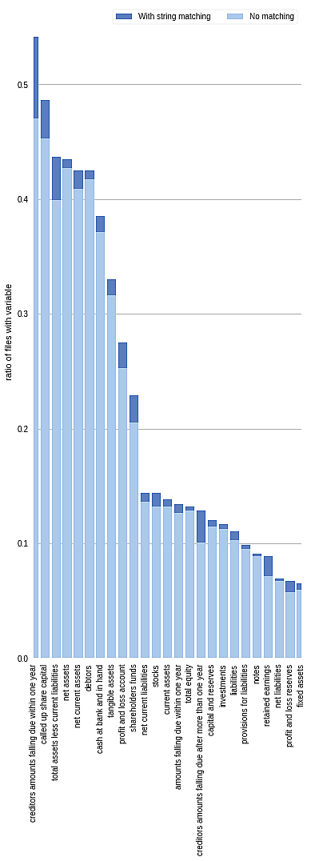
There are two possible avenues to improve this. First is to adapt the regex string or some other rules based method to specifically target a small number of variables. The second would be to develop a more sophisticated approach identifying variables, values, dates and units in a table that can be applied more generally. The approach will depend on the use-case fot these data.

Grouping variables
Given that theres is such a variety of variables, it may be useful to see how these are related so we apply some clustering to see if the variable names can be grouped by common words. The variables that occour in =>1% of all pdfs that return data. The variables are cleaned, removing punctiation, non-alphanumeric characters, multiple whitespace and stopwords. From these bigrams were created as it was assummed word order for commonly occouring phrases had context. Count-Vectorization was used to count occourences of words and bigrams in a variable name. These counts gave the quantitative word vectors to use for clustering. Further processing was performed on these word vectors using truncated Single Value Decompostition (SVD) [ref] and t-SNE[ref] to reduce the sparse word vectors to two dimensions.

Clustering
K-means clustering was then applied to the data. Selection of k, the number of clusters, is typically somewhat arbitary, but an elbow plot can be used for choosing between different values of k. We take a range of k as 2-12 meaning we expect a minimum mean cluster size of 5 as we have 61 finacial variables. Or in other words, we are assuming each variable to be similar to at least 5 other variables. The elbow plot below [fig] shows the number of clusters on the horizontal axis and the distortion on the vertical axis. Distortion computes the mean-sum-squared distance of each point to the defined centre of its cluster. Therefore, smaller distortion is better. The elbow method of k selection, means that we take k where distortion stops decreasing as k increases – the inflection point or ‘elbow’ on the plot. Therefore, we select 8 clusters [figure] based on [figure]. We can see that the data has some structure, which the clustering picks up on. But the clusters are not that distinct, meaning that the clustering and/or data processing approach(es) here might not be particularly good at selecting distict groups.

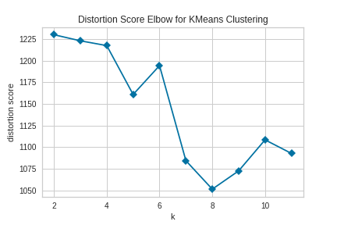
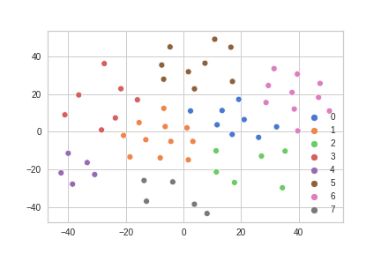

Word groupings
The word groupings below show the different variables chosen in each group. This is shown in [table] with the variable name, the processed variable name used for clustering ( ‘_’ indicates where two words are considered a bi-gram) and the cluster. A summary by cluster is shown below.
Cluster | Most contain the words...
0 | Liabilites
1 | No clear pattern
2 | No clear pattern
3 | No clear pattern
4 | Amounts falling
5 | Funds
6 | Assets
7 | Capital or reserve

These show some variables cluster well when there are a few with similar words, like assests, liabilites or funds but some that show no real pattern. The plot of the data [figure] that shows some structure exists, but no clear clusters for all data points is reflected here, 3 out of the 8 clusters show no real pattern in the variable names. However, it is interesting that this approach can pull out some similarly named variables in some clusters, meaning there is validity in the approach.

Variable accuracy
This section describes how the extracted variables were compared to the pdfs to check their accuracy. It was not possible to check all 506 documents. So the data was inspected to identify a number of potentially suprious values and check documents based on a confidence measure output by tesseract where it evaluates its own output. Essentially there are two questions; what is the quality of output from documents where there are likely errors? – an estimated worst case sceniario and how trustworthy is the confidence measure from tesseract?

Sample section
The data was checked for the following errors
- Non-standard currencies
examples;
£7000
- 2.253−£0.01−
- C425845
- £2,007
- £0.00
- £6,000
- Invalid years
examples;
2006
2005
- Less than 50% tesseract confidence
- Value has been misread and is actually the year
examples;
in the range of 1999-2020
- non-numeric financial values
With the exception of the last one where there were no non-numerical values, all returned some potentially suspect values. It was suspected that if there was one potentially erroneous value in a document there would likely be more, so the entire document was checked. This mean that 122 out of 506 (24%) documents that returned values would be checked.
A further random stratified sample of 40 pdfs were selected for checking. These were stratified by quartiles of the tesseract confidence metric wiht 10 pdfs selected from each quartile.
Checking took approximatley 5 minutes per PDF with some taking much longer. In total this took approximatly 14 hours.

Results
These files contained a total of 2892 variables averaging approximatley 18 variables per document. Of these variables, 1949 (67%) were correct with no errors.
We can consider the reason for each error and consider their number, impact and discuss their ease of fixing either with an improved method or in post-processing the data. There are two common errors where “notes” has been incorrectly read in as a value and where the year has been misread. The latter is typically from documents which have a format of dd-mm-yy or similar as opposed to just the year the value refers to. The third issue is where the value could not be found for checking – this could be some sort of misread, but it could also be that the value was simpley not spotted in the document when checking.
 | error | number
0 | incorrect year | 171
1 | is notes row | 100
2 | value not found in doc | 122

Together these make up 393 of the total. If these are excluded. The error rate reduces to 78%. The majority of errors are either variable name misreads, variable value misreads or where two variables have been incorrectly read as one variable. These can be attributed to the tesseract OCR or variable extraction process.

Overall assessment

Appendix
The below table contains varaible names, the processed text that was used to create the vectors for clustering (words joined by ‘_’ are a bigram) and the clusters themselves.
Variable name | Processed variable name | Cluster
net current assets liabilities | net_current assets liabilities | 0
total liabilities | total liabilities | 0
liabilities | liabilities | 0
share capital | share capital | 0
net current liabilities | net_current liabilities | 0
provisions for liabilities | provisions liabilities | 0
net liabilities | net liabilities | 0
current liabilities | current liabilities | 0
investments | investments | 1
trade and other receivables | trade receivables | 1
inventories | inventories | 1
donations and legacies | donations legacies | 1
notes | notes | 1
debtors cash at bank | debtors cash_bank | 1
debtors | debtors | 1
ordinary shares of each | ordinary shares | 1
cash at bank | cash_bank | 1
retained earnings | retained earnings | 1
stocks | stocks | 1
deferred tax | deferred tax | 2
net current liabilitiesassets | net_current liabilitiesassets | 2
cash and cash equivalents | cash cash equivalents | 2
loans and other debts due to members | loans debts members | 2
members other interests | members interests | 2
net current assetsliabilities | net_current assetsliabilities | 2
prepayments and accrued income | prepayments accrued income | 3
property plant and equipment | property plant equipment | 3
taxation including deferred tax | taxation including deferred tax | 3
accruals and deferred income | accruals deferred income | 3
investment property | investment property | 3
debtors cash at bank and in hand | debtors cash_bank hand | 3
cash at bank and in hand | cash_bank hand | 3
amounts falling due within one year | amounts_falling year | 4
debtors amounts falling due within one year | debtors amounts_falling year | 4
amounts falling due after more than one year | amounts_falling year | 4
creditors amounts falling due within one year | creditors amounts_falling year | 4
creditors amounts falling due after more than one year | creditors amounts_falling year | 4
shareholders funds | shareholders funds | 5
shareholders deficit | shareholders deficit | 5
total equity | total equity | 5
restricted funds | restricted funds | 5
unrestricted funds | unrestricted funds | 5
total funds carried forward | total funds carried forward | 5
net movement in funds | net movement funds | 5
total shareholders funds | total shareholders funds | 5
total funds brought forward | total funds brought forward | 5
total current assets | total current assets | 6
total net assets liabilities | total net assets liabilities | 6
total assets less current liabilities | total assets current liabilities | 6
total assets | total assets | 6
net assets | net assets | 6
net current assets | net_current assets | 6
current assets | current assets | 6
fixed assets | fixed assets | 6
intangible assets | intangible assets | 6
tangible assets | tangible assets | 6
called up share capital | called share capital | 7
capital redemption reserve | capital redemption reserve | 7
profit and loss reserves | profit loss reserves | 7
profit and loss account | profit loss account | 7
capital and reserves | capital reserves | 7

