Metadata model repository components and how to update them

Version Notes
Document - v 1, 08/07/26, model version 1.6. Author : Samantha Iacob, DA

Intro
The ONS metadata model and some key artifacts are hosted on GitHub at https://github.com/ONSdigital/enterprise_metadata_model_updates
They are also temporarily mirrored on SharePoint here

Why GitHub:
- The models are mostly technical artifacts so it made sense to put it somewhere that technical people like engineers and solutions architects are already comfortable with
- Repos can be laid out so they’re accessible to non-technical staff (using the readme.md and directory structure)
- GitHub has robust version control so you can look at previous iterations of the repository (through the list of commits, here)
- Secured through ONS Digital but accessible from any device on or off network as long as you have an ONS Digital account and 2FA. You can also clone it right to your computer and read the whole repo offline if you want.
- Collaboration is easy and multiple people can commit updates in a controlled way
- It renders csv files really nicely which is convenient for Erwin reports
- It also renders markdown which is easier to use and less irritating than Word in general.
- Used by other organisations doing the same sort of thing, like UNECE (GSIM, GSBPM etc)

Why not SharePoint:
Everyone in ONS has access to SharePoint but…
- SharePoint mostly seems to do version control at the file level and not the overall project level so it’s annoying if in some updates some files change and others don’t, you probably have to keep a document log
- I’d have to set up a SharePoint page as a front for the project which is annoying and clunky
- Kind of locked in to Office file types if you want to actually use the collaboration and version control stuff. Even then it’s hard to maintain order over a group of files.
- Unclear if retention rules actually let you delete anything without a maybe not technically allowable amount of messing around or if you’re stuck keeping everything and tacking on version numbers on the end of files.
- Group based permissions make it annoying to select collaborators
- Have to make the Erwin reports look pretty in Excel which is added work
- Technical people don’t like it

Why not Confluence:
It can make a user-friendly page which business-oriented people like, and has good version controls but…
- I’ve noticed that technical people like engineers and developers will sometimes pretend not to have access to it even though they probably do since they mostly use Jira. There’s no way I’ve found of tricking them into admitting that
- It doesn’t seem to really be able to do anything GitHub can’t
Basically the choice is between GitHub and Confluence with GitHub being more technical-user facing and Confluence being more business-user facing. Since I think the kinds of people who are going to be poring over logical and physical diagrams are more likely to be technical I favour GitHub as the source of truth. Also if we decided to surface our models in the future (we may choose to for cross-government integration or maybe just to take credit for building a cool public data catalogue) GitHub makes this very easy.
SharePoint is currently used as a mirror for the GitHub but it might be easier to use Confluence for that in future as I believe there are integrations that let it automatically mirror GitHub repos. Or we could decide to just not.

Repo Overview
The repo currently (as of v1.5) contains these important bits:
- A “diagrams” directory which contains the conceptual and logical metadata model diagrams, and subdirectories for domain profiles (currently only dissemination).
  - Inside the domain profile diagrams subdirectories there are the conceptual and logical domain profile diagrams and another subdirectory containing instance models
- A “documentation” directory which has the documentation for the metadata model and some subdirectories:
  - “decisions” containing the architectural decision record files
  - Domain profile folders containing the documentation for each domain profile (currently only dissemination)
- The “reports” directory which holds the entity definitions and logical dictionaries for the metadata model in csv format.
- A “README.md” at the root directory which is the front page for the repo with version info, the update schedule, news, the overall metadata model diagrams and some contact info.
Most or all of these are changed in some way with each update.

Updating the repo
This is done with Git on the laptop in probably the usual way though I am aware I am being lazy about adding the files properly.
In the project directory I do:
- git pull (to get an up-to-date copy of the repo in case something changed for some reason)
- then I add whatever files (usually the diagrams and documentation, making sure the version number lines up to the model version number)
- git checkout -b new_branch (new_branch is whatever I want to call the branch, usually version_1_5 or something like that)
- git add . (to add all the changed files and remove anything that’s been deleted. This is a lazy way to do this)
- git commit -m “commit message” (where “commit message” is a short summary of the changes)
- git push -u origin new_branch (to upload)
- Then I go to the repo in the browser and accept & merge the push. I then edit the README.md file in the browser to make sure the version info and news is fresh and the image links for the diagrams are pointing at the new metadata model diagrams (if changed)
- Then back in the Git console, git checkout main, and git pull to mirror what’s in the repo again.

Components

Architecture Decision Record
This repo features an architecture decision record (ADR) in the documents directory. Each time a significant choice is made in the model a new record is created.
This repo explains it well including linking to the Michael Nygard article it’s based on.
You can create new ADRs by making a copy of an existing one and using it as a template (increment the number in the file name and change the description so it makes sense). Or you can use ADR tools which is what I do because it’s slightly less work.
In console type “pip install adr”
From there you can initialise the ADR directory and start adding your own ADRs if you like by following the instructions in the ADR tools repo.
I’m aware that the ADR format I’ve chosen falls a bit short of UK govt standards for the ADRs in that they also want lists of stakeholders and a bunch of other things at a minimum but I figured it’s better to have something than nothing and the basic ADR is pretty good really.
It’s important to Charles that the ADRs are written in third person instead of first person. I know this because he made fun of me once for it.

Diagrams
The model is maintained in the Erwin Mart, in the root directory because I messed up saving once. It’s called ONS_Metadata_Model_LPM.
The model is divided into Subject Areas - the main ONS Metadata Model and Dissemination. Other domain profiles/business areas will be added, such as DORA and KIM, and these will be in their own Subject Areas as well until they can be arranged into specific GSBPM phases like dissemination was.
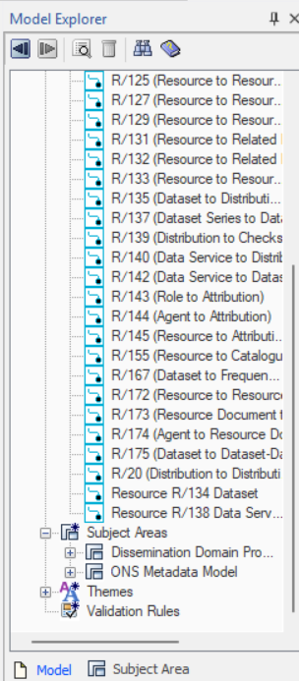
Or if you click Subject area at the bottom you can switch between them using a drop down at the top..
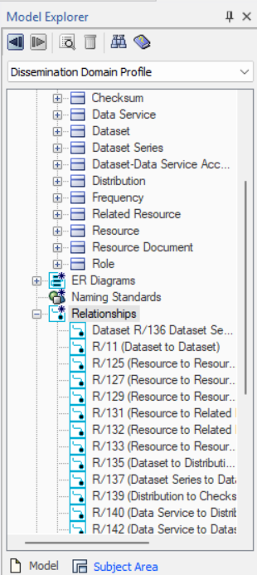

Each subject area should contain a conceptual model and a logical model. If a physical model is available it might be there too (currently none are available).
Each subject area/domain profile is a subset of the overall model - not all entities in the model are members of each of the domain profiles.
If any part of the model or domain profile is changed in Erwin it’s important to update the info panel in the top left corner with the dates, author and version number etc and re-export all the diagrams to ensure that they’re all referring to the same version.

Reports
Reports are generated in Erwin using a saved profile which I’ve attached here:
If you copy that and paste it somewhere on your computer you can open it in Erwin’s report designer. It’s just an Entity Definition and Logical Dictionary report at the moment.
When you run those off they will probably duplicate data because the entities and attributes exist in the metadata model as well as the domain profiles. Just use excel to delete any rows you don’t want before adding the reports to the repo (I keep the metadata model subject area and delete the domain-specific ones).
For some reason there are a few phantom attributes that I can’t get rid of from the model (I’m working on it). They show up in the reports with the definition “??? Not to be used for any attributes”. I filter on that in excel and delete those rows too before uploading. I also change the names of the outputs to “Entity_Definitions_x.x.csv” and “Logical_Dictionary_x.x.csv” where “x.x” is the version number. Other than that there’s no real formatting needed.

README.md
Updated after all the other bits of the repo are uploaded and merged. This is so it can have links to the images and documents that have been uploaded.
Please refer to the GitHub markdown formatting syntax guidance if you need info on this. You can use the existing README.md as a template.

Versioning
Versions are usually x.y.z (ie 1.5.1) where x is the major version number, y is the minor version number and (optionally) z is the patch version number. The purpose of the version number is to align the various artifacts around the model, so documentation, reports and diagrams etc can be guaranteed to refer to the same model.
The major version is when a large breaking change has taken place in the model - for instance this is likely to happen when a new domain profile is added because it will introduce new classes and require reconfiguring existing ones. This hasn’t happened yet because the model has mostly been about Dissemination so far. I figure when DORA is incorporated that will begin version 2 and KIM additions will kick off version 3 but something else could happen depending on how the project unfolds.
The minor version is when the model is updated (classes or attributes added or removed). These are substantial and intentional changes, an example could be when the Document class was moved or changing the link between Data Services and Resource to Data Service and Dataset, etc. There probably should be at least one ADR generated for each change that could increment the minor version number (since if no decisions have been made nothing needs to change).
The patch version is when there is a mistake or something that needs fixing, like a spelling error or missing relationship line on the model diagram (when the relationship is actually in the model already but got hidden in Erwin somehow, which has happened a couple of times). This isn’t a major change or particularly important.
In general I only iterate the numbers when it’s time for a release (when it is shared) so any number of updates in a release cycle will only increase the minor number by one. This is because people generally won’t have access to updated documents etc until they are pushed to the repo.
The version number in the README.md is also followed by the Erwin version number in case a data architect needs to go look at the specific version of the model. I typically save several times on Erwin between updates so that version number goes up pretty quickly.

SharePoint mirror
The mirror is here
It contains the artifacts from the GitHub. It’s slightly tedious to update and I’d like to not have to do it for a lot longer. I would expect this to not continue once the initial work with DS-DP is complete because SharePoint is not good for the reasons given above, and because eventually it will fall out of step with the repo and become worse than useless. As the model expands the work of mirroring will also get harder so it would be good to nip this in the bud before we add another profile. If it’s completely essential to keep this going (because business users also pretend to be unable to access GitHub and there’s no way of tricking them into admitting they can) it might be possible to automatically populate a Confluence page from GitHub whenever it updates though I don’t know how to do this just yet.
Thank you for reading, I can also give you a tour of the update process if it would help!

- Samantha Iacob (samantha.iacob@ons.gov.uk)

