Data Architecture :

Dissemination/ Digital Publishing Domain Profile Documentation

Governance
Approver | Role | Business Area | Date Approved
Charles Baird | Deputy Director | Data Growth and Operations – Data Architecture, Location and Indexing
Kirti Tandel | Lead Data Architect | Data Growth and Operations – Data Architecture, Location and Indexing

Version History
Version | Status | Author / Editor | Change Type | Summary of Change
0.1 | Draft | Samantha Iacob | Draft | Initial rough draft
0.2 | Draft | Samantha Iacob | Draft | Bring documentation in line with metadata model 1.5 for review.
1.0 | Released | Samantha Iacob | Update | Incorporate feedback, align to model v 1.6 and changes and release.

Model Version Information
This document is currently based on the ONS Metadata Model version 1.5 (released 26 June 2026). This model is in early development so some class and property names may differ between this document and the live model and domain profile for Dissemination / Digital Publishing.
For the latest version of this domain profile please refer to the model’s GitHub repository. It is currently mirrored on SharePoint though in the longer term GitHub will become the only place this is updated.
It’s strongly recommended you register with the ONS organisation on GitHub for access to this repository and many others. For instructions on this please refer to this ServiceNow page.

Table of Contents
Governance 1
Model Version Information 1
Purpose 3
Conceptual metadata model for Dissemination 4
Logical metadata model for Dissemination 5
Domain profile diagram for Dissemination 6
Domain profile diagram notes 7
Instance diagram for typical dataset series and its distributions 8
Instance diagram notes 9
Metadata fields and language 9
Datasets and Dataset Series 10
Minimal published dataset structure 10
Themes 10
Dates 10
Frequency and Releases 10
Usage Notes and Version Notes 11
Quality Designation 11
Documentation 11
Related Resources 12
Data Service 12
Distribution 12
Download URL 12
Distribution Description 12
Media Type and File Format 12
Conforms To 13
Agent, Role and Attribution 13
Next steps 14
Further Information & Contact Details 14
Additional Reading 14
Contact Us 14

Purpose
This document details a Domain Profile, which is a subset of the overall metadata model tailored for a particular part of the statistical production process. As such it doesn’t discuss the model more generally or go into detail on areas which are common to all domains (such as versioning using the model, how agents, roles and attributions work or what the major classes are). It also doesn’t have any detail on concepts such as modelling levels or what a domain profile is. It’s recommended that you first read the Metadata Model Documentation which is available in the GitHub repository or the SharePoint, linked above.
Please note that this is an early draft which will be expanded on, for now it is incomplete (it will be accompanied by a physical model and schema for implementation, guidance relating to the schema and standards that apply for the domain metadata) but should still be of use to anyone trying to understand how the metadata model will apply to the dissemination phase of the statistical production process. Feedback as to what properties, classes and information are useful or lacking at this stage would be very gratefully received.

Conceptual metadata model for Dissemination
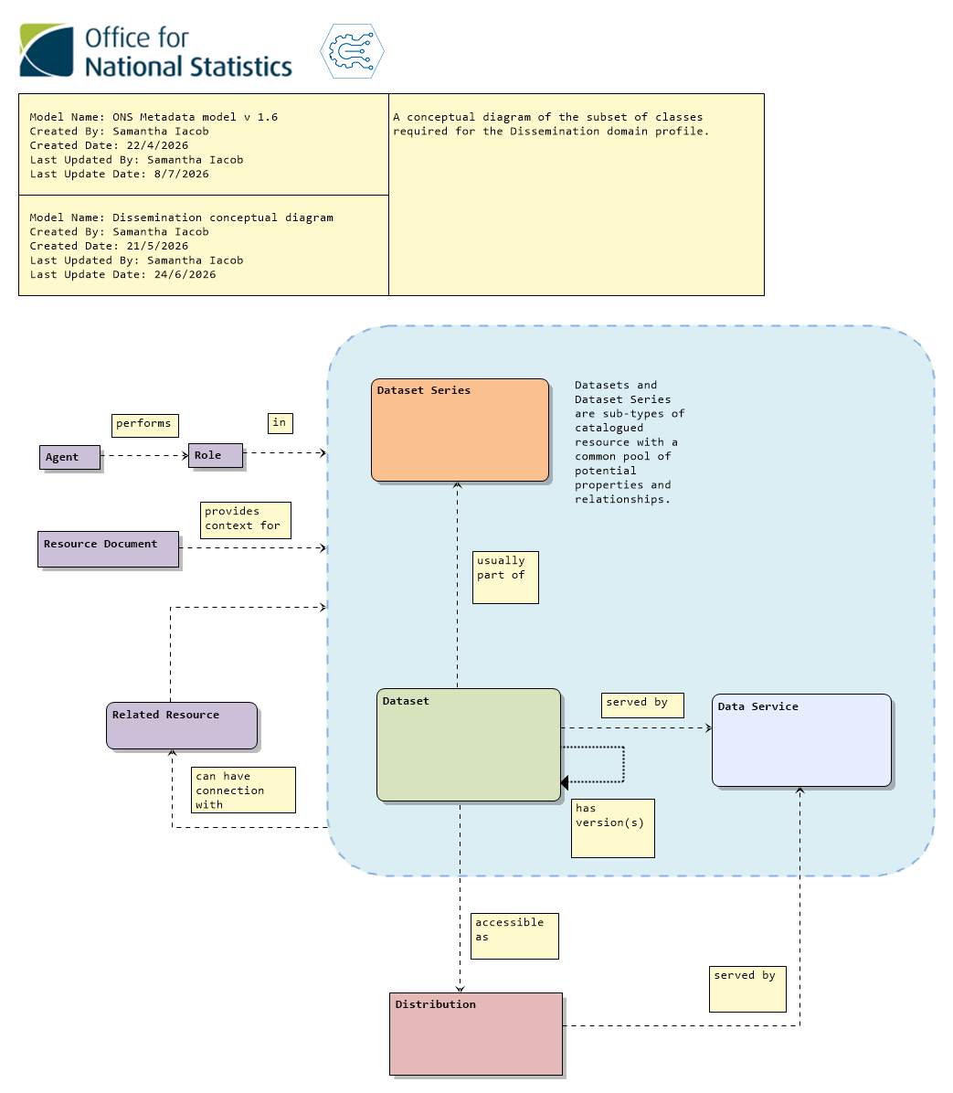

Logical metadata model for Dissemination
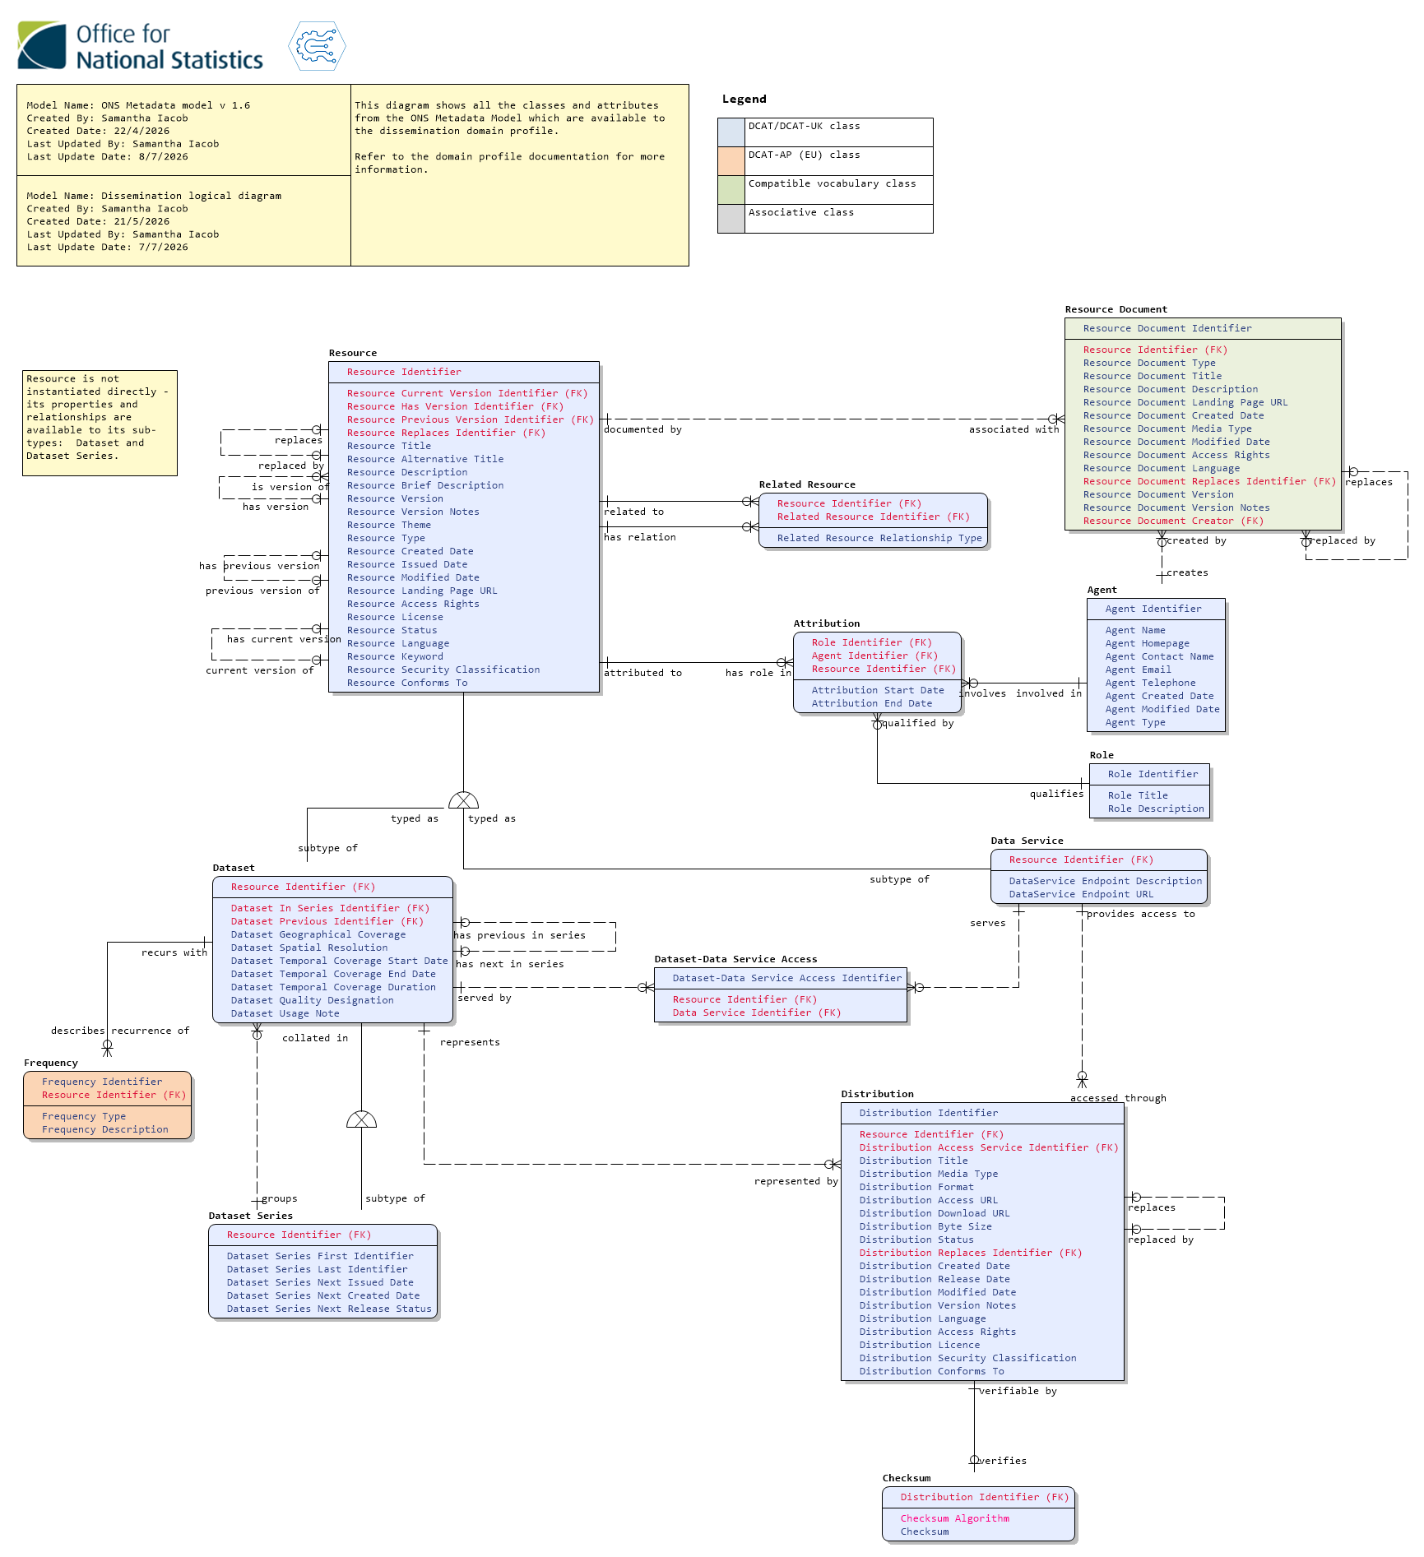
Please note that these diagrams show all the classes and properties that are available to the dissemination profile from the metadata model - you may not need to use all the properties.

Domain profile diagram for Dissemination
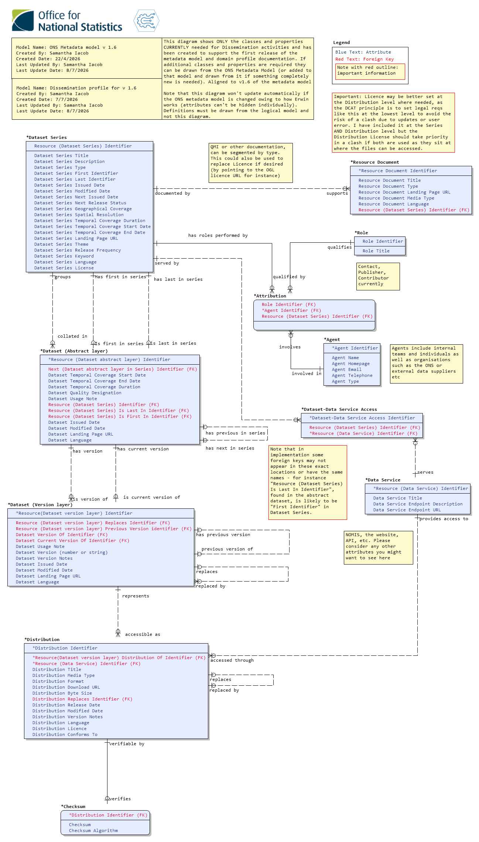

Domain profile diagram notes
The diagram shows a entity-relationship diagram model which shows how the classes and properties introduced in the previous diagrams would be used in the dissemination context. A further step is required for implementation from here - a physical model and schema, which may entail changing the property names or where they appear in the model to meet the specific requirements of the system it is implemented in.
The asterisk before the entity names in the diagram is due to a limitation in the data modelling software and can be ignored.

Instance diagram for typical dataset series and its distributions
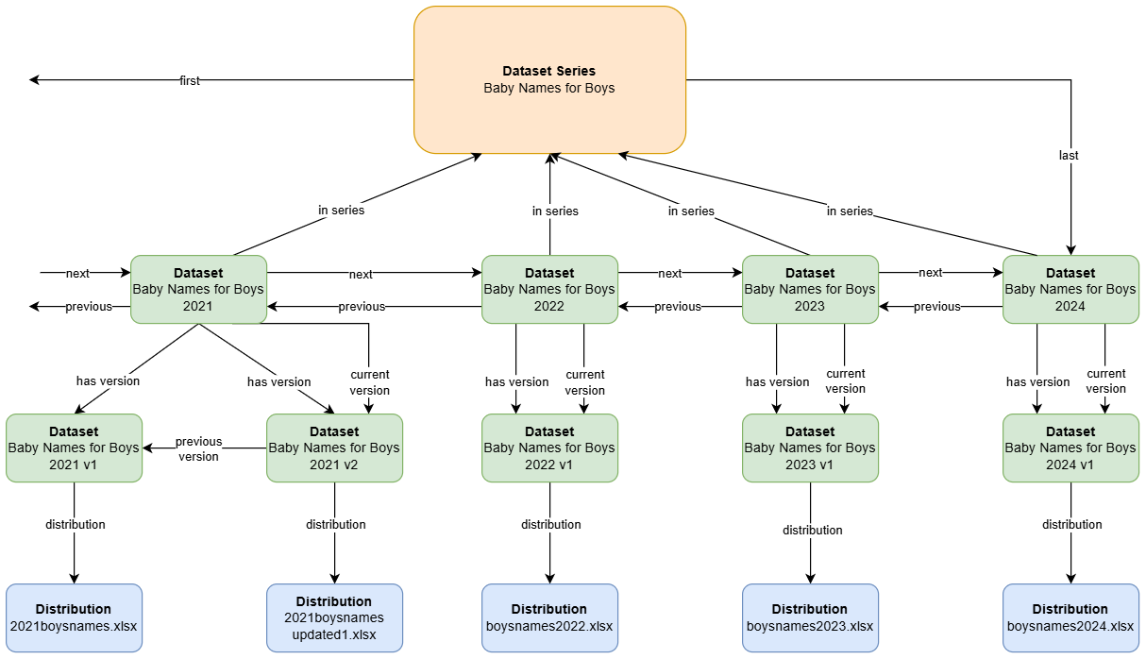

Instance diagram notes
This instance diagram shows only the relationships between dataset series, datasets and distributions in a typical publication on the ONS website. It doesn’t display the other properties which are expected to be populated at the various levels.
The top level is the dataset series level which corresponds to https://www.ons.gov.uk/peoplepopulationandcommunity/birthsdeathsandmarriages/livebirths/datasets/babynamesenglandandwalesbabynamesstatisticsboys . This is what the website calls a dataset. A dataset series can be identified as it will have “first” and “last” identifiers corresponding to the first and last datasets in the series.
The next level down is the annual/regularly published datasets, which are named editions on the website. An example is the 2021 Edition which can be found here: https://www.ons.gov.uk/peoplepopulationandcommunity/birthsdeathsandmarriages/livebirths/datasets/babynamesenglandandwalesbabynamesstatisticsboys/2021 . These can be identified as they will have an “in series” identifier, showing which series they belong to.
Below this are what are called versions on the website. These can be identified by the “distribution” identifier, which points to a particular accessible representation of the dataset. It’s expected that all datasets will have at least one version but can have more. Versions are linked to their immediately preceding version using the “previous version” identifier. This allows a version chain to be built.
At the bottom of the instance diagram are the distributions which provide a link to the downloadable file and some additional metadata (file size, name, etc). Each version of a published dataset must have at least one distribution.

Metadata fields and language
Welsh language metadata fields are important to meet our commitment to promote the Welsh language, especially as much of the ONS is based in Wales. These have not been modelled owing to a lack of time and Welsh language expertise but it is a topic that is under consideration and will be addressed in future versions of the model and domain profile.

Datasets and Dataset Series
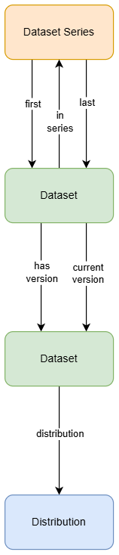

Minimal published dataset structure
Published datasets must have the minimal structure of a dataset series, two levels of dataset (a dataset that contains all its versions and points to the latest version), and a distribution.
Even if there is only one dataset in a series and a single version this will allow the series and versions to expand over time as needed. It provides a consistent structure that allows certain properties to be completed at certain levels (for instance, QMI documentation and the actors and roles associated with a dataset will sit at the dataset series level, and version notes will sit at the lower dataset level).
A possible exception may be for ad hoc datasets (including user-requested data). These do not need to belong to a series or be versioned. Instead they are constructed as a dataset linked directly to one or more distributions.

Themes
In this model Resource Theme combines the concepts of Theme and Topic. As a topic can have only one parent theme, this means that a parent theme can be derived from a topic.
This means that for this profile Resource Theme can be entered as an array, with the primary theme and/or topic being the first entry in the array.
It’s noted that Digital Publishing wants editorial control of the theme and topic ontology and work needs to be done to manage the source of truth here.

Dates
Datasets have access to three dates - Created, Issued and Modified Dates. For this profile the only required date is Resource Issued Date which refers to the datetime a resource is published or made publicly available for the first time.

Frequency and Releases
This should be found at the Dataset Series level. Although more than one Frequency is possible, the Frequency required by Dissemination is the publication frequency. Dataset Series also contains a property called Dataset Series Next Issued Date which is the projected date of the next publication in a series, and Dataset Series Next Release Status which gives further details. These are both optional.

Usage Notes and Version Notes
In previous iterations of the model, Alerts and Usage Notes were types of Annotation which were used to display a message on a website. This was reviewed and it was decided to fold Alerts and Usage Notes into a Usage Note property which is available to Dataset and Dataset Series classes, and for the Annotation class to be removed. This will be reviewed in future.
Use cases for Alerts such as notifying that a data series has been discontinued would be better covered through the Resource Status property, which is intended to work as a flexible lifecycle indicator that should cover any stage a dataset is in.
Version Notes, which show changes between versions of a dataset or distribution, are supplied at the lower level of Dataset in the illustration (the versioned dataset) using the property Resource Version Notes. These are also available at the Distribution level if needed, using Distribution Version Notes.

Quality Designation
The ONS Metadata Model currently has no mechanism for managing quality, so as a stopgap measure this is an enumerated list which should allow a choice of accredited official, official or official-in-development.

Documentation
Documentation is not directly managed by the model but is instead captured by the Resource Document class. An instance of this class represents a document (which could be anything broadly construed as a “document” but is assumed for dissemination purposes to be an electronic record which is accessible at a URL) in relation to a particular resource (most likely a dataset series). This means that if the same document refers to more than one resource, each resource will capture that connection in a separate Resource Document instantiation.
For dissemination purposes the minimum information needed for Resource Documentation is:
- Title
- Description
- Type (for instance, QMI)
- Landing Page URL
The other properties available to Resource Documentation shouldn’t be required. Please see the Metadata Model Documentation for more information on this class.

Related Resources
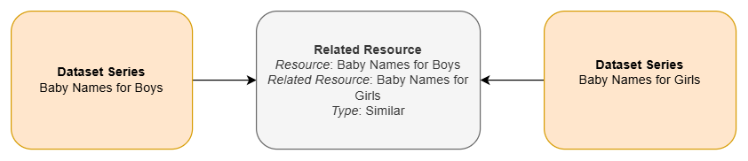
The Related Resource class is able to link resources to one another as shown above, linking two dataset series together based on their conceptual similarity. This could be used in future to show users other publications that could be of interest to them. The Type property describes how the resources are linked. The controlled vocabulary for this property hasn’t been defined yet and feedback for how this could be useful would be very welcome.

Data Service
A dataset should be served by one or more data services, and a distribution should be served by only one. Data services include APIs, servers or any collection of operations that give access to data.
As a sub-type of Resource, Data Service may also be versioned in the same way as Datasets, with an abstract higher layer pointing to the current version and a version chain built using “Replaces”. Currently, validity can be detailed in the Data Service’s Resource Description property and using Resource Status. In future this may be expanded on using a “Time Period” class which is being developed that would allow some overlap of validity.

Distribution

Download URL
The Distribution Download URL is the location that the file is downloadable from. Each distribution will likely relate to a single file so for CSV-W there should be a separate distribution and download URL for its CSV and JSON components. These are linked at the Dataset level, at the lowest level of abstraction (in general, the version will point to one or more distributions).

Distribution Description
As it is useful to have both the OpenAPI specification and the Developer Hub HTML version that is rendered from this specification, the Distribution Description should be an array of two URLs, with the first URL pointing to the OpenAPI spec and the second pointing to the HTML version.

Media Type and File Format
The Distribution Media Type is an enumerated list which encompasses most common file types (based on the IANA Media Types list. File Format is intended to be used for a file type that isn’t found in this list. If Distribution Media Type is filled out the Distribution File Format is unnecessary.

Conforms To
Conforms To refers to a standard rather than a schema. If Distribution Conforms To is used in this area, for example for a CSV that forms part of a CSV-W, it would contain the URL for the CSV-W standard (https://w3c.github.io/csvw/syntax/ for instance) rather than the URI for that file’s associated JSON.

Agent, Role and Attribution
For the dissemination domain profile there are three major roles that should be present in a dataset - the contact, publisher and contributor(s). These are created using the Agent, Role and Attribution classes described in the Metadata Model Documentation. The minimum metadata for each in this profile is the Role Name, Agent Name and Agent Email. For the publisher and contributors a homepage URL is also required. Contacts may optionally also have a phone number.
The Agent can be a named individual, a team or an organisation. Organisations require a name and a HTTP address, and teams and individuals require an email address and optionally a phone number.

Next steps
- Understand the theme and topic taxonomies and establish how a central source of truth will be maintained/mirrored.
- Produce a physical model and template schema.

Further Information & Contact Details

Additional Reading
The metadata model is based mostly on DCAT, preferring to take classes and resources from standard vocabularies and their approved extensions in this order of descending preference:
DCAT version 3 (Data Catalogue Vocabulary)
DCAT-UK (the UK Cross-Government Metadata Exchange Model)
DCAT-AP (the European implementation of DCAT)
DDI-CDI (Data Documentation Initiative Cross Domain Integration language)
Within the model each class and property clearly identifies which vocabulary it has been drawn from.
The ONS Metadata Model and domain profiles are hosted on a GitHub repository within the secure ONS Digital group (you will need an ONS Digital Account to access). This receives regular updates with a major release (currently) each Friday, though this will slow down as early development winds down and we find a more regular pace. Of particular interest within the repository are the entity definition and logical dictionary reports and the Architectural Decision Record which lists all decisions made about the model and who made them.
The repository will also host domain profiles and their documentation as they are completed, and this document as well.

Contact Us
In the first instance reach out to Samantha Iacob, Hollie Young or Kirti Tandel.

