Data Architecture : ONS Metadata Model and Domain Profiles

Governance
Approver | Role | Business Area | Date Approved
Charles Baird | Deputy Director | Data Growth and Operations – Data Architecture, Location and Indexing
Kirti Tandel | Lead Data Architect | Data Growth and Operations – Data Architecture, Location and Indexing

Version History
Version | Status | Author / Editor | Change Type | Summary of Change
0.1 | Draft | Samantha Iacob | Draft | Initial rough

Model Version Information
This document and its illustrations are based on the ONS Metadata Model version 1.3.1 (released 19 May 2026). As the model is in early development some class and property names may differ between this document and the live model, however the information about how the model works overall is unlikely to change greatly between updates. This document will be revised as the model is expanded.
For the latest version of this model please refer to the model’s GitHub repository. It is currently mirrored on SharePoint though in the longer term GitHub will become the only place this is updated.
It’s strongly recommended you register with the ONS organisation on GitHub for access to this repository and many others. For instructions on this please refer to this ServiceNow page:
(I Want Something -> 04 - Software, Applications & Platforms -> GitHub)

Table of Contents
Governance 1
Model Version Information 1
Executive Summary 3
Introduction 3
Purpose 4
Audience 4
Terminology 5
Components 5
Conceptual Metadata Model 6
Core concepts 7
Logical Metadata Model 7
Explanation of key classes 9
Series 10
Versioning 11
Actors, Roles and Attribution 12
Next Steps 12
Further Information & Contact Details 13
Additional Reading 13
Contact Us 13

Executive Summary

Introduction
The Data Architecture branch in DPSG are designing and implementing a strategic metadata framework to support data discovery, governance, quality, reuse, exchange and automation. A key part of this work includes designing a coherent enterprise-wide metadata model that defines the key classes and properties for a future metadata catalogue.
This model will furnish each business area with a tailored subset of those classes and properties, depending on their requirements. This subset, along with other supporting documentation, is known as a Domain Profile. A Domain profile constrains the model for a specific business purpose and supports technical implementation alongside their associated Domain-Specific Data Standard.
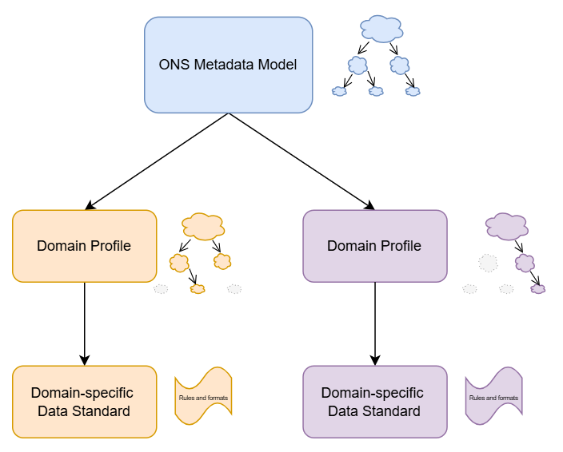
As the metadata model evolves over time under the oversight of Data Architecture Branch, the domain profiles also will feed back into the metadata model, refining and expanding it as more business areas are included.
The document focuses primarily on the ONS Metadata Model - although domain profiles will be explained briefly here, they will be covered in more detail in their separate future releases.

Purpose
The purpose of this document is to explain the ONS Metadata Model and how it meets the requirement for an enterprise-wide, standards-aligned model which can be used to develop domain profiles across the statistical production process.
The model and supporting domain profiles are intended to:
- Support consistent implementation across data platforms, pipelines, and catalogues;
- Enable governance and auditability, including provenance and versioning, and support approval tracking and agreement‑level constraints as the ONS Data Catalogue matures;
- Improve discoverability and reuse of data by providing uniform metadata structures;
- Ensure interoperability with open standards such as DCAT, DDI-CDI, DCMI, FOAF, and SKOS.
Each domain profile will be accompanied by a formal data standard for that domain which will guide technical implementation.

Audience
The intended audience for this document is:
- Data practitioners such as data architects and data engineers
- Consumers, reviewers and producers of ONS metadata. This includes, but is not limited to the following roles:
  - Business Users (all levels)
  - Strategic data roles such as Chief Data Officer (CDO) and Deputy CDO
  - Information Asset (Data) Owners

  - Data Governance Roles such as Data Domain Owner, Data Stewards, Data Custodian, Data Governance Managers
  - Data Service roles such as Data Service Owner
  - Business Analysts
  - Business Architects

  - Enterprise Architects
  - Solution Architects
  - Technical Architects
  - Operational Support
The document is intended as a short guide to the ONS Metadata Model and Domain Profiles. Some technical terms have been used which may have more meaning to the technical community in ONS. If you have any questions please reach out to the Data Architecture Branch in the first instance.

Terminology
Class has been used to describe the main entities or subjects involved in the model. These appear as boxes on the diagrams.
A Property is an attribute of a class. In the logical model these are listed inside the boxes.
A Relationship describes how two classes interact with one another. These appear as labelled lines between the boxes on the models.

The naming convention of classes and properties closely follow the DCAT vocabulary or a compatible international standard, with some adjustments to meet ONS-specific requirements at the logical modelling level. Some differences may occur as our logical modelling standards require us to name properties in a certain way, or if a particular property or class is needed to meet a requirement.

Components

The ONS Metadata Model defines standardised metadata elements, structures, and rules needed to describe data consistently across all domains. It ensures metadata captured across systems is standardised, interoperable, and ready for use in the data catalogue and across the business. It consists of Conceptual and Logical Data Models containing all classes and properties available to the business.
A Domain Profile is a specialised subset of the ONS metadata model for a particular domain, use case or a business area, and includes logical and physical data models defining the relevant metadata requirements, vocabularies, and constraints in a machine-readable way. It defines the specific, enforceable metadata requirements for a particular subject area or domain, ensuring that metadata captured within that domain is consistent, governed, and aligned to the organisation wide models and standards.
A Domain-Specific Data Standard defines the agreed rules, formats, and quality expectations for how specific types of data and metadata must be structured and recorded, ensuring consistency, interoperability, and reliable reuse across systems and dissemination processes.

Conceptual Metadata Model

A conceptual metadata model explains the structure of the catalogue using only the core concepts and the relationships between them. It isn’t detailed enough to inform a functional catalogue on its own but is designed to be easy to read and communicate:
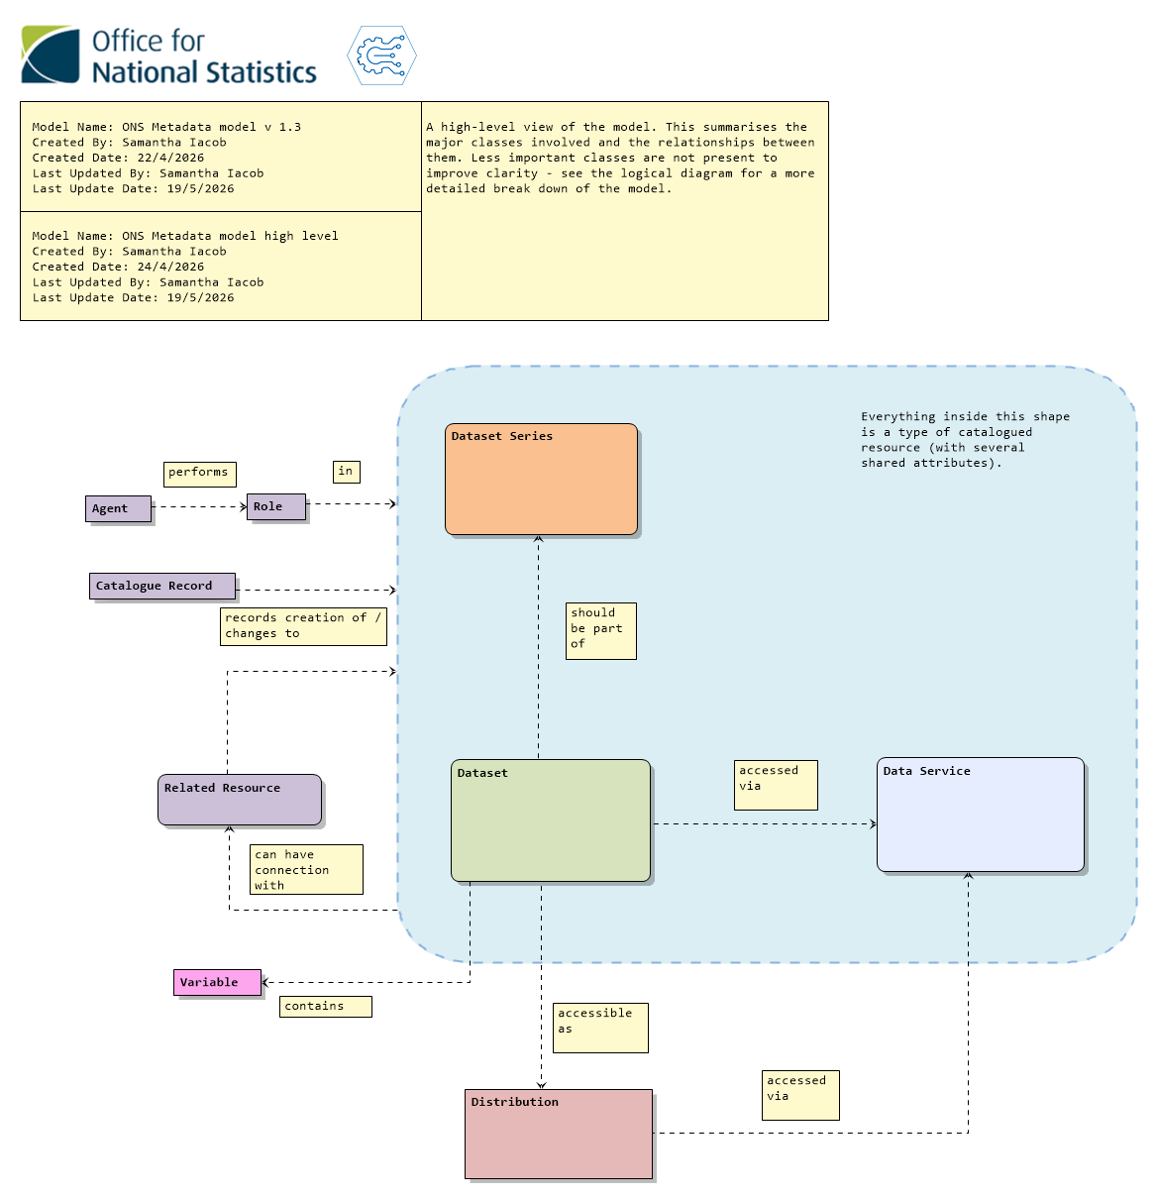

Core concepts
The catalogue is primarily focused on the classes within the filled blue area - catalogued resources. At present these are Datasets, Dataset Series, and Data Services. These have a number of similar properties which allow for them to be identified in the catalogue and for version control, and they also have access to supporting classes such as Related Resource and Actors/ Roles (these will be described in more detail later)
A Dataset in this model describes any collection of data or information. Importantly, documentation is a type of dataset. A data delivery, a table or an Excel spreadsheet are examples of datasets.
A Dataset Series is a collection of datasets that are published separately but are grouped by a shared characteristic. A regular publication would be an example. Individual datasets are also expected to belong to a Dataset Series (see below).
A Data Service in the catalogue describes a method by which data is accessed - for instance an API or storage method. SharePoint is a data service providing access to the information stored there, for instance. This area of the model is still being developed.
A dataset is accessible as one or more Distribution(s), which is a specific representation of the dataset including details of its storage location, its file size and media type.
Resources are related to one another as a Related Resource. This class links datasets to publications or dataset series to their QMI documentation for example.
A Catalogue Record reflects changes made to the entries in the catalogue rather than the resources themselves. For instance, it records when a dataset was added to the catalogue, but not when the actual dataset was published.
An Agent is a person or an organisation who carries out some Role , or function, in relation to a resource. The Population Statistics team may be the data steward of a dataset or dataset series.
For more details please see the Reports section of the model’s GitHub repository.

Logical Metadata Model
The logical metadata model explains data structures in a way that is independent of a particular technology. It’s a blueprint which incorporates business logic and which forms the basis of physical models and database/catalogue design.
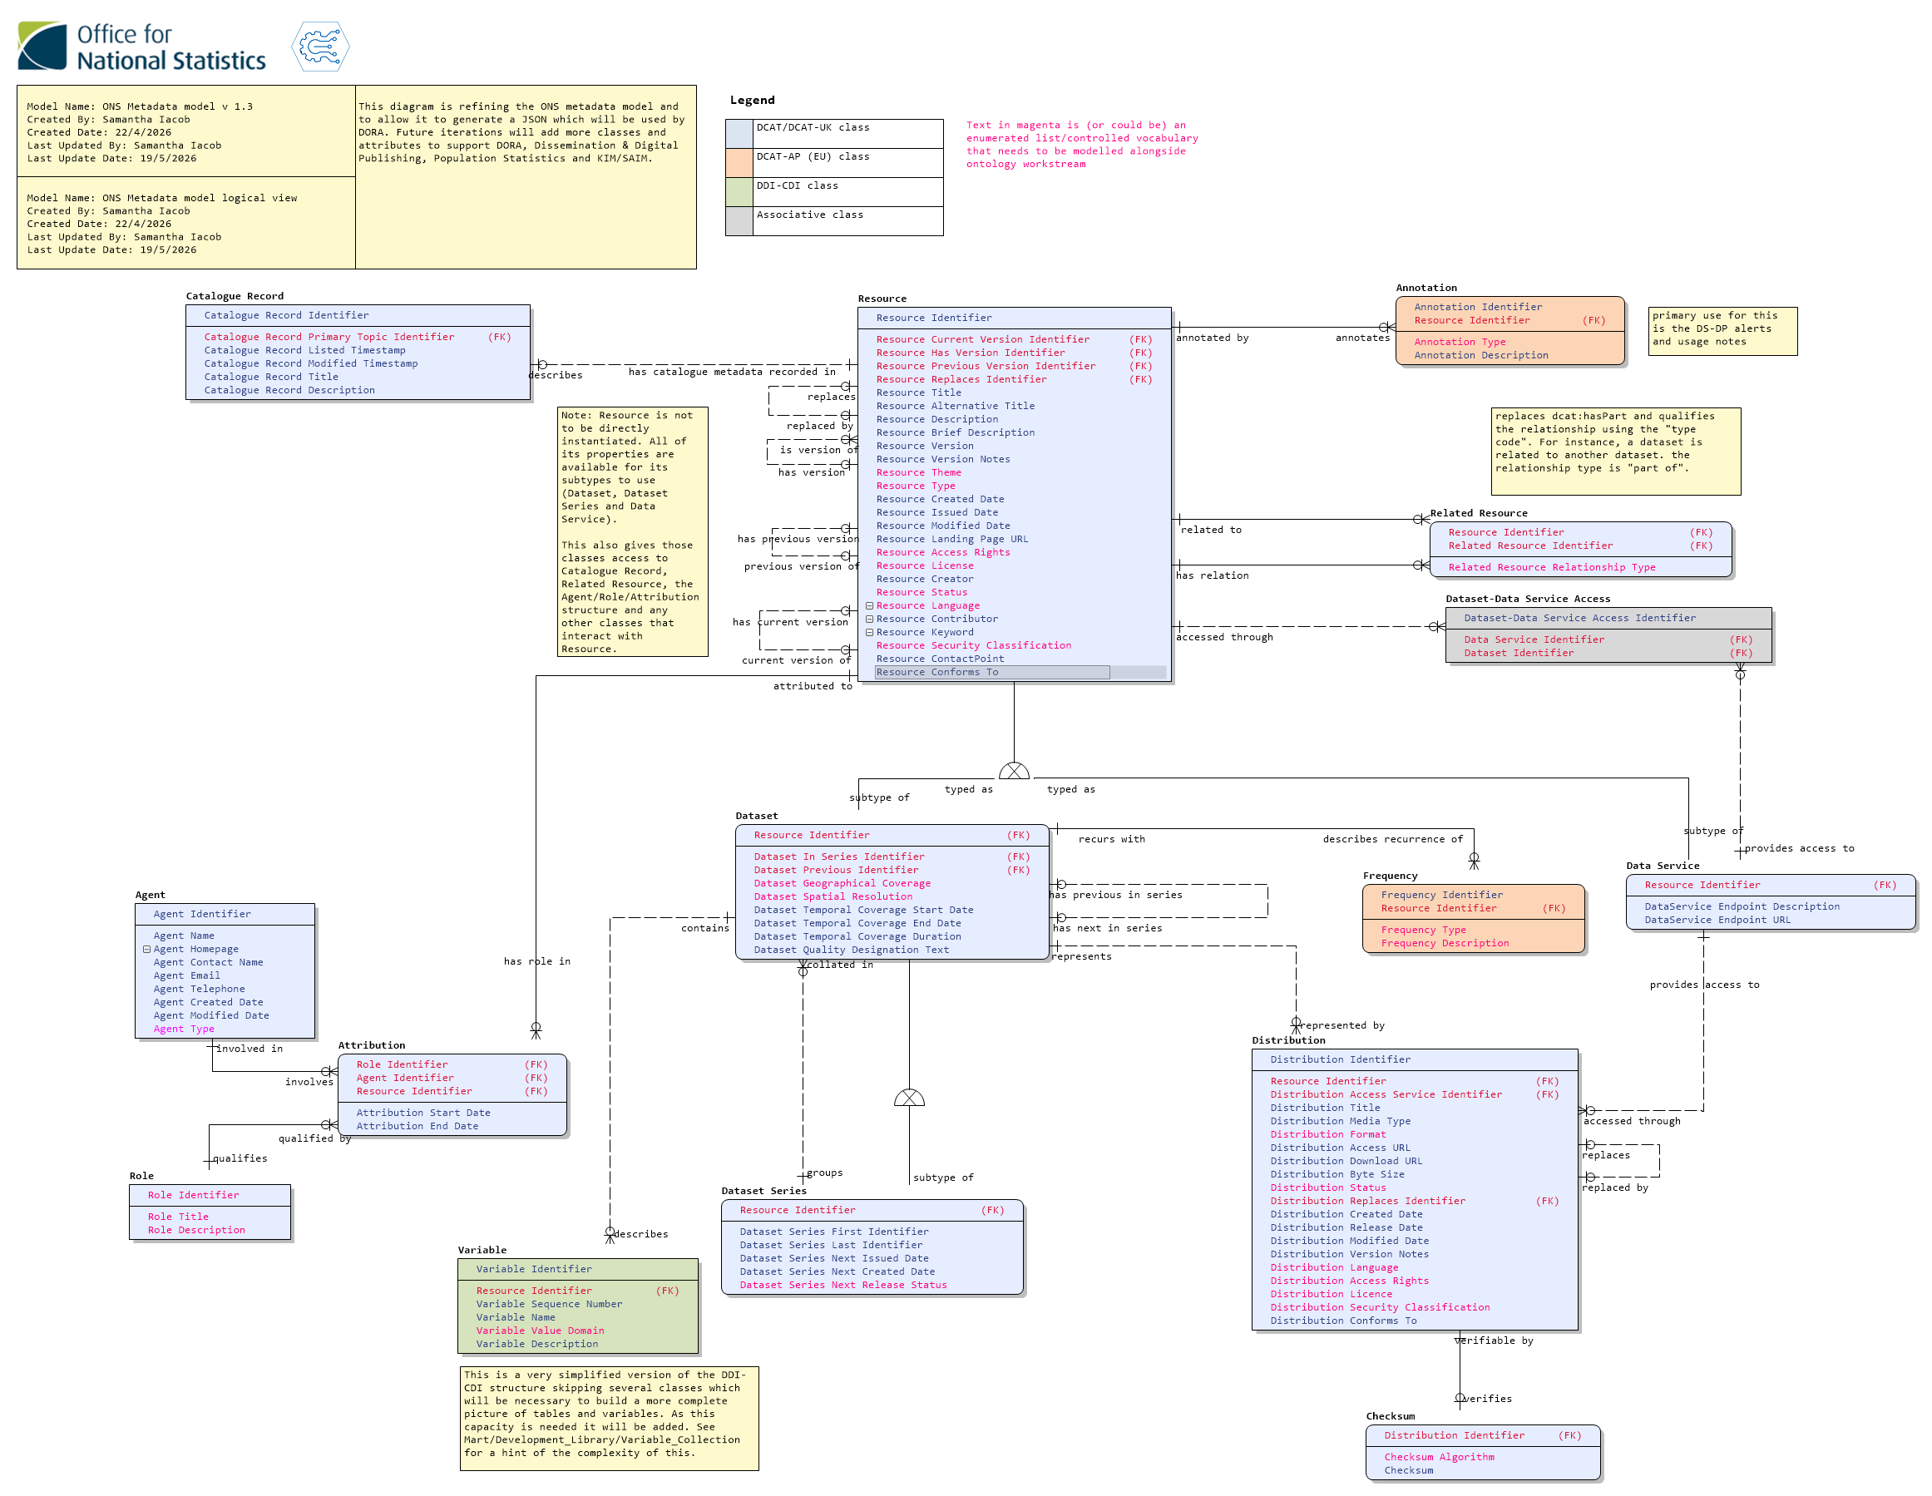

Explanation of key classes

Resource
The Resource is the largest class in the model, however it’s not intended to ever be used directly (you would never register an object of the Resource class in the catalogue). It’s a supertype which contains properties which are common to its subtypes - the Dataset and Data Service classes.
This means that a Dataset could use Title, Description, Created Date, the version identifiers, and more (what properties a dataset would actually use from Resource is defined by the relevant domain profile). Datasets and Data Services also have properties of their own, which they can use in addition to anything in Resource. Dataset Series is a subtype of Dataset, which means it can use any of its own properties, and any property available to Dataset or Resource.
Importantly, its relationships are also inherited by its subtypes. A Dataset, Dataset Series or a Data Service can have Related Resources and have associated Catalogue Records and so on.

Dataset Series
The Dataset Series is intended to be used as a container for datasets. As it can use all the properties and relationships of dataset and resource classes, it’s an appropriate place to attach high-level information that applies to every dataset belonging to a collection such as the identity of the Data Steward. It also has properties that help keep the datasets in the series organised and indicate when the series is next expected to be added to.
A Dataset Series can have different values in its properties than the individual datasets that make it up - for instance a dataset might have a temporal (time) coverage of one year but ten of them in a series together have a coverage of ten years.

Dataset
A dataset is any collection of data or information which can be accessed or downloaded. A dataset can contain datasets and we would envision a structure where a dataset is made up of one or more versions, each of which links to a distribution. See the versioning section below for an illustration of how this is intended to work.

Annotation
Annotation allows business areas to add brief notes to a resource which can be passed on to an API or other data service. Examples of an annotation are alerts which appear on a website, or usage notes for researchers.

Frequency
A dataset or dataset series may have more than one frequency of interest to the business - frequency of collection, delivery, publication and so on. This class allows multiple different types of frequency to be associated with a dataset or series.

Distribution
The Distribution contains all the details about where and how a particular representation of a dataset can be accessed. It is not considered a catalogued resource in its own right, and doesn’t have access to any resource properties or relationships.

Series
As described earlier, a Dataset Series is a container for datasets that have something in common - for instance an annual publication or monthly ingest. Throughout all domain profiles we expect that every dataset will be part of a series - even if it is a single dataset. This will provide a consistent structure across the organisation and allow a common top level when dealing with datasets that will let us attach the same kind of information (owners, associated documentation, etc) at the same level in the catalogue. This will be expanded on in the domain profiles.
Dataset series work by indicating the first and last datasets in the series (these may be the same dataset in practice). Each dataset in the series identifies the series it belongs to, and the previous and next in the series. This allows a chain to be built.

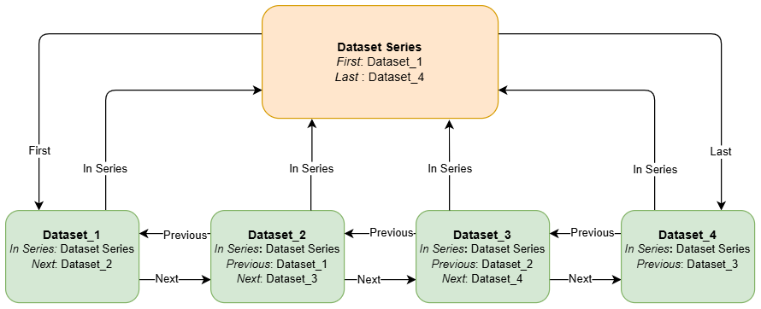

A single dataset which is alone in a series will not have a value assigned to Previous or Next. The Dataset Series to which it belongs will identify that dataset as the First and Last.

Versioning
This model provides two different methods of versioning, version and replace. Properties relating to these are found in the Resource class and are available to all catalogued resources. Distributions only have the replace method available.

Version method
The typical method of version control used for datasets where previous versions are preserved and intended to be accessible. This involves datasets being constructed in two layers - an abstract layer which acts as a container for all of its versions and points to its latest version using the properties Has Version and Current Version, and the individual versions in the lower layer linked to one another with Previous Version.
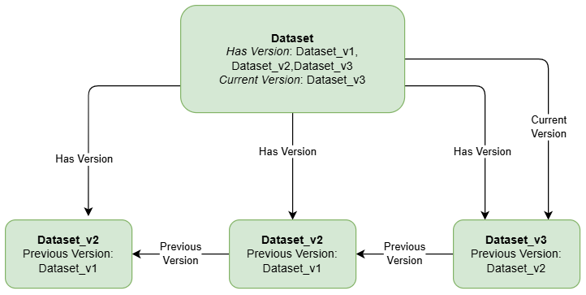
This will create a minimal version chain. The versions can be further fleshed out with a version name or number and version notes using the appropriate properties.

Replace method
Replace is used in the same way but only where a new version completely supersedes or replaces the other and the previous version isn’t intended to be accessed or preserved. It uses the property Replaces rather than Previous Version. While it is available to datasets depending on the domain profile it is mainly expected to be used in distributions where a change in distribution completely replaces the file that will be accessed. It doesn’t necessarily imply a version chain so shouldn’t be used if the version chain is important.
For more in-depth information please see the DCAT explanation of versioning.

Actors, Roles and Attribution
The Attribution system allows for any number of roles (activities) and agents (people, teams and organisations) to be related to a catalogued resource. The attribution class enables basic tracking of the validity of an attribution as well - for instance if it has an end date, we know that person is no longer performing that role.

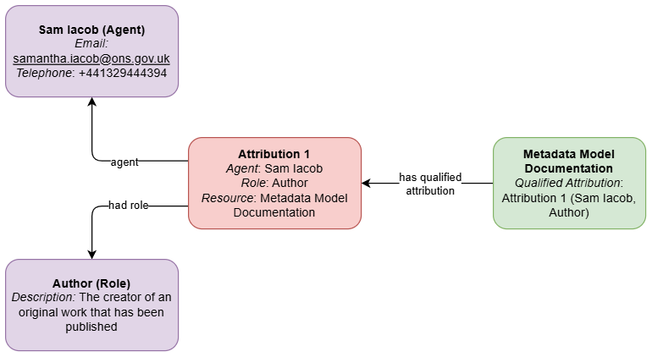
In addition there are currently some “hard-coded” roles in the Resource class - Contact Point, Creator and Contributor. These properties provide a simple way to note down the details of key individuals in a “who do I email about this dataset” kind of way without the need to instantiate an agent, role and attribution. However, it may be preferable to use the full attribution system as well for these properties. This is likely to be developed further in the future.

Next Steps
The model is currently being developed by the Enterprise Metadata Management team in the Data Architecture Branch. Aside from expanding the classes and properties to meet requirements of the business areas wanting to align their systems with the ONS Metadata Model and building domain profiles for those areas, a non-exhaustive lists of next steps includes:
- Solidifying the Data Service class
- Building out controlled vocabularies, especially type lists
- Developing a Documentation model (or deciding not to do that)
- Creating domain profiles

Further Information & Contact Details

Additional Reading
The metadata model is based mostly on DCAT, preferring to take classes and resources from standard vocabularies and their approved extensions in this order of descending preference:
DCAT-UK (the UK Cross-Government Metadata Exchange Model)
DCAT version 3 (Data Catalogue Vocabulary)
DCAT-AP (the European implementation of DCAT)
DDI-CDI (Data Documentation Initiative Cross Domain Integration language)
Within the model each class and property clearly identifies which vocabulary it has been drawn from.
The ONS Metadata Model is hosted on a GitHub repository within the secure ONS Digital group (you will need an ONS Digital Account to access this). This receives regular updates with a major release (currently) each Friday, though this will slow down as early development winds down and we find a more regular pace. Of particular interest within the repository are the entity definition and logical dictionary reports and the Architectural Decision Record which lists all decisions made about the model and who made them.
The repository will also host domain profiles and their documentation as they are completed, and this document as well.
For now a copy of the model diagrams, reports and documents can be found on the EMM SharePoint.

Contact Us
In the first instance reach out to Samantha Iacob, Hollie Young or Kirti Tandel.

