Data Architecture :

Dissemination/ Digital Publishing Domain Profile Documentation

Governance
Approver | Role | Business Area | Date Approved
Charles Baird | Deputy Director | Data Growth and Operations – Data Architecture, Location and Indexing
Kirti Tandel | Lead Data Architect | Data Growth and Operations – Data Architecture, Location and Indexing

Version History
Version | Status | Author / Editor | Change Type | Summary of Change
0.1 | Draft | Samantha Iacob | Draft | Initial very rough draft

Model Version Information
This document is currently based on the ONS Metadata Model version 1.4 (released 22 May 2026). This model is in early development so some class and property names may differ between this document and the live model and domain profile for Dissemination / Digital Publishing.
For the latest version of this domain profile please refer to the model’s GitHub repository. It is currently mirrored on SharePoint though in the longer term GitHub will become the only place this is updated.
It’s strongly recommended you register with the ONS organisation on GitHub for access to this repository and many others. For instructions on this please refer to this ServiceNow page:
(I Want Something -> 04 - Software, Applications & Platforms -> GitHub)

Table of Contents
Governance 1
Model Version Information 1
Purpose 2
Conceptual metadata model for DS-DP 3
Logical metadata model for DS-DP 4
Instance diagram for typical dataset 5
Instance diagram notes 6
Minimal published dataset structure 7
Documentation 8
Linking a resource to a document using Related Resource 8
Instance diagram with (some) properties 9
Next steps 10
Further Information & Contact Details 10
Additional Reading 10
Contact Us 10

Purpose
This document details a Domain Profile, which is a subset of the overall metadata model tailored for a particular part of the statistical production process. As such it doesn’t discuss the model more generally or go into detail on areas which are common to all domains (such as versioning using the model, how agents, roles and attributions work or what the major classes are). It also doesn’t have any detail on concepts such as modelling levels or what a domain profile is. It’s recommended that you first read the Metadata Model Documentation which is available in the GitHub repository or the SharePoint, linked above.
Please note that this is an early draft which will be expanded on, for now it is incomplete but should still be of use to anyone trying to understand how the metadata model will apply to the dissemination and digital publishing space.

Conceptual metadata model for DS-DP
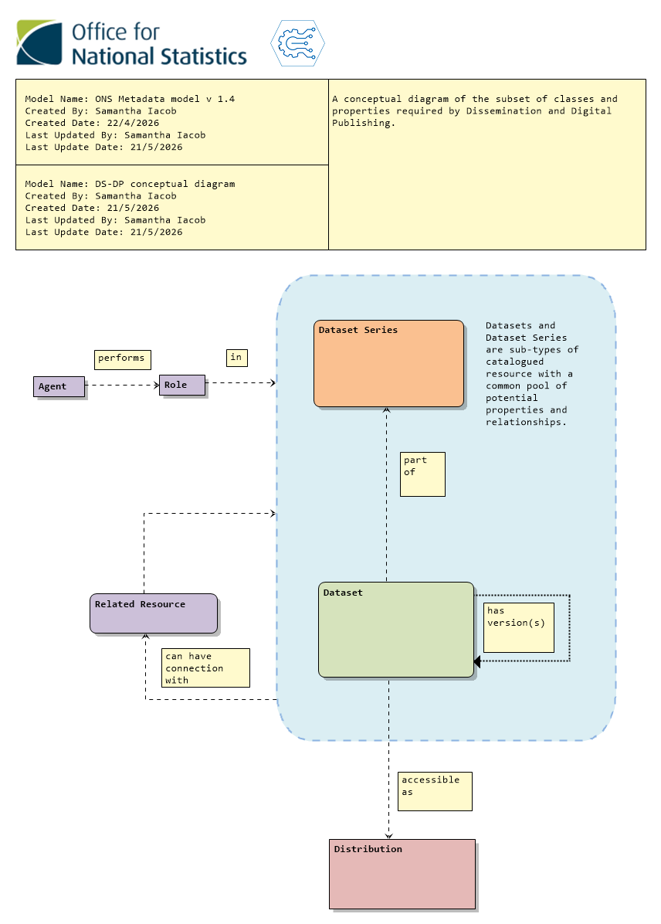

Logical metadata model for DS-DP
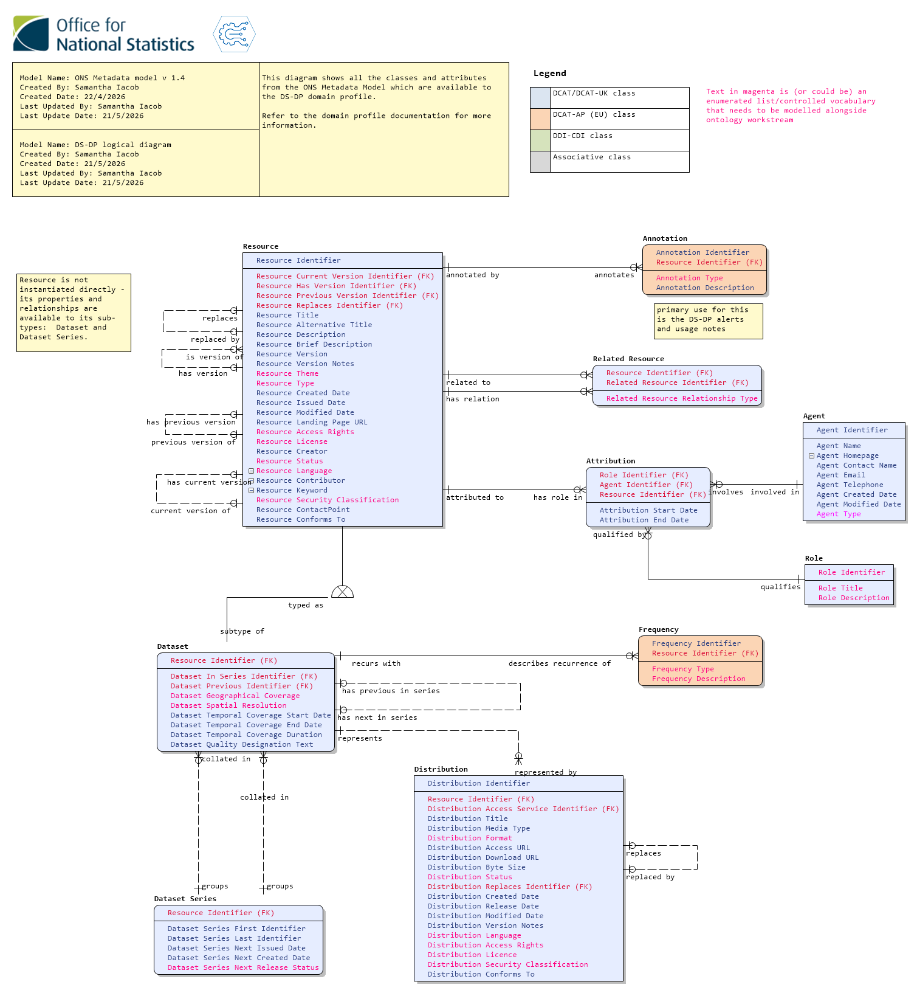

Instance diagram for typical dataset
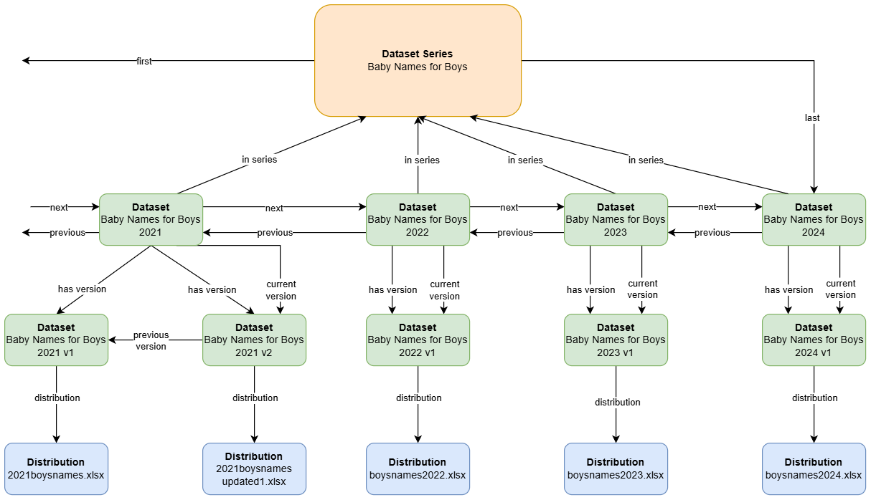

Instance diagram notes
This instance diagram shows only the relationships between dataset series, datasets and distributions in a typical publication on the ONS website. It doesn’t display the other properties which are expected to be populated at the various levels.
The top level is the dataset series level which corresponds to https://www.ons.gov.uk/peoplepopulationandcommunity/birthsdeathsandmarriages/livebirths/datasets/babynamesenglandandwalesbabynamesstatisticsboys . This is what the website calls a dataset. A dataset series can be identified as it will have “first” and “last” identifiers corresponding to the first and last datasets in the series.
The next level down is the annual/regularly published datasets, which are named editions on the website. An example is the 2021 Edition which can be found here: https://www.ons.gov.uk/peoplepopulationandcommunity/birthsdeathsandmarriages/livebirths/datasets/babynamesenglandandwalesbabynamesstatisticsboys/2021 . These can be identified as they will have an “in series” identifier, showing which series they belong to.
Below this are what are called versions on the website. These can be identified by the “distribution” identifier, which points to a particular accessible representation of the dataset. It’s expected that all datasets will have at least one version but can have more. Versions are linked to their immediately preceding version using the “previous version” identifier. This allows a version chain to be built.
At the bottom of the instance diagram are the distributions which provide a link to the downloadable file and some additional metadata (file size, name, etc). Each version of a published dataset must have at least one distribution.

Minimal published dataset structure
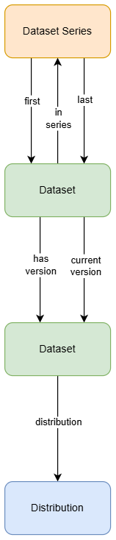

All published datasets must have the minimal structure of a dataset series, two levels of dataset (a dataset that contains all its versions and points to the latest version), and a distribution.
Even if there is only one dataset in a series and a single version this will allow the series and versions to expand over time as needed. It provides a consistent structure that allows certain properties to be completed at certain levels (for instance, QMI documentation and the actors and roles associated with a dataset will sit at the dataset series level, and version notes will sit at the lower dataset level).

Documentation
All documentation is treated as a dataset (an accessible collection of information or data published or curated by a single agent) in its own right in this model. It is an exception to the above structure as documentation is not required to belong to a series or necessarily have a distribution that is captured by the domain profile. At a minimum it should be instantiated as a dataset with the following properties:
- Title
- Description
- Type (Documentation)
- Created Date
- Issued Date
- Modified Date
- Landing Page URL
- Access Rights
- Licence
- Creator
- Status
- Language
- Security Classification
- Contact Point
If it’s possible or desirable to hold metadata about the document itself (for instance its format, then it can be associated with a distribution like any other dataset. Access rights, security and licence information can be stored at the distribution level instead if desirable.

Linking a resource to a document using Related Resource
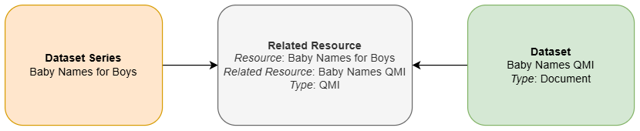
The Related Resource class is able to link resources (datasets and dataset series) to one another as shown above. Common link types can be selected in the Related Resource class’s Type property. Non-document links may include “part of” to show that a dataset is part of another dataset (perhaps a publication) or “used in” to demonstrate usage of some kind. These types need to be fleshed out as they are the main way to link datasets and documents together outside of the dataset series -> dataset -> dataset (version) -> distribution structure.

Instance diagram with (some) properties
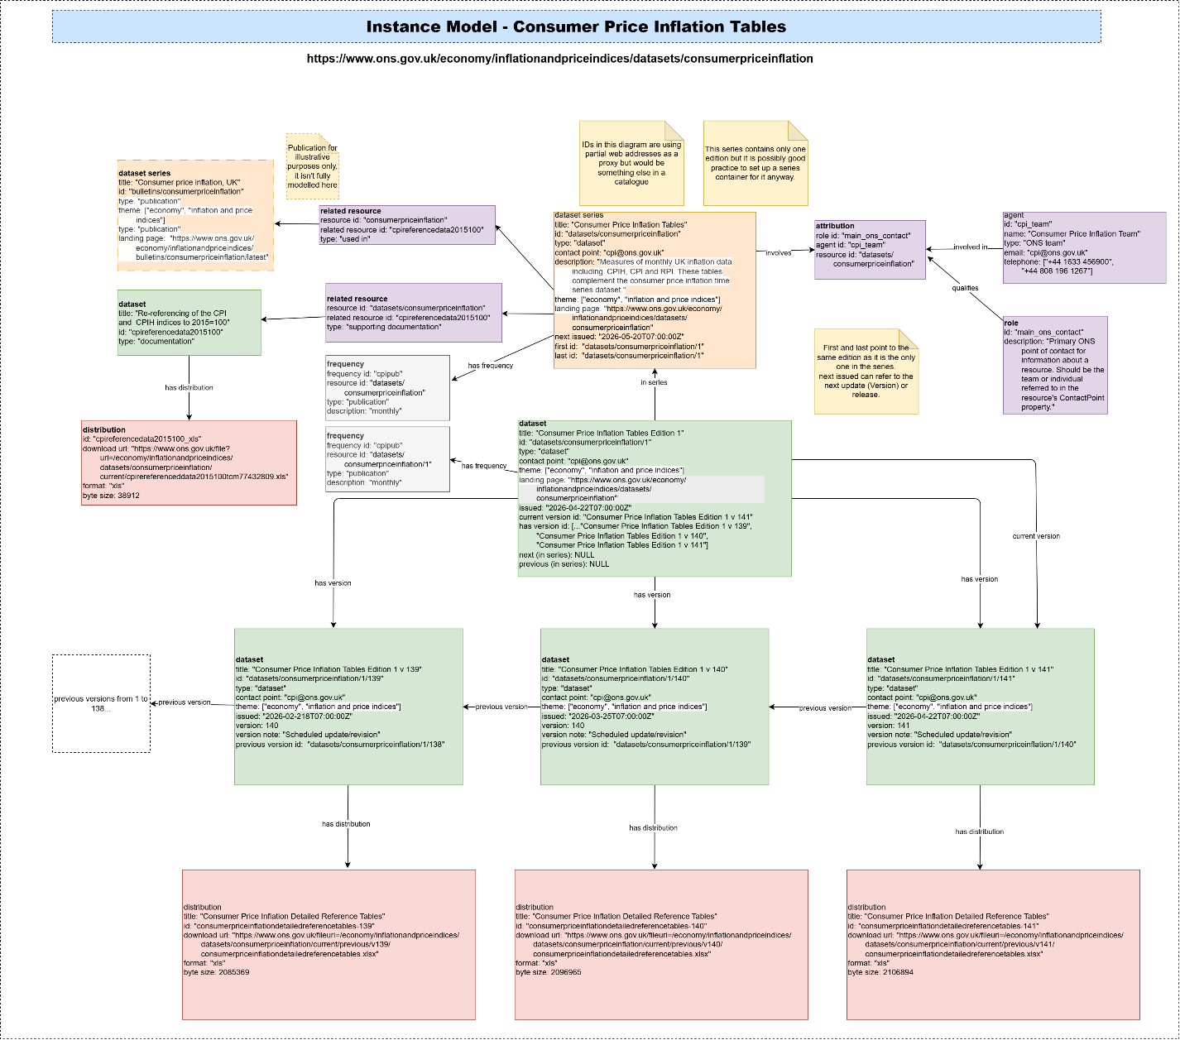
This draft shows a portion of a relatively uncommon publication type - with only one edition-level dataset and numerous versions. It shows how documents and other resources could be associated with the CPI tables and displays an attributed role. While it is not complete it should provide a basic illustration of the working of the model and form a basis for further conversation.

Next steps
- Gather initial feedback on this and the metadata model documentation.
- Improve the more complex instance diagram
- Produce a complete list of the properties expected for each class at each “level” where applicable (for instance edition and version)

Further Information & Contact Details

Additional Reading
The metadata model is based mostly on DCAT, preferring to take classes and resources from standard vocabularies and their approved extensions in this order of descending preference:
DCAT-UK (the UK Cross-Government Metadata Exchange Model)
DCAT version 3 (Data Catalogue Vocabulary)
DCAT-AP (the European implementation of DCAT)
DDI-CDI (Data Documentation Initiative Cross Domain Integration language)
Within the model each class and property clearly identifies which vocabulary it has been drawn from.
The ONS Metadata Model and domain profiles are hosted on a GitHub repository within the secure ONS Digital group (you will need an ONS Digital Account to access). This receives regular updates with a major release (currently) each Friday, though this will slow down as early development winds down and we find a more regular pace. Of particular interest within the repository are the entity definition and logical dictionary reports and the Architectural Decision Record which lists all decisions made about the model and who made them.
The repository will also host domain profiles and their documentation as they are completed, and this document as well.

Contact Us
In the first instance reach out to Samantha Iacob, Hollie Young or Kirti Tandel.

