**Scoring Algorithm**

1. Read model quantiles $q$ and corresponding values $v$ from the dataset for a forecast date $d$, target end date $t$ and model $m$ along with $G$ the corresponding ground truth.
2. Generate 1D grid **V** for **v** such that **V** = [floor(vmin)+0.5 : ceil(vmax)-0.5] and each grid point is separated by dV=1 (I want a small dV and I want to keep it the same across all model forecasts).
3. Calculate **Q** corresponding to **V** based on interpolation (e.g. linear or PCHIP) of **q**.
4. Find the numerical derivative $f = dQ/dV$ (e.g. Python np.gradient(Q,V)). This is the pdf.
5. Find the grid points Vi and Vi+1 thatG the true value falls.
   1. If both grid points are available, then define p(G) = dV $\frac{f\left(V_{i+1}\right)+f(V_{i})}{2}$* .
   2. Else assign p(G) = 0 (although this probability is non-zero, it is significantly small).
6. The score S is then $S_{m,d,t}=\log{p(G)}$, such that larger score means higher fitness.

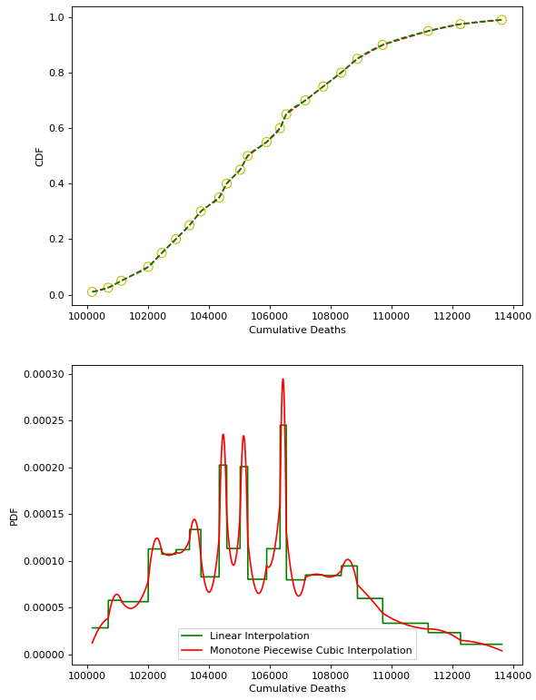

Figure 1: Example interpolation schemes

With this algorithm we penalize models with large prediction intervals. When we integrate the obtained pdf p and compare with the provided cdf, we see the difference between the two is small.

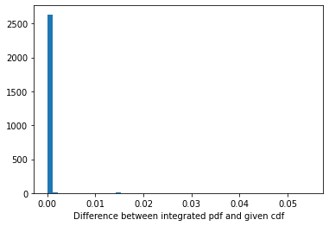

**Caveats:**

1. We assign -Inf for some $S_{m,d,t}$ when the reported prediction quantiles do not encompass the ground truth G. When reporting average scores, we use *nanmean* and do not penalize models for completely missing the ground truth.
2. When reporting average forward score for a model, we give equal weights to forecasts made earlier in time. For example, if a model m made a forecast on di,di+1, and di+2 for a particular target date t, our average forward score is the average of $\left\{S_{m,d_{i},t},S_{m,d_{i+1},t},S_{m,d_{i+2},t}\right\}$.