CSIP5101_2024_601
Database Systems and Design

Database design and Implementation (EER Modelling and SQL)

BSTM ACTIVE SCENARIO

Table of Contents
Stage 1: Scenario and Conceptual Database Design 3
Task 1: Bstm Active Scenario 3
Task 2: Conceptual Database Design 6
2.1: EER Diagram 6
2.2 List of Assumptions 7
2.3 Enterprise Rules 8
Stage 2: Logical Database Design and Oracle SQL Implementation/Querying 9
Task 3: Logical Database Design for Scenario 9
Task 4: Create the tables using Oracle DBMS 9
Task 5: Data Population 10
Task 6: SQL Query Writing 12
Stage 3: Argument 14
Task 7: Importance of Data-Centred Approach 14
References 15
Appendix 16
Conditions Used 19

Stage 1: Scenario and Conceptual Database Design
Task 1: Bstm Active Scenario
BSTM Active is a national leisure contractor with the mission of encouraging everyone to engage in physical activities for at least 45 minutes, seven times a week. The company operates leisure centres across the country, in collaboration with more than 10 local authorities. These centres are equipped with various facilities, including state-of-the-art gyms, Olympic-sized swimming pools, and water parks, that cater for different customer needs, such as professional athletes, families, and casual visitors.
There are other services offered which include personal training, professional swimming facilities, and group exercise classes. The company’s offerings are designed to accommodate both individual and group activities, providing options for all ages and fitness levels. The company allows flexibility in payment, offering either pay-as-you-go options or long-term membership contracts.

Operations for Database Support:
To effectively manage the complex operations of BSTM Active, a robust database system is required. The database should support the following key operations:

1. Membership and Client Management: The database needs to manage member profiles, including personal information, membership types (pay-as-you-go or long-term contracts), and activity preferences (gym, swimming, group classes, etc.). There should also be tracking for attendance and payments.

2. Facility and Service Scheduling: BSTM Active offers services such as personal training sessions, group classes, and water park access. The database should track the availability of these services, allowing members to book sessions, and ensuring that personal trainers, swimming lanes, and exercise classes are properly scheduled.

3. Staff Management: BSTM Active employs personal trainers, instructors, and other staff across the other centres. The database should handle staff information, such as qualifications, availability, and schedules, ensuring that the right personnel are assigned to various activities.

4. Facility Information and Usage: Each centre has different facilities, such as gyms, swimming pools, and water parks. The database should keep track of these facilities, their usage rates, and maintenance schedules. It should also ensure that equipment is well-maintained and available to clients.

5. Partnerships with Local Authorities: Since BSTM Active works with local authorities, the database should track these partnerships, including the terms of agreements, performance metrics, and financial transactions related to these collaborations.

Scenario Description
A new Customer named Kate Graham registers with BSTM Active by providing her personal details, which are inserted into the Customers table. After registration, she selects a premium membership, prompting the system to retrieve her CustomerID and insert a new record in the Memberships table.

When querying available facilities, the system selects all records from the Facilities table, including their associated BranchID. Kate then decides to enroll in a yoga class, leading the system to retrieve the class details from the Classes table and insert an enrollment record linking her CustomerID to the ClassID.

She makes a payment for her premium membership, resulting in a new transaction record being inserted into the Transactions table with her CustomerID, payment amount, date, and method. Finally, when Kate wishes to view her past transactions, the system selects all transaction records from the Transactions table associated with her CustomerID.

Summative Scenarios for BSTM Active
- Customer Registration: A new customer named Kate registers with BSTM Active by providing her personal details, which are then inserted into the Customer table.

- Membership Enrollment: After her registration, Kate selects a premium membership. The system retrieves her CustomerID from the Customer table and inserts a new record in the Memberships table to link her CustomerID to the premium membership.

- Facility Information Query: A Customer queries available facilities at BSTM Active, prompting the system to select all records from the Facilities table, including their associated BranchID.

- Class Enrollment: Kate decides to enroll in a yoga class. The system retrieves the class details from the Classestable, including the FacilityID, and then inserts an enrollment record (assuming a ClassRegistrations table) linking Kate's CustomerID to the FACILTYID.

- Making a Payment: Kate makes a payment for her premium membership. The system inserts a new transaction record into the Transactions table with her CustomerID, payment amount, date, and payment method.

- Viewing Transaction History: Kate wants to view her past transactions. The system selects all transaction records from the Transactions table that are associated with her CustomerID.

Detailed Database Operations
These operations detail the specific actions needed to support the scenario above:
- Insert New Customer: Insert Kate's personal details into the Customers table.
- Retrieve CustomerID: Retrieve Kate's CustomerID from the Customers table using her email.
- Insert Membership: Insert a new record in the Memberships table linking Kate's CustomerID to a premium membership.
- Query Available Facilities: Select all records from the Facilities table, including their associated BranchID.
- Retrieve Class Details: Retrieve details of the yoga class from the Classes table.
- Insert Class Enrollment: Insert an enrollment record linking Kate's CustomerID to the ClassID of the yoga class.
- Insert Transaction: Insert a new transaction record into the Payments table for Kate's premium membership payment.
- Query Transaction History: Select all transaction records from the Payments table associated with Kate's CustomerID.
These operations detail the specific actions needed to support the scenario involving Customer registration, membership enrollment, facility queries, class enrollment, payment processing, and transaction history retrieval.

Task 2: Conceptual Database Design
Entities and Relationships:
The database will involve at least four strong entities, such as:
- Customer (Strong Entity): Contains customers personal details like Name, Address, Phone number.
- Staff (Strong Entity): Tracking managers, personal trainers, instructors, and support staff, their qualifications, and schedules.
- Branch (Strong Entity): Contains information like branchID, name and location.
- Vendors (Strong Entity): Details of partnerships, including contact information and agreement terms.
- Membership: Storing details of individual customers, their membership type, and subscription length.
- Payment: Contains information about amount, date and payment method.
- Manager: Contains information on name, department and branch.
- Facilities: Information on gyms, swimming pools, water parks, and maintenance schedules.

The system will also incorporate a specialisation: generalisation structure for staff, where managers, personal trainers, group class instructors, and administrative staff are specialisations under a general “Staff” entity.

2.1: EER Diagram
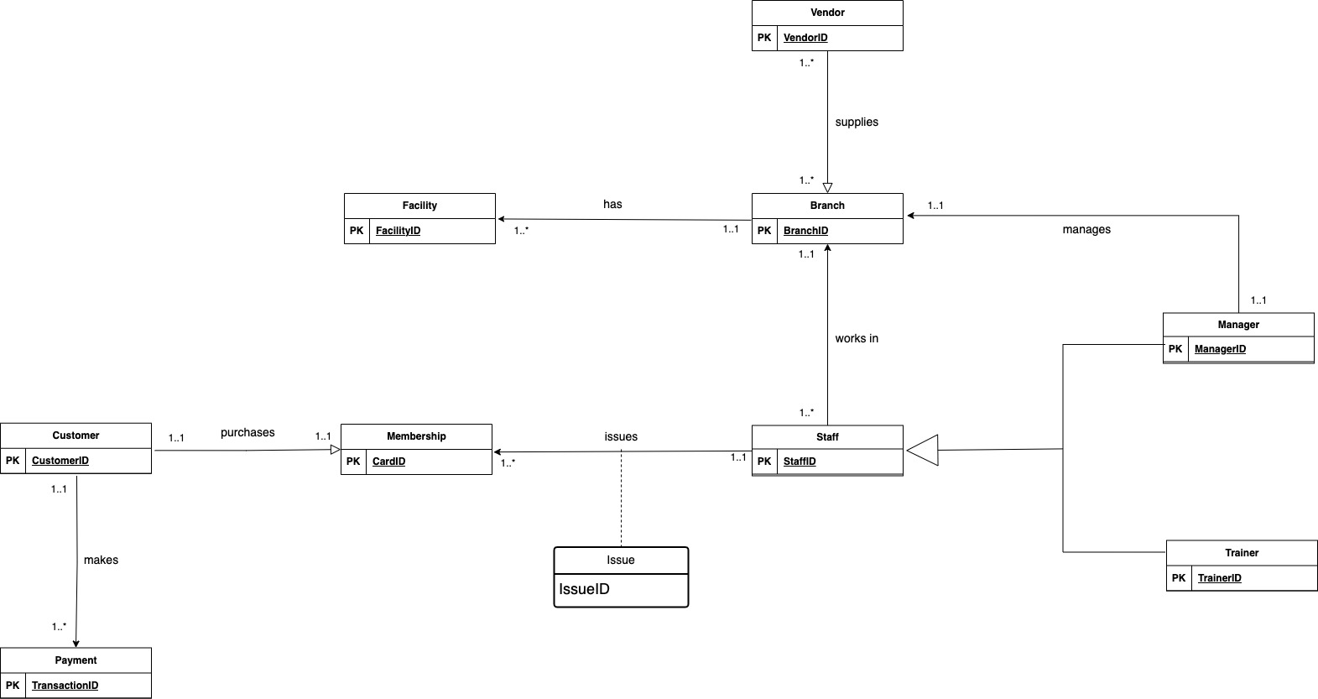

2.2 List of Assumptions
Below are some assumptions made during the conceptual database design for BSTM Active and its systems
- User Registration:
  - All users must provide valid personal information (name, email, phone, date of birth) during registration.
  - Users can register online or in person at any of the leisure centers.
- Membership Types:
  - Memberships are available in multiple types (e.g., Premium, Standard), each with specific benefits and pricing.
  - Users can only hold one active membership at a time.
- Payment Processing:
  - Users have access to various payment methods (e.g., credit card, cash).
  - All payments are processed securely and immediately reflected in the transaction history.
- Facilities and Classes:
  - Each facility has a defined capacity that cannot be exceeded.
  - Users must enroll in classes in advance to secure their spot.
- Transactions:
  - Each transaction is linked to a specific user and corresponds to a service (e.g., membership fee, class fee).
  - Transaction records are stored indefinitely for accounting and user reference.
- Staff Roles:
  - Staff members can have different roles (e.g., manager, trainer) that define their responsibilities and access levels.
- Branches:
  - Each facility is associated with a specific branch, and facilities cannot operate independently of their branches.
  - The branch location and contact information are assumed to be accurate and up-to-date.
- Feedback and Support:
  - Users can provide feedback and seek support for issues related to memberships, facilities, and classes, though this is not directly captured in the current schema.
- System Accessibility:
  - The system is accessible via various devices (e.g., computers, smartphones) to facilitate user interactions.
  - Users can view their membership status, transaction history, and class schedules online.

2.3 Enterprise Rules
Below are diagrams that represent the enterprise rules as displayed in the EER Diagram

Staff
Manager
Trainer
Staff is divided into two Manager and Trainer, a TopDown approach
Manager | 1..1 manages 1..1 | Branch |  | Vendor | 1..* supplies 1..* | Branch
A manager manages one branch A vendor can supply one or many branches
A branch is managed by one manager Many branches can be supplied by one or many vendors
Staff | 1..1 issues 1..* | Membership |  | Branch | 1..1 has 1..* | Facilty
A staff can issue one or many memberships A branch has one or many facilities
Many memberships can be issued by one staff
Customer | 1..1 purchases 1..1 | Membership |  | Staff | 1..* works in 1..1 | Branch
A customer can purchase one membership A staff works in one branch
A membership can be purchased by one customer A branch is worked by one or many staff
Customer | 1..1 | makes | 1..* | Payment
A customer can make one or many payments

Stage 2: Logical Database Design and Oracle SQL Implementation/Querying

Task 3: Logical Database Design for Scenario
Customer: customerID, FirstName, LastName, Address, PhoneNumber, ActivityPreference
Staff: staffID, FirstName, LastName, Role, Qualification, Salary
Branch: branchID, BranchName, BranchLocation, PostCode
Vendor: vendorID, ServiceRendered, ContractLength, PaymentPeriod
Manager: managerID, FullName, Department, BranchLocation, StaffID(FK)
Membership: membershipcardID, MembershipType, SubscriptionLength, CustomerID(FK)
Payment: transactionID, PaymentMethod, AmountPaid, PaymentDate, CustomerID(FK)
Facility: facilityID, FacilityType, Capacity, MaintenanceSchedule

*Primary keys are in bold and underlined and in blue colour
*Foreign keys are in bold and italics

Task 4: Create the tables using Oracle DBMS
- Create Customer Table
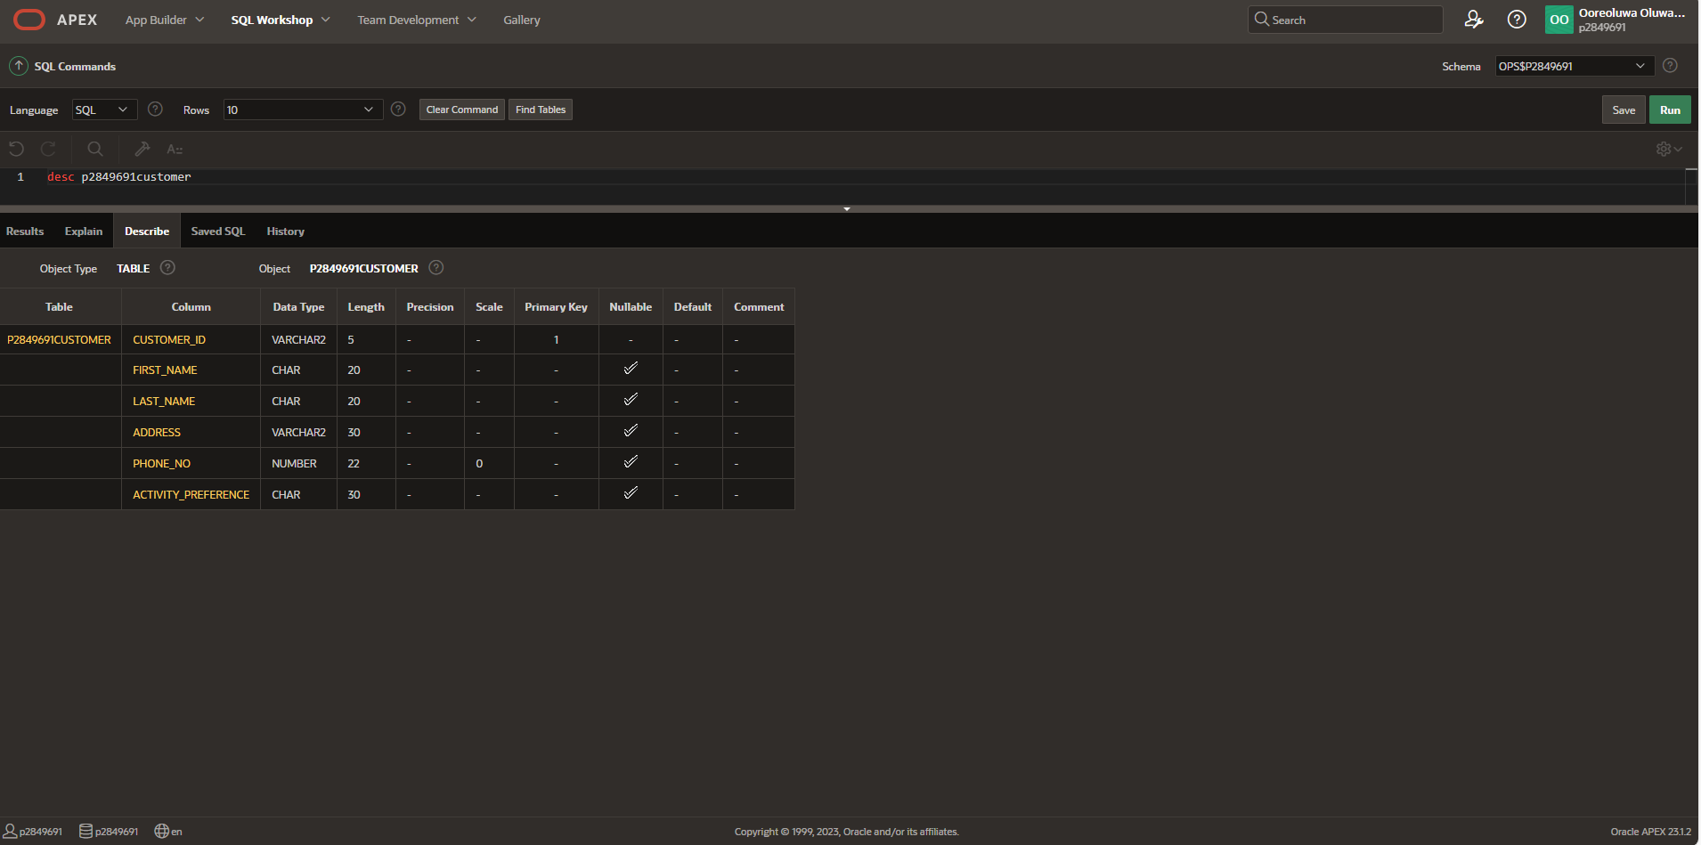
- Create Staff Table
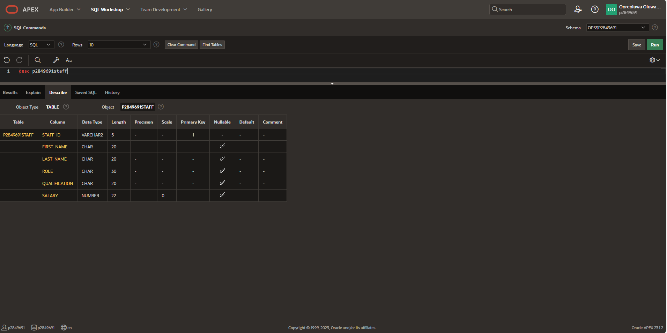
- Create Branch Table
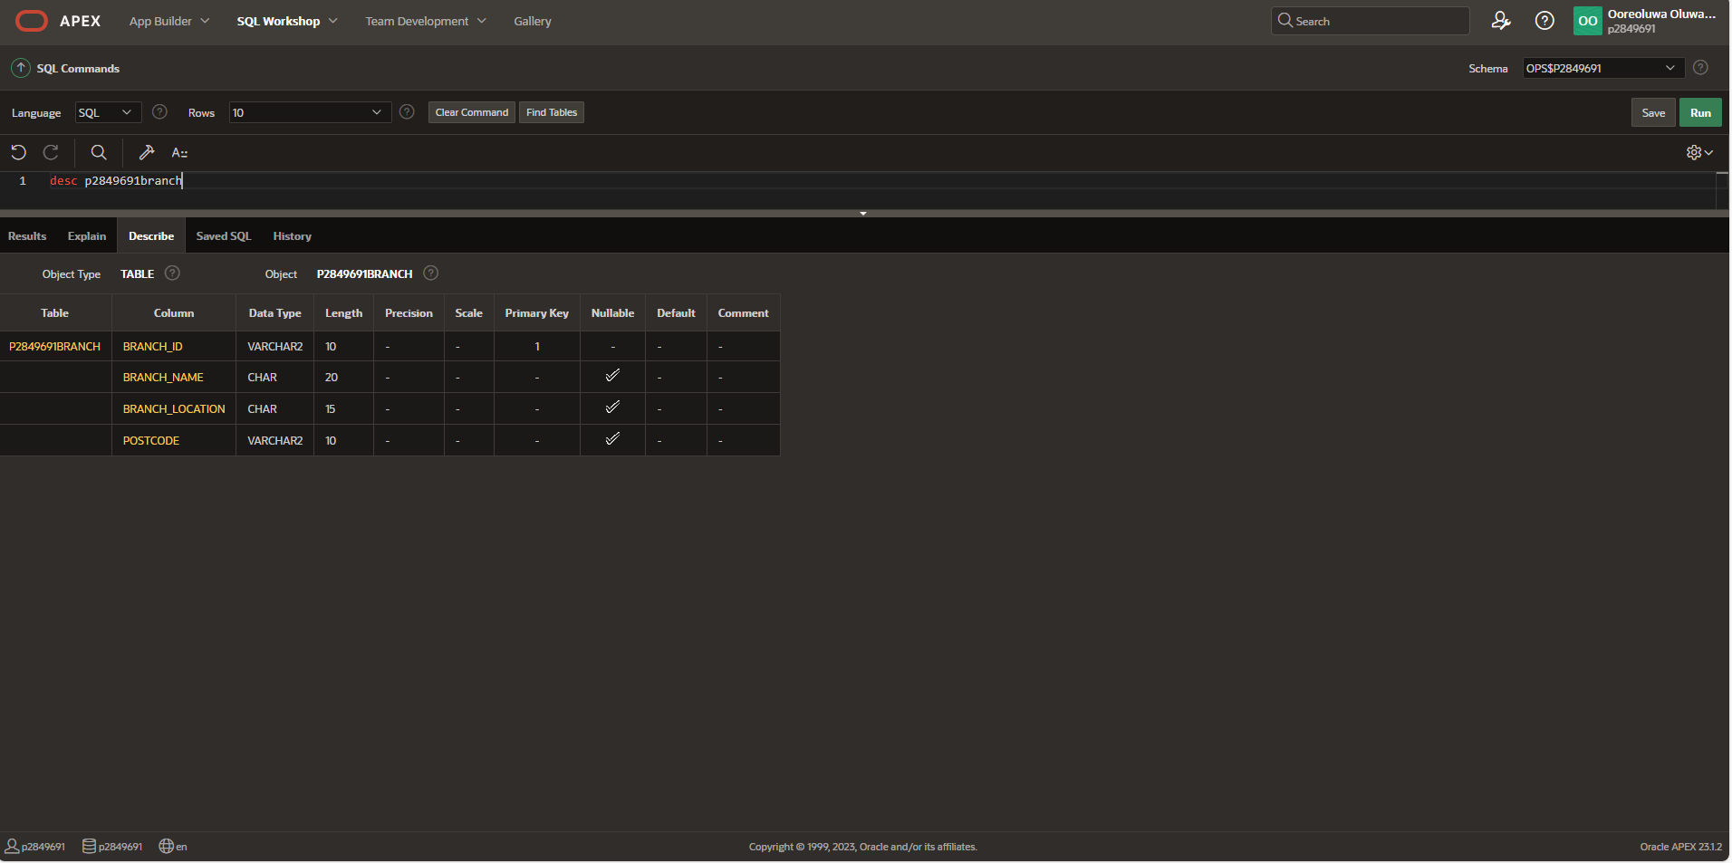
- Create Vendor Table
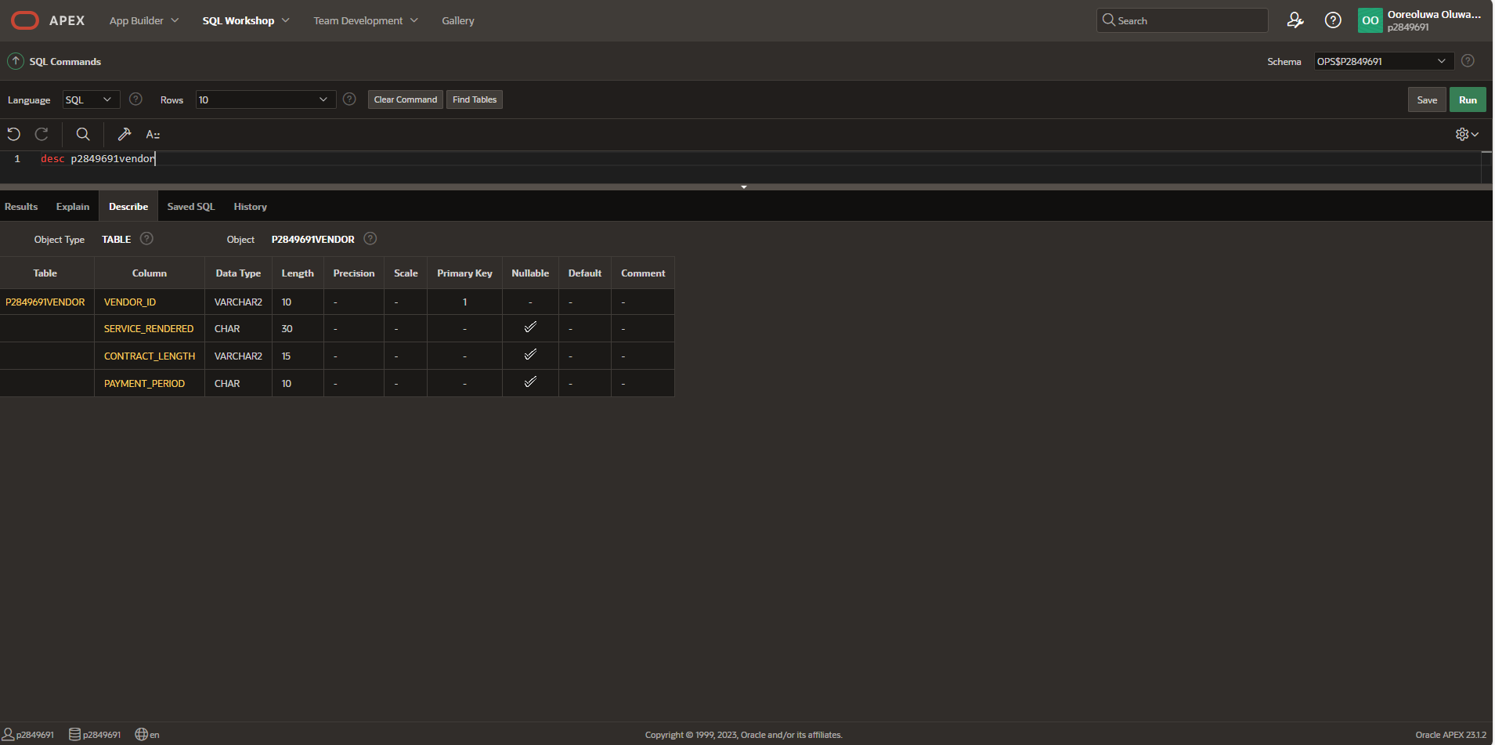

Task 5: Data Population
Customer Table
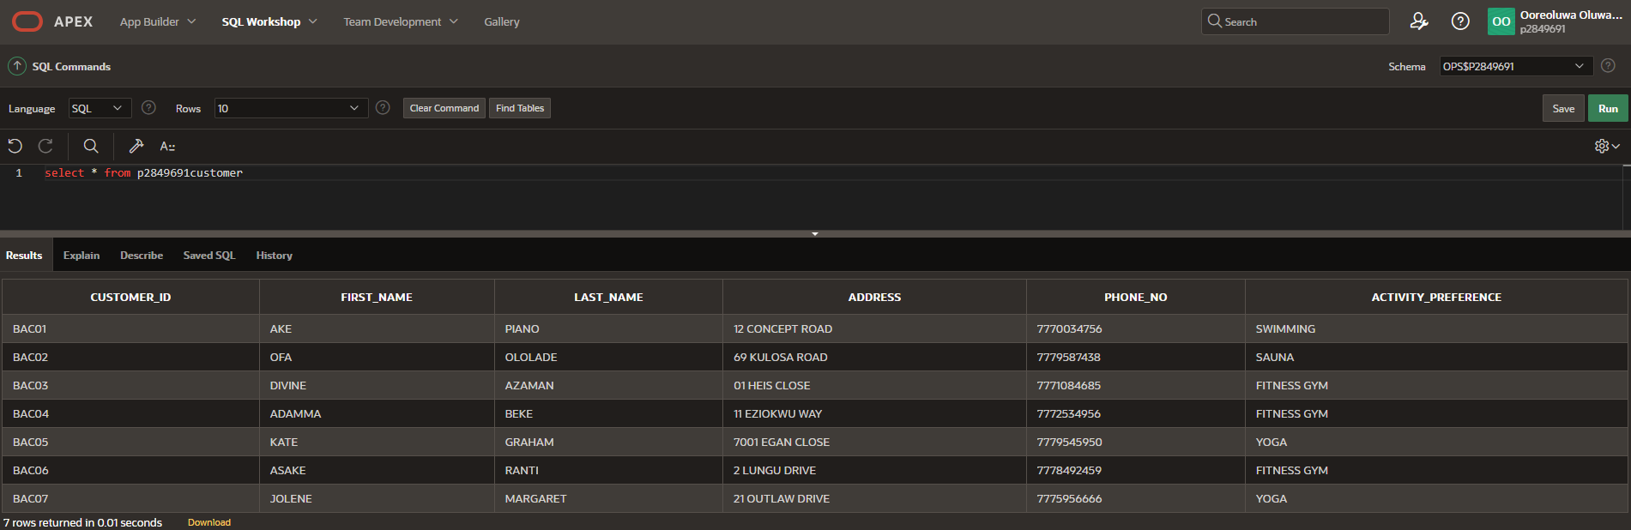

Staff Table

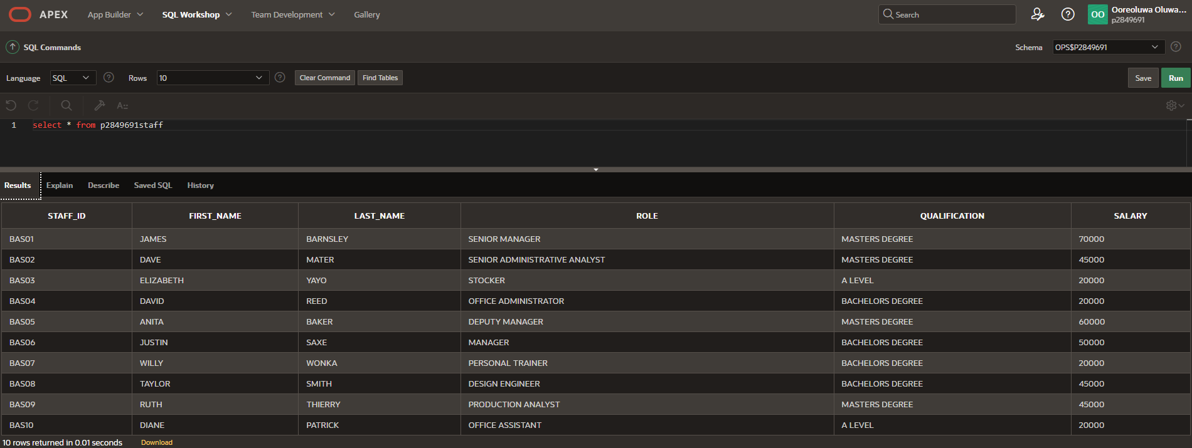
Branch Table

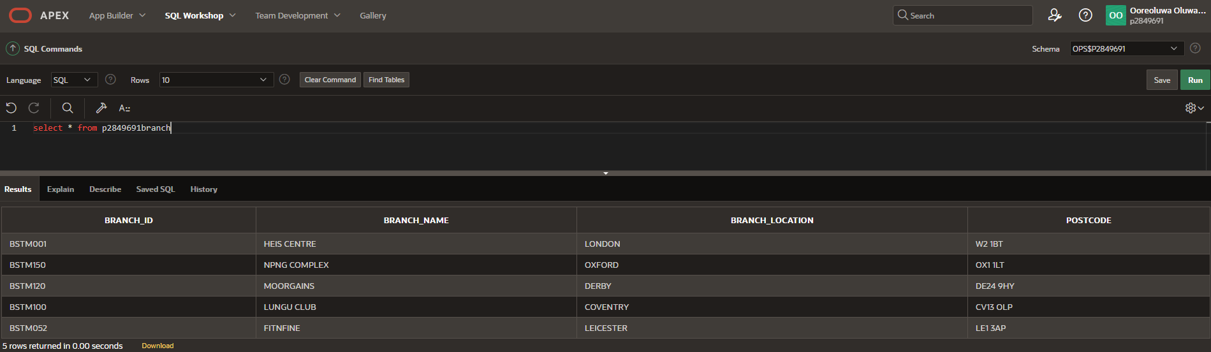

Vendor Table

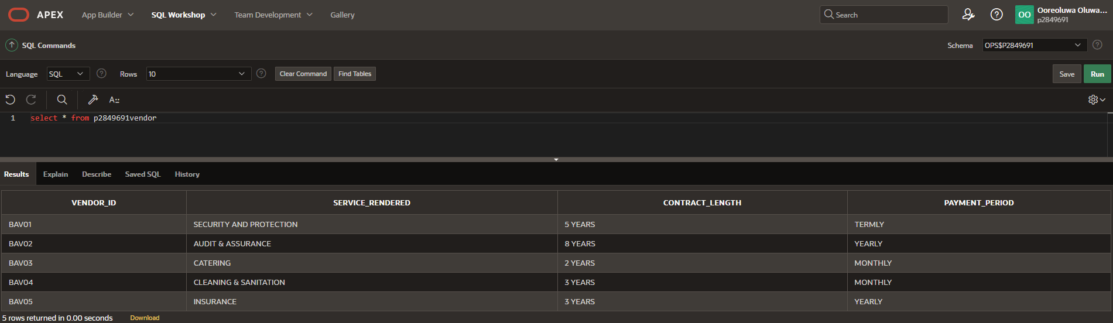

Manager Table

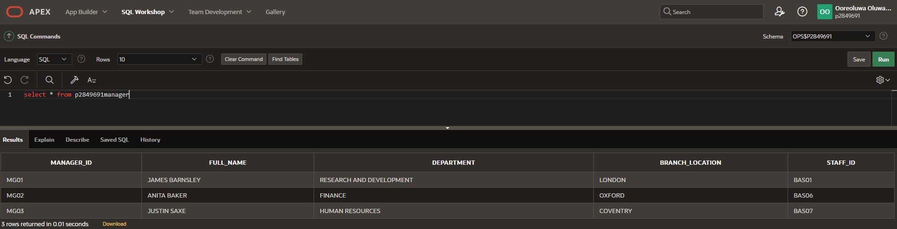

Membership Table

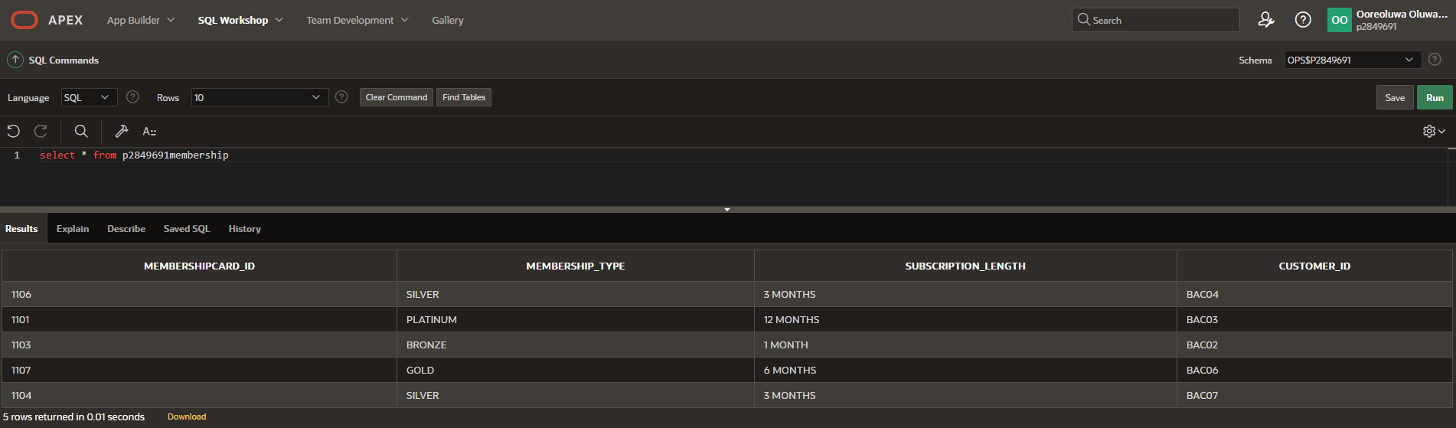

Payment Table

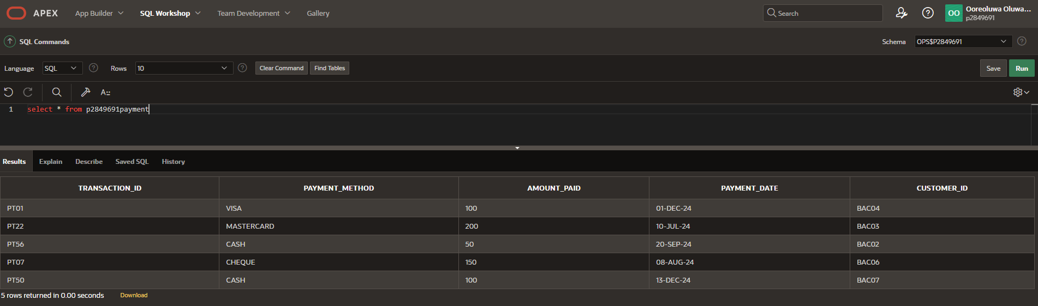

Facility Table

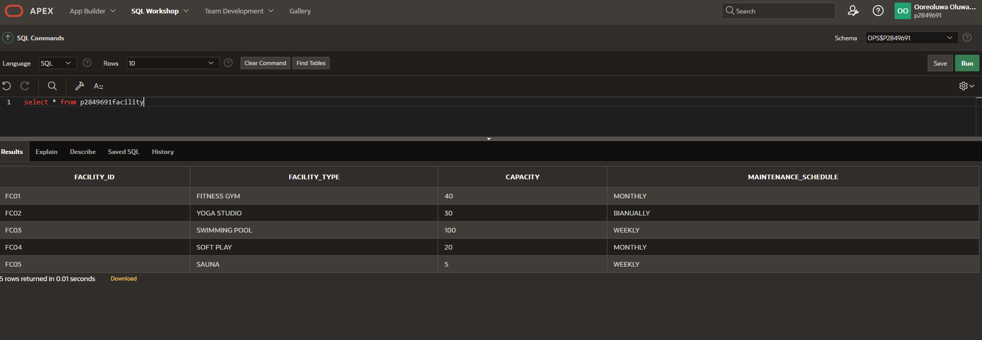

Task 6: SQL Query Writing

- INNER JOIN: Get a list of Departments in that have managers and their branches.
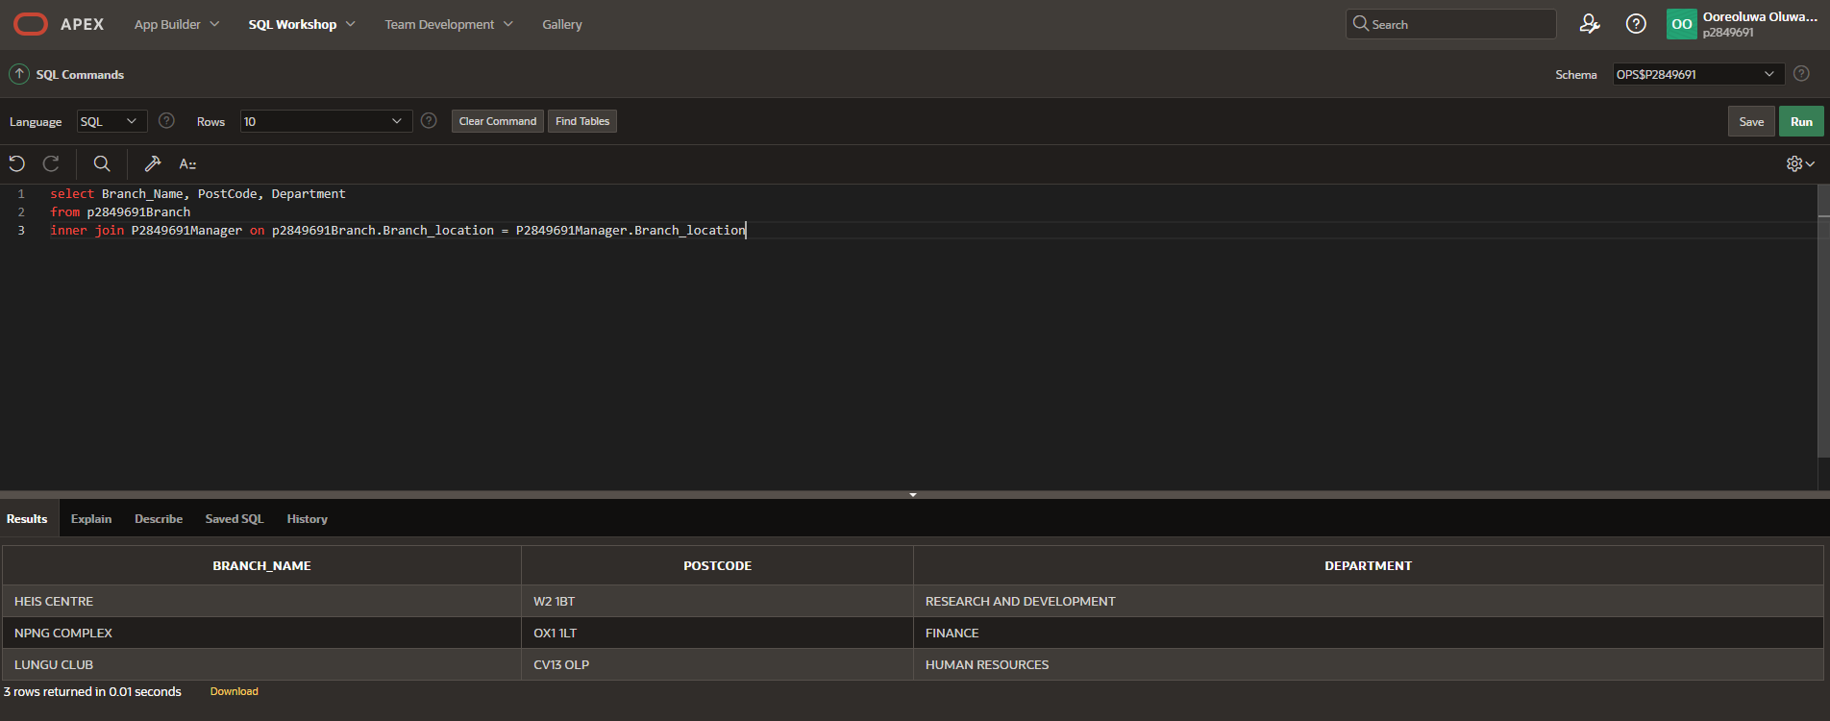

- OUTER JOIN: Get a list of MembershipCardID, CustomerID and their membership details.

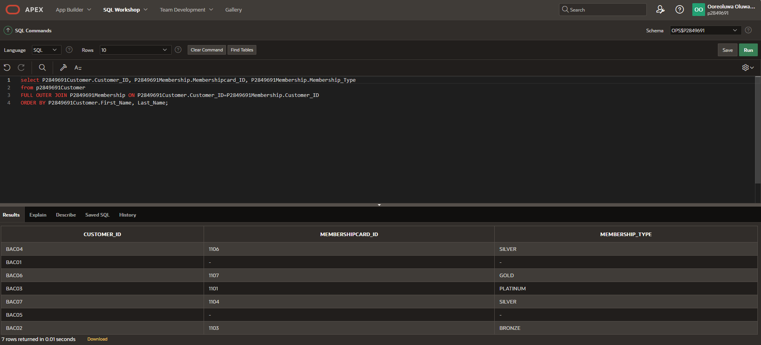

- ‘Count’ Condition: Show me total number of staffID whose salary is above 40000.

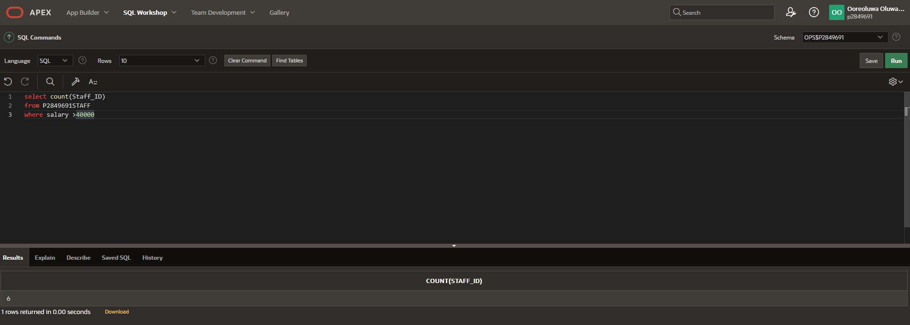

- ‘IN’ Condition: Show the staff details of those who have a qualification in MASTERS DEGREE.

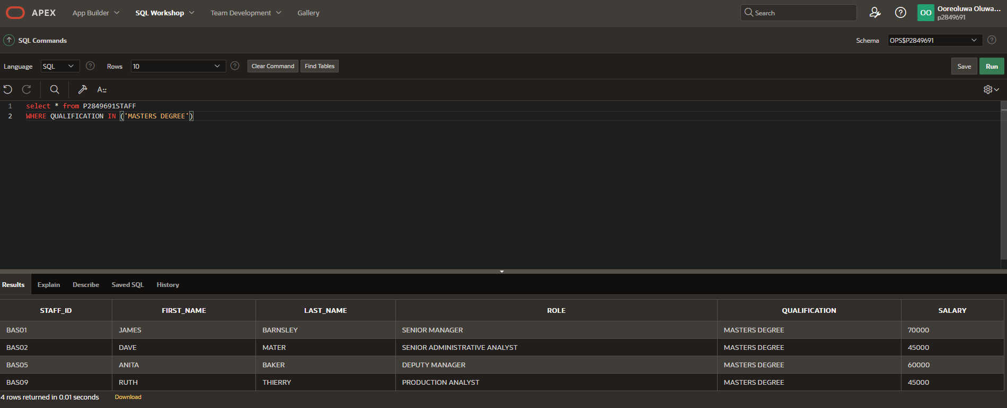

- ‘>’ Condition: Show the list of customers who made a transaction above 50.
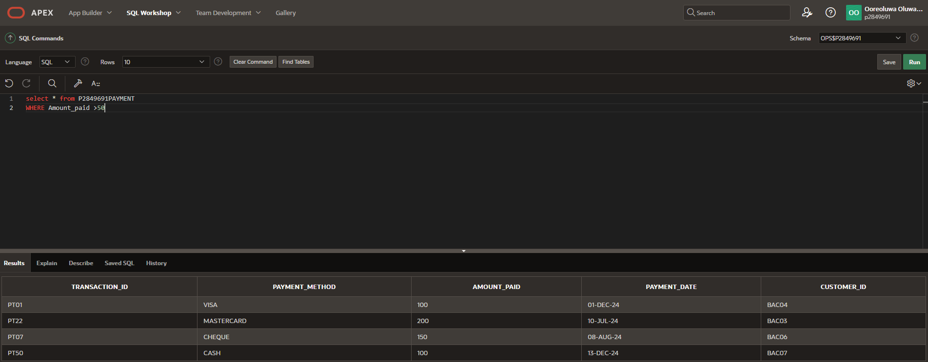
- ‘ORDER BY’ Condition: Show the list of facility details and order their capacity in ascending order.
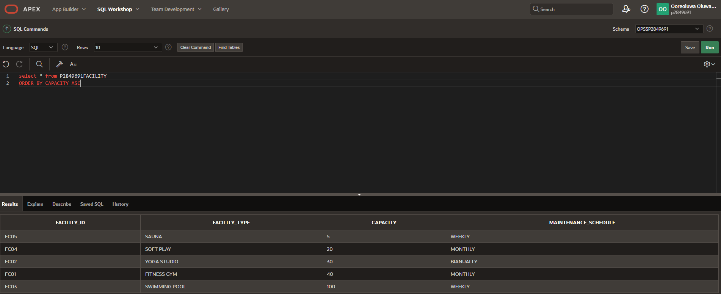

Stage 3: Argument

Task 7: Importance of Data-Centred Approach
A data-centered approach is a system that creates opportunities for data re-use, data production and availability techniques, and semantic standards at its core. A data-centered approach can substantially speed up many operations and procedures and address several issues pertaining to the creation of compounds and their reliability evaluation. Organizations can improve decision-making, decrease redundancy, streamline operations, and increase consistency by implementing a data-centered framework.
According to research, companies may address significant issues in scientific and industrial areas, like the need for quicker innovation cycles and more reliable product development, by giving priority to data integration, semantic interoperability, and data sharing policies(Pavel et al., 2022).

According to (Russo et al., 2013), we can determine that this approach assists models in recording domain-relevant object types, their properties, potential states and lifecycles, and their relationships, all of which combine to create a complex data structure or information model. The activities that depend on and act upon object-related information, resulting in modifications to attribute values, relations, and object states, may be identified and defined thanks to this data model. The Data-centred system promotes data maintenance. Data in real-world applications is dynamic and needs regular updates to stay accurate and essential. In dynamic and constantly evolving circumstances, maintaining data effectively is essential to guaranteeing its quality, consistency, and dependability. Without constant maintenance, data can easily become inaccurate or out-of-date, which can impair system performance and lead to bad decisions (Zha et al., 2023). Data maintenance is therefore crucial since it may support informed decision-making and preserve operational integrity over time.

A significant trade-off in SQL database design involves selecting between a table layout that facilitates easy and rapid data retrieval and one that prioritizes computational efficiency, potentially complicating the process of inspecting synoptic data views, such as in human-machine interfaces or reports.

References
Pavel, A., Saarimäki, L.A., Möbus, L., Federico, A., Serra, A. and Greco, D. (2022). The potential of a data centred approach & knowledge graph data representation in chemical safety and drug design. Computational and Structural Biotechnology Journal, 20, pp.4837–4849.
Russo, A., Massimo Mecella, Patrizi, F. and Montali, M. (2013). Implementing and Running Data-Centric Dynamic Systems. CiteSeer X (The Pennsylvania State University), [online] 31, pp.225–232. doi:https://doi.org/10.1109/soca.2013.37.
Zha, D., Pervaiz Bhat, Z., Yang, F., Zaid, P., Bhat, K.-H., Lai, F., Yang, Z., Jiang, S. and Zhong, X. (2023). Data-centric Artificial Intelligence: A Survey. 2023. Data-centric Artificial Intelligence: A Survey, [online] 1(1), p.39.

Appendix
CREATE TABLE P2849691Customer(
Customer_ID VARCHAR(5),
First_Name CHAR(20),
Last_Name CHAR(20),
Address VARCHAR(30),
Phone_No INT,
Activity_Preference CHAR(30),
PRIMARY KEY(Customer_ID));

INSERT INTO p2849691CUSTOMER VALUES ('BAC01', 'AKE', 'PIANO','12 CONCEPT ROAD',7770034756, 'SWIMMING');
INSERT INTO p2849691CUSTOMER VALUES ('BAC02', 'OFA', 'OLOLADE', '69 KULOSA ROAD',7779587438, 'SAUNA');
INSERT INTO p2849691CUSTOMER VALUES ('BAC03', 'DIVINE', 'AZAMAN', '01 HEIS CLOSE',7771084685, 'FITNESS GYM');
INSERT INTO p2849691CUSTOMER VALUES ('BAC04', 'ADAMMA', 'BEKE ','11 EZIOKWU WAY', 7772534956, 'FITNESS GYM');
INSERT INTO p2849691CUSTOMER VALUES ('BAC05', 'KATE', 'GRAHAM','7001 EGAN CLOSE', 7779545950, 'YOGA');
INSERT INTO p2849691CUSTOMER VALUES ('BAC06', 'ASAKE', 'RANTI','2 LUNGU DRIVE', 7778492459, 'FITNESS GYM');
INSERT INTO p2849691CUSTOMER VALUES ('BAC07', 'JOLENE', 'MARGARET','21 OUTLAW DRIVE', 7775956666, 'YOGA');

CREATE TABLE P2849691Staff(
Staff_ID VARCHAR(5),
First_Name CHAR(20),
Last_Name CHAR(20),
Role CHAR(30),
Qualification CHAR(20),
Salary INT,
PRIMARY KEY(Staff_ID));

INSERT INTO p2849691STAFF VALUES ('BAS01', 'JAMES', 'BARNSLEY','SENIOR MANAGER', 'MASTERS DEGREE', 70000);
INSERT INTO p2849691STAFF VALUES ('BAS02', 'DAVE', 'MATER', 'SENIOR ADMINISTRATIVE ANALYST', 'MASTERS DEGREE', 45000);
INSERT INTO p2849691STAFF VALUES ('BAS03', 'ELIZABETH', 'YAYO', 'STOCKER', 'A LEVEL', 20000);
INSERT INTO p2849691STAFF VALUES ('BAS04', 'DAVID', 'REED', 'OFFICE ADMINISTRATOR', 'BACHELORS DEGREE', 20000);
INSERT INTO p2849691STAFF VALUES ('BAS05', 'ANITA', 'BAKER', ' DEPUTY MANAGER', 'MASTERS DEGREE', 60000);
INSERT INTO p2849691STAFF VALUES ('BAS06', 'JUSTIN', 'SAXE', 'MANAGER', 'BACHELORS DEGREE', 50000);
INSERT INTO p2849691STAFF VALUES ('BAS07', 'WILLY', 'WONKA', 'PERSONAL TRAINER', 'BACHELORS DEGREE', 20000);
INSERT INTO p2849691STAFF VALUES ('BAS08', 'TAYLOR', 'SMITH', 'DESIGN ENGINEER', 'BACHELORS DEGREE', 45000);
INSERT INTO p2849691STAFF VALUES ('BAS09', 'RUTH', 'THIERRY', 'PRODUCTION ANALYST', 'MASTERS DEGREE', 45000);
INSERT INTO p2849691STAFF VALUES ('BAS10', 'DIANE', 'PATRICK', 'OFFICE ASSISTANT', 'A LEVEL', 20000);

CREATE TABLE P2849691Branch(
Branch_ID VARCHAR(10),
Branch_Name CHAR(20),
Branch_Location CHAR(15),
Postcode VARCHAR(10),
PRIMARY KEY(Branch_ID));

INSERT INTO p2849691BRANCH VALUES ('BSTM001', 'HEIS CENTRE', 'LONDON', 'W2 1BT');
INSERT INTO p2849691BRANCH VALUES ('BSTM150', 'NPNG COMPLEX', 'OXFORD', 'OX1 1LT');
INSERT INTO p2849691BRANCH VALUES ('BSTM120', 'MOORGAINS', 'DERBY', 'DE24 9HY');
INSERT INTO p2849691BRANCH VALUES ('BSTM100', 'LUNGU CLUB', 'COVENTRY', 'CV13 OLP');
INSERT INTO p2849691BRANCH VALUES ('BSTM052', 'FITNFINE', 'LEICESTER', 'LE1 3AP');

CREATE TABLE P2849691Vendor(
Vendor_ID VARCHAR(10),
Service_Rendered CHAR(30),
Contract_Length VARCHAR(15),
Payment_Period CHAR(10),
PRIMARY KEY(Vendor_ID));

INSERT INTO p2849691VENDOR VALUES ('BAV01', 'SECURITY AND PROTECTION', '5 YEARS', 'TERMLY');
INSERT INTO p2849691VENDOR VALUES ('BAV02', 'AUDIT & ASSURANCE', '8 YEARS', 'YEARLY');
INSERT INTO p2849691VENDOR VALUES ('BAV03', 'CATERING', '2 YEARS', 'MONTHLY');
INSERT INTO p2849691VENDOR VALUES ('BAV04', 'CLEANING & SANITATION', '3 YEARS', 'MONTHLY');
INSERT INTO p2849691VENDOR VALUES ('BAV05', 'INSURANCE', '3 YEARS', 'YEARLY');

CREATE TABLE P2849691Manager(
Manager_ID VARCHAR(10),
Full_Name CHAR(15),
Department CHAR(30),
Branch_Location CHAR(10),
Staff_ID VARCHAR(10),
CONSTRAINT P2849691MANAGER_FOREIGN_KEY FOREIGN KEY (STAFF_ID) REFERENCES P2849691STAFF (STAFF_ID),
PRIMARY KEY(Manager_ID));

INSERT INTO p2849691MANAGER VALUES ('MG01', 'JAMES BARNSLEY', 'RESEARCH AND DEVELOPMENT', 'LONDON', 'BAS01');
INSERT INTO p2849691MANAGER VALUES ('MG02', 'ANITA BAKER', 'FINANCE', 'OXFORD', 'BAS06');
INSERT INTO p2849691MANAGER VALUES ('MG03', 'JUSTIN SAXE', 'HUMAN RESOURCES', 'COVENTRY', 'BAS07');

CREATE TABLE P2849691Membership(
MembershipCard_ID INT,
Membership_Type CHAR(10),
Subscription_Length VARCHAR(10),
Customer_ID VARCHAR(10),
CONSTRAINT P2849691MEMBERSHIP_FOREIGN_KEY FOREIGN KEY (CUSTOMER_ID) REFERENCES P2849691CUSTOMER (CUSTOMER_ID),
PRIMARY KEY(MembershipCard_ID));

INSERT INTO p2849691MEMBERSHIP VALUES ('1106', 'SILVER', '3 MONTHS', 'BAC04');
INSERT INTO p2849691MEMBERSHIP VALUES ('1101', 'PLATINUM', '12 MONTHS', 'BAC03');
INSERT INTO p2849691MEMBERSHIP VALUES ('1103', 'BRONZE', '1 MONTH', 'BAC02');
INSERT INTO p2849691MEMBERSHIP VALUES ('1107', 'GOLD', '6 MONTHS', 'BAC06');
INSERT INTO p2849691MEMBERSHIP VALUES ('1104', 'SILVER', '3 MONTHS', 'BAC07');

CREATE TABLE P2849691Payment(
Transaction_ID VARCHAR(5),
Payment_Method CHAR(10),
Amount_Paid NUMBER(5,2),
Payment_Date DATE,
Customer_ID VARCHAR(10),
CONSTRAINT P2849691PAYMENT_FOREIGN_KEY FOREIGN KEY (CUSTOMER_ID) REFERENCES P2849691CUSTOMER (CUSTOMER_ID),
PRIMARY KEY(Transaction_ID));

INSERT INTO p2849691PAYMENT VALUES ('PT01', 'VISA', '100.00', TO_DATE('01-12-2024', 'DD-MM-YYYY'), 'BAC04');
INSERT INTO p2849691PAYMENT VALUES ('PT22', 'MASTERCARD', '200.00', TO_DATE('10-07-2024', 'DD-MM-YYYY'), 'BAC03');
INSERT INTO p2849691PAYMENT VALUES ('PT56', 'CASH', '50.00', TO_DATE('20-09-2024', 'DD-MM-YYYY'), 'BAC02');
INSERT INTO p2849691PAYMENT VALUES ('PT07', 'CHEQUE', '150.00', TO_DATE('08-08-2024', 'DD-MM-YYYY'), 'BAC06');
INSERT INTO p2849691PAYMENT VALUES ('PT50', 'CASH', '100.00', TO_DATE('13-12-2024', 'DD-MM-YYYY'), 'BAC07');

CREATE TABLE P2849691Facility(
Facility_ID VARCHAR(5),
Facility_Type CHAR(15),
Capacity INT,
Maintenance_Schedule VARCHAR(10),
PRIMARY KEY(Facility_ID));
INSERT INTO p2849691FACILITY VALUES ('FC01', 'FITNESS GYM', 40, 'MONTHLY');
INSERT INTO p2849691FACILITY VALUES ('FC02', 'YOGA STUDIO', 30, 'BIANUALLY');
INSERT INTO p2849691FACILITY VALUES ('FC03', 'SWIMMING POOL', 100, 'WEEKLY');
INSERT INTO p2849691FACILITY VALUES ('FC04', 'SOFT PLAY', 20, 'MONTHLY');
INSERT INTO p2849691FACILITY VALUES ('FC05', 'SAUNA', 5, ' WEEKLY');

Conditions Used
INNER JOIN
select Branch_Name, PostCode, Department
from p2849691Branch
inner join P2849691Manager on p2849691Branch.Branch_location = P2849691Manager.Branch_location

RESULT: We will join the p2849691Branch table with the P2849691Manager table, by using the Branch_Location field from both tables.

OUTER JOIN
select P2849691Customer.Customer_ID, P2849691Membership.Membershipcard_ID, P2849691Membership.Membership_Type
from p2849691Customer
FULL OUTER JOIN P2849691Membership ON P2849691Customer.Customer_ID=P2849691Membership.Customer_ID
ORDER BY P2849691Customer.First_Name, Last_Name;
RESULT: The FULL OUTER JOIN query returns all matching records from both tables whether the other table matches or not. So, if there are rows in "P2849691Customer" that do not have matches in "P2849691Membership", or if there are rows in "P2849691Membership" that do not have matches in "P2849691Customer", those rows will be listed as well.

COUNT
select count(Staff_ID)
from P2849691STAFF
where salary >40000
RESULT = SHOWS TOTAL NUMBER OF STAFF_ID WHOSE SALARY IS ABOVE 40000

IN condition
select * from P2849691STAFF
WHERE QUALIFICATION IN ('MASTERS DEGREE')
RESULT = SHOWS THE LIST OF STAFF WHOSE QUALIFICATION IS MASTERS DEGREE
The IN operator allows you to specify multiple values in a WHERE clause

‘>’ Condition
select * from P2849691PAYMENT
WHERE Amount_paid >50
RESULT = SHOWS ALL AMOUNT_PAID GREATER THAN 50

ORDER BY Condition
select * from P2849691FACILITY
ORDER BY CAPACITY ASC
RESULT = SHOWS THE LIST OF ALL FACILITIES ARRANGING THEM BY CAPACITY IN ASCENDING ORDER

