# Fluorescences页面总设计（20250607版本）：

注：

本页面的设计包括3个**段落**，每个段落单独设计，图片为设计布局的参考图。

1. **段落1**

**段落1**包含：**三个区域**，各个区域的分布参考**图1**，各个区域的文字内容如下：

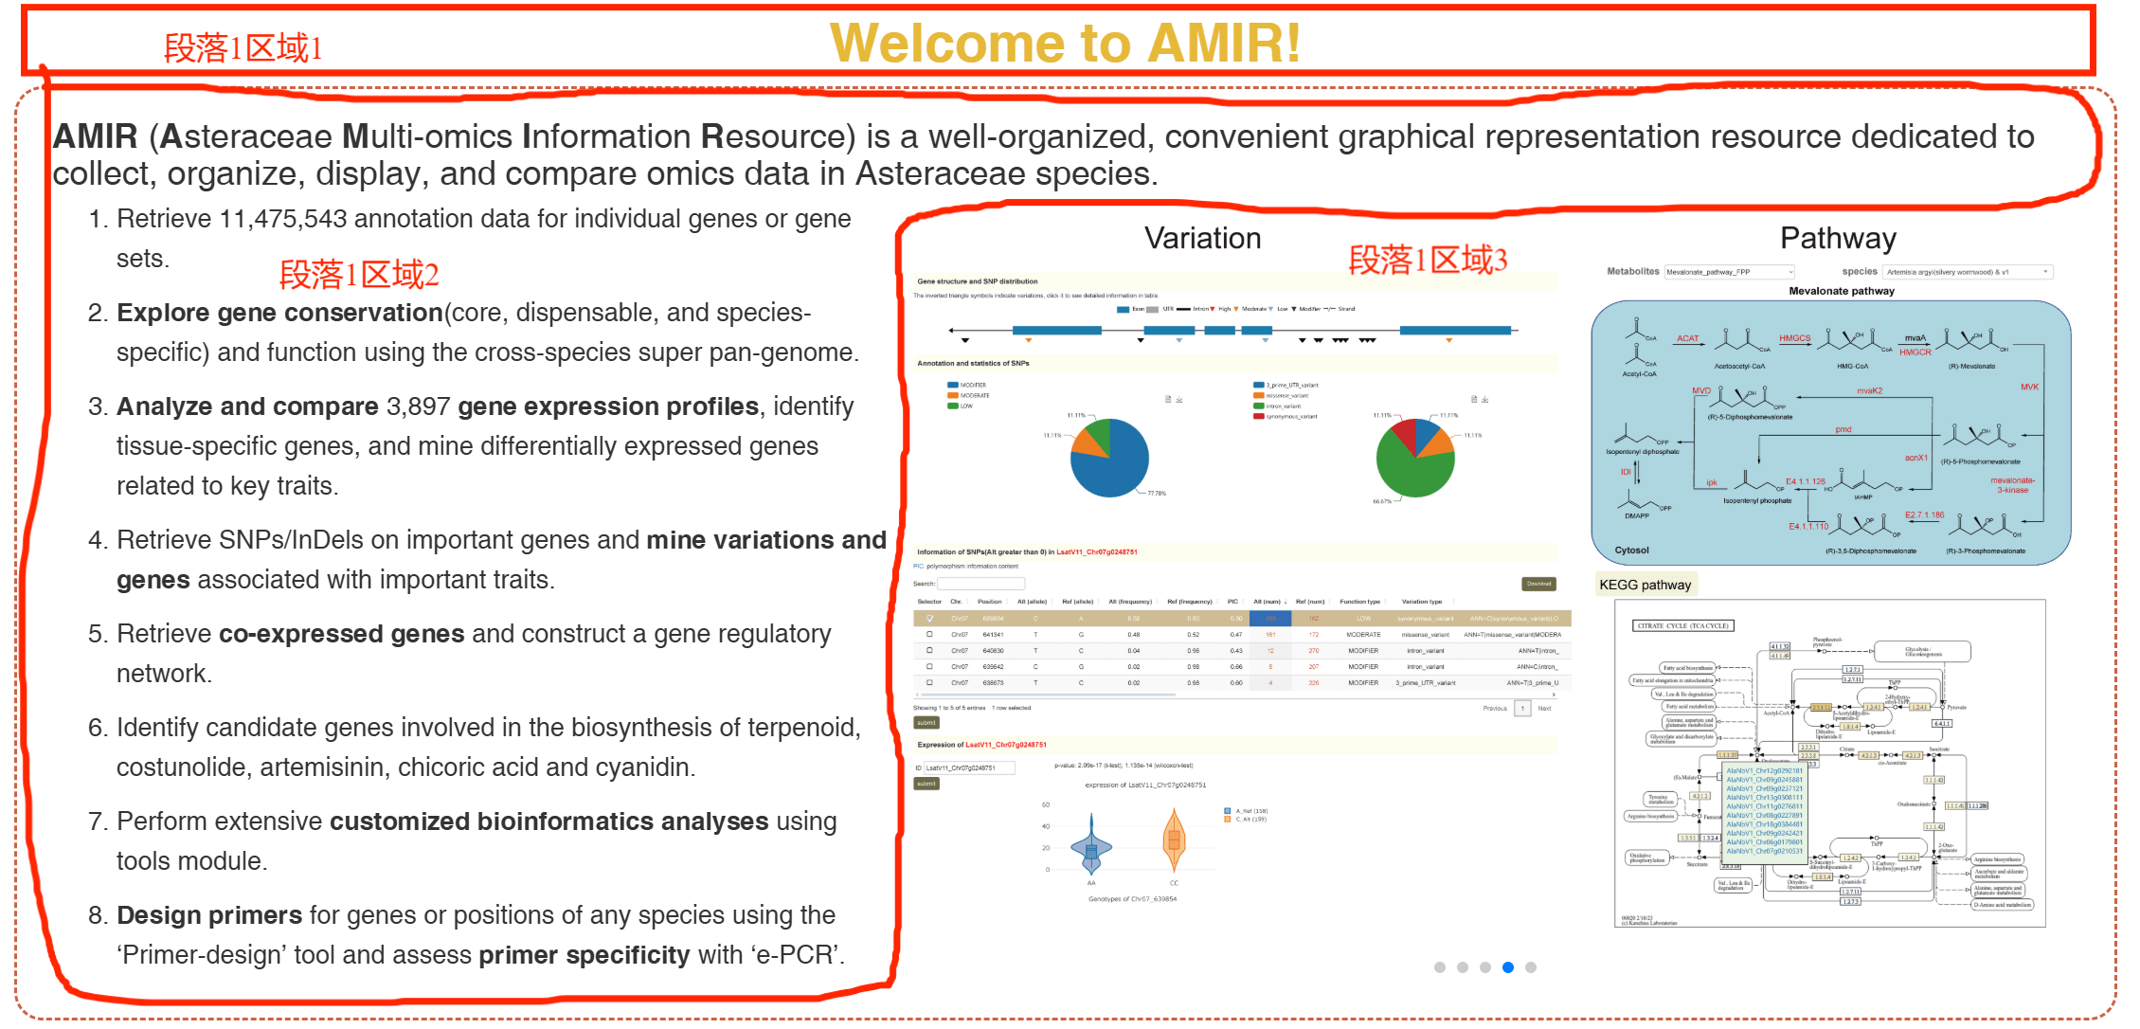

**图1**

**段落1区域1（标题）**：

Fluorescences and Light-up RNA aptamers

**段落1区域2（文本）：**

Light-up RNA aptamers are fluorescent RNA molecules that become fluorescent upon binding to specific fluorophores. This concept emerged from the need for non-invasive, real-time imaging tools to study RNA molecules and their interactions within living cells. Traditional fluorescent tags like GFP (green fluorescent protein) are not suitable for RNA because they are protein-based 1. Thus, the development of RNA-based fluorescent tags (light-up RNA aptamers) became crucial for expanding the toolkit available for RNA visualization and functional studies.

1. Core Structure and Fluorescence Activation Mechanism: G-Quadruplex Platforms, Triplex Cap and Binding Pocket, Triplex Cap and Binding Pocket.

2. Three Key Mechanisms for Fluorescence Regulation: Twisted Intramolecular Charge Transfer (TICT), Contact Quenching (CQ), Spirolactonization (SP).

3. Cutting-Edge Technological Advances: Avidity-Enhanced Dimeric Aptamers, Logic-Gated Aptamers, Design driven by Artificial Intelligence.

4. Applications: High-sensitivity detection, Live cell RNA imaging, Multi-target synchronous imaging.

5. Challenges: Intracellular delivery, Background signal, Rational design tools.

**段落1区域3（滑动图片）：**

这部分放像“Home”页一样自动切换的图片（Figure 1-Figure 5，见压缩包），格式参考**图2**，图片下方的黑色和白色字体分别是 标题 和 副标题，点击图片可以链接或导航到其他页面或区域。

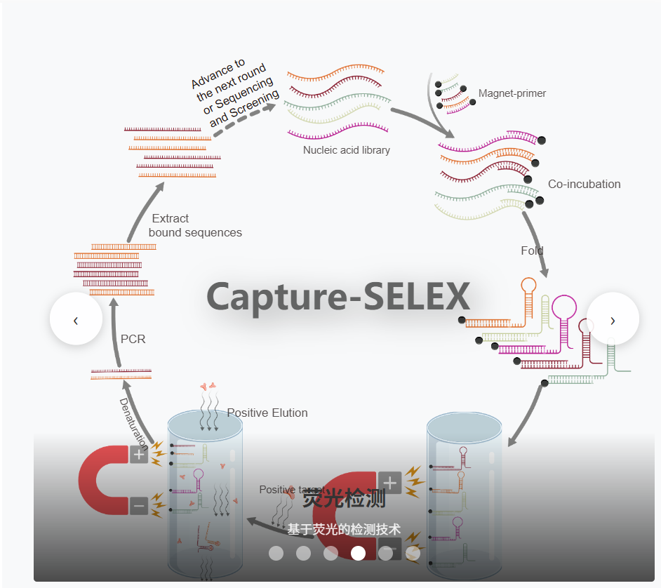

**图2**

|  |  |  |  |
| --- | --- | --- | --- |
|  | **标题** | **副标题** | **链接或导航** |
| *Figure 1.svg* | Core Structure | Dynamic Conformational Switching | 导航到本页面的**段落3_二级标题1** |
| *Figure 2.svg* | Fluorescence Activation Mechanism | Twisted Intramolecular Charge Transfer, Contact Quenching and Spirolactonization | 导航到本页面的**段落3_3级标题1** |
| *Figure 3.svg* | Light-Up RNA Aptamers | Biomedical application tools | https://aptamer.ribocentre.org/_posts/Corn-aptamer |
| *Figure 4.svg* | Structures | Secondary and tertiary structures | https://aptamer.ribocentre.org/_posts/Corn-aptamer |
| *Figure 5.svg* | Fluorescent molecules | Fluorescence based on affinity | 导航到本页面的**段落3_2级标题3** |

1. **段落2**  
   该段落的布局参考Home页的对应部分，包括一个 **搜索栏1，数据统计仪表盘1，数据详情表1**，各个区域的布局如**图3**和**图4**所示，文字内容如下：



**图3**

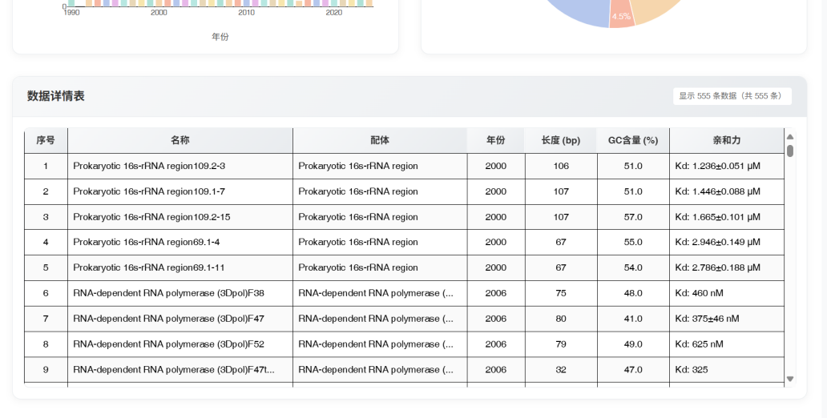

**图4**

**搜索栏1：**  
格式如**图3**所示，其中搜索框中的文字“Enter the aptamer name, sequence or ligand...”，下方的几个关键词为：“Sequences”“Ligands”“Structures”“Mechanisms”“Applications”，点击关键词可以链接或导航到其他页面或区域，对应关系如下表。

|  |  |
| --- | --- |
| **关键词** | **链接或导航** |
| Sequences | 导航到本页面的**段落2_数据详情表1** |
| Ligands | 导航到本页面的**段落3_表格1** |
| Structures | https://aptamer.ribocentre.org/Ribocentre-aptamer/ |
| Mechanisms | 导航到本页面的**段落3_3级标题1** |
| Applications | https://aptamer.ribocentre.org/applications/ |

**数据统计仪表盘1：**  
格式参考**图3**，左图柱状图 题目为“**Publication Trends by Year**”，右图饼图题目为“**Distribution of Fluorophore Activation Mechanisms**”。饼图的分类字段参考 数据详情表1。

**数据详情表1：**

格式参考**图4**，左上角标题为“Light-Up RNA Aptamers”，表中各行各列的内容参考*Fluorescences页面aptamer序列与荧光小分子等信息对应表_20250604.xlsx* （见压缩包）的 A-H列（即从Number列到Relevant 3D structures列）。后面的“PubMed linker”列用作“Years”列的导航链接，“More information”列用作“Sequence name”列的导航链接（没有对应的先行先不添加导航链接）。“Mechanisms”列为饼图的分类字段。

1. **段落3**

**段落3**从上到下依次包含：**一级标题，文本a ，二级标题1，文本b，图0，图注0**(图注要紧贴上方的图片，可以与别的类型的文本格式有别，显示出与图片的一体)**，三级标题1，文本1，图1，图注1，三级标题2，文本2，图2，图注2，三级标题3，文本3，图3，图注3 ，文本4，表格1，二级标题2，文本c，表格1，参考文献**。

**一级标题：**

Light-up RNA aptamers

**文本a：**

The discovery of Spinach, the first light-up RNA aptamer, by Jaffrey and colleagues in 2011 marked a significant milestone. Spinach binds to a fluorophore called DFHBI and emits green fluorescence, mimicking GFP 2. Following Spinach, several other light-up aptamers were developed, including Mango, Broccoli, and Corn, each binding to different fluorophores and exhibiting different fluorescence properties 3, 4, 5. Researchers optimize light-up RNA aptamers for improved brightness, stability, and minimal background fluorescence. This involves iterative cycles of selection and mutation to enhance the aptamer’s performance for better performance in cellular environments 6, 7, 8.

Light-up RNA aptamers represent a significant advancement in the study of RNA biology, offering a versatile and powerful tool for real-time imaging and functional analysis of RNA molecules in living cells 9.

**二级标题1：**  
Fluorogenic mechanisms

**文本b：**

Light-up RNA aptamers contain specific binding sites that interact with small-molecule fluorophores. These fluorophores are non-fluorescent or weakly fluorescent in the absence of the aptamer. Upon binding to the aptamer, the fluorophore undergoes a conformational change that enhances its fluorescence properties. This binding typically occurs through a combination of hydrogen bonding, Van der Waals interactions, and stacking interactions within the RNA’s three-dimensional structure.

Understanding their mechanism of action involves exploring how these aptamers interact with their fluorophores to produce fluorescence, the structural basis of their function, and the principles guiding their design and optimization 10.

**图0：**见压缩包文件

***light-up aptamer.svg***

**图注0:**

Structural Basis: Molecular Framework for Fluorescence Activation. Aptamers precisely identify the chemical groups of fluorophores through base complementarity or structural complementarity. After binding, the excited state energy of the fluorophore is effectively converted into fluorescence emission through the restriction of the rigid structure of the fitting body, rather than heat energy or vibration energy loss.

**三级标题1：**

Twisted Intramolecular Charge Transfer (TICT)

**文本1：**

TICT refers to a mechanism where the binding of a target induces a conformational change in the RNA aptamer, leading to the activation or enhancement of fluorescence through a twisted charge-transfer state. This state involves the separation of charge within the molecule, resulting in a geometry that promotes fluorescence.

In the unbound state, the RNA aptamer and its fluorophore may be in a non-planar or less twisted conformation with limited charge separation, leading to weak or no fluorescence. Upon binding to a specific target, the aptamer undergoes a conformational change that facilitates a twist between the donor and acceptor moieties within the fluorophore. This twist maximizes the charge separation, creating an intramolecular charge transfer state with a large dipole moment. The TICT state stabilizes the fluorophore in a way that enhances its fluorescence emission, often resulting in a red-shifted and intensified fluorescence signal compared to the non-twisted state.

**图1：**

*Twisted intramolecular charge transfer (TICT)_20260526.svg*

**图注1:**

TICT mechanism regulates fluorescence activation through conformational dynamics of fluorophores.

**三级标题2：**

Contact Quenching (CQ)

**文本2：**

Contact quenching in light-up RNA aptamers involves the reduction or elimination of fluorescence due to the close physical proximity of a quencher molecule to the fluorophore. This process is highly dependent on the spatial arrangement and interaction between the RNA aptamer and its target.

In the absence of the target, the fluorophore may be in close proximity to a quencher moiety within the RNA aptamer, resulting in minimal fluorescence. Binding of the target induces a conformational change in the RNA aptamer that separates the fluorophore from the quencher. The increased distance between the fluorophore and quencher reduces the efficiency of non-radiative energy transfer, allowing the fluorophore to emit fluorescence. The efficiency of contact quenching and subsequent fluorescence recovery can be modulated by the nature of the target-aptamer interaction and the specific design of the aptamer.

Light-up RNA aptamers exploiting contact quenching are used in biosensors to detect various biomolecules by monitoring changes in fluorescence.These aptamers facilitate the detection and quantification of analytes in complex mixtures.

**图2：**

*Contact quenching (CQ)_20260526.svg*

**图注2:**

CQ operates via direct physical interaction between the fluorophore and quencher.

**三级标题3：**

Spirolactonization (SP)

**文本3：**

Spirolactonization in light-up RNA aptamers involves the formation of a spirolactone ring structure upon binding to a target. This structural change enhances the fluorescence of the aptamer, providing a clear signal upon target recognition.

In the absence of the target, the RNA aptamer remains in a conformation that does not support spirolactone formation, leading to weak or no fluorescence. Binding of the target induces a conformational rearrangement in the aptamer, promoting the formation of a spirolactone ring. The formation of the spirolactone ring stabilizes the fluorophore in a fluorescent state, significantly enhancing its emission properties. The structural rigidity and planarity introduced by the spirolactone ring reduce non-radiative decay pathways, leading to a bright fluorescence signal.

Spirolactonization-based light-up RNA aptamers are used to detect specific targets with high sensitivity and specificity. These aptamers can serve dual functions in theranostics, providing both diagnostic imaging and therapeutic action.

**图3：**

*Spirolactonization (SP)_20250526.svg*

**图注3:**

SP is exemplified by rhodamine-based probes. Aptamer binding alters the local microenvironment, triggering lactone ring-opening to yield the fluorescent zwitterionic form.

**二级标题2：**

Properties of Fluorophore-Aptamer pairs

**文本c：**

Each light-up RNA aptamer is usually specific to a particular fluorophore. The specificity arises from the precise shape and chemical environment of the binding pocket within the RNA. The sequence and structure of the aptamer dictate the compatibility with the fluorophore, ensuring selective binding and fluorescence activation. Researchers focused on optimizing these aptamers for improved brightness, stability, and minimal background fluorescence. This included engineering the aptamers and fluorophores for better performance in cellular environments.

The table below lists several fluorescent small molecular-RNA pairings for which interaction patterns have been known through crystallographic studies or NMR. (The table only shows the representative individuals of each type of fluorescent small molecule. For more details, click on small molecule to jump to the corresponding view.)

**表格1：**

|  |  |  |  |  |  |  |  |  |
| --- | --- | --- | --- | --- | --- | --- | --- | --- |
| Fluorescent molecule | UPAC | Molecular Formula | Molar mass | CAS | Excitation (nm) | Emission (nm) | Aptamer | Fluorogenic mechanisms |
| DFHBI | (5Z)-5-[(3,5-difluoro-4-hydroxyphenyl)methylidene]-2,3-dimethylimidazol-4-one | C12H10F2N2O2 | 252.22 g/mol | 1241390-29-3 | 469 | 501 | Spinach | TICT |
| MG | [4-[[4-(dimethylamino)phenyl]-phenylmethylidene]cyclohexa-2,5-dien-1-ylidene]-dimethylazanium;chloride | C23H25ClN2 | 364.9 g/mol | 569-64-2 | 630 | 655 | MG aptamer | TICT |
| HBC 530 | 4-[(E)-1-cyano-2-[4-[2-hydroxyethyl(methyl)amino]phenyl]ethenyl]benzonitrile | C19H17N3O | 303.4 g/mol | 156840-13-0 | 485 | 530 | Pepper | TICT |
| TO1 | 4-methylbenzenesulfonate;(2Z)-3-methyl-2-[(1-methylquinolin-1-ium-4-yl)methylidene]-1,3-benzothiazole | C26H24N2O3S2 | 476.6 g/mol | 107091-89-4 | 510 | 535 | Mango | TICT |
| DFHO | (5Z)-5-[(3,5-difluoro-4-hydroxyphenyl)methylidene]-3-methyl-2-(nitrosomethylidene)imidazolidin-4-one | C12H9F2N3O3 | 281.21 g/mol | 1420815-34-4 | 505 | 545 | Corn | TICT |
| DMHBI | 5-[(4-hydroxy-3,5-dimethoxyphenyl)methylidene]-2,3-dimethylimidazol-4-one | C14H16N2O4 | 276.29 g/mol | 1629243-34-0 | 400 | 537 | Chili | TICT |
| YO3 | (2Z)-3-methyl-2-[(E)-3-(1-methylquinolin-1-ium-4-yl)prop-2-enylidene]-1,3-benzoxazole | C21H19N2O+ | 315.4 g/mol | - | 595 | 620 | Mango-III | TICT |
| ThT | 4-(3,6-dimethyl-1,3-benzothiazol-3-ium-2-yl)-N,N-dimethylaniline | C17H19ClN2S | 318.9 g/mol | 2390-54-7 | 455 | 485 | Beetroot | TICT |
| TMR | 2-[3-(dimethylamino)-6-dimethylazaniumylidenexanthen-9-yl]benzoate | C24H22N2O3 | 386.4 g/mol | 120718-52-7 | 564 | 587 | TMR3 aptamer | CQ |
| DFAME | methyl 3-[4-[(3,5-difluoro-4-hydroxyphenyl)methylidene]-1-methyl-5-oxoimidazol-2-yl]prop-2-enoate | C15H12F2N2O4 | 322.26 g/mol | 1420815-55-9 | 514 | 619 | Beetroot | TICT |
| OTB | 3-methyl-2-[(3-methyl-1,3-benzothiazol-3-ium-2-yl)methylidene]-1,3-benzoxazole | C17H15N2OS+ | 295.4 g/mol | - | 380 | 421 | DIRs2-Apt | TICT |
| NBSI | (5Z)-2-[(E)-2-(4-fluorophenyl)ethenyl]-5-[[4-[2-hydroxyethyl(methyl)amino]phenyl]methylidene]-3-methylimidazol-4-one | C22H22FN3O2 | 379.4 g/mol | - | 524 | 580 | Clivias | TICT |
| TMR-DN | Tetramethylrhodamine-Dinitroaniline | C37H38N6O10 | 726.7 g/mol | - | 545 | 570 | RhoBAST | CQ |

**参考文献：**

1. Pédelacq, J. D., Cabantous, S., Tran, T., Terwilliger, T. C., & Waldo, G. S. (2006). Engineering and characterization of a superfolder green fluorescent protein. Nature biotechnology, 24(1), 79-88.  
   *<https://pubmed.ncbi.nlm.nih.gov/16369541/>*
2. Paige, J. S., Wu, K. Y., & Jaffrey, S. R. (2011). RNA mimics of green fluorescent protein. Science (New York, N.Y.), 333(6042), 642-646.

*https://pubmed.ncbi.nlm.nih.gov/21798953/*

1. Dolgosheina, E. V., Jeng, S. C., Panchapakesan, S. S., Cojocaru, R., Chen, P. S., Wilson, P. D., Hawkins, N., Wiggins, P. A., & Unrau, P. J. (2014). RNA mango aptamer-fluorophore: a bright, high-affinity complex for RNA labeling and tracking. ACS chemical biology, 9(10), 2412-2420.

*https://pubmed.ncbi.nlm.nih.gov/25101481/*

1. Song, W., Filonov, G. S., Kim, H., Hirsch, M., Li, X., Moon, J. D., & Jaffrey, S. R. (2017). Imaging RNA polymerase III transcription using a photostable RNA-fluorophore complex. Nature chemical biology, 13(11), 1187-1194.

*https://pubmed.ncbi.nlm.nih.gov/28945233/*

1. Filonov, G. S., Moon, J. D., Svensen, N., & Jaffrey, S. R. (2014). Broccoli: rapid selection of an RNA mimic of green fluorescent protein by fluorescence-based selection and directed evolution. Journal of the American Chemical Society, 136(46), 16299-16308.

*https://pubmed.ncbi.nlm.nih.gov/25337688/*

1. Song, W., Strack, R. L., Svensen, N., & Jaffrey, S. R. (2014). Plug-and-play fluorophores extend the spectral properties of Spinach. Journal of the American Chemical Society, 136(4), 1198-1201.

*https://pubmed.ncbi.nlm.nih.gov/24393009/*

1. Autour, A., C Y Jeng, S., D Cawte, A., Abdolahzadeh, A., Galli, A., Panchapakesan, S. S. S., Rueda, D., Ryckelynck, M., & Unrau, P. J. (2018). Fluorogenic RNA Mango aptamers for imaging small non-coding RNAs in mammalian cells. Nature communications, 9(1), 656.

*https://pubmed.ncbi.nlm.nih.gov/29440634/*

1. Zhang, Q., Su, C., Tian, X., & Zhang, C. Y. (2023). Corn-Based Fluorescent Light-Up Biosensors with Improved Signal-to-Background Ratio for Label-Free Detection of Long Noncoding RNAs. Analytical chemistry, 95(20), 8097-8104.

*https://pubmed.ncbi.nlm.nih.gov/37171156/*

1. Neubacher, S., & Hennig, S. (2019). RNA Structure and Cellular Applications of Fluorescent Light-Up Aptamers. Angewandte Chemie (International ed. in English), 58(5), 1266-1279.

*https://pubmed.ncbi.nlm.nih.gov/30102012/*

1. Lu, X., Kong, K. Y. S., & Unrau, P. J. (2023). Harmonizing the growing fluorogenic RNA aptamer toolbox for RNA detection and imaging. Chemical Society reviews, 52(12), 4071-4098.

*https://pubmed.ncbi.nlm.nih.gov/37278064/*