Software Requirements Specification

ARGOUML 0.34
ECLIPSE-SDK-4.2.2

November 22nd, 2014

Mess Management System

Avidipto Chakraborty (2012B3A7506G)
Nihanth Subramanya(2012A3PS151G)
Ayush Pandey (2012B4A7714G)
Vipul Singh (2012B3A7511G)
Rohith Ramakrishnan(2013A7PS124G)
Bhargav Srinivasa(2013A7PS053G)

Submitted in partial fulfillment
Of the requirements of
CS F213 OBJECT ORIENTED PROGRAMMING

Table of Contents

Table of Contents i
List of Figures ii
1.0. Introduction 1
1.1. Purpose 1
1.2. Scope of Project 1
1.3. Glossary 2
1.4. References 2
1.5. Overview of Document 2
2.0. Overall Description 4
2.1 System Environment 4
2.2 Functional Requirements Specification 5
2.2.1 Mess Convener Use Case ...................................................................................................................... 5
Use case: Hygiene Check .................................................................................................................. 5
Use case: Complaints......................................................................................................................... 5
Use case: Menu.................................................................................................................................. 5
Use case: Food Rates ........................................................................................................................ 5
Use case: Problems ........................................................................................................................... 5
2.2.2 Mess Manager Use Case....................................................................................................................... 6
Use case: Hygiene Check ................................................................................................................... 6
Use case: Workers Leave ................................................................................................................... 6
Use case: Add/Fire Employees........................................................................................................... 6
Use case: Menu .................................................................................................................................. 6
Use case: Inventory ............................................................................................................................ 6
Use case: Swipe ID Card .....................................................................................................................6
2.2.3 Students Use Cases................................................................................................................................ 7
Use case: Swipe ID card ................................................................................................................... 7
Use case: Vote Option....................................................................................................................... 7
Use case: Leave Application ............................................................................................................. 7
Use case: Complaints ........................................................................................................................ 7
2.2.4 SWD Use Cases ..................................................................................................................................... 8
Use case: Swipe ID card.................................................................................................................... 8
Use case: Vote Option........................................................................................................................ 8
Use case: Leave Application ............................................................................................................. 8
3.0. Functional Requirements 15
3.1.1 Mess Convener => Hygiene Check 15
3.1.2 Mess Convener => Complaints 15
3.1.3 Mess Convener => Menu 15
3.1.4 Mess Convener => Workers Leave 15
3.1.5 Mess Convener => Add/Fire Employee 15
3.1.6 Mess Convener => Menu 15
3.1.7 Students=> Swipe ID Cards 16
3.1.8 Students=> Vote Option 16
3.1.9 Students=> Leave Application 16
3.1.10 Students=> Complaints 16
3.1.11 SWD=> Swipe ID Cards 17

3.1.12 SWD=> Vote Option 17
3.1.13 SWD=> Leave Application 17

List of Figures

Figure 1 – Quality Management 6
Figure 2 – Man Management 6
Figure 3 – Resource Management 7

1.0. Introduction

1.1. Purpose
The purpose of this document is to present a detailed description of the Mess Management System. It will explain the purpose and features of the system, the interfaces of the system, what the system will do, and the constraints under which this system must operate.

1.2. Scope of Project
This project replicates the existing system of mess management of BITS Pilani Goa campus. This system intends to improve existing mess management system by eliminating some problems faced by mess. It’s an interactive system wherein information is received from User Interface and processed by the program. A unique feature of this program among many other features is that Server authentication and session management for users has been applied to SWD.

Due to lack of time some classes may have been left incomplete and a few features that are the part of daily mess management would not have been covered by us which we sincerely regret.

1.3. Glossary

Term | Definition
Mess Convener | Representative of the CSA in mess committee who looks after the functioning of mess management system
Mess Manager | Person appointed by mess owner to oversee day to day activities of mess
Server | Stores data regarding student IDs, password and leave application
Student | Students of BITS Pilani Goa campus.
SWD | Database managed by student welfare department.
Software Requirements  Specification | A document that completely describes all of the functions of a proposed system and the constraints under which it must operate. For example, this document.

1.4. Overview of Document
The next chapter, the Overall Description section, of this document gives an overview of the functionality of the product. It describes the informal requirements and is used to establish a context for the technical requirements specification in the next chapter.
Both sections of the document describe the same software product in its entirety, but are intended for different audiences and thus use different language.

2.0. Overall Description

2.1 System Environment
Quality Management

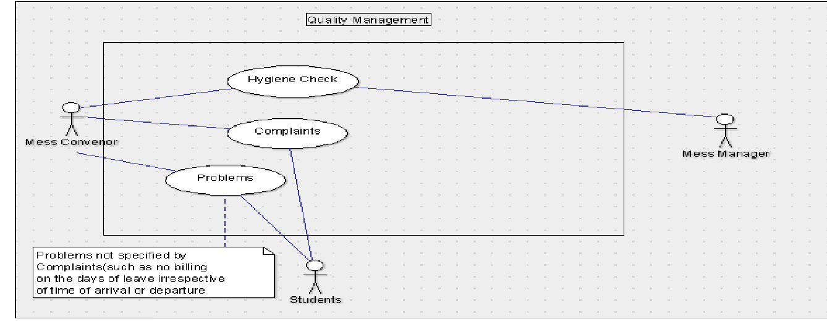

Man Management

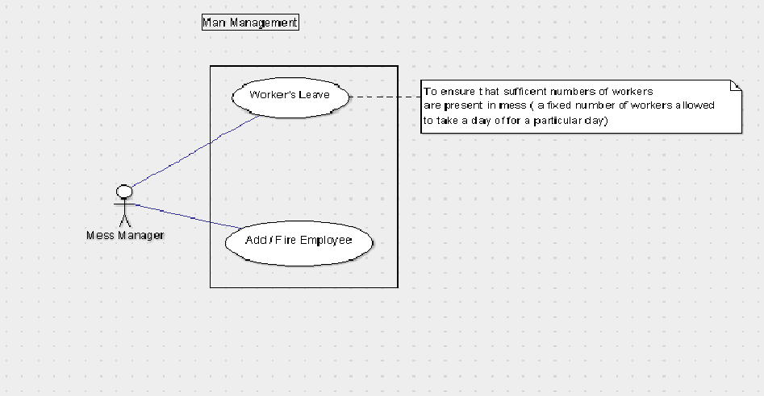
Resource Management

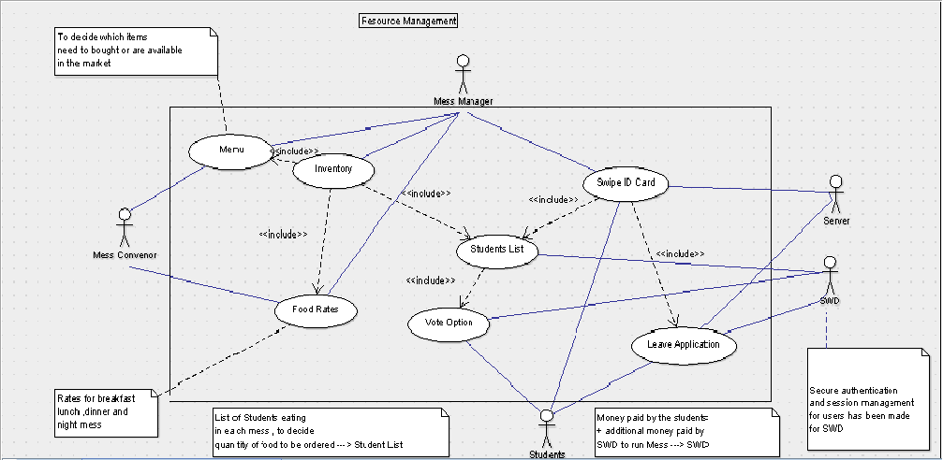

The Mess Management system has five active actors.
- Mess Convener
- Mess Manager
- Server
- Students
- SWD
These actors have different activities which are described in the next section of this document.

2.2 Functional Requirements Specification
This section outlines the use cases for each of the active actors separately.
2.2.1 Mess Convener Use Case
The Mess Convener has following set of use cases:

Hygiene Check
Mess convener
Complaints
Menu
Food Rates

Problems

Use case: Hygiene Check

Brief Description
The Mess convener checks the kitchen hygiene of mess and submits the report to system.

Initial Step-By-Step Description.

- The Mess Convener checks the hygiene of mess
- He then updates the table – hygiene check which is stored in the database
- He specifies the month and designation of person updating hygiene check table

Use case: Complaints

Brief Description
The Mess convener looks into complaint book and tries to resolve the issue by contacting mess manager or faculty coordinator

Initial Step-By-Step Description.

- The Mess Convener access the complaints table present in the database.
- He contacts the mess manager and tries to get the issue resolved within 2-3 days.
- If the issue is not resolved he sends an email to the faculty coordinator to resolve the issue

Use case: Menu

Brief Description
The Mess convener along with mess manager decides the menu.

Initial Step-By-Step Description.

- The Mess Convener consults mess representatives of different hostels to know the demands of students
- He then contacts the mess manager to know which items are available in market
- Finally he updates the menu table where he specifies the date, time and changed menu.

Use case: Food Rates

Brief Description
The Mess convener along with mess manager and faculty coordinator decides the most appropriate rates for each meal provided in mess.

Initial Step-By-Step Description.

- The Mess Convener provides the list of students expected to eat in each mess.
- Then food rates are decided in consultation with faculty coordinator based on the budget provided to the mess manager.

Use case: Problems

Brief Description
The Mess convener tries to address problems that are not specified by Complaints(such as no billing on the days of leave irrespective of time of arrival or departure.)

Initial Step-By-Step Description.

- The Mess Convener looks into software and hardware problems faced by mess.
- He then enlists the help of students into rectifying the software problems

2.2.2 Mess Manager use cases

Hygiene Check
Mess manager
Workers leave
Add/fire employee
Menu

Inventory

Swipe ID card

Use case: Hygiene Check

Brief Description
The Mess manager checks the hygiene of mess and fills the report of every month into the table “hygiene check”

Initial Step-By-Step Description.

- The Mess Manager does regular hygiene check to ensure hygiene is maintained in mess.
- He then inserts the data into the table – hygiene check.
- He specifies the month and designation of person updating hygiene check table.

Use case: workers leave

Brief Description
The Mess manager has to allot leave to workers in such a way that sufficient no. of workers are present at all times.

Initial Step-By-Step Description.

- The Mess Manager approves the leave application of a certain no. of mess workers.
- He gives priority to emergency cases or workers who have taken less no. of holidays.

Use case: Add/fire employee

Brief Description
The Mess manager adds or fire employee based on certain factors.

Initial Step-By-Step Description.

- The Mess Manager add/fires employees on the basis of behavior, performance and budget.
- He adds employees to meet the additional requirements.

Use case: Menu

Brief Description
Menu is decided on consultation with mess manager.

Initial Step-By-Step Description.

- The Mess Manager decides menu with consultation with mess convener.
- Mess manager updates mess menu in table “menu”
- Here the specifies the day and time of menu data in menu table
- If the string time doesn’t match any of the default values (i.e. breakfast, lunch, dinner) then an error report is sent.

Use case: Inventory

Brief Description
Inventory is managed by mess manager

Initial Step-By-Step Description.

- The Mess Manager has to decide the quantity of items to procure on basis of funds available, item’s priced in market and no. of people eating in mess.

Use case: Swipe ID card

Brief Description
Mess manager has to ensure that each and every student eating a meal has swiped his ID card.

Initial Step-By-Step Description.

- The Mess Manager has to ensure that only registered people should eat in that mess.

2.2.4 Students

Swipe ID Card
Students
Vote Option
Leave Application
Complaints

Problems

Use case: Swipe ID card

Brief Description:

Students need to Swipe their ID Cards to eat a meal.

Initial Step-By-Step Description:

- System Checks whether the student has eaten already. It displays the message “Student Has Already Consumed Meal...!!” on failure.
- System Checks whether the student is on leave. It displays the message ”Student is on vacation” on failure.
- System Checks whether the student belongs to a particular mess. It displays the message “You are not from this mess...!!” on failure.

Use Case: Vote Option

Brief Description:

Students have to choose a particular mess for every month. This provides information on number of students eating and money required to respective mess.

Use Case: Leave Application

Brief Description:

The number of days a student applies leave for, are not billed by the mess. Currently the problem faced by the mess authority is that, irrespective of the time of arrival or departure of a student, the days of arrival and departure are not billed and the student has to pay extra to eat in mess.

Use Case: Complaints

Brief Description:

If a Student is dissatisfied by the service provided by the mess he/she can file a complaint in the complaint book.

Initial Step-By-Step Description:

1. System accepts complaint from a user interface notifies the concerned authority and maintains the list of unresolved complaints.

Use Case: Problems

Brief Description:

Students might help addressing a few of the problems faced by mess. For Example CS students can help addressing software problems.

2.2.5 SWD

Swipe ID Card
SWD
Vote Option
Leave Application

Use case: Swipe ID Card

Brief Description:

SWD provides the list of students opted for the particular mess to mess manager.

Initial Step-By-Step Description

- SWD stores the value of studentID and mess option in a table “studentlist”
- This data is then used by mess manager to ensure that no student eat a particular meal more than once
- SWD can add/remove any student from studentlist table.

Use Case: Vote Option

Brief Description:

SWD conducts voting to choose mess and stores the number of students opted for each mess in its data base. SWD randomly allots mess to the people who failed to opt for a particular mess.

Use Case: Leave Application

Brief Description:

Information regarding the number of students that have taken leave for a particular day is provided to the server by SWD.

Initial Step-By-Step Description

- SWD takes the leave requests from student.
- It then updates the leave table in its database.

Server authentication and session management for users has been applied to SWD

    - Server

Here server stores the data regarding student IDs, password and leave application which we access with the help of JDBC from our java code.

SWD interacts with server for storing all student details and leave applications

3.Requirements Specification

3.1 Functional Requirements

    - Mess convener => Hygiene Check

Use case name | Hygiene check
Trigger | The mess convener access the mess portal
Precondition | Mess convener must have carefully analyzed the hygiene conditions of mess
Basic Path | - Mess convener access the web portal  - He then updates the report in “hygiene report” table  - He specifies the date of report and designation of person adding that report
Postcondition | The hygiene report table is thus updated weekly and hygiene of mess is maintained.
Exception Path | none

    - Mess convener => complaints

Use case name | Complaints
Trigger | The mess convener access the mess portal
Precondition | Mess convener must look after the complaints filed by the students/mess authorities.
Basic Path | - The Mess Convener access the complaints table present in the database.  - He contacts the mess manager and tries to get the issue resolved within 2-3 days.  - If the issue is not resolved he sends an email to the faculty coordinator to resolve the issue
Postcondition | The complaints which have been resolved are removed from complaints table.
Exception Path | There can be direct interaction between person filing complain and mess convener. So the issue can be resolved without the use of complaint table present in the database.
    - Mess convener => Menu

Use case name | Menu
Trigger | The mess convener access the mess portal
Precondition | Mess convener must have a discussion with mess representatives of different hostels to know the demand of students.
Basic Path | - After knowing the demand of students, mess manager contacts the mess manager to know which items are available in market  - Finally he updates the menu table where he specifies the date, time and changed menu.
Postcondition | The menu of mess changed based the demand of students
Exception Path | Menu might change due to some financial issues with consent of mess authorities and faculty coordinator.

    - Mess Manager => Workers leave

Use case name | Workers leave
Trigger | The mess manger access mess web page
Precondition | The mess worker must have applied for leave and specified their date of leave.
Basic Path | - The Mess Manager looks at the list of employers who have applied for leave.  - He then approves leave of certain no. of mess workers.  - He gives priority to emergency cases or workers who have taken less no. of holidays.
Postcondition | Leave applications seen by mess manager are removed from the database. The employers are notified whether their leave has been approved or not
Exception Path | In emergency cases mess manager can give leave without any leave application

    - Mess Manager => add/fire employee

Use case name | Add/fire employee
Trigger | The mess manager access mess web page
Precondition | Mess manager must look after the working of every employee.
Basic Path | - Mess convener access the web portal  - The Mess Manager add/fires employees on the basis of behavior, performance and budget.  - He adds employees to meet the additional requirements.
Postcondition | The list of employee gets updated.
Exception Path | none

    - Mess Manager => menu

Use case name | Menu
Trigger | The mess manager access the mess portal
Precondition | Mess convener must have an idea about the resources and capital available.
Basic Path | - The Mess Manager decides menu with consultation with mess convener.  - Mess manager updates mess menu in table “menu”  - Here the specifies the day and time of menu data in menu table  - If the string time doesn’t match any of the default values (i.e. breakfast, lunch, dinner) then an error report is sent.
Postcondition | Mess menu is changed as per need.
Exception Path | none

    - Students => swipe ID card

Use case name | Swipe ID card
Trigger | The student login on mess portal
Precondition | Student have to choose that mess for that particular month.
Basic Path | - Student enters his/her ID on a system which has the database of all students  - System Checks whether the student has eaten already. It displays the message “Student Has Already Consumed Meal...!!” on failure.  - System Checks whether the student is on leave. It displays the message ”Student is on vacation” on failure.  - System Checks whether the student belongs to a particular mess. It displays the message “You are not from this mess...!!” on failure
Postcondition | Student is able to eat food in that mess
Exception Path | Student can pay and eat in any mess.

    - Students => Vote option

Use case name | Vote option
Trigger | The student login on mess portal
Precondition | Student must login on SWD during the period when mess option is available
Basic Path | - Student login on SWD  - He then selects the mess option for that particular month  - He can give feedback if he wants
Postcondition | Student is able to select mess for every particular month
Exception Path | none

    - Students => Leave application

Use case name | Leave application
Trigger | The student login on SWD
Precondition | Student must login on SWD at least 2 days before the date leave
Basic Path | - Student login on SWD  - He then specifies the date of leave  - He needs to write the reason of leave
Postcondition | Student leave is approved. So mess billing during leave will be nill.
Exception Path | none

    - Students => complains

Use case name | Complains
Trigger | The student login on mess portal
Precondition | Student must insert his ID no and password to login
Basic Path | - Student login on mess portal  - He then specifies his complaint subject and complaint body  - The table “complaint” present in database is updated. This table stores userID, complain subject, complain body and complaint status.
Postcondition | Complains which are resolved are removed from the table and those with unresolved status are informed to authorites.
Exception Path | none

    - SWD => Swipe ID card

Use case name | Swipe ID card
Trigger | When a student choose a mess.
Precondition
Basic Path | - SWD stores the value of studentID and mess option in a table “studentlist”  - This data is then used by mess manager to ensure that no student eat a particular meal more than once  - SWD can add/remove any student from studentlist table.  - SWD interacts with the server.
Postcondition | Student who has not registered can’t eat in that mess.
Exception Path | none

    - SWD => Vote option

Use case name | Vote option
Trigger | When a student choose a mess.
Precondition
Basic Path | SWD conducts voting to choose mess and stores the number of students opted for each mess in its data base.  SWD randomly allots mess to the people who failed to opt for a particular mess.
Postcondition | Mess choice of all students are stored in SWD database.
Exception Path | none

    - SWD => Leave application

Use case name | Leave application
Trigger | When a student login on SWD
Precondition
Basic Path | - SWD takes the leave requests from student.  - It then updates the leave table in its database.
Postcondition | The “studentlist”
Exception Path | none

