**Software Requirements Specification**

Version 1.0

<<Annotated Version>>

October 29, 2014

**Mess Management System**

Abhinav Srivastava

Varun V Gopal

Anuj Modi

Siddhant Pardeshi

Tejas Jogi

Suhail Mannan Jadliwala

Sagar Verma

Submitted in partial fulfillment

of the requirements of

CS F213

**Object Oriented Programming**

<<Any comments inside double brackets such as these are *not* part of this SRS but are comments upon this SRS example to help the reader understand the point being made.

This work is based upon the submissions of the Project 2014 CS F213. The students who submitted these team projects were Abhinav Srivastava, Varun V Gopal, Anuj Modi, Siddhant Pardeshi, Tejas Jogi, Suhail Mannan Jadliwala, Sagar Verma.

. >>

Table of Contents

1.0 Introduction 2

1.1. Purpose 2

1.2. Scope of Project 2

1.4. References 2

1.5. Overview of Document 3

2.0 Overall Description 4

2.1 System Environment 4

2.2 Functional Requirements Specification 5

2.2.1 Student 5

*2.2.2 Mess Crew* 9

*2.2.3 Mess Administrator* 13

*2.2.4 Guest* 19

*2.2.5 Server* 22

2.3 User Characteristics 24

2.3.1 Authentication 24

2.3.2 GUI 24

2.4 Database 25

2.5 Security 25

3.0 Technology Implementation 26

# 1.0 Introduction

## 1.1. Purpose

The purpose of this document is to present a detailed description of the Mess Management System. It will explain the purpose and features of the system, the interfaces of the system, what the system will do, the constraints under which it must operate and how the system will react to external stimuli. This document is intended for both the users and the developers of the system.

## 1.2. Scope of Project

This software system will be a Mess Management System for the Students and Mess Staff. This system will be designed to ease the work of choosing the mess, viewing the menu, applying for leave for students. And from admin’s point of view it will help them to keep better track of the huge database of the people enrolled in the mess, displaying the menu and keeping track of the employees and food stock and their payments.

***1.3. Glossary***

|  |  |
| --- | --- |
| **Term** | **Definition** |
| Guest | Any person who has not paid a Mess Advance |
| Database | Collection of all the information monitored by this system. |
| Mess Crew | The Mess Staff: Cooking, Serving and Cleanup |
| Mess Admin | The person who has access to the database and manages the server |
| Student | A person who is studying in the college and has paid a Mess Advance |
| Software Requirements Specification | A document that completely describes all of the functions of a proposed system and the constraints under which it must operate. For example, this document. |
| Server | The central terminal that handles authentication and databases. |
| User | Anyone who uses the system |

## 1.4. References

IEEE. *IEEE Std 830-1998 IEEE Recommended Practice for Software Requirements Specifications.* IEEE Computer Society, 1998.

## 1.5. Overview of Document

The next chapter, the Overall Description section, of this document gives an overview of the functionality of the product. It describes the informal requirements and is used to establish a context for the technical requirements specification in the next chapter.

The third chapter, Requirements Specification section, of this document is written primarily for the developers and describes in technical terms the details of the functionality of the product.

Both sections of the document describe the same software product in its entirety, but are intended for different audiences and thus use different language.

# 2.0 Overall Description

## 2.1 System Environment

**Mess**

**Management**

**System**

Student Mess Admin

Mess Crew

Server

Guest

The Mess Management System has five active actors. Student, Guest, Mess Crew, Mess Admin and Server.

## 2.2 Functional Requirements Specification

This section outlines the use cases for each of the active actors separately. The Student, the Mess Crew, the Mess Admin, the Guest and Server.

### 2.2.1 Student

**Student Use Case**

Student

Report

Leave

View

Menu

Give

Feedback

View Mess

Dues & Bills

Select

Mess

Student

Login

#### Use case: Student Login

**Diagram:**

Student

Student Login

**Brief Description**

The Student is authenticated in to the Mess Management System using their ID Number.

**Initial Step-By-Step Description**

1. The Student fills in their ID number either by typing or scanning the bar code.
2. The System validates their ID.
3. If login is valid, the system displays a menu with options for student

#### Use case: Report Leave

**Diagram:**

Student

Report

Leave

Lea

**Brief Description**

The Student reports absence from college to the mess, to avail concessions.

**Initial Step-By-Step Description**

Before this use case can be initiated, the Student has already logged in

1. The Student logs in and selects the Report Leave option.
2. The Student specifies the date and time of arrival and departure.
3. The System stores the information in the server and uses it accordingly to manage the due details of the Student.

#### Use case: View Menu

**Diagram:**

Student

View

Menu

**Brief Description**

The Student views the menu in either mess for the next week.

**Initial Step-By-Step Description**

Before this use case can be initiated, the Student has already logged in

1. The Student logs in and selects the View Menu option.
2. The Student selects the day of the week and the meal (i.e. Breakfast, Lunch, Evening Snacks, or Dinner) for which to view the menu. The student also has the option to view the menu for the current meal time.
3. The menu for the requested day and time is displayed depending on the Student’s opted mess by the System. If the student selected current meal time, the system synchronizes the time with the server and fetches the details accordingly.

#### Use case: Give Feedback

**Diagram:**

Student

Give

Feedback

**Brief Description**

The Student can give feedback regarding the quality of food, cleanliness of mess, etc.

**Initial Step-By-Step Description**

Before this use case can be initiated, the Student has already logged in

1. The Student logs in and selects the Give Feedback option.
2. The Student specifies the type of feedback/complaint by selecting from a list provided.
3. The Student gives a brief description in the area provided, and submits the form for reference.
4. The system stores the feedback in the server to make it viewable to the Mess Admin.

#### Use case: View Mess Dues & Bills

**Diagram:**

Student

View Mess

Dues & Bills

**Brief Description**

The Student views the Mess Dues and summary of already paid bills.

**Initial Step-By-Step Description**

Before this use case can be initiated, the Student has already logged in

1. The Student logs in and selects the Mess Dues & Bills option.
2. The Student selects the month for which to view Dues or Bills.
3. The System retrieves the requested information from the server database and makes it available to the student.

#### Use case: Select Mess

**Diagram:**

Student

Select

Mess

**Brief Description**

The Student selects the mess for the next month.

**Initial Step-By-Step Description**

Before this use case can be initiated, the Student has already logged in

1. The Student logs in and selects the Select Mess option.
2. The System provides the Student a choice between A & C mess provided the deadline for choosing hasn’t yet passed. If the deadline has passed, this option will be greyed.
3. The System stores the choice and updates the Student Details with the server accordingly.

### ***2.2.2 Mess Crew***

**Mess crew Use Cases**

Mess Crew

View

Payments

View

Menu

Update Food Stock

View Shifts

Apply for leave

Crew

Login

#### Use case: Crew Login

**Diagram:**

Mess Crew

Crew Login

**Brief Description**

The Crew logs in to the Mess Management System using their username and password.

**Initial Step-By-Step Description**

1. The Mess Crew member fills in their username.

2. The member enters their unique password.

3. The System validates their login.

4. If login is valid, the system takes the person to their homepage

#### Use case: Apply for leave

**Diagram:**

Mess Crew

Apply for leave

**Brief Description**

The Crew member requests the admin for leave.

**Initial Step-By-Step Description**

Before this use case can be initiated, the Crew member has already logged in.

1. The Crew member logs in and selects the Report Leave option.

2. He/she specifies the date and time of arrival and departure.

3. The System forwards the application to the mess admin and updates the database.

4. The Mess Admin has the ability to approve or disapprove the leave request and thus manage crew shifts.

5. The shift database is updated according to the mess admin’s decision.

#### Use case: View Menu

**Diagram:**

Mess Crew

View

Menu

**Brief Description**

The Mess Crew member views the menu in mess for the next week.

**Initial Step-By-Step Description**

Before this use case can be initiated, the Mess Crew has already logged in

1. The Mess Crew member logs in and selects the View Menu option.

2. He/she selects the day of the week and the meal(i.e. Breakfast, Lunch, Evening Snacks, or Dinner)for which to view the menu.

3. The menu for the requested day and time is displayed.

#### Use case: Update Food Stock

**Diagram:**

Mess Crew

Update Food Stock

**Brief Description**

The Mess Crew can update the information regarding the Food Stock.

**Initial Step-By-Step Description**

Before this use case can be initiated, the Mess Crew has already logged in

1. The Mess Crew logs in and selects the Update Food Stock option.

2. The Mess Crew updates the current stock info.

3. The system stores the updated info to the database and the server.

#### Use case: View Payments

**Diagram:**

Mess Crew

View Payments

**Brief Description**

The Mess Crew views the details of their pending payments.

**Initial Step-By-Step Description**

Before this use case can be initiated, the Mess Crew has already logged in

1. The Mess Crew member logs in and selects the View Payments option.

2. He/she selects the month for which to view Payments.

3. The System retrieves the requested information from the server’s database and makes it available to him/her.

#### Use case: View Shifts

**Diagram:**

Mess Crew

View Shifts

**Brief Description**

The Mess Crew views the information regarding shifts of work.

**Initial Step-By-Step Description**

Before this use case can be initiated, the Mess Crew has already logged in

1. The Mess Crew logs in and selects the View Shifts option.

2. The System provides the Mess Crew with an option of the day for which he has to view his shifts.

3. The System fetches the details from the server and displays them accordingly.

### ***2.2.3 Mess Administrator***

**Mess Administrator Use Cases**

The Mess Admin has the following sets of use cases:

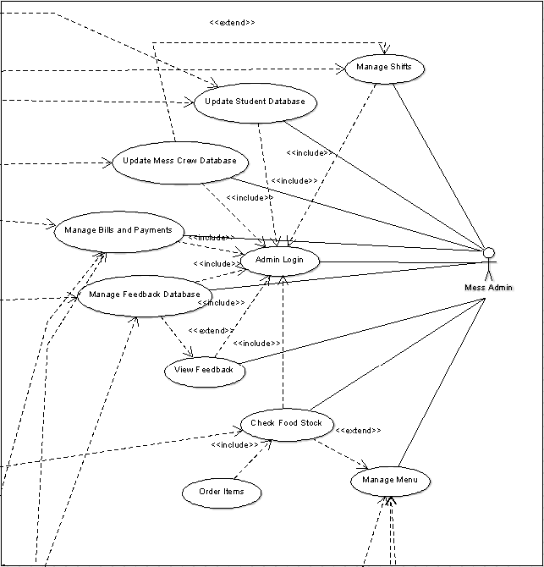

#### Use Case: Mess Admin Login

**Diagram:**

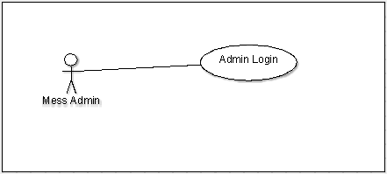

**Brief Description**

Mess Admin is a person who controls various activities(as mentioned in the use cases diagram) of the mess. The Mess Admin attempts to login and identify himself from the mess terminal in order to access options available to him.

**Initial Step-by-Step Description**

This use case can be initiated from a dedicated ‘Mess Admin’ portal which is implemented in the software interface by a ‘Mess Admin’ button.

1. The Mess Admin clicks on the ‘Mess Admin’ button
2. The system requests for a username and password to authenticate.
3. The authentication details entered by the Mess Admin are processed by the server.
4. If successful, a menu with options available to admin is displayed.

#### Use Case: Menu& Stock Management

**Diagram:**

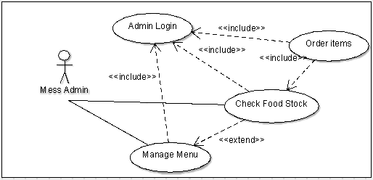

**Brief Description**

After logging in, the Mess Admin has three options to adjust his menu according to stock available and manage the stock

**Initial Description**

Initiating this use case requires the Mess Admin to authenticate himself by logging in.

1. The Mess Admin clicks on ‘Order Items’ to place order for the amount of stock that he needs. For that he needs to check the available stock at “Check food Stock” which the system displays.
2. He can also choose ‘Check food Stock’ to check stock at his convenience, which the system displays.
3. The Mess Admin can select ‘Manage Menu’ to change the menu for certain day according food stock available.

#### Use Case: Check Feedback

**Diagram:**

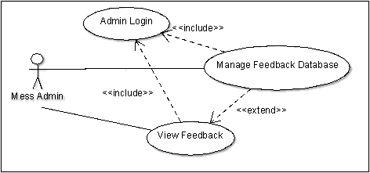

**Brief Description**

The Mess Admin can check feedbacks from guests and students and manage(add) entries to feedback database manually.

**Initial Description**

Initiating this use case requires the Mess Admin to authenticate himself by logging in.

1. The Mess Admin clicks on ‘View Feedback’.The system presents the admin with all the feedback entries from the feedback database, stored at the server.
2. The Mess Admin clicks on ‘Manage Feedback’. He can directly access the database from the server and add or delete entries.

#### Use Case: Manage Bills and Payments

**Diagram:**

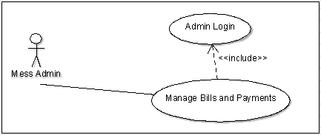

**Brief Description**

The Mess Admin updates the Payment & Billing database for students, guests and Mess workers to view.

**Initial Description**

Initiating this use case requires the Mess Admin to authenticate himself by logging in.

1. The Guest clicks on ‘Manage Bills and Payments’.
2. He searches the student or guests who has an outstanding payment or the worker who has to receive salary.
3. He updates their respective profiles (objects) with latest credit or debit to them.
4. The system records these updates and the worker, guests or student can view it when they log in.

#### Use Case: Crew Management

**Diagram:**

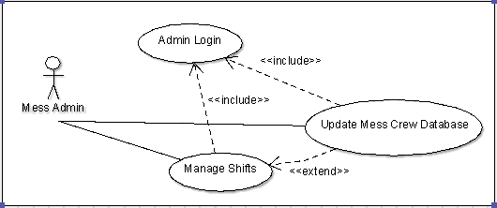

**Brief Description**

The Mess Admin can manage the shifts of the mess workers, add new employees and see there leave requests.

**Initial Description**

Initiating this use case requires the Mess Admin to authenticate himself by logging in.

1. The Guest clicks on ‘Crew Database’. He has the options to add a new employee and to see worker leave application.
2. The Guest clicks on ‘Manage Shift’. He can change the worker’s shift which the worker can see when he choose ‘View Shift” option. He can determine how to manage these shifts by checking which workers are on leave and who are not from ‘Crew Database’

#### Use Case: Student Details

**Diagram:**

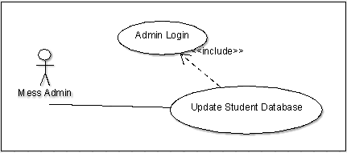

**Brief Description**

The Mess Admin is able to view students enrolled in the mess for that month and view number of students on leave.

**Initial Description**

Initiating this use case requires the Mess Admin to authenticate himself by logging in.

1. The Guest clicks on ‘Students’.
2. The system displays all the students enrolled in the mess for that month and alongside displays whether they are on leave that day.

### ***2.2.4 Guest***

**Guest Use Cases**

The Guest has the following sets of use cases:

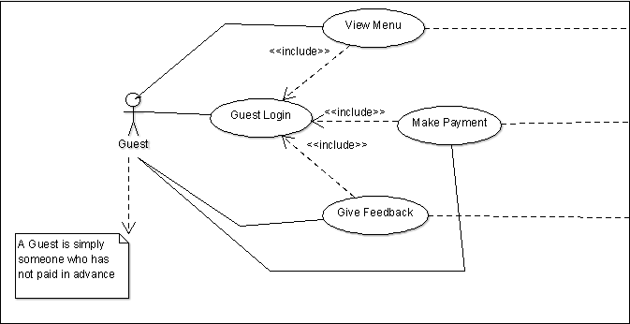

#### Use Case: Guest Login

**Diagram:**

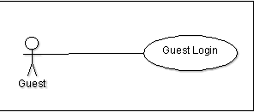

**Brief Description**

As commented, a guest is a person who has not paid a mess advance. The Guest attempts to login and identify himself from the mess terminal in order to access options available to guests.

**Initial Step-by-Step Description**

This use case can be initiated from a dedicated ‘Guest’ portal which is implemented in the software interface by a ‘Guest’ button.

* + - 1. The Guest clicks on the ‘Guest’ button
      2. The system requests for a name to reference, in case the guest leaves feedback.
      3. A menu with options available to guests is displayed.

#### Use Case: View Menu

**Diagram:**

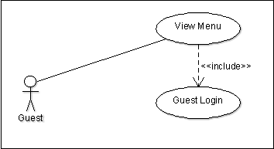

**Brief Description**

The Guest views the mess menu for that particular day and time.

**Initial Step-by-Step Description**

Initiating this use case requires the guest to identify himself by logging in.

* + - 1. The Guest clicks on ‘View Menu’
      2. The system presents a list of food items served by the mess on that day at the time of the meal by accessing the Mess Menu database.

#### Use Case: Give Feedback

**Diagram:**

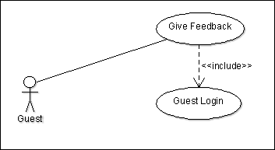

**Brief Description**

The Guest leaves feedback about the mess.

**Initial Step-by-Step Description**

Initiating this use case requires the guest to identify himself by logging in.

* + - 1. The Guest clicks on ‘Give Feedback’

2. The system presents the guest with a form with fields for text input.

3. The Guest enters his input.

4. The system records this feedback by updating the feedback database.

#### Use Case: Make Payment

**Diagram:**

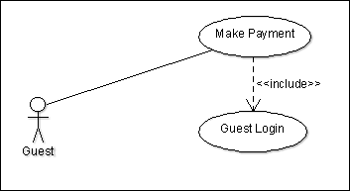

**Brief Description**

The Guest must pay for the meal if he decides to be served.

**Initial Step-by-Step Description**

Initiating this use case requires the guest to identify himself by logging in.

1. The Guest clicks on ‘Make Payment’.
2. The system fetches the cost of the meal from the menu and presents it to the guest.
3. The Guest pays cash.
4. The system records the payment as a credit to its accounts.

### 

### ***2.2.5 Server***

**Server Use Cases**

The Server actor has been created to manage the Mess Database. This database can be accessed by the Mess Admin only. The Server has the following sets of use cases:

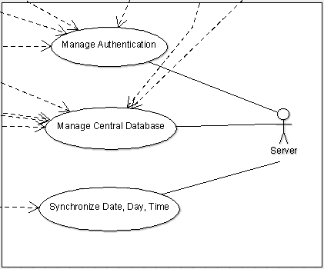

#### Use Case: Manage Authentication

**Diagram:**

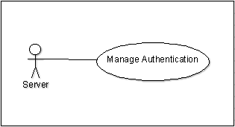

**Brief Description**

Here, the server manages the authentication of all types of users(Mess Admin, Mess Employee, Student & Guest). For the Mess Admin and the Mess Employee(also Student when he wants to choose mess or enter feedback), the server checks the username and password when one tries to log in. For the Student, the server only checks the ID. For Guest, only his name.

#### Use Case: Manage Central Database

**Diagram:**

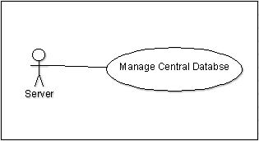

**Brief Description**

Here, the server manages changes done to the Student, Crew and Feedback Databases by all the users.

#### Use Case: Date & Time Synchronization

**Diagram:**

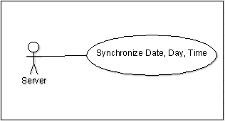

**Brief Description**

There are cases when the server provides data, upon request, according to certain dates and time during the day. They are:

1. When any user clicks the ‘View Menu’ option, the server, according to the time & day, displays the menu of the forthcoming meal (at 11:00am on the Monday, View Menu will show Monday Lunch Menu).
2. If any Student is on leave on certain days and he enter his Id in mess, the server will realize he is on leave and show a message accordingly.
3. When the Mess Admin wants to view which mess workers are on leave on a certain day, the server will cross-reference the days of leave with current date and show the names accordingly.

## 2.3 User Characteristics

### 2.3.1 Authentication

The Student needs to enter his ID Number or scan his ID card to be authenticated. The Authentication server has an inbuilt functionality that alerts the mess admin in case the student logs in more than once for a particular meal, i.e, if the student attempts to eat the meal more than once, during the same meal session.

The Mess Crew and Mess Admin is expected can able to login using their unique username and password combinations.

The Guest can login directly by entering is name. His name will be stored in the database of people who have eaten the meal.

### 

### 2.3.2 GUI

Our software will support a browser based GUI that is compatible with multiple operating systems supporting HTML. We will be using the Windows Builder plugin of the Eclipe to design this GUI.

## 2.4 Database

The data descriptions of each of these data entities are as follows:

**Student Data Entity**

|  |  |  |  |
| --- | --- | --- | --- |
| **Data Item** | **Type** | **Description** | **Comment** |
| Name | Text | Name of Student |  |
| ID | Text | ID number | Used to login |  |
| Dues | Array | Dues details |  |  |
| Feedback | Text | Feedback written by Student |  |  |
| Leave | Text | Dates of Student leave | Student will not be billed for these dates |  |
| Mess | Text | Mess Option Selected |  |  |

**Mess Crew Data Entity**

|  |  |  |  |
| --- | --- | --- | --- |
| **Data Item** | **Type** | **Description** | **Comment** |
| Name | Text | Name of Mess Crew |  |
| Username | Text | Unique ID | Used to login |
| Leave | Text | Dates of absence | Shifts will be adjusted accordingly |
| Salary Details | Array | Details of salary |  |

**Mess Admin Data Entity**

|  |  |  |  |
| --- | --- | --- | --- |
| **Data Item** | **Type** | **Description** | **Comment** |
| Name | Text | Name of Admin |  |
| Username | Text | Unique ID | Used to login |

## 2.5 Security

The server on which the Mess Management System resides will have its own security to prevent unauthorized *read/write*/*edit* access.

The Admin’s account and the individual Mess Crew accounts are password protected. Only the Admin will have write/edit access to the server and the databases stored on it.

Student accounts need only a username for authentication to ensure smooth functioning of the mess.

# 3.0 Technology Implementation

* 1. **Framework**

We had the option to make our software desktop based or web based. We have chosen to develop it as an online platform to ensure compatibility with multiple systems. In doing so, we’ve effectively shifted the compatibility constraint from the OS to the browser.

We are using the following technologies to implement our software

* + - 1. Java JDK 7
      2. HTML
      3. Swing

We are using a plugin software called WindowBuilder Pro which is a powerful and easy to use bi-directional Java GUI designer that makes it very easy to create Java GUI applications without spending a lot of time writing code to display simple forms

* 1. **Software Requirements**

The following software is required for the development of the project:

* + - 1. Argouml (Version 0.34)
      2. Eclipse (Luna)
      3. WindowBuilder Pro for Eclipse (Version 1.7.4)
      4. Microsoft Office (Version 2013)