# **Project Requirements**

# **October 29th, 2014**

# **Zephyr Management System**

# Aashutosh B Sai

# Aditya Bhalla

# Ayush Kumar

# Keshav Patil

# Rohan Goutam Patnaik

Sahil Kulshrestha

Yatharth Narang

# 

# **Submitted in partial fulfillment**

# **Of the requirements of**

# **CS F213 Object Oriented Programming**

# 

# 

# 

# **1.0. Introduction**

## 1.1. Purpose

The purpose of this document is to present a detailed structure and functioning of Zephyr fest, an inter hostel fest of BITS Pilani, K.K. Birla Goa Campus. It will explain the purpose and functioning of various departments that are interlinked and work towards various activities and take up different roles. It also represents the hierarchy that is followed among different bodies which is required for passing permissions such as budget constraints , event venues permissions etc. This document is intended for both the stakeholders and the developers of the system and is requirement for completion of the OOP course.

## 1.2. Scope of Project

This software system will be a Fest Simulation System for the members of various departments that are directly or indirectly involved in organizing the fest. This system will be designed to maximize the user’s understandability of the fest regarding functioning and roles that various characters take up. Maximizing the users’ understandability can help in a smoother functioning of the fest and to teach new inductees what roles might suit them better.

## 1.3. Glossary

|  |  |
| --- | --- |
| **Term** | **Definition** |
| Administration | A body consisting of faculty which provides permissions for various venues and reimbursements. |
| Chief Coordinator | Person responsible for promotion of various events and sending notifications to Hostel Representatives. |
| Convener | Person responsible for integrating the whole fest by coordinating with various departments. |
| Controls Member | Person responsible for PR Drives, posters and procurement of materials for the events. |
| CSA | An authoritative body that interacts with Convener and Administration regarding the important issues relating to the fest. |
| Department | A body responsible for taking specific jobs or responsibilities of the fest. |
| Events Head | Person responsible for allotting event managers, publishing rulebook for fest and for notifications to all hostels. |
| Finance Head | Person responsible for finalizing the budget and making payments to various performers. |
| Hostel Representative | Person who acts as a point of contact between zephyr controls and hostel participants. |
| Participant | Person who participates in the events from respective hostels. |
| Performers | Person finalized by convener and finance head to entertain the audience. |
| Student | Person who takes part in the fest by means of ordering souvenirs such as t-shirts and by attending special nights. |

## 1.4. Overview of Document

The next chapter, the Overall Description section, of this document gives an overview of the functionality of the product. It describes the informal requirements and is used to establish a context for the technical requirements specification in the next chapter.

**Chapter 2 : Overall Description**

The software for events, finances, special nights and management of Zephyr Controls are based on the use case diagrams that have been made. The roles of each of the major actors have been explained and how they interact with the system has also been explained. Each of the actors plays different roles and the interaction between actors is of a different nature in each of the domains. Some actors exist only in certain domains where they have a certain role.

**2.1. Functional Requirements Specification**

This section outlines the use cases for each of the active readers separately. Zephyr has the following actors:

1. Zephyr Controls member

2. Convener

3. Chief Coordinator

4. Events head

5. Finance head

6. Council of Student Affairs (CSA)

7. Performers (comedian etc.)

8. Hostel Representatives

9. Departments

10. Participants

11. College Administration

12. Students

**2.1.1. Zephyr Controls Member Use Case**

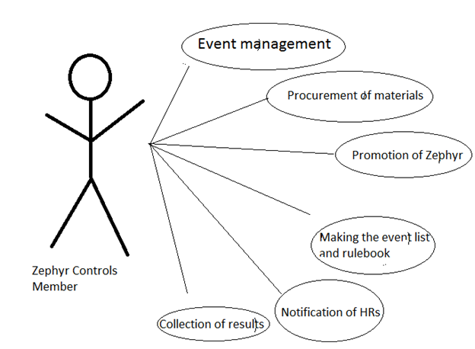

Use Case:

1. Event management

2. Procurement of materials

3. Promotion of Zephyr

4. Making the event list and rulebook

5. Notification of HRs

6. Collection of results

**Brief description:**

A member of Zephyr Controls is responsible for carrying out all the routine work for the fest.

**Description:**

1. Before the fest, the member is responsible for getting all the required materials.

The fest cannot start if all required materials have not been purchased.

2. The event list and the rulebook should also be ready in advance.

3. Before the beginning of the fest a certain amount of promotion should have been done.

4. An event starts only when at least one member of the controls is present.

5. At the scheduled time, the controls member notifies all the participants and the hostel representatives.

6. Then the event starts and at the end the result is declared and the scoresheet is collected by the member. This is then sent to update the leaderboards.

**2.1.2. Zephyr Convener Use Case**

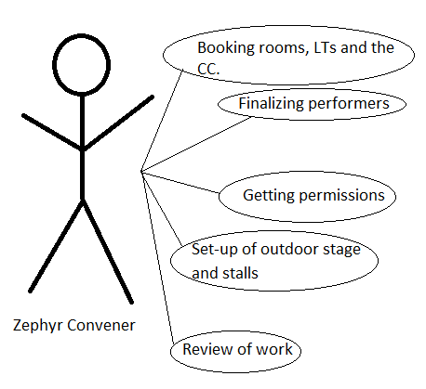

Use case:

1. Getting permissions

2. Finalizing performers

3. Booking rooms, LTs and the CC.

4. Set-up of outdoor stage and stalls

5. Review of work

**Brief description:**

The main job of the convener is to ensure everything is in order.

**Description:**

1. The convener is responsible for getting all permissions for the fest. The fest begins only after all permissions have been taken.

2. The performers (including the comedian, the DJ and the karaoke) have to be fixed before the beginning of the fest.

3. For any event to start, the corresponding venue must be booked by the convener.

4. The convener coordinates with the departments and is responsible for the set-up of the outdoor stage and the stalls before the start of Zephyr.

5. All work of different controls members and event managers is reviewed and any improvement is suggested.

**2.1.3. Chief Coordinator use case**

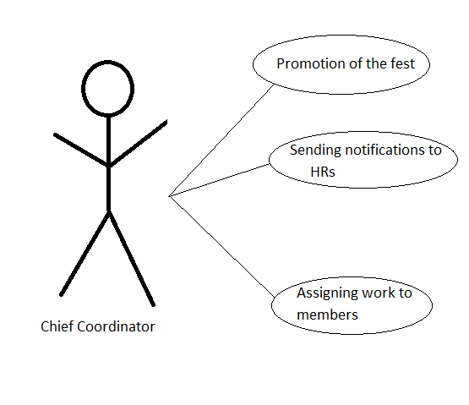

Use case:

1. Promotion of the fest
2. Sending notifications to HRs.
3. Assigning work to members.

**Brief description:**

The chief coordinator is responsible for coordinating activities within Zephyr Controls and with the hostels.

**Description:**

1. The chief coordinator is responsible for coordinating the promotional activities of the fest.

2. The chief coordinator deals with the hostel representatives and exchanges the required information with the hostels.

3. The chief coordinator also assigns the work to all the controls members and coordinates their activities.

### 2.1.4. Events head Use Case

**Diagram:**

|  |  |
| --- | --- |
|  | eventshead.png |
|  |  |

**Brief Description**

The events head handles logistics and organization of events.

**Initial Step-By-Step Description**

1. The events head has to publicize all the events

2. The events head has to make rule book

3. The events head has to procure materials for the event

4. The events head has to maintain the scoresheet and results

### 2.1.5. Finance Head Use Casefinancehead.png

|  |  |
| --- | --- |
|  |  |
|  |  |

**Brief Description**

The finance head handles all expenditure,income and budget related details.

**Initial Step-By-Step Description**

Before this use case can be initiated, the finance head has an idea about all events and performers fees.

1. The Finance Head has to plan the budget

2. The Finance head has to fix the budget

3. The finance head has to fix fees of performers

4. The Finance Head has to make all reimbursements

### 2.1.6. CSA Use Cases

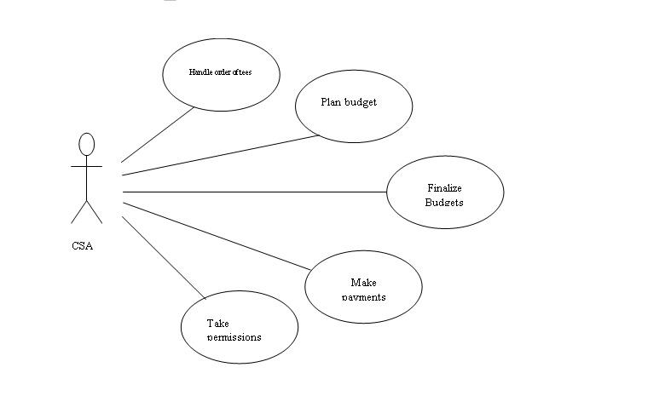

|  |  |
| --- | --- |
|  |  |
|  | |  |  | | --- | --- | |  |  | |  |  | |

**Brief Description**

The CSA takes all the final calls regarding finances and takes all the permissions required.

**Initial Step-By-Step Description**

Before this use case can be initiated, the CSA has information about all events all payments

1. The CSA helps finance head in deciding and finalizing budget.

2. The CSA makes payments to all the performers.

3. The CSA has to handle orders of tees.

4. Take necessary permissions for the festival.

**2.1.7. Performers Use Case**

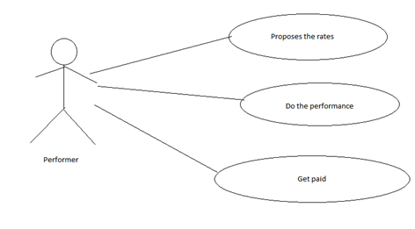

**Brief Description**

The performer performs the necessary acts during the night of the festival.

**Initial Step-By-Step Description**

1. Performer proposes the rate for the performance.

2. After fixing the rate, the performer starts the performance.

3. Once the performance is done, the performer is paid the money.

**2.1.8. Hostel Representatives Use Case**

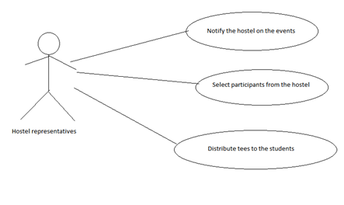

**Brief Description**

Hostel representatives are responsible for the notification of events, selection of participants and distribution of Tees in their hostel.

**Initial Step-By-Step Description**

1. Notifies the hostel on the events.

2. Selects the participants that represent the hostel for the events.

3. Distributes the tees to the students.

**2.1.9. Departments Use Case**

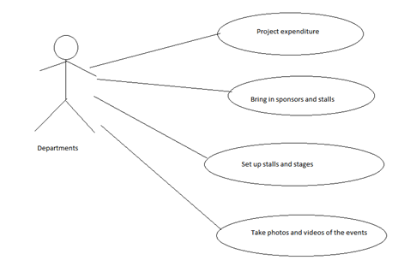

**Brief Description**

Departments are responsible for the smooth functioning of the festival. They form the many parts of the fest like bring in the sponsorship, setting up structures and taking of photos and videos.

**Initial Step-By-Step Description**

1. All the departments project their expenditure.

2. DOSM brings in the sponsorship and stalls for the fest.

3. Backstage sets up the stalls and the outdoor stage. They are also responsible for the maintenance of the auditorium.

4. DOPY is responsible for the procurement of photos and videos of the events.

**2.1.10. Participants Use Case**

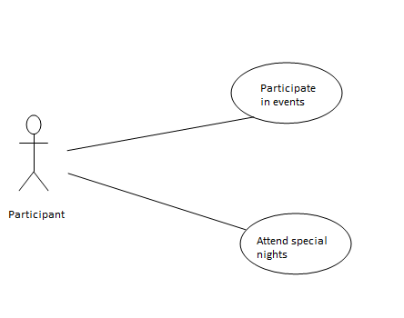

**Brief Description**

Participants are responsible for taking part and competing in events.

**Initial Step-By-Step Description**

1. Register for an event.
2. Participate in an event.
3. Attend special nights if registered.

**2.1.11. College Administration Use Case**

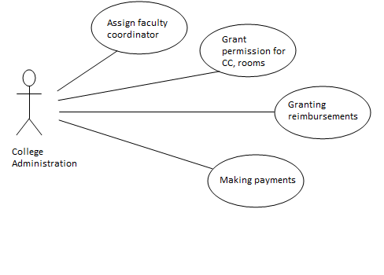

**Brief Description**

College administration is responsible for ensuring that the fest proceeds in a regulated manner.

.

**Initial Step-By-Step Description**

1. They assign a faculty coordinator for Zephyr.
2. They grant permissions for college infrastructure like CC, rooms etc.
3. They make payments for the fest.
4. They grant reimbursements for expenses incurred during the fest.

**2.1.12. Students Use Case**

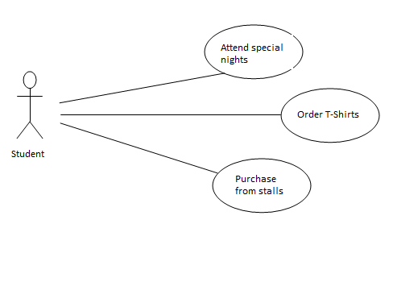

**Brief Description**

Students are responsible for enjoying and being entertained in the fest.

.

**Initial Step-By-Step Description**

1. They register for special nights.
2. They attend special nights.
3. They place orders for T-shirts and receive them.
4. They make purchases from stalls.
5. They may spectate events too.