<Elementary-Building> Project plan

Team info

Team number : 7

Team name : CafeStarz

Team members : SeungChul-Lee(PM, SA), MinGyu-Kim(SA), HoJeong-Lee(SD), YongJae-Lee(SD)

Contents

1. Goal of project (p.2)
2. UI sketches (p.3-4)
3. Class-diagram (p.4)
4. Team member roles (p.5)
5. Schedule (p.6)

## Goal of project

Huge Goal - “educational application for teaching programming concepts for elementary school children” - oop_proejct_instructions.pdf

Specific Goal

1. Teach the Loop concept of prgramming
2. Teach the modularization concept of programming
3. Teach above two concepts to elementary student by playing game “Elementary-Bulding”

Game user’s goal

1. Make a building that is exactly same as the blueprint.

## UI sketches

UI’s frames

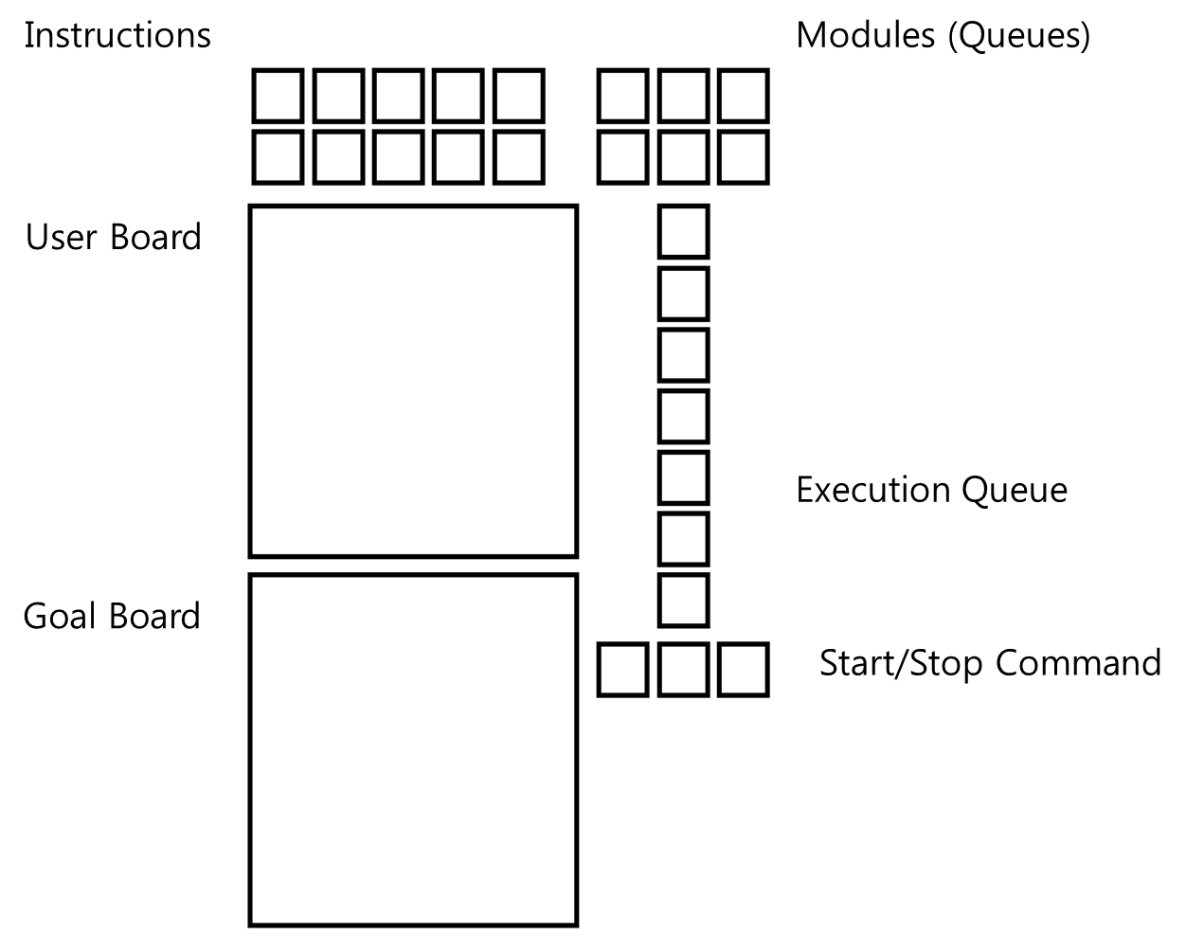

Figure 1 : UI’s frame

* UI components

1. Instruction buttons
   1. User can add instructions into current module by clicking the instruction button
2. Modules
   1. User can pick a module by clicking the module button
3. Execution Queue
   1. User can check the current module’s instructions by watching the execution queue.
4. User Board
   1. User can see the building procedures by watching this user board.
5. Goal Board
   1. The Goal Board shows the blue-print of the goal building.
6. Start/Stop Command
   1. User can start the currently seleted module by the play button.
   2. User can pause the current procedure.
   3. User can stop the current procedure.

## Class-diagram

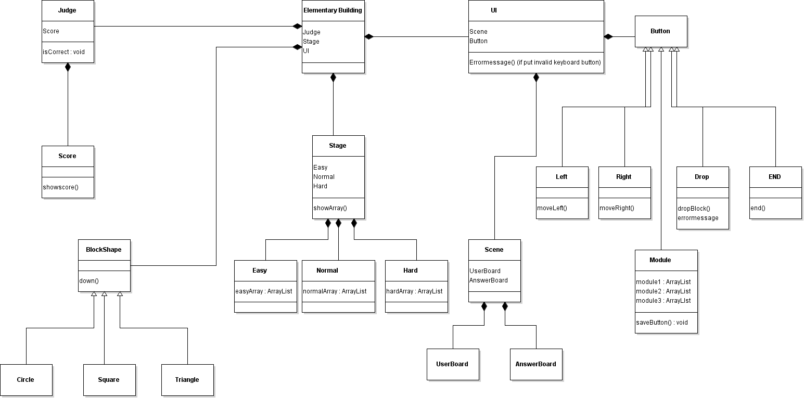

Figure 2 : class-diagram of "Elementary-Building Game"

## Team member roles

* How to work?
* Applying “Waterfall Model” to this project (All software-major students have learned the waterfall model when they were freshmen)
* How to divide tasks? And roles? Based on waterfall model?
* 1. Product Manager : team leader, adjust team schedule, set goal of project, make requirement-doc, do presentation, assign tasks to members
* 2. Software Architects : draw a class-diagram based on requirement-doc, claim or suggest opinions to PM about the requirement-doc, write simple classes that have no implementation and write comments to each classes to give hints for implementation.
* 3. Software Developers : write codes base on the class files given from SA. Clain or suggest opinions to SA about the classes and class-diagram.
* Test & Debug : All members have to test and debug.
* How to store and share project data? (ex. Source-code, ui-components)
* We are using GitHub.
* Github repo : <https://github.com/OOPCafeStarz/elementary-building>
* Team id: @[OOPCafeStarz](https://github.com/OOPCafeStarz)
* Member id :
* SeungChul- Lee : @ [lsc4719](https://github.com/lsc4719)
* Mingyu-Kim : @[kmg8280](https://github.com/kmg8280)
* HoJeong-Lee : @[Lee-Hojeong](https://github.com/Lee-Hojeong)
* YongJae-Lee : @[LYongJae](https://github.com/LYongJae)

## Schedule

*Regular meeting time : Fri 04:00 p.m. at pal 334, Tue 04:00 p.m. at pal 334

|  |  |
| --- | --- |
| **April** | **tasks** |
| 1st week | What we are going to make? (make a requirement sheet) |
| 2nd week | Making requirement sheet & java swing package research |
| 3rd week | Draw class-diagram based on requirement sheet |
| 4th week | Draw class-diagram based on requirement sheet & write comments |
| 6th week | Implementation |
| 7th week | Implementation |
| 8th week | Test & Debug |
| 9th week | Test & Debug |
| 10th week | Test & Debug, prepare final pt |
| 11th week | Submit source code |