

JavaEE 作业
( 2015届 )

学 院： 数理与信息工程学院
专 业： 软件工程（英）
学生姓名： 胡明志 学号： 201532120120

Catalog

First assignment：Preliminary test, JSP 3
Second assignments：cookies 7
Third assignments：Servlet 14
Fourth assignments：JavaBean 21
Fifth assignments：MVC example 32
Sixth assignments：Filter example 39
Seventh assignments：JDBC 46
Eighth assignments：DBCP 51
Ninth assignments：EL 57
Tenth assignments: JSTL example 62
Eleventh assignments: Upload download 68
Twelfth assignments: Struts2 82


First assignment：Preliminary test, JSP
一．The knowledge point about theme
1.First understand the writing standard of JavaEE JSP, directive and JSP files, JSP files can be used with the HTML label, the need for the use of Java language to <%%> tags can be invoked.
2.Script output, the output variables do not need to "symbol", the other is the need to use the "symbol" to ensure that the output, with the connection between the number.
3.The output of -exprssion, the definition of the variables used <%%>, each defined variable in the output when you need to use the <%=i%> format to ensure the output, fixed is not required.
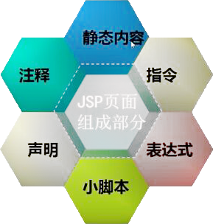
As shown in picture 1.1

二．Result
Display multiplication table with using expression
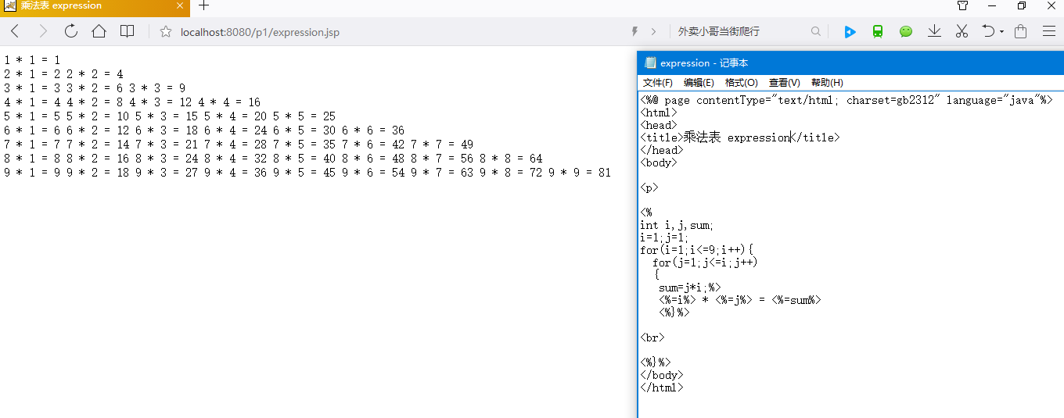

Display multiplication table with using script
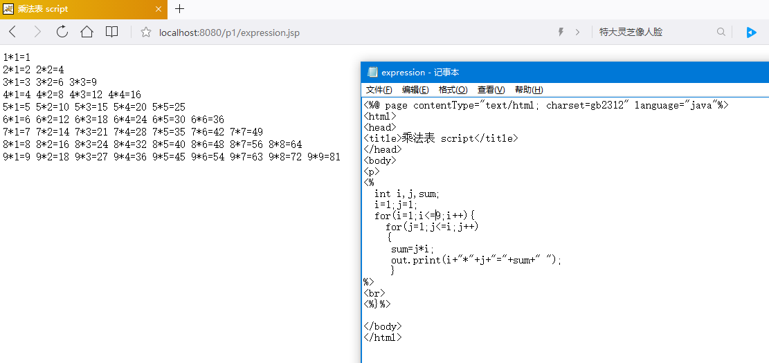
- Summary
The initial JavaEE, use the JSP programming language, is different from the Java needs GUI to realize the visualization window, the preparation of JSP can be directly used HTML language web front-end interface, just use the 99 multiplication table of the label used <%%> is an important part of the use of JSP language, the combination of Java and HTML language, I think is very easy to use.
- Source code
Cal1.jsp
<%@ page contentType="text/html; charset=gb2312" language="java"%>
<html>
<head>
<title>乘法表 script</title>
</head>
<body>
<p>
<%
int i,j,sum;
i=1;j=1;
for(i=1;i<=9;i++){
for(j=1;j<=i;j++)
{
sum=j*i;
out.print(i+"*"+j+"="+sum+" ");
}
%>
<br>
<%}%>
</body>
</html>
Cal2.jsp
<%@ page contentType="text/html; charset=gb2312" language="java"%>
<html>
<head>
<title>乘法表 expression</title>
</head>
<body>
<p>
<%
int i,j,sum;
i=1;j=1;
for(i=1;i<=9;i++){
for(j=1;j<=i;j++)
{
sum=j*i;%>
<%=i%> * <%=j%> = <%=sum%>
<%}%>
<br>
<%}%>
</body>
</html>

Second assignments：cookies
一．The knowledge point about theme
1.In the login.jsp interface, the first is the form action, can make the data input to jump to the next page, then cookie method, set the name property for the cookie object, which can be preserved in the name of the user login interface. And the use of JS, to ensure that the input box can not be empty.

2.Validate interface, using getparameter access to the start page pass over the value, and use the equals method and compare whether the stored password for the account information comparison, if the ratio of successful, continue, otherwise it will pop output Login failed .And return to the landing interface, if successful, the operation method, continue to cookie the cookie.setMaxAge method to set the length of time the information preservation method of setAttribute, only the value for the page Jump, if parameter is only worth null,
1.2 cookies
getRequestDispatcher request and reponse at the same time can pass down. To use or operate to save multiple accounts.
3.In the main page (string) session.getattribute operation to obtain the value of a page, and to compare the value of the logined is set to true, is to show welcome + user, or return to the landing interface.
二．Result
Login interface：
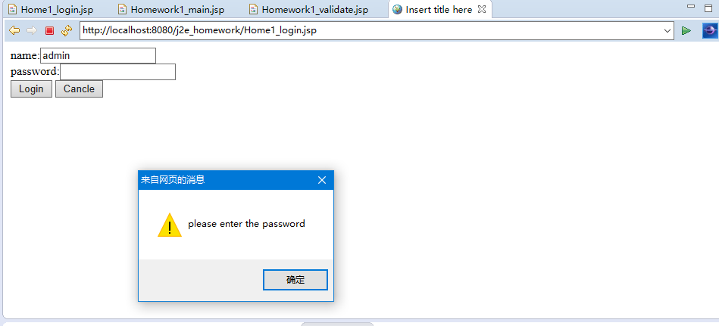
Login successful
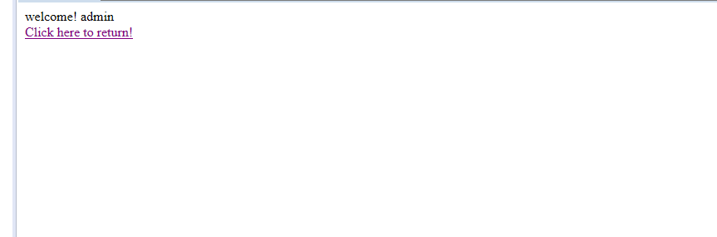
Landing failure
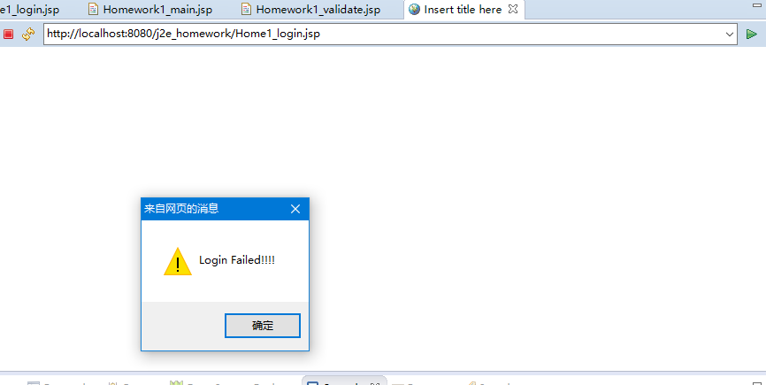

Welcome user admin1
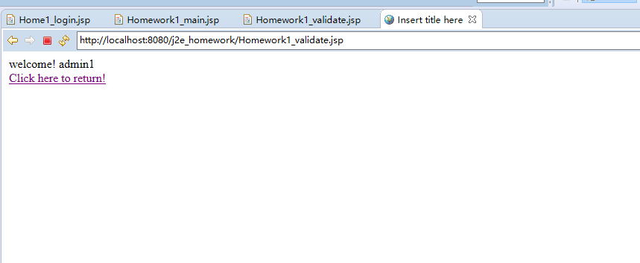
Welcome user admin2
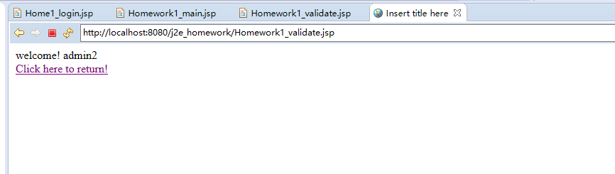
三．Summary
The second experiment is to understand and use JSP in cookie, through the examples we can find that cookie data is more like packets for storage and transmission between pages worth, for some time the unnecessary data read from the database, we can set the cookie, for example, save the password, the information stored directly in the web page, this I was on the cookie of this experiment in a general understanding.
四．Source code
Home1_login.jsp
<%@ page language="java" contentType="text/html; charset=UTF-8"
pageEncoding="UTF-8"%>
<!DOCTYPE html PUBLIC "-//W3C//DTD HTML 4.01 Transitional//EN" "http://www.w3.org/TR/html4/loose.dtd">
<html>
<head>
<meta http-equiv="Content-Type" content="text/html; charset=UTF-8">
<title>Insert title here</title>
<script language="javascript">
function check() { //验证用户名字段是否为空
username= document.form1.name.value;
if (username == "")
{ alert("Please enter the username");
document.form1.name.focus();
return false;
} else{
//验证密码字段是否为空
password = document.form1.password.value;
if (password == "") {
alert("please enter the password");
document.form1.password.focus();
return false; }
}
}
</script>
</head>
<body>
<%
Cookie[] cookies = request.getCookies();
String loginName = "";
if (cookies != null) {
for (int i = 0; i < cookies.length; i++) {
Cookie cookie = cookies[i];
if ("loginName".equals(cookie.getName())) {
loginName = cookie.getValue();
break;
}
}
}
%>

<form name="form1" action="Homework1_validate.jsp" method="post">
name:<input type="text" name="name" value="<%=loginName%>" ><br>
password:<input type="text" name="password"><br> <input
type="submit" name="submit" value="Login" onClick="return check()"> <input
type="reset" name="reset" value="Cancle">

</body>
</html>

Homework1_validate.jsp
<%@ page language="java" contentType="text/html; charset=UTF-8"
pageEncoding="UTF-8"%>
<!DOCTYPE html PUBLIC "-//W3C//DTD HTML 4.01 Transitional//EN" "http://www.w3.org/TR/html4/loose.dtd">
<html>
<head>
<meta http-equiv="Content-Type" content="text/html; charset=UTF-8">
<title>Insert title here</title>
</head>
<body>

<%
String username= request.getParameter("name");
String password = request.getParameter("password");

out.print("name");
if(("admin".equals(username)&&"123456".equals(password))||("admin1".equals(username)&&"123".equals(password))||("admin2".equals(username)&&"789".equals(password))){
Cookie cookie=new Cookie("loginName", username);
cookie.setMaxAge(3600);
response.addCookie(cookie);
session.setAttribute("Logined","true");
session.setAttribute("str1",username);
request.getRequestDispatcher("Homework1_main.jsp").forward(request, response);

}
else{%>
<script language="javascript">
alert("Login Failed!!!!");
window.location="Home1_login.jsp";
</script>
<%}
%>

</body>
</html>

Home1_login.jsp
<%@ page language="java" contentType="text/html; charset=UTF-8"
pageEncoding="UTF-8"%>
<!DOCTYPE html PUBLIC "-//W3C//DTD HTML 4.01 Transitional//EN" "http://www.w3.org/TR/html4/loose.dtd">
<html>
<head>
<meta http-equiv="Content-Type" content="text/html; charset=UTF-8">
<title>Insert title here</title>

</head>
<body>
<%
String logined=(String)session.getAttribute("Logined");
%>
<%
if(!"true".equals(logined))
{
response.sendRedirect("Home1_login.jsp");
}
%>

welcome! <%=(String)session.getAttribute("str1") %><br>
<a href="Home1_login.jsp">Click here to return!</a>
</body>
</html>

Third assignments：Servlet
- The knowledge point about theme
1.In the login interface LOGIN.jsp, use post to submit user input account password, use the submit and reset types in the submission and revocation of keys, and submit and function check () is to allow the user to input the blank information, the system can prompt the user input is empty.
2.With the role of action, check_action.jsp began to jump to the screen, drive connection code will run mysql, and then log on to the MySQL database, check whether a user input account and password, if not, the user will display the login failed, and returns LOGIN.jsp, if the user is logged in successfully, will enter the Admin.jsp interface
3.When the user enters the Admin.jsp display interface, access, and href will enable a user to return to the LOGIN screen.
4.We completed the basic function, users can identify whether the user has been archived in the database, the user information will not stop at the outside, and can connect the jump interface switching function between the interface. We discuss that in the realization of MySQL link, JDBC is more stable, JSP file connection is simple.
二．Result
Sign in
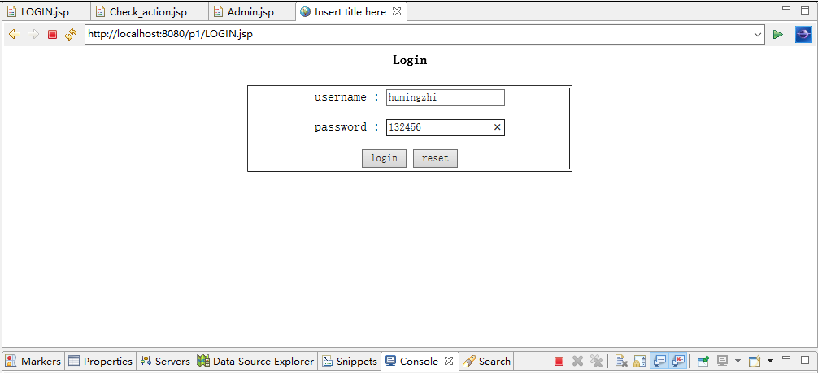Logon password not entered
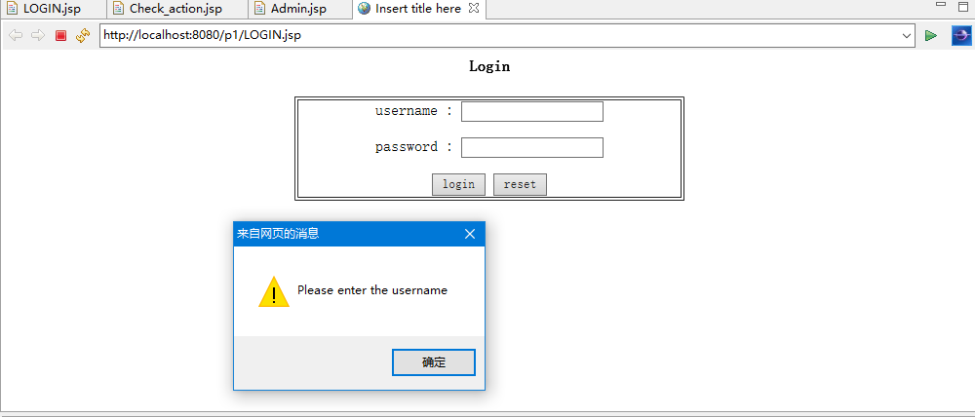
Login successful
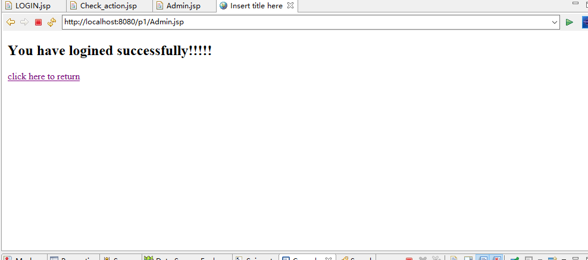

Landing failure
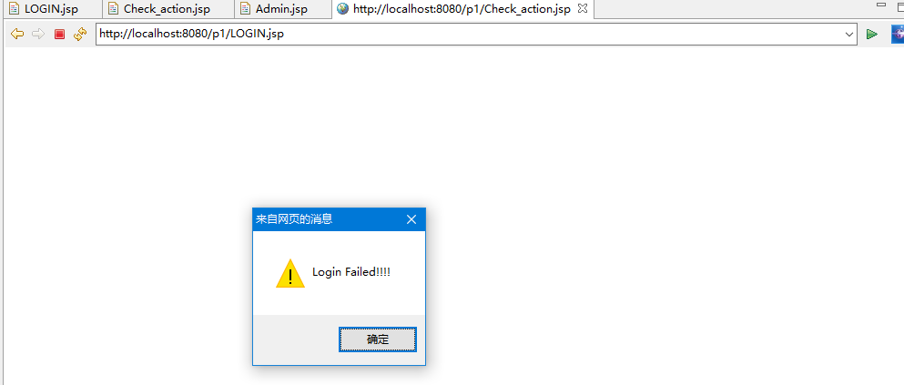三．Summary
The third experiment is to use cookie and servlet to screen the user's login interface, enter the correct value, jump to the successful servlet, and then to the make sure the message,then to failed page. Mainly through the form using cookie and servlet to obtain data, and then compared with the pre-set data, the correct, the next step. The experiment was deepened with the knowledge of the last lesson, but it was more smooth and easier to accept.
四．Source code
LOGIN.jsp
<%@ page contentType="text/html;charset=gb2312"%>
<%@ page import="java.util.*"%>
<head>
<meta http-equiv="Content-Type" content="text/html; charset=gb2312">
<title>Insert title here</title>
<script language="javascript">

function check() { //验证用户名字段是否为空
username= document.form1.name.value;
if (username == "")
{ alert("Please enter the username");
document.form1.name.focus();
return false;
} else{
//验证密码字段是否为空
password = document.form1.password.value;
if (password == "") {
alert("please enter the password");
document.form1.password.focus();
return false; }
}
}
</script>
</head>
<body>
<h4 align="center">Login</h4>

<form method="post" name="form1" action="Check.action">

<table border="1px" align="center" width="400px" length="200px">
<tr>
<td><p align="center">username : <input type="text" name="name" size="20"></p>
<p align="center">password : <input type="test" name="password" size="20"> </p>
<p align="center"><input name="submit" type="submit" value="login" onClick="return check()">
<input name="reset" type="reset" value="reset"></p>
</tr>
</table> </form></body></html>
Admin.jsp
<%@ page language="java" contentType="text/html; charset=ISO-8859-1"
pageEncoding="ISO-8859-1"%>
<!DOCTYPE html PUBLIC "-//W3C//DTD HTML 4.01 Transitional//EN" "http://www.w3.org/TR/html4/loose.dtd">
<html>
<head>
<meta http-equiv="Content-Type" content="text/html; charset=ISO-8859-1">
<title>Insert title here</title>
</head>
<body>
<h2 aling="center">You have logined successfully!!!!! </h2>
<a href=LOGIN.jsp>click here to return </a>
</body></html>

Servlet.java
package com.hmz.servlet;

import java.io.IOException;
import java.io.PrintWriter;

import javax.servlet.ServletException;
import javax.servlet.annotation.WebServlet;
import javax.servlet.http.HttpServlet;
import javax.servlet.http.HttpServletRequest;
import javax.servlet.http.HttpServletResponse;

/**
* Servlet implementation class servlet
*/
@WebServlet("/servlet")
public class servlet extends HttpServlet {
private static final long serialVersionUID = 1L;

/**
* @see HttpServlet#HttpServlet()
*/
public servlet() {
super();
// TODO Auto-generated constructor stub
}

/**
* @see HttpServlet#doGet(HttpServletRequest request, HttpServletResponse response)
*/
protected void doGet(HttpServletRequest request, HttpServletResponse response) throws ServletException, IOException {
// TODO Auto-generated method stub
}

/**
* @see HttpServlet#doPost(HttpServletRequest request, HttpServletResponse response)
*/
protected void doPost(HttpServletRequest request, HttpServletResponse response) throws ServletException, IOException {
// TODO Auto-generated method stub
String person =request.getParameter("person");
String content =request.getParameter("content");
response.setContentType("text/html;charset=utf-8");
String username=request.getParameter("name");
String password=request.getParameter("password");
Connection con;
Statement sql;
ResultSet rs;
try{ Class.forName("com.mysql.jdbc.Driver");
}catch(ClassNotFoundException e)
{ out.print(e);
}
try {
con=DriverManager.getConnection("jdbc:mysql://localhost:3306/runoob","root","123456");
sql=con.createStatement();
rs=sql.executeQuery("select * from p_user where username='"+username+"' and password='"+password+"'");
if(rs.next())
{ session.setAttribute("login","true");
response.sendRedirect("Admin.jsp");
}else{ %>
alert("Login Failed!!!!");
window.location="LOGIN.jsp";
}
con.close();
}
catch(SQLException e)
{ out.print(e);
}
RequestDispatcher
view=request.getRequestDispatcher("Admin.jsp");
view.forward(request, response);
}}
}
Web.xml
<?xml version="1.0" encoding="UTF-8"?>
<web-app xmlns:xsi="http://www.w3.org/2001/XMLSchema-instance" xmlns="http://java.sun.com/xml/ns/javaee" xsi:schemaLocation="http://java.sun.com/xml/ns/javaee http://java.sun.com/xml/ns/javaee/web-app_3_0.xsd" id="WebApp_ID" version="3.0">
<display-name>Javaee6th</display-name>
<welcome-file-list>
<welcome-file>index.html</welcome-file>
<welcome-file>index.htm</welcome-file>
<welcome-file>index.jsp</welcome-file>
<welcome-file>default.html</welcome-file>
<welcome-file>default.htm</welcome-file>
<welcome-file>default.jsp</welcome-file>
</welcome-file-list>
<servlet>
<servlet-name>bb</servlet-name>
<servlet-class>com.hmz.servlet.servlet</servlet-class>
</servlet>
<servlet-mapping>
<servlet-name>bb</servlet-name>
<url-pattern>/check.action</url-pattern>
</servlet-mapping></web-app>

Fourth assignments：JavaBean
- The knowledge point about theme
1.JavaBean itself is a kind of object oriented programming, which belongs to Java, in the JSP to the application of JSP provided Javabean tags to simple class, all classes must be put in a bag, nothing in WEB package does not exist. All classes must be declared as public class so that they can be accessed externally. All attributes in a class must be encapsulated, that is, using the private declaration. If you need to be externally operated, you must write the corresponding setter, getter method.There is at least one non parametric construction method in a JavaBean, which is used in JSP tags.In the homework the class of com.lms.User, and the validate.jsp called.
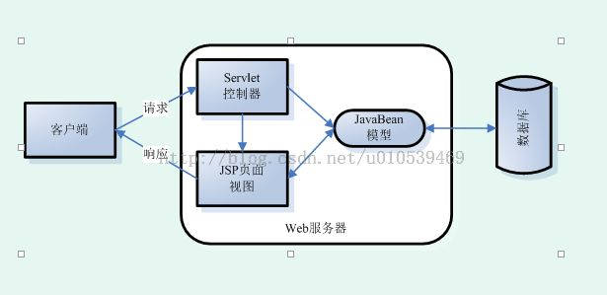1.3 JavaBean
2. With regard to the realization of the registration function, we use JDBC and JavaBean class to achieve this, such as the work of the class, register.jsp and associated com.lms.DBbean. In the use of JavaBean, we need to create a new Java class to create the database method function, and then call the Java method in the JavaBean class, to achieve the effect of the registration function.
二．Result
Login interface
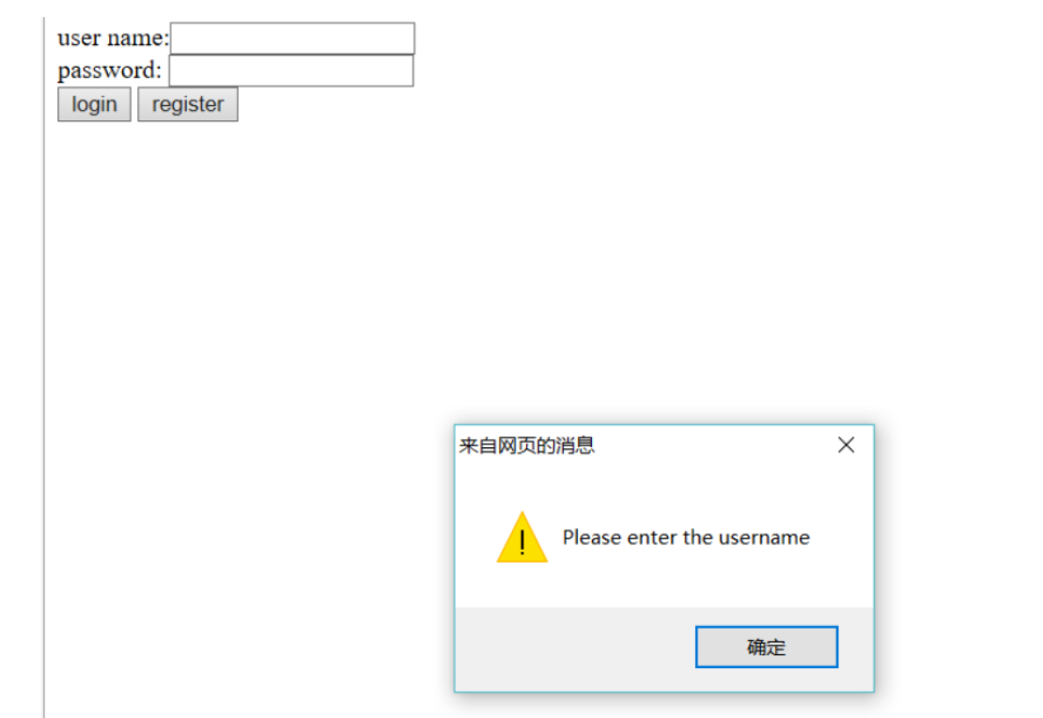
Login successful
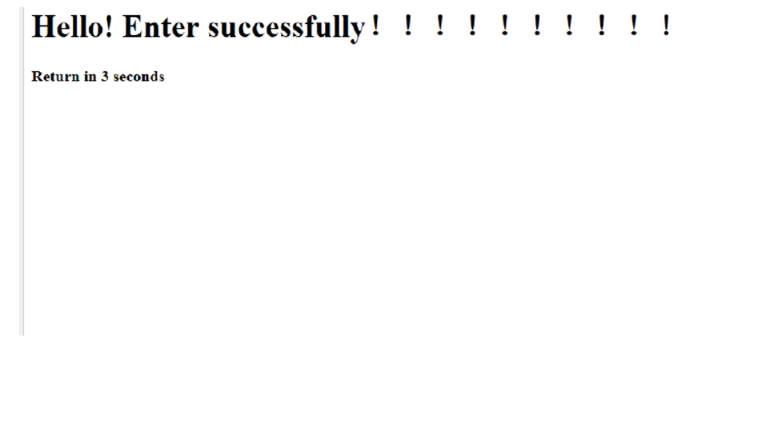

Registration interface
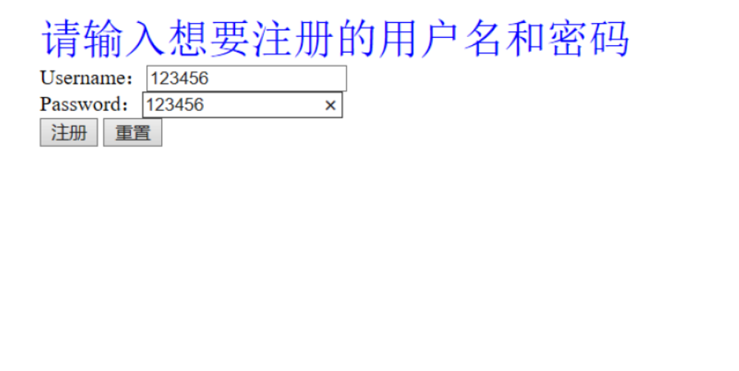
login was successful
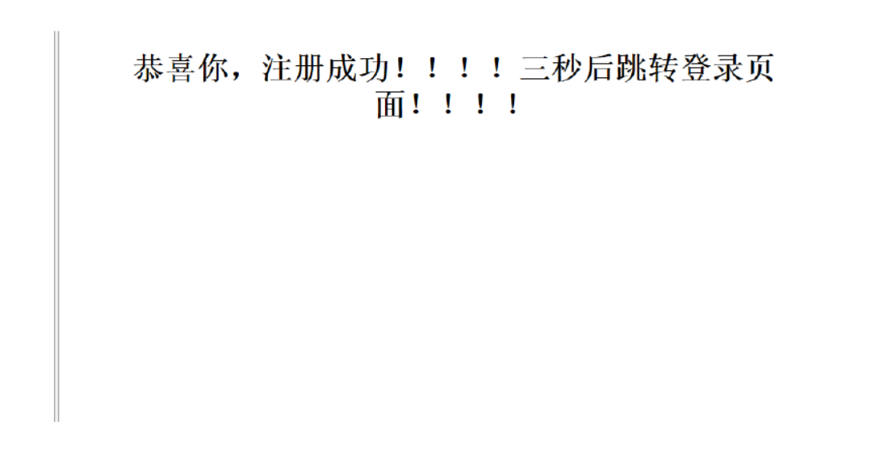
User name password entry error
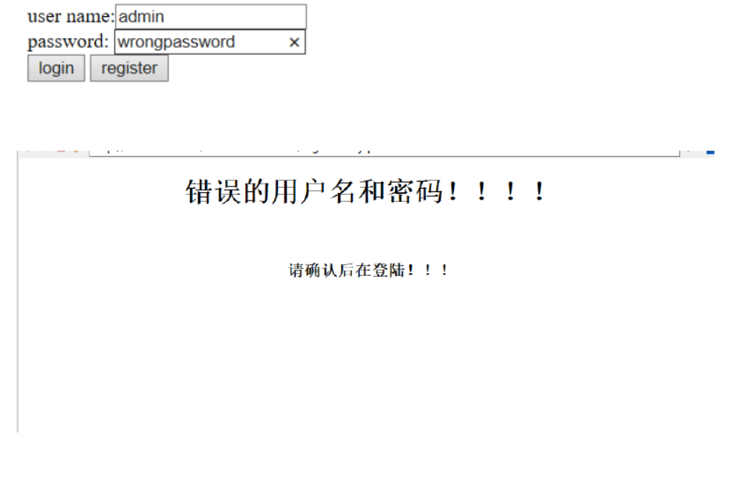database information
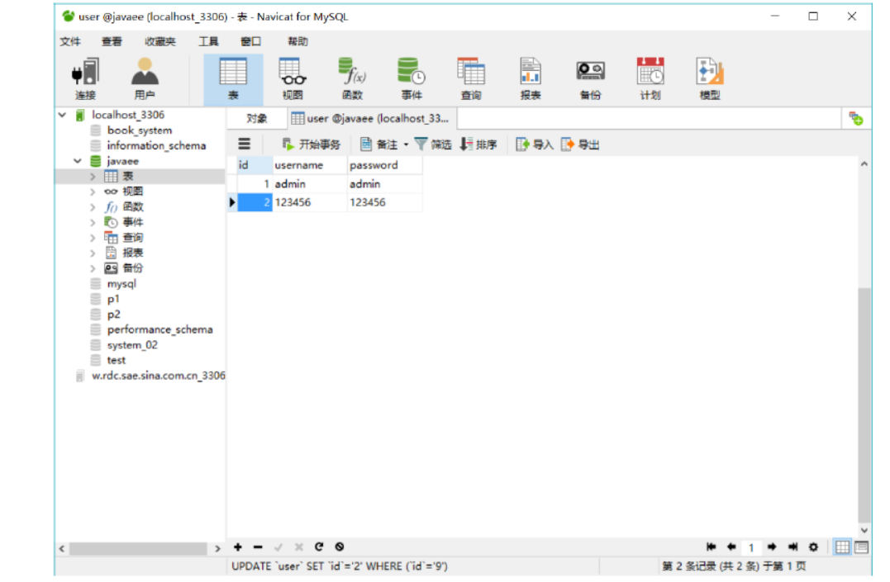

- Summary
The fourth experiment is to use the JavaBean attribute in JSP, model class to connect Java, gets the input value for the implementation of the registration function, user login, user data through the Java model into the database, need to understand and use the knowledge of JDBC and JavaBean and the basic use of the link. I think this experiment is difficult, but through unremitting efforts, we can basically understand the content and use.
四．Source code
Login.jsp
<%@ page language="java" contentType="text/html; charset=UTF-8"
pageEncoding="UTF-8"%>
<!DOCTYPE html PUBLIC "-//W3C//DTD HTML 4.01 Transitional//EN"
"http://www.w3.org/TR/html4/loose.dtd">
<html>
<head>
<meta http-equiv="Content-Type" content="text/html; charset=UTF-8">
<title>Insert title here</title>
</head>
<body>
<script language="javascript">
function check(){
username= document.form1.username.value;
if(username==""){
alert("Please enter the username");
document.form1.name.focus();
return false;
}else
{
password =document.form1.password.value;
if(password == "")
{
alert("Please enter the password");
document.form1.password.focus();
return false;
}
}
}
</script>
<form action ="validate.jsp" method="post" name="form1">
user name:<input type="text" name="username" ><br>
password: <input type="text" name="password" ><br>
<input type="submit" value="login" onClick="return check()">
<input type="button" value="register"
onclick="javascript:location.href='register.jsp'">
</form>
</body>
</html>
loginfailed.jsp
<%@ page language="java" contentType="text/html; charset=UTF-8"
pageEncoding="UTF-8"%>
<!DOCTYPE html PUBLIC "-//W3C//DTD HTML 4.01 Transitional//EN"
"http://www.w3.org/TR/html4/loose.dtd">
<html>
<head>
<meta http-equiv="Content-Type" content="text/html; charset=UTF-8">
<title>Insert title here</title>
</head>
<body>
<center>
<h1>错误的用户名和密码！！！！</h1>
<br/><h3>请确认后在登陆！！！</h3><%
response.setHeader("Refresh","2;url=login.jsp");%>
</center>
</body>
</html>

Main.jsp
<%@ page language="java" contentType="text/html; charset=UTF-8"
pageEncoding="UTF-8"%>
<jsp:useBean id="user" class="com.lms.User" ></jsp:useBean>
<html>
<head>
<meta http-equiv="Content-Type" content="text/html; charset=UTF-8">
<title>Insert title here</title>
</head>
<body>
<h1>Hello! Enter successfully！！！！！！！！！！
<br>
<h4>Return in 3 seconds</h4>
<%
response.setHeader("Refresh","3;url=login.jsp");%>
</h1>
</body>
</html>
Register_action.jsp
<%@ page language="java" contentType="text/html; charset=UTF-8"
pageEncoding="UTF-8"%>
<%@ page import="java.sql.*"%>
<!DOCTYPE html PUBLIC "-//W3C//DTD HTML 4.01 Transitional//EN"
"http://www.w3.org/TR/html4/loose.dtd">
<html>
<head>
<meta http-equiv="Content-Type" content="text/html; charset=UTF-8">
<title>Insert title here</title>
</head>
<body>
<%
Connection conn=null;
Statement stmt=null;
try{
Class.forName("com.mysql.jdbc.Driver");
conn=DriverManager.getConnection("jdbc:mysql://localhost:3306/javaee?
useSSL=true","root", "123456");
stmt=conn.createStatement(ResultSet.TYPE_SCROLL_SENSITIVE,ResultSet.C
ONCUR_READ_ONLY);
String user=request.getParameter("username");
String passw=request.getParameter("password");
String sql="insert into user (username, password) values
('"+user+"','"+passw+"')";
stmt.executeUpdate(sql);%><center>
<h1>恭喜你，注册成功！！！！三秒后跳转登录页面！！！！</h1><%
response.setHeader("Refresh","3;url=login.jsp");
%>
</center><%
}catch(Exception e1){
out.print(e1); }
%>
</body>
</html>
Register.jsp
<%@ page language="java" contentType="text/html; charset=UTF-8"
pageEncoding="UTF-8"%>
<!DOCTYPE html PUBLIC "-//W3C//DTD HTML 4.01 Transitional//EN"
"http://www.w3.org/TR/html4/loose.dtd">
<html>
<head>
<meta http-equiv="Content-Type" content="text/html; charset=UTF-8">
<title>Insert title here</title>
</head>
<body>
<form action="register_action.jsp" methord="post">
<font color="blue" size="6px">请输入想要注册的用户名和密码</font>
<br>Username：<input type="text" name="username"><br>
Password：<input type="test" name="password"><br>
<input type="submit" value="注册">
<input type="reset" value="重置">
</tr>
</body>
</html>
Validate.jsp
<%@ page language="java" contentType="text/html; charset=ISO-8859-1"
pageEncoding="ISO-8859-1" %>
<%@ page import="java.sql.*" %>
<%@ page import="com.lms.DBbean"%>
<%@ page import="com.lms.User"%>
<jsp:useBean id="myDBbean" class="com.lms.DBbean"></jsp:useBean>
<jsp:useBean id="user" class="com.lms.User"
scope="session"></jsp:useBean>
<html>
<head>
<meta http-equiv="Content-Type" content="text/html; charset=ISO-8859-
1">
<title>Insert title here</title>
</head>
<body>
<jsp:setProperty property="*" name="user" />
<%
String username = user.getUsername();
String password = user.getPassword();
String sql = "select * from user where username='"+username+"'and
password='"+password+"'";
ResultSet rs = myDBbean.query(sql);
if(rs.next()){
response.sendRedirect("main.jsp");
}else{
response.sendRedirect("loginfailed.jsp");
}
%>
</body>
</html>
com.lms.DBbean.java
package com.lms;
import java.sql.*;
public class DBbean {
Connection con = null;
Statement stat = null;
PreparedStatement pstat = null;
ResultSet rs = null;
//无参数的构造函数
public DBbean() {}
//取得数据库连接
public Connection getCon(){
try{
Class.forName("com.mysql.jdbc.Driver").newInstance();
String url =
"jdbc:mysql://localhost:3306/javaee?user=root&password=123456";
con = DriverManager.getConnection(url);
}catch(Exception ex){
ex.printStackTrace();
}
return con;
}
//执行数据库更新
public void update(String sql){
try{
con = getCon();
stat = con.createStatement();
stat.executeUpdate(sql);
}catch(Exception ex){
ex.printStackTrace();
}
}
//执行数据库更新
public void update(String sql,String[] args){
try{
con = getCon();
pstat = con.prepareStatement(sql);
for (int i=0;i<args.length;i++){
pstat.setString(i+1,args[i]);
}
pstat.executeUpdate();
}catch(Exception ex){
ex.printStackTrace();
}}
//执行数据库查询并返回查询结果
public ResultSet query(String sql){
try{
con = getCon();
stat = con.createStatement();
rs = stat.executeQuery(sql);
}catch(Exception ex){
ex.printStackTrace();
}
return rs;
}//关闭数据库连接
public void close(){
try{
if (rs != null)rs.close();
if (stat != null)stat.close();
if (pstat != null)pstat.close();
if (con != null)con.close();
}catch(Exception ex){
ex.printStackTrace();
}}}
com.lms.User.java
package com.lms;
public class User {
String username;
String password;
public String getUsername() {
return username;
}
public void setUsername(String username) {
this.username = username;
}
public String getPassword() {
return password;
}
public void setPassword(String password) {
this.password = password;
}
}

Fifth assignments：MVC example
一.The knowledge point about theme
1.JavaEE MVC architecture, divided into three layers, Model,View, Controller layer, Model (model) is used in the application process to deal with the data logic part. Typically a model object is responsible for accessing data in a database. View (view) is the part of the application that handles data display. Typically the view is created based on the model data. Controller (controller) is a part of the application that handles user interaction. Typically, the controller is responsible for reading data from the view, controlling user input, and sending data to the model.
2.In my case, the View layer is composed of form.jsp and end.jsp,Controller layer is composed of BeerSelectServlet.java servlet, the Model layer is composed of BeerExpert.java, configuration of mapping between XML documents,
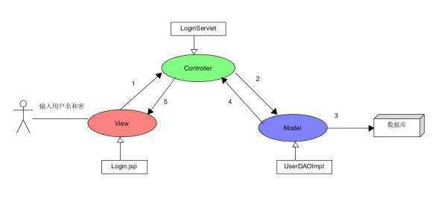
the main process in my understanding is: after running the program, the XML file and the view layer of the JSP file to run at the same time, when the user makes a request in the view layer, the system will be based on the path of the XML file, sends a request to the controller layer, and the layer through the model layer data processing, then sent to the view Display.
二．Result
Select the type interface
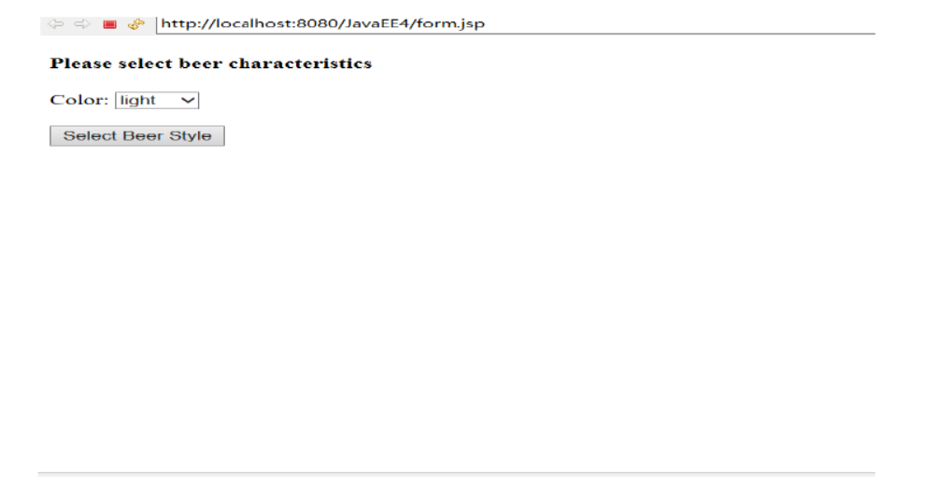Get result interface
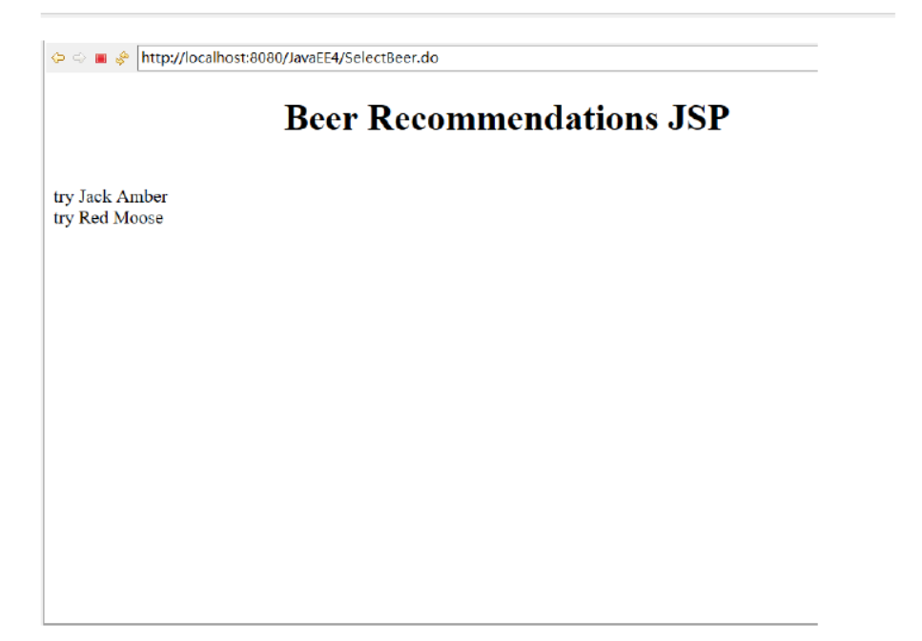

Get another result interface
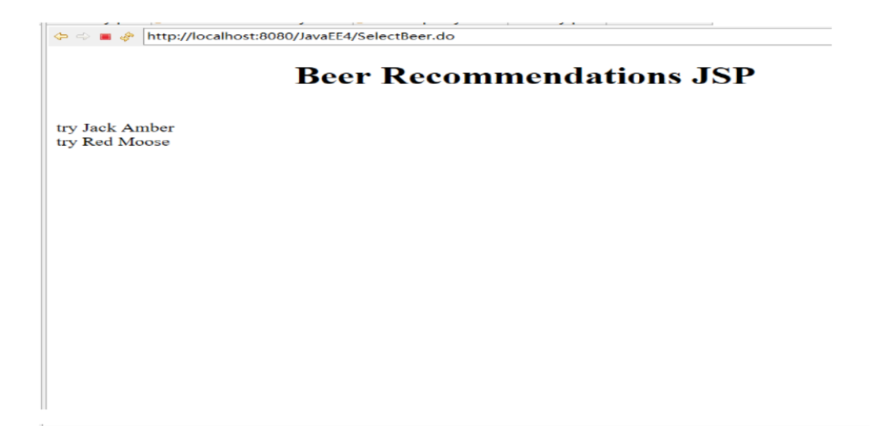Another result interface
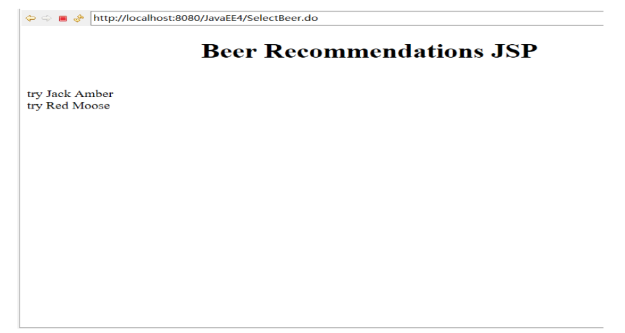三．Summary
The fifth experiment uses JSP's MVC structure model for example exercises. In my opinion, MVC can use it mainly to understand what MVC is.MVC full name is Model View Controller (model) is the model view controller (view) - (controller) abbreviation, a software design model, a business logic and data display interface, tissue isolation method code, business logic will be gathered in a component inside, and improvement in interface and customization user interaction at the same time, do not need to write business logic. MVC is uniquely developed for mapping traditional input, processing, and output functions in a logical graphical user interface structure.
四．Source code
view层
form.jsp
<%@ page language="java" contentType="text/html; charset=UTF-8"
pageEncoding="UTF-8"%>
<!DOCTYPE html PUBLIC "-//W3C//DTD HTML 4.01 Transitional//EN"
"http://www.w3.org/TR/html4/loose.dtd">
<html>
<head>
<meta http-equiv="Content-Type" content="text/html; charset=UTF-8">
<title>Insert title here</title>
</head>
<body>
<h4>Please select beer characteristics</h4>
<form action="SelectBeer.do" method="POST" focus="color">
Color:
<select property="color" name="color">
<option value="light">light</option>
<option value="amber">amber</option>
<option value="brown">brown</option>
<option value="dark">dark</option>
<option value="red">red</option>
</select>
<br/><br/>
<input type="submit" value="Select Beer Style" />
</form>
</body>
</html>

End.jsp
<%@page import="java.util.Iterator"%>
<%@page import="java.util.ArrayList"%>
<%@ page language="java" contentType="text/html; charset=UTF-8"
pageEncoding="UTF-8"%>
<!DOCTYPE html PUBLIC "-//W3C//DTD HTML 4.01 Transitional//EN"
"http://www.w3.org/TR/html4/loose.dtd">
<html>
<head>
<meta http-equiv="Content-Type" content="text/html; charset=UTF-8">
<h1 align="center">Beer Recommendations JSP</h1>
<title>Insert title here</title>
</head>
<body>
<%
ArrayList styles = (ArrayList)request.getAttribute("styles");
Iterator it = styles.iterator();
while(it.hasNext()) {
out.print("<br>try " + it.next());
}
%>
</body>
</html>
Controller层
BeerSelectServlet
package com.hmz.Controler;
import java.io.IOException;
import java.util.List;
import javax.servlet.RequestDispatcher;
import javax.servlet.ServletConfig;
import javax.servlet.ServletException;
import javax.servlet.annotation.WebServlet;
import javax.servlet.http.HttpServlet;
import javax.servlet.http.HttpServletRequest;
import javax.servlet.http.HttpServletResponse;
import com.hmz.Model.BeerExpert;
/**
* Servlet implementation class BeerSelectServlet
*/
@WebServlet("/BeerSelectServlet")
public class BeerSelectServlet extends HttpServlet {
private static final long serialVersionUID = 1L;
/**
* @see HttpServlet#HttpServlet()
*/
public BeerSelectServlet() {
super();
// TODO Auto-generated constructor stub
}

public void init(ServletConfig config) throws ServletException
{}
/**
* @see HttpServlet#doGet(HttpServletRequest request,
HttpServletResponse response)
*/
protected void doGet(HttpServletRequest request,
HttpServletResponse response) throws ServletException, IOException {
// TODO Auto-generated method stub
}
/**
* @see HttpServlet#doPost(HttpServletRequest request,
HttpServletResponse response)
*/
protected void doPost(HttpServletRequest request,
HttpServletResponse response) throws ServletException, IOException {
String c=(String) request.getParameter("color");
BeerExpert be=new BeerExpert();
List result=be.getBrands(c);
request.setAttribute("styles", result);
RequestDispatcher
view=request.getRequestDispatcher("end.jsp");
view.forward(request, response);
}}
Model层
BeerExpert
package com.hmz.Model;
import java.util.ArrayList;
public class BeerExpert {
public ArrayList getBrands(String color) {
ArrayList brands = new ArrayList();
if (color.equals("amber")) {
brands.add("Jack Amber");
brands.add("Red Moose");
}
else {
brands.add("Jail Pale Ale");
brands.add("Gout Stout");
}
return(brands);
}}
Web.xml
<?xml version="1.0" encoding="UTF-8"?>
<web-app xmlns:xsi="http://www.w3.org/2001/XMLSchema-instance"
xmlns="http://java.sun.com/xml/ns/javaee"
xsi:schemaLocation="http://java.sun.com/xml/ns/javaee
http://java.sun.com/xml/ns/javaee/web-app_3_0.xsd" id="WebApp_ID"
version="3.0">
<display-name>JavaEE4</display-name>
<servlet>
<servlet-name>bb</servlet-name>
<servlet-class>com.hmz.Controler.BeerSelectServlet</servletclass>
</servlet>
<servlet-mapping>
<servlet-name>bb</servlet-name>
<url-pattern>/SelectBeer.do</url-pattern>
</servlet-mapping>
<welcome-file-list>
<welcome-file>form.jsp</welcome-file>
</welcome-file-list>
</web-app>

Sixth assignments：Filter example
- The knowledge point about theme
1.Based on the model of the user input information of the previous MVC model, this is a join filter that allows the user to request that the severlt type can be stopped by a filter when it is sent to the.
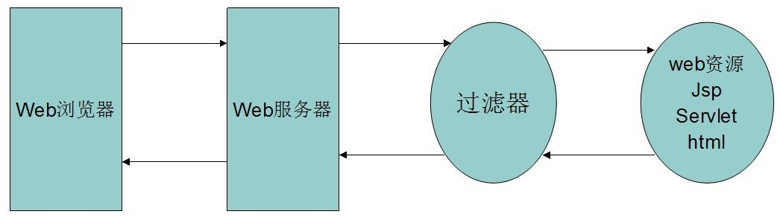
2.In order to realize the process of 1, first need to create a filter class, join our set character type request.setCharacterEncoding code in the dofilter method in which ("UTF-8"), and path configuration of fliter in XML, with * or the designated mapping document directly, or change the @WebFilter directly in the fliter class in ("/servlet"). In this way, a basic filter is realized.
二．Result
Send message interface
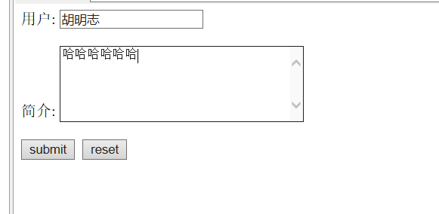

No interceptor used to add transcoding statements
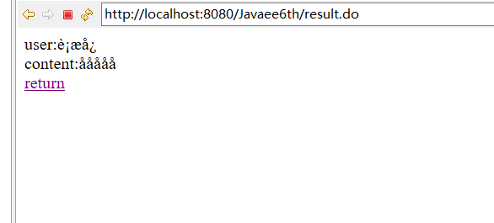
Using interceptor to add transcoding statements
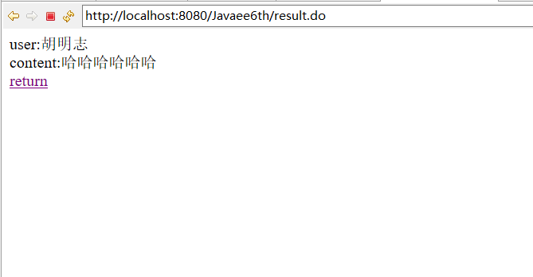三．Summary
The sixth experiment earlier compared simple, mainly in the data by adding an interceptor between response and request data transmission, will be stopped, and in the process of adding some conversion code, such as the conversion of the demo encoding, of course, there are other interceptor thoroughfare, because we also encountered less, at present only know about the use of transcoding interceptor. Still need to strengthen the links after.
四．Source code
Index.jsp
<%@ page language="java" contentType="text/html; charset=utf-8"
pageEncoding="utf-8"%>
<!DOCTYPE html PUBLIC "-//W3C//DTD HTML 4.01 Transitional//EN" "http://www.w3.org/TR/html4/loose.dtd">
<html>
<head>
<meta http-equiv="Content-Type" content="text/html; charset=ISO-8859-1">
<title>Insert title here</title>
</head>
<body>

<form id="form1" name="form1" method="post" action="result.do" >
用户: <input name="person" type="text" id="person" ><br><br>
简介: <textarea rows="5" cols="30" name="content"></textarea>
<br><br>
<input type="submit" name="Submit" value="submit">
&nbsp;<input type="reset" name="Submit2" value="reset">

</form>
</body>
</html>
Filter.java
package com.hmz.filter;
import java.io.IOException;
import javax.servlet.FilterChain;
import javax.servlet.FilterConfig;
import javax.servlet.ServletException;
import javax.servlet.ServletRequest;
import javax.servlet.ServletResponse;
import javax.servlet.annotation.WebFilter;

/**
* Servlet Filter implementation class Filter
*/
//@WebFilter("/servlet")
public class Filter implements javax.servlet.Filter {

/**
* Default constructor.
*/
public Filter() {
// TODO Auto-generated constructor stub
}

/**
* @see Filter#destroy()
*/
public void destroy() {
// TODO Auto-generated method stub
}

/**
* @see Filter#doFilter(ServletRequest, ServletResponse, FilterChain)
*/
public void doFilter(ServletRequest request, ServletResponse response, FilterChain chain) throws IOException, ServletException {
// TODO Auto-generated method stub
// place your code here

// pass the request along the filter chain
request.setCharacterEncoding("UTF-8");
chain.doFilter(request, response);

}

/**
* @see Filter#init(FilterConfig)
*/
public void init(FilterConfig fConfig) throws ServletException {
// TODO Auto-generated method stub
}

}
Servlet.java
package com.hmz.servlet;

import java.io.IOException;
import java.io.PrintWriter;

import javax.servlet.ServletException;
import javax.servlet.annotation.WebServlet;
import javax.servlet.http.HttpServlet;
import javax.servlet.http.HttpServletRequest;
import javax.servlet.http.HttpServletResponse;

/**
* Servlet implementation class servlet
*/
@WebServlet("/servlet")
public class servlet extends HttpServlet {
private static final long serialVersionUID = 1L;

/**
* @see HttpServlet#HttpServlet()
*/
public servlet() {
super();
// TODO Auto-generated constructor stub
}

/**
* @see HttpServlet#doGet(HttpServletRequest request, HttpServletResponse response)
*/
protected void doGet(HttpServletRequest request, HttpServletResponse response) throws ServletException, IOException {
// TODO Auto-generated method stub
}

/**
* @see HttpServlet#doPost(HttpServletRequest request, HttpServletResponse response)
*/
protected void doPost(HttpServletRequest request, HttpServletResponse response) throws ServletException, IOException {
// TODO Auto-generated method stub
String person =request.getParameter("person");
String content =request.getParameter("content");
response.setContentType("text/html;charset=utf-8");
PrintWriter out=response.getWriter();
out.println("<html><head><title>gain message </title></head><body>");
out.println("user:" +person +"<br>");
out.println("content:" +content+"<br>");
out.println("<a href='index.jsp'>return</a>");
out.println("</body></html>");
out.close();

}

}
Web.xml
<?xml version="1.0" encoding="UTF-8"?>
<web-app xmlns:xsi="http://www.w3.org/2001/XMLSchema-instance" xmlns="http://java.sun.com/xml/ns/javaee" xsi:schemaLocation="http://java.sun.com/xml/ns/javaee http://java.sun.com/xml/ns/javaee/web-app_3_0.xsd" id="WebApp_ID" version="3.0">
<display-name>Javaee6th</display-name>
<welcome-file-list>
<welcome-file>index.html</welcome-file>
<welcome-file>index.htm</welcome-file>
<welcome-file>index.jsp</welcome-file>
<welcome-file>default.html</welcome-file>
<welcome-file>default.htm</welcome-file>
<welcome-file>default.jsp</welcome-file>
</welcome-file-list>

<filter>
<filter-name>aa</filter-name>
<filter-class>com.hmz.filter.Filter</filter-class>
</filter>

<filter-mapping>
<filter-name>aa</filter-name>
<url-pattern>/</url-pattern>
</filter-mapping>
<servlet>
<servlet-name>bb</servlet-name>
<servlet-class>com.hmz.servlet.servlet</servlet-class>
</servlet>
<servlet-mapping>
<servlet-name>bb</servlet-name>
<url-pattern>/result.do</url-pattern>
</servlet-mapping></web-app>

Seventh assignments：JDBC
- The knowledge point about theme
1.On the JavaEE connection database, the use of JDBC technology, the code is relatively fixed format, the first load driver, register driver manager, Class.forName,
2.Then the database is connected to fill in the URL, the main database address, database name, and sometimes need to add the character code upload.
3.And then fill in the database user name, password, create a connection Conn, after the completion of the SQL statement in accordance with the demand, and create new objects to accept the SQL statement execution result, the string value is converted to a double or int type is needed in this case, after insertion into the database.
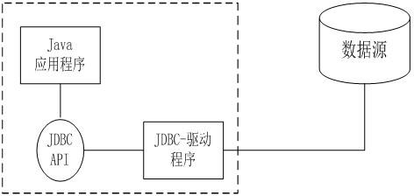
4.Remember to close the database after using the database.
5.In this case, if you need to enter the Chinese characters, you can add the character code at the beginning of the conversion code.
二．Result
Added data
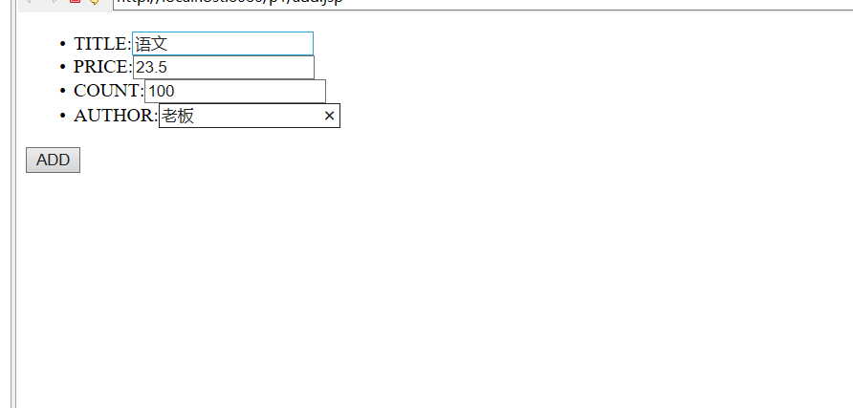Add success
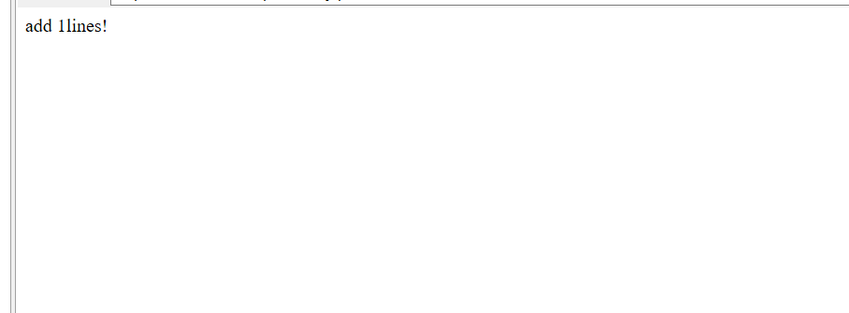Database information added
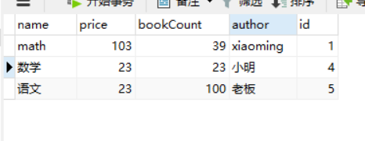
三．Summary
This experiment is to learn how to use JDBC to connect to the database, first import the corresponding database connection jar package, and then load the driver, fill in the corresponding URL database account password, through various data need to call the database in the SQL statement, then the data reflect to the page. The whole process is more fixed, learning to use once, after all, basically no difficulty.
四．Source code
add.jsp
<%@ page language="java" contentType="text/html; charset=utf-8"
pageEncoding="utf-8"%>
<!DOCTYPE html PUBLIC "-//W3C//DTD HTML 4.01 Transitional//EN" "http://www.w3.org/TR/html4/loose.dtd">
<html>
<head>
<meta http-equiv="Content-Type" content="text/html; charset=utf-8">
<title>Insert title here</title>
</head>
<body>

<form action="index.jsp" method="post">

<ul>
<li>TITLE:<input type="text" name="name"/></li>
<li>PRICE:<input type="text" name="price"/> </li>
<li>COUNT:<input type="text" name="bookCount"/></li>
<li>AUTHOR:<input type="text" name="author"/></li>
</ul>
<input type="submit" value="ADD"/>
</form>
</body>
</html>

Index.jsp
<%@ page language="java" contentType="text/html; charset=utf-8"
pageEncoding="utf-8"%>
<%@ page import="java.sql.*" %>
<%
request.setCharacterEncoding("utf-8");
%>
<!DOCTYPE html PUBLIC "-//W3C//DTD HTML 4.01 Transitional//EN" "http://www.w3.org/TR/html4/loose.dtd">
<html>
<head>
<meta http-equiv="Content-Type" content="text/html; charset=utf-8">
<title>Insert title here</title>
</head>
<body>
<%
try {
Class.forName("com.mysql.jdbc.Driver"); // 加载数据库驱动，注册到驱动管理器
String url = "jdbc:mysql://localhost:3306/javaee?useUnicode=true&characterEncoding=UTF-8"; // 数据库连接字符串
String username = "root"; // 数据库用户名
String password = "123456"; // 数据库密码
// 创建Connection连接
Connection conn =DriverManager.getConnection(url,username,password);
String sql="insert into tb_book(name,price,bookCount,author) values(?,?,?,?)";
PreparedStatement ps=conn.prepareStatement(sql);
ps.setString(1, request.getParameter("name"));
ps.setDouble(2, Double.parseDouble(request.getParameter("price")));
ps.setInt(3, Integer.parseInt(request.getParameter("bookCount")));
ps.setString(4, request.getParameter("author"));
int row = ps.executeUpdate();
if(row > 0){
out.print("add " + row +"lines!");

}
ps.close();
conn.close();
} catch (ClassNotFoundException e) {
e.printStackTrace();
} catch (SQLException e) {
e.printStackTrace();
}
%>
</body>
</html>

Eighth assignments：DBCP
- The knowledge point about theme
1.Database connection pool is used to bring the Tomcat database connection pool, configure the servers file in context.xml, and the project's web.xml configuration Ref, to ensure that the project can connect to the database connection pool.
2.Create a model layer, model.java, which sets the setget method for table data.
3.Create an interface class, and create a method, and then implement the interface class, which calls the model layer to obtain the data in the database, and all add to the list, and then the method returns list.
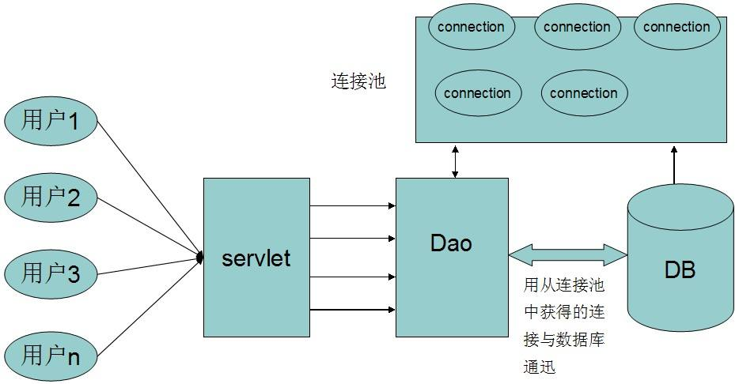
4.Create a DAO factory, return to the realization of the DAO interface class, and finally in the JSP file through the DAO factory to achieve DAO implementation of the class method, and call the method to obtain data, traverse the list and output.
- Result
Data obtained through the connection pool
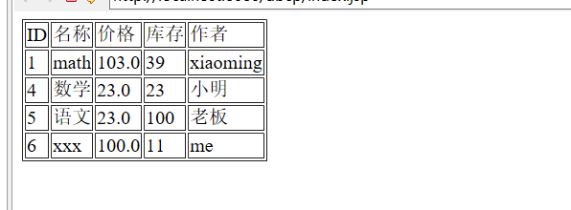

- Summary
The eighth test was based on the JDBC of the seventh experiment, DBCP, where the database connection pool was designed to reduce the consumption of data resources per JDBC. Through the connection pool, equivalent to set up an intermediate converter, the connection pool will be required data from the database once, to reduce the Dao layer directly access to database resource consumption, greatly increase the use efficiency. The use of database connection pool, you need to configure the corresponding files in the content.xml and web.xml files using Tomcat built-in DBCP or import their own DBCPjar package are possible, process is relatively fixed, learn a basic can be used.
四．Source code
View层
Index.jsp
<%@page import="java.util.Iterator"%>
<%@page import="com.lms.dao.model"%>
<%@page import="com.lms.dao.DaoFactory"%>
<%@page import="java.util.ArrayList"%>
<%@ page language="java" contentType="text/html; charset=UTF-8"
pageEncoding="UTF-8"%>
<%@ page import="com.lms.dao.Dao" %>
<jsp:directive.page import="com.lms.dao.DBTest"/>
<jsp:directive.page import="java.util.List"/>

<!DOCTYPE html PUBLIC "-//W3C//DTD HTML 4.01 Transitional//EN" "http://www.w3.org/TR/html4/loose.dtd">
<html>
<head>
<meta http-equiv="Content-Type" content="text/html; charset=UTF-8">
<title>Insert title here</title>
</head>
<body>

<%
//通过DAO工厂获得DAO实现类实例
Dao userDAO = DaoFactory.getUserDAOInstance();
//查询所有用户
List<model> all = userDAO.findAll();
Iterator<model> iter = all.iterator();
//遍历输出所有用户信息
%>
<table border="1px">
<tr>
<td>ID</td>
<td>名称</td>
<td>价格</td>
<td>库存</td>
<td>作者</td>
</tr>
<%
while(iter.hasNext()) {
model user = iter.next();
%>
<tr>
<td><% out.print(user.getId());%></td>
<td><% out.print(user.getName());%></td>
<td><% out.print(user.getPrice());%></td>
<td><% out.print(user.getBookCount());%></td>
<td><% out.print(user.getAuthor());%></td>
</tr>
<%} %>
</table>

</body>
</html>
Control层
Dao.java
package com.lms.dao;
import java.util.* ;
public interface Dao {

public List findAll() throws Exception;
}

Daofactory.java
package com.lms.dao;

public class DaoFactory {
public static Dao getUserDAOInstance(){
return new DaoImpl() ;
}
}
daoImpl.java
package com.lms.dao;

import java.util.List;
import java.sql.Connection;
import java.sql.PreparedStatement;
import java.sql.ResultSet;
import java.sql.Statement;
import java.util.ArrayList;
import java.util.List;
public class DaoImpl extends DBTest implements Dao {
@Override
public List findAll() throws Exception {
// TODO Auto-generated method stub
Connection conn = null;
Statement stmt = null;
ResultSet rs = null;
List<model> list = new ArrayList<model>();
try {
conn = ds.getConnection();

stmt = conn.createStatement();
rs = stmt.executeQuery("select * from tb_book");

while (rs.next()) {

model model = new model();
model.setId(rs.getInt("id"));
model.setAuthor(rs.getString("author"));
model.setBookCount(rs.getInt("bookCount"));
model.setName(rs.getString("name"));
model.setPrice(rs.getDouble("price"));
list.add(model);
} } finally {
if (rs != null)
rs.close();
if (stmt != null)
stmt.close();
if (conn != null)
conn.close();
}
return list;
}}
Model.java
package com.lms.dao;

public class model {

String name;
String author;
int id;
double price;
int bookCount;
public String getName() {
return name;
}
public void setName(String name) {
this.name = name;
}
public String getAuthor() {
return author;
}
public void setAuthor(String author) {
this.author = author;
}
public int getId() {
return id;
}
public void setId(int id) {
this.id = id;
}
public double getPrice() {
return price;
}
public void setPrice(double price) {
this.price = price;
}
public int getBookCount() {
return bookCount;
}
public void setBookCount(int bookCount) {
this.bookCount = bookCount;
}

Ninth assignments：EL
一．The knowledge point about theme
1.The role of EL is to make the JSP more convenient to write, if in accordance with the previous method, you need to <%=...... % > like, write more tedious, EL offers the operation outside of the JSP elements in the preparation of expression function. Its syntax structure ${a}, you can also add variables such as pagescope in the range of values, and so on.
2.The use of EL in this experiment is mainly a basic assignment to get the basic usage of EL. Then you can get the information such as port number, text type, encoding information, buffsize and so on through EL and JSP respectively.
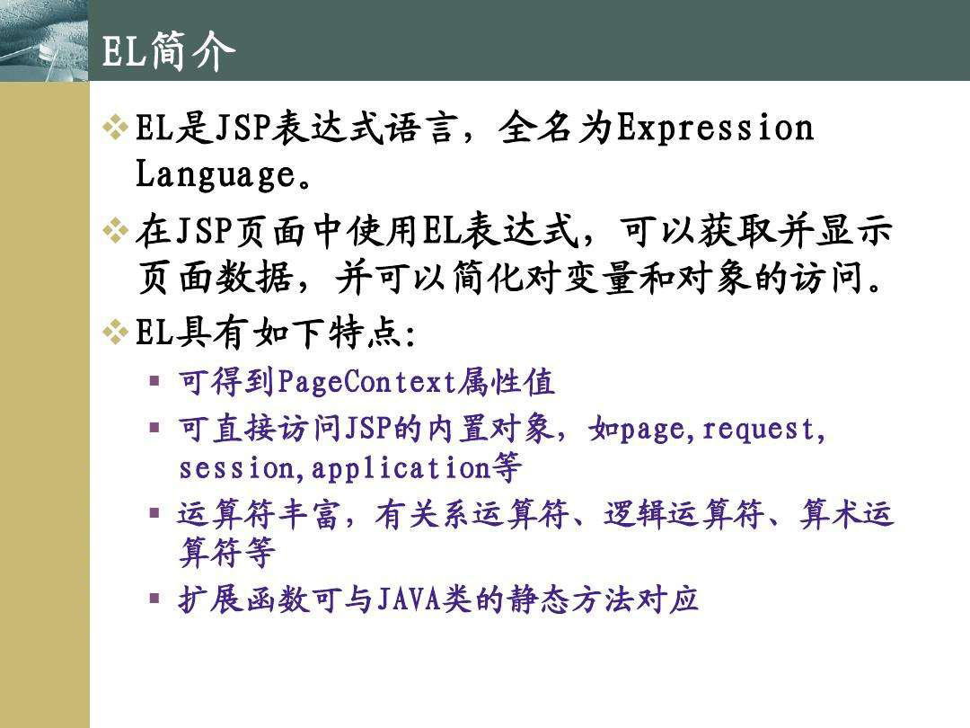
3.Then you get the checkbox type data sent through the form, the fixed data for different values of the same name, and the access to the radio frame data via the EL mode.
4.EL uses javaBean and calls the Java class method and the JSP tag approach works, but the wording is more simple.
5.Get the value sent by the form, the user name, and so on, you can get, cookies, the effect is the same.
二．Result
表单提交页面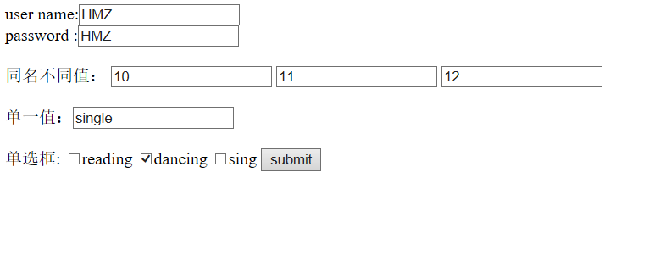通过EL获取结果界面
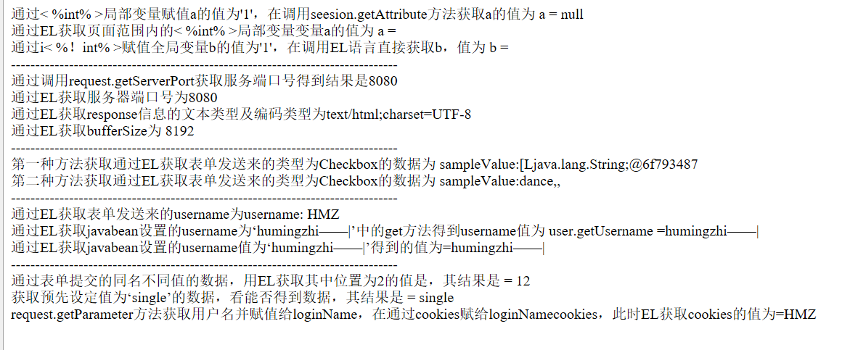
三.Summary
This experiment is a use of the EL language,and EL provides the ability to use runtime expressions outside the scope of JSP scripting elements. Scripting elements are elements in a page that can be used to embed Java code into a JSP file. They are commonly used for object manipulation and execution of computations that affect the generated content. The EL expression is added as a scripting element. EL language content is relatively simple, after the use of this demo, we should be able to use many times after the familiar EL language.
- Source code
Login.jsp
<%@ page language="java" contentType="text/html; charset=UTF-8"
pageEncoding="UTF-8"%>
<!DOCTYPE html PUBLIC "-//W3C//DTD HTML 4.01 Transitional//EN" "http://www.w3.org/TR/html4/loose.dtd">
<html>
<head>
<meta http-equiv="Content-Type" content="text/html; charset=UTF-8">
<title>Insert title here</title>
</head>
<body>
<form action="ELdemo.jsp" method="post">
user name:<input type="text" name="username"><br />
password :<input type="text" name="password"><br />

<br>
同名不同值：
<input type="text" name="sampleValue" value="10">
<input type="text" name="sampleValue" value="11">
<input type="text" name="sampleValue" value="12"> <br>
<br>
单一值：<input type="text" name="singleValue" value="single"> <br>
<br>
单选框:
<input type="checkbox" name="interest" value="read">reading
<input type="checkbox" name="interest" value="dance">dancing
<input type="checkbox" name="interest" value="sing">sing
<input type="submit" value="submit">
</form>
</body>
</html>
ELdemo.jsp
<%@ page language="java" contentType="text/html; charset=UTF-8"
pageEncoding="UTF-8"%>
<%@ page import="com.lms.User"%>
<jsp:useBean id="user" class="com.lms.User"></jsp:useBean>
<jsp:setProperty property="username" name="user" value="humingzhi——|" />
<!DOCTYPE html PUBLIC "-//W3C//DTD HTML 4.01 Transitional//EN" "http://www.w3.org/TR/html4/loose.dtd">
<html>
<head>
<meta http-equiv="Content-Type" content="text/html; charset=UTF-8">
<title>Insert title here</title>
</head>
<body>
<%!
int b=1;
%>
<%
int a=1;
String loginName=request.getParameter("username");
Cookie cookie=new Cookie("loginNamecookies",loginName);
cookie.setMaxAge(3600);//seconds
response.addCookie(cookie);
%>

通过< %int% >局部变量赋值a的值为'1'，在调用seesion.getAttribute方法获取a的值为 a = <%=session.getAttribute("a") %><br />
通过EL获取页面范围内的< %int% >局部变量变量a的值为 a = ${pageScope.a} <br>
通过i< %！int% >赋值全局变量b的值为'1'，在调用EL语言直接获取b，值为 b = ${b} <br />
--------------------------------------------------------------------------------<br>
通过调用request.getServerPort获取服务端口号得到结果是<%=request.getServerPort()%><br>
通过EL获取服务器端口号为${pageContext.request.serverPort} <br />
通过EL获取response信息的文本类型及编码类型为${pageContext.response.contentType}</br>
通过EL获取bufferSize为 ${pageContext.out.bufferSize}</br>
--------------------------------------------------------------------------------<br>
第一种方法获取通过EL获取表单发送来的类型为Checkbox的数据为 sampleValue:${paramValues.interest}<br />

第二种方法获取通过EL获取表单发送来的类型为Checkbox的数据为 sampleValue:${paramValues.interest[0]},${paramValues.interest[1]},${paramValues.interest[2]}
<br>--------------------------------------------------------------------------------<br>
通过EL获取表单发送来的username为username: ${param.username}<br />
通过EL获取javabean设置的username为‘humingzhi——|’中的get方法得到username值为 user.getUsername =${user.getUsername()} </br>
通过EL获取javabean设置的username值为‘humingzhi——|’得到的值为=${user.username }<br>
--------------------------------------------------------------------------------<br>
通过表单提交的同名不同值的数据，用EL获取其中位置为2的值是，其结果是 = ${paramValues.sampleValue[2]}<br>
获取预先设定值为‘single’的数据，看能否得到数据，其结果是 = ${param.singleValue} <br>
request.getParameter方法获取用户名并赋值给loginName，在通过cookies赋给loginNamecookies，此时EL获取cookies的值为=${cookie.loginNamecookies.value}</br>
</body>
</html>

Tenth assignments: JSTL example
一．The knowledge point about theme
1.Referencing the JSP tag library can make the JSP interface more concise and a tool for rapid development.
2.Using Jstl+EL is easy to understand, and it automatically gets values from the server and is highly coupled with jsp.
3.Jstl is a custom tag library collection that implements common features common to web applications.
4.On the reference JSTL, generally need to import standard.jar and list.jar package, and then in the appropriate JSP page import package, and you can use it.

Figure 1-1

二．Result
标签基本使用
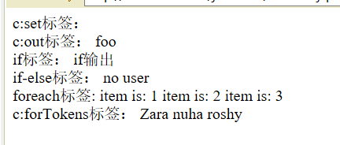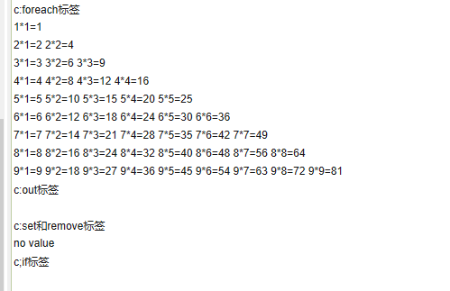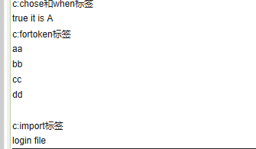
- Summary
For this experiment, I have basic tags for JSTL, such as set, out, if, foreach, token, and for other pages inside the page, and so on. And the realization of a 99 multiplication table example, other basic examples are relatively simple.
四．Source code
Index.jsp
<%@ page language="java" contentType="text/html; charset=utf-8"
pageEncoding="utf-8"%>
<%@ taglib uri="http://java.sun.com/jsp/jstl/core" prefix="c"%>
<!DOCTYPE html PUBLIC "-//W3C//DTD HTML 4.01 Transitional//EN" "http://www.w3.org/TR/html4/loose.dtd">
<html>
<head>
<meta http-equiv="Content-Type" content="text/html; charset=utf-8">
<title>Insert title here</title>
</head>
<body>

<h2>c:foreach标签</h2>
<c:forEach var="i" begin="1" end="9" step="1">
<c:forEach var="j" begin="1" end="${i}" step="1">
${i}*${j}=${i*j}
</c:forEach>
<br>
</c:forEach>
<h2>c:out标签</h2>
<c:out value="${i}"></c:out>
<br />
<h2>c:set和remove标签</h2>
<c:set var="a" value="hello! tomcat" scope="session"></c:set>
<c:set var="a" scope="session">This is jstl</c:set>
<c:remove var="a" />
<c:out value="${sessionScope.a}" default="no value"></c:out>
<br />
<h2>c;if标签</h2>
<c:set var="n" value="90" />

<c:if test="${n>=60 }" var="result">
</c:if>
<br>
<h2>c:chose和when标签</h2>
${result}
<c:choose>
<c:when test="${n>=90}">
it is A
</c:when>
<c:when test="${n>=80}">
it is B
</c:when>
<c:when test="${n>=60}">
it is C
</c:when>
<c:otherwise>
D
</c:otherwise>
</c:choose>
<br>
<h2>c:fortoken标签</h2>
<c:forTokens items="aa,bb,cc,dd" delims="," var="aValue">
${aValue} <br>
</c:forTokens>
<br>
<h2>c:import标签</h2>
<jsp:include page="/login.jsp"></jsp:include>
<c:import url="http://www.sohu.com" />
<br>
<br />
</body>
</html>
NewFile.jsp
<%@ page language="java" contentType="text/html; charset=UTF-8"
pageEncoding="UTF-8"%>
<%@ taglib prefix="c" uri="http://java.sun.com/jsp/jstl/core"%>
<!DOCTYPE html PUBLIC "-//W3C//DTD HTML 4.01 Transitional//EN" "http://www.w3.org/TR/html4/loose.dtd">
<html>
<head>
<meta http-equiv="Content-Type" content="text/html; charset=UTF-8">
<title>首页</title>
</head>
<body>
c:set标签：
<c:set var="varName" value="foo" scope="session" />
<br> c:out标签：
<c:out value="${varName}" default="default value" />
<br> if标签：
<c:if test="${varName=='foo'}">
if输出
</c:if>
<br> if-else标签：
<c:choose>
<c:when test="${empty param.username}">
no user
</c:when>
<c:when test="${1==1}">
invalid section
</c:when>
<c:otherwise>
otherwise
</c:otherwise>
</c:choose>
<br> foreach标签:
<c:forEach var="i" begin="1" end="3">
item is: <c:out value="${i}" />
</c:forEach>
<br> c:forTokens标签：
<c:forTokens items="Zara,nuha,roshy" delims="," var="name">
<c:out value="${name}" />
</c:forTokens>
</body>
</html>

Eleventh assignments: Upload download
一．The knowledge point about theme
- Users can upload and download function, first upload form submission form is submitted to file, the other processing of the page, the page processing processing there are many kinds of forms, can be Apach or use ServletFileUpload upload com-
ponent upload fileupload.jar SmartUpload package, etc....
- the meaning of enctype= "multipart/form-data" in the form is to set the MIME encoding of the form. By default, the encoding format is application/x -www -form-urlencoded, can not be used for file upload; only the use of the multipart/ form-data, to com- plete the transfer of file data, the operation.Enctype = "mult- ipart/form-data" is uploading binary data; the value of the form in input is passed in the 2 decimal way. 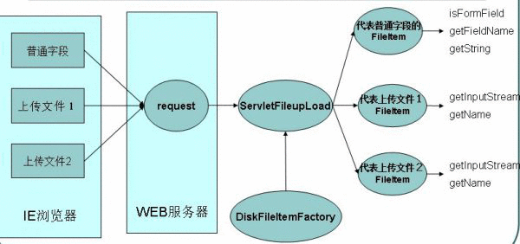Form inside the input value to 2 hexadecimal way in the past, so request won't get value. That is to say, adding this code to request will not succeed.
3. Download Interface use, use stream as download, FileInputStream, Out - putStream, first through File access to download path, and then use the stream to download the uploaded file.
二．Result
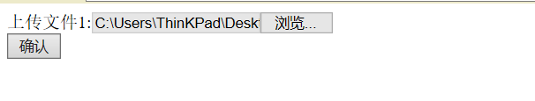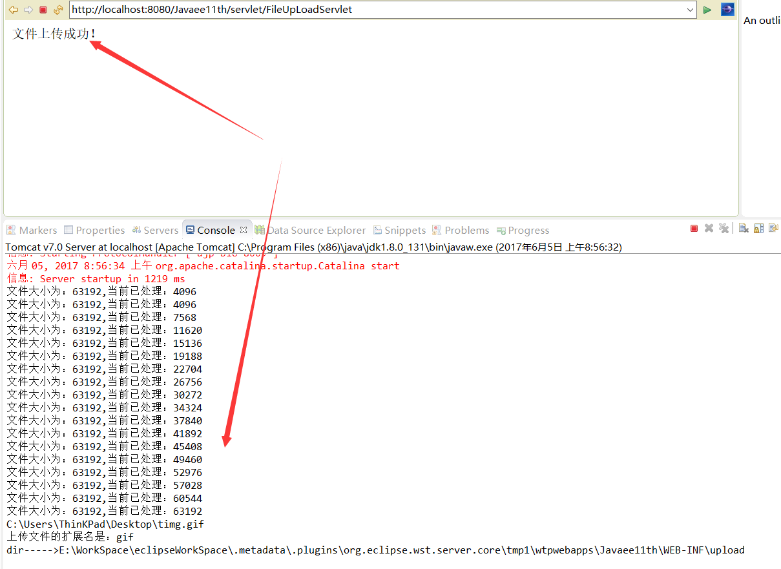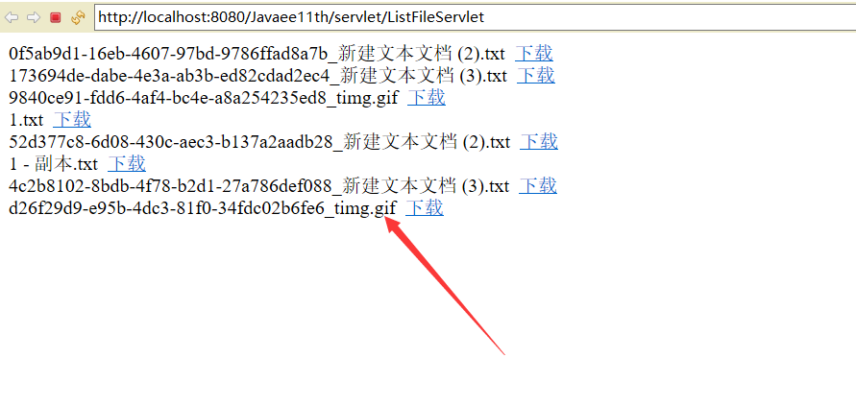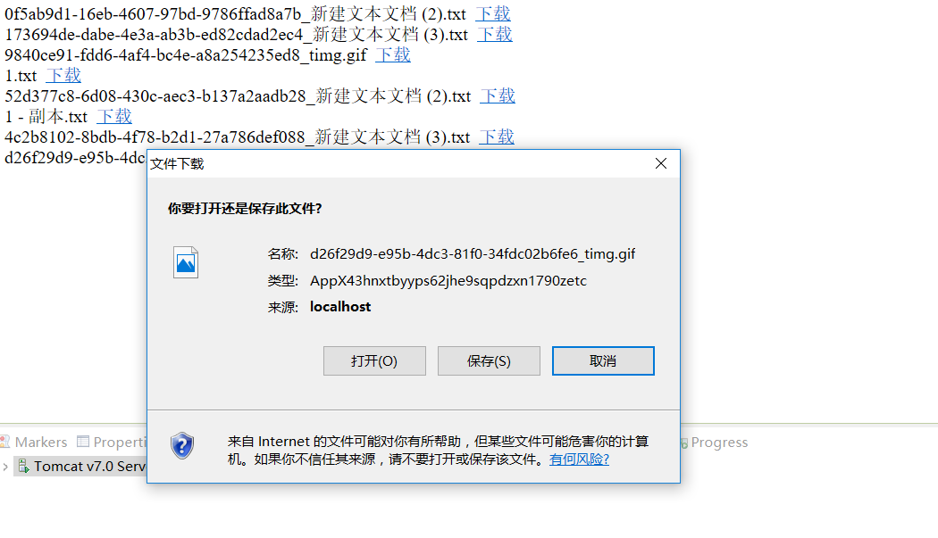三.Summary
- This time the use of servlet to achieve, in the web.xml configuration information, to upload the page I upload the file name in order to avoid duplication, using make - FileName method is defined for each file name, and then use the JSTL to return to the JSP page upload news. WorkSpace\ .metadata\.plugins\org.eclipse.wst.server.core\tmp1\wtpwebapps\Javaee11th\WEB-INF\upload1.. This address is the saved address of the file uploaded by eclipse. The address is downloaded here and you can browse the uploaded file.
- Get file upload, send requests to the JSP page data set, the download link for file link address, after switching to the servlet download page, use the flow as a download service output file stream, get download files.

四．Source code
Upload.jsp
<%@ page language="java" import="java.util.*" pageEncoding="utf-8"%>

<!DOCTYPE HTML PUBLIC "-//W3C//DTD HTML 4.01 Transitional//EN">
<html>
<head>
<title>文件上传</title>
</head>

<body>
<!--
表单中enctype="multipart/form-data"的意思，是设置表单的MIME编码。
默认情况，这个编码格式是application/x-www-form-urlencoded，不能用于文件上传；
只有使用了multipart/form-data，才能完整的传递文件数据，进行下面的操作.
-->
<form action="${pageContext.request.contextPath }/servlet/FileUpLoadServlet" enctype="multipart/form-data" method="post">
上传文件1:<input type="file" name="file1"><br>
<input type="submit" value="确认">
</form></html>
Download.jsp
</body>
<%@ page language="java" import="java.util.*" pageEncoding="utf-8"%>
<%@ taglib uri="http://java.sun.com/jsp/jstl/core" prefix="c" %>
<%
String path = request.getContextPath();
String basePath = request.getScheme()+"://"+request.getServerName()+":"+request.getServerPort()+path+"/";
%>

<!DOCTYPE HTML PUBLIC "-//W3C//DTD HTML 4.01 Transitional//EN">
<html>
<head>
<base href="<%=basePath%>">

<title>My JSP 'download.jsp' starting page</title>

<meta http-equiv="pragma" content="no-cache">
<meta http-equiv="cache-control" content="no-cache">
<meta http-equiv="expires" content="0">
<meta http-equiv="keywords" content="keyword1,keyword2,keyword3">
<meta http-equiv="description" content="This is my page">
<!--
<link rel="stylesheet" type="text/css" href="styles.css">
-->

</head>

<body>
<c:forEach var="entry" items="${fileMap }">
<c:url value="/servlet/FileDownLoad" var="url">
<c:param name="fileName" value="${entry.value}"></c:param>
</c:url>
${entry.key } &nbsp;<a href="${url }">下载</a> <br>

</c:forEach>
</body>
</html>
Message.jsp
<%@ page language="java" import="java.util.*" pageEncoding="utf-8"%>

<html>
<head>

<title>消息提示</title>

</head>

<body>
${message}
</body>
</html>
Web.xml
<?xml version="1.0" encoding="UTF-8"?>
<web-app xmlns:xsi="http://www.w3.org/2001/XMLSchema-instance" xmlns="http://java.sun.com/xml/ns/javaee" xsi:schemaLocation="http://java.sun.com/xml/ns/javaee http://java.sun.com/xml/ns/javaee/web-app_3_0.xsd" id="WebApp_ID" version="3.0">
<display-name>FileDownLoad</display-name>
<servlet>
<description>This is the description of my J2EE component</description>
<display-name>This is the display name of my J2EE component</display-name>
<servlet-name>FileDownLoad</servlet-name>
<servlet-class>com.hmz.download.FileDownLoad</servlet-class>
</servlet>

<servlet>
<description>This is the description of my J2EE component</description>
<display-name>This is the display name of my J2EE component</display-name>
<servlet-name>FileUpLoadServlet</servlet-name>
<servlet-class>com.hmz.upload.uploadServlet</servlet-class>
</servlet>

<servlet>
<description>This is the description of my J2EE component</description>
<display-name>This is the display name of my J2EE component</display-name>
<servlet-name>ListFileServlet</servlet-name>
<servlet-class>com.hmz.download.ListFileServlet</servlet-class>
</servlet>

<servlet-mapping>
<servlet-name>FileDownLoad</servlet-name>
<url-pattern>/servlet/FileDownLoad</url-pattern>
</servlet-mapping>

<servlet-mapping>
<servlet-name>FileUpLoadServlet</servlet-name>
<url-pattern>/servlet/FileUpLoadServlet</url-pattern>
</servlet-mapping>

<servlet-mapping>
<servlet-name>ListFileServlet</servlet-name>
<url-pattern>/servlet/ListFileServlet</url-pattern>
</servlet-mapping>

<welcome-file-list>
<welcome-file>index.html</welcome-file>
<welcome-file>index.htm</welcome-file>
<welcome-file>index.jsp</welcome-file>
<welcome-file>default.html</welcome-file>
<welcome-file>default.htm</welcome-file>
<welcome-file>default.jsp</welcome-file>
</welcome-file-list>
</web-app>
Fileupload.java
public void doGet(HttpServletRequest request, HttpServletResponse response)
throws ServletException, IOException {

// 得到上传文件的保存目录，将上传的文件存放于WEB-INF目录下，不允许外界直接访问，保证上传
String savePath = this.getServletContext().getRealPath(
"/WEB-INF/upload");

// 上传时生成临时文件保存目录
String tempPath = this.getServletContext().getRealPath("/WEB-INF/temp");
File tempFile = new File(tempPath);
if (!tempFile.exists()) {
// 如果不存在就创建一个
tempFile.mkdir();
}

// 消息提示
String message = "";
try {
// 使用Apache文件上传组件处理上传步骤
// 1.创建一个DiskFileItemFactory工厂
DiskFileItemFactory factory = new DiskFileItemFactory();

// 设置工厂的缓冲区的大小，当上传的文件大小超过缓冲区的大小时，就会生成一个临时文件存储于临时目录中
factory.setSizeThreshold(1024 * 100);// 默认为10kb，在此设置为100kb

// 设置上传时生成的；临时文件的保存目录
factory.setRepository(tempFile);

// 2.创建一个文件上传解析器
ServletFileUpload upload = new ServletFileUpload(factory);
// 监听文件上传进度
upload.setProgressListener(new ProgressListener() {

@Override
public void update(long arg0, long arg1, int arg2) {
System.out.println("文件大小为：" + arg1 + ",当前已处理：" + arg0);

}
});

// 解决上传文件名的中文乱码
upload.setHeaderEncoding("UTF-8");

// 3.判断提交上来的数据是否是上传表单的数据
if (!ServletFileUpload.isMultipartContent(request)) {
return;
}

// 设置上传单个文件的大小的最大值，目前是设置为1024*1024，也就是1MB
upload.setFileSizeMax(1024 * 1024);

// 设置上传文件总量的最大值，最大值=同时上传的多个文件的大小的最大值的和，目前设置为1MB
upload.setSizeMax(1024 * 1024 * 10);

// 4.使用ServletFileUpload解析器解析上传数据，解析结果返回的是一个List<FileItem>集合，每一个FileItem对应一个Form表单的输入项
List<FileItem> list = upload.parseRequest(request);

for (FileItem item : list) {
// 如果fileitem中封装的是普通输入项的数据
if (item.isFormField()) {
String name = item.getFieldName();
// 解决普通输入项的数据的中文乱码问题
String value = item.getString("UTF-8");
System.out.println(name + "=" + value);
} else {// 如果fileItem中封装的是上传文件

// 得到上传的文件名称
String fileName = item.getName();
System.out.println(fileName);

if (fileName == null || fileName.trim().equals("")) {
continue;
}
/*
* 注意：不同的浏览器提交的文件名是不一样的，有些浏览器提交上来的文件名是带有路径的， 如：
* c:\a\b\1.txt，而有些只是单纯的文件名，如：1.txt
*/

// 处理获取到的上传文件的文件名的路径部分，只保留文件名部分
fileName = fileName
.substring(fileName.lastIndexOf("\\") + 1);
// 得到文件的扩展名
String fileExtName = fileName.substring(fileName
.lastIndexOf(".") + 1);
// 如果需要限制上传的文件类型，那么可以通过文件的宽展名来判断

System.out.println("上传文件的扩展名是：" + fileExtName);

// 获取item中的上传文件输入流
InputStream in = item.getInputStream();

// 得到文件保存的名称;
String saveFileName = makeFileName(fileName);

// 得到文件的保存目录
String realSavePath = makePath(saveFileName, savePath);

// 创建一个文件输出流
FileOutputStream out = new FileOutputStream(realSavePath
+ "\\" + saveFileName);

// 创建一个缓冲区
byte buffer[] = new byte[1024];
int length = 0;
// 循环将输入流读入到缓冲区当中，(len=in.read(buffer))!=-1就表示in里面还有数据
while ((length = in.read(buffer)) != -1) {
out.write(buffer, 0, length);
}

// 关闭输入流
in.close();
// 关闭输出流
out.close();
// 删除处理文件上传时生成的临时文件
item.delete();
}
}
message = "文件上传成功！";
// return ;
} catch (FileUploadBase.FileSizeLimitExceededException e) {
e.printStackTrace();
request.setAttribute("message", "单个文件超出最大值！");
request.getRequestDispatcher("/message.jsp").forward(request,
response);
} catch (FileUploadBase.SizeLimitExceededException e) {
e.printStackTrace();
request.setAttribute("message", "上传文件的总大小超出限制的最大值！");
request.getRequestDispatcher("/message.jsp").forward(request,
response);
} catch (Exception e) {
message = "文件上传失败！";
e.printStackTrace();
}
request.setAttribute("message", message);
request.getRequestDispatcher("/message.jsp").forward(request, response);
}

/**
* 为防止一个目录下面出现太多文件，要使用hash算法打散存储 也可以用时间来命名
*
* @param saveFileName
* @param savePath
* @return String
*/
private String makePath(String saveFileName, String savePath) {

// 得到文件名的hashCode的值，得到的就是fileName这个字符串对象在内存中的地址
int hashcode = saveFileName.hashCode();
// int dir1 = hashcode & 0xf;// 0---15

// int dir2 = (hashcode & 0xf0) >> 4;// 0--15
// 构造新的保存目录
String dir = savePath /*+ "\\" + dir1 + "\\" + dir2 */;// upload\2\3
System.out.println("dir----->" + dir);

File file = new File(dir);

if (!file.exists()) {
file.mkdirs();
}
return dir;
}

/**
* 为了避免同一个目录下存放太多的文件，以时间为单位，每天创建一个新目录，并将上传的文件放在在该目录下
* @param savePath
* @return String
*/

@SuppressWarnings("unused")
private String makeSavePath(String savePath){

//产生一个随机数，避免上传的文件名重复问题
savePath=UUID.randomUUID().toString()+"_"+savePath;

Date date=new Date();
SimpleDateFormat sdf=new SimpleDateFormat("yyyyMMdd");
String temp=sdf.format(date);

temp=this.getServletContext().getRealPath("/WEB-INF/upload")+File.separator+temp;

File file=new File(temp);
if(!file.exists()){
file.mkdirs();
}

//savaPath---->D:\Program Files\MyEclipse\apache-tomcat-7.0.52\webapps\day23\WEB-INF\ upload\20160910\9asfdaswep-sdg-g_table.txt
savePath=temp+File.separator+savePath;
return savePath;
}

/**
* 生成上传文件的文件名，文件名以:uuid+"_"+文件的原始名称
*
* @param fileName
* @return uuid+"_"+文件的原始名称
*/

private String makeFileName(String fileName) {

return UUID.randomUUID().toString() + "_" + fileName;
}

public void doPost(HttpServletRequest request, HttpServletResponse response)
throws ServletException, IOException {

doGet(request, response);
}

Filedownload.java
public void doGet(HttpServletRequest request, HttpServletResponse response)
throws ServletException, IOException {

String fileName=request.getParameter("fileName");
//解决参数乱码
fileName=new String(fileName.getBytes("iso8859-1"),"UTF-8");

fileName=this.getServletContext().getRealPath("/WEB-INF/upload/"+fileName);
// System.out.println(fileName+"-------->"+File.separator);
/*
* 检查文件是否存在、、略
*/
//设置响应头，控制浏览器下载该文件
response.setHeader("content-disposition", "attachment;filename="+URLEncoder.encode(fileName.substring(fileName.lastIndexOf(File.separator)+1),"UTF-8"));

//文件下载
FileInputStream inputStream=new FileInputStream(fileName);
OutputStream outputStream=response.getOutputStream();

byte []buffer=new byte[1024];
int length=0;

while((length=inputStream.read(buffer))!=-1){
outputStream.write(buffer, 0, length);
}
inputStream.close();
outputStream.close();
}
ListFile.java
public void doGet(HttpServletRequest request, HttpServletResponse response)
throws ServletException, IOException {

Map<String, String> fileMap=new HashMap<String, String>();
String filePath=this.getServletContext().getRealPath("/WEB-INF/upload");

listFile(fileMap,filePath);

request.setAttribute("fileMap", fileMap);
request.getRequestDispatcher("/download.jsp").forward(request, response);

}

//将upload下的文件名及路径封装到fileMap中
private void listFile(Map<String, String> fileMap, String filePath) {
// filePath="/WEB-INF/upload";
File file=new File(filePath);
//获取该目录下的所有文件
File []files=file.listFiles();

for (File file2 : files) {
//如果file2代表的不是文件，而是一个目录，就跳过
if(file.isFile()){
continue;
}
String fileName=file2.getName();
fileMap.put(fileName, fileName);

}

}

Twelfth assignments: Struts2
一．The knowledge point about theme
1.The principle of 1.Struts2 architecture operation provides us with a clear implementation of MVC, such as interceptors.
The principle is as follows
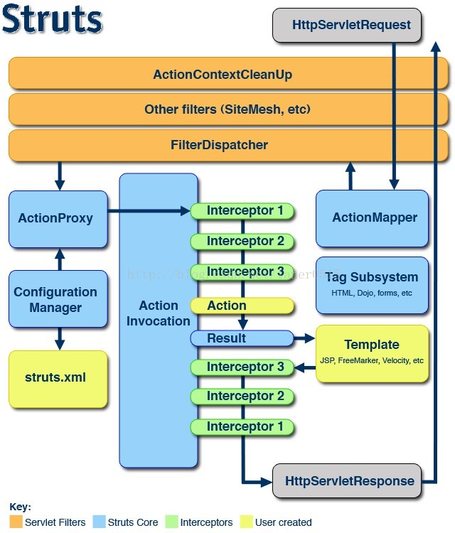
The client initializes a pointer to the Servlet container (such as Tomcat) of the request, the request through a series of filters (Filter) (called a ActionContextCleanUp optional filter, these filters in the filter for the integration of Struts2 and other frameworks is helpful, for example: SiteMesh Plugin) then FilterDispatcher is called FilterDispatcher, ask ActionMapper to please decide the need to call a Action Filter Dispatcher is the core of the controller is the core of the C control layer in mvc.
If ActionMapper decides to need to call a Action Filter Dispatcher to the processing of the request to ActionProxy, ActionProxy by Configura -tionManager asked the framework configuration file, find the Action class, need to call here, we usually read from the struts.xml configuration. ActionProxy creates an instance of ActionInvocation. The ActionInvocation instance invokes the naming pattern, which involves the call of the associated interceptor (Intercepter) before and after the call to Action.
二．Result
Login screen, wrong user password
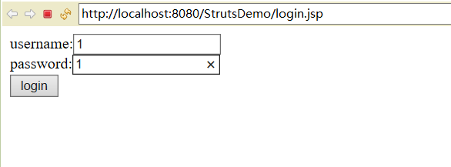
Error interface returned
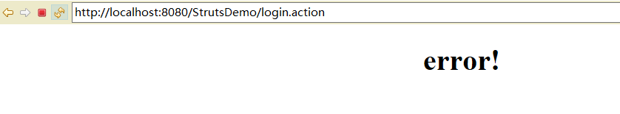
Successful landing
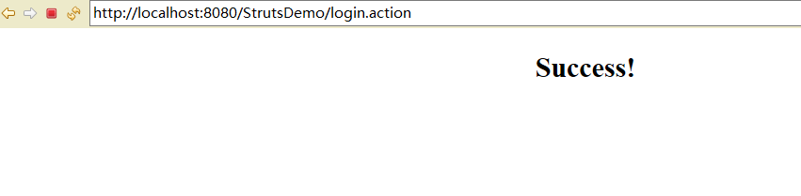
三.Summary
- in this experiment, the data transmission process, can be understood as: first in the landing interface, form form submission address is login.action, so action will be sent to the org.apache.struts2.dispatcher.ng.filter.StrutsPrepareAndExecuteFilter filter in web.xml, and then transmitted through the filter to the struts.xml, <action name= "login" class = "com. Lms. Action" check "method= LoginAction." ><result name = "suc cess >/loginSuccess.jsp</result>" <result name = "error" >/error.jsp</result> </action> through this way, sent to the processing of the page action. Send the response to the specified interface by processing the result.
四．Source code
Login.jsp
<%@ page language="java" contentType="text/html; charset=UTF-8"
pageEncoding="UTF-8"%>
<!DOCTYPE html PUBLIC "-//W3C//DTD HTML 4.01 Transitional//EN" "http://www.w3.org/TR/html4/loose.dtd">
<html>
<head>
<meta http-equiv="Content-Type" content="text/html; charset=UTF-8">
<title>Insert title here</title>
</head>
<body>
<form action="login.action" method="post">
username:<input type="text" name="username"><br>
password:<input type="text" name="password"><br>
<input type="submit" value="login">
</body>
</html>
Error.jsp
<%@ page language="java" contentType="text/html; charset=ISO-8859-1"
pageEncoding="ISO-8859-1"%>
<!DOCTYPE html PUBLIC "-//W3C//DTD HTML 4.01 Transitional//EN" "http://www.w3.org/TR/html4/loose.dtd">
<html>
<head>
<meta http-equiv="Content-Type" content="text/html; charset=ISO-8859-1">
<title>Insert title here</title>
</head>
<body>
<h1 align="center">error!</h1>
</body>
</html>
loginSuccess.jsp
<%@ page language="java" contentType="text/html; charset=UTF-8"
pageEncoding="UTF-8"%>
<!DOCTYPE html PUBLIC "-//W3C//DTD HTML 4.01 Transitional//EN" "http://www.w3.org/TR/html4/loose.dtd">
<html>
<head>
<meta http-equiv="Content-Type" content="text/html; charset=UTF-8">
<title>Insert title here</title>
</head>
<body>
<h2 align="center">Success!</h2>
</body>
</html>
LoginAction.java
package com.lms.actions;

import com.opensymphony.xwork2.ActionSupport;

public class LoginAction extends ActionSupport {
String username;
String password;
public String getUsername() {
return username;
}

public void setUsername(String username) {
this.username = username;
}
public String getPassword() {
return password;
}
public void setPassword(String password) {
this.password = password;
}
@Override
public String execute() throws Exception {
// TODO Auto-generated method stub
return super.execute();
}

public String check() throws Exception {
// TODO Auto-generated method stub
if ("admin".equals(username) && "admin".equals(password))//scott是用户名，tiger是密码
return "success";
else
return "error";
}
}
Web.xml
<?xml version="1.0" encoding="UTF-8"?>
<web-app xmlns:xsi="http://www.w3.org/2001/XMLSchema-instance"
xmlns="http://java.sun.com/xml/ns/javaee"
xsi:schemaLocation="http://java.sun.com/xml/ns/javaee http://java.sun.com/xml/ns/javaee/web-app_3_0.xsd"
id="WebApp_ID" version="3.0">
<display-name>StrutsDemo</display-name>
<welcome-file-list>
<welcome-file>index.html</welcome-file>
<welcome-file>index.htm</welcome-file>
<welcome-file>index.jsp</welcome-file>
<welcome-file>default.html</welcome-file>
<welcome-file>default.htm</welcome-file>
<welcome-file>default.jsp</welcome-file>
</welcome-file-list>
<filter>
<filter-name>struts2</filter-name>
<filter-class>org.apache.struts2.dispatcher.ng.filter.StrutsPrepareAndExecuteFilter</filter-class>
</filter>
<filter-mapping>
<filter-name>struts2</filter-name>
<url-pattern>/*</url-pattern>
</filter-mapping>
</web-app>
Struts.xml
<?xml version="1.0" encoding="UTF-8"?>
<!DOCTYPE struts PUBLIC
"-//Apache Software Foundation//DTD Struts Configuration 2.3//EN"
"http://struts.apache.org/dtds/struts-2.3.dtd">
<struts>

<constant name="struts.enable.DynamicMethodInvocation" value="true" />

<package name="myPackage" extends="struts-default">

<action name="first" class="com.lms.actions.UserAction" >
<result >/first.jsp</result>
</action>
<action name="hello" class="com.lms.actions.UserAction" method="hello">
<result name="success">/first.jsp</result>
<result name="error">/error.jsp</result>
</action>
<action name="login" class="com.lms.actions.LoginAction" method="check">
<result name="success">/loginSuccess.jsp</result>
<result name="error">/error.jsp</result>
</action>
</package>

</struts>

