Andreas Adelmann, PSI
Ming Li, Jianjun Yang, CIAE
2009-12-30
Isochronous Field Map Generation of a 800MeV Proton Cyclotron

This is a summary of results obtained during Andreas Adelmann’s visit to CIAE from November 29 to December 10. The isochronous field with soft edges of the 9 sector 800MeV Cyclotron was calculated, together with the betatron tunes, and the phase slip. The static equilibrium orbit (SEO) was computed with CYCLOP. The SEO was then subsequently used as initial conditions for single particle tracking including acceleration with the code OPAL-CYCL. The results of the two codes agree very well, and the accelerated phase slip was also checked by using OPAL-CYCL.
- Median Plane Field Calculation

In order to obtain the basic focusing characteristics of the magnetic field configuration, a code for field-map-building developed by Jianjun Yang was further developed and translated Matlab. The code generates the field map on the median plane. The fridge fields is very important for focusing characteristic, especially in vertical direction, Enge’s empirical function is used as an approach of the fridge fields.
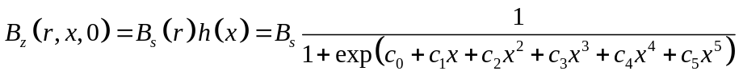
In our case, 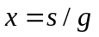 is the azimuthal distance to the hard edge of the magnet in units of the full gap of the sector magnet.
.
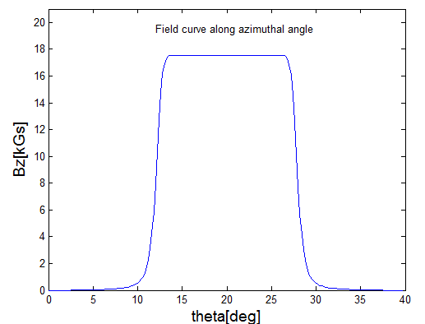
Fig. 1. 800MeV Cyclotron field along the azimuthal angle of a single period at r=476cm

Because the 9 sectors are identically, the field map must be periodic. In consequence the field data of a single period (40º) is needed for the calculation. Using our Matlab code, the total field is computed by superposition of the contributions of one sector including the neighboring two sectors.

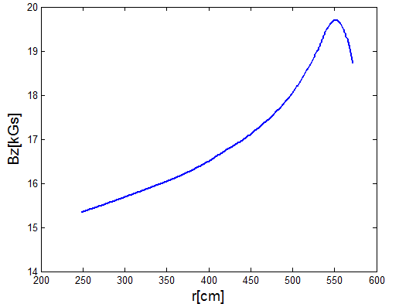
Fig. 2 The maximal field B_{s} on the median plane
In the expression mentioned above, the hill gap g has an effect on the field fall-off steepness. As the max field on median plane B_{s} varies from 1.55T to 1.96T, the width of g should not be constant. In our Matlab code, an inverse problem was solved, in order to obtain the gap-width as function of radius:
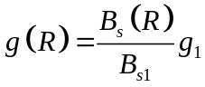
where g₁ and B_{s1} represent the hill gap and the max field at 100MeV respectively. For the time being, we set g₁ to 10cm.
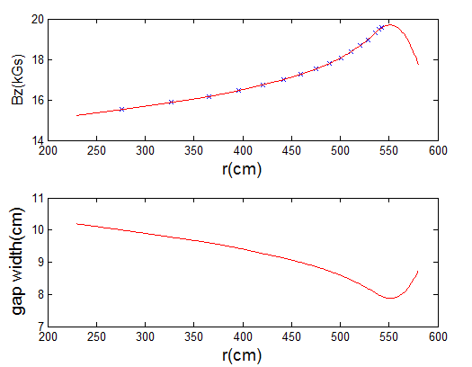
Fig. 3 Max field B_{s} (up) and hill gap g(below)

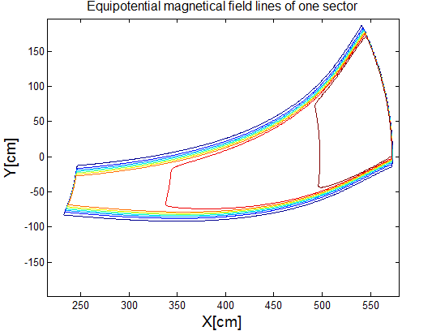
Fig. 4. Contour lines of magnetic field of one sector
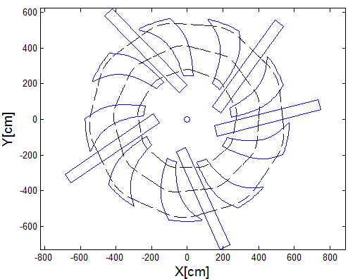
Fig. 5. Sketch of the 800MeV cyclotron after the fine tuning
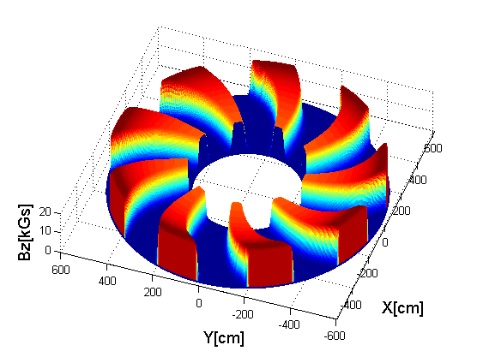
Fig. 6. Isochronous field map on the median plane
- Betatron Tune and Phase Slip
By fine tuning of the magnet geometries and the curve of B_{s}, an almost isochronous field map was established . The final layout of the cyclotron is shown in Fig. 5, and accordingly the final field map is shown in Fig. 6.
Once the isochronous field map is established, the focusing characteristic and the accelerating orbit properties can be calculated by CYCLOP and OPAL-CYCL.
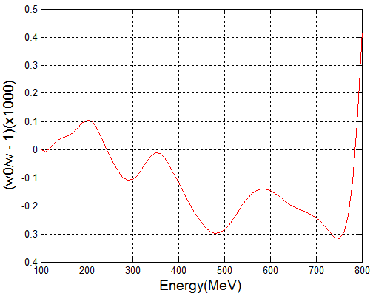
Fig. 7.Local phase slip (CYCLOP)
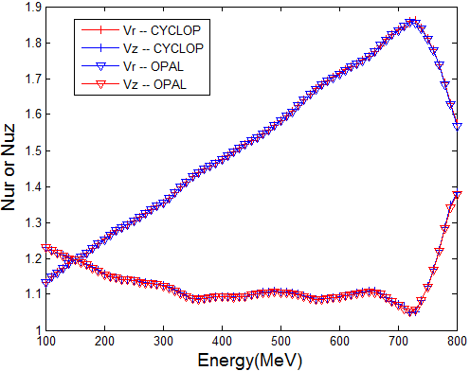
Fig. 8. Betatron tune vs. energy
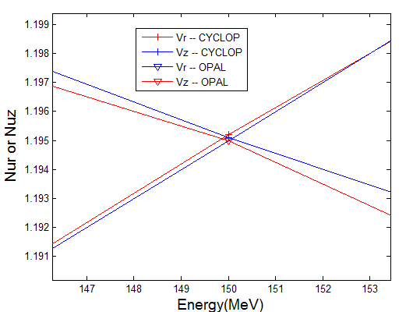
Fig. 9. Local zoom in at the 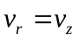 resonance

From figure 9 , we see that the difference between CYCLOP and OPAL-CYCL is negliable.

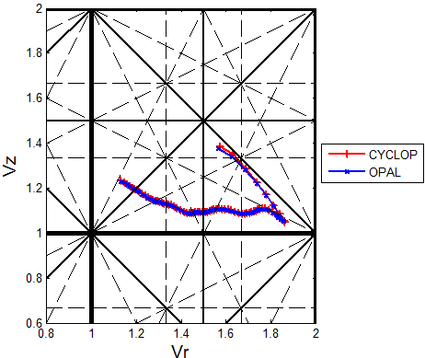
Fig. 10 Betatron tune diagram

From Fig 10 we observe:
- the vertical betatron tune 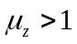 at all energies,
- 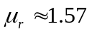 at extraction energy of 800 MeV and
- no dangerous resonance lines are crossed.

However, the second resonance 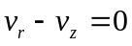 is unavoidable.

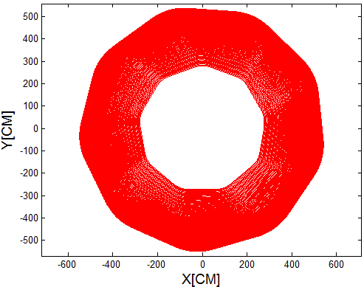
Fig. 11 Accelerated orbit calculated with OPAL-CYCL

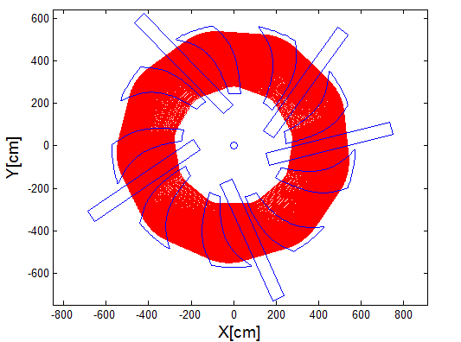
Fig. 12 Accelerated orbit and accelerator structure
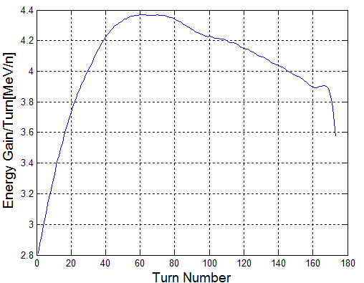
Fig. 13 Energy gain obtained with OPAL-CYCL

The peak voltage of cavity varies along the radial direction as cosine shape. Although the peak voltage at low energy is relative low, the energy increases rapidly because of the large radial gain per turn and the small phase shift. At the last few turns, the energy gain per turn at extraction falls down sharply because of the large phase shift.
This is the side effects if we want to increase the turn separation of the last turn. However, considering the energy gain at the last turn is 3.6MV, compared to the peak energy 4.0MV, phase slip is still in the acceptable range.
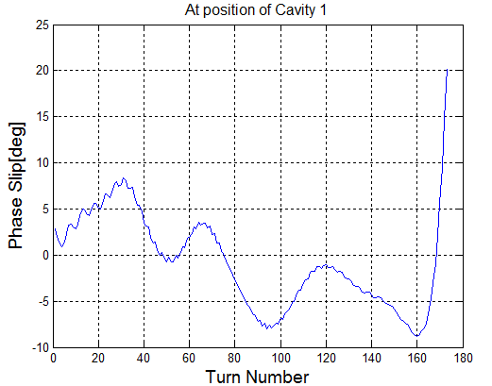
Fig. 14 Phase Slip At Position Of The First Cavity

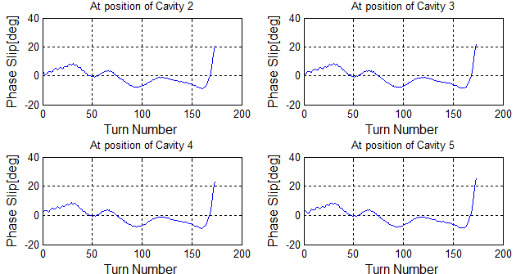
Fig. 15 Phase slip at position of the other 4 cavities

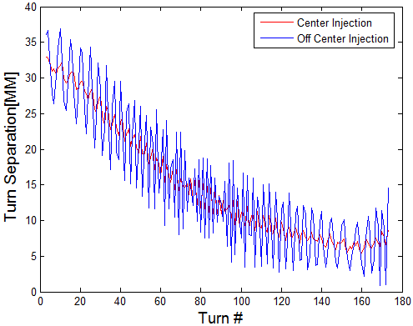
Fig. 16 Turn Separation Comparison Between Center and Off Center Injection

- Conclusion and Future Work
In this work, the isochronous field with soft edges of the 9 sector solution of the proposed 800MeV Cyclotron is established mathematically and the betatron tune and the phase slip of this solution is calculated numerically. The result shows the phase slip during acceleration is less than ±10 degree. As a simplified model, the result is good enough and can be taken as the start point for 3D magnetic field building and maget structure design.
The results above show that the concept design of 800MeV Cyclotron seems feasible.However, this is just the beginning and more detailed work is going on. As the next step, the following work will be carried out.

  - Magnetic Field 3D Design
  - RF Cavity 3D Design
  - Single Particle Beam Dynamics
  - Multiple Particle tracking
  - Flat-Top Cavity
  - Large Scale Multiple Objective Optimization

