OPEN_NEXT
Deliverable 3.5
Finalised demonstrators - usability-tested, verified and validated demonstrators


This project is funded by the European Union’s Horizon 2020 Research and Innovation Programme under the Grand Agreement no. 869984.
OPEN_NEXT – Transforming collaborative product creation
Consortium:
# | Participant Legal Name | Short Name | Country
1 | TECHNISCHE UNIVERSITAT BERLIN | TUB | DE
2 | INSTITUT POLYTECHNIQUE DE GRENOBLE | GINP | FR
3 | ALEXANDER VON HUMBOLDT-INSTITUT FURINTERNET UND GESELLSCHAFT GGMBH | HIIG | DE
4 | UNIVERSITY OF BATH | UBA | UK
5 | ZENTRUM FUR SOZIALE INNOVATION GMBH | ZSI | AT
6 | FRAUNHOFER GESELLSCHAFT ZUR FOERDERUNG DER ANGEWANDTEN FORSCHUNG E.V. | FHG | DE
7 | DANSK DESIGN CENTER APS | DDC | DK
8 | WIKIMEDIA DEUTSCHLAND - GESELLSCHAFT ZUR FÖRDERUNG FREIEN WISSENS EV | WMDE | DE
9 | WIKIFACTORY EUROPE SL | WIF | ES
10 | STICHTING WAAG SOCIETY | WAAG | NL
11 | MAKER | MAK | DK
12 | AGILE HEAP EV | FLB | DE
13 | SONO MOTORS GMBH | SOM | DE
14 | OPNTEC GMBH | OPT | DE
15 | STYKKA APS | STY | DK
16 | TILL WOLFER | XYZC | DE
17 | FICTION FACTORY | FIF | NL
18 | M2M4ALL | SOD | NL
19 | INNOC OSTERREICHISCHE GESELLSCHAFT FUR INNOVATIVE COMPUTERWISSENSCHAFTEN | HAL | AT

Duration: 09/2019-08/2022
Grant: H2020-869984
Contact (coordinator): Prof Dr-Ing Roland JOCHEM
Address: Technische Universität Berlin, Sekretariat PTZ 3, Pascalstr. 8-9, 10587 Berlin
E-mail: roland.jochem@tu-berlin.de

Disclaimer: The contents of this document are not intended to replace consultation of any applicable legal sources or the necessary advice of a legal expert, where appropriate. All information in this document is provided "as is" and no guarantee or warranty is given that the information is fit for any particular purpose. The user, therefore, uses the information at his/her sole risk and liability. For the avoidance of all doubts, the European Commission has no liability in respect of this document, which is merely representing the views of the author(s).
D3.5 – „Finalised demonstrators - usability-tested, verified and validated demonstrators“

Review and approval status:
 | Name and Surname | Role in the Project | Partner
Author(s) | Martin Häuer;  Erik;  Cansu | Work Package Lead;  Research Associate;  Research Associate | IPK
 | Pen | Work Package Development | UBA
 | Max Kampik | Work Package Development | WIF
Reviewed by | xxx | xxx | xxx
 | xxx | xxx | xxx
Approved by | Robert MIES | Project Coordinator | TUB

History of changes:
Version | Date | Description of changes | By
0.1 | xxx | Initial draft | Martin Häuer
0.2 | xxx | Second draft version | Martin Häuer
0.3 | xxx | Draft for review | Martin Häuer
1.0 | xxx | Final document for final  project management  verification | Martin Häuer

Details:
Dissemination level | Open Access
Due date | 31.10.2021
Issue date | xxx
Contract No. | 869984
Responsible Partner | FHG
File name | D3.5_Validation of demonstrators.odt

Keywords:
Open source hardware, OSH metadata ontology, ICT for OSH, design reuse, open source development, distributed database, collaborative production
Executive Summary:
xxx

Table of Contents
>_1 Introduction 1
1.1 Context 2
1.2 Testing plan 2
>_2 Results & Next Steps 3
2.1 Wikifactory 4
2.1.1 Wikifactory Frontend 4
2.1.2 Wikifactory Backend 4
2.1.3 Collaborative Production Tools 4
2.1.4 Dashboard 4
2.1.5 Skill-based Matchmaking 5
2.2 LOSH 5
2.2.1 LOSH Frontend 5
2.2.2 LOSH Backend 5
2.2.3 LOSH Reporter 5
2.3 OSH Repository Checker 5
>_3 Licenses & Attributions 6
>_4 References 9

List of abbreviations and terms
API | Application Programming Interface
DOI | Digital Object Identifier
FOSS | Free/Open Source Software
GNU | GNU’s Not Unix (recursive acronym)
JSON | JavaScript Object Notation (file format)
JSON-LD | JavaScript Object Notation for Linked Data (file format)
LOD | Linked Open Data
LOSH | Library for Open Source Hardware
OKH | Open Know-How
OKHv1 | Open Know-How Manifest Specification Version 1.0
OSH | Open Source Hardware
PCB | Printed Circuit Board
QR | Quick Response (used in the context of a matrix barcode (QR code))
RDF | Resource Description Framework
RDF2WB | Resource Description Framework to Wikibase
SME | Small and Medium-Sized Enterprises
SPARQL | Simple Protocol and RDF Query Language
TOML | Tom's Obvious, Minimal Language (file format)
URL | Uniform Resource Locator

Table of Figures
Figure 1: Connection with target groups in tasks of this work package (WP3) 4
Figure 2: Data flow principle of LOSH 11
Figure 3: Data upload via an integrated online platform 14
Figure 4: Screenshot of the "Sion PowerPlanter" project on the Wikifactory platform 15
Figure 5: Screenshot of the imported "Sion PowerPlanter" project on the LOSH frontend 16
Figure 6: Data upload via the use of a manifest file 17
Figure 7: Screenshot of the "OHLOOM" project on the GitLab platform 18
Figure 8: Screenshot of the imported "OHLOOM" project on the LOSH frontend 19
Figure 9: Direct data upload using the Wikibase API 20
Figure 10: Screenshot of the web interface of LOSH's advanced query service 24
Figure 11: Interactions with and between OSH communities for this deliverable 37

Index of Tables
Table 1: Overview of the modules forming the LOSH system 8

Introduction

Target group requirements
Target group of WP3
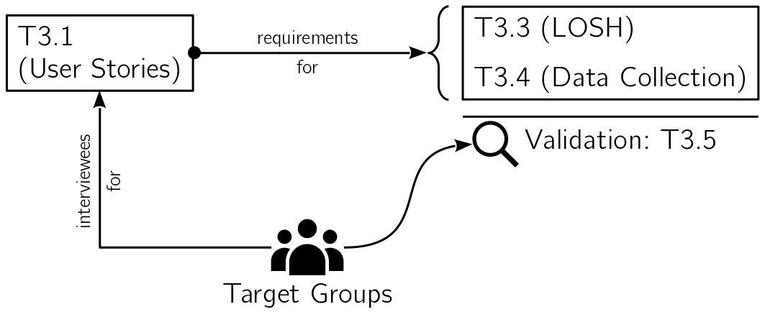
Summary of requirements from T3.1?
→ what MVPs/features did we want to validate? (see table in section Testing Plan)

Testing plan
In order to validate the features summarised in chapter 1.1 the methods listed in Table 1 have been chosen. Since the tools differ in use case, target group and development status, dedicated testing plans have been desigend for each tool. For further details regarding the tools and their development, please refer to the corresponding deliverable reports:
- D3.2 „Platform demonstrator“ report xxx
- D3.3 „Wikibase instance demonstrator“ report (Häuer & Sonika Gogineni, 2021)
- D3.4 „Populated database“ report xxx
Table 1: Overview of validation methods per tool
Tool | Method | Related deliverable
Wikifactory frontend | tested by target group | D3.2
Wikifactory Request-for-quotation system | tested by target group | D3.2
Wikifactory import/export tool | validated by application
Dashboard | tested by target group | D2.2
Skill-based matchmaking |  | D3.2
ML-based identification of production metadata |  | D3.2
LOSH search | tested by target group | D3.3/D3.4
LOSH backend | validated by application | D3.3/D3.4
LOSH manifest file creator | tested by target group | D3.4
OSH repository checker | tested by target group | D3.3
LOSH reporter | validated by application | D3.4

The following chapter outlines how these methods have been applied for the validation of the tools, the results and consequent outlooks.

Validation results

Wikifactory

Wikifactory frontend

Short description

Validation method

Validation results

Summary & outlook

Wikifactory import/export tool

Short description
allows for transfer or files from one platform to another, when developing open source hardware online (currently Google Drive, Dropbox, Wikifactory and git-based services (such as GitHub or GitLab). Hence providing communities and companies with the ability to move projects across platforms without facing vendor lock-in. The tool is currently available as a standalone software package and will be integrated into the Wikifacty platform.

Tool and source code are available here.

Validation method
implemented into the backend → validated by use

Validation results

Summary & outlook

Collaborative production tools

Request-for-quotation system

Short description
The now available “request for quotation” system on the Wikifactory platform (https://wikifactory.com/marketplace/) helps matchmaking hardware designs with suitable manufactures (currently 260+ manufacturers for 3D printing, CNC, sheet metal fabrication and injection molding).

Validation method
user tested (OPEN_NEXT SMEs and representatives from the OSH community) + heuristic analysis

Validation results

Summary & outlook

ML-based detection of production metadata

Short description
A machine-learning-based algorithm (https://github.com/OPEN-NEXT/Named-Entity-Recognition-for-extracting-Open-Source-Hardware-project-metadata) detects production-related metadata in documentation, helping to extract relevant information to identify suitable manufacturers.

Validation method

Validation results

Summary & outlook

Dashboard

Short description
The T2.2 dashboard mines detailed metadata about open source hardware (OSH) projects on GitHub or Wikifactory, useful for project and community management and in technology search. It also computes derived metrics and statements e.g. “This project seem to be heavily centred on one user”.
Data will be publicly available via an application programming interface (API) so that other platforms and services can easily embed the data (as planned for the Wikifactory platform, see below). There’s also a simple frontend to explore the current data set.
Frontend & demo
Code

Validation method
user tested (OPEN_NEXT SMEs and representatives from the OSH community) + heuristic analysis

Validation results

Summary & outlook

Skill-based matchmaking

Short description
aims to connect project needs with contributor capacities within open source communities. A project can tag open issues with specific skills needed to fulfil those tasks, while contributors can “earn” skill tags when working on these issues (e.g. solving an issue tagged with “python” presupposes that the contributor is skilled in programming, specifically the python language). The service is currently embedded into the wikifactory platform so that new issues in issues can bear skill tags (see attached screenshot “WIF-skill”).
Find the code here and an example issue here.

Validation method

Validation results
- automatic production metadata recognition
- test on set of sample to validate performance
- 1:1 interview with platform owner (Appropedia) to get perspective regarding practical applicability and usefulness
- skill ontology (@Erik)
-Validation ontology itself → MA, UF
- The validation of the skill ontology demonstrator focuses on the implementability in a platform. For this purpose, the first stage of the ontology demonstrator was handed over to the implementation partner WIF, who implemented the demonstrator on a local version of the platform and gave feedback on the provision and functionality of the ontology.
In the first step, the demonstrator was modified to be able to deploy it in a docker container environment.
The second iteration involves the "localisation" of the ontology. In the first stage of the demonstrator, the ontology was hosted and accessed in the public project repository. For this, user data was anonymised in order to make it publicly available. For use within the platform, however, the original user data is required in order to link the ontology data to actual users. For this purpose, services had to be developed to host the ontology with its data locally and privately within the demonstrator.
Another point was the timeliness of the user data. In the first stage, these data were static, i.e. query results from user data, provided via the WIF Graphql API, were stored as JSON files in the demonstrator. Updating was not implemented as a function, which is an exclusion criterion for practical use of the demonstrator on the platform. This function was added later. The "localisation" also changed the query function with regard to endpoint and address mechanism and was adapted accordingly.
- heuristic analysis
- UF 1\
As a contributor on an OSH online platform, I want to add my skills and interests to my profile, so that others know more about my abilities.
- UF 2\
As a contributor on an OSH online platform, I want to find projects that require my specific skills in tasks, so that I can use, improve or evolve my skills.
- UF 3\
As a project core team, we want to find contributors based on their skills and interests so that they can help in carrying out a specific task.
- '+ further testing of validation day tools, if needed

Summary & outlook

LOSH

LOSH search

Short description
The “Library of Open Source Hardware” (LOSH) features a distributed knowledge base for OSH designs. The knowledge base is fed automatically by a crawler and from different online platforms, automatic quality checks are performed on that data before uploading it.
LOSH as a free-of-charge online service has been designed to support users to:
- find existing OSH solutions for design reuse or replication;
- identify relevant communities in a specific field of technology;
- scan the OSH market faster (e.g. to identify gaps and overlaps) in order to pilot new business cases.
Target groups of related ICT solutions are OSH communities (including fab labs and SMEs) and platform owners (such as Wikifactory). The knowledge base will be explorable through an intuitive frontend and an advanced query service.
For instance, SMEs can use LOSH during ideation to explore what has been done, how and by whom. This helps to:
- find a feasible design for a specific problem, while considering practical limits visible in existent, similar solutions;
- reduce development efforts by (possibly) directly copying (parts of) existent solutions for the desired use case;
- get connected with the communities behind relevant solutions in order to collaborate on joint efforts.
References (linked)
- Metadata specification and computable data model (ontology)
- Wikibase instance (backend) with advanced query service
current mock-up of the frontend (code)

Validation method
The search functionality of LOSH has been identified a key feature in previous tasks of the work package (for further details please refer to the reports for D3.1 „User stories of collaborative engineering needs“ and D3.3 „Wikibase instance demonstrator“). The function has been tested in its production environment (hosted under http://losh.opennext.eu/) by:
- the target groups to assess the practical value of the tool,
- internally using the heuristic analysis method resulting in more detailled outputs and suggestions to facilitate further developments and bug fixing.

User testing
The user testing with the target groups has been carried out in two sessions:
- in an internal workshop with SMEs piloting open-source-based business models in OPEN_NEXT to give space for committed representatives of the primary target group of this project to provide high-quality feedback; for data input a survey was used, further feedback was directly documented in the form of issues in the respective GitHub repository;
- with a larger group of actors in the field of OSH (SMEs, makerspaces, researchers and community representatives) using only a survey with instructions and small tasks to complete while using the LOSH search functionality.
The latter on the one hand brought unbiased feedback from representatives of a target group that have never been in contact with LOSH before and on the other helped to communicate the release of LOSH. The surveys used for data input were identical in both sessions. Feedback
2 gives a quantitative overview of the notified groups that have been contacted for this validation; the corresponding raw data can be found in the spreadsheet file “validation-invites.fods“ in the folder “raw data“, attached to this report.
Table 2: Quantitative overview of notified groups for the validation of LOSH
Name | Category | Recipients | Returns
OPEN_NEXT Consortium + Demonstrators | OSH SME | 35
OPEN_NEXT Consortium + Demonstrators | OSH research | 38
OPEN_NEXT Consortium + Demonstrators | fablab/makerspace | 21
OPEN_NEXT Consortium + Demonstrators | other consortium partner | 24
Open Source Ecology Germany | OSH community (OSH projects yet without relevant commercial use) | 406
D3.1 interviewees | OSH SME | 11
D3.1 interviewees | fablab/makerspace | 2
D3.1 interviewees | OSH community (OSH projects yet without relevant commercial use) | 6

Heuristic analysis
A first heuristic analysis has been carried out in the former deliverable D3.4 „Populated database“, evaluating the usability of the frontend. For further details please refer to the respective result report attached to the D3.4 report (ref). However, dedicated evaluation of the search functionality was not carried out for D3.4.
To test the search functionality of LOSH, the instructions and tasks from the survey for the user testing (see the previous section) have been followed and fulfilled internally, while errors and potential flaws have been documented as issues in the GitHub repository of the LOSH frontend. For this the perspective of an SME has been taken, seeking to reuse OSH documentation for commercial use; at best by replicating the OSH design (or parts of it) directly or using it as source of inspiration to develop a respective product.
To use representative search terms, the most frequent search term from the general purpose OSH search engine „Open Hardware Observatory“ (OHO) have been used.

Validation results

User testing
survey results from workshop
survey-only results

Heuristic analysis
search functionality:
search results get very unrelated from page 3…5 onwards
very poor results for composed search terms → the more words the more irrelevant results
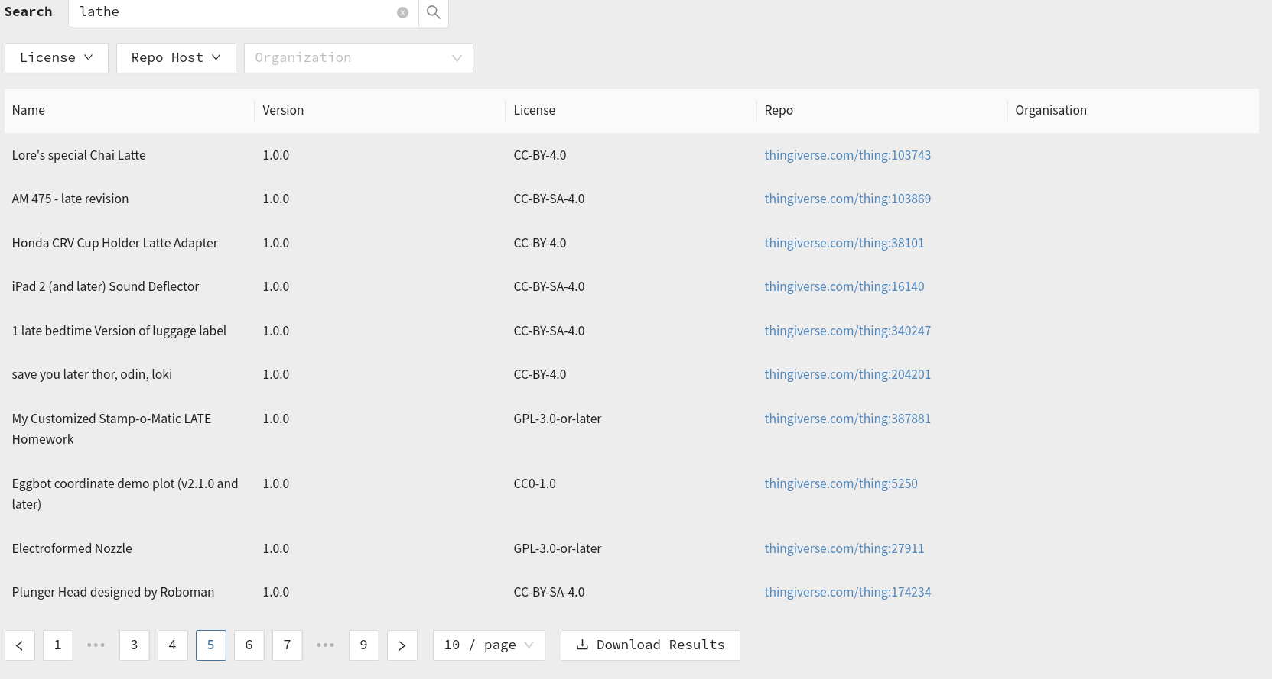
no way to apply multiple filter option of the same filter option (e.g. multiple repo hosts); either all or only one
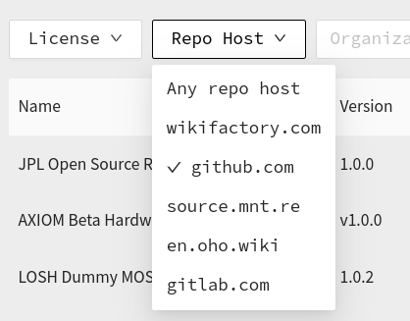
missing search features:
group versions (or only display latest)
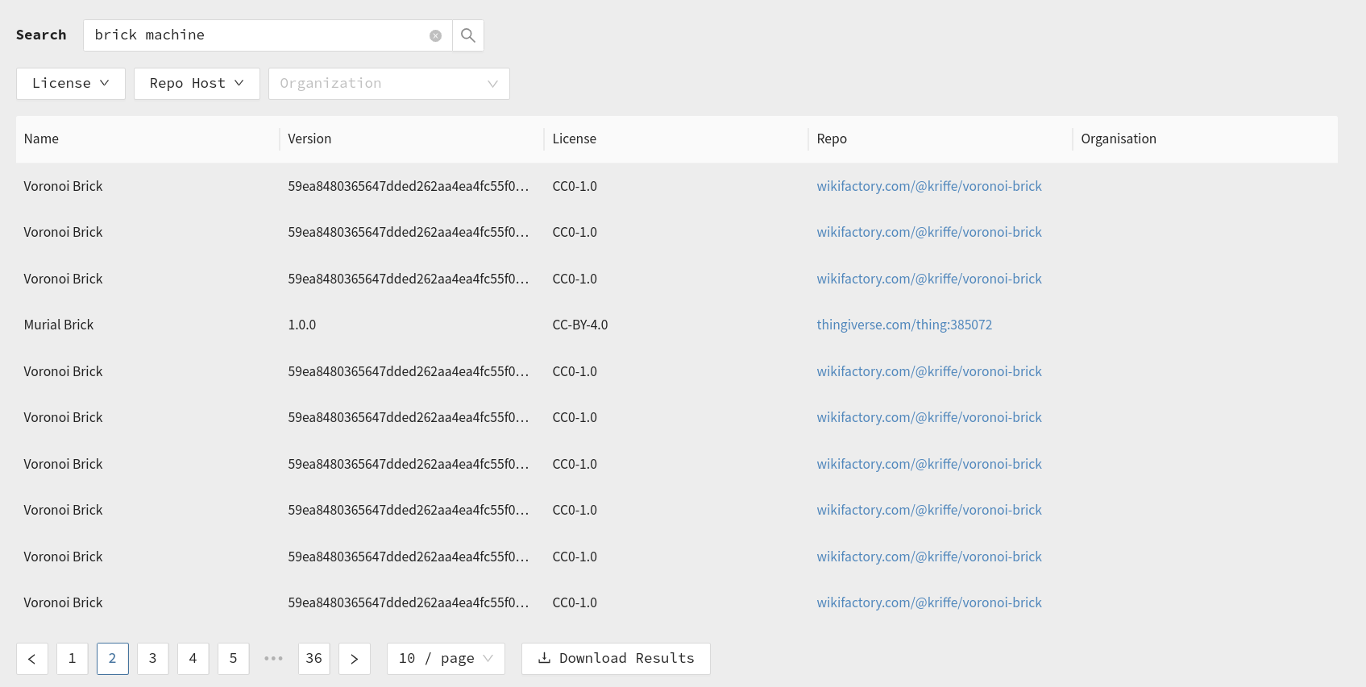

GitHub issues
only rough description and table into annex?
Issue ID | Content | Type | Severity/Value | Comment | Source
118 | automatic content translation into most common languages used for European patents | feature request | 4 | improves accessibility of search results, specifically for patent attorneys | Community
120 | add counter for total search results | feature request | 3 | quick statistical information about how many OSH designs are available a) for a certain search term or b) on a specific platform | Heuristic analysis
121 | filter results for open file formats, identify | feature request | 4 | allows to quickly filter for modifiable designs and assess documentation readiness | Heuristic analysis
122 | download results only works for current page | bug report | 5 | download feature thereby practically broken for most users | User testing
123 | “results per page” sometimes not selectable | bug report | 2 | may result in an inconvenient view, but does not affect the search functionality | User testing
124 | order “repo hosts” by number of search results (omitting repo hosts without results) | feature request | 4 | would significantly increase the value of this filter function | User testing
125 | add thumbnails for the results on the search page | feature request | 4 | would allow for much faster assessment of relevance of search results | User testing
129 | “go to repo” of version-specific page always points to the latest version of the repository | bug report | 4 | feature essentially broken; likely causes confusion; however, does not break essential functions of the search functionality | Heuristic analysis
130 | “OSHWA” missing in “repo hosts” filter | bug report | 5 | important source of metadata not available through the filter | Heuristic analysis

Summary & outlook
general purpose is a big term → it would be beneficial to map technology categories (CPC classes) covered by LOSH (see LOSH reporter)
more images! extremely helps to quickly filter results
positive testimonial:
Johannes Střelka-Petz, [01.07.22 12:08]
Text basiertes interface, reduziert auf die wichtigen funkionen, das ist gut zugänglich. Html elemente beschreiben die funktion. (Button, header, usw.) Ist für blinde un sehbehinderte menschen sehr viel einfacher zu benutzen als thingiverse.
Johannes Střelka-Petz, [01.07.22 12:11]
Wir wollen über diesen zugang noch mehr Informationen aus den silos abgreifen können. Bitte die gute Arbeit vorsetzen.

LOSH manifest file creator

Short description
The OKH-LOSH Manifest File Creator offers a web interface to create, manipulate or fix manifest files. A Manifest file is a plain text file containing metadata about an OSH project. For platforms that don’t offer a suitable API for the LOSH backend to extract informative metadata (such as GitHub), manifest files are the only way to integrate OSH projects into the LOSH knowledge base. The same applies to online hosting services that don’t provide any API at all (such as project-specific web pages or the Appropedia platform) – as long as the access to manifest files can be communicated to the Krawler, metadata can be extracted.
However, writing plain text metadata files can be challenging for users with no prior coding experience. Syntax errors would result in failed data parsing, while the user itself wouldn’t get any feedback on whether their manifest file is corrupt as the error occurs during crawling.
The tool is configured by the official JSON schema deployed alongside with the OKH-LOSH specification. When the specification is changed (by changing the JSON schema), the data fields in the interface of the OKH-LOSH Manifest File Creator change accordingly. Since the tool is meant to be further maintained on a community basis, it has been designed in a way to keep these maintenance efforts at a minimum.
The source code of the tool has been published under a free/open licence on the GitLab instance of OSEGeV, which also hosts all LOSH-related tools:
https://gitlab.opensourceecology.de/verein/projekte/okh-losh-manifest-creator .
Deployment of the tool is done using GitLab’s “continuous deployment” functionality. Hence, no further installation steps are required to use the tool.
With the OKH-LOSH Manifest File Creator users can create, edit and validate manifest files without needing to read and understand the OKH-LOSH specification or the required syntax for the defined data fields. The tool can be accessed under the following URL and runs in the browser: https://manifest.opennext.eu/ .
The interface is kept minimalist and is split into two sides, as shown in 1.
Manifest files can be either created directly in the web interface (using the left side of the page) or uploaded and edited. The final manifest file is shown on the right side of the page. Editing is allowed on both sides as they are synchronised. Consequently, users could edit or paste sections directly on the “code side” (right) and presume in the dialogue boxes on the left.
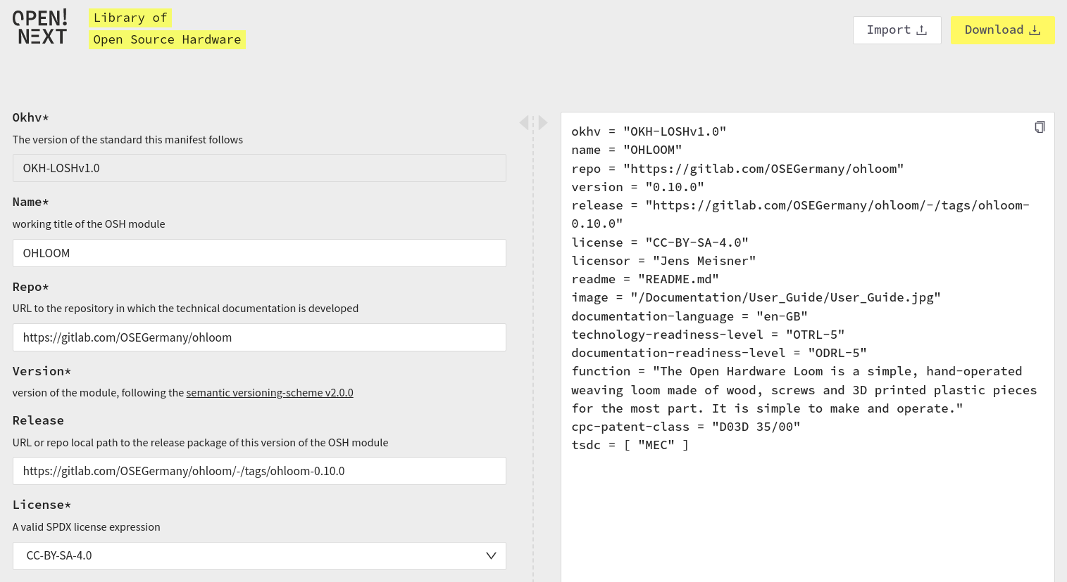Figure 1: View of the interface of the OKH-LOSH Manifest File Creator while editing an uploaded manifest file
Where possible, the interface offers tooltips and predefined options to choose from, e.g. a drop-down menu containing all officially endorsed free/open licences. This should additionally support users when determining metadata for their OSH project for the first time. Not yet filled, mandatory fields are highlighted, as shown in 2. Consequently, the tool includes an automatic validation of manifest files to ensure that resulting files can be parsed by the LOSH backend without errors.
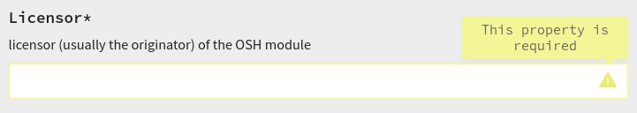Figure 2: Detail view of a highlighted mandatory field

Validation method
as losh search

Validation results

Summary & outlook

LOSH backend

Short description
Wikibase, RDF2WB, Appropedia Scraper, Crawler modules
add graphic showing how the LOSH backend works

Validation method
implemented into the backend → validated by use

Validation results

Summary & outlook

LOSH reporter

Short description

Validation method
first report published → validated by application

Validation results

Summary & outlook

OSH repository checker

Short description
The OSH Repository checker is a command line tool for quality assessment of OSH projects (“technical project linting”). It checks whether a project repository adheres to community best practices regarding how technical documentation is stored in git repositories (which have been identified to be a top choice for OSH development (Mies et al., 2020).
The tool analyses locally stored repositories and returns an assessment report. The report uses the markdown format so that it can be pasted directly into the issue description of the corresponding OSH project. The output renders as a ToDo list for each yet open point to be resolved for full compliance with community best practices – see 3 and 4.
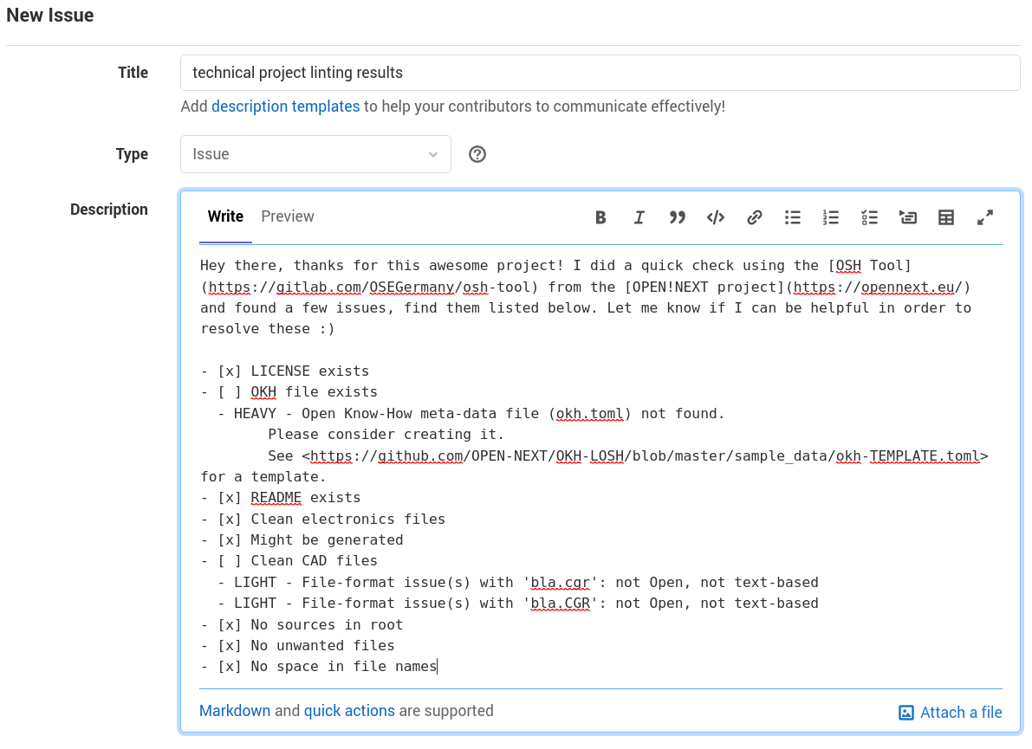Figure 3: Example issue on GitLab with assessment report directly copied from the tool's output
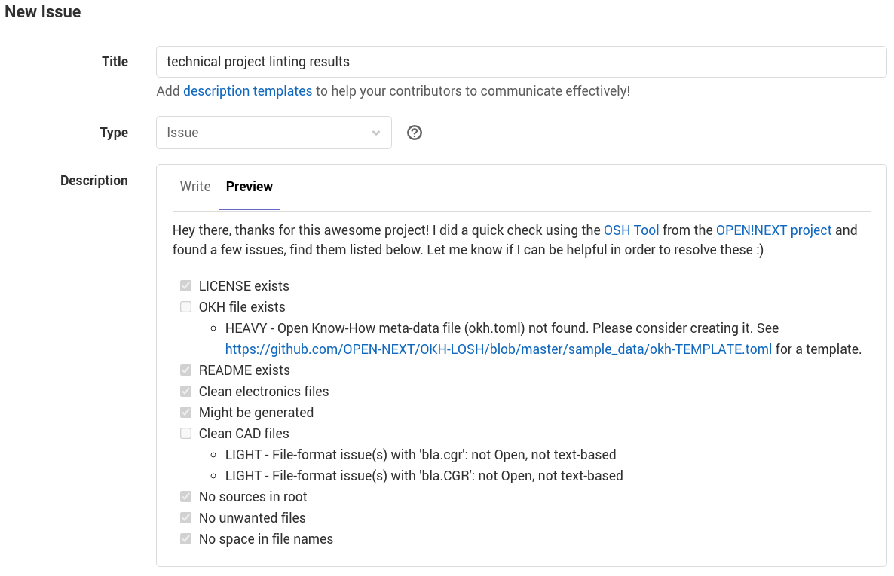Figure 4: Rendered view of the example issue shown in 3
Adhering to such practices has several benefits for different user groups when dealing with the technical documentation of the project, e.g.:
- higher familiarity for users/replicators, external contributors, manufacturers and reviewers (e.g. from conformity assessment bodies according to DIN SPEC 3105-2);
- improved efficiency for git-based services (smaller, easier to handle repositories, meaningful diffs);
- any software dealing with the content can recognise project metadata and essential files (e.g. source files) much easier;
- content can be easier ported to other hosting platfo^rms (or any other system dealing with projects) (less lock-in effect);
- improved comparability among OSH projects;
- improved reusability e.g. when used as a module within another OSH project (e.g. an open source phone using an open source GPS module).
The source code has been documented and published under a free/open licence through the following GitLab-repository: https://gitlab.com/OSEGermany/osh-tool .

Validation method
community-tested, first issues created

Validation results

Summary & outlook

Interpretation of the results
…possibly merge into Summary

Summary
xxx

Licenses & attributions
All software and related documents have been licensed under the GNU General Public License Version 3.
This report has been licensed under the Creative Commons Attribution 4.0 International license and made publicly available on GitHub.
The report, including the annexure, uses the following images under free/open licenses:
Image | Name & Source (linked) | Author | License
 | document | arjuazka | CC BY 3.0
 | platform | Adrien Coquet | CC BY 3.0
 | scientist | Gregor Cresnar | CC BY 3.0
 | transporter | Ralf Schmitzer | CC BY 3.0
 | Wikibase logo | H. Snater | GPLv3
 | database | IcoMoon | CC BY 3.0
 | process | un·delivered | CC BY 3.0
 | Binoculars | Gabriele Malaspina | CC BY 3.0
 | GitLab logo | GitLab | CC BY-NC-SA 4.0
 | GitHub logo | GitHub | NOT FREE (fair use) https://github.com/logos
 | book | Deemak Daksina | CC BY 3.0
 | robot | Jean-Philippe Cabaroc | CC BY 3.0
 | group | Arif Arif | CC BY 3.0
 | engineer | Gan Khoon Lay | CC BY 3.0
 | geek | Ayub Irawan | CC BY 3.0
 | Laptop | Mario Köstl | CC BY 3.0
 | Plug | mikicon | CC BY 3.0
 | search bar | FayraLovers | CC BY 3.0
 | Upload | Cynthia Yosephine | CC BY 3.0

References
Häuer, M., & Sonika Gogineni. (2021). OPEN-NEXT/D3.3-Report: V1.0.2 (v1.0.2). Zenodo. https://doi.org/10.5281/ZENODO.5638687
Mies, R., Bonvoisin, J., & Stark, R. (2020). DEVELOPMENT OF OPEN SOURCE HARDWARE IN ONLINE COMMUNITIES: INVESTIGATING REQUIREMENTS FOR GROUPWARE. Proceedings of the Design Society: DESIGN Conference, 1, 997–1006. https://doi.org/10.1017/dsd.2020.38

This includes the following software modules: Wikibase, RDF2WB, Appropedia scraper and the crawler modules for GitHub, Wikifactory, OSHWA and Thingiverse including all related scripts.
Thanks to the Open Hardware Observatory e.V. (non-profit) for collaboration!
https://github.com/OPEN-NEXT/LOSH-OKH-JSON-Schemas
https://www.gnu.org/licenses/gpl-3.0.html
https://creativecommons.org/licenses/by/4.0/legalcode
https://github.com/OPEN-NEXT/D3.3-Report

