EPC User’s Guide

Editor: | EURECOM
Deliverable nature: | Public
Due date:
Delivery date: | May, 2016
Version: | 0.11
Total number of pages: | 39
Reviewed by:
Keywords: | EPC, LTE, MME, S-GW, P-GW, HSS, S1AP, DIAMETER

Abstract
The deliverable presents the EPC developed by EURECOM, its configuration, installation testing and running.

List of authors

Company | Authors
EURECOM | Christian BONNET, Lionel GAUTHIER, Rohit GUPTA, Florian KALTENBERGER, Raymond KNOPP, Adlen Ksentini, Navid NIKAIEN, Cedric ROUX.
OPEN CELLS | Laurent THOMAS.

History
Modified by | Date | Version | Comments
Lionel GAUTHIER | 09/06/2015 | 0.1 | Initial Draft
Lionel GAUTHIER | 11/06/2015 | 0.2 | Minor corrections
Lionel GAUTHIER | 20/07/2015 | 0.3 | Changes in dir and file names for git repo
Lionel GAUTHIER | 29/07/2015 | 0.4 | Minor corrections (build, get sources from git)
Lionel GAUTHIER | 09/09/2015 | 0.5 | Minor corrections (build_epc script)
Lionel GAUTHIER | 21/09/2015 | 0.6 | History, GTP-U installation for EPC
Lionel GAUTHIER | 14/12/2015 | 0.7 | Removed epc config file when eNB and EPC are co-located, added description of S1AP scenario replay
Lionel GAUTHIER | 22/02/2016 | 0.8 | Move from docx with embedded Visio drawings to odt format. Align the documentation to tag v0.2.0 of develop and master branches on https://gitlab.eurecom.fr/oai/openair-cn
Lionel GAUTHIER | 06/04/2016 | 0.9 | Align the documentation to commit 5e1289bd506f33a1bbf196d55c86641021ccca70 of “unstable” branch https://gitlab.eurecom.fr/oai/openair-cn
Lionel GAUTHIER | 07/05/2016 | 0,10 | Updated section “S1AP scenario replay”
Lionel GAUTHIER | 07/25/2016 | 0.11 | Add generation of certificates

Table of Contents
Table of Contents
Introduction 8
Overview 8
Deployment scenario 8
EPC Installation 10
Operating system 10
EPC source code 10
Get the code without login 10
Get the code with login (contributors) 10
Additional software 11
The Better String Library (http://bstring.sourceforge.net/) 12
HSS 13
HSS pre-installation 13
Mysql server installation 13
Phpmyadmin installation details 13
HSS configuration 15
Step 1 15
Step 2 16
Step 3 16
Step 4 16
HSS build 16
HSS run 17
First run 17
Later runs 20
MME 21
MME pre-installation 21
MME configuration 21
Step 1 21
MME section 21
SGW section 24
Step 2 24
Step 3 24
MME build 25
Before MME first run 25
MME run 25
SP_GW 26
SP-GW pre-installation 26
SP-GW configuration 26
Step 1 26
SGW section 26
Network interfaces section 26
PGW section 27
SPGW run 28
Supported scenarios in EPC 29
E-UTRAN Initial attach 29
Attach with IMSI 29
Attach with GUTI 29
Tracking Area Update procedures 29
Routing Area Update procedures 29
Service Request procedures 29
UE triggered Service Request 29
Network triggered Service Request 29
S1 Release procedure 29
GUTI Reallocation procedure 29
Detach procedure 29
UE-Initiated Detach procedure for E-UTRAN 29
MME-Initiated Detach procedure for E-UTRAN 29
HSS-Initiated Detach procedure for E-UTRAN 29
HSS User Profile management function procedure 29
Bearer deactivation 30
PDN GW initiated bearer deactivation 30
MME initiated Dedicated Bearer Deactivation 30
Intra E-UTRAN handover 30
Annex A: Tools for observing, debugging. 31
Wireshark/tshark 31
Mscgen 31
S1AP scenario replay 33
Overall process 33
Step0: Install required software on the “scenario replay”testbed 33
openairinterface5g installation 33
openair-cn installation 34
openair-cn-scenarios installation 34
Step1: Flowchart of network capture on S1-C 34
Step2: Generate a generic scenario 37
Step3: Create configuration files for the “scenario replay” testbed 37
Replay a S1AP generic scenario 39

Index of Tables
Table 1: 3rd party software 12
Table 2: HSS configuration fields 16
Table 3: SQL Table structure mmeidentity 18
Table 4: SQL Table structure pdn 19
Table 5: SQL Table structure users 20
Table 6: MME configuration main section 22
Table 7: MME configuration subsection ITTI 22
Table 8: MME configuration subsection S6a 22
Table 9: MME configuration subsection SCTP 22
Table 10: MME configuration subsection S1AP 22
Table 11: MME configuration subsection GUMMEI 22
Table 12: MME configuration subsection TAI LIST 23
Table 13: MME configuration subsection NAS 23
Table 14: MME configuration subsection Network Interfaces 23
Table 15: MME configuration subsection Network Interfaces 24
Table 16: MME configuration section SGW 24
Table 17: S-GW configuration subsection Network Interfaces 26
Table 18: MME configuration subsection ITTI 27
Table 19: MME configuration subsection Network Interfaces 27
Table 20: P-GW configuration main section 27
Table 21: P-GW configuration subsection Network Interfaces 28
Table 22: P-GW configuration subsection IP Address Pool Selection 28

Abbreviations
3GPP Third Generation Partnership Project.
APN Access Point Name.
CIDR Classless Inter-Domain Routing.
eNB e Node B.
EPC Evolved Packet Core.
EPS Evolved Packet System.
FQDN Fully qualified domain name.
HSS Home Subscriber Server.
IMEI International Mobile Station Equipment Identity.
IMEISV International Mobile Station Equipment Identity Software
Version.
LTE Long Term Evolution.
MME Mobility Management Entity.
MSISDN Mobile Station International Subscriber Directory Number.
NW Network.
P-GW PDN Gateway, Packet Data Network Gateway.
PDN Packet Data Network.
QoS Quality of Service.
SCTP Stream Control Transmission Protocol.
S-GW Serving Gateway.
SIM Subscriber Identity Module.
TCP Transmission Control Protocol.
USIM Universal Subscriber Identity Module.
- Introduction
  - Overview
The EURECOM EPC is a bundle of software components that provides the MME, S+P-GW, HSS functions of the LTE core EPC architecture (http://www.3gpp.org/DynaReport/23002.htm).

eNB
MME
HSS
SGW
PGW
S1-C

S6-a

S11

S5/S8

SGI

S1-U

SGSN
S3

S4

PCRF
Gxc

Gx

S6-d

Network function Implemented in openair-cn
Implemented in openairinterface5g
Not implemented, not interfaced
S10

Figure 1 EURECOM core network entities overview

The link to other network entities such as a SGSN, PCRF is actually studied.

  - Deployment scenario
One deployment scenario is considered with the EURECOM EPC.
Actually the SGW and the PGW are merged together, there is no S5/S8 interfaces between the two functional entities.
The MME is a network entity that can be deployed on its own host or can be co-located with any other LTE network entity (SPGW, HSS). Even if it works we do not recommand the deployment of the MME on a eNB.
The SPGW is a network entity that can be deployed on its own host or can be co-located with the MME or/and with the HSS.

GTPUSP kernel module
spgw executable or
spgwd daemon
mme executable or
mmed daemon
hss executable or
hssd daemon
MME
HSS
SGW
PGW
S1-C

S6-a

S11

SGI

S1-U

Figure 2 EPC Deployment view

- EPC Installation
  - Operating system
The EPC software has only been tested on UBUNTU 14.04x64 LINUX distribution on Intel x86 64 bits platforms. Actually on the host running the SP-GW, the GTPv1-U implementation requires that your host run a kernel version equal to 3.19 (we use 3.19.0-28).

  - EPC source code
Important!
In this document OPENAIRCN_DIR is the path to the EPC source code top directory (i.e. openair-cn working directory).
It is assumed that you are logged onto your machine(s) as a non root user and you configured your system to be a sudoer user.

The EPC software can be obtained from our git server. You will need a git client to get the sources.

If git is not installed on your computer, execute in a shell the following command (Ubuntu):
user@host:~ sudo apt-get install git

Configure git with your name/email address (only important if you are developer and want to checkin code to Git):

git config --global user.name "Your Name"
git config --global user.email "Your email address"

Add a certificate from gitlab.eurecom.fr to your Ubuntu 14.04 installation (you need to be root user):
root@host:~# echo -n | openssl s_client -showcerts -connect gitlab.eurecom.fr:443 2>/dev/null | sed -ne '/-BEGIN CERTIFICATE-/,/-END CERTIFICATE-/p' >> /etc/ssl/certs/ca-certificates.crt

Important!
In this document OPENAIRCN_DIR is the path to the EPC source code top directory (i.e. openair-cn working directory).

    - Get the code without login
In order to checkout the Git repository (for OAI Users without login to gitlab server)
user@host:~ git clone https://gitlab.eurecom.fr/oai/openair-cn.git

    - Get the code with login (contributors)
In order to check out the Git repository (for OAI Developers/admins with login to gitlab server)
Please send an email to openair_tech@eurecom.fr to be added to the repository as a developer (only important for users who want to commit code to the repository). If you do not have an account on gitlab.eurecom.fr, please register yourself to gitlab.eurecom.fr.

Checkout with using ssh keys:
You will need to put your ssh keys in https://gitlab.eurecom.fr/profile/keys to access to the git repo. Once that is done, checkout the git repository using:

git clone git@gitlab.eurecom.fr:oai/openair-cn.git

Checkout with user name/password prompt:
git clone https://YOUR_USERNAME@gitlab.eurecom.fr/oai/openair-cn.git

  - Additional software
Some software installations have to be done prior to build the core network entities.

Please find for information, bellow a summary of third party software included in source tree or that must be installed prior to EPC components compilation.
Installed software | MME entity | S/P-GW entity | HSS entity | Licence
UBUNTU packages | Removed packages:  libgnutls-dev 'libgnutlsxx2?' nettle-dev nettle-bin.  build/dev/debug tools:  autoconf automake bison build-essential cmake cmake-curses-gui doxygen doxygen-gui flex gccxml gdb git pkg-config subversion valgrind Kcachegrind.  Network tools:  ethtool iperf iproute vlan tshark  Libraries:  guile-2.0-dev libconfig8-dev libgcrypt11-dev libgmp-dev libhogweed2 libgtk-3-dev libidn2-0-dev libidn11-dev libpthread-stubs0-dev libsctp1 libsctp-dev libssl-dev libtool libxml2 libxml2-dev mscgen openssl python.  Others:  check phpmyadmin python-dev python-pexpect unzip | build/dev/debug tools:  autoconf, automake, bison, build-essential, cmake, cmake-curses-gui, doxygen, doxygen-gui, flex, gccxml, gdb, git, pkg-config, subversion.  Removed packages:  libgnutls-dev 'libgnutlsxx2?' nettle-dev nettle-bin. | Removed packages:  libgnutls-dev 'libgnutlsxx2?' nettle-dev nettle-bin.  build/dev/debug tools:  autoconf automake bison build-essential cmake cmake-curses-gui doxygen doxygen-gui flex gdb pkg-config.  git subversion.  Libraries:  libconfig8-dev libgcrypt11-dev libidn2-0-dev libidn11-dev libmysqlclient-dev libpthread-stubs0-dev libsctp1 libsctp-dev libssl-dev libtool mysql-client mysql-server openssl.  Others:  phpmyadmin python-pexpect | ...
Nettle (ftp://ftp.lysator.liu.se/pub/security/lsh/nettle-2.5.tar.gz) | Yes  Dependancy:  autoconf automake build-essential libgmp-dev. | No | Yes | LGPL
Gnutls (ftp://ftp.gnutls.org/gcrypt/gnutls/v3.1/gnutls-3.1.23.tar.xz) | Yes  Dependancy:  autoconf automake build-essential  libtasn1-6-dev libtasn1-6-dbg libp11-kit-dev libp11-kit0-dbg libtspi-dev libtspi1 libidn2-0-dev libidn11-dev | No | Yes | LGPLv2.1+
FreeDiameter (http://www.freediameter.net/hg/freeDiameter/archive/1.2.0.tar.gz) | Yes  Dependancy:  autoconf automake bison build-essential cmake cmake-curses-gui debhelper flex g++ gcc gdb libgcrypt-dev libidn11-dev libmysqlclient-dev libpq-dev libsctp1 libsctp-dev libxml2-dev mercurial python-dev ssl-cert swig | No | Yes | BSD 3 clause license. Check subdirs for copyright informations:  extensions/dict_sip/*  extensions/app_sip/*  extensions/app_radgw/rgwx_sip.c  extensions/app_diameap/*  extensions/dict_mip6a/*  extensions/dict_mip6i/*  extensions/dict_nas_mipv6/*  extensions/dict_rfc5777/*
Asn1c  (https://github.com/vlm/asn1c/trunk revision 1516) | Yes  Dependancy:  autoconf automake bison build-essential flex gcc libtool | No | No | BSD 2-Clause Licence
SRC/UTILS/tree.h | Yes | Yes | No | BSD 2-Clause Licence
SRC/UTILS/queue.h | Yes | Yes | No | BSD 3-Clause Licence
SRC/UTILS/LFDS/liblfds6.1.1.  (http://liblfds.org/) | Yes | Yes | No | No license
SRC/GTPV2-C/nwgtpv2c-0.11 | Yes | Yes | No | Free licence
xtables_addons patched for OAI (https://gitlab.eurecom.fr/oai/xtables-addons-oai.git) | No | Yes  Dependancy:  autoconf automake build-essential dkms iptables iptables-dev linux-headers.  Run a kernel version equal to 3.19 (we use 3.19.0-28) | No | GPLv2
The Better String Library (http://bstring.sourceforge.net/) | Yes | Yes | No | BSD 3-Clause Licence
Table 1: 3rd party software

These softwares will be installed by helper scripts, this will be described in following sections.

  - HSS
    - HSS pre-installation
In OPENAIRCN_DIR/SCRIPTS directory, execute the following command:
user@hss-host:~/openair-cn/SCRIPTS$ ./build_hss -i
This command will install the required softwares on your host.
Find bellow some hints for some interactive software installations (mysql-server, phpmyadmin).

      - Mysql server installation

Enter here a password for root user, lets call it MS_PW_ROOT.
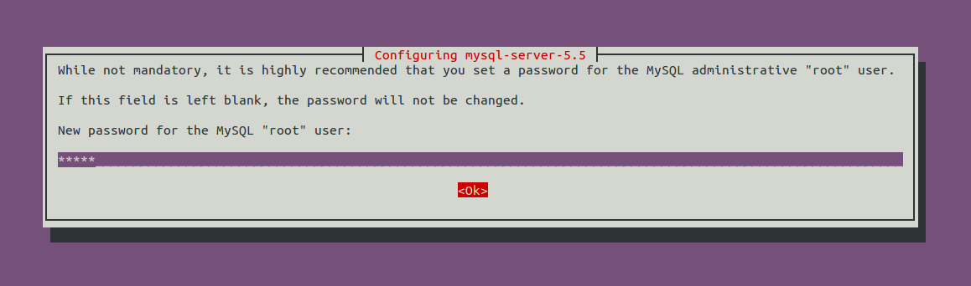
Figure 3 Mysql installation root password

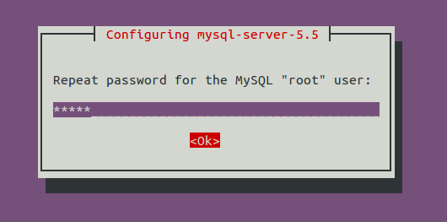
Figure 4 Mysql installation root password repeat
The mysql-server installation process ends here.
      - Phpmyadmin installation details
You should prefer the easiest way
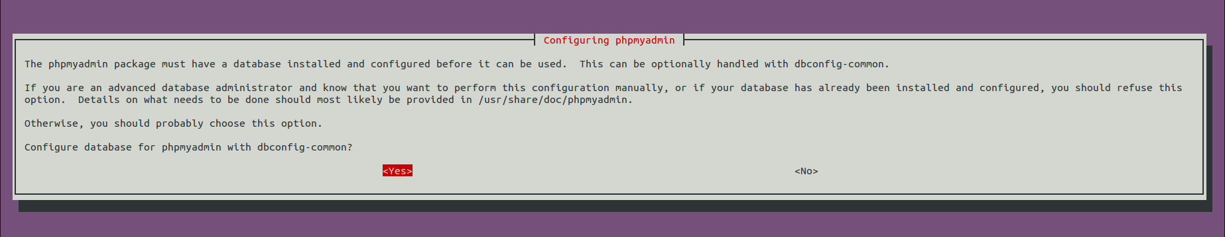
Figure 5 Phpmyadmin installation conf DB

Enter here the MS_PW_ROOT.:
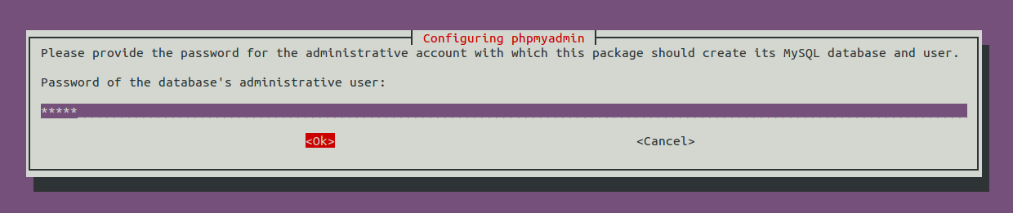
Figure 6 Phpmyadmin installation DB admin password

Please, enter here what will be the phpmyadmin application password, lets call it MS_PW_PHP:
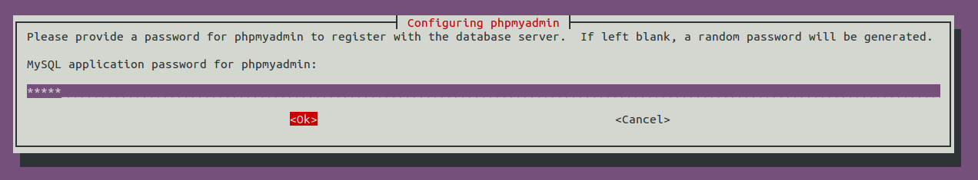
Figure 7 Phpmyadmin installation application password

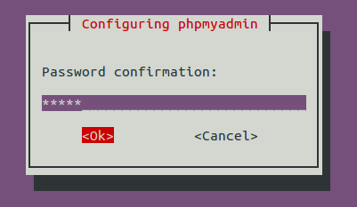
Figure 8 Phpmyadmin installation application password confirmation
Choose the web server that has to be configured: Apache.
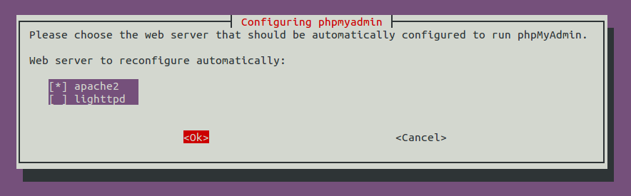
Figure 9 Phpmyadmin installation web server selection

    - HSS configuration
In this section is describd the step by step configuration of the HSS, any parameter can be customized upon your need (mysql server address, mySQL user name, mySQL password, HSS OP key, location of freeDiameter configuration file, realm).
A template of the HSS configuration file can be found at OPENAIRCN_DIR/ETC/hss.conf. This configuration file follows the libconfig file syntax (http://www.hyperrealm.com/libconfig).
Content of OPENAIRCN_DIR/ETC/hss.conf:
HSS :
{
## MySQL mandatory options
MYSQL_server = "127.0.0.1";
MYSQL_user = "@MYSQL_user@";
MYSQL_pass = "@MYSQL_pass@";
MYSQL_db = "oai_db";

## HSS options
OPERATOR_key = "1006020f0a478bf6b699f15c062e42b3"; # OP key for oai_db.sql

RANDOM = "true";

## Freediameter options
FD_conf = "/usr/local/etc/oai/freeDiameter/hss_fd.conf";
};

      - Step 1
Copy the file OPENAIRCN_DIR/ETC/hss.conf in /usr/local/etc/oai directory:

user@hss-host:~/openair-cn/SCRIPTS$ sudo mkdir -p /usr/local/etc/oai/freeDiameter
user@hss-host:~/openair-cn/SCRIPTS$ sudo cp $OPENAIRCN_DIR/ETC/hss.conf \ /usr/local/etc/oai
Please take care of the permissions of your hss.conf file.
Then customize your copied HSS configuration file:

Parameter | Type
MYSQL_server | String | IP address of the MySQL server instance where the HSS DB is stored.
MYSQL_user | String, user login | HSS administrator login, could be “hssadmin”.
MYSQL_pass | String, password | HSS administrator password, should be MS_PW_PHP.
MYSQL_db | String, database name | Database name, default is oai_db for EURECOM subscribers.
OPERATOR_key | String | Operator key in plain text.
RANDOM | String, allowed values “yes”, “no”. | Default value is “true”. Set false when you want to capture or replay S1-C scenarios.
FD_conf | String | Path to HSS freeDiameter configuration file.
Table 2: HSS configuration fields

      - Step 2
Copy the files OPENAIRCN_DIR/ETC/hss_fd.conf, OPENAIRCN_DIR/ETC/acl.conf in /usr/local/etc/oai/freeDiameter directory:
user@hss-host:~/openair-cn/SCRIPTS$ sudo cp $OPENAIRCN_DIR/ETC/acl.conf $OPENAIRCN_DIR/ETC/hss_fd.conf /usr/local/etc/oai/freeDiameter
Please take care of the permissions of your configuration files.
Then customize your copied hss_fd.conf, acl.conf configuration files if necessary, if you follow this document, it should not be necessary, otherwise please refer to freeDiameter documentation.

      - Step 3
A FQDN has to be set for the HSS (see hss_fd.conf). An easy way to do that is to fill this FQDN in the /etc/hosts file:
For example on a host with hostname 'yang':
yang@yang:$ cat /etc/hosts
127.0.0.1 localhost
127.0.1.1 yang.openair4G.eur yang #Your hostname here
127.0.1.1 hss.openair4G.eur hss

      - Step 4
Generate HSS certificates:
user@hss-host:~/openair-cn/SCRIPTS$ ./check_hss_s6a_certificate /usr/local/etc/oai/freeDiameter hss.openair4G.eur

    - HSS build
HSS can be built in two different ways: an executable that can run in a controlling terminal, or a daemon that run in the background.
In OPENAIRCN_DIR/SCRIPTS directory, depending on the chosen target execute the following command:
user@hss-host:~/openair-cn/SCRIPTS$ ./build_hss --clean --debug
or
user@hss-host:~/openair-cn/SCRIPTS$ ./build_hss --clean --debug --daemon
This command will compile the right target oai_hss or oai_hssd.

    - HSS run
In OPENAIRCN_DIR/SCRIPTS directory, a helper script called run_hss is provided for running the HSS.
Here are the run_hss options:
./run_hss -h

Usage: run_hss [OPTION]...
Run the HSS executable (experimental).

Options:
Mandatory arguments to long options are mandatory for short options too.
-c, --config-file filename Config file to be used by HSS if you don't want to use the default one: /usr/local/etc/oai/hss.conf
-e, --export-db filename Export current database to a SQL file, file prefix is $OPENAIRCN_DIR/SRC/OAI_HSS/db. (useful for replaying test scenarios)
-D, --daemon Run the daemon.
-i, --import-db filename Import SQL file to current database, file prefix is $OPENAIRCN_DIR/SRC/OAI_HSS/db. (useful for replaying test scenarios or restoring original database content)
-I, --install-hss-files Install HSS config files.
-g, --gdb Run with GDB.
-h, --help Print this help.
-k, --kill Kill the running local HSS.

      - First run
        - Customize HSS database content
SQL operations (display, update, export, etc) can be done easily with the help of phpMyAdmin, you have to open the following URL with your browser: http://yourhsshost/phpmyadmin.
Otherwise you can use any other MySQL tool, script compatible with MySQL.
The steps for adding a subscriber are the following:
- Add your MME(s) in table mmeidentity
- Add subscriber(s) in table users
user.imsi=IMSI of your USIM.
user.msisdn= MSISDN of your USIM (unused).
users.imei=NULL
users.imei_sv=NULL
users.ms_ps_status=’PURGED’
users.rau_tau_timer=120
users.ue_ambr_ul=50000000
users.ue_ambr_dl=100000000
users.access_restriction=47
users.mme_cap=0
users.mmeidentity_idmmeidentity=’your MME key’
users.RFSP-Index=1
users.urrp_mme=0
users.sqn=’your USIM programmed SQN’
users.rand=0
users.OPc=’the OPc key’ (will be computed by the oai_hss executable)
- Add subscriber(s) in table pdn.

Table mmeidentity:
Structure:
Field | Type | Null | Key | Default | Extra
idmmeidentity | int(11) | NO | PRI | NULL | auto_increment
mmehost | varchar(255) | YES |  | NULL
mmerealm | varchar(200) | YES |  | NULL
UE-Reachability | tinyint(1) | NO |  | NULL
Table 3: SQL Table structure mmeidentity
Column idmmeIdentity is the primary key of a MME.
Column mmehost contains the FQDN of a MME.
Column mmerealm contains the realm of a MME.

Example of content:
+---------------+------------------------+---------------+-----------------+
| idmmeidentity | mmehost | mmerealm | UE-Reachability |
+---------------+------------------------+---------------+-----------------+
| 2 | yang.openair4G.eur | openair4G.eur | 0 |
| 1 | ng40-erc.openair4G.eur | openair4G.eur | 0 |
| 3 | ABEILLE.openair4G.eur | openair4G.eur | 0 |
+---------------+------------------------+---------------+-----------------+

Table pdn:
This table contains mainly the association between a subscriber (users_imsi) and a APN (apn), and its QOS parameters.

Structure:
Field | Type | Null | Key | Default | Extra
id | int(11) | NO | PRI | NULL | auto_increment
apn | varchar(60) | NO |  | NULL
pdn_type | enum('IPv4','IPv6','IPv4v6','IPv4_or_IPv6') | NO |  | NULL
pdn_ipv4 | varchar(15) | YES |  | NULL | 0.0.0.0
pdn_ipv6 | varchar(45) | YES |  | NULL | 0:0:0:0:0:0:0:0
aggregate_ambr_ul | int(10) unsigned | YES |  | 50000000
aggregate_ambr_dl | int(10) unsigned | YES |  | 100000000
pgw_id | int(11) | NO | PRI | NULL
users_imsi | varchar(15) | NO | PRI
qci | tinyint(3) unsigned | NO |  | 9
priority_level | tinyint(3) unsigned | NO |  | 15
pre_emp_cap | enum('ENABLED','DISABLED') | YES |  | DISABLED
pre_emp_vul | enum('ENABLED','DISABLED') | YES |  | DISABLED
LIPA-Permissions | enum('LIPA-prohibited','LIPA-only','LIPA-conditional') | YES |  | LIPA-only
Table 4: SQL Table structure pdn
Column id is the primary key of a pdn entry.
Column pdn_type contains the type of PDN, actually only IPv4 is supported.
Column pdn_ipv4 contains the IPv4 address of the PDN (unused).
Column pdn_ipv6 contains the IPv6 address of the PDN (unused).
Column aggregate_ambr_ul TODO
Column aggregate_ambr_dl TODO
Column pgw_id TODO
Column users_imsi TODO
Column qci TODO
Column priority_level TODO
Column pre_emp_capability TODO
Column pre_emp_vulnerability TODO
Column LIPA_Permissions TODO

Table users
This table contains mainly the informations about a subscriber: its IMSI, IMEI, key LTE K, SQN, operator key OP, QOS parameters, the last known MME identity where the subscriber registered.
Structure:

Field | Type | Null | Key | Default | Extra
imsi | varchar(15) | NO | PRI | NULL
msisdn | varchar(46) | YES |  | NULL
imei | varchar(15) | YES |  | NULL
imei_sv | varchar(2) | YES |  | NULL
ms_ps_status | enum('PURGED','NOT_PURGED') | YES |  | PURGED
rau_tau_timer | int(10) unsigned | YES |  | 120
ue_ambr_ul | bigint(20) unsigned | YES |  | 50000000
ue_ambr_dl | bigint(20) unsigned | YES |  | 100000000
access_restriction | int(10) unsigned | YES |  | 60
mme_cap | int(10) unsigned zerofill | YES |  | NULL
mmeidentity_idmmeidentity | int(11) | NO | PRI | 0
key | varbinary(16) | NO |  | 0
RFSP-Index | smallint(5) unsigned | NO |  | 1
urrp_mme | tinyint(1) | NO |  | 0
sqn | bigint(20) unsigned zerofill | NO |  | NULL
rand | varbinary(16) | NO |  | NULL
OPc | varbinary(16) | YES |  | NULL
Table 5: SQL Table structure users
TODO column description.

      - Later runs
By default (otherwise you know what you are doing) for all following runs of the HSS, use:
user@hss-host:~/openair-cn/SCRIPTS$ ./run_hss
or
user@hss-host:~/openair-cn/SCRIPTS$ ./run_hss --daemon

  - MME
    - MME pre-installation
In OPENAIRCN_DIR/SCRIPTS directory, execute the following command:
user@mme-host:~/openair-cn/SCRIPTS$ ./build_mme -i
This command will install the required softwares on your host.

    - MME configuration
A template of the MME configuration file can be found at OPENAIRCN_DIR/ETC/mme.conf. This configuration file follows the libconfig file syntax (http://www.hyperrealm.com/libconfig).

      - Step 1
Copy the file OPENAIRCN_DIR/ETC/mme.conf in /usr/local/etc/oai directory:

user@mme-host:~/openair-cn/SCRIPTS$ sudo mkdir -p /usr/local/etc/oai/freeDiameter
user@mme-host:~/openair-cn/SCRIPTS$ sudo cp $OPENAIRCN_DIR/ETC/mme.conf /usr/local/etc/oai
Please take care of the permissions of your mme.conf file.

Then customize your copied MME configuration file:
      - MME section

Parameter | Type
RUN_MODE | String | Allowed values: “OTHER”, “TEST”. Set “OTHER” for normal operations, set “TEST” for S1C scenario player.
REALM | String | Diameter realm of the MME, default is openair4G.eur.
MAXENB | Num/Integer | Maximum number of eNB that can connect to MME.
MAXUE | Num/Integer | For debug purpose, used to restrict the number of served UEs the MME can handle.
RELATIVE_CAPACITY | Num/Integer | Even though this parameter is not used by the MME for controlling the MME load balancing within a pool (at least for now), the parameter has to be forwarded to the eNB during association procedure. Values going from 0 to 255, (Default value is 15)
MME_STATISTIC_TIMER | Num/Integer | Displayed statistic period in logs.
EMERGENCY_ATTACH_SUPPORTED | String | Actually only “no” is supported
UNAUTHENTICATED_IMSI_SUPPORTED | String | Actually only “no” is supported
EPS_NETWORK_FEATURE_SUPPORT_IMS_VOICE_OVER_PS_SESSION_IN_S1 | String | Actually only “no” is supported
EPS_NETWORK_FEATURE_SUPPORT_EMERGENCY_BEARER_SERVICES_IN_S1_MODE | String | Actually only “no” is supported
EPS_NETWORK_FEATURE_SUPPORT_LOCATION_SERVICES_VIA_EPC | String | Actually only “no” is supported
EPS_NETWORK_FEATURE_SUPPORT_EXTENDED_SERVICE_REQUEST | String | Actually only “no” is supported
IP_CAPABILITY | String | Actually only IPV4 is supported, (Choice between IPV4, IPV4V6, IPV4ORV6)
Table 6: MME configuration main section

        - INTERTASK_INTERFACE subsection
Parameter | Type
ITTI_QUEUE_SIZE | Num/Integer | Upper bound for the message queue size expressed in bytes (all messages exchanged by tasks have the same size). Restrict the number of messages in queues or detect a possible MME overload.
Table 7: MME configuration subsection ITTI

        - S6A subsection
Parameter | Type
S6A_CONF | String | FreeDiameter MME config file path, default value is “/usr/local/etc/oai/freeDiameter/mme_fd.conf”.
HSS_HOSTNAME | String | HSS hostname, default value is “hss”.
Table 8: MME configuration subsection S6a

        - SCTP subsection
Parameter | Type
SCTP_INSTREAMS | Num/Integer | Maximum number of SCTP input streams allowed for a S1-C connection.
SCTP_OUTSTREAMS | Num/Integer | Maximum number of SCTP output streams allowed for a S1-C connection.
Table 9: MME configuration subsection SCTP

        - S1AP subsection
Parameter | Type
S1AP_OUTCOME_TIMER | Num/Integer | Once an outcome is sent from MME to eNB, the MME locally starts a timer to abort the procedure and release UE context if the expected answer to this outcome is not received at the expiry of this timer. This timer is expressed in seconds. (Default value = 5 seconds)
Table 10: MME configuration subsection S1AP

        - GUMMEI LIST subsection
This section contains the GUMMEIs of the MME, actually only one GUMMEI is supported.
Parameter | Type
{MCC, MNC, MME_GID, MME_CODE} | String/String/String/String | Mobile country code of GUMMEI, Mobile network code of GUMMEI, MME group ID of GUMMEI, MME code of GUMMEI
Table 11: MME configuration subsection GUMMEI

        - TAI LIST subsection
The content of this section should be consistent with content of GUMMEI LIST section (MCC/MNC)
Parameter | Type
{MCC/MNC/TAC} | String/String/String | Each entry of the list is a triplet of a MCC, MNC and TAC. There can be up to 16 tracking areas identity set in this list. Actually we do not support shared networks, so the MCC/MNC field should all be equal among the list
Table 12: MME configuration subsection TAI LIST

        - NAS subsection
Parameter | Type
ORDERED_SUPPORTED_INTEGRITY_ALGORITHM_LIST | Array of String | Preference list in decreasing order of supported integrity algorithms, actually supported integrity algorithms are EIA0, EIA1, EIA2
ORDERED_SUPPORTED_CIPHERING_ALGORITHM_LIST | Array of String | Preference list in decreasing order of supported integrity algorithms, actually supported integrity algorithms are EEA0, EEA1, EEA2
T3402 | Integer | EMM timer, duration in minutes.
T3412 | Integer | EMM timer, duration in minutes.
T3485 | Integer | ESM timer, duration in seconds, unused (TODO).
T3486 | Integer | ESM timer, duration in seconds, unused (TODO).
T3489 | Integer | ESM timer, duration in seconds, unused (TODO).
T3495 | Integer | ESM timer, duration in seconds, unused (TODO).
Table 13: MME configuration subsection NAS

        - Network interfaces subsection
Parameter | Type
MME_INTERFACE_NAME_FOR_S1_MME | String | Interface name for S1-MME (S1-C), this interface name can be a real ethernet interface or a virtual ethernet interface. The script run_mme can configure it and bring it up if you provide the -i/--set-nw-interfaces option.
MME_IPV4_ADDRESS_FOR_S1_MME | String, CIDR | Binded address for S1-MME
MME_INTERFACE_NAME_FOR_S11_MME | String | Interface name for S11, this interface name can be a real ethernet interface or a virtual ethernet interface. The script run_mme can configure it and bring it up if you provide the -i/--set-nw-interfaces option.
MME_IPV4_ADDRESS_FOR_S11_MME | String, CIDR | Binded address for S11.
Table 14: MME configuration subsection Network Interfaces

        - Logging subsection
Parameter | Type
OUTPUT | String | choice in { "CONSOLE", "UNBUFFERED_CONSOLE", "`path to file`", "`IPv4@`:`TCP port num`"}.  Choise "CONSOLE" means that logs go to STDOUT, STDERR in a manner that even if multiple concurrent threads dump a lot of logs, traces cannot overlap (the cost here is that we need buffering).  Choice "UNBUFFERED_CONSOLE" means that logs go directly to STDOUT, STDERR, traces may overlap.  Choice "`path to file`", for example “/tmp/mme.log” is a file receiving the dump of logs without overlaping traces.  Choice "`IPv4@`:`TCP port num`" (for example “192.168.12.17:6789”) dump the logs towards a TCP server. The logs cat be easily displayed or dumped into a file with netcat (nc -kl 6789).
COLOR | String | Choice in { "yes", "no" } means use of ANSI styling codes or no. TODO
SCTP_LOG_LEVEL | String | Log level choice in { "EMERGENCY", "ALERT", "CRITICAL", "ERROR", "WARNING", "NOTICE", "INFO", "DEBUG", "TRACE"}
S1AP_LOG_LEVEL | String | Idem as above
NAS_LOG_LEVEL | String | Idem as above
MME_APP_LOG_LEVEL | String | Idem as above
S6A_LOG_LEVEL | String | Idem as above
UTIL_LOG_LEVEL | String | Idem as above
MSC_LOG_LEVEL | String | Idem as above
ITTI_LOG_LEVEL | String | Idem as above
ASN1_VERBOSITY | String | Choice in {“none”, “info”, “annoying”}
Table 15: MME configuration subsection Network Interfaces

      - SGW section
The PGW, SGW selections are not implemented yet, so we need a mechanism that replace these selection: yet, we only support one PDN, one PGW, one SGW.
        - Network interfaces subsection
Parameter | Type
SGW_IPV4_ADDRESS_FOR_S11 | String, CIDR | Binded SGW address for S11.
Table 16: MME configuration section SGW

      - Step 2
Copy the file OPENAIRCN_DIR/ETC/mme_fd.conf in /usr/local/etc/oai/freeDiameter directory:
user@hss-host:~/openair-cn/SCRIPTS$ sudo mkdir -p /usr/local/etc/oai/freeDiameter
user@hss-host:~/openair-cn/SCRIPTS$ sudo cp $OPENAIRCN_DIR/ETC/mme_fd.conf /usr/local/etc/oai/freeDiameter
Please take care of the permissions of your configuration files.
Then customize your copied mme_fd.conf configuration files (Identity value, realm), please refer to freeDiameter documentation.

      - Step 3
A FQDN has to be set for the MME (see mme_fd.conf). An easy way to do that is to set this FQDN in the /etc/hosts file:
For example on a host with hostname 'yang':
yang@yang:$ cat /etc/hosts
127.0.0.1 localhost
127.0.1.1 yang.openair4G.eur yang # MME host
127.0.1.1 hss.openair4G.eur hss # HSS located on MME host

    - MME build
MME can be built in two different ways: an executable that can run in a controlling terminal, or a daemon that run in the background.
In OPENAIRCN_DIR/SCRIPTS directory, depending on the chosen target execute the following command:
user@mme-host:~/openair-cn/SCRIPTS$ ./build_mme --clean
or
user@mme-host:~/openair-cn/SCRIPTS$ ./build_mme --clean --daemon
This command will compile the right target oai_mme or oai_mmed.

    - Before MME first run
Prior the first run of the MME, you will have to generate certificates:
user@hss-host:~/openair-cn/SCRIPTS$./check_mme_s6a_certificate /usr/local/etc/oai/freeDiameter yang.openair4G.eur

    - MME run
In OPENAIRCN_DIR/SCRIPTS directory, a helper script called run_mme is provided for running the MME.
user@hss-host:~/openair-cn/SCRIPTS$ ./run_mme
or
user@hss-host:~/openair-cn/SCRIPTS$ ./run_mme --daemon

  - SP_GW
    - SP-GW pre-installation
In OPENAIRCN_DIR/SCRIPTS directory, execute the following command:
user@mme-host:~/openair-cn/SCRIPTS$ ./build_spgw -i
This command will install the required softwares on your host.

    - SP-GW configuration
A template of the SP-GW configuration file can be found at OPENAIRCN_DIR/ETC/spgw.conf. This configuration file follows the libconfig file syntax (http://www.hyperrealm.com/libconfig).

      - Step 1
Copy the file OPENAIRCN_DIR/ETC/mme.conf in /usr/local/etc/oai directory:

user@mme-host:~/openair-cn/SCRIPTS$ sudo mkdir -p /usr/local/etc/oai
user@mme-host:~/openair-cn/SCRIPTS$ sudo cp $OPENAIRCN_DIR/ETC/spgw.conf /usr/local/etc/oai
Please take care of the permissions of your spgw.conf file.

Then customize your copied SP-GW configuration file:
      - SGW section
    - Network interfaces section
Parameter | Type
SGW_INTERFACE_NAME_FOR_S11 | String | Interface name for S11.
SGW_IPV4_ADDRESS_FOR_S11 | String, CIDR notation | Binded address for S11.
SGW_INTERFACE_NAME_FOR_S1U_S12_S4_UP | String | Interface name for S1-U, this interface name can be a real ethernet interface or a virtual ethernet interface. The script run_spgw can configure it and bring it up if you provide the -i/--set-nw-interfaces option.
SGW_IPV4_ADDRESS_FOR_S1U_S12_S4_UP | String, CIDR notation | Binded address for S1-U
SGW_IPV4_PORT_FOR_S1U_S12_S4_UP | Num/Integer | Port number for S1-U (IANA), Should be 2152
SGW_INTERFACE_NAME_FOR_S5_S8_UP | String, | Interface name for S5 or S8, set to “none” because unused
SGW_IPV4_ADDRESS_FOR_S5_S8_UP | String, CIDR notation | Binded address for S5 or S8, set to 0.0.0.0/xx because unused
Table 17: S-GW configuration subsection Network Interfaces

        - INTERTASK_INTERFACE subsection
Parameter | Type
ITTI_QUEUE_SIZE | Num/Integer | Upper bound for the message queue size expressed in bytes (all messages exchanged by tasks have the same size). Restrict the number of messages in queues or detect a possible overload.
Table 18: MME configuration subsection ITTI

        - Logging subsection
Parameter | Type
OUTPUT | String | choice in { "CONSOLE", "UNBUFFERED_CONSOLE", "`path to file`", "`IPv4@`:`TCP port num`"}.  Choise "CONSOLE" means that logs go to STDOUT, STDERR in a manner that even if multiple concurrent threads dump a lot of logs, traces cannot overlap (the cost here is that we need buffering).  Choice "UNBUFFERED_CONSOLE" means that logs go directly to STDOUT, STDERR, traces may overlap.  Choice "`path to file`", for example “/tmp/spgw.log” is a file receiving the dump of logs without overlaping traces.  Choice "`IPv4@`:`TCP port num`" (for example “192.168.12.18:6789”) dump the logs towards a TCP server. The logs cat be easily displayed or dumped into a file with netcat (nc -kl 6789).
COLOR | String | Choice in { "yes", "no" } means use of ANSI styling codes or no. TODO
UDP_LOG_LEVEL | String | Log level choice in { "EMERGENCY", "ALERT", "CRITICAL", "ERROR", "WARNING", "NOTICE", "INFO", "DEBUG", "TRACE"}
GTPV1U_LOG_LEVEL | String | Idem as above
GTPV2C_LOG_LEVEL | String | Idem as above
SPGW_APP_LOG_LEVEL | String | Idem as above
S11_LOG_LEVEL | String | Idem as above
Table 19: MME configuration subsection Network Interfaces

      - PGW section
        - Main section
Parameter | Type
DEFAULT_DNS_1_IPV4_ADDRESS | String, IPv4 dot decimal | IPv4 address of primary default DNS that can be queried by UEs
DEFAULT_DNS_2_IPV4_ADDRESS | String, IPv4 dot decimal | IPv4 address of secondary default DNS that can be queried by UEs
FORCE_PUSH_PROTOCOL_CONFIGURATION_OPTIONS | String | Non standard feature, normally should be set to "no", but you may need to set to yes for UE that do not explicitly request a PDN address through NAS signalling, MTU, DNS are also pushed even if not requested.
Table 20: P-GW configuration main section

        - Network interfaces section
Parameter | Type
PGW_INTERFACE_NAME_FOR_S5_S8 | String | Interface name for S5 or S8, “none” because unused
PGW_IPV4_ADDRESS_FOR_S5_S8 | String, CIDR notation | Binded address for S5 or S8, (0.0.0.0/xx) because unused
PGW_INTERFACE_NAME_FOR_SGI | String | Interface name for SGi
PGW_IPV4_ADDRESS_FOR_SGI | String, CIDR notation | Used IPv4 address for SGi, useful if UE traffic is masqueraded.
PGW_MASQUERADE_SGI | String | Should outgoing UE IPv4 traffic be masqueraded (source NAT), “yes” or “no”.
Table 21: P-GW configuration subsection Network Interfaces

        - IP Address Pool section
Parameter | Type
IPV4_LIST | String, CIDR notation | List of IPv4 netmasks that designate a list of available IPv4 addresses for UEs
Table 22: P-GW configuration subsection IP Address Pool Selection

    - SPGW run
In OPENAIRCN_DIR/SCRIPTS directory, a helper script called run_spgw is provided for running the SPGW.
user@hss-host:~/openair-cn/SCRIPTS$ ./run_spgw -r
or
user@hss-host:~/openair-cn/SCRIPTS$ ./run_spgw -r --daemon
- Supported scenarios in EPC
  - E-UTRAN Initial attach
    - Attach with IMSI
TODO Add MSCGEN SEQ diagram
    - Attach with GUTI
TODO Add MSCGEN SEQ diagram
  - Tracking Area Update procedures
TODO Add MSCGEN SEQ diagram
  - Routing Area Update procedures
Not supported yet.
  - Service Request procedures
    - UE triggered Service Request
TODO Add MSCGEN SEQ diagram
    - Network triggered Service Request
Not supported yet.
  - S1 Release procedure
TODO Add MSCGEN SEQ diagram
  - GUTI Reallocation procedure
Not supported yet.
  - Detach procedure
    - UE-Initiated Detach procedure for E-UTRAN
TODO Add MSCGEN SEQ diagram
    - MME-Initiated Detach procedure for E-UTRAN
    - HSS-Initiated Detach procedure for E-UTRAN
Not supported.
  - HSS User Profile management function procedure
Not supported.
  - Bearer deactivation
    - PDN GW initiated bearer deactivation
Not supported
    - MME initiated Dedicated Bearer Deactivation
Not supported yet
  - Intra E-UTRAN handover
Not supported yet

- Annex A: Tools for observing, debugging.

  - Wireshark/tshark
You can launch wireshark instances on S1 (filter s1ap, gtpu), S6A (filter diameter, if TCP is the undelying protocol, you can select a TCP packet relative to the DIAMETER exchange and the select decode as DIAMETER).

  - Mscgen
Extract from http://www.mcternan.me.uk/mscgen/: “Mscgen is a small program that parses Message Sequence Chart descriptions and produces PNG, SVG, EPS or server side image maps (ismaps) as the output. Message Sequence Charts (MSCs) are a way of representing entities and interactions over some time period”…” Mscgen aims to provide a simple text language that is clear to create, edit and understand, which can also be transformed into common image formats for display or printing.”…

Openair use mscgen to offer another view of events (SDUs, timers, etc) that happens inside an executable and also (still under development) PDUs exchanged between protocol entities.
Openair HSS don't have the msgen feature.

Important:
Check that mscgen traces are configured for being generated (CFLAG MESSAGE_CHART_GENERATOR set to true in OPENAIRCN_DIR/BUILD/MME/CMakeLists.template)
You have to instruct the mme executable to dump the ITTI messages to a file with the argument -m path_to_directory. The mscgen files will be located under the specified directory, in a directory containing the time of the generated traces (text and png files).

Example:

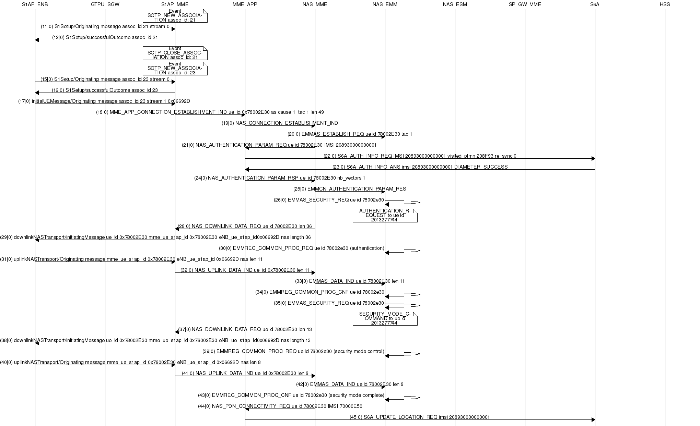
Figure 9 Mscgen output example

  - S1AP scenario replay
The aim of this tool is helping for MME bug reports, MME development, non-regression test, debug purpose, it allows to replay without the help of any eNB(s) or UE(s) a S1AP scenario previously captured as a pcap dumped file.

    - Overall process
Capture a scenario on S1-C network
Build a generic scenario
Replay scenario
Scenario resource files
Figure 10 Workflow of scenario replay

In order to replay a scenario, a scenario has to be played/captured (step 1), then the captured artefacts have to processed in order to generate a generic scenario (step 2) ready to be replayed on any other testbed (step 3).

    - Step0: Install required software on the “scenario replay”testbed
Note: If your “scenario replay” testbed and the “scenario capture testbed are the same” then step into section 4.3.2.1“openairinterface5g installation” only.
For the ease of all operations, the targeted testbed is only one host called here “testbed”.
On the host “testbed”, clone all 3 git repositories : openairinterface5g (git@gitlab.eurecom.fr:oai/openairinterface5g.git or https://gitlab.eurecom.fr/oai/openairinterface5g.git), openair-cn-scenarios (git@gitlab.eurecom.fr:oai/openair-cn-scenarios.git or https://gitlab.eurecom.fr/oai/openair-cn-scenarios.git) and openair-cn (git@gitlab.eurecom.fr:oai/openair-cn.git or https://gitlab.eurecom.fr/oai/openair-cn.git).

      - openairinterface5g installation
In the directory openairinterface5g:
user@testbed:~/openairinterface5g$ source .oaienv
user@testbed:~/openairinterface5g$ cd cmake_targets
user@testbed:~/cmake_targets$ ./build_oai -I --install-optional-packages
user@testbed:~/cmake_targets$ cd tools
user@testbed:~/tools$ ./build_test_epc_tools --clean --debug

      - openair-cn installation
In openair-cn directory:
user@testbed:~/openair-cn/SCRIPTS$ cd SCRIPTS
user@testbed:~/openair-cn/SCRIPTS$ ./build_hss --check-installed-software
user@testbed:~/openair-cn/SCRIPTS$ ./build_mme –check-installed-software
user@testbed:~/openair-cn/SCRIPTS$ ./build_mme --install-gtpu-kernel-module
user@testbed:~/openair-cn/SCRIPTS$ ./build_spgw –check-installed-software
user@testbed:~/openair-cn/SCRIPTS$ ./build_mme --clean --daemon
user@testbed:~/openair-cn/SCRIPTS$ ./build_spgw --clean --daemon
user@testbed:~/openair-cn/SCRIPTS$ ./build_hss --clean --daemon

      - openair-cn-scenarios installation
You should set an environment variable OPENAIRCN_DIR pointing to openair-cn directory, otherwise you will be later prompted for openair-cn directory location.
For example:
user@testbed:~$ echo 'export OPENAIRCN_DIR=/home/user/openair-cn' >> ~/.bashrc

    - Step1: Flowchart of network capture on S1-C
The goal of this step is to capture a SCTP/S1AP trace that we want to be able to replay.

Step a: Run HSS
The HSS database has first to be configured for not generating randoms in security algorithms, otherwise we will not be able to replay trace coming from UE(s).
In the HSS configuration file /usr/local/etc/oai/hss.conf, set RANDOM to false:
RANDOM = "false";

In order to be able to replay the scenario in the same conditions, the initial content of the database has to be saved.
The extra argument that has to be passed in addition to other arguments to the run_hss script is:
--export-db /tmp/hss_db.sql

Step b: run MME
No change here compared to standard case.
Step c: run SP-GW
No change here compared to standard case.
Step d: start a pcap-ng capture on S1-C
This step is not automated, you have to start on your own a tool to capture the network traffic on the S1-C network. (you can use wireshark).
VERY IMPORTANT 1: PLEASE filter the packets with the following filter string:
“s1ap or sctp.chunk_type == INIT or sctp.chunk_type == INIT_ACK or sctp.chunk_type == COOKIE_ECHO or sctp.chunk_type == COOKIE_ACK”.
VERY IMPORTANT 2: We need the scenario from the beginning, that means the we need to have the SCTP INIT and SCTP INIT_ACK messages captured, so you must start the capture before lauching the eNB(s).
Step e: start the eNB(s)
The eNB config files will be used later to make a scenario independent of IP addresses.
Step f: run your scenario

Step g: save the captured scenario
At the end of this process please save in a created subdirectory of openair-cn-scenarios/SCENARIOS/S1 whose name reflects the test case success or failure:
- The eNB(s) config file(s) with the name “enb.conf”
- The MME config file with the name “mme.conf”
- The MME freeDiameter config file with the name “mme_fd.conf”
- The SPGW config file with the name “spgw.conf”
- The exported database SQL file with the name “hss_db.sql”.
- The pcap-ng file containing all SCTP and S1AP traffic (filtered with “s1ap or sctp.chunk_type == INIT or sctp.chunk_type == INIT_ACK or sctp.chunk_type == COOKIE_ECHO or sctp.chunk_type == COOKIE_ACK”) occurred on S1-C network with the name “s1.pcapng”.
- The HSS and mySQL security parameters in a file named hss_credentials.txt:
OPERATOR_KEY="youroperatorkey"
MYSQL_USER="yourdbuser"
MYSQL_PASSWORD="yourdbpassword"

Begin

Start
HSS
hss.conf
hss_fd.conf
acl.conf
Input
hss_db.sql
Exported

Start
MME
mme.conf
mme_fd.conf
Input

Start
SPGW
spgw.conf
Input

Start
PCAP capture on S1-C
s1.pcapng
Captured

Start
eNB
enb.conf
Input

END

Figure 11 Workflow of scenario capture

The files listed in the flowchart figure are part of the “scenario resource files”, that means that if you want to replay the captured S1-C scenario, they will have to be saved in a created subdirectory of openair-cn-scenarios/SCENARIOS/S1 (on your personal git branch for most cases).

    - Step2: Generate a generic scenario
The scenario captured as a pcap file now have to be transformed in a XML file with abstracted IP addresses.
In openair-cn-scenarios/SCRIPTS, run the following command:
user@testbed:~/openair-cn-scenarios/SCRIPTS$ ./s1_prepare_test_scenarios

This command generates a copy of the S1-C pcap scenario, but with abstract IP addresses, for example:
...
<ip.src value="enb0_s1c"/>
<ip.dst value="mme0_s1c_0"/>
...

Replace IP src and dst addresses with generic IP addresses
s1.pcapng
s1.xml
s1.pdml

enb.conf

Figure 12 Captured scenario to generic scenario
    - Step3: Create configuration files for the “scenario replay” testbed
You have to create the network plan for the “scenario replay” testbed. The configuration files of the LTE network entities (eNB, MME, SPGW, HSS) will be a merge of the “scenario capture” testbed configuration files and the “scenario replay” network plan.

“Scenario capture” configuration files
“Scenario replay” configuration files
LTE parameters
(TAIs, PLMNs, etc)

“Scenario replay” testbed network plan
+ configured FQDNs (MME, HSS)
IP addresses, NW interfaces, FQDNs

Figure 13 Scenario replay configuration files

Here is the network plan used by EURECOM for replaying scenarios.
Default network namespace

Network namespace

enb-test
Scenario Player
MME
HSS
SGW
PGW
S1-C

S6-a

S11

SGI

S1-U

lo 127.0.0.1
lo 127.0.0.1
s1cenb
192.171.1.1/24
s1uenb
192.171.10.1/24
s11mme
192.171.11.1/24
s11sgw
192.171.11.2/24
s1cmme
192.171.1.2/24
s1usgw
192.171.10.2/24
None
0.0.0.0
DB server

Figure 14 Proposed “replay network plan”

After the creation of the 3 configuration files for the 3 network entities, the content of the scenario directory should look like this example:

user@testbed:~/EURECOM/openair-cn-scenarios/SCENARIOS/S1/NR_TESTS/PON_POFF$ ls -1
enb.conf
enb.replay.conf
enb.replay.run_options.txt
hss_credentials.txt
hss_db.replay.sql
hss_db.sql
hss_fd.conf
mme.conf
mme_fd.conf
mme.replay.conf
s1.html
s1.pcapng
s1.pdml
s1.xml
spgw.conf
spgw.replay.conf
test_epc_generate_scenario.history

    - Replay a S1AP generic scenario
For replaying a scenario open a terminal and go into directory openair-cn-scenarios/SCRIPTS and run the following command:

user@testbed:~/EURECOM/openair-cn-scenarios/SCRIPTS$ ./s1_run_test_scenario -S /home/eurecom/EURECOM/openair-cn-scenarios/SCENARIOS/S1/NR_TESTS/PON_POFF

