Oregon State University

OPEnS Lab

Creating a Three Setting   
Rain Catcher Calibrator

Jose Manuel Lopez Alcala

August 12, 2016

Project Supervisor: Dr. Selker

# **Objective**

This validation device is intended to calibrate any rain catcher on which it is used. It uses 500mL of water and has three flow rates. The estimated time for each flow rate is five, fifteen and thirty minutes. This specific version of the calibrator is intended to fit on the upper section of the rain gauge developed at Oregon State University in the OPEnS lab.

**Concept:**

**Mariotte’s Bottle:** The Mariotte Bottle was named after the French physicist Edme Mariotte. This bottle is designed to deliver a constant flow of liquid which is established by the distance between the air inlet and the water outlet and the diameter of the water outlet orifice.

The Mariotte bottle approach was the basis for the entire project. The early prototype was just a 500mL plastic measuring flask with one orifice on the cap and one on the side.

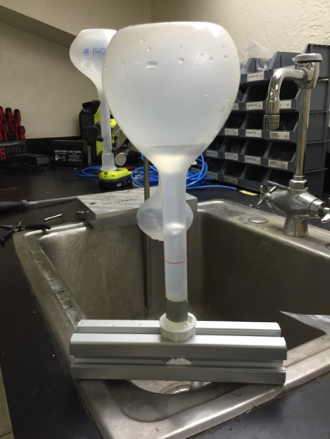

Figure 1: First prototype

-

# **Design Iterations**

**FIRST DESIGN:**

The first design was a tapered cylinder with a cut out for an O-ring to seal the sides and orifices of different sizes. This design did not work. The pressure on the both orifices would be equal because the difference in height was zero. This design created a cap rather than calibration valve. Some air bubbles would be allowed in but water was not coming out at constant rate. After a couple seconds the valve stop working.

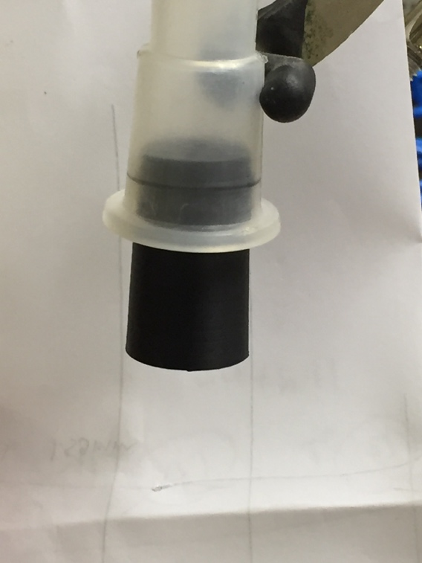 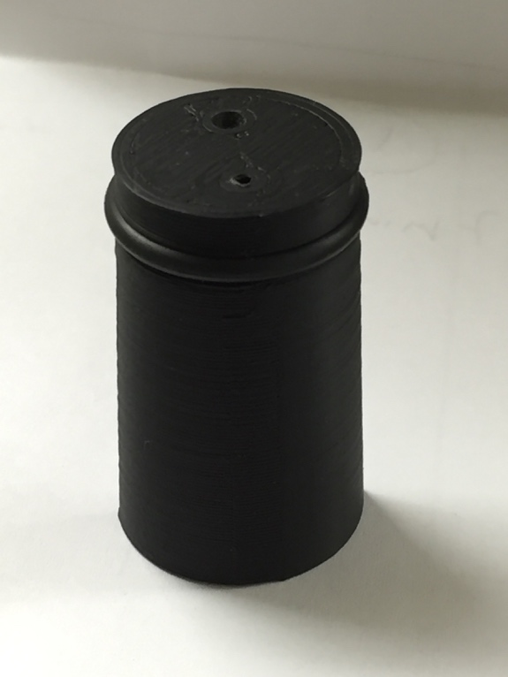

Figure 3: First valve prototype

Figure 2: First valve prototype attached to flask

**SECOND DESIGN:**

The second design had an extended tube coming out the top of the section that goes in the inside of the measuring flask. This design was an improvement over the first one, but it was still having problems letting air into the flask. One down side to this design was that the piece that we added to let air in could break easily. We need this piece to be strong and as maintenance-free as possible. Further development was necessary.

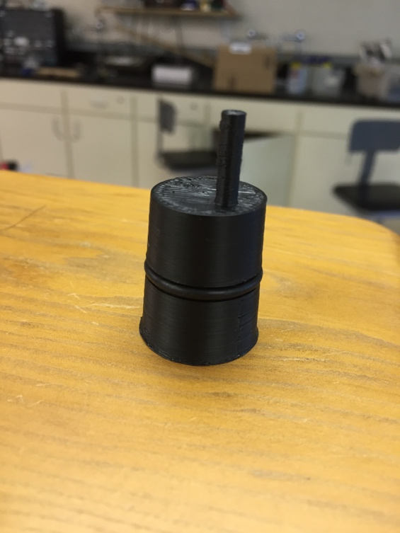

# 

Figure 4: Second valve prototype

**THIRD DESIGN:**

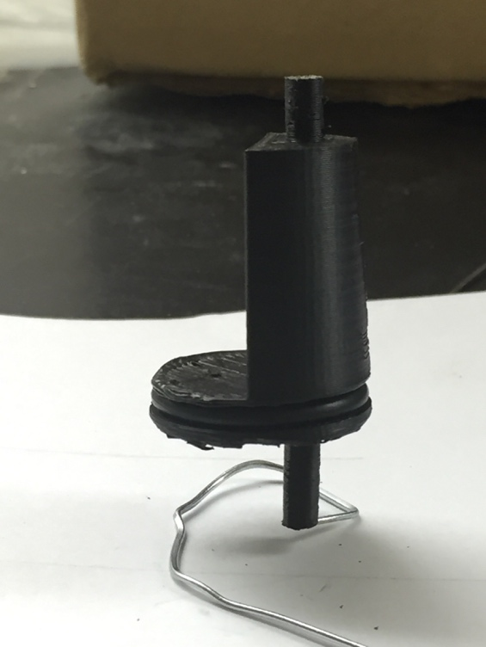This design had a more complex structure than the past designs. To increase the distance between the two holes half of the cylinder was omitted. This subtraction to the design gave the valve a better flow of water. A couple of components that were reconsidered were the tubes that were extending out of the valve on both extremes. These tubes where there to aid with the distance difference between both holes, but were still breaking off easily.

Figure 5: Third valve prototype

**FOURTH DESIGN:**

This iteration gave the best results of them all. It omitted half the cylinder and had the air inlet raised 22mm above the water outlet. The only concern with this revision is that it was not consistent. It would last the longest and it would drip water at a constant rate but after a certain time it would stop. Timing is a crucial component of this piece and we need consistency and timing to be as perfect as possible.

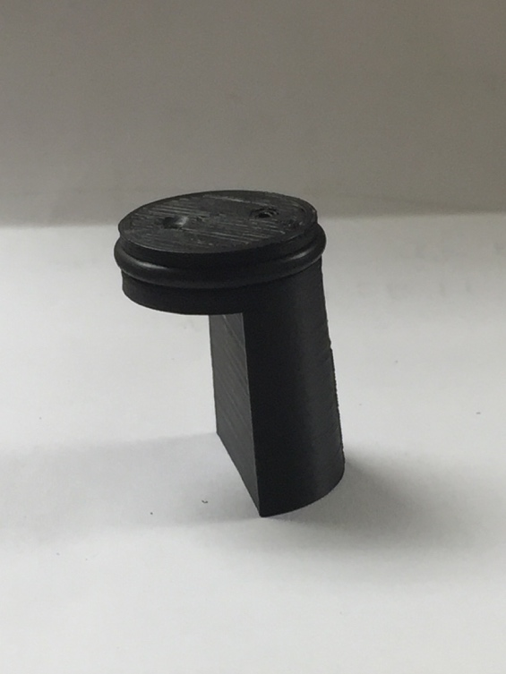

Figure 6: Fourth valve prototype

**FIFTH DESIGN:**

This was the final iteration. This version has 60mm height distance from the air inlet and the water outlet. One of the advantages of this version is that the it is one solid piece with no pieces that can easily break off. This valve supplied a constant flow rate and dripped every drop of water from the 500mL measuring flask.

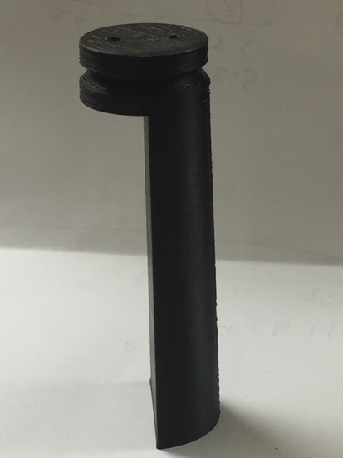

Figure 7: Fifth valve prototype

**Three Setting Valve**

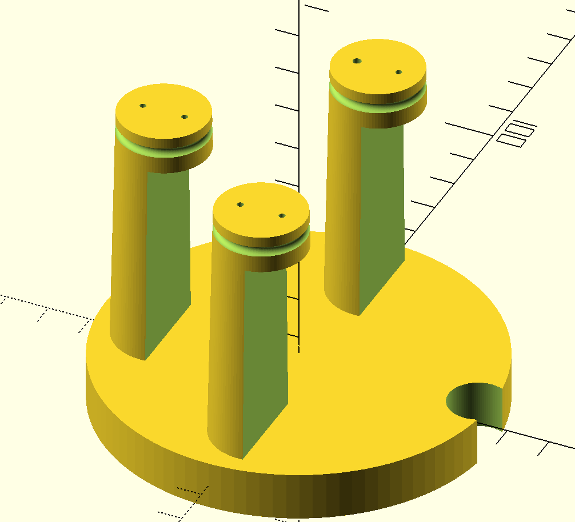After finishing the single valve design, the three setting valve was designed using the single valve code.

Figure 8: Three setting valve design (OpenSCAD)

The calibrator has three single valves the rest on a plate that has a circular cutout for another sensor the is already installed on the rain catcher.

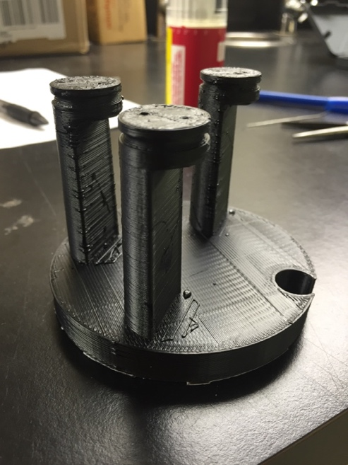

Figure 9: Three setting calibrator

The final times that the calibrator was able to achieve are slightly different from the original set of times. The calibrator comes in approximately twenty, ten and five minute settings. Even though the times are not exactly the same as the proposed ones, these valves have constant and reliable rates that can calibrate the rain gauge accurately.

**Printing and Drilling:**

At the OPEnS lab we use a Lulzbot TAZ5 and black ABS plastic to print the calibrator. After it has printed we let it cool down and proceed to drilling it. The five-minute setting gets drilled with a 1.47mm drill bit for the air inlet and a 1.96mm drill bit for the water outlet. The ten-minute setting gets drilled with a 1.57mm drill bit for both orifices. The thirty-minute setting does not get drilled. The orifice only gets cleaned out with a thin 0.85mm diameter paper clip.

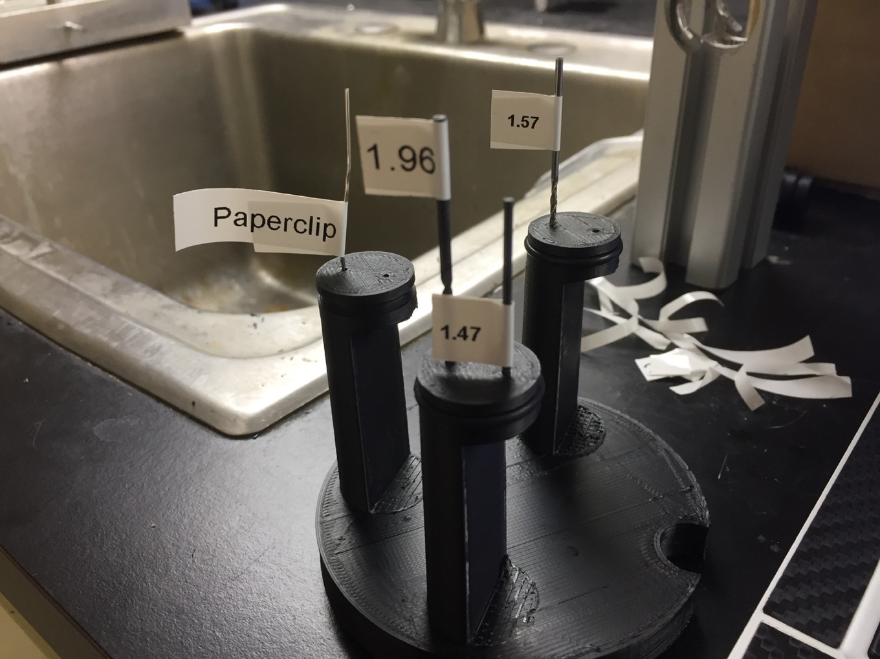

Figure 10: Drill sizes and their respective locations

**Data**

Every calibrator printed at the OPEnS lab is tested for optimal performance. The graphs presented in this paper are examples of the accuracy of our calibrators.