Data Requirements
As the primary purpose of this section is to modify the simulator’s calculated pore volumes and transmissibilities, then the properties used to define these arrays must have been fully defined in the GRID section. The arrays available for modification in the EDIT section are listed in Table 7.1 together with the associated GRID arrays used to generate the EDIT property array.
Cartesian And Irregular Corner-Point Grids  Keywords |  | Radial Grid Keywords
GRID | EDIT | GRID | EDIT
TOPS | DEPTH | TOPS | DEPTH
DX | PORV | DR | PORV
DY | PORV | THETA | PORV
DZ | PORV | DZ | PORV
DZNET | PORV | DZNET | PORV
PORO | PORV | PORO | PORV
NTG | PORV | NTG | PORV
PERMX | TRANX | PERMR | TRANR
MULTX | TRANX | MULTR | TRANR
PERMY | TRANY | PERMTHT | TRANTHT
MULTY | TRANY | MULTTHT | TRANTHT
PERMZ | TRANZ | PERMZ | TRANZ
MULTZ | TRANZ | MULTZ | TRANZ
Notes:
- Currently Radial Grids have not been implemented in OPM Flow.
- The GRID property association to the EDIT property is only indicative as several variables, DZNET and NTG for example, are also used in the transmissibility calculations.

Table 7.1: EDIT Section Arrays Available for Modification

An example pore volume array (PORV property) from the Volve field is shown in Figure 7.1 and Figure 7.2 illustrates the model’s transmissibility in the x-direction (TRANX).

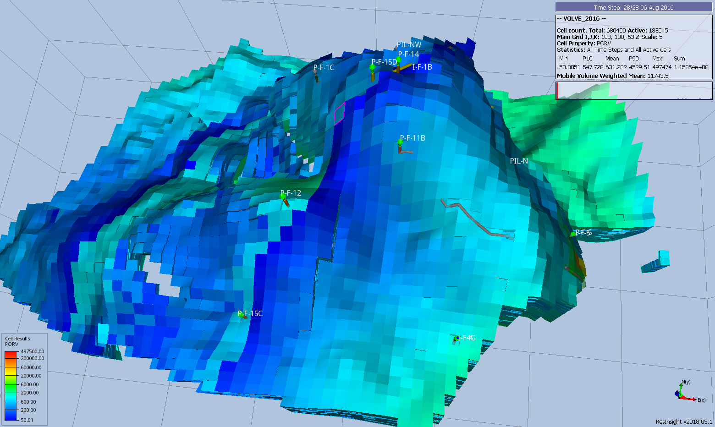Figure 7.1: Volve Full Field Model PORV Array
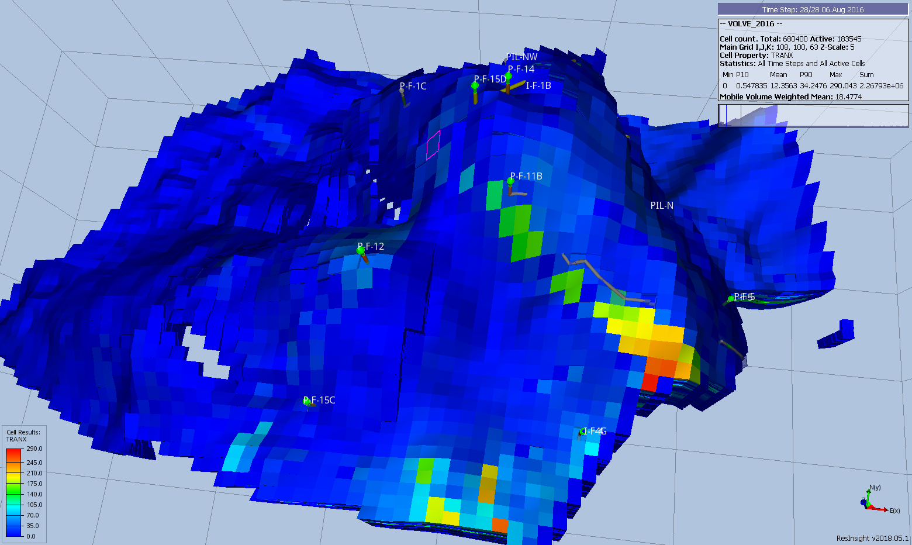Figure 7.2: Volve Full Field Model TRANX Array

The Volve Data was approved for data sharing in 2018 by the initiative of the last Operating company, Equinor and approved by the license partners ExxonMobil E&P Norway AS and Bayerngas Norge AS in the end of 2017.

