Data Requirements
OPM Flow, like most numerical modeling software, uses a default value of one for the various region arrays and thus if there is only one PVT data set for example, then there is no need to define the region array associated with allocating the PVT tables (via the PVTNUM keyword in the REGIONS section), as all cells will be allocated PVT table number one. However, if there are more than one PVT table entered in the PROPS section and PVTNUM is not defined in the model, then PVT tables greater than one will not be used and there will be no warning message indicating the fact.
Table 9.1 summarizes the various property region data and their associated keywords.
No. | REGIONS  Keyword | Standard Property Regions | Property  Section
1 | EQLNUM | EQLNUM – Define the Equilibration Region Numbers. Equilibrium region allocation based on the EQUIL keyword in the SOLUTION section. | SOLUTION
2 | FIPNUM | FIPNUM – Define the Fluid In-Place Region Numbers. Fluid In-Place reporting via the FIPNUM array that divides the model into different fluid in-place reporting regions. | REGIONS
3 | PVTNUM | PVTNUM – Define the PVT Regions. PVT table allocation of the DENSITY, PVDG, PVDO, PVTG, PVTO, PVCO, PVTW, and ROCK tables. | PROPS
4 | SATNUM | SATNUM – Define the Saturation Table Region Numbers. Saturation (relative permeability) table allocation of the SGFN, SWFN, SOF2, SOF3, SGOF, and SWOF tables. This array is for the standard drainage, as opposed to the imbibition curves, used in all models. There are separate region arrays for alternative relative permeability curves. | PROPS
 | Function Specific Regions
5 | ENDNUM | ENDNUM – Define the End-Point Scaling Depth Region Numbers. ENPTVD and ENKRVD versus depth table allocation for when ENDSCALE option has been activated in the RUNSPEC section. | PROPS
6 | FIP | FIP – Define the Fluid In-Place Names and Region and Numbers. Fluid In-Place reporting via the FIP array that divides the model into different fluid in-place reporting regions. | REGIONS
7 | FIPOWG | FIPOWG – Activate Oil, Gas, and Water FIP Zone Reporting. Fluid In-Place reporting for the total oil, gas, and water in the model. There is no region property array for this keyword, as the simulator calculates the total phase volumes based on the contacts entered via the EQUIL keyword in the SOLUTION section. | REGIONS
8 | HBNUM | HBNUM – Define Herschel-Bulkley Region Numbers. Herschel-Bulkley rheological property table region numbers. | PROPS
9 | HWSNUM | HWSNUM – Define the Saturation Table Region Numbers (High Salinity and Water Wet). High salinity water wet saturation table allocation using the high salinity water wet saturation SWFN and SOFN tables. This is an alias for the SURFWNUM property region which is also not supported by OPM Flow. | PROPS
10 | IMBNUM | IMBNUM – Define the Imbibition Saturation Table Region Numbers. Imbibition saturation table allocation of the SWFN, SOF2, SOF3, or SWOF imbibition tables. | PROPS
11 | IMBNUMMF | IMBNUMMF – Define the Imbibition Saturation Table Region Numbers (Matrix-Fracture). Imbibition saturation tables region numbers for flow between the matrix and fracture blocks, for when the Hysteresis option has been activated in Dual Porosity or Dual Permeability runs. | PROPS
12 | KRNUM | KRNUM – Define the Directional Saturation Table Region Numbers. Direction dependent saturation tables region numbers for when Directional Dependent Saturation Function option has been activated by the DIRECT parameter on the SATOPTS. | PROPS
13 | KRNUMMF | KRNUMMF – Define the Saturation Table Region Numbers (Matrix-Fracture). Drainage saturation tables region numbers for flow between the matrix and fracture blocks in a Dual Porosity or Dual Permeability model. | PROPS
14 | LSLTWNUM | LSLTWNUM – Define the Low Salt Water Wet Saturation Table Region Numbers. Low salt water wet saturation tables region numbers for when the Low Salinity option for the Brine model and the Surfactant Wettability option have been activated for the model. | PROPS
15 | LSNUM | LSNUM – Define the Low Salt Oil Wet Saturation Table Region Numbers. Low salt oil wet saturation tables region numbers for the Low Salinity Brine model. | PROPS
16 | LWSLTNUM | LWSLTNUM – Define the Low Salt Oil Wet Saturation Table Region Numbers. Low salt oil wet saturation table region numbers for the Low Salinity Brine model. | PROPS
17 | LWSNUM | LWSNUM – Define the Low Salt Water Wet Saturation Table Region Numbers. Low salt water wet saturation table region numbers for when the Low Salinity option for the Brine model and the Surfactant Wettability option have been activated for the model. | PROPS
18 | MISCNUM | MISCNUM – Define the Miscibility Region Numbers. Miscible regions based on the TLMIXPAR records when the MISCIBLE or SOLVENT keywords have been activated in the RUNSPEC section. | PROPS
19 | OPERNUM | OPERNUM – Define Regions for Mathematical Operations on Arrays. OPERATER keyword region numbers that can also be used with the EQUALREG, ADDREG, COPYREG, MULTIREG, MULTREGP, and MULTREGT keywords, as well as the OPERATER keyword in calculating various grid properties in the GRID and REGIONS section. | GRID  EDIT  PROPS  REGIONS  SOLUTION
20 | PENUM | PENUM – Define the Petro-Elastic Region Numbers. Petro-elastic region numbers for petro-elastic coefficients, bulk modulus functions and shear modulus functions. | PROPS
21 | PLMIXNUM | PLMIXNUM – Define the Polymer Region Numbers. Polymer region numbers for the mixing tables, and the maximum polymer and salt concentrations for the Polymer option. | PROPS
22 | RESIDNUM | RESIDNUM – Define Vertical Equilibrium Residual Flow Region Numbers. Vertical Equilibrium residual flow calculation saturation tables or when region numbers for the Vertical Equilibrium option. | PROPS
23 | ROCKNUM | ROCKNUM – Define Rock Compaction Table Region Numbers. Rock compaction table allocation for when the ROCKCOMP keyword as been activated in the RUNSPEC section, that allocates the ROCKTAB series of tables to a cell. | PROPS
24 | SURFNUM | SURFNUM – Define the Surfactant Miscible Saturation Table Region Numbers. Surfactant saturation (relative permeability) tables allocation allocating the SWFN, SOF2, SOF3, or SWOF as miscible tables. | PROPS
25 | SURFWNUM | SURFWNUM – Define the Saturation Table Region Numbers (High Salinity and Water Wet). High salinity water wet saturation table allocation using the high salinity water wet saturation SWFN and SOFN tables. | PROPS
26 | TNUM | TNUM – Define Passive Tracer Concentration Regions. Partitioned Tracer option region numbers for this option. | PROPS
27 | TRKPF | TRKPF – Define Partitioned Tracer Regions. Defines the regions associated with partition tracers and the partitioning tables allocated to grid blocks for when the Partitioned Tracer option has been enabled by the PARTTRAC keyword in the RUNSPEC section. | PROPS
28 | WH2NUM | WH2NUM – Define WAG Hysteresis Saturation Table Region Numbers (Two Phase). Two phase Water-Alternating-Gas (“WAG”) hysteresis saturation table region numbers for when the hysteresis option has been activated by the WAGHYSTR variable on the SATOPTS keyword in the RUNSPEC. | PROPS
29 | WH3NUM | WH3NUM – Define WAG Hysteresis Saturation Table Region Numbers (Three Phase). Three phase WAG hysteresis saturation table region numbers for when the hysteresis option has been activated by the WAGHYSTR variable on the SATOPTS keyword in the RUNSPEC. | PROPS
Notes:
- Note that not all keywords and features listed above are implemented in OPM Flow. Cells not colored in the No. column indicate the keyword is supported or partially supported by OPM Flow, cells colored gray indicate that the keyword is not applicable and will be ignored by the simulator, and finally, cells colored in orange indicate keywords that are not supported by OPM Flow and will be ignored by the simulator.
- Note that is common to set the FIPNUM array to be equal to the EQLNUM to have fluid in-place reporting for each equilibrium region, this can be done by using the COPY keyword to copy the EQLNUM array to the FIPNUM array.
Table 9.1: REGIONS Section Allocation Array Summary

Note
Earth modeling software may export the region arrays to be loaded into the simulator with values starting from zero instead of one. This may result in an error message if these cells are active in the model, if the cells are inactive then the zero values will be ignored by the simulator.

A complete property data set associated with a region keyword is required for each region number allocated to the cells. For example, if the fluid properties for the model are the same (for example, PVTO and PVDG keyword data), but the rock compressibility is varying with depth resulting in, say three different ROCK keyword records, then there has to be three PVTNUM regions and three complete PVT data sets in order to allocate the three ROCK records. This would mean that the PVTO and PVDG records, in this instance, would have to be repeated three times to match the three ROCK keyword records.
Example SATNUM and EQLNUM arrays from the Volve field are displayed in Figure 9.1 and Figure 9.2, respectively.
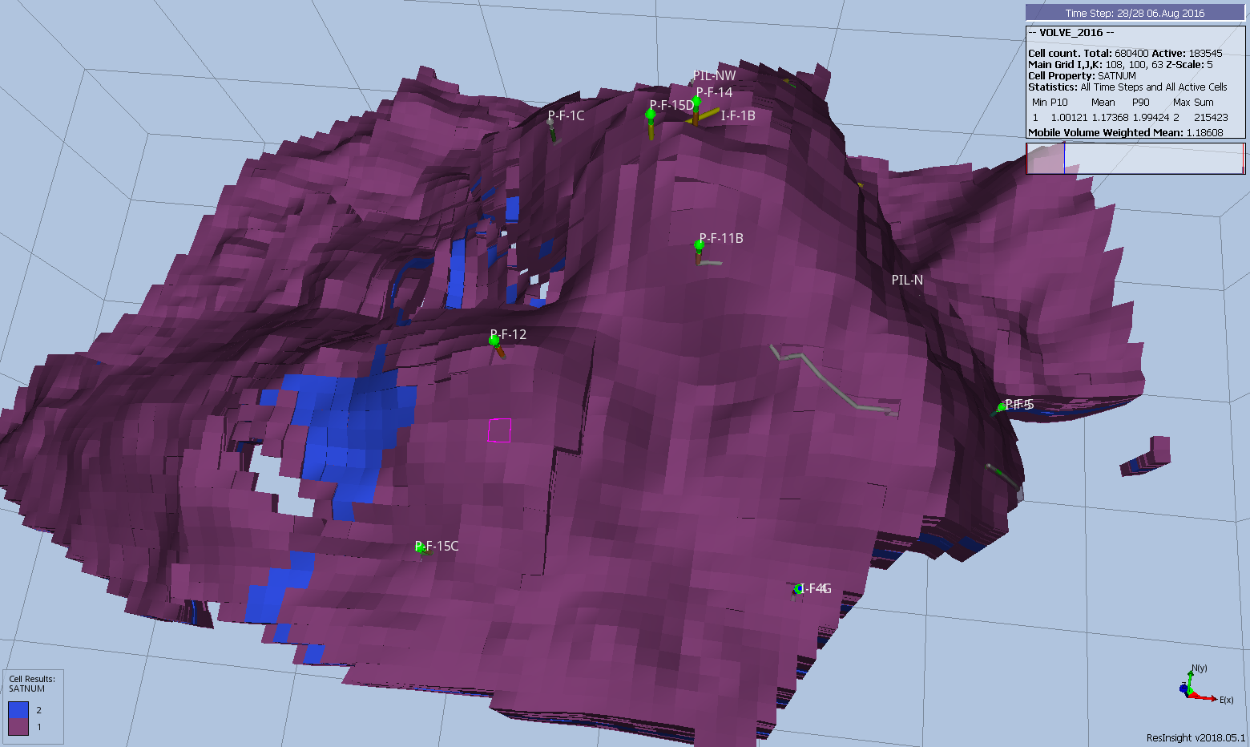Figure 9.1: Volve Full Field Model SATNUM Array

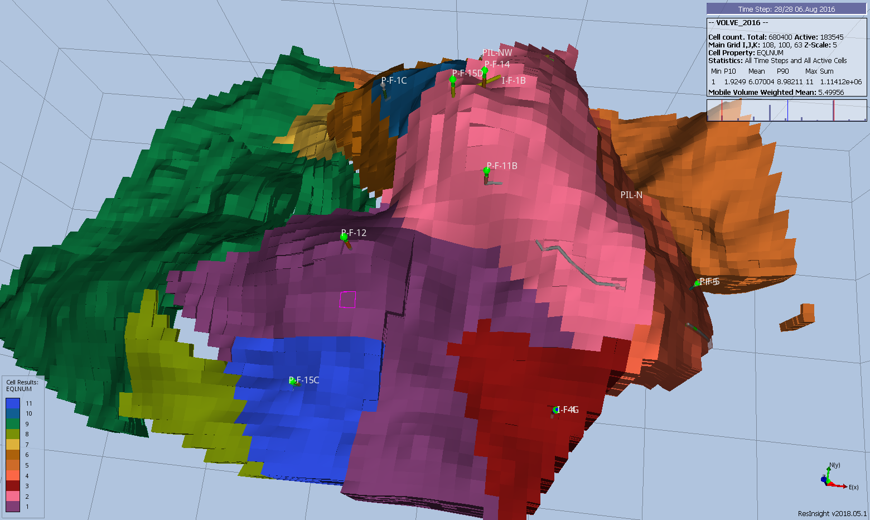Figure 9.2: Volve Full Field Model EQLNUM Array

The Volve Data was approved for data sharing in 2018 by the initiative of the last Operating company, Equinor and approved by the license partners ExxonMobil E&P Norway AS and Bayerngas Norge AS in the end of 2017.

