

Report: OOP Project Fr September 2020
TEAM 15

Virtual Global College Application 1

Team
Alex SLAMA 22833
Rémi WARTER 23177
Thomas D’ANGLEJAN 22840
Aurélien LESUR 22838
Paul COIFFET 23179
Teacher
John Rowley

October-December 2020
Preface
The purpose of this document is to describe the progress of our OOP project. It is the result of the work that has enabled us to produce this report. This report contains all the elements of the project. First, from a technical point of view, we will present the specifications. We will describe the functioning of our project as well as the elements that prove that it is working well. To finish the technical part, we will present our impressions of the project concerning the technical difficulties encountered and the perspectives opened. The second part of this report aims to present how we managed the project. We will first present how the project was divided into tasks to better divide the work, and then how the work was organised within the team. We will then present the Trello tool that was developed. The third part aims to present all the contributions of the project: from a technical, project management, pedagogical and then personal point of view. We hope that you will enjoy reading this report as much as we did throughout the project.

Summary
I. Technical Report
1. specifications
2. Functional and detailed specifications
3. Tests and validation
4. Technical difficulties and solutions
II. Project management report
1. Team organisation
2. Trello
3. Difficulties encountered in the management of the project and solutions provided
III. Contributions of the project
1. Scientific and technical contributions
2. Input on project management
3. Personal contribution

- Technical Report

- Specifications

The specifications were provided to us at the beginning of the project.
We have been assigned to design and implement an application to register and manage courses, students, and faculty members across the three branches of Virtual Global College.
In our application, we have registering of Students for courses and their ongoing attendance for courses, managing student contact and personal identifying information, tracking of Academic Progress of students, tracking Payment of fees, including partial payments, tracking of Exams, assignments, dates and results.
Faculty Members should be able to access to Student's Grade Book, Student's Attendance, and contact detail of students.
All administrator has Super Privileges for creating courses, timetables etc. Faculty member have Privileges pertaining to their students. Student have privileges that only permits the to see details pertaining to them. Between seven optional features, we must choose four of them. We manage timetable, fee payment, attendance, assessment, and assessment's results.
This assignment had to be done in C# via Visual Studio, we had 8 weeks for this project.

2. Functional and detailed specifications

First, we have created a class user which has as attribute: a name, a first name, a gender, a phone number, an email, a login and a password. The user corresponds to a person who wants to connect to our application. This person can be a student, an administrator, or a teacher. We have created three classes representing each case.
The student can carry out several actions. He can register for courses, pay for his year, see his absences, his timetable. In his timetable, he can see his courses and future exams. Students can also modify their personal data such as their contacts. He or she has access to his or her grades after the teacher has entered the grade and given him or her access to it.
The teacher is linked to one or more subjects. Depending on his or her class and subject, he or she can act on the student list. Indeed, he can enter notes, create checks on the student's timetable. He can also mark the absent student by specifying the type of absence (late or absent).
The administrator can create subjects, create a timetable for each pupil, create exams or courses in the pupil's timetable and check whether the pupil has paid for the year.
Through many methods, users can act on different models, each containing a key. Indeed, each user has an identifier that gives them access to the models. The models are classes. We have created an absence class, an exam class, a fresh class, a subject class and a course class.
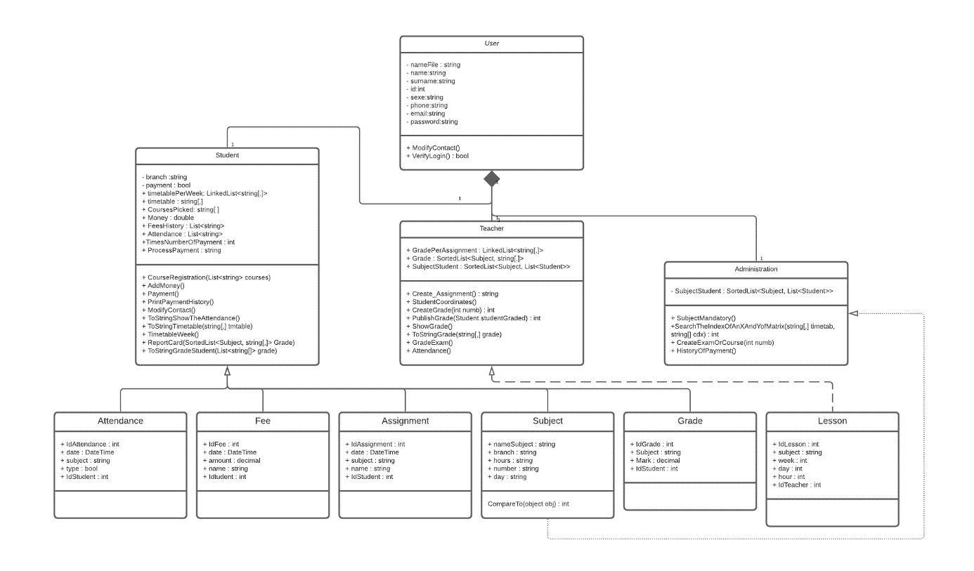

We chose to use an SQL server to house the database. Indeed, SQL is more convenient for us because we can test the methods by easily adding different students, teachers, or administrators. The SQL server is quite intuitive and easy to understand.

3. Tests and validation

First, user have to login.
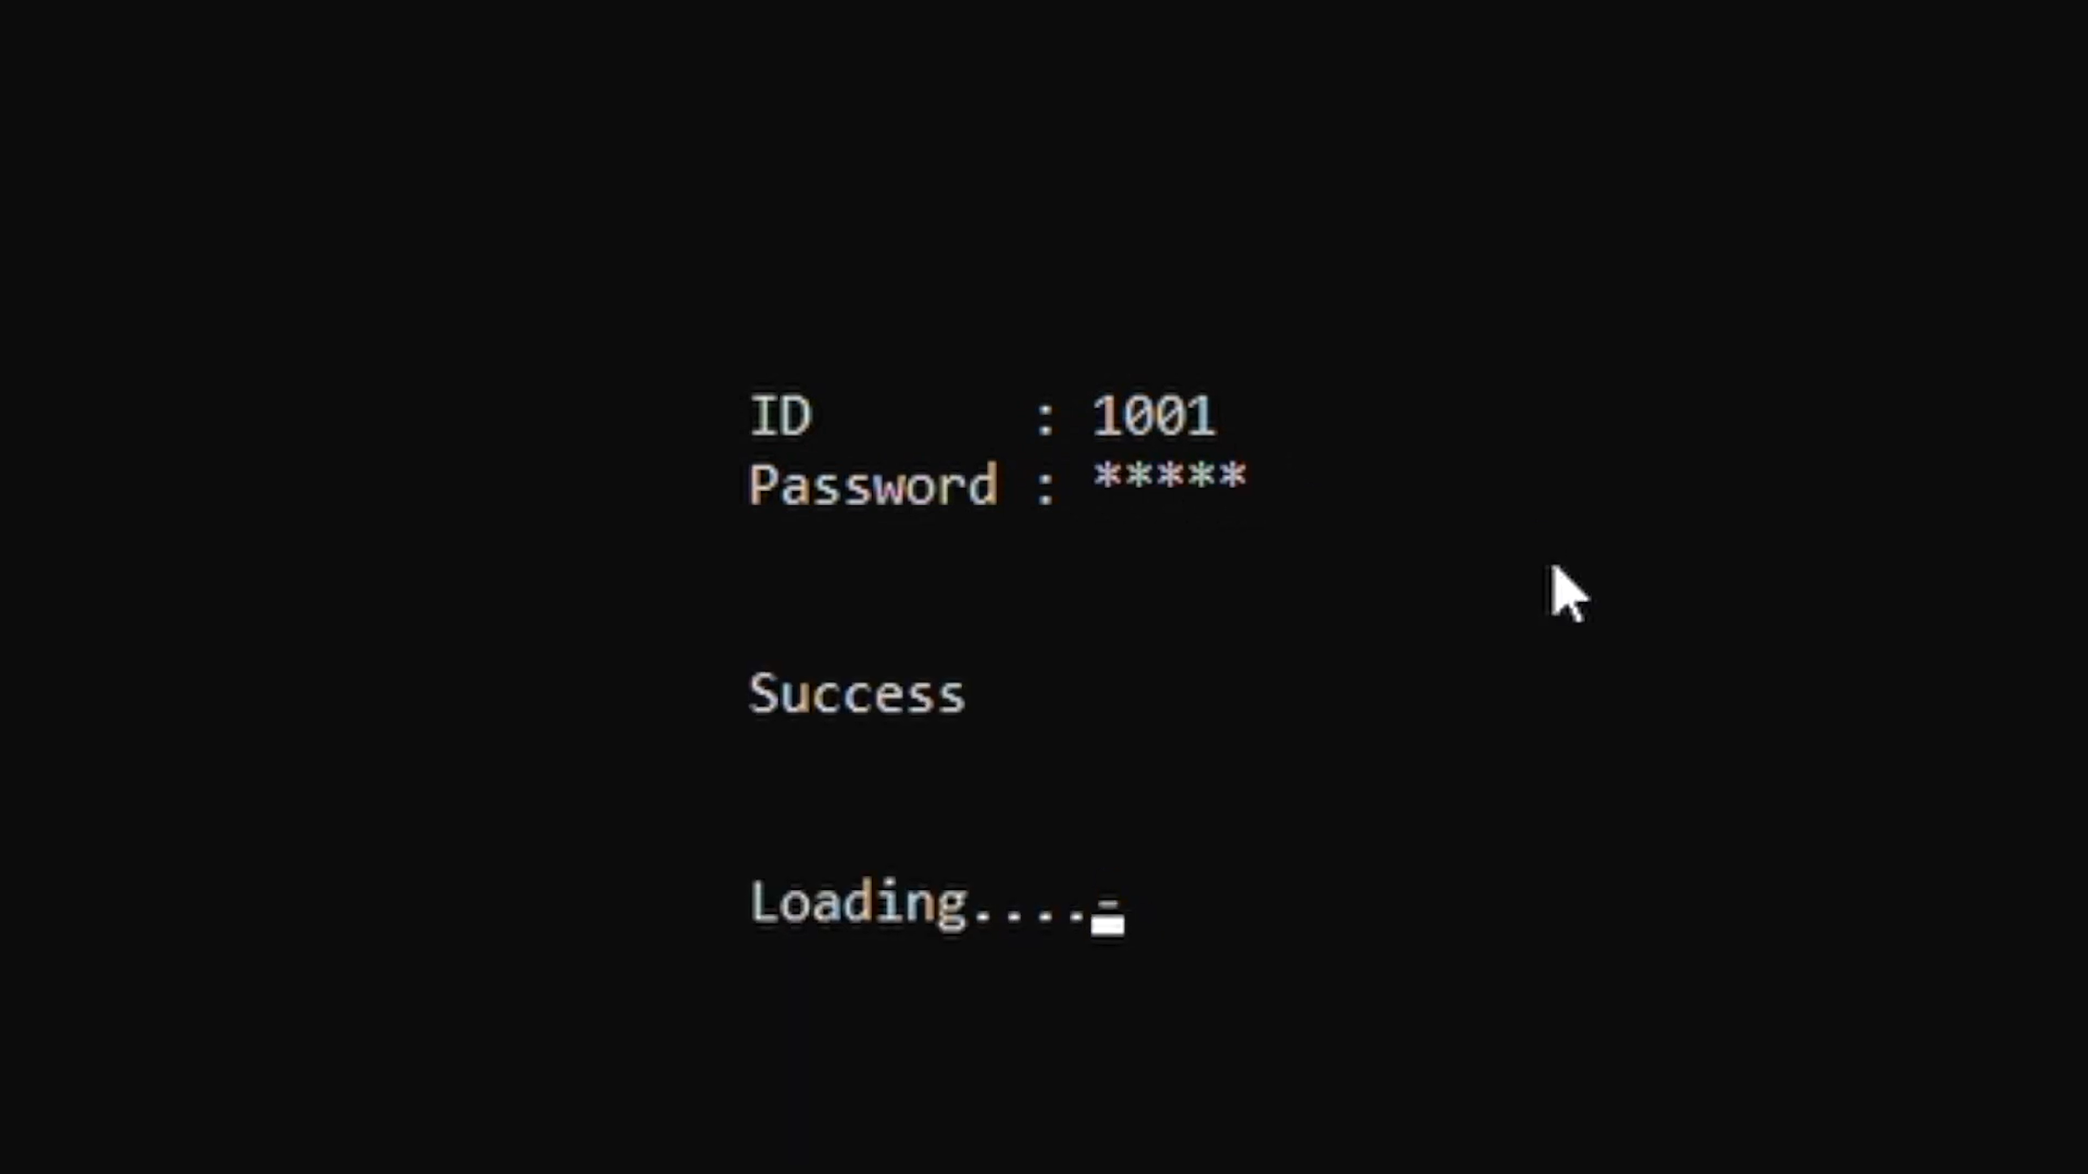

If the user is a student, he can see his information and do some action.
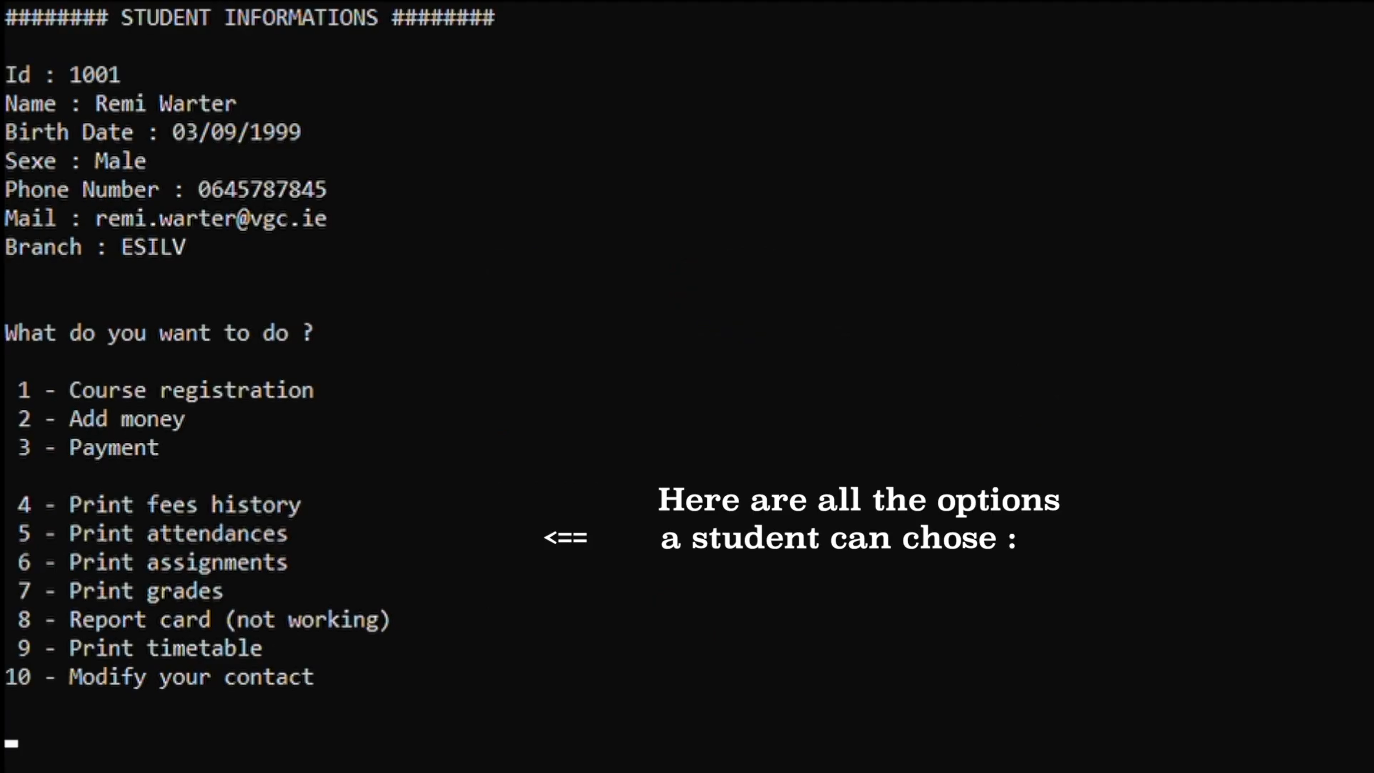

For example, he can pay his fees. There are two process, he can pay once or thrice if he wants.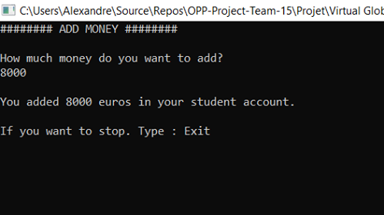
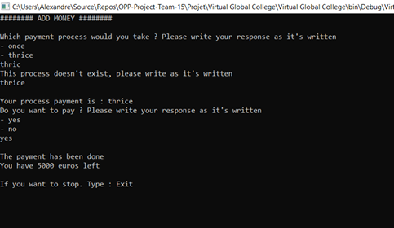

He can also see his timetable.
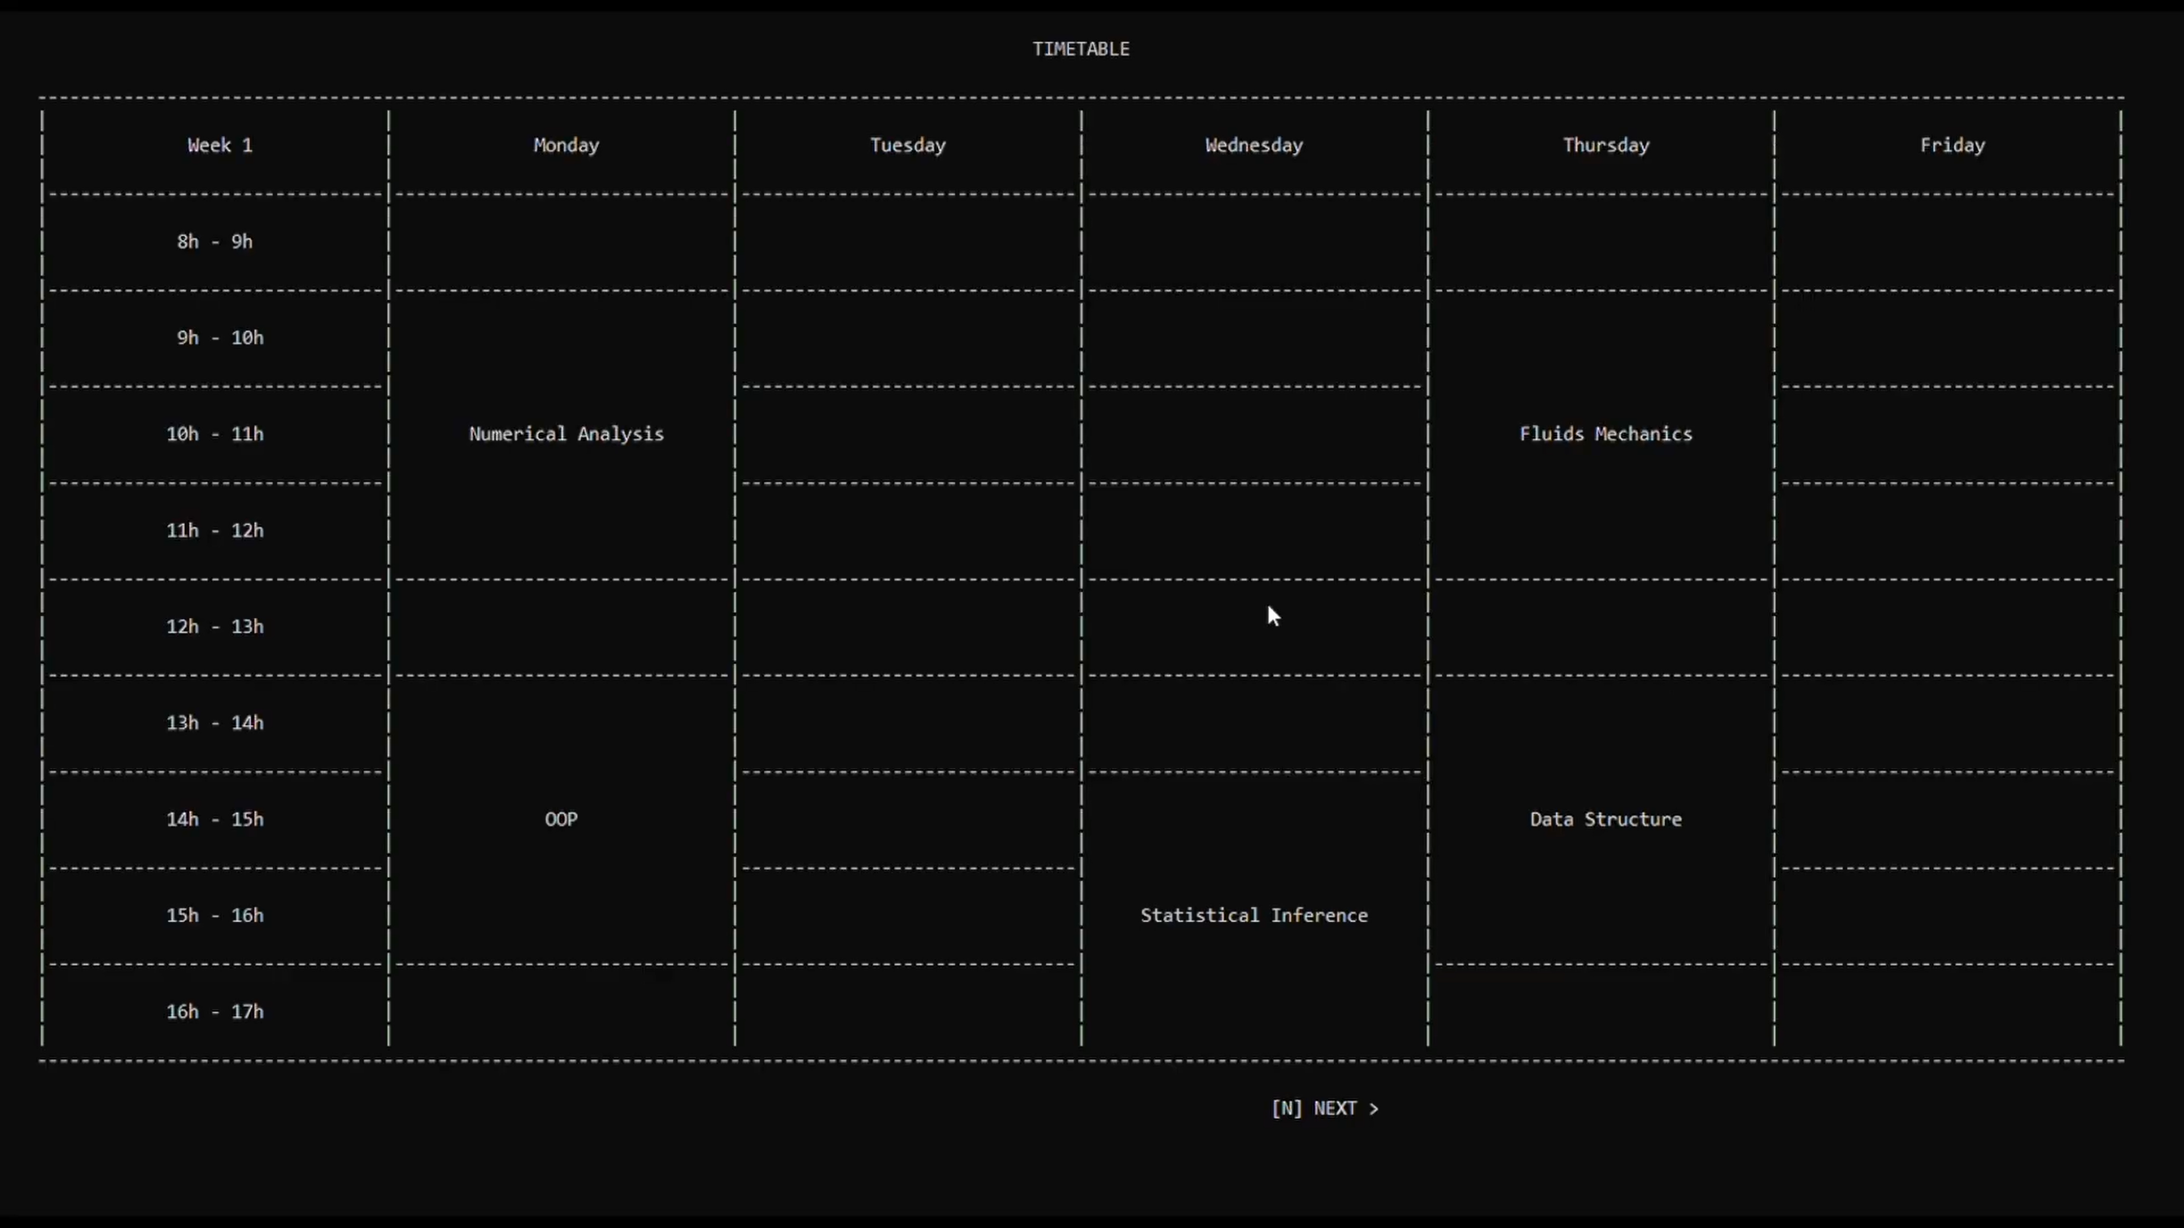

If the user is an administrator, he can see his information and do 13 actions.
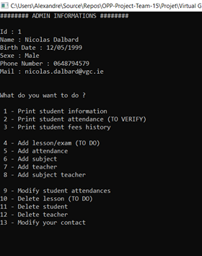
For example, he can print student fees history.
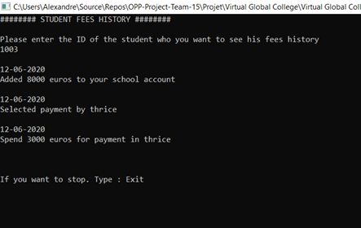
If the user is a teacher, he can do 7 actions.
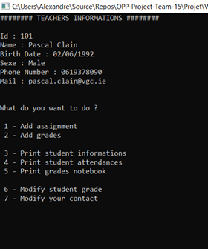
For example, he can add assignment in student’s timetable.
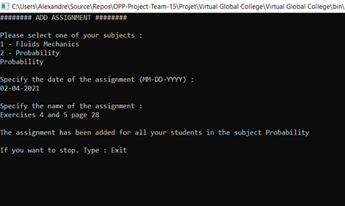

4. Technical difficulties and solutions
The SQL manager server that hosted our data was only accessible by one person in the group, the server host. So, we took an internet SQL server so that everyone could access the database. The fact remains that sometimes the C# program is not able to connect to the server. This is not a compilation start, it is just a connection problem. The connection problem remains rare and you just must restart the programme for it to work.

II- Project management report

Introduction

Project management is an essential part of a successful project. Everyone's technical skills must be considered, but proper project management is also essential to ensure that the project is carried out as efficiently as possible.

- Organisation of the team

The team is made up of 5 roommates, so it was easy for us to get organised. We used Messenger, Zoom and WhatsApp to communicate about our different tasks. To share our different documents, we created a Teams group. To create the UMLs, we used the Lucid chart tool.
To carry out our project, we had to determine the different tasks, divide them up and distribute them fairly between us. To do this, we created a UML Diagram bringing together the different actors and the actions they could do. During the first two weeks, we got to know the subject, established the functions needed to fulfil the needs, researched the technologies we could use and determined the tasks to be carried out. Our project is composed of 2 essential parts: the construction of the code in C# and the use of a database via the SQL tool.
We started by building the code after having done the UMLs. Then we implemented the SQL language in our different methods.

- Trello

We used the tool we were advised to use to help us get organised. Indeed, we had to use Trello and the team leader, Aurélien, updated it regularly.
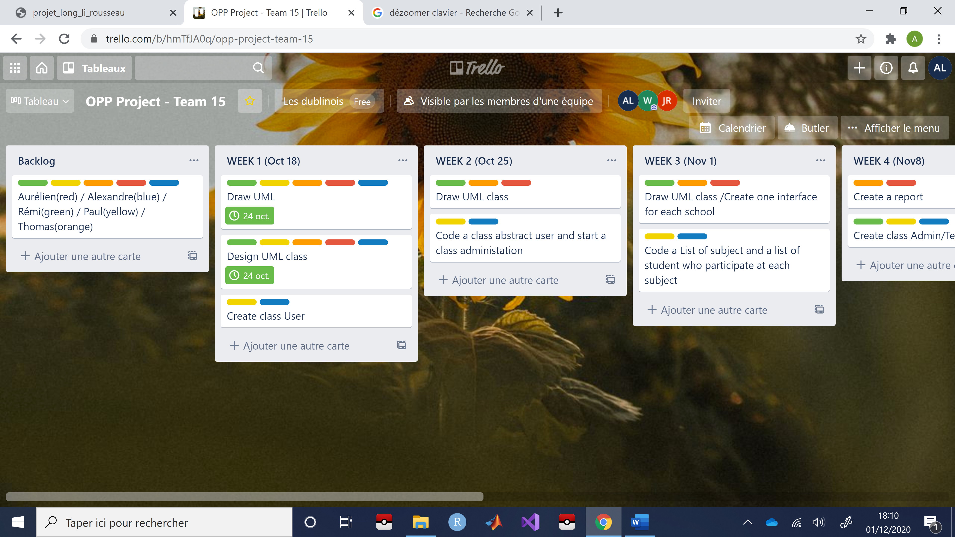
Each coloured label represents a person in the project.
Here are pictures of our Trello so that you can understand the progress of the project.
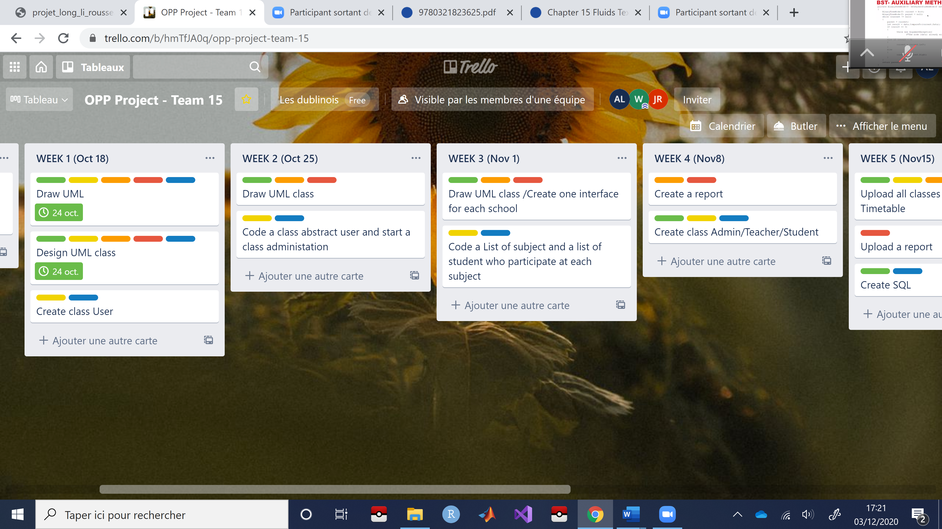
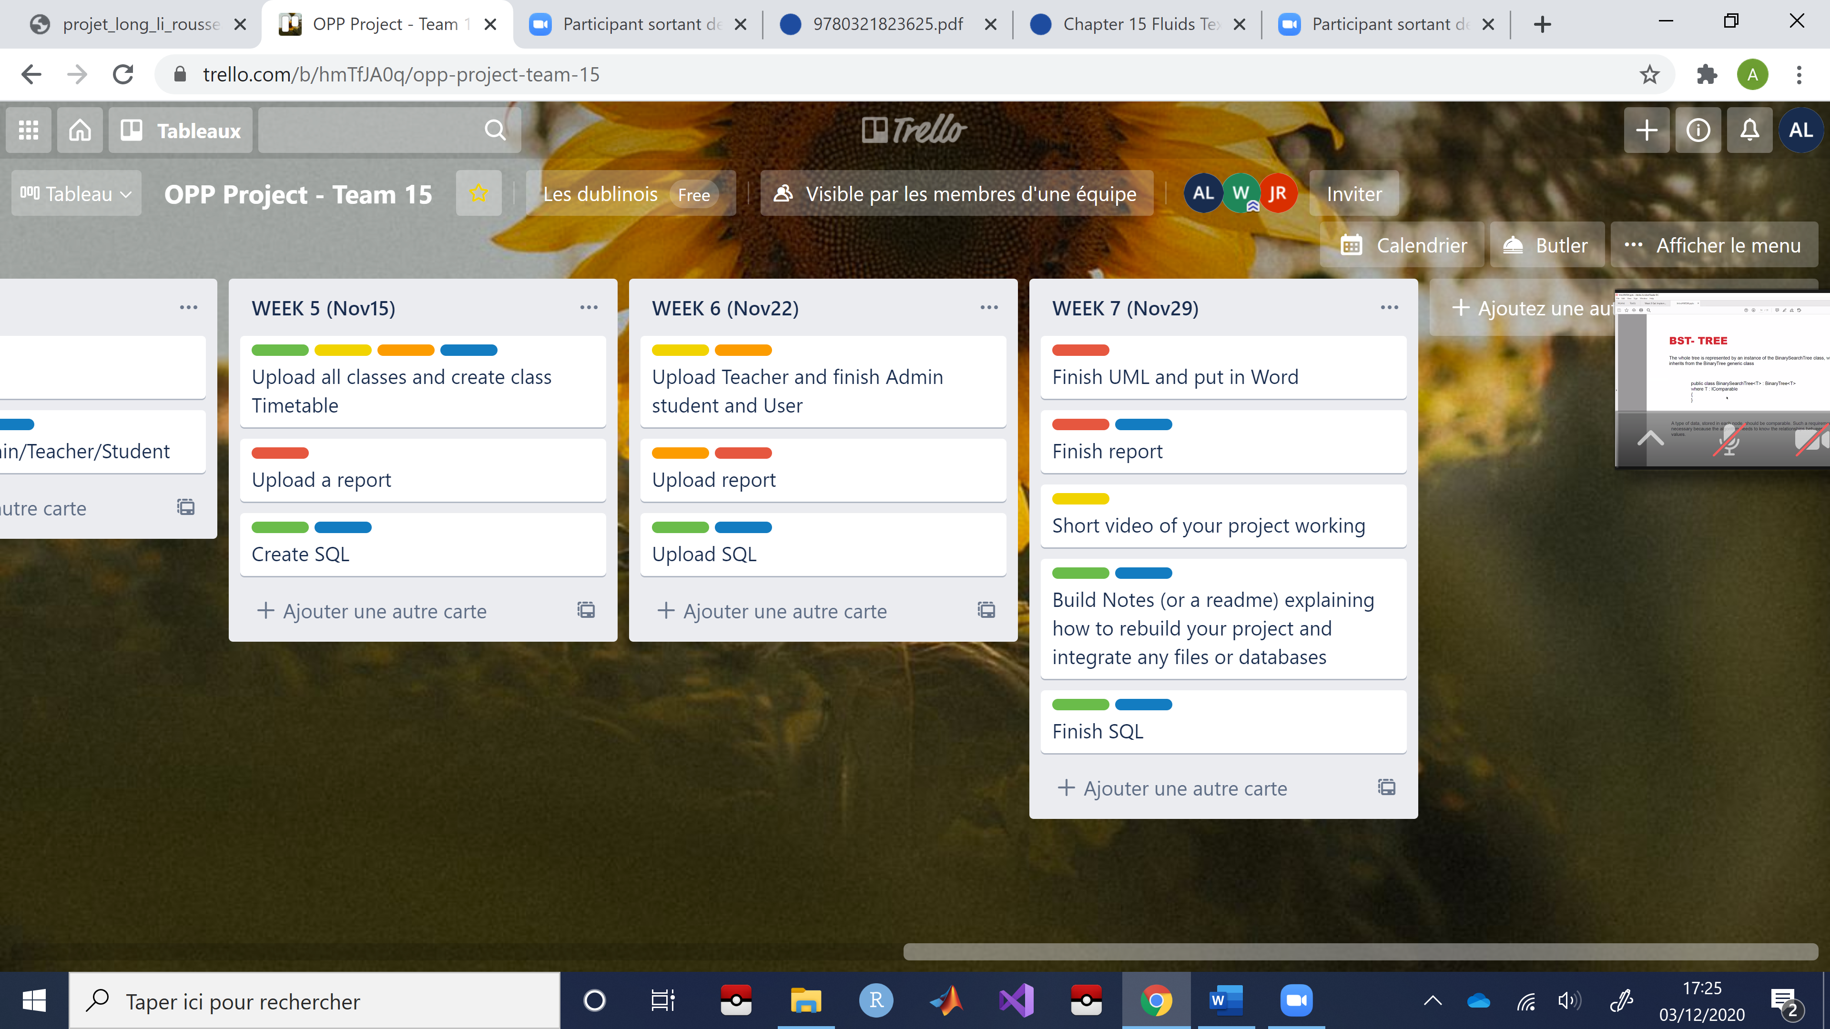
Thanks to Trello, the team leader had a good idea of everyone's investment and pushed the less active members of the group to work harder. Of course, some of us loved the project and those of us invested a lot.

- Difficulties encountered in the management of the project and solutions provided

Despite this organisation, there have been some minor problems in determining the duration of certain tasks. Indeed, as we had never worked with SQL before, we found it difficult to evaluate the time needed for each task. Indeed, SQL had to be pooled, which caused some problems because only a few people could test the project. Nevertheless, by working together, we were able to solve the problem by using a server that was accessible to everyone.
We did not have any problems getting along because we had known each other for a long time and knew how everyone worked.

III. Contributions of the project
This 8-week long project is a good experience, it brought us a lot, both technically and in terms of project management.
1. Technical contributions
This project allowed us to practice coding in C#. We also acquired notions in SQL. In addition, we tried to create a site in html. The knowledge gained from this project will serve us in the future.
2. Input on project management
We have confirmed that communication is paramount when working together. A dialogue via email or instant messaging will never replace a face-to-face interview. Luckily for us, we were roommates and it made communication much easier. We can also emphasize that we must always succeed in motivating the other person with the ideas we bring and think before we go down a path.
3. Personal contribution
Each member of the team had personal contributions during the project.
Aurélien: I have improved my skills in leadership and learn about SQL language.
Alexandre: I liked the project which took us a lot of time, but which made us discover new tools that will be useful to me later
Rémi: I did a lot of SQL and I hope to be able to reuse it in my future projects
Paul: Despite the difficulties encountered, I think that git hub will be useful to me for future remote group projects
Thomas: I have learnt SQL language thanks to this project.

