Servo Motor Health Parameters Dashboard

Project Report

1. Executive Summary
The Servo Motor Health Parameters Dashboard is a full-stack web application for monitoring and visualizing servo motor health metrics in real time. It provides motor setup management, live parameter trends (vibration, temperature, current consumption, belt tension), and historical data logs with status highlighting.
Real-time data is displayed using MQTT (Message Queuing Telemetry Transport), enabling live updates from sensors and equipment to the dashboard. The system uses a React frontend, Node.js/Express backend, and SQLite database, with a modern UI including a 3D background and collapsible sidebar.

2. Technology Stack

2.1 Frontend
Technology | Version / Purpose
React | 18.2.0 – UI framework
Vite | 7.x – Build tool and dev server
Chart.js | 4.5.x – Charts and graphs
react-chartjs-2 | 5.3.x – React bindings for Chart.js
chartjs-plugin-zoom | 2.2.x – Zoom and pan on charts
Three.js | 0.182.x – 3D background (Hero3D)
@react-three/fiber | 8.15.x – React renderer for Three.js
@react-three/drei | 9.122.x – Three.js helpers
react-icons | 4.12.x – Icon set
Lucide React | 0.563.x – Additional icons

2.2 Backend
Technology | Version / Purpose
Node.js | Runtime
Express | 4.21.x – HTTP API server
better-sqlite3 | 11.7.x – SQLite database driver
cors | 2.8.x – Cross-origin resource sharing

2.3 Database
Component | Description
SQLite | File-based database (motor.db)
Tables | motor_setup, live_trends (with indexes)

2.4 Development & Tooling
Tool | Purpose
concurrently | Run frontend and backend (npm run dev:full)

3. Real-Time Data: MQTT
MQTT is used for displaying real-time data on the dashboard.
Sensor and motor data are published to an MQTT broker; the backend or a dedicated service subscribes to these topics and persists or forwards the data. The dashboard shows live parameter values (vibration, temperature, current consumption, belt tension) and updates the Live Trends graphs as new MQTT messages arrive. This design ensures low-latency, scalable real-time monitoring suitable for industrial environments.

4. Features of the Dashboard

4.1 Navigation & Layout
• Collapsible sidebar – Transparent sidebar that collapses to icons only.
• 3D background (Hero3D) – Three.js-based background.
• Live status indicator – Top-right connection/live state.

4.2 Motor Setup
• Motor model dropdown – HK, HG, HF, HF-KP, LM-F, TM-RB series.
• Motor name and rating – Name and High Level / Low Level.
• Model-based images – Each model has an associated image from assets.
• CRUD operations – Create, read, update, delete motor configurations; data in SQLite motor_setup.

4.3 Live Data Trends
• Parameter types – Vibration, Temperature, Current Consumption, Belt Tension.
• Time scaling – 15 min, 30 min, 1 hr, 4 hr, 8 hr.
• Time window filter – Start/end date-time and "Today".
• Search and Clear – Apply filters and clear.
• Zoom and pan – Chart.js zoom plugin on time-series.
• Graph-only view – No data table; focus on visualization.

4.4 Data Logs
• Tabular view – Table with solid borders, center-aligned values.
• Parameter filter and date/time pickers.
• Status column – Critical / Warning / Normal; only near-high and above-high values highlighted (e.g. dark red/orange).

4.5 Other Pages
• Home – Overview and quick stats. Motor Health – Detailed metrics. Alarms – Real-time alarms. Maintenance – Schedule and tasks. Settings – Configuration.

5. System Architecture Diagram
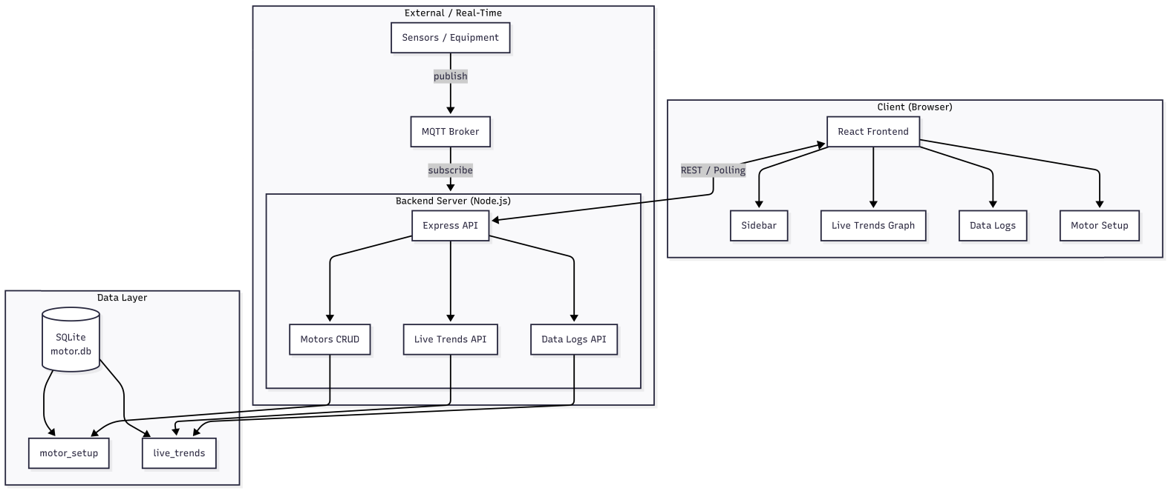
• Client (Browser): React Frontend → Sidebar, Live Trends Graph, Data Logs, Motor Setup.
• Backend (Node.js): Express API → Motors CRUD, Live Trends API, Data Logs API.
• Data Layer: SQLite (motor.db) → motor_setup, live_trends.
• External: Sensors publish to MQTT Broker; Backend subscribes. Frontend communicates with API via REST/polling.

Data Flow (Real-Time Path)
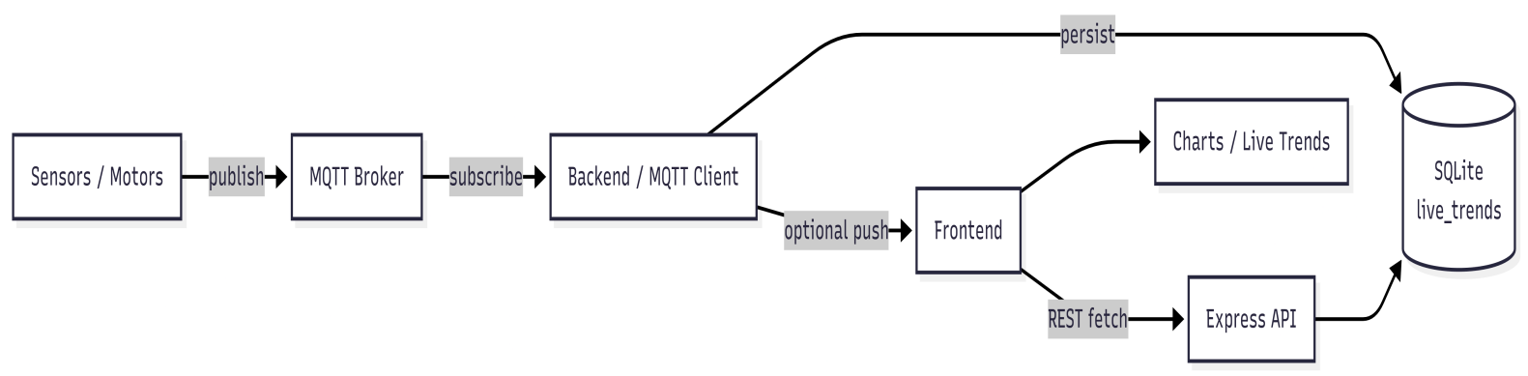
Sensors/Motors → publish → MQTT Broker → subscribe → Backend/MQTT Client → persist → SQLite (live_trends). Frontend fetches via REST from Express API and displays Charts / Live Trends.

User Flow: Live Trends
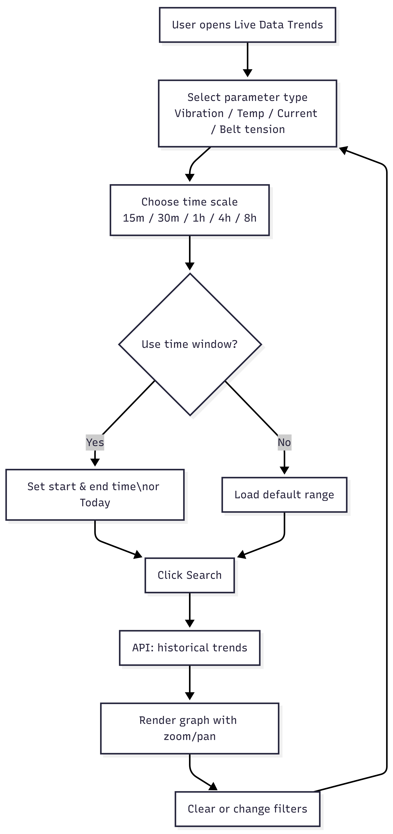
User opens Live Data Trends → Select parameter type → Choose time scale (15m–8h) → Optionally set time window (start/end or Today) → Click Search → API returns historical trends → Graph renders with zoom/pan → User can Clear or change filters.

Database Schema
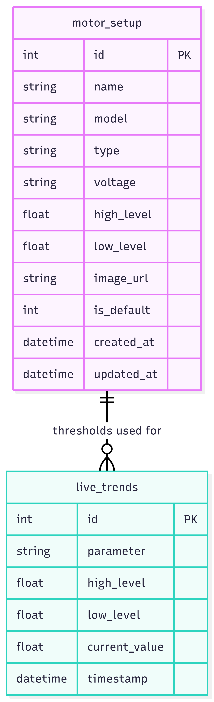

8.1 motor_setup
id (PK), name, model, type, voltage, high_level, low_level, image_url, is_default, created_at, updated_at.

8.2 live_trends
id (PK), parameter, high_level, low_level, current_value, timestamp. Index on (parameter, timestamp).

9. API Overview
Method | Endpoint | Description
GET | /api/motors | List all motors
GET | /api/motors/:id | Get one motor
POST | /api/motors | Create motor
PUT | /api/motors/:id | Update motor
DELETE | /api/motors/:id | Delete motor (non-default only)
POST | /api/live-trends | Save one live trend sample
GET | /api/live-trends | Get live trends (parameter, limit)
GET | /api/live-trends/latest | Latest value per parameter
GET | /api/live-trends/historical | Historical by minutesAgo, parameter, afterTimestamp
DELETE | /api/live-trends | Delete trends for a parameter

10. Conclusion
The Servo Motor Health Parameters Dashboard delivers motor setup management, real-time data display via MQTT, live trend visualization with time scaling and zoom/pan, and data logs with status highlighting. The tech stack (React, Vite, Chart.js, Three.js, Node.js, Express, SQLite) supports a modern, responsive UI and scalable backend.
End of Report

