Ohm Sweet Home
Joshua Le
Lawson Parr
Kim Peteros
Caiden Rueben
Vivek Samuel

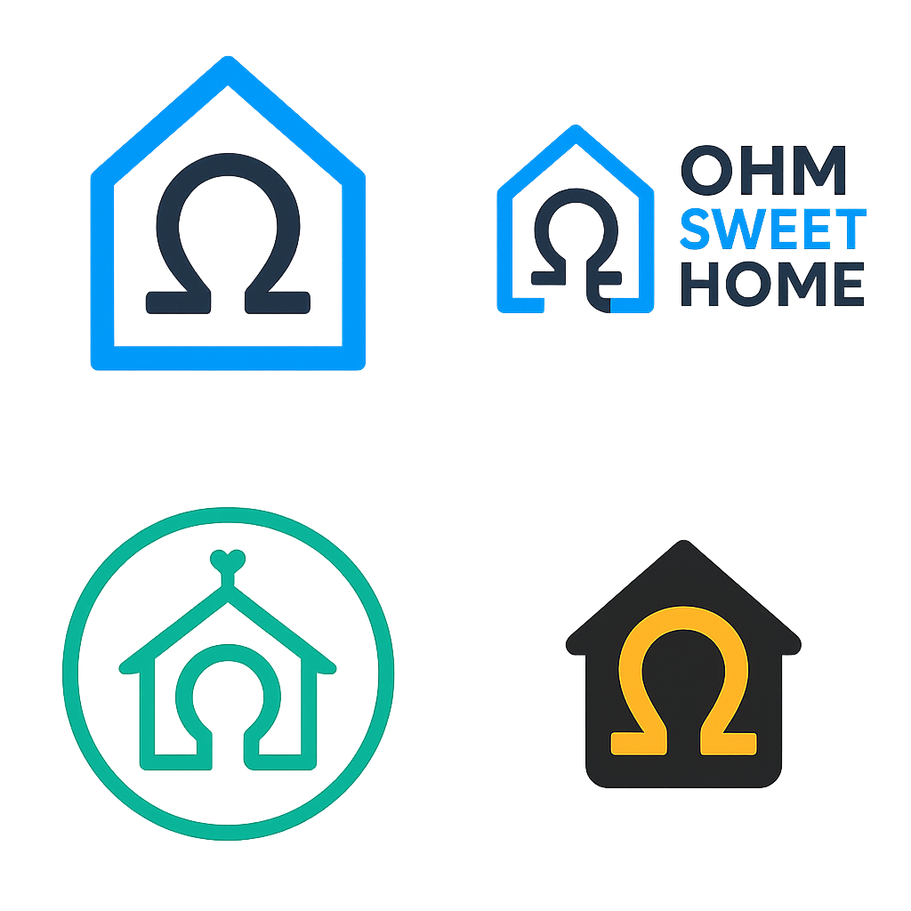
Concept of Operations

REVISION – A
September 9, 2025
Concept of Operations
for
Ohm Sweet Home

Team Ohm Sweet Home
Approved by:
_____________________________
Kim Peteros Date
_____________________________
Prof. Kalafatis Date
_____________________________
Vishwam Raval Date

Change Record
Rev. | Date | Originator | Approvals | Description
1 | 9/9/2025 | Kim Peteros |  | Draft Release

Table of Contents
Table of Contents 3
List of Figures 4
1. Executive Summary 5
1. Introduction 5
1.1. Background 6
1.2. Overview 7
1.3. Referenced Documents and Standards 8
2. Operating Concept 9
2.1. Scope 9
2.2. Operational Description and Constraints 11
2.3. System Description 12
2.4. Modes of Operations 13
2.5. Users 15
2.6. Support 17
3. Scenario(s) 18
4. Analysis 20
4.1. Summary of Proposed Improvements 20
4.2. Disadvantages and Limitations 21
4.3. Alternatives 21
4.4. Impact 21

List of Figures
Figure 1: Home Power Monitor Systems Block Diagram 7
Figure 2: Home Power Monitor Installation 15

Executive Summary
The Home Power Monitor is a cost-effective system that provides homeowners with actionable, device-level insights into their electricity usage. As energy costs rise, our solution helps users understand exactly which devices are driving demand. The system integrates five subsystems: an Analog Front End (AFE) to capture electrical signals, a PCB to house the hardware, Digital Signal Processing (DSP) to extract key features, Machine Learning (ML) to identify individual appliances, and a Mobile App for real-time monitoring. By combining precise sensing with advanced analytics, our monitor empowers users to reduce energy waste and lower their utility bills.

Introduction
Household electricity consumption drives both utility costs and environmental impact. While most homes have smart meters or utility monitoring, these typically provide only aggregate usage data, offering little insight into which appliances consume the most energy. As a result, opportunities for savings, efficiency, and sustainability often go unrealized.
The Home Power Monitor project addresses this gap by designing a system that measures, analyzes, and classifies energy use at a more granular level. Using affordable sensors, embedded signal processing, machine learning, and a user-friendly app, the system monitors total household consumption and attributes usage to specific devices in near real time.
This interdisciplinary project integrates multiple subsystems: the Analog Front End (AFE) conditions sensor signals, PCB Management combines power and communication hardware, the DSP subsystem extracts features like rms voltage/current, power, and harmonics, and the Machine Learning subsystem identifies devices. Finally, the Application Development subsystem delivers actionable insights through a mobile interface.
Motivated by rising energy costs and sustainability concerns, the Home Power Monitor demonstrates the feasibility of detailed energy monitoring with low-cost components, offering immediate user value and a scalable path toward smart-grid integration.

Background
Current residential energy monitoring is typically limited to whole-home smart meters provided by utility companies. While these devices record total consumption and may allow for daily or hourly breakdowns, they do not provide appliance-level visibility. As a result, users are often left guessing which devices contribute most to their utility bill, reducing the effectiveness of conservation efforts.
Some aftermarket energy monitors exist on the consumer market; however, they are often expensive, closed-source, or rely on proprietary ecosystems that limit flexibility. In addition, many of these products require invasive installation or lack robust analytics, making them inaccessible to the average household.
The Home Power Monitor project is designed to enhance these limitations by delivering a system that is:
- More informative – Using digital signal processing and machine learning, the system provides detailed insights at the device level rather than only whole-home usage.
- More accessible – The design emphasizes low-cost components, a modular PCB, and straightforward installation at the electrical panel.
- More adaptable – By generating standardized JSON data streams and a custom mobile application, the system can evolve beyond monitoring to integrate with future smart home or grid-interactive technologies.
In essence, the proposed project enhances existing monitoring by adding device detection, advanced analytics, and a user-centric interface while replacing the need for costly commercial solutions. It bridges the gap between simple utility data and full smart-home energy management, giving households a practical tool to reduce waste and make informed energy decisions.

Overview
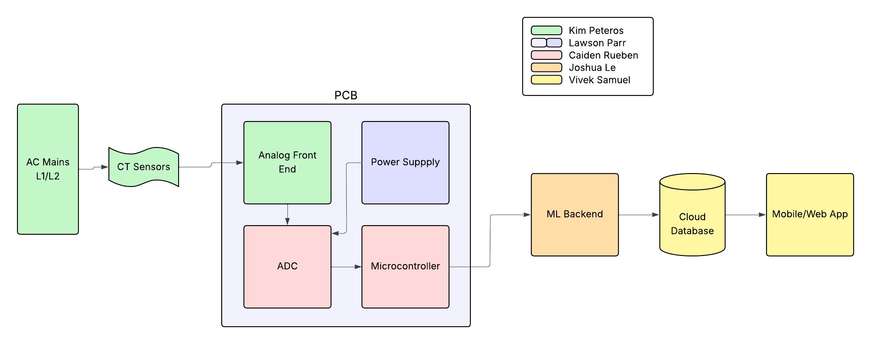
Figure 1: Home Power Monitor System Block Diagram
The Home Power Monitor is a multidisciplinary system that combines sensing hardware, embedded processing, intelligent analytics, and user-facing software to provide household residents with actionable insight into their energy consumption. The system is organized into five subsystems, Analog Front End (AFE), PCB Management, Digital Signal Processing (DSP), Machine Learning (ML), and Application Development, which work together to deliver accurate data collection, advanced analysis, and a user-friendly interface.
At the foundation of the system, the Analog Front End (AFE) acquires raw current and voltage signals directly from the household electrical panel. Current transformers (CTs) measure line currents, while voltage dividers or isolation sensors capture the corresponding voltage waveforms. These signals are conditioned through filtering, scaling, and isolation circuitry to ensure safety and fidelity before digitization.
The PCB Management subsystem provides the physical integration platform for the project. It consolidates the AFE, microcontroller, power supply, and wireless communication hardware onto a single, custom-designed printed circuit board. By managing the hardware interconnections, this subsystem ensures reliability, compactness, and scalability. It also simplifies the installation process for end users by housing multiple sensing and processing elements in a single unit.
Once the analog signals are digitized, the DSP subsystem takes responsibility for extracting meaningful features. Algorithms implemented on the microcontroller compute metrics such as RMS voltage and current, instantaneous power, real and reactive power, power factor, and harmonic distortion. The DSP subsystem also performs windowing and spectral analysis to capture the load signatures needed for device-level identification. These outputs are structured into JSON-formatted data packets, ensuring consistency for downstream processing and external applications.
The Machine Learning (ML) subsystem processes the feature sets generated by DSP to identify and classify individual appliances. By leveraging training datasets of common load signatures, the ML algorithms can distinguish devices such as refrigerators, HVAC units, or lighting systems, even when they operate simultaneously. Over time, the ML models can be refined and retrained to improve accuracy, adapt to new devices, and accommodate variations in household electrical environments.
The final subsystem, Application Development, focuses on delivering insights to the end user through a mobile or web-based application. This interface displays total household consumption, disaggregated device-level usage, power quality metrics, and historical trends. Users can interact with the data visually through graphs, charts, and notifications, allowing them to identify inefficiencies, track costs, and make informed decisions about their energy usage. The app also serves as the bridge between technical system outputs and practical consumer utility.
Together, these subsystems form a modular yet tightly integrated architecture. The hardware and PCB components enable safe and reliable data collection, the DSP and ML subsystems transform raw measurements into actionable intelligence, and the app development subsystem ensures accessibility and ease of use. This layered approach allows the Home Power Monitor to be more informative, affordable, and adaptable than existing consumer energy monitoring solutions, while maintaining a clear structure that supports future enhancements such as smart-home integration or utility-side data sharing.

Referenced Documents and Standards
The Home Power Monitor project aligns with relevant electrical, communication, and data standards to ensure safe operation, reliable performance, and interoperability. The following documents and standards have been considered:
- IEEE Standards
  - IEEE Std 1459-2010: Definitions for the Measurement of Electric Power Quantities Under Sinusoidal, Non-Sinusoidal, Balanced, or Unbalanced Conditions.
  - IEEE Std 519-2014: Recommended Practice and Requirements for Harmonic Control in Electric Power Systems.
- Electrical Safety Standards
  - NFPA 70 (National Electrical Code): Guidance for safe installation of electrical equipment in residential environments.
  - IEC 61010: Safety requirements for electrical equipment for measurement, control, and laboratory use.
- Communication and Data Standards
  - IEEE 802.11: Wireless LAN (Wi-Fi) communication standard used for transmitting system data.
  - JSON (JavaScript Object Notation): Standardized data format for structured telemetry between subsystems and the mobile application.
- Referenced Project Documents
  - Capstone Team Specification Document (rev. 1.0).
  - Subsystem Requirements and Interface Control Documents (ICDs).
  - Manufacturer datasheets for current transformers, voltage sensors, and microcontroller components.
By adhering to these standards and referencing established documents, the project ensures consistency, safety, and a solid foundation for both prototype development and potential future scalability.

Operating Concept

Scope
The scope of the Home Power Monitor project is to design, build, and demonstrate a prototype system capable of acquiring, processing, classifying, and presenting household electrical usage data at both the total and device levels. The system will be deployed on a residential electrical panel in a controlled demonstration environment and is intended as a proof-of-concept for affordable, scalable home energy monitoring.
In-Scope Features:
- Analog Front End (AFE): Measurement of current and voltage waveforms through non-intrusive sensors (e.g., current transformers and voltage dividers) with proper signal conditioning.
- PCB Management: Integration of sensing, processing, power regulation, and wireless communication hardware on a single printed circuit board.
- Digital Signal Processing (DSP): Computation of RMS values, real and reactive power, power factor, harmonic distortion, and other features needed for classification.
- Machine Learning (ML): Identification of appliances through pattern recognition of electrical signatures, with support for adding new devices through a training mode.
- Application Development: A mobile application to display real-time and historical consumption data, device breakdowns, and basic alerts.
Out-of-Scope Features:
- Utility-side integration (e.g., sending data to electric companies or participating in demand-response programs).
- Full-scale commercial productization, including UL certification, enclosure design, or large-scale manufacturing.
- High-voltage electrical work beyond safe CT-based measurement; direct mains wiring is excluded for safety.
- Advanced smart-home automation features (e.g., remotely controlling appliances).
System Boundaries:
The system begins with the measurement of household electrical signals at the panel and ends with visualization of processed results on the user’s mobile application. External systems such as the utility provider’s smart meter or third-party smart-home devices are not part of the current scope but represent potential future extensions.
By defining this scope, the project ensures feasibility within the academic timeline while demonstrating the key functionality of a modern, intelligent home energy monitoring solution.

Operational Description and Constraints
The Home Power Monitor is intended for residential use as a non-intrusive energy monitoring tool. A homeowner, technician, or qualified installer clamps the current transformers (CTs) around the service conductors in the household electrical panel and connects the voltage sensing hardware. Once powered, the system begins acquiring current and voltage waveforms.
The embedded microcontroller processes these signals in real time, calculating standard electrical metrics such as RMS values, real and reactive power, and power factor. These metrics, along with higher-order features such as harmonic distortion, are formatted into JSON packets and transmitted wirelessly.
The machine learning subsystem interprets the extracted features to classify which appliances are operating. This classification, together with aggregate consumption data, is then displayed to the user through the mobile application. The user can interact with the app to view live household consumption, drill down into per-device usage, and review historical energy patterns. In training mode, users can also label new devices, allowing the system to expand its knowledge base.
Constraints:
- Safety: Direct interaction with mains voltage is strictly avoided. CTs and voltage dividers are used to ensure safe, isolated measurements. Installation must comply with standard electrical safety codes (e.g., NEC, IEC).
- Accuracy: Classification accuracy depends on the quality of training data and the distinctiveness of device signatures. Ambiguities may arise when devices with similar load characteristics operate simultaneously.
- Scalability: The prototype is designed for single-home use. Extension to multi-unit dwellings or integration with utility systems is outside the current project scope.
- Resources: Operation is limited by the computational power, memory, and communication bandwidth of the selected microcontroller and wireless modules.
- Environment: The system assumes a stable residential power grid (60 Hz, ~120/240 V). It has not been tested for industrial or three-phase systems. This operational description and the defined constraints ensure that the Home Power Monitor can be used effectively by residential consumers while remaining safe, reliable, and within the scope of an academic prototype.

System Description
The Home Power Monitor system is a modular, multi-subsystem design intended to capture, process, classify, and present residential energy usage data in real time. The system is composed of five primary subsystems—Analog Front End (AFE), PCB Management, Digital Signal Processing (DSP), Machine Learning (ML), and Application Development—that work together to provide an end-to-end energy monitoring solution.
- Analog Front End (AFE):
The AFE acquires raw electrical signals through current transformers and voltage sensors placed at the residential electrical panel. These signals are filtered, isolated, and scaled to safe voltage levels suitable for digitization. The AFE ensures that the quality and safety of measurements are maintained before they are sent downstream.
- PCB Management:
A custom printed circuit board (PCB) integrates the hardware required for sensing, computation, and wireless communication. It houses the microcontroller, analog-to-digital converters (ADCs), power supply regulation, and Wi-Fi/Bluetooth modules. The PCB acts as the central hub, providing reliable connectivity between subsystems while minimizing system footprint.
- Digital Signal Processing (DSP):
Running on the embedded microcontroller, the DSP subsystem processes digitized signals to extract meaningful features. This includes RMS voltage and current, real and reactive power, apparent power, power factor, harmonic distortion, and phase information. The DSP organizes these outputs into structured JSON data packets, enabling interoperability with both the ML subsystem and the application.
- Machine Learning (ML):
The ML subsystem leverages DSP-generated features to classify individual appliances and devices. Using trained load-signature models, it identifies devices operating in the home, flags unknown devices, and supports a training mode for user-labeled additions.
- Application Development:
A mobile application provides the user interface, enabling real-time monitoring, device-level breakdowns, and historical consumption review. Users can also participate in training new devices and receive notifications about unusual loads or inefficiencies.
- System-Level Operation:
Signals flow from the electrical panel into the AFE, then through the PCB to the DSP subsystem for feature extraction. Extracted features are interpreted by the ML subsystem to determine device-level activity. Both system-level metrics and device classifications are transmitted wirelessly to the mobile app, where the user interacts with the data. This layered, modular architecture ensures the Home Power Monitor is safe, scalable, and user-centric, while providing a foundation for future enhancements such as smart-grid integration or demand-response applications.

Modes of Operations
The Home Power Monitor system is designed to support multiple modes of operation, each addressing a specific phase of use or user need. The following modes have been identified:
- Initialization Mode
  - Occurs when the system is first powered on or reset.
  - The PCB subsystem configures the microcontroller, initializes wireless communication, and verifies sensor connections.
  - A baseline calibration may be performed to ensure measurement accuracy.
- Normal Monitoring Mode
  - Default operating mode once initialization is complete.
  - The AFE continuously acquires current and voltage signals.
  - The DSP subsystem extracts electrical features and transmits structured data packets to the mobile application.
  - The ML subsystem classifies known appliances in real time.
  - The mobile app presents aggregate and per-device usage to the user.
- Learning / Training Mode
  - Activated when a new or unrecognized device is detected.
  - The ML subsystem temporarily records load signatures over several on/off cycles.
  - The user labels the device through the mobile app.
  - The new signature is added to the device classification library for future recognition.
- Historical Analysis Mode
  - Provides review of past consumption data through the mobile app.
  - Users can examine daily, weekly, or monthly trends, compare device usage over time, and identify long-term inefficiencies.
  - Data is retrieved from local storage or app-side databases.
- Error / Safe Mode
  - Entered if the system encounters abnormal operating conditions (e.g., sensor fault, communication loss, or power anomaly).
  - In this mode, data collection is paused, the system maintains a safe idle state, and the user is notified through the app.
  - These operational modes ensure that the Home Power Monitor is not only capable of providing real-time insights, but also adaptable to new devices, useful for long-term tracking, and resilient to system errors.

Users
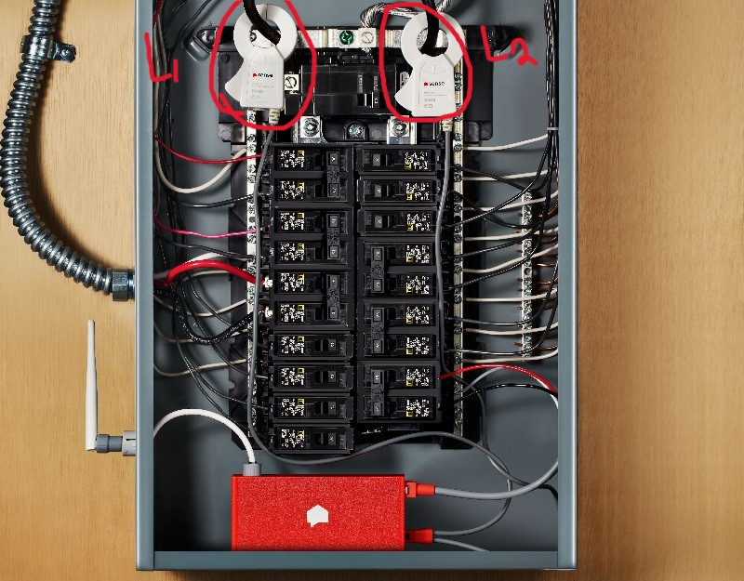
Figure 2: Home Power Monitor Installation
The Home Power Monitor is designed primarily for residential consumers but involves different types of users across its lifecycle.
- Homeowners / Residents (Primary End Users):
  - Role: Interact with the mobile application to monitor real-time energy use, view appliance-level breakdowns, and review historical data.
  - Characteristics:
    - Minimal technical training required; app interface is designed to be intuitive.
    - Expected to use the system casually (checking daily usage, monitoring large appliances, etc.).
    - Benefit from reduced energy costs, increased awareness of consumption, and improved ability to adopt sustainable practices.
- Installers / Technically Skilled Users:
  - Role: Perform the initial installation of current transformers (CTs) and voltage sensors at the household electrical panel.
  - Characteristics:
    - Moderate electrical knowledge required to ensure safe and code-compliant installation.
    - Could include electricians, technically inclined homeowners, or team members during demonstration.
    - Ensure sensors are properly clamped and PCB hardware is powered safely.
  - Training Needs: A brief installation guide or safety sheet is sufficient for qualified personnel.
- Secondary Beneficiaries:
  - Academic Team / Developers: The student team benefits from the project as a learning and design exercise in integrating hardware, DSP, ML, and app development.
  - Future Utility Providers or Researchers: Although not part of this prototype’s immediate scope, energy companies or research groups could benefit from the framework by adapting it for broader smart-grid or demand-response applications.
Summary:
The primary users require little to no training beyond app usage, while installation requires moderate technical skill. The system ultimately benefits homeowners by providing actionable insight into energy consumption, with potential secondary benefits to researchers and future commercial adopters.

Support
Support for the Home Power Monitor system will be delivered through a combination of documentation, training materials, and technical assistance, ensuring that both installation and ongoing use are accessible to the intended user base.
- User Documentation:
  - A User Manual will be provided, detailing system setup, safe installation practices, and step-by-step instructions for connecting sensors, powering the unit, and pairing the mobile application.
  - The manual will also include troubleshooting guides for common issues such as connectivity failures, app synchronization problems, or inaccurate readings.
  - Clear safety warnings will emphasize that installation around electrical panels should be performed by qualified individuals.
- Technical Documentation:
  - A Technical Reference Guide will be available for advanced users, developers, or future teams. This will include subsystem block diagrams, firmware structure, JSON data formats, and machine learning training workflows.
  - PCB schematics, parts lists, and sensor datasheets will be archived for reproducibility and maintenance.
- Training Materials:
  - Quick-start guides and visual aids (diagrams, annotated photos) will simplify installation and system initialization.
  - Video demonstrations may be developed for classroom or user-friendly instruction.
- Technical Support:
  - During the capstone project, technical support will be provided directly by the student development team. Users experiencing issues can rely on team members for troubleshooting and updates.
  - In a commercial deployment, support would expand to include dedicated email or phone support channels, online FAQs, and periodic firmware/app updates.
Summary:
By combining clear documentation, practical training materials, and responsive technical assistance, the Home Power Monitor ensures that both homeowners and technically skilled installers have the resources necessary to use the system safely, effectively, and with confidence.

Scenario(s)
3.1 Scenario Name #1 – Real-Time Monitoring of Household Energy
In this scenario, a homeowner installs the Home Power Monitor system at their main electrical panel and uses the companion mobile app to observe energy usage.
- Setup and Initialization
  - The user powers on the Home Power Monitor device after installation.
  - The device begins acquiring current and voltage signals from the AFE subsystem.
  - The PCB subsystem digitizes the conditioned signals and provides them to the DSP subsystem.
- Data Processing
  - The DSP subsystem calculates RMS voltage, RMS current, real power, reactive power, and power factor for each measurement frame.
  - JSON-formatted packets are generated and transmitted wirelessly to the mobile application.
- Machine Learning Classification
  - The ML subsystem receives extracted features from the DSP and applies trained models to classify active devices.
  - If multiple devices are operating simultaneously, the subsystem separates their signatures and labels them individually.
- User Interaction
  - The mobile application displays real-time household consumption, breaking down usage by device.
  - The user can toggle between real-time and historical views to identify patterns (e.g., HVAC consumption spikes at certain times of day).
  - Notifications may alert the user if unusual loads are detected, such as a device running longer than normal.
Outcome:
The homeowner gains clear, actionable visibility into their household energy usage. They can see which devices are consuming the most power, recognize inefficiencies, and make informed decisions to reduce energy costs.

3.2 Scenario Name #2 – Device Training and Learning Mode
In this scenario, a homeowner introduces a new appliance into the household (e.g., a space heater) and the Home Power Monitor adapts to recognize it in future operation.
- Setup and Device Operation
  - The user powers on the new appliance while the Home Power Monitor is active.
  - The AFE subsystem senses the electrical load signature from the appliance and conditions the signals for digitization.
- Data Acquisition and Processing
  - The PCB subsystem digitizes the conditioned signals and passes them to the DSP subsystem.
  - DSP algorithms calculate RMS values, instantaneous power, harmonic distortion, and transient characteristics unique to the new device.
- Machine Learning Adaptation
  - The ML subsystem initially classifies the load as “unknown” since it does not match any trained device signature.
  - The system enters a learning mode where it records the device’s operational features over multiple on/off cycles.
  - The recorded signatures are stored in the local training dataset and associated with a user-provided label (e.g., “Space Heater”).
- User Interaction
  - Through the mobile application, the system prompts the user to confirm or name the newly detected device.
  - The app provides a guided workflow, showing when to power the device on and off to capture sufficient training data.
  - Once training is complete, the device appears in the app’s monitored device list.
Outcome:
The Home Power Monitor successfully adapts to recognize new appliances without requiring manual recalibration of the hardware or software. From this point onward, the system can automatically identify and track the space heater’s energy consumption in both real-time and historical views.

Analysis

Summary of Proposed Improvements
- The system improves user privacy by performing initial analysis on the device, minimizing the cloud data transfer required by competitors.
- By using a custom Analog Front End and modern ML models, the system is designed for higher accuracy and faster appliance identification.
- A local-first approach creates the possibility for an offline mode and direct smart home integrations, giving users true data ownership.
- The mobile app will focus on providing clear, actionable recommendations by directly linking energy consumption to its monetary cost.

Disadvantages and Limitations
- The system requires professional installation by an electrician, which adds a significant cost and logistical barrier for users.
- The ML model will have inherent limitations in identifying unseen, variable-state, or concurrently running appliances.
- A custom hardware design with more powerful onboard processing may lead to a higher retail price than simpler alternatives.
- While some processing is local, the full user experience still depends on a reliable Wi-Fi connection and the availability of the cloud backend.

Alternatives
- Individual smart plugs offer perfect accuracy for monitored devices but cannot provide a whole-home solution or monitor hard-wired appliances.
- Using utility smart meter data is free but has a very low resolution, making it unsuitable for real-time monitoring or appliance identification.
- Per-circuit monitors offer more granularity than a single sensor but are more complex to install and cannot distinguish between multiple devices on the same circuit.

Impact
- The system aims to reduce a home's carbon footprint by encouraging energy savings, though the device itself has an environmental cost from manufacturing and e-waste.
- It promotes financial savings and energy literacy but risks creating a "green divide" where benefits are mainly accessible to higher-income households.
- The primary ethical concern is user privacy, which is addressed through a local-first processing architecture and robust data security measures.

