Ohm Sweet Home
Joshua Le
Lawson Parr
Kim Peteros
Caiden Rueben
Vivek Samuel

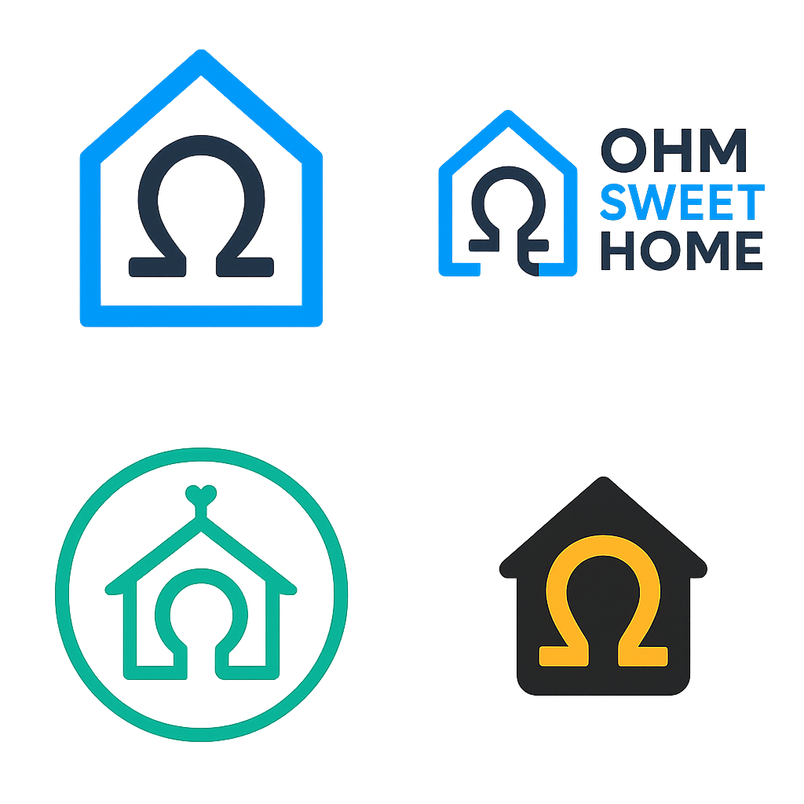

Execution Schedule/Plan

Execution Schedule for Home Power Monitor 2
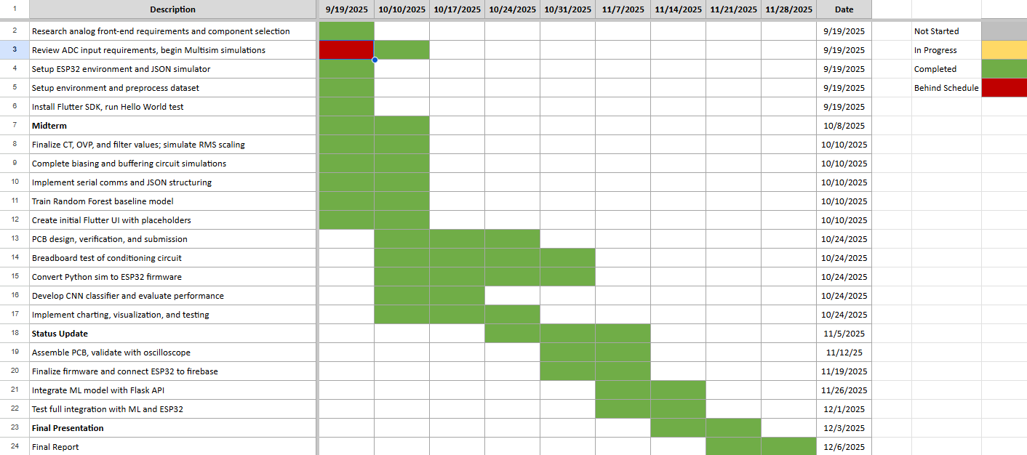

Project Execution
Work | End Date | Owner | Status | Date Completed
CONOPS | 9/17/25 | All | ✅ Complete | 9/14/25
FSR | 10/4/25 | All | ✅ Complete | 10/4/25
ICD | 10/4/25 | All | ✅ Complete | 10/4/2025
Midterm Presentation | 10/8/25 | All | ✅ Complete | 10/8/25
Subsystem 1 (AFE) — Research analog front-end requirements and component selection | 10/10/25 | Kim Peteros | ✅ Complete | 10/9/2025
Subsystem 2 (PCB) — Review ADC input requirements, begin SPICE simulations | 10/10/25 | Lawson Parr | ✅ Complete | 10/10/2025
Embedded Systems — Setup ESP32 environment and JSON simulator | 10/10/25 | Caiden Rueben | ✅ Complete | 10/8/2025
Machine Learning — Setup environment and preprocess dataset | 10/10/25 | Joshua Le | ✅ Complete | 10/9/2025
App Development — Install Flutter SDK, run Hello World test | 10/10/25 | Vivek Samuel | ✅ Complete | 10/8/2025
Status/Progress Update 1 | 10/10/25 | All | ✅ Complete | 10/24/25
Subsystem 1 — Finalize CT, OVP, and filter values; simulate RMS scaling | 10/24/25 | Kim Peteros | ✅ Complete | 10/20/25
Subsystem 2 — Complete biasing and buffering circuit simulations | 10/24/25 | Lawson Parr | ✅ Complete | 10/18/25
Embedded Systems — Implement serial comms and JSON structuring | 10/24/25 | Caiden Rueben | ✅ Complete | 10/22/2025
Machine Learning — Train Random Forest baseline model | 10/24/25 | Joshua Le | ✅ Complete | 10/22/2025
App Development — Create initial Flutter UI with placeholders | 10/24/25 | Vivek Samuel | ✅ Complete | 10/21/2025
Progress Update 2 | 10/24/25 | All | ✅ Complete | 11/7/25
Subsystem 1 — PCB design, verification, and submission | 11/7/25 | Kim Peteros | ✅ Complete | 11/2/25
Subsystem 2 — Breadboard test of conditioning circuit | 11/7/25 | Lawson Parr | ✅ Complete | 11/4/25
Embedded Systems — Convert Python sim to ESP32 firmware | 11/7/25 | Caiden Rueben | ✅ Complete | 11/5/2025
Machine Learning — Develop CNN classifier and evaluate performance | 11/7/25 | Joshua Le | ✅ Complete | 11/6/2025
App Development — Implement charting, visualization, and testing | 11/7/25 | Vivek Samuel | ✅ Complete | 11/4/2025
Progress Update 3 | 11/7/25 | All | ✅ Complete | 11/21/25
Subsystem 1 — Assemble PCB, validate with oscilloscope | 11/21/25 | Kim Peteros | ✅ Complete | 11/21/2025
Subsystem 2 — Assemble PCB and confirm signal integrity | 11/21/25 | Lawson Parr | ✅ Complete | 11/19/2025
Embedded Systems — Finalize firmware and verify JSON streaming | 11/21/25 | Caiden Rueben | ✅ Complete | 11/20/2025
Machine Learning — Integrate ML model with Flask API | 11/21/25 | Joshua Le | ✅ Complete | 11/21/2025
App Development — Test full integration with ML and ESP32 | 11/21/25 | Vivek Samuel | ✅ Complete | 11/21/2025
Final Presentation | 12/3/25 | All | ✅ Complete | 12/3/2025
Final Report | 12/6/25 | All | ✅ Complete | 12/6/2025
Ohm Sweet Home
Joshua Le
Lawson Parr
Kim Peteros
Caiden Rueben
Vivek Samuel



Validation Plan

Project Validation
Task | Specification | Result | Owner
AFE Simulation Accuracy | RMS voltage readings within ±3% of target voltage. | ✅ Complete | Kim Peteros
AFE Measurement Accuracy | RMS voltage readings within ±3% of target current and CT clamps sensing properly. | ✅ Complete | Kim Peteros
Signal Conditioning bias  Accuracy | Centers the AC signal at mid-rail 1.65 V within ±5% keeps it inside 0–3.3 V | ✅ Complete | Lawson Parr
Signal Conditioning Voltage Constraints | Ensures the AC signal stays inside 0–3.3 V no room for error | ✅ Complete | Lawson Parr
Signal Conditioning Filtering Efficiency | Makes EMI above 2 kHZ clean while staying inside 0–3.3 V range. | ✅ Complete | Lawson Parr
DSP Feature Extraction Consistency | RMS and harmonic data stable within ±1% variation across 5 cycles | ✅ Complete | Caiden Rueben
DSP Latency | Feature computation < 250 ms per measurement frame | ✅ Complete | Caiden Rueben
ML Classification Accuracy | ≥ 90% correct identification across known appliance dataset | ✅ Complete | Joshua Le
ML False Positive Rate | ≤ 10% incorrect device labeling | ✅ Complete | Joshua Le
App Data Refresh Rate | Updated visualization within 2 s of DSP output | ✅ Complete | Vivek Samuel
App Notification Delay | User alert triggered within 3 s of classification event | ✅ Complete | Vivek Samuel
System Reliability | ≥ 99% successful data packet delivery from AFE → PCB → App | In Progress | All
Safety Compliance | Verified isolation between high-voltage and logic domains (per IEC 61010) | In Progress | Kim, Lawson
Overall System Endurance | Continuous operation ≥ 4 hours without communication loss | In Progress | All

