* Create a new visual studio project (C++, DLL)
* Delete the x32 configuration
* Add the engine as reference
* Include the engine
* Execute the following command in after building (Post-Build Event)
* Change the build order
* Add the vld.props and freeimage.props property sheets (located in Dependencies folder)
* Add “PLUGIN_EXPORTS” to the preprocessor definitions
* Change C++ version to the latest one

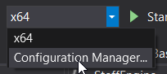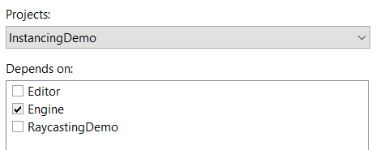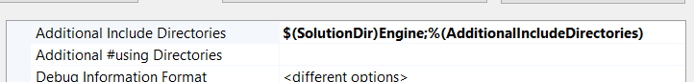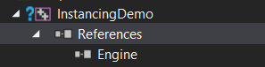

xcopy "$(SolutionDir)x64\$(Configuration)\$(ProjectName).dll" "$(SolutionDir)Resources\Scripts" /Y