# Readme Steps for Stream Network Creation from LiDAR Grids

## Scripts used:

1. PreProcessGrid_RevMarch6.py
2. workflow_revMarch6.py
3. createflownetwork_revMarch6.py (only used to update reclassify function and generate varying resolution stream networks)

The Flow chart below shows the overall workflow of the scripts and the various ArcGIS commands and input variables that were used to create the stream network.

**Initial Steps before Running Scripts**

-Create a folder for each watershed being processed. For example for Beaver Creek create a folder with the name “BeaverCrk”. Note: The name of the final stream network being created will use the name of the folder, so it is suggested to give a descriptive name (less than 8 characters if possible)

-Clip LiDAR grid to each watershed and label it. Keep name 8 characters or less and avoid any spaces or special characters.

-Include the clipped dam breaks and watershed boundary shapefile in the folder created. Name the files “DamBreaks.shp” and “Boundary.shp”. Files must be named exactly and everything must be in same projection. Note: Naming the files as suggested is important as the file names are hardcoded in order to have minimal interaction with the script. It can be changed though if required but will require renaming it in the script.

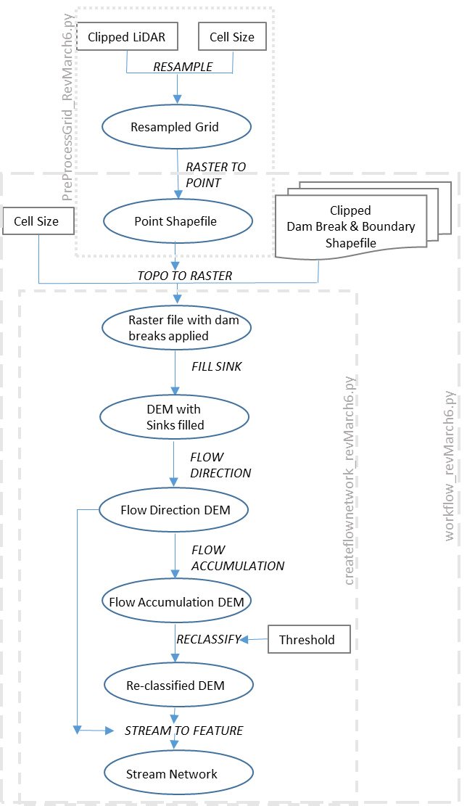

## Pre Process Grid

This step converts LiDAR grid to points

-Open *PreProcessGrid_RevMarch6.py* with IDLE.

-Update **grid name** and **cell size**, 9 feet is default which was found to be optimal based on LiDAR grid resolution of 3 ft when testing Beaver Creek. This can be updated in the future to whatever the analysis calls for. Specifically the variables “LiDAR_clip” and “Cell_size” need to updated in the script (please see figure below)

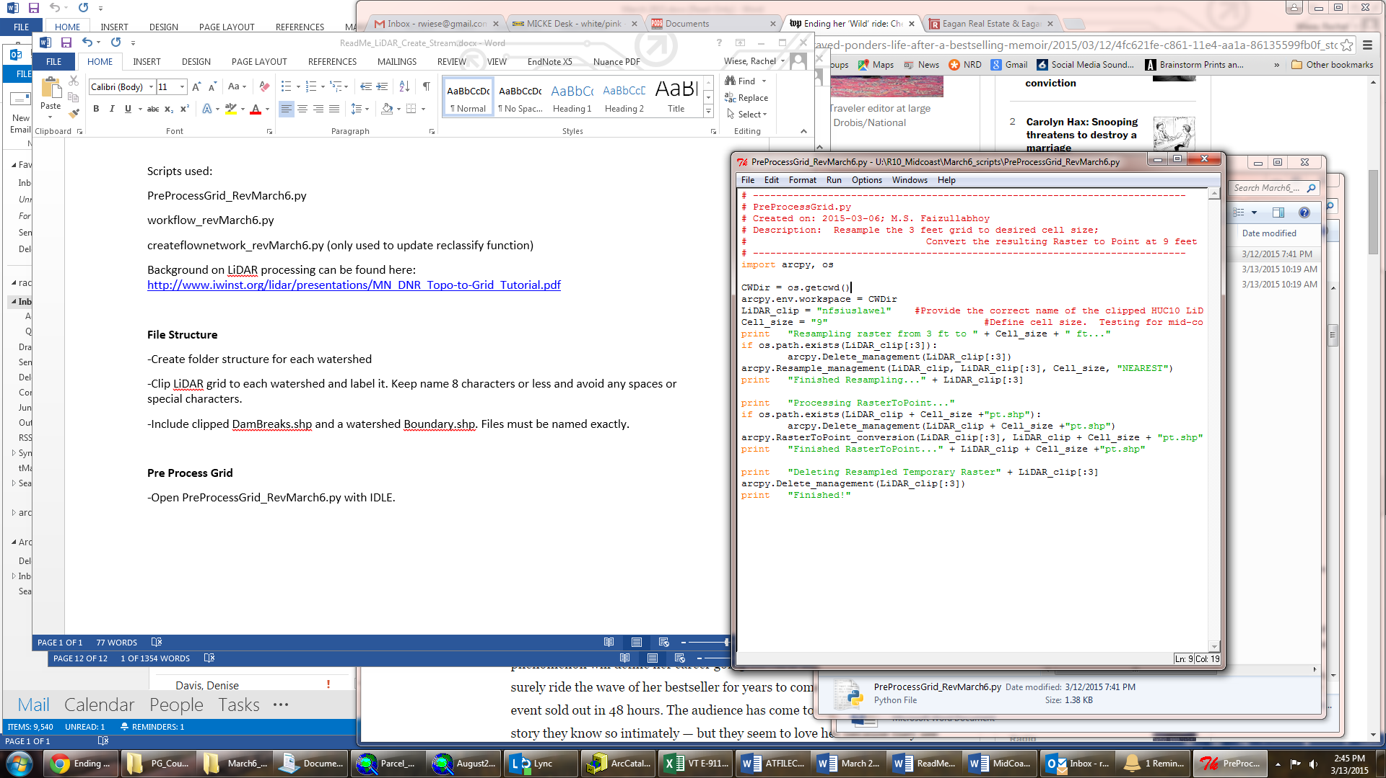

-Save script and run.

## Workflow

This step processes the resulting points shapefile after running the *PreProcessGrid_RevMarch6.py* using the specified Dam Breaks into a new grid for creating the updated stream network.

-Open the script *workflow_revMarch6.py* with IDLE.

-Update the points shapefile name (created in the previous step) and cell size. Specifically the variables “Rast9ftPts_shp” and “cell_size” need to be updated (as shown circled in the figure below). . If cell size was changed then update it here. Nine feet was the default cell size selected for resampling that was done in the preprocessing step and for the Topo to Raster conversion that is done in this step.

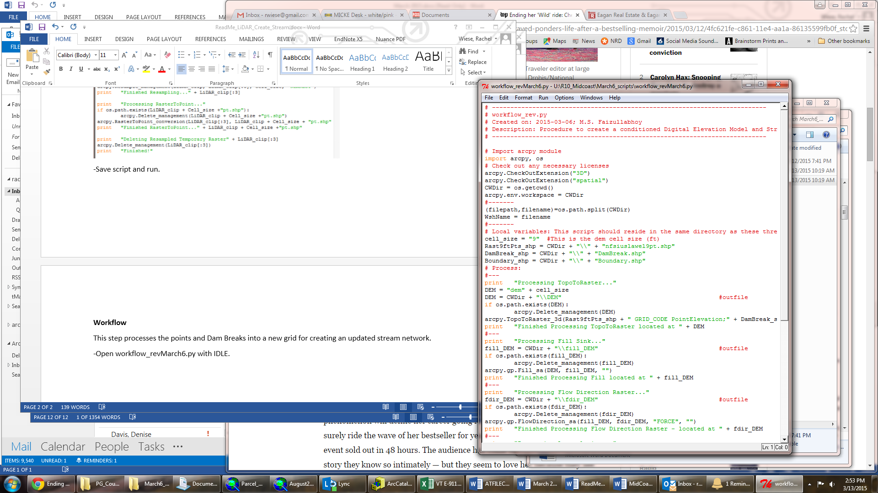

-Save script and Run. This script typically requires 3-8 hours of run time for each watershed

- The script will create a stream network at a default threshold of 8000.

-To change stream resolution without adjusting grid file the *createflownetwork_revMarch6.py* can be used before. If stream network looks good then stop here.

## **Create Flow Network Separately**

**This script** assumes a raster file at desired resolution with dam breaks applied already exists(i.e. **it can** only be used after *workflow_revMarch6.py* has been run at least once)

-Open *createflownetwork_revMarch6.py* with IDLE.

-Update threshold value in circle below (i.e. the “SetThreshold” variable).

-Suggested values range from 3000-10,000 depending on desired resolution.

