Setup Schema Evolution Project

Download org.json.jar file from below URL:

<https://www.google.co.in/url?sa=t&rct=j&q=&esrc=s&source=web&cd=2&cad=rja&uact=8&ved=0ahUKEwiNiMn874rMAhUUS44KHRO_AE4QFggiMAE&url=http%3A%2F%2Fwww.java2s.com%2FCode%2FJar%2Fo%2FDownloadorgjsonjar.htm&usg=AFQjCNFCwcnWASg-h5N1w33z945OVlTY-A>

Download the org-json.jar to local as shown below:

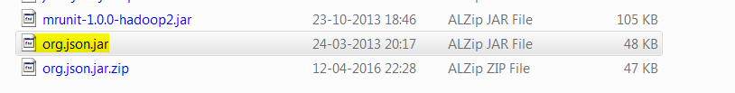

Add the org.json.jar to lib directory of project

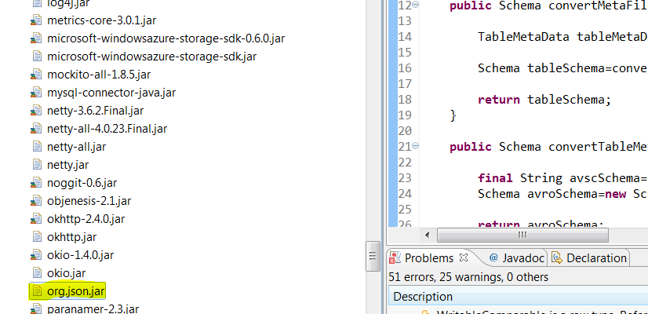

Add to build path:

Date: 25-06-2016

Owner: TejasviReddy22

Email: [tejasvireddy22@gmail.com](mailto:tejasvireddy22@gmail.com)

Following are the task:

1. Checkout schema evolution project code from github following is the url:

https://github.com/svaduka/SchemaEvolution.git

1. Checkout HDFS Service project code from github following is the url:

<https://github.com/Laboros/HDFSService.git>