RIS Footer Documentation

# Overview

The RIS Footer is the footer located at the bottom of all Office of Research and Commercialization (ORC) applications. The footer is made up of navigation buttons, login/session information (if applicable), as well as the ORC logo. The footer is to allow users to inject custom information and styles based on the objectives of the said application the footer is being used with. The goal behind the RIS Footer was to emulate the same procedure as the black bar project, providing a means of creating a generalized, yet completely customizable, footer for all ORC applications.

# Custom-Set Information & Styles

The main feature of the RIS footer is to allow the use of custom-defined information for both the content and styles of the footer. By default, the application uses information pertaining to the Office of Research and Commercialization, but can be overwritten through the use of HTML. Alongside this, the RIS Footer was designed to allow many different options for customizing its visual design. By default, the footer can be set to a Dark or Light theme, as well as allow the user to implement their own theme if they so desire (See *Implementation*).

# Navigation Buttons

The navigation buttons are there to provide the users with simple navigation and application functions. This can range from Log in/out functions, contact links, credits, home page links, etc.

# Login Info

If the web application using the footer has any type of session login, the RIS Footer will be able to display any of the necessary login information for that session. Currently it will display the user’s name, role, and location they logged in from (Shown as an I.P. address). If no login information is being used, the footer will hide this section from the HTML. This information currently uses information from the ColdFusion server.

# Copyright Information

At the bottom of the footer is the copyright information. By default, this includes the credits, logo, copyright information, and the support information.

# Files

The 2 files are as follows:

1. ris_footer.js
2. footer_styles.css

**ris_footer.js:** This file is what creates the footer within the web application. It’s used by placing it inside the HTML of the web pages the footer is being added to.

**footer_styles.css:** This file provides the styling for the footer. The footer is made to be consistent in appearance on multiple sized monitors.

# Implementation

## Embedding onto a Website

Implementation of the RIS Footer was designed to be as hands free as possible, requiring only basic knowledge of HTML, JSON, and CSS(If using a custom theme). The steps for using the RIS Footer are listed below:

1. Create a <**div**> element with the **id**: “**ris_footer**” [*Figure 1.1*] on the page you wish to add the RIS Footer.
2. Create a script element that has the src attribute pointed to the RIS Footer JavaScript file. [*Figure 1.2*]
3. Create another script element that will hold the variable containing your custom information (See *Customizing Data* for creating the custom JSON Object) for the footer. [*Figure 1.3*]

## Customizing Data

In order to use custom information, users will need to create a custom JSON object with the variable name **customInfo**. As of now, the custom information is structured as shown in *Figure 1.3*. By default, the footer comes with preset information regarding its theme & copyright information

The type of information that the footer can use (along with their respective name in the JSON object) is as follows:

* **theme** (string): Selects which theme will be used for the RIS Footer
  + **Accepted Value(s):** “default”, “light”, and “custom”
* **customThemeLoc** (string): URL location of the CSS file containing styles for custom themes
  + **Accepted Value(s):** any valid url
* **leftBtns** & **rightBtns** (object array): A list of the buttons that will be displayed on the left and right sides of the footer.
  + When creating the buttons, the user will make an array of objects for each individual button.
  + Button Parameters:
    - text (required): Text that will be displayed on the button
    - url (optional): URL Address to the desired web page.
    - onClick (optional): JavaScript function that will be initiated when the button is clicked.
* **loginInfo** (object): Information to be displayed if any login information needs to be displayed.
  + **Parameters:** 
    - **Name:** User ID of the logged in user
    - **Access:** Access Level/Role of the logged in user.
    - **IPaddress:** IP address of logged in user
* **extraInfo** (object): Information to be displayed if any additional information needs to be displayed.
  + **Parameters:** Any valid string notated JSON.
* **copyright** (object): Copyright information for UCF ORC
  + **Parameters:**

Some of the rules for creating the customInfo object are as follows.

* The custom information **must be declared as customInfo*.*** Otherwise the custom information will not be used in the footer.

## Working with Custom Themes

When working with themes in the RIS Footer, the user can choose between a selection of preset themes, as well as implement their own theme. See *Figure 3.1* for examples of the themes available.

## Working With Fixed-Width Pages

## Dependencies

The RIS Footer is dependent on jQuery 1.11.3. If the footer is being used without the RIS BlackBar, the footer will add a script object pointing towards the CDN of jQuery 1.11.3. If the footer is being used in tandem with the RIS Header, then it will skip this initialization step.

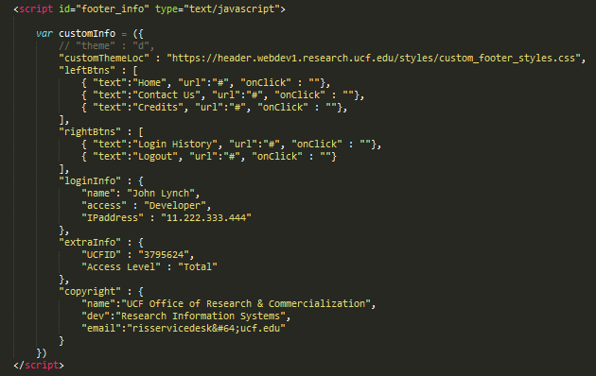

Figure 1.3

Figure .2

Figure 1.1

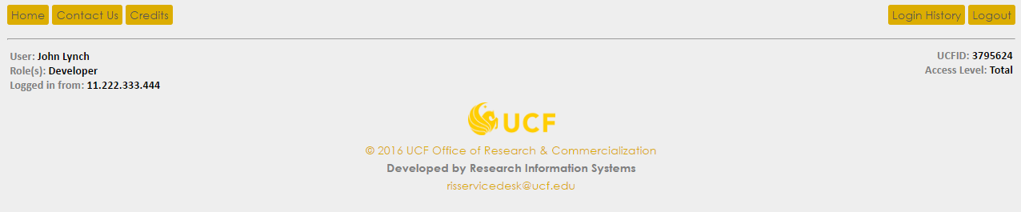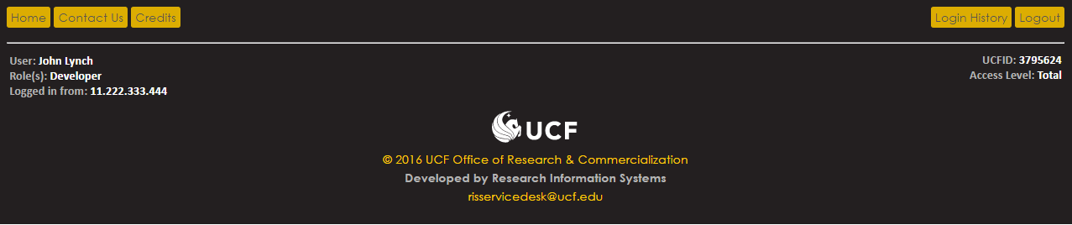

Figure 3.2 Light

Figure 3.1 Default

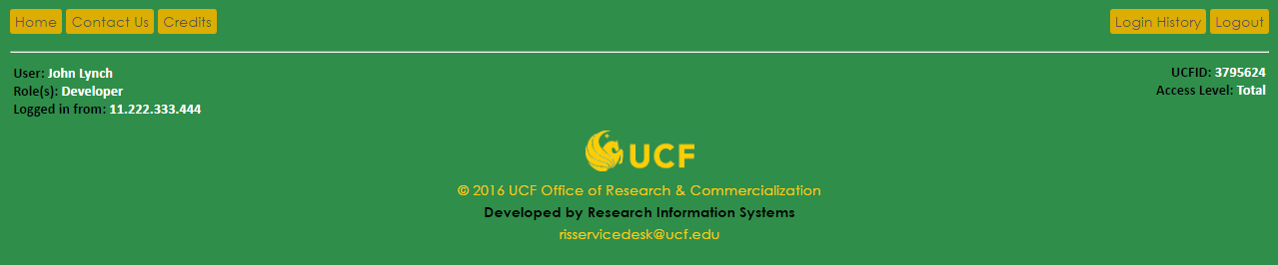

Figure 3.3 Custom Example