1. **Chose a visualization**

**Share of parliamentary seats of women over different continents (barchart)**



**2.) Create an interaction storyboard**

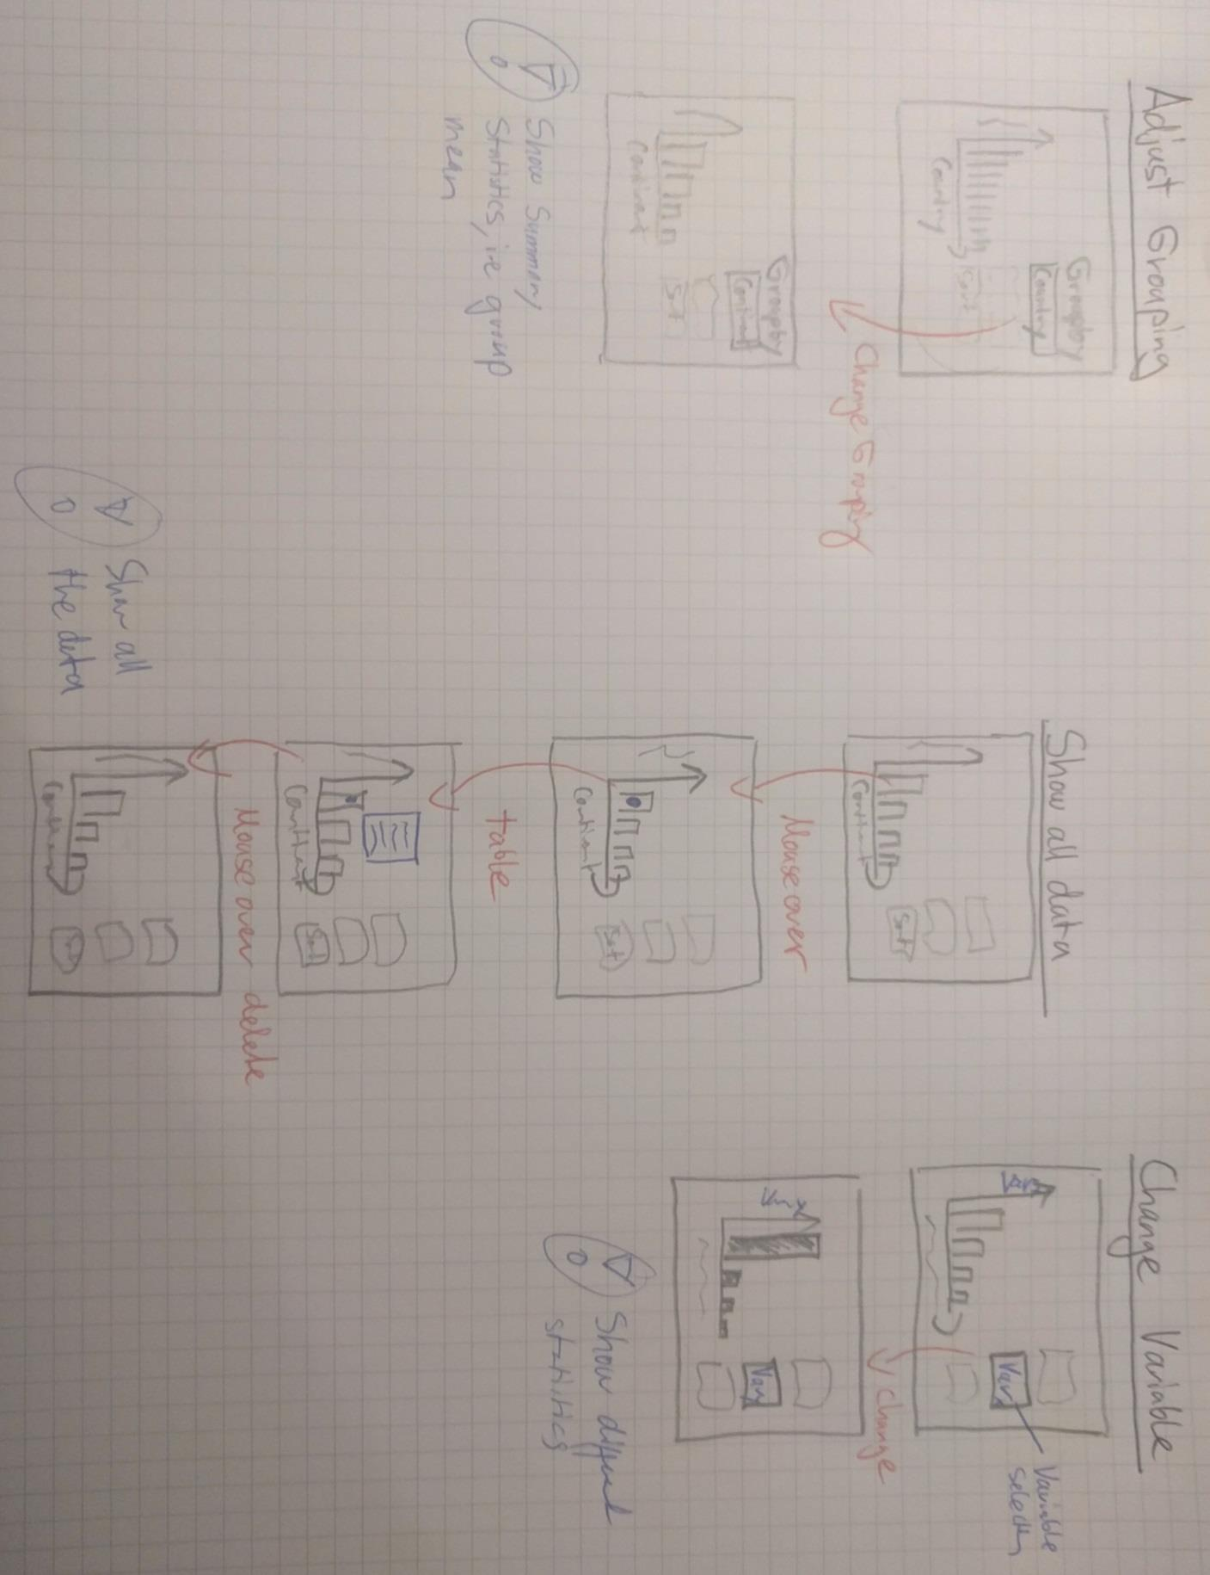

**Three Interaction Strategies:**

* Adjust the overall grouping of the variable (i.e., mean of Higher Level Groups (e.g, continent vs. country)
* Show all the selected tabular data (i.e, show a table when hovering over a bar)
* Change the describing variable (e.g., switch from inequality to human development)

3. **Answer the following questions/tasks for EACH interaction:**

Which questions can you answer by using your interactions?

Use the *Heer & Shneiderman* taxonomy to classify every interaction.

**Interaction I**

What is the country/continent with the highest share (group mean) of women in

parliament?

* *Heer & Shneiderman* taxonomy: Sort, Filter, Derive, Coordinate & Organize

**Interaction II**

When seeing an interesting country through the hover effect it is possible to get new hypotheses and/or get more information for one specific country/continents.

* *Heer & Shneiderman* taxonomy: Data, View & Select.

**Interaction III**

How is Human Development or other variables distributed (every numeric variables is selectable) over the continents/countries.

* *Heer & Shneiderman* taxonomy: Sort, Filter, Derive, Coordinate & Organize