**Sketch Analysis** 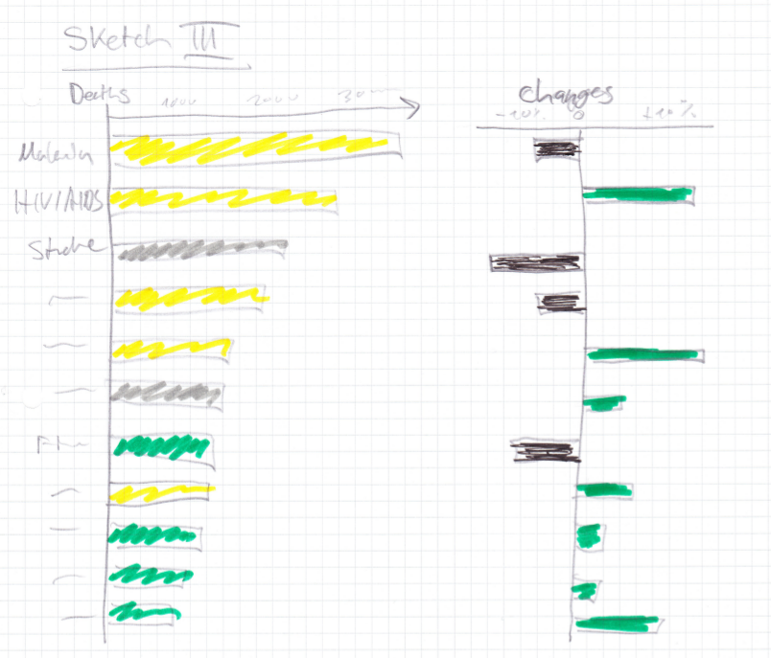

1. **For each data type, describe how it is encoded in your redesign using Bertin’s marks and channels.**

Annual percentage change 🡪 Barchart (length) & Color (black 🡪 negative, green 🡪 positive)

Injuries 🡪 Barchart (length) & Color (Green)

Infectious diseaseases/birth problems 🡪 Barchart (length) & Color (Yellow)

Noncommunicable diseases 🡪 Barchart (length) & Color (Red)

1. **How are the perceptual channels contrast and color used in your chosen sketch?**

They are used to make it easier to compare the absolute levels of diseases/injuries. The barcharts are in a pareto fashion ordered and grouped through their color. That makes it easy for the human reader to compare the sizes and group the categories trough the color.

1. **How are Tufte’s design principles used or violated in your sketch?**

The problematic 3D element of the former graph is gone. The data/ink ratio stays on a good level. Problematic is the color usage. Especially in the graph that indicates the percentage change. The color as well as the direction are coding the same thing. This is according to Tufte not necessary, i.e., the left/right direction would be sufficient.