

NEIGHBORHOOD

LEADER PROGRAM

Edit turf delivery message – 14 August 2022

Select the Manage NLs tab, then click the link for “Edit the body of the email to deliver a turf to an NL” and the body of the email is revealed. You can change any of the text you find here.

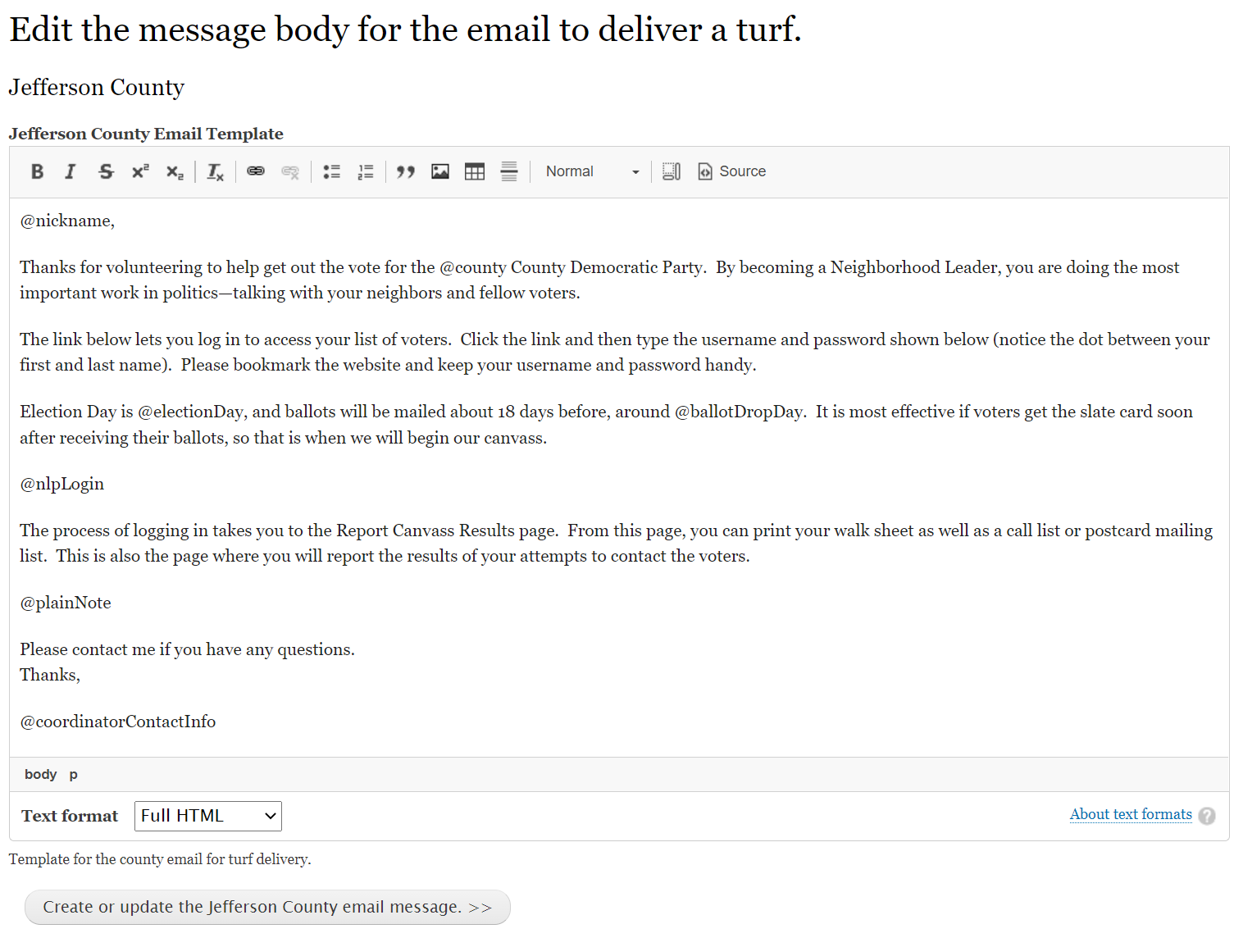



There are four substitutions you can use to personalize the email.

@nickname – first name of the recipient

@nlpLogin – login information

@plainNote – a note provided at the time the email was sent

@coordinatorContactInfo – contact information for the county coordinator.

These fields will be changed to actual values just before the email is sent.

When you are done, click the “create or update …” button. All subsequent emails sent by the county will have this text.