NEIGHBORHOOD

LEADER PROGRAM



Dear Neighborhood Leader,

Thanks for signing up for the Democratic Party of Oregon Neighborhood Leader Program (NLP). You will be doing the most important work in politics today, simply by talking with a few of your neighbors.

The NLP plan is simple; we provide you with a list of approximately thirty-five households with registered Democrats who live close to you. Prior to the election, you will visit and talk with them. Your list of assigned voters and a map will be sent to you via email. You will be asked to log into the NLP Services website to get your material. Print out this material for your use. The slate cards, if used, will be printed by the county party. Please plan to pick up the slate cards.

We ask that you encourage the voters on your list to vote and give them a copy of our slate card. If you chose, you can also provide additional candidate literature.

Please make at least one attempt to speak with the people on your list. If they are not home, you can either leave the slate card and campaign literature, or return another day. Many of our Neighborhood Leaders are making multiple attempts to have a face to face conversation. This persistence is based on the proven results of increased voter participation after a personal contact.

For each voter contact attempt, record the result on your printed list of voters. If the voter is not at home, leave the literature in a visible place for them to see and read. DO NOT PUT THE LIT IN THEIR MAILBOX! Hand write a note letting the voter know who you are and, if you can, give them your phone number.

As soon as possible after you attempt contact with a voter, please log into your turf at NLP Services website and record your result.

On the weekend before the election, please plan to call the voters whose ballots have not yet been received and remind them to return their ballot to a drop off location (it will be too late to mail the ballot). This simple step is very important to the success of this election. You can determine who has not yet returned a ballot by logging into your turf.

Lastly, we intend to continue this program through future elections. The goal of the program is for you to form relationships with your Democratic neighbors so that they have a personal connection to the Democratic Party. Have fun, talk to your neighbors, and let us know how it turns out.

**Online Reporting of Canvas Results**

Canvass results that you report online are periodically transferred to VoteBuilder, our state database for campaigns. Coordinated campaigns can see the result of your contact and can use it to improve their campaign results. It will be vitally important for all of us to complete our tasks and report results to enhance our chances of winning.

Go to your county party website and look for the link to the “Neighborhood Leader Login”. Or, go to [www.nlpservices.org](http://www.nlpservices.org) and click on your county’s name. This link will take you to the data entry tool. The login uses your name and a password. The password was sent to you in the email that delivered your turf.

A personal contact is the most effective way to encourage someone to vote. When you contact a voter, please ask them to commit to vote in the upcoming election. We use the answer to the pledge to vote survey question as the metric for an authentic face-to-face contact. When you fail to meet the voter, use the contact option. We track attempted contacts as well as actual face-to-face conversations.

If a campaign wants us to collect voter preference, you can ask if they support the candidate and record the answer in the Candidate ID column. Also, some lists will include voters estimated to vote Democratic. If you find that a voter leans conservative, check the box to help us improve our database.

**Data Entry Page**

These links allow you to print a new copy of your walk sheet, print a mailing list for a post card, or print a call list the last reminder to vote.

First, enter the date of your contact with voters on your list.

Then use the drop-down menu to select the nature of the voter contact you made.

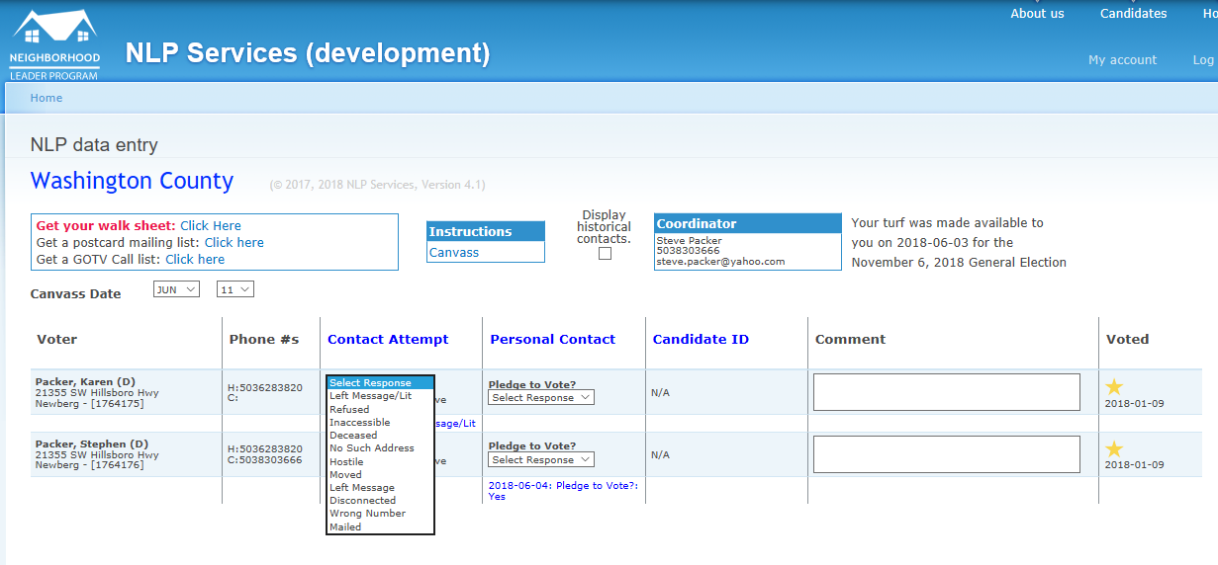

You can also enter a candidate ID if requested by the campaign or a note for yourself.

The gold star tells you the person voted in this election. The other information is this voter’s voting record.

Contact information for this election cycle will be displayed in blue. Information in grey is from prior elections. Red indicates a new entry that was just saved.

Record a personal contact with the voter by reporting the response to the pledge to vote request.

Check this box if the voter should not be on our list of supporters.

If you check this box, you will see information about prior contact with this voter.

