

NEIGHBORHOOD

LEADER PROGRAM

Dear Neighborhood Leader,

Thanks for signing up for the Democratic Party of Oregon Neighborhood Leader Program (NLP). You will be doing the most important work in politics today, simply by talking with a few of your neighbors.

The NLP plan is simple; we provide you with a list of approximately thirty-five households with registered Democrats who live close to you. Prior to the election, you will visit and talk with them. Your list of assigned voters and a map will be sent to you via email. You will be asked to log into the NLP Services website to get your material. Print out this material for your use. The slate cards will be printed by the county party. Please plan to pick up the slate cards.

We ask that you encourage the voters on your list to vote and give them a copy of our slate card. If you chose, you could also provide additional candidate literature.

Please make at least one attempt to speak with the people on your list. If they are not home, you can either leave the slate card and campaign literature or return another day. Many of our Neighborhood Leaders are making multiple attempts to have a face-to-face conversation. This persistence is based on the proven results of increased voter participation after a personal contact.

For each voter contact attempt, record the result on your printed list of voters. If the voter is not at home, leave the literature in a visible place for them to see and read. DO NOT PUT THE LIT IN THEIR MAILBOX! Handwrite a note letting the voter know who you are and, if you can, give them your phone number.

As soon as possible after you attempt contact with a voter, please log into your turf at NLP Services website and record your result.

On the weekend before the election, please plan to call the voters whose ballots have not yet been received and remind them to return their ballot to a drop off location (it will be too late to mail the ballot). This simple step is important to the success of this election. You can determine who has not yet returned a ballot by logging into your turf.

Lastly, we intend to continue this program through future elections. The goal of the program is for you to form relationships with your Democratic neighbors so that they have a personal connection to the Democratic Party. Have fun, talk to your neighbors, and let us know how it turns out.



**Online Reporting of Canvas Results**

Canvass results that you report online are transferred to VoteBuilder, our state database for campaigns. Coordinated campaigns can see the result of your contact and can use it to improve their campaign results. It will be vitally important for all of us to complete our tasks and report results to enhance our chances of winning.

Go to your county party website and look for the link to the “Neighborhood Leader Login”. Or go to [www.nlpservices.org](http://www.nlpservices.org) and login. This link will take you to the data entry tool. The login uses your name and a password. The password was sent to you in the email that delivered your turf.

A personal contact is the most effective way to encourage someone to vote. When you contact a voter, please ask them to commit to vote in the upcoming election. When you fail to contact the voter, use the “No voter contact” option.

**Data Entry Page**

This tab takes you to a page to print your walk sheet, print a mailing list for a post card, or print a call list the last reminder to vote.

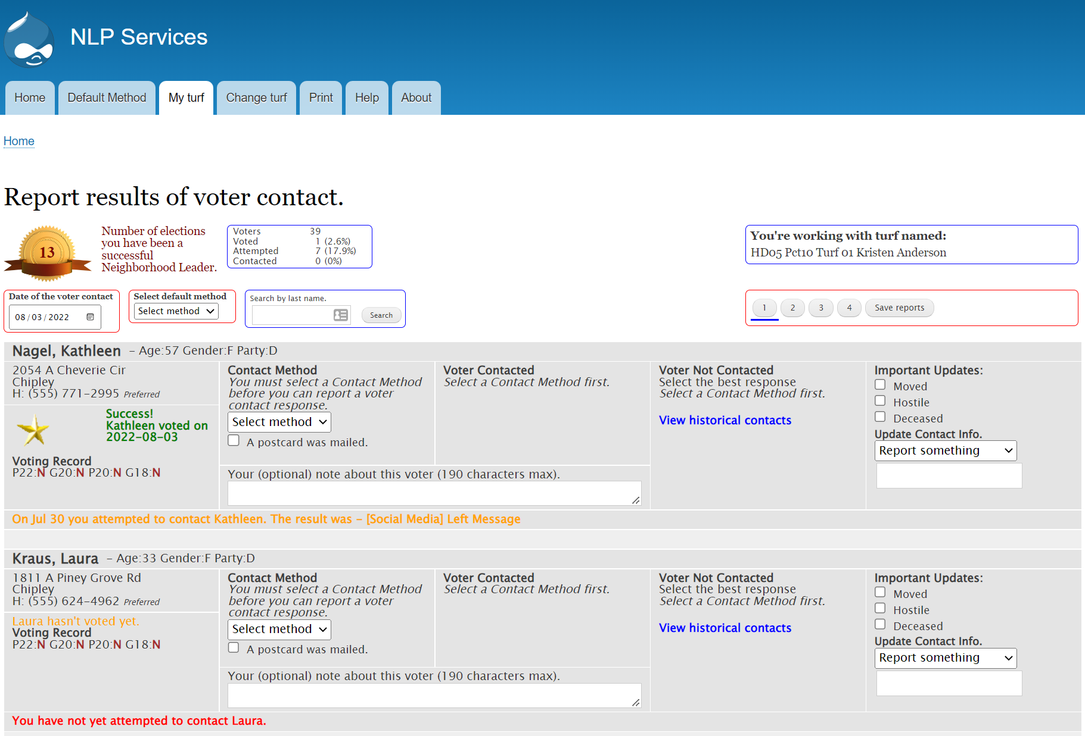

Be sure to click Save.

First, enter the date of your contact with voters on your list.

If you have a preferred method of contacting voters, select it here. It saves you a few steps later.

If the voter has turned in a ballot, you will see a gold star here.

Change the contact method if different than already suggested.

If you contact the voter, be sure to try to get a commitment to vote.

The note field is for you to record additional information about your contact with the voter.

If you learned new contact information, use this option to help us update our database.

If you tried but could not contact the voter, record that here.

When you are done with data entry for these voters, either click “Save report” or click one of the page changes. If you do not do one of these choices, the contact information you entered will be lost.

The “Help” tab offers some information about the data entry. And, the “Change turf” tab is available for those who have more than one turf.

**For Rural Areas**



Put the handwritten address

here

Put your return address sticker here.

Avoid this area as the USPS will put a bar code sticker

here

A personal note goes here