Модуль 4. Лабораторная 2
1) Для заданной на схеме schema-lab2 сети, состоящей из управляемых коммутаторов и персональных компьютеров настроить протокол STP, назначив явно один из коммутаторов корневым настройкой приоритета.
enable
configure terminal

spanning-tree mode pvst
spanning-tree vlan 1 priority 4096

end
write memory

2) Проверить доступность каждого с каждым всех персональных компьютеров (VPCS), результаты запротоколировать.
Pc1: 192.168.1.1/24
Pc2: 192.168.1.2/24
Pc3: 192.168.1.3/24
Pc4: 192.168.1.4/24
Pc5: 192.168.1.5/24
Pc6: 192.168.1.6/24

PC1
PC1> ping 192.168.1.2

84 bytes from 192.168.1.2 icmp_seq=1 ttl=64 time=9.760 ms
84 bytes from 192.168.1.2 icmp_seq=2 ttl=64 time=10.927 ms
84 bytes from 192.168.1.2 icmp_seq=3 ttl=64 time=6.717 ms
84 bytes from 192.168.1.2 icmp_seq=4 ttl=64 time=8.502 ms
84 bytes from 192.168.1.2 icmp_seq=5 ttl=64 time=11.410 ms

PC1> ping 192.168.1.3

84 bytes from 192.168.1.3 icmp_seq=1 ttl=64 time=21.875 ms
84 bytes from 192.168.1.3 icmp_seq=2 ttl=64 time=19.357 ms
84 bytes from 192.168.1.3 icmp_seq=3 ttl=64 time=31.971 ms
84 bytes from 192.168.1.3 icmp_seq=4 ttl=64 time=34.014 ms
84 bytes from 192.168.1.3 icmp_seq=5 ttl=64 time=13.564 ms

PC1> ping 192.168.1.4

84 bytes from 192.168.1.4 icmp_seq=1 ttl=64 time=27.122 ms
84 bytes from 192.168.1.4 icmp_seq=2 ttl=64 time=20.346 ms
84 bytes from 192.168.1.4 icmp_seq=3 ttl=64 time=32.051 ms
84 bytes from 192.168.1.4 icmp_seq=4 ttl=64 time=13.722 ms
84 bytes from 192.168.1.4 icmp_seq=5 ttl=64 time=45.993 ms

PC1> ping 192.168.1.5

84 bytes from 192.168.1.5 icmp_seq=1 ttl=64 time=15.271 ms
84 bytes from 192.168.1.5 icmp_seq=2 ttl=64 time=28.451 ms
84 bytes from 192.168.1.5 icmp_seq=3 ttl=64 time=25.044 ms
84 bytes from 192.168.1.5 icmp_seq=4 ttl=64 time=32.282 ms
84 bytes from 192.168.1.5 icmp_seq=5 ttl=64 time=29.001 ms

PC1> ping 192.168.1.6

84 bytes from 192.168.1.6 icmp_seq=1 ttl=64 time=26.351 ms
84 bytes from 192.168.1.6 icmp_seq=2 ttl=64 time=31.836 ms
84 bytes from 192.168.1.6 icmp_seq=3 ttl=64 time=22.867 ms
84 bytes from 192.168.1.6 icmp_seq=4 ttl=64 time=32.638 ms
84 bytes from 192.168.1.6 icmp_seq=5 ttl=64 time=14.773 ms

PC2
PC2> ping 192.168.1.1

84 bytes from 192.168.1.1 icmp_seq=1 ttl=64 time=8.528 ms
84 bytes from 192.168.1.1 icmp_seq=2 ttl=64 time=21.951 ms
84 bytes from 192.168.1.1 icmp_seq=3 ttl=64 time=12.542 ms
84 bytes from 192.168.1.1 icmp_seq=4 ttl=64 time=14.201 ms
84 bytes from 192.168.1.1 icmp_seq=5 ttl=64 time=15.004 ms

PC2> ping 192.168.1.3

84 bytes from 192.168.1.3 icmp_seq=1 ttl=64 time=13.182 ms
84 bytes from 192.168.1.3 icmp_seq=2 ttl=64 time=36.509 ms
84 bytes from 192.168.1.3 icmp_seq=3 ttl=64 time=14.507 ms
84 bytes from 192.168.1.3 icmp_seq=4 ttl=64 time=16.247 ms
84 bytes from 192.168.1.3 icmp_seq=5 ttl=64 time=43.867 ms

PC2> ping 192.168.1.4

84 bytes from 192.168.1.4 icmp_seq=1 ttl=64 time=20.239 ms
84 bytes from 192.168.1.4 icmp_seq=2 ttl=64 time=17.615 ms
84 bytes from 192.168.1.4 icmp_seq=3 ttl=64 time=39.282 ms
84 bytes from 192.168.1.4 icmp_seq=4 ttl=64 time=24.063 ms
84 bytes from 192.168.1.4 icmp_seq=5 ttl=64 time=15.791 ms

PC2> ping 192.168.1.5

84 bytes from 192.168.1.5 icmp_seq=1 ttl=64 time=18.394 ms
84 bytes from 192.168.1.5 icmp_seq=2 ttl=64 time=11.356 ms
84 bytes from 192.168.1.5 icmp_seq=3 ttl=64 time=26.689 ms
84 bytes from 192.168.1.5 icmp_seq=4 ttl=64 time=39.720 ms
84 bytes from 192.168.1.5 icmp_seq=5 ttl=64 time=24.802 ms

PC2> ping 192.168.1.6

84 bytes from 192.168.1.6 icmp_seq=1 ttl=64 time=25.381 ms
84 bytes from 192.168.1.6 icmp_seq=2 ttl=64 time=18.318 ms
84 bytes from 192.168.1.6 icmp_seq=3 ttl=64 time=15.131 ms
84 bytes from 192.168.1.6 icmp_seq=4 ttl=64 time=43.937 ms
84 bytes from 192.168.1.6 icmp_seq=5 ttl=64 time=27.686 ms

PC3
PC3> ping 192.168.1.1

84 bytes from 192.168.1.1 icmp_seq=1 ttl=64 time=34.622 ms
84 bytes from 192.168.1.1 icmp_seq=2 ttl=64 time=22.836 ms
84 bytes from 192.168.1.1 icmp_seq=3 ttl=64 time=27.244 ms
84 bytes from 192.168.1.1 icmp_seq=4 ttl=64 time=34.114 ms
84 bytes from 192.168.1.1 icmp_seq=5 ttl=64 time=14.061 ms

PC3> ping 192.168.1.2

84 bytes from 192.168.1.2 icmp_seq=1 ttl=64 time=46.955 ms
84 bytes from 192.168.1.2 icmp_seq=2 ttl=64 time=31.023 ms
84 bytes from 192.168.1.2 icmp_seq=3 ttl=64 time=22.501 ms
84 bytes from 192.168.1.2 icmp_seq=4 ttl=64 time=20.599 ms
84 bytes from 192.168.1.2 icmp_seq=5 ttl=64 time=22.436 ms

PC3> ping 192.168.1.4

84 bytes from 192.168.1.4 icmp_seq=1 ttl=64 time=6.967 ms
84 bytes from 192.168.1.4 icmp_seq=2 ttl=64 time=4.267 ms
84 bytes from 192.168.1.4 icmp_seq=3 ttl=64 time=6.951 ms
84 bytes from 192.168.1.4 icmp_seq=4 ttl=64 time=16.543 ms
84 bytes from 192.168.1.4 icmp_seq=5 ttl=64 time=22.052 ms

PC3> ping 192.168.1.5

84 bytes from 192.168.1.5 icmp_seq=1 ttl=64 time=23.584 ms
84 bytes from 192.168.1.5 icmp_seq=2 ttl=64 time=13.928 ms
84 bytes from 192.168.1.5 icmp_seq=3 ttl=64 time=26.011 ms
84 bytes from 192.168.1.5 icmp_seq=4 ttl=64 time=11.169 ms
84 bytes from 192.168.1.5 icmp_seq=5 ttl=64 time=17.261 ms

PC3> ping 192.168.1.6

84 bytes from 192.168.1.6 icmp_seq=1 ttl=64 time=14.225 ms
84 bytes from 192.168.1.6 icmp_seq=2 ttl=64 time=29.458 ms
84 bytes from 192.168.1.6 icmp_seq=3 ttl=64 time=26.569 ms
84 bytes from 192.168.1.6 icmp_seq=4 ttl=64 time=21.221 ms
84 bytes from 192.168.1.6 icmp_seq=5 ttl=64 time=12.049 ms

PC4
PC4> ping 192.168.1.1

84 bytes from 192.168.1.1 icmp_seq=1 ttl=64 time=30.891 ms
84 bytes from 192.168.1.1 icmp_seq=2 ttl=64 time=37.190 ms
84 bytes from 192.168.1.1 icmp_seq=3 ttl=64 time=20.463 ms
84 bytes from 192.168.1.1 icmp_seq=4 ttl=64 time=20.981 ms
84 bytes from 192.168.1.1 icmp_seq=5 ttl=64 time=26.292 ms

PC4> ping 192.168.1.2

84 bytes from 192.168.1.2 icmp_seq=1 ttl=64 time=8.587 ms
84 bytes from 192.168.1.2 icmp_seq=2 ttl=64 time=18.192 ms
84 bytes from 192.168.1.2 icmp_seq=3 ttl=64 time=33.370 ms
84 bytes from 192.168.1.2 icmp_seq=4 ttl=64 time=35.565 ms
84 bytes from 192.168.1.2 icmp_seq=5 ttl=64 time=49.178 ms

PC4> ping 192.168.1.3

84 bytes from 192.168.1.3 icmp_seq=1 ttl=64 time=6.080 ms
84 bytes from 192.168.1.3 icmp_seq=2 ttl=64 time=16.165 ms
84 bytes from 192.168.1.3 icmp_seq=3 ttl=64 time=5.306 ms
84 bytes from 192.168.1.3 icmp_seq=4 ttl=64 time=10.158 ms
84 bytes from 192.168.1.3 icmp_seq=5 ttl=64 time=7.624 ms

PC4> ping 192.168.1.5

84 bytes from 192.168.1.5 icmp_seq=1 ttl=64 time=30.515 ms
84 bytes from 192.168.1.5 icmp_seq=2 ttl=64 time=22.053 ms
84 bytes from 192.168.1.5 icmp_seq=3 ttl=64 time=35.681 ms
84 bytes from 192.168.1.5 icmp_seq=4 ttl=64 time=16.939 ms
84 bytes from 192.168.1.5 icmp_seq=5 ttl=64 time=33.074 ms

PC4> ping 192.168.1.6

84 bytes from 192.168.1.6 icmp_seq=1 ttl=64 time=19.125 ms
84 bytes from 192.168.1.6 icmp_seq=2 ttl=64 time=39.212 ms
84 bytes from 192.168.1.6 icmp_seq=3 ttl=64 time=13.260 ms
84 bytes from 192.168.1.6 icmp_seq=4 ttl=64 time=16.006 ms
84 bytes from 192.168.1.6 icmp_seq=5 ttl=64 time=41.488 ms

PC5
PC5> ping 192.168.1.1

84 bytes from 192.168.1.1 icmp_seq=1 ttl=64 time=28.169 ms
84 bytes from 192.168.1.1 icmp_seq=2 ttl=64 time=10.408 ms
84 bytes from 192.168.1.1 icmp_seq=3 ttl=64 time=20.094 ms
84 bytes from 192.168.1.1 icmp_seq=4 ttl=64 time=22.752 ms
84 bytes from 192.168.1.1 icmp_seq=5 ttl=64 time=36.769 ms

PC5> ping 192.168.1.2

84 bytes from 192.168.1.2 icmp_seq=1 ttl=64 time=16.013 ms
84 bytes from 192.168.1.2 icmp_seq=2 ttl=64 time=40.667 ms
84 bytes from 192.168.1.2 icmp_seq=3 ttl=64 time=32.685 ms
84 bytes from 192.168.1.2 icmp_seq=4 ttl=64 time=33.872 ms
84 bytes from 192.168.1.2 icmp_seq=5 ttl=64 time=16.520 ms

PC5> ping 192.168.1.3

84 bytes from 192.168.1.3 icmp_seq=1 ttl=64 time=13.409 ms
84 bytes from 192.168.1.3 icmp_seq=2 ttl=64 time=18.605 ms
84 bytes from 192.168.1.3 icmp_seq=3 ttl=64 time=16.409 ms
84 bytes from 192.168.1.3 icmp_seq=4 ttl=64 time=28.769 ms
84 bytes from 192.168.1.3 icmp_seq=5 ttl=64 time=31.353 ms

PC5> ping 192.168.1.4

84 bytes from 192.168.1.4 icmp_seq=1 ttl=64 time=41.190 ms
84 bytes from 192.168.1.4 icmp_seq=2 ttl=64 time=24.048 ms
84 bytes from 192.168.1.4 icmp_seq=3 ttl=64 time=33.920 ms
84 bytes from 192.168.1.4 icmp_seq=4 ttl=64 time=17.874 ms
84 bytes from 192.168.1.4 icmp_seq=5 ttl=64 time=17.890 ms

PC5> ping 192.168.1.6

84 bytes from 192.168.1.6 icmp_seq=1 ttl=64 time=8.092 ms
84 bytes from 192.168.1.6 icmp_seq=2 ttl=64 time=4.190 ms
84 bytes from 192.168.1.6 icmp_seq=3 ttl=64 time=4.122 ms
84 bytes from 192.168.1.6 icmp_seq=4 ttl=64 time=5.140 ms
84 bytes from 192.168.1.6 icmp_seq=5 ttl=64 time=14.813 ms

PC6
PC6> ping 192.168.1.1

84 bytes from 192.168.1.1 icmp_seq=1 ttl=64 time=16.321 ms
84 bytes from 192.168.1.1 icmp_seq=2 ttl=64 time=24.786 ms
84 bytes from 192.168.1.1 icmp_seq=3 ttl=64 time=34.993 ms
84 bytes from 192.168.1.1 icmp_seq=4 ttl=64 time=19.314 ms
84 bytes from 192.168.1.1 icmp_seq=5 ttl=64 time=26.061 ms

PC6> ping 192.168.1.2

84 bytes from 192.168.1.2 icmp_seq=1 ttl=64 time=14.662 ms
84 bytes from 192.168.1.2 icmp_seq=2 ttl=64 time=21.941 ms
84 bytes from 192.168.1.2 icmp_seq=3 ttl=64 time=12.427 ms
84 bytes from 192.168.1.2 icmp_seq=4 ttl=64 time=31.497 ms
84 bytes from 192.168.1.2 icmp_seq=5 ttl=64 time=24.086 ms

PC6> ping 192.168.1.3

84 bytes from 192.168.1.3 icmp_seq=1 ttl=64 time=25.078 ms
84 bytes from 192.168.1.3 icmp_seq=2 ttl=64 time=15.737 ms
84 bytes from 192.168.1.3 icmp_seq=3 ttl=64 time=36.999 ms
84 bytes from 192.168.1.3 icmp_seq=4 ttl=64 time=44.908 ms
84 bytes from 192.168.1.3 icmp_seq=5 ttl=64 time=24.925 ms

PC6> ping 192.168.1.4

84 bytes from 192.168.1.4 icmp_seq=1 ttl=64 time=30.930 ms
84 bytes from 192.168.1.4 icmp_seq=2 ttl=64 time=17.348 ms
84 bytes from 192.168.1.4 icmp_seq=3 ttl=64 time=10.419 ms
84 bytes from 192.168.1.4 icmp_seq=4 ttl=64 time=14.205 ms
84 bytes from 192.168.1.4 icmp_seq=5 ttl=64 time=45.110 ms

PC6> ping 192.168.1.5

84 bytes from 192.168.1.5 icmp_seq=1 ttl=64 time=7.215 ms
84 bytes from 192.168.1.5 icmp_seq=2 ttl=64 time=5.674 ms
84 bytes from 192.168.1.5 icmp_seq=3 ttl=64 time=14.364 ms
84 bytes from 192.168.1.5 icmp_seq=4 ttl=64 time=9.175 ms
84 bytes from 192.168.1.5 icmp_seq=5 ttl=64 time=15.180 ms

3) На изображении схемы отметить BID каждого коммутатора и режимы работы портов (RP/DP/blocked) и стоимости маршрутов, результат сохранить в файл.
Стоимость всех маршрутов: 4
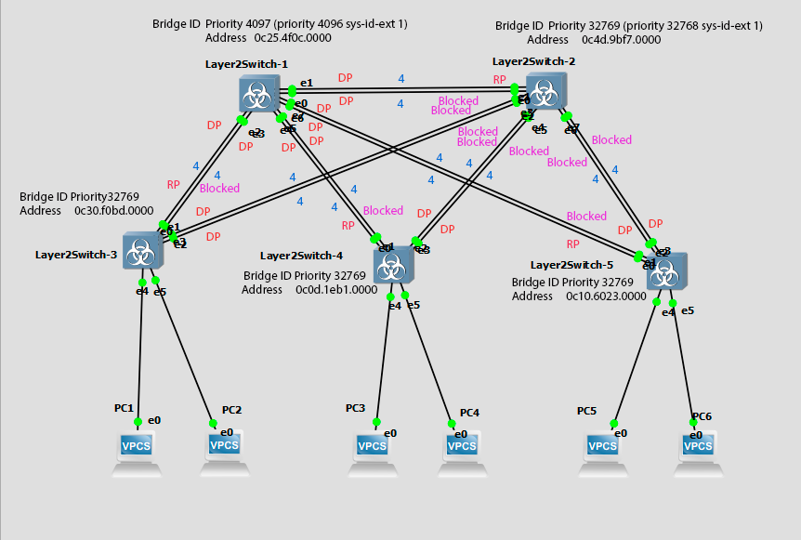

4) При помощи wireshark отследить передачу пакетов hello от корневого коммутатора на всех линках (nb!), результаты включить в отчет.
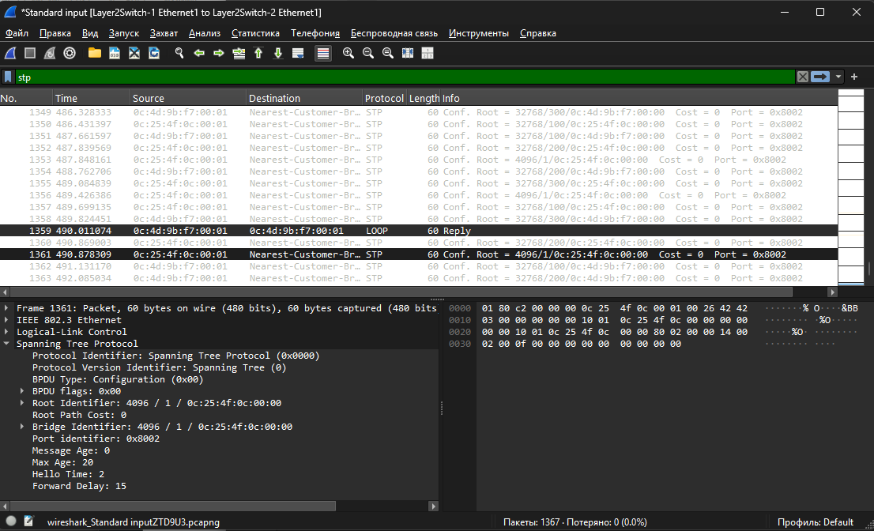
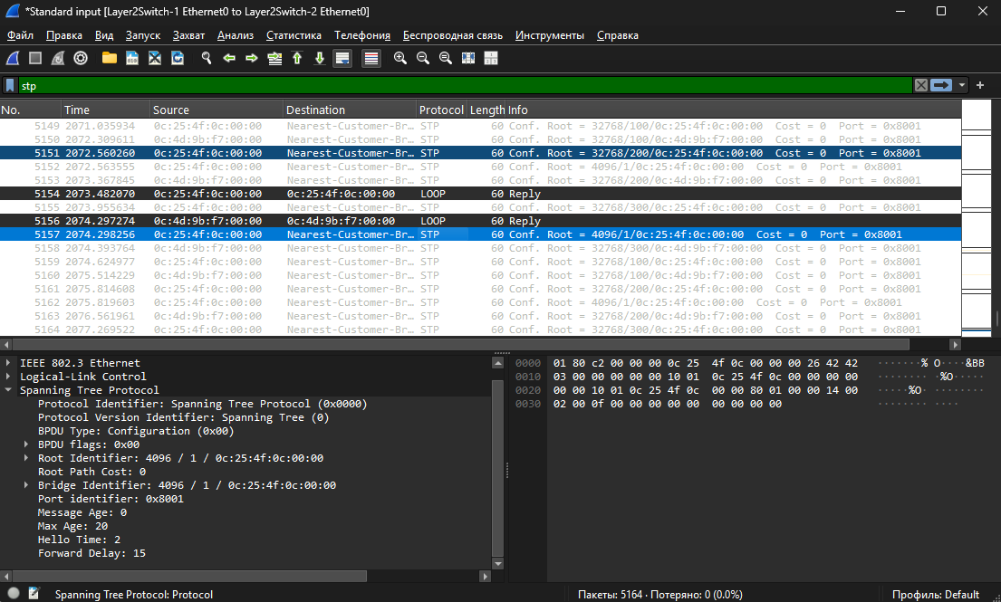
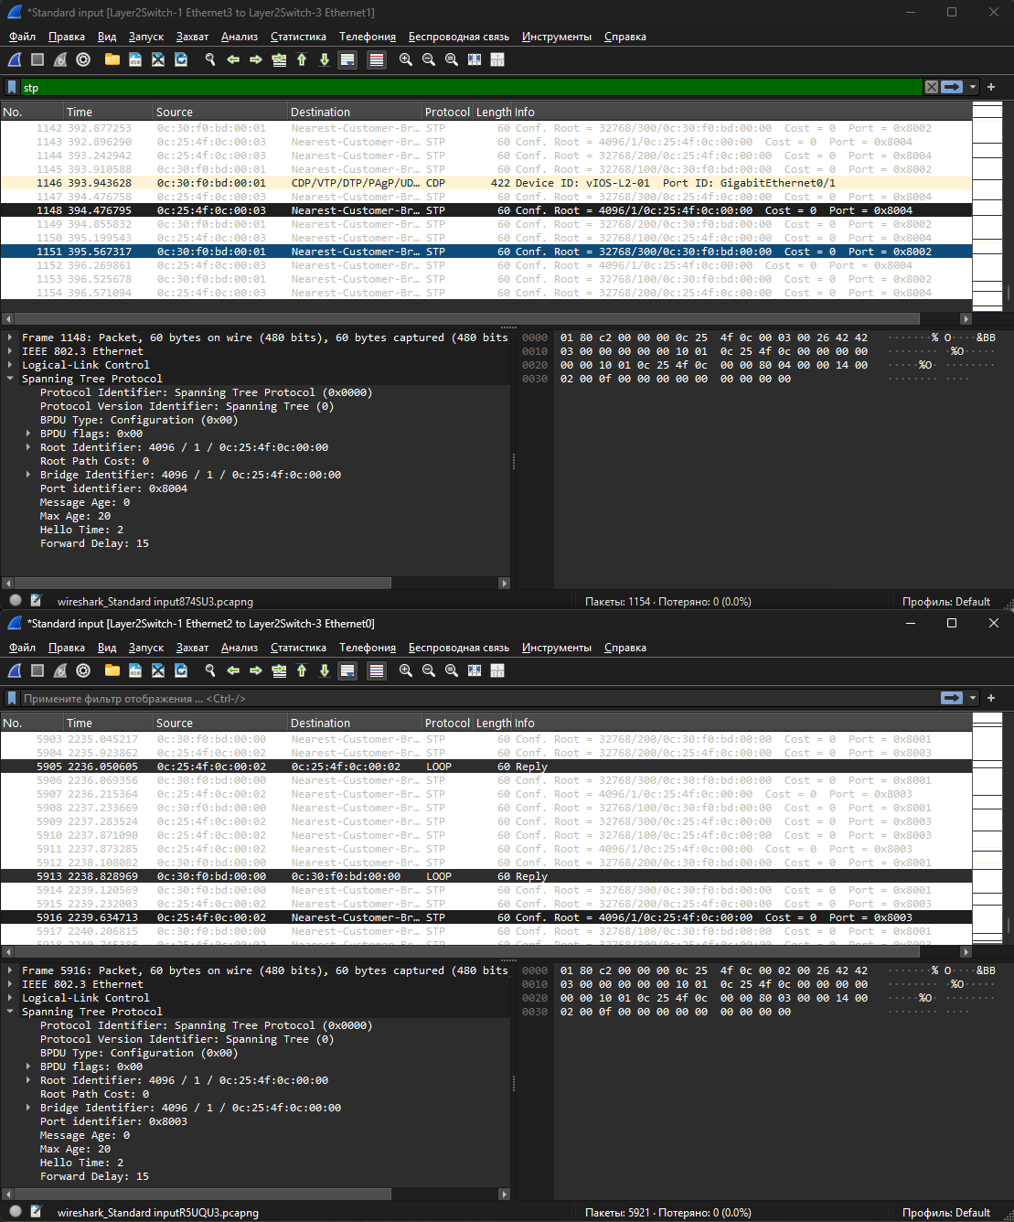
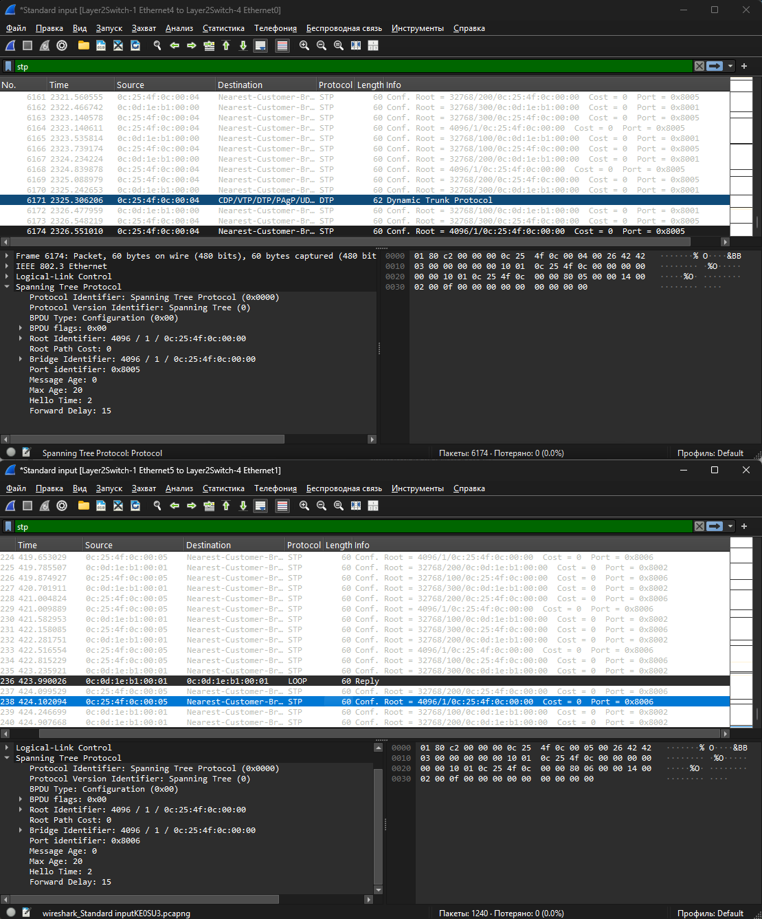
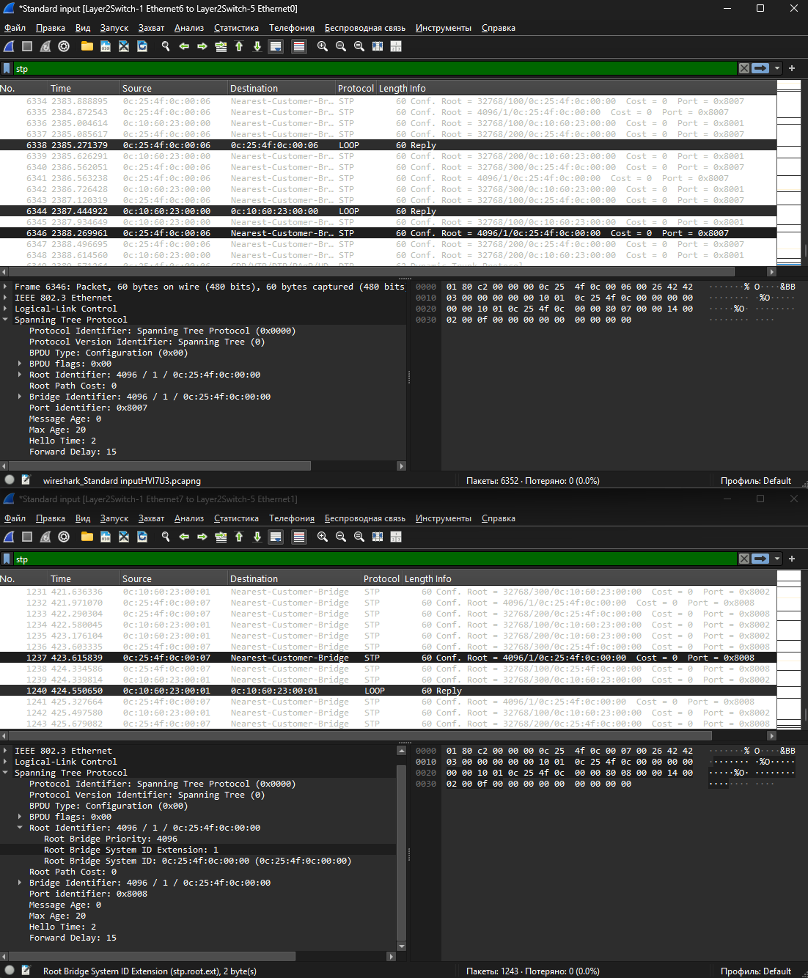
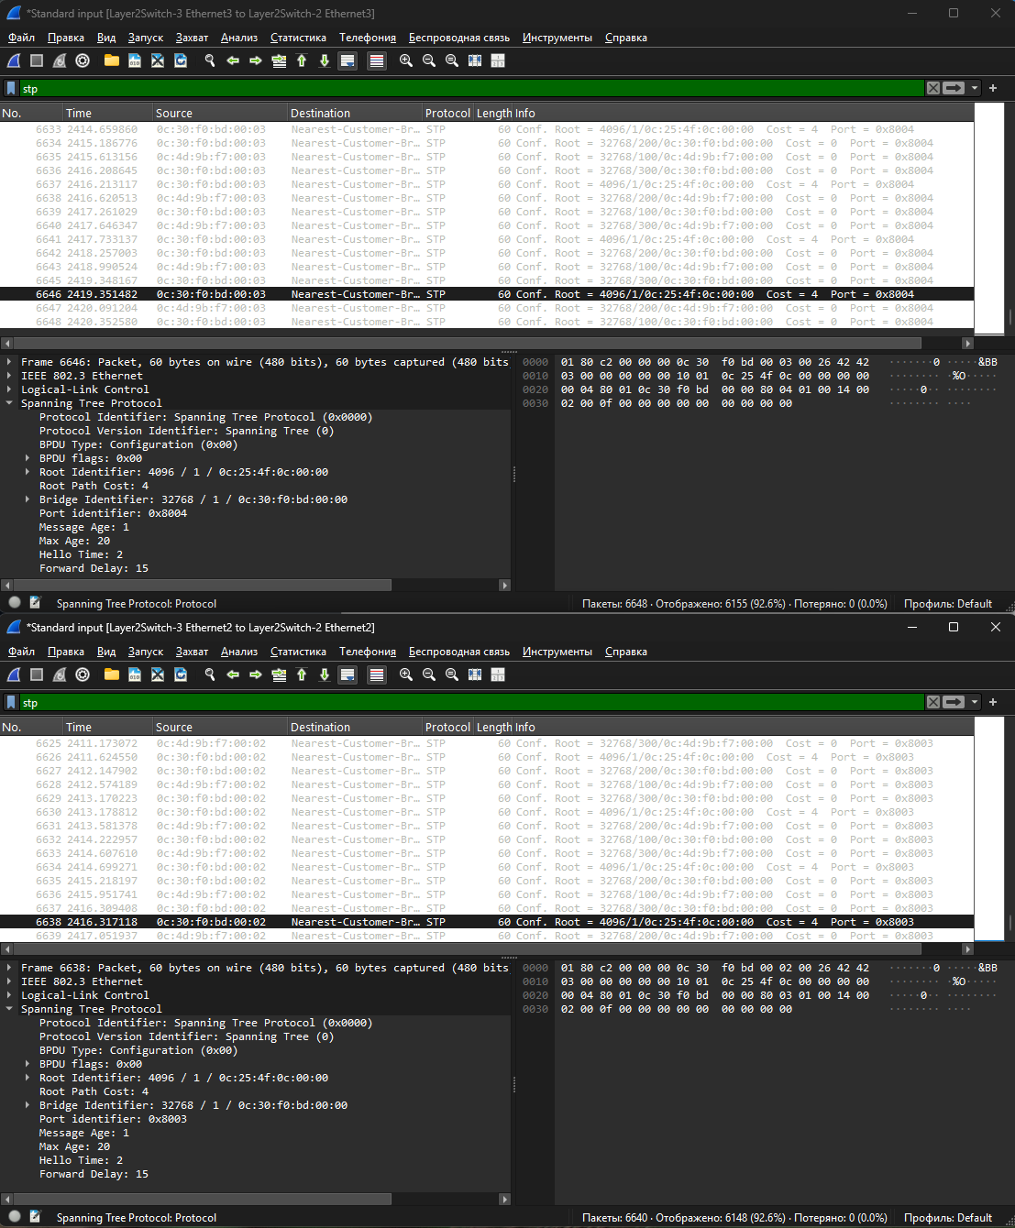
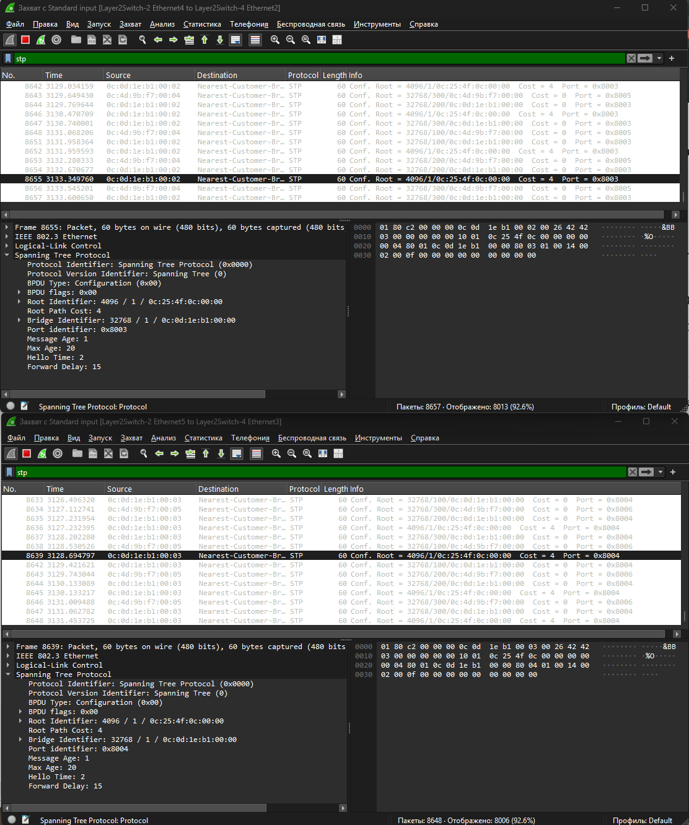
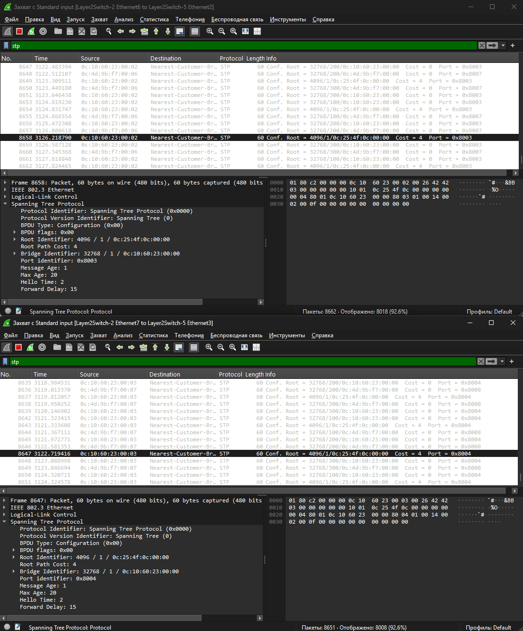
Для фильтрации использовался фильтр stp. На всех линках были Configuration BPDU, содержащие информацию о корневом коммутаторе. Для VLAN 1 в поле Root Identifier указан BID корневого коммутатора Layer2Switch-1 — 4096 / 1 / 0c:25:4f:c0:00:00. Значение Hello Time = 2 показывает, что служебные BPDU формируются с периодом 2 секунды.
5) Изменить стоимость маршрута для порта RP произвольного назначенного (designated) коммутатора, повторить действия из п.3, результат сохранить в отдельный файл.
enable
configure terminal
interface GigabitEthernet0/0
spanning-tree vlan 1 cost 10
end
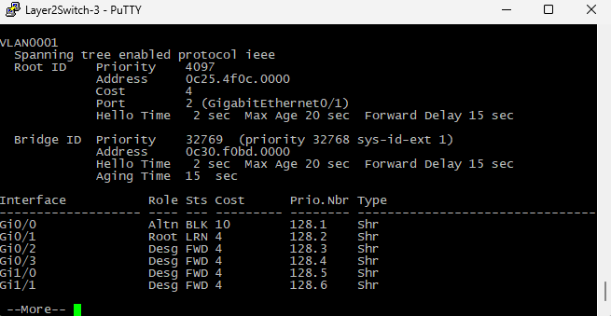
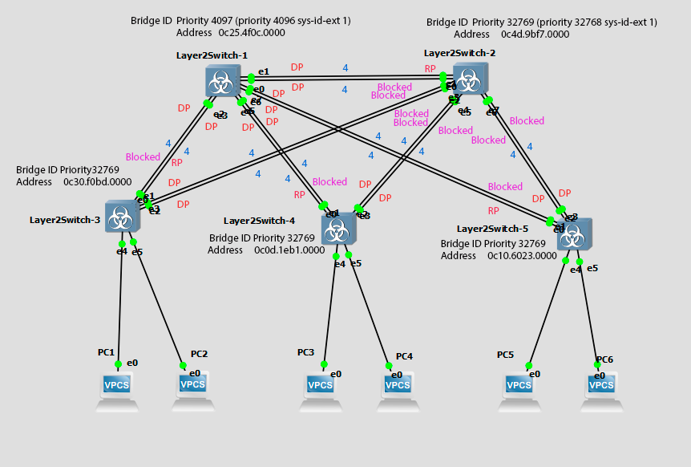
6) Сохранить файлы конфигураций устройств в виде набора файлов с именами, соответствующими именам устройств.

