REQUIREMENTS ANALYSIS

Contents

Introduction 1

Project Vision and Objectives 2

Functional Requirements 3

Business: 3

Administrative: 3

User: 3

System: 3

Non-Functional Requirements 4

Social and Ethical: 4

Legal: 4

Security: 4

Reliability/Availability: 4

Scalability: 4

User Stories 5

Project Backlog 6

UML Diagrams 7

# Introduction

As per software development best practices, Group A has collectively built up this document (based on the information supplied by the client, ECO Badge) to detail the Requirements Analysis phase of the project. The content of this document is not concrete – Requirements and designs are expected to change on an incremental basis as per agile standards.

The overall intent of this document is to outline the scope of the project and the expectations of the final deliverable that Group A is to deliver by the end of the academic year. This document will be used by Group A (the development team) to prove to ECO Badge (the client) that they understand the functionality that the final deliverable will provide. Likewise, this document is required to enable the development team to pursue the next Agile stage – design.

# Project Vision and Objectives

The vision of the client’s business as a whole is as follows:

*“Our vision is to eradicate unsustainable buying habits and business practices, supporting ethical consumption globally; building a community of gardeners who can, together, take care of this world we inhabit.”*

Therefore, the project vision, which is heavily related to the business’s aims, is as follows:

In present times, humanity is globally contributing to a massive amount of wastage – whether this is to do with food or resources. To try to reduce the amount of waste being produced ECO Badge has manufactured a solution that will promote small/medium sized businesses that are sustainable and eco-conscious, in an attempt to persuade more businesses to adapt to similar environmentally friendly practices.

The goal of this project is to make a website that targets the following target audiences:

* Eco-conscious consumers
* Eco-conscious *interested* consumers
* Food establishments

The website will be a gateway for consumers to educate themselves on how to support environmental change, as well as a tool for consumers to find businesses that adhere to these principles. The website will also be used by food establishments to learn about how to adopt to eco-friendly practices, as well as being a way of promotion for those that already do.

Initially, this project will be a simple website, but there is a motive to develop a mobile app alongside the website, as well as making the app integrate with other service providers that can use display ECO Badge ratings.

Whether it is presented via a mobile app or website format, the MVP must feature:

* A database that stores each business profile as a record
* A directory webpage that fetches the businesses stored within the database
* A filter system that allows users to query directories on the directory webpage
* A homepage that links users to other pages that users can navigate between:
  + About us o Directory o Signup/Sign in
  + Business and Consumer profiles
  + Business and Staff portals (edit profiles or page content) o Contact us

It can be assumed that the features listed above will not change as they determine the minimum expectations of the project – however, it can also be assumed that many more features may be added to the project via the extension of the project, as multiple interactions will elicit different types of feedback that will shape the MVP.

A potential limitation of the project could therefore be if main features need to be repeatedly altered in different iterations – this could alter time constraints and cause the project to be fixated on minor changes that are requested, instead of big features that still need to be implemented.

Overall, this project will be split across multiple Agile phases and documentations for Analysis (this current document) and Design will be procured. Likewise, other minor forms of documentation may also be created – such as minutes from scrum meetings.

# Functional Requirements

## Business:

* We need a website that can be accessed by consumers, businesses, and staff
* We need customers to be able to browse different business directories
* We need customers and businesses to be able to have their own profiles
* We need to be able to securely store sign in information
* We need to be able to securely store profile information
* We need to show information in a concise and clear way to users

* We do not want unauthorised businesses to create accounts

## Administrative:

• Produce environmental impact scores for consumers on their profiles

## User:

* Admins need to be able to manage consumer and business profiles
* Admins need to be able to view all emails collected via the website
* Admins need to be able to edit pages to update information
* Customers need to be able to view directories
* Customers need to be able to edit profile information
* Businesses need to be able to submit re-score forms
* Businesses need to be able to edit business information and menus

## System:

* Must contain the following webpages: o Homepage o About us o Directory o Signup/Sign in

o Business, Staff and Consumer profiles (editable) o Contact us

* Must have navbar/footbars on every page
* Must have a database to store profiles
* Must have logins for all users
* Must be compatible with phones and desktop
* Pages can be static

# Non-Functional Requirements

## Social and Ethical:

* The website should be suitable to use for people with visibility disorders/disabilities/impairments
* The website should contain accessibility features for all types of users

## Legal:

* User data should be stored effectively and kept private
* The system must adhere to the Companies Act 2006 – identify business
* The system must adhere to the GDPR – explain to users how personal data is used • The system must adhere to the Equality Act 2010 – ensure inclusivity

## Security:

* Passwords should be encrypted
* Separate account types for admin and consumers
* Strong password policy

## Reliability/Availability:

* System should be active at all times – 24/7
* Hyperlinks should be fully functional

## Scalability:

* Database must be scalable
* Database must be editable – new fields can be added

# User Stories

The following user stories have been made for the three primary stakeholders that are relevant to this project. These user stories depict the expected functionality from a user perspective,

|  |  |
| --- | --- |
| As a  **Consumer**  **…** | I want to be able to view all directories, so that I can choose which businesses to eat at. |
| I want to be able to filter the directories, so that I can find specific types of businesses easier. |
| I want to be able to read more about sustainability, so that I can educate myself. |
| I want to be able to sign myself up to the ECO Badge newsletter, so that I can be informed about ecoconscious content. |
| I want to be able to create/view my consumer profile, so that I can track my environmental impact. |
| I want to be able to use the website on my mobile device and desktop so that I can access the website through multiple means and whenever I want to. |

|  |  |
| --- | --- |
| As an  **Admin**  **…** | I want to be able to edit pages, so that I can update information |
| I want to be able to manage business profiles/ business members, so that I can see specific details about specific accounts and fulfil my admin duties. |
| I want to be able to view all email collected via the website, so that I can perform administrator tasks in accordance to email content. |

|  |  |
| --- | --- |
| As a  **Business…** | (Paid member) I want to be able to access my profile portal, so that I can update profile data. |
| (Paid member) I want to be able to access my profile portal, so that I can reply to customer reviews. |
| (Paid member) I want to be able to access my profile portal, so that I can update our business’s menu. |
| (Paid member) I want to be able to access my profile portal, so that I can schedule my venue for a re-score. |
| I want to be able to learn about how the ECO Badge scores are determined, so that I can appeal more to eco-conscious viewers by changing how the business operates. |

|  |  |
| --- | --- |
| As a  **General User**  **…** | I want to be able to sign in, so that I can access my portal space. |
| … |
| … |

# Project Backlog

The following backlog has been based upon the User Stories (defined on page 3). Furthermore, the backlog has been prioritised in a MoSCoW format. There are no features that have been identified that fit under the ‘Wont Have’ category.

|  |  |
| --- | --- |
| **MUST** | As a consumer, I want to be able to view all directories, so that I can choose which businesses to eat at. |
| As a consumer, I want to be able to filter the directories, so that I can find specific types of businesses easier. |
| As a consumer, I want to be able to create/view my consumer profile, so that I can track my environmental impact. |
| As a user, I want to be able to sign in, so that I can access my portal space. |
| As an admin, I want to be able to edit pages, so that I can update information. |
| As an admin, I want to be able to manage business profiles/ business members, so that I can see specific details about specific accounts and fulfil my admin duties. |
| As a business, (Paid member) I want to be able to access my profile portal, so that I can update profile data. |
| As a business, (Paid member) I want to be able to access my profile portal, so that I can reply to customer reviews. |
| As a business, (Paid member) I want to be able to access my profile portal, so that I can update our business’s menu. |
| As a business, (Paid member) I want to be able to access my profile portal, so that I can schedule my venue for a re-score. |
| **SHOULD** | As a consumer, I want to be able to use the website on my mobile device and desktop so that I can access the website through multiple means and whenever I want to. |
| As an admin, I want to be able to view all email collected via the website, so that I can perform administrator tasks in accordance to email content. |
| As a business, I want to be able to learn about how the ECO Badge scores are determined, so that I can appeal more to eco-conscious viewers by changing how the business operates. |
| **COULD** | As a consumer, I want to be able to read more about sustainability, so that I can educate myself. |
| As a consumer, I want to be able to sign myself up to the ECO Badge newsletter, so that I can be informed about eco-conscious content. |

# UML Diagrams

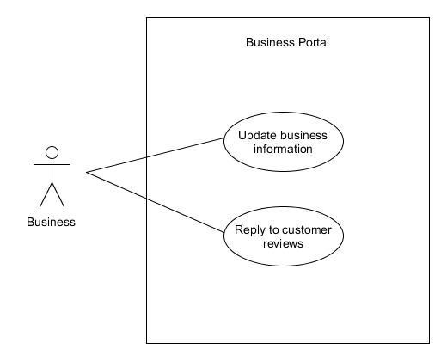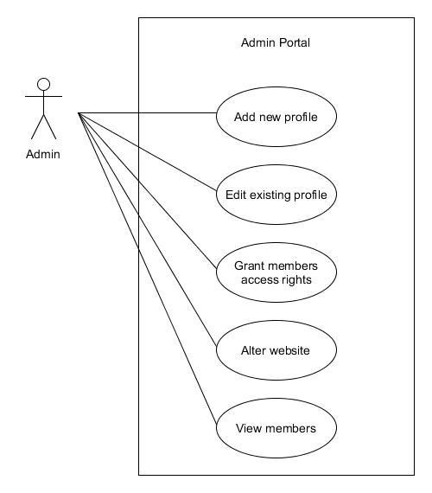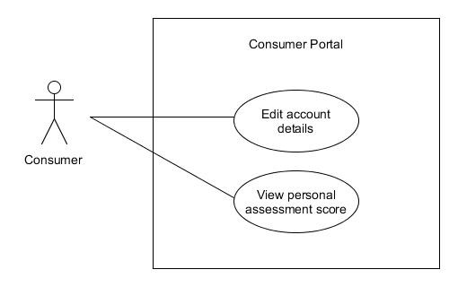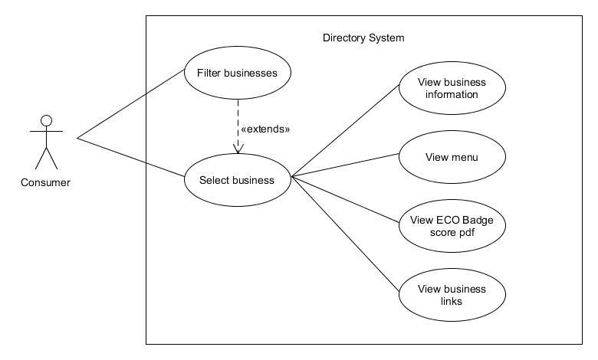

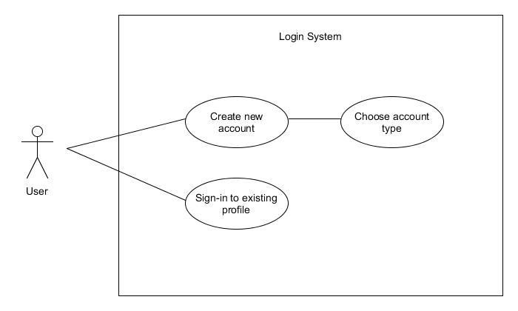

|  |  |
| --- | --- |
| Name: | Create consumer account |
| Short description: | A consumer wants to create an account so that they can view the business directories |
| Precondition(s): | User must not be already signed in |
| Postcondition(s): | A free consumer account has been created |
| Error situations: | 1. invalid name 2. invalid email address 3. invalid password |
| System state in the event of an error: | Account cannot be created |
| Actors: | Consumer |
| Trigger: | Consumer selects to CREATE ACCOUNT |
| Standard process: | 1. Consumer selects FREE GENERAL account type 2. Consumer inputs forename 3. Consumer inputs surname 4. Consumer inputs email 5. Consumer inputs password 6. Consumer inputs password again for validation 7. Consumer submits information |
| Alternative processes | N/A |

|  |  |
| --- | --- |
| Name: | Create business account |
| Short description: | A business wants to create an account so that they can be listed on the directory and be scored. |
| Precondition(s): | Business user must not be already signed in |
| Postcondition(s): | A PAID BUSINESS user account has been created |
| Error situations: | 1. invalid name 2. invalid email address 3. invalid password 4. invalid business / business does not exist |
| System state in the event of an error: | Account cannot be created |
| Actors: | Business user |
| Trigger: | Business user selects to CREATE ACCOUNT |
| Standard process: | 1. Business user selects PAID MEMBER account type 2. Business user inputs forename 3. Business user inputs surname 4. Business user inputs email 5. Business user inputs password 6. Business user inputs password again for validation 7. Business user inputs business name 8. Business user submits information |
| Alternative processes | N/A |