ORMAP Taxlot Editing Toolbar version 2.1.3
Copyright © 2008 ORMAP Tech Group. All rights reserved.

The ORMAP Taxlot Editing Toolbar gives the user tools to edit taxlots and related features in compliance with the ORMAP standard.

Locate Feature Tool

General Description:
The Locate Tool changes the map extent to the extent of either a MapIndex or Taxlot polygon depending on user input values (a map number or a map number and tax lot). In addition to this the tool provides a way to override the auto-attributing of features based upon the underlying MapIndex and specifically set the MapIndex for all features added or modified.

Prerequisites:
- Must have the MapIndex and Taxlot polygon feature classes loaded into the active data frame of the current map document.

How to Use:
To Display or Hide the Locate Feature Dialog:

- Press the Locate Tool on the ORMAP Editing Toolbar.

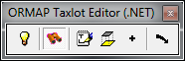

- The Locate Tool dock-able window with either display or hide. The button will indicate the down position if the window is visible and the up position if the window is hidden. Because this is a dock-able window you have the option of either docking the window or using it as a standard window. Docking the window is helpful if you plan on leaving the window open for an extended period of time.

To Locate a Feature:

- Start typing in the Map Number box and a list of matching map numbers will appear in the drop-down below. Type in the entire map number, partially enter the Map Number and use the arrow keys to move up or down the list, or scroll and select it from the list. If you wish to locate a taxlot instead of a map number you must first enter the map number then start typing in the taxlot number in the Taxlot drop-down. Taxlots present within the MapIndex map number that you entered will display in the Taxlot drop-down list. You can press Alt+f at any time to initiate the find or press the tab key until focus is on the Find button and press f.

Note: The Map Number is case sensitive but WILL select a Map Number regardless of case. For example, if Map Number 221014DB000 exists in the dropdown list but you type 221014db000, then the uppercase version will be selected when you finish typing the Map Number. If the lowercase version exists then it will be selected. If they both exist then whichever one you typed will be selected. If using mixed case then you must type the Map Number exactly as it appears in the list.

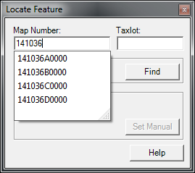 OR 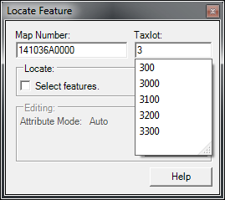

- If you wish to select the feature in addition to locating it (zooming to it), check the box labeled “Select features”.

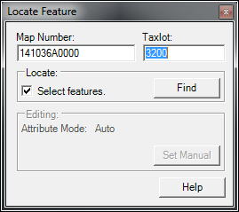

- Press the Find button.

To set the Editing Attribute Mode:

- Be sure that an edit session has been started and editing is set to update all taxlot fields by verifying the Light Bulb button is pressed down.

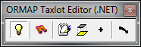

- If the Map Number has not already been entered then start typing in the Map Number box and a list of matching map numbers will appear in the drop-down below. Type in the entire map number, partially enter the Map Number and use the arrow keys to move up or down the list, or scroll and select it from the list.

- Press the Set Manual button or press Alt+m on your keyboard to set the Attribute Mode to manual.

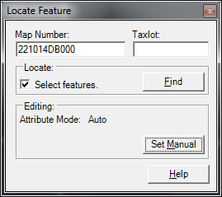

- Press the Set Auto button or press Alt+a on your keyboard to set the Attribute Mode back to Auto.

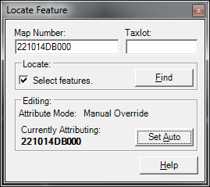

- To reset the Map Number enter the new Map Number and press Set Auto followed by Set Manual again.

Notes:
- The Map Number combo box updates to include any new map numbers that have been created whenever you close and then re-open the form.

Reporting Bugs and Requesting New Features:
For instructions on how to report a bug or request a new feature, go the bottom of the help form or to Editor ► Options ► ORMAP Taxlot Editor and click Report Bug or Request New Feature.

