ORMAP Taxlot Editing Toolbar version 2.0
Copyright © 2008 ORMAP Tech Group. All rights reserved.

The ORMAP Taxlot Editing Toolbar gives the user tools to edit taxlots and related features in compliance with the ORMAP standard.

Settings

Overview:
The ORMAP Taxlot Editing Toolbar is an editor extension designed to work with data in the standard ORMAP data model format. Local users of this data model often customize it to meet local needs and data idiosyncrasies. The ORMAP Taxlot Editing Toolbar user can configure the tool settings to match local variations in feature class names, field names and other parameters.

No More ormap.ini File:
Previous versions of these tools used the ormap.ini file to store user configuration settings. The current version replaces this file with embedded default settings carried in the tool library itself (OrmapTaxlotEditing.dll). When the user changes these settings to local values using the Settings interface (see the Changing Settings section below), a new file called user.config is saved on the user’s computer. This file can be shared with other local users (see the Sharing Settings section below).

Changing Settings:
To change the ORMAP settings to local values, launch ArcMap and go to Editor ► Options ► ORMAP Taxlot Editor tab and click Settings. This will open the ORMAP Taxlot Editing Settings window.

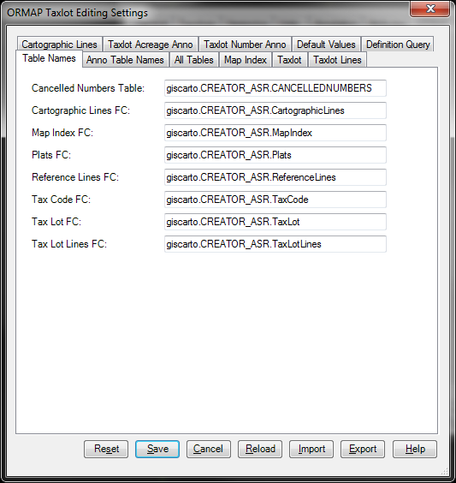

The buttons at the bottom of the window do the following:

Save Stores the current values of the settings in persistent storage and closes the window.

Reset Restores the application settings values to their corresponding default properties (overwriting any current changes).

Cancel Closes the window without saving any modified settings.

Reload Refreshes the application settings values with saved values from persistent storage (overwriting any current changes).

Import Imports the settings values from another user.config file (overwriting any current changes).

Help Launches this help file.

Changing Settings:
Here's how to share your ORMAP Taxlot Editing Toolbar settings (user.config file).

- Install the ORMAP Taxlot Editing Toolbar on the first computer.

- Launch ArcMap on the first computer and go to the Editor toolbar, Editor menu, Options menu item, ORMAP Taxlot Editor tab. On that tab, click the Settings button. Change the settings to match your local data (see your old ormap.ini file for a reference, most settings are similarly named) and click the Save button. Close all windows and ArcMap.

- When you save these new settings, a new user.config file is created on your machine. This is saved to a location like this (your exact location will vary):

C:\Documents and Settings\<Your Windows Username>\...
Local Settings\Application Data\ESRI\...
DefaultDomain_Path_pz0lsv5r40zaegw4she55pczc5ncbj1k\...
<ArcGIS Version Number>\user.config

Copy the new user.config file at this location to a location (e.g. on your network or on portable media) that all users have access to.

- Install the ORMAP Taxlot Editing Toolbar on a second computer.

- On the second computer, copy the user.config file from the shared location (see step 3 above) to the directory you installed the OPET.NET tools to. The default location is C:\Program Files\ORMAP\ORMAP Taxlot Editing Toolbar.

- Launch ArcMap on the second computer and go to the Editor toolbar, Editor menu, Options menu item, ORMAP Taxlot Editor tab. On that tab, click the Settings button. Click the Import button. This will import the settings from the user.config file in the install directory (e.g. C:\Program Files\ORMAP\ORMAP Taxlot Editing Toolbar\user.config). Click the Save button. Close all windows and ArcMap.

Repeat steps 4-6 for each additional computer.

Reporting Bugs and Requesting New Features:
For instructions on how to report a bug or request a new feature, go the bottom of the help form or to Editor ► Options ► ORMAP Taxlot Editor and click Report Bug or Request New Feature.

