ORMAP Taxlot Editing Toolbar version 3.0
Copyright © 2008 ORMAP Tech Group. All rights reserved.

The ORMAP Taxlot Editing Toolbar gives the user tools to edit taxlots and related features in compliance with the ORMAP standard.

Add Arrow Tool

General Description:
The “Add Arrows” Tool adds new features to the cartographic lines feature class. Within the tool two different types of arrows can be added.

Prerequisites:
- Must have the MapIndex, Cartographic lines, and Taxlot (polygon) feature classes loaded into the active data frame of the current map document.

How to Use:
- Start editing the Cartographic Lines feature class.

- To add a Standard Arrow.
  - Press the “Add Arrows” button.

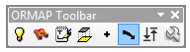

  - Select the type of arrow to be added.

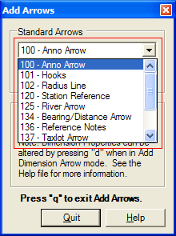

  - Press the “Add Arrow” button.

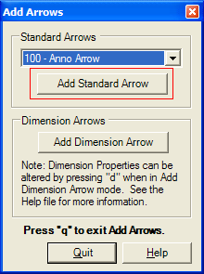

  - Click on map as many times as desired to define the arrow.

  - Click on the map and hold down the ‘SHIFT’ key to end the arrow. Arrow appears on the map.

  - Repeat steps d and e to add additional arrows.

  - Press the ‘Q’ button on your keyboard to quit adding arrows.

- To add Dimension Arrows.
  - Select Editor ► Snapping... and check snapping for Taxlot feature class (end and vertex)

  - Select Editor ► Options... select General tab, check Show Snap Tips and set a snapping tolerance.

  - Press the “Add Arrows” button.

  - Press the “Dimension Arrow” button.

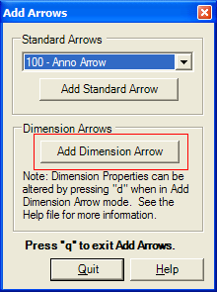

  - Click where you want the first dimension arrow to be (usually end or vertex of the Taxlot polygon feature class).

  - Click where you want the second dimension arrow to be (usually end or vertex of the Taxlot polygon feature class).

  - Click a third time on the side of the Taxlot polygon line that you want the arrows to draw (repeat as many times as you like).

  - Press the “Q” button to quit the dimension arrow tool.

  - To make dimension arrows twice as large (i.e. for some annotation set far from the line) hold the shift key down while clicking the 3rd mouse click.

  - To manually set dimension arrow sizes, shape, and smoothness press the “D” button after pressing the dimension arrow button for additional form options.

    - Curve ratio
    - Line length ratio
    - Smooth ratio
    - Manually add checkbox
The manually add checkbox allows the user to input 3 mouse clicks to manually add one dimension arrow formed in any shape they like. It ignores curve and line length ratio values, but does use the smooth ratio value.

    - Reset Button
Reset the form to all default values.

    - Apply Button
Apply the current set values to the dimension arrow that will be added.

Reporting Bugs and Requesting New Features:
For instructions on how to report a bug or request a new feature, go the bottom of the help form or to Editor ► Options ► ORMAP Taxlot Editor and click Report Bug or Request New Feature.

